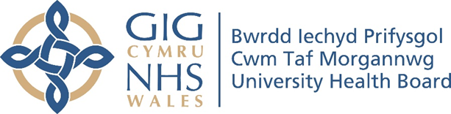

RESEARCH & DEVELOPMENT CONFERENCE 2024
POSTER PRESENTATION :
Switch from Intravenous to oral antibiotics in probable early onset neonatal infection

Author/s: Ahmed, S., Al-Muzaffar, I.
Department: Neonantal Medicine, Children & Young People, Cwm Taf Morgannwg University Health Board.

Introduction:
Current management of early onset neonatal infection includes at least 36 hours of intravenous (IV) antibiotics. Antibiotics are usually discontinued if baby is well, C-reactive protein (CRP) values are reassuring and cultures taken from sterile sites are negative. However, if there are ongoing concerns like raised C-reactive protein (CRP), then IV antibiotics are continued in a hospital setting for up to 7 days. The RAIN study was done in Netherland with 17 hospitals included, evaluated the safety and efficacy of early intravenous to oral antibiotic switch in neonates. The study showed that intravenous to oral switch is not inferior to a full course of intravenous antibiotics in neonates who received prolonged antibiotic course because of a probable bacterial infection. Our current practice has major impact on neonatal wellbeing and is associated with substantial health-care costs. Switching to a less invasive route of administration will be beneficial for neonates and their carers, as it will reduce the hospital length of stay and associated health-care costs

Aim:
This aims of this project were to evaluate current practice of management of neonates with probable early onset infection, and evaluate the potential impact of a change in practice of introducing switch at 48 hours from intravenous to oral antibiotic.
Methodology:
In this quantitative retrospective case project, we studied all babies who were born in the time period 01/01/2024 and 31/07/2024 at Prince Charles Hospital, >34+6 weeks gestational age, who received intravenous antibiotics in the first 72 hours of life, with a negative blood culture, maximum C-reactive protein value of < 50 mg/L, and decision to continue treatment with antibiotics beyond 36 hours. Data were obtained from neonatal handover sheets, Welsh Clinical Portal and digitised clinical record saved on CITO. No data identifier was collected. Excel software was used to analyse data.

Results:
20 babies met selection criteria. Median gestational age was 38 weeks (Range 36-41). Average birth weight 3.3Kg (Range 2.3 – 4.2Kg). 35% had history of maternal prolonged rupture of membranes. 70% born by caesarean section. 80% were symptomatic after birth. 80% were admitted to the neonatal unit. Median of the highest C-reactive protein value was 24 (Range 13-48). Total number of days of intravenous antibiotics was 90 days. The potential impact of the
proposed change of practice was 33% reduction in IV gentamicin doses, 66% reduction in IV Benzyl penicillin doses, and 56% reduction in IV antibiotic days. If we implement this practice change across the health board; 68 babies will potentially benefit every year with 64 doses of IV Gentamicin, 381 doses of IV Benzyl penicillin, and 170 antibiotic days saved.

Conclusion:
An early intravenous-to-oral antibiotic switch in neonates with probable bacterial infection potentially enables earlier discharge home and reduce the burden of IV antibiotics and health care costs.

