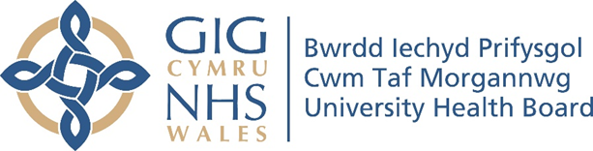

RESEARCH & DEVELOPMENT CONFERENCE 2024
POSTER PRESENTATION :
Public health student evaluation of teaching qualitative research using interactive methods.
Author/s: Livingstone, A¹., Singh Bhadoria, A²., Pontin, D¹., Saxena, V²., Thomas, M¹., Mehta, A²., Wallace, C¹.
Department: ¹Faculty of Life Sciences and Education, Universityof South Wales. ²Department of Community and Family Medicine, All India Institute of Medical Science(India).

Introduction:
Interactive teaching methods aid post graduate students in learning qualitative research. Four academic researchers from the United Kingdom had an opportunity to teach qualitative research methods, specifically consensus methods, to the Master of Public Health students (MPH) during a visit to India. This teaching formed part of a work package with AIIMS (All India Institute of Medical Sciences) Rishikesh, India exploring the concept of family resilience among families with children under 6yrs. We used the experiences of the MPH students to gain knowledge and create meaning [1] about using consensus methods.
Aim:
The workshops aimed to introduce the concept of family resilience by using the question, “What will be the three top public health priorities in India to support family resilience in the 21st century?” as a central theme for all the workshops.

Methodology:
We introduced qualitative research methods and hands-on experience of consensus methods to the students. The students were introduced to Delphi and GCM (Group Concept Mapping) methods during workshop 1. Workshop 2 introduced NGT (Nominal Group Technique) via a short presentation followed by a practical hands-on session using GCM data from workshop 1. The last workshop (3) focused on the World Café method.

Results:
The students evaluated the workshops highly and asked for online sessions on GCM, NGT and World Café which will be planned in the future. We concluded that the post graduate curriculum for master’s in public health studies would benefit from teaching using interactive research methods which will enhance their critical thinking and autonomy. Secondly although the MPH curriculum had quantitative methods in place, introducing qualitative consensus methods will open new avenues into future research. Finally, teaching using practical demonstration gives students a voice and makes learning effective and enjoyable.

Conclusion:
he concept of family resilience was disseminated to the students who work closely in the communities of Rishikesh India.
Post graduate curriculum for master’s in public health studies would benefit from teaching using interactive research methods which will enhance their critical thinking and autonomy
Although the MPH curriculum had quantitative methods in place, introducing qualitative consensus methods will open new avenues into future research.
Teaching using practical demonstration gives students a voice and makes learning effective and enjoyable

