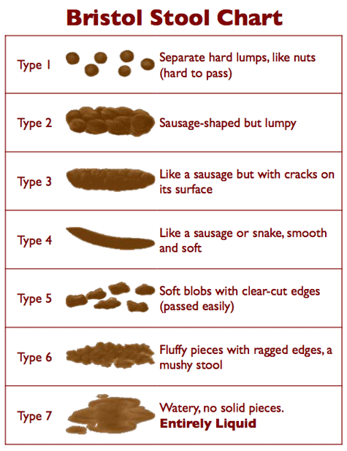
https://www.continence.org.au/pages/bristol-stool-chart.html

