AGENDA ITEM
5.2

PLANNING, PERFORMANCE & FINANCE COMMITTEE

INTEGRATED PERFORMANCE DASHBOARD

Date of meeting | 4th May 2023

FOI Status | Open/Public

If closed please indicate reason | Not Applicable - Public Report

Prepared by | Jose Roper, Senior Performance Monitoring Officer
Presented by | Linda Prosser, Executive Director of Strategy and Transformation
Approving Executive Sponsor | Linda Prosser, Executive Director of Strategy and Transformation

Report purpose | FOR DISCUSSION / REVIEW

Engagement (internal/external) undertaken to date (including receipt/consideration at Committee/group)
Committee/Group/Individuals | Date | Outcome
Linda Prosser | 13/04/2023 | Choose an item.

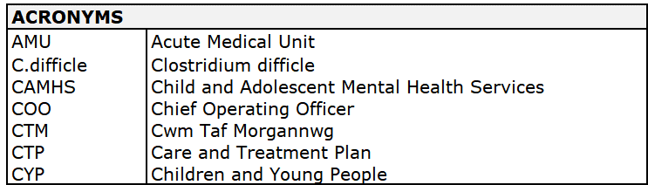
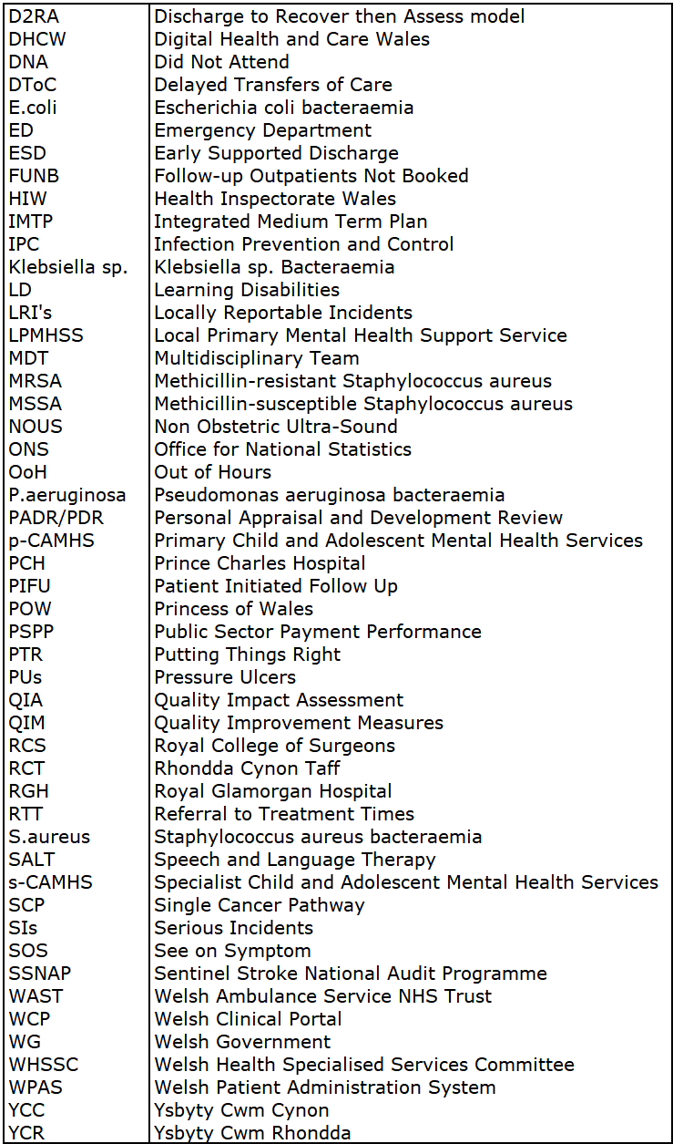
- SITUATION/BACKGROUND

  - This report sets out the UHB’s performance against the Welsh Government’s (WG) Performance Framework and other priority areas for the UHB.

  - The report is intended to provide an ongoing assessment of the UHB’s progress in delivering the Ministerial and Health Board’s priorities as described in our Integrated Medium Term Plan, concentrating on areas of greatest priority and those areas where a significant change in performance has been observed, rather than a full discrete evaluation of all measures.

Quadruple Aim Strategic Scorecards continue to be included in section 2.1 of this paper, in order to provide visible and robust assurance to CTMUHB Board and its Committee’s on delivery, facilitating scrutiny and challenge progress against performance on a regular basis.

The Quadruple Aim metrics endorsed by Welsh Government, continues into 2022/23 and incorporates the Ministerial Priorities: https://gov.wales/nhs-wales-performance-framework-2022-2023

- SPECIFIC MATTERS FOR CONSIDERATION BY THIS MEETING (ASSESSMENT)

  - The UHB’s strategic assessment of progress towards delivery of the NHS Wales Quadruple Aim are shown below:
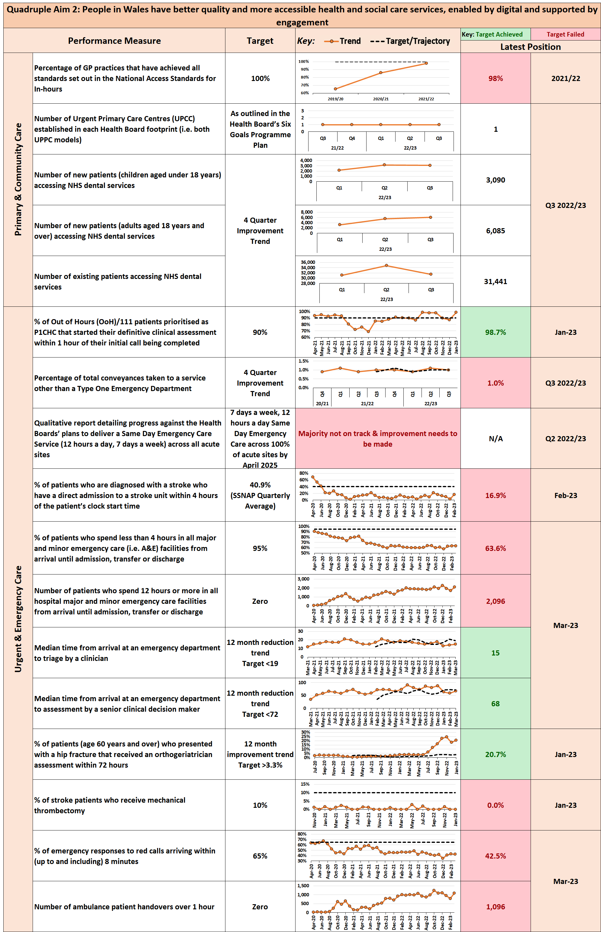
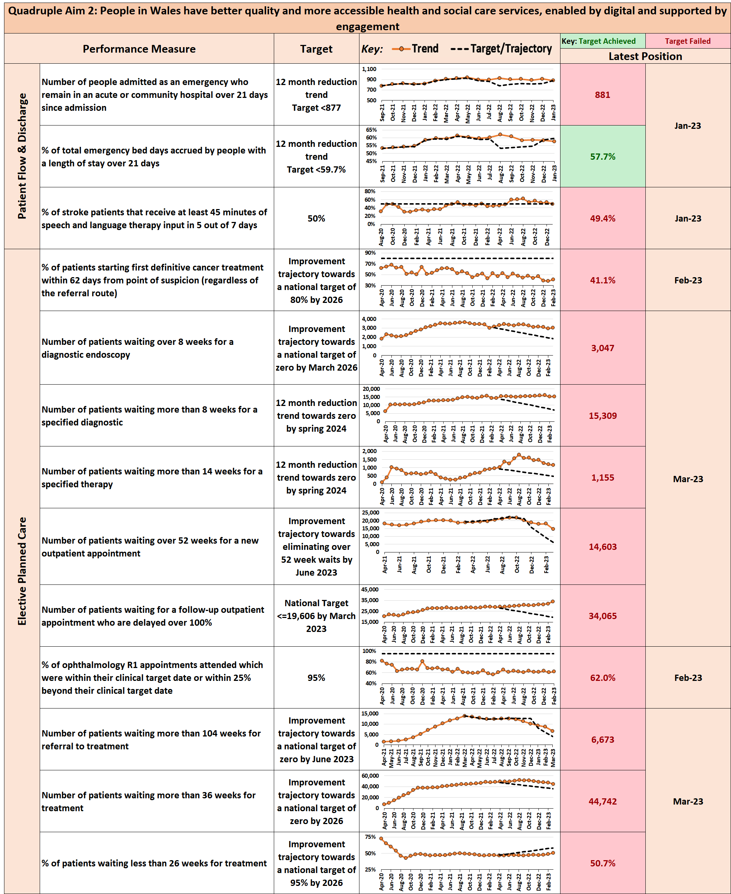

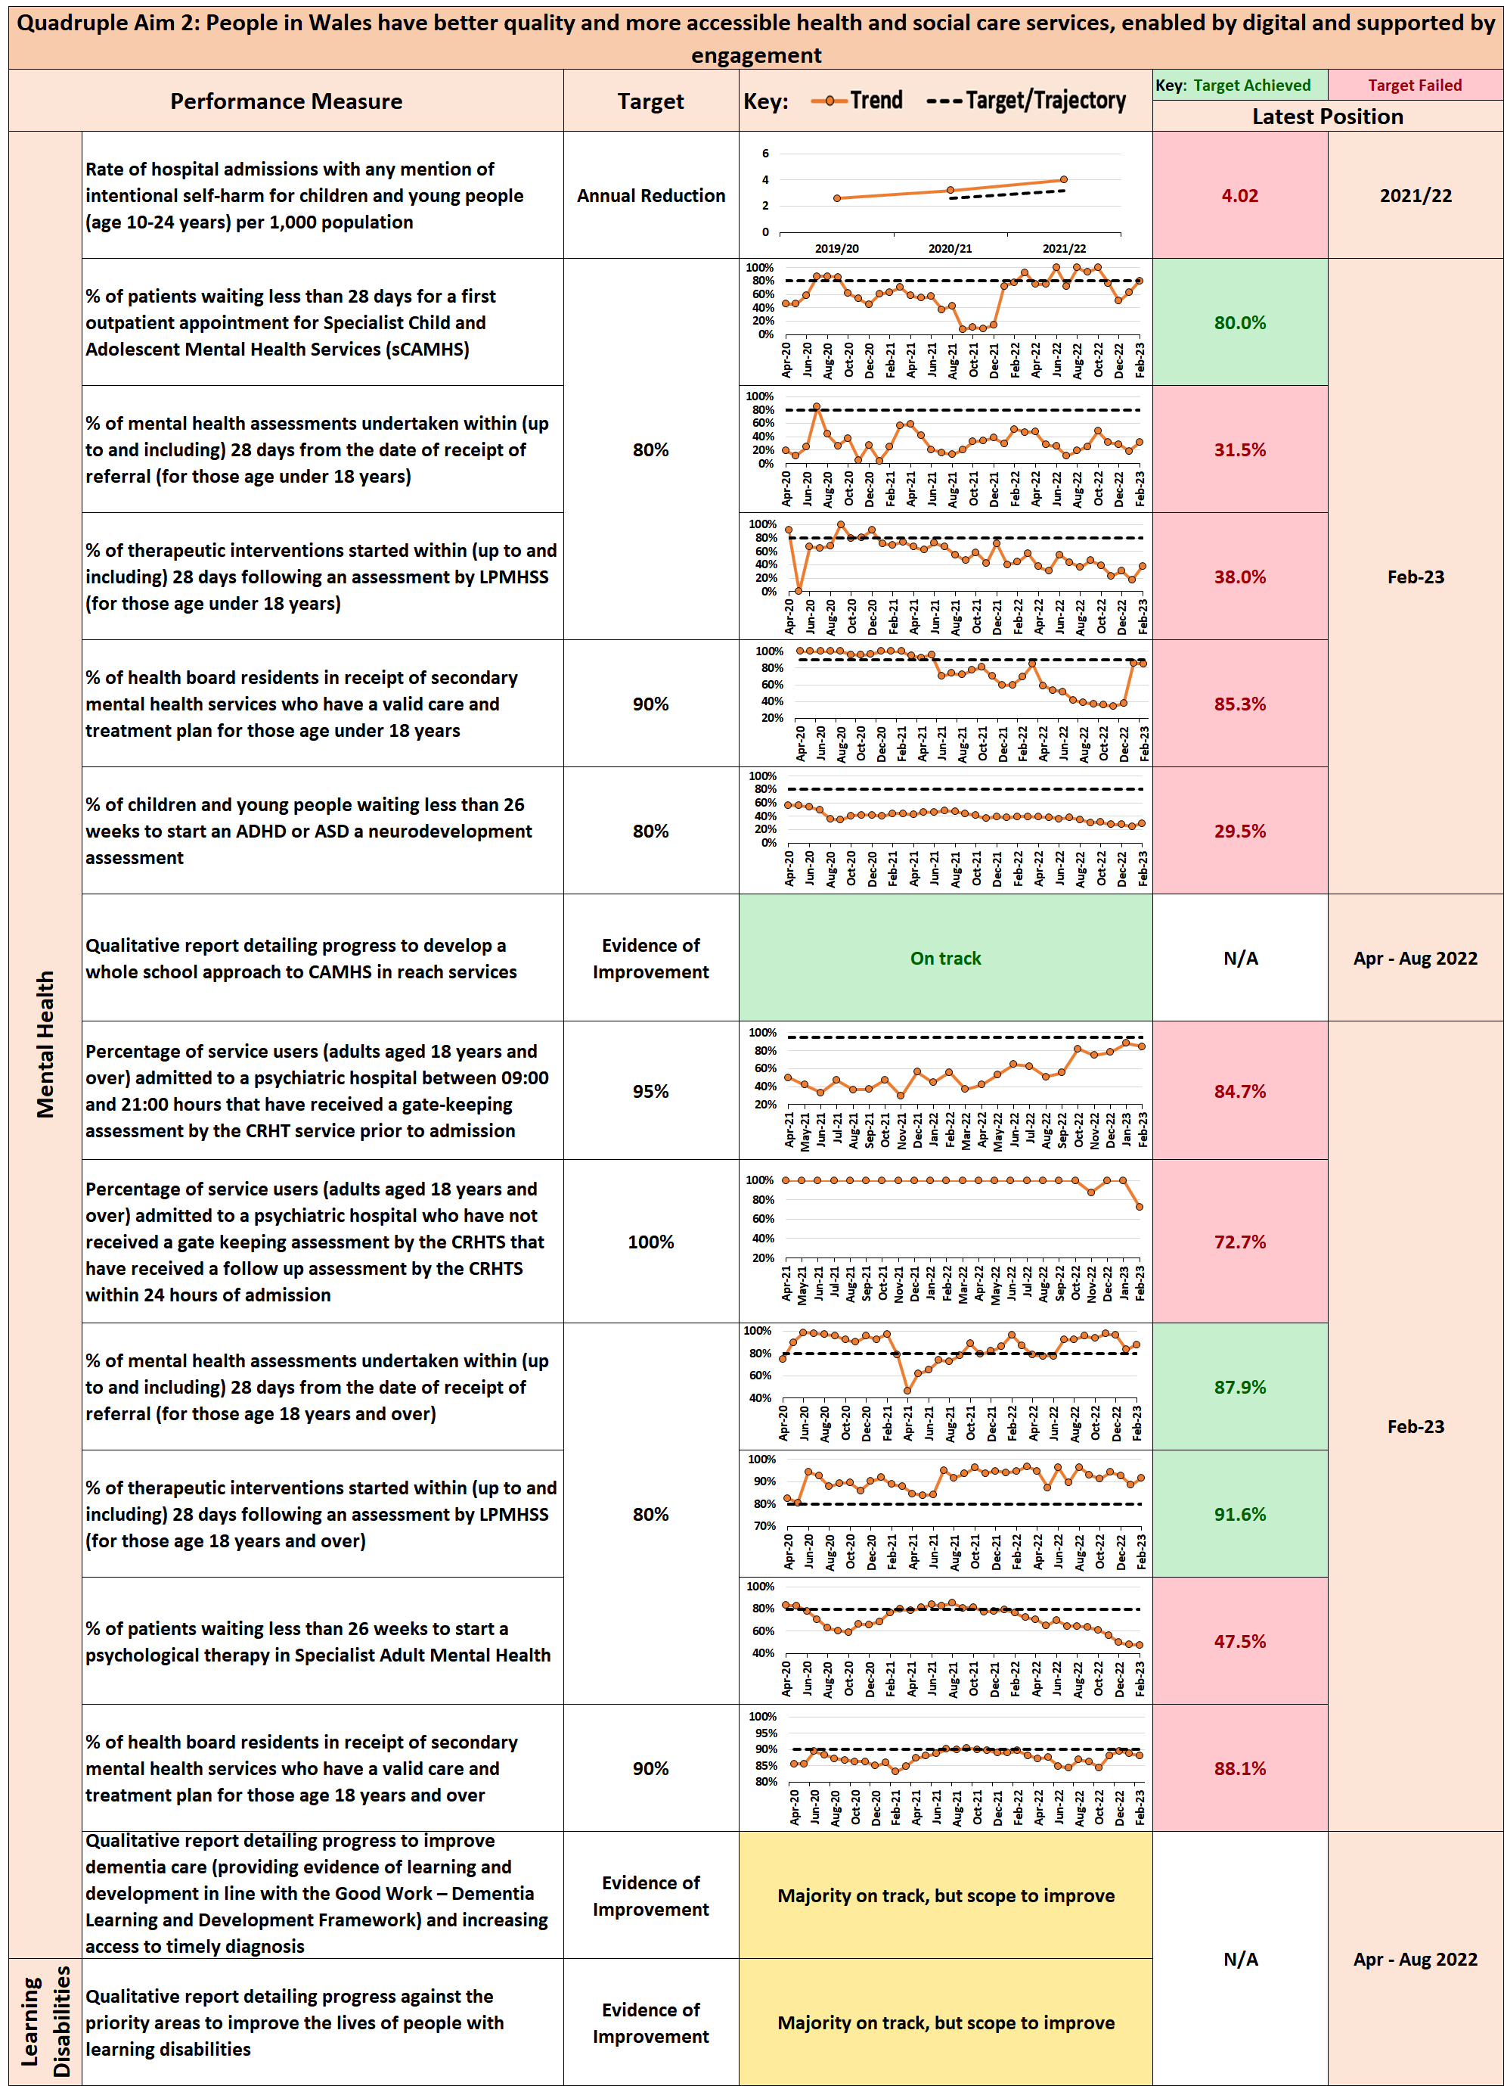

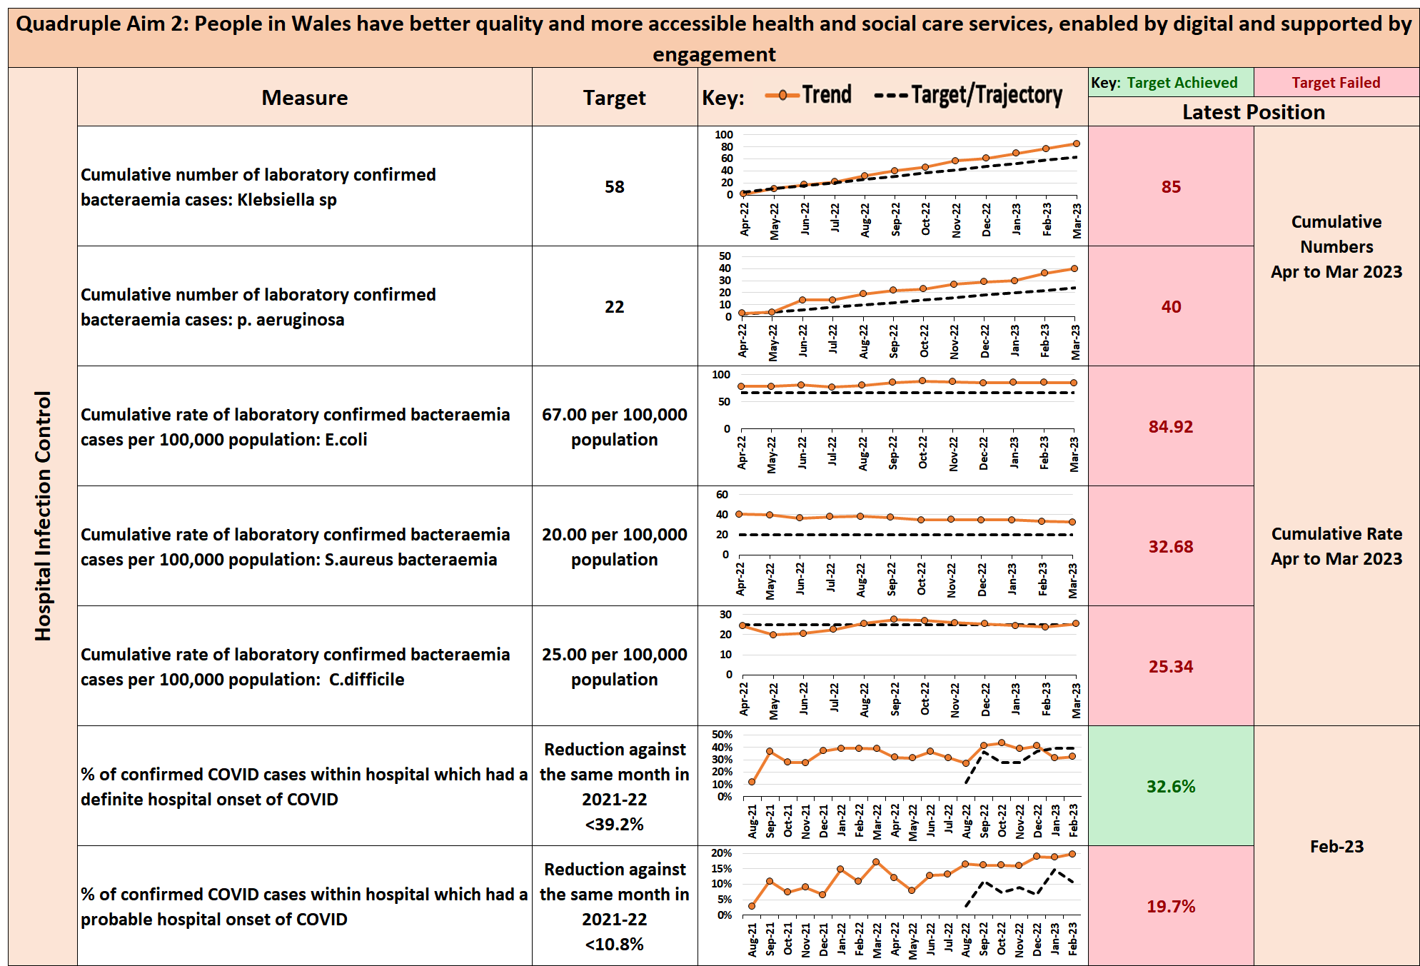

  - Access
Detailed analysis is provided in the following section of this report, but in summary, the main themes of the Access Scorecard are:
    - Urgent Care:

During March, just under 64% of patients were treated within 4 hours in our Emergency and Minor Injury Departments, with around a fifth of ambulances ready to respond to the next ‘999’ call within 15 minutes of arrival at an ED.
There were 15,864 attendances over the course of the month, 1.2% more attendances than in the equivalent period last year.
Both the CTM fifteen & sixty minute ambulance handover compliance fell during March to 20.4% and 52.7% respectively, with compliance continuing to remain at low levels, as seen throughout 2022/23.

    - Stroke Care:

Overall, performance against the desired standards in stroke care continues to remain at low levels within CTM. Whilst absolute performance varies month on month, statistical analysis would suggest that any variances are natural rather than special cause in nature.

Unfortunately, during the month no stroke patient was admitted to the stroke unit at POW within the 4 hour timeframe, whilst an improvement, albeit low, was observed at PCH with around a quarter of the 41 stroke patients receiving this required timeliness of care.

Just over half (52.5%) of the total diagnosed stroke patients within CTM received a scan within the hour, whilst 39 of the 59 (66.1%) admitted stroke patients were assessed by a stroke specialist within 24 hours.

    - Planned Care & Cancer Care:

The CTM performance against the health board’s improvement trajectories for access to planned care and cancer care for 2022/23 (shown page 19), indicates that we remain behind where we should be in regards to new outpatients productivity and cancer treatment, but provisionally better than anticipated for those patients waiting in excess of 104 & 52 weeks for treatment, with a deterioration in the management for follow up outpatient appointments.

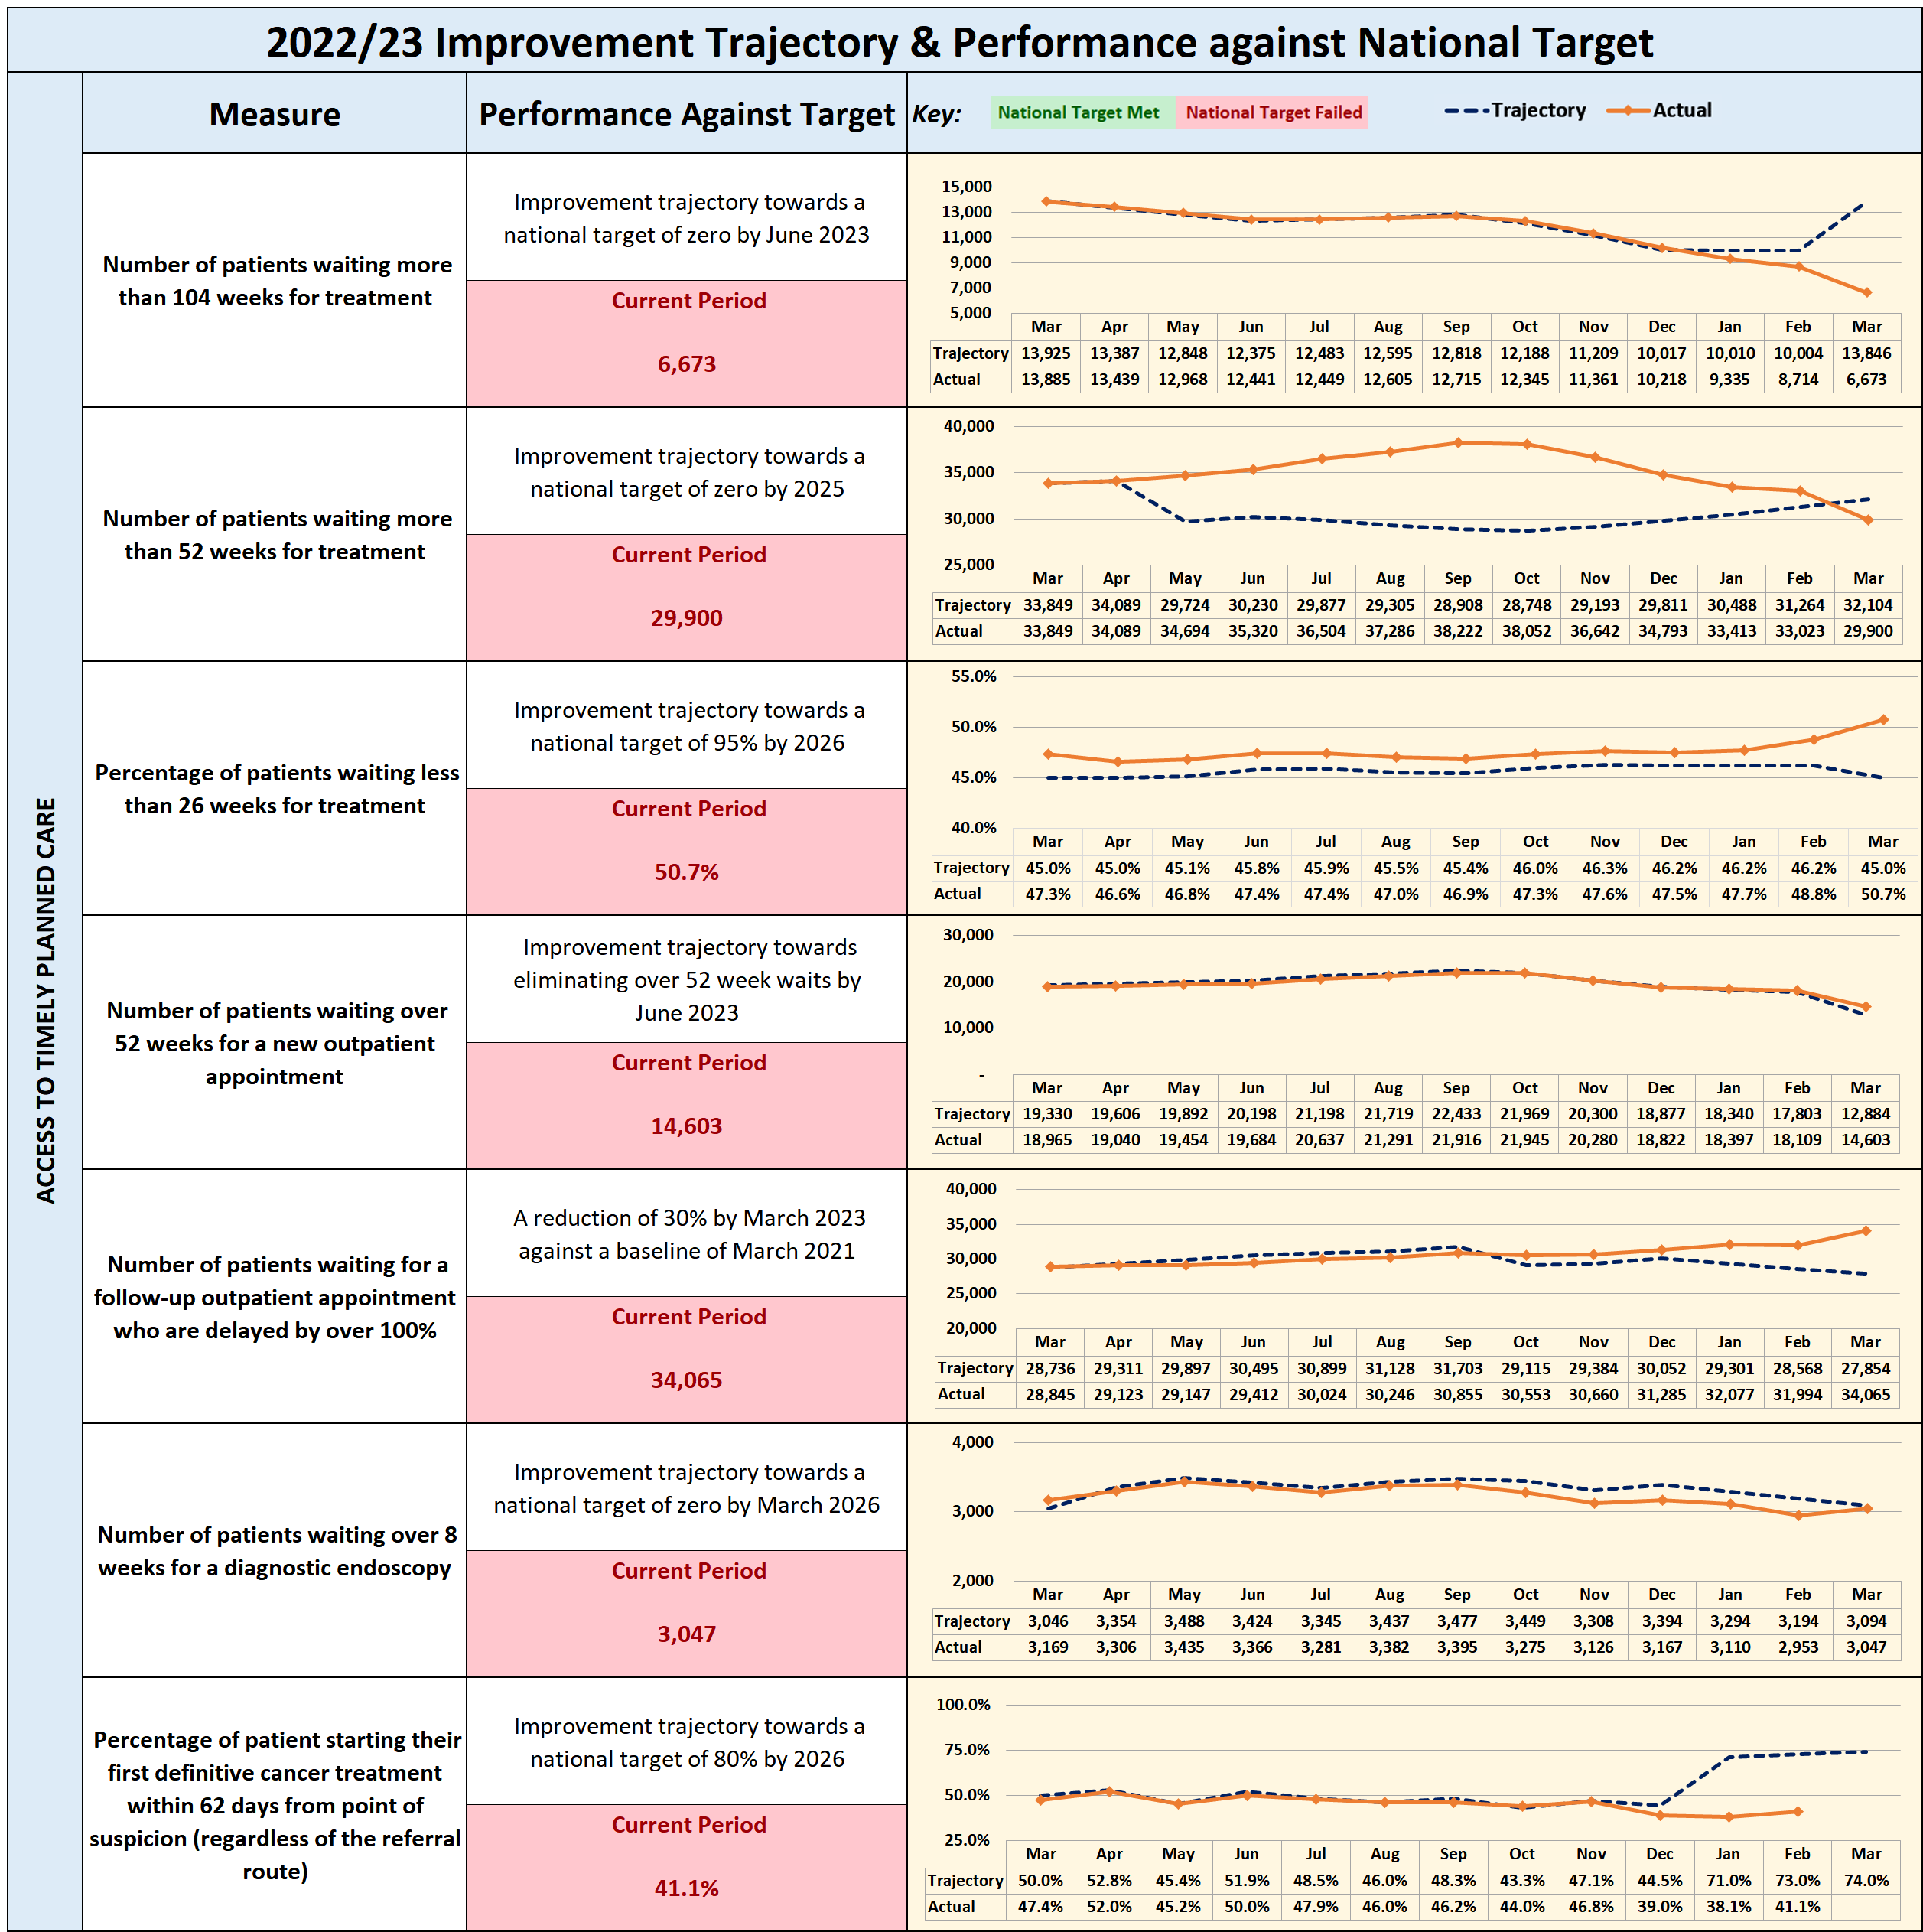

 | Cwm Taf Morgannwg – Inpatient / Day Case Activity – to week ending 2nd April 2023

Activity Undertaken within Internal Hospital Capacity – Inpatient and Day Case

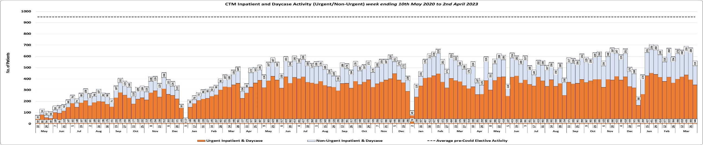
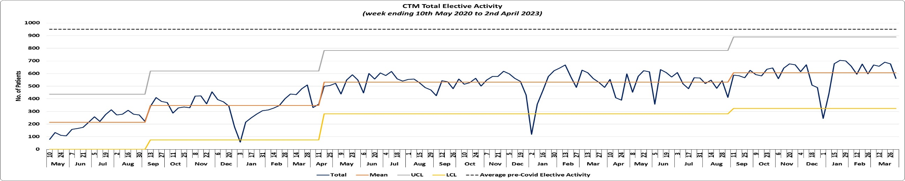
Greatest Volume Specialties compared to pre & intra Covid |  |  |  |  | How are we doing?
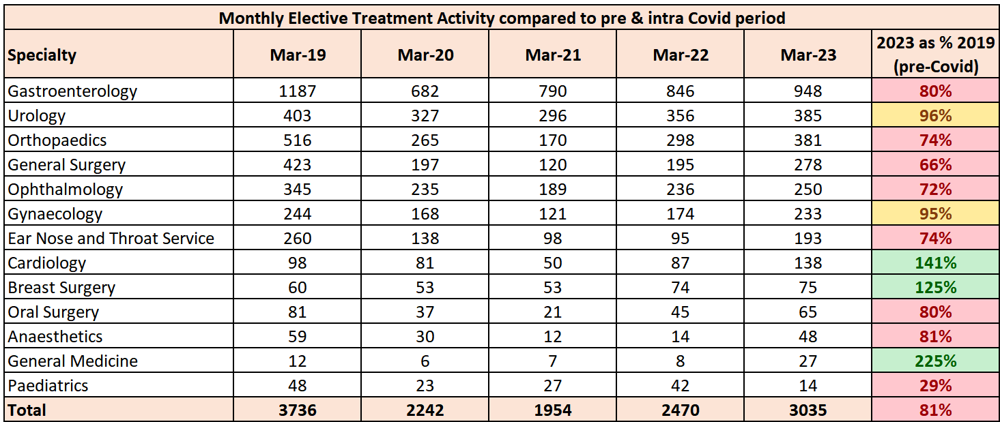 |  |  |  |  | As per the charts above, the number of weekly elective treatments has been gradually increasing, with the average number of treatments for March at 651 treatments per week, which is the highest level seen since the start of the Covid pandemic. In total 3,254 cases were undertaken in March, but despite this increase, current elective cases are around 20% fewer than pre-Covid.  Since the start of April 2021 to date, CTM have sent 2,778 patients to be treated at Spire and Nuffield Hospitals. Of these patients, 1,881 (on average 78 patients per month) have been treated, as detailed below:  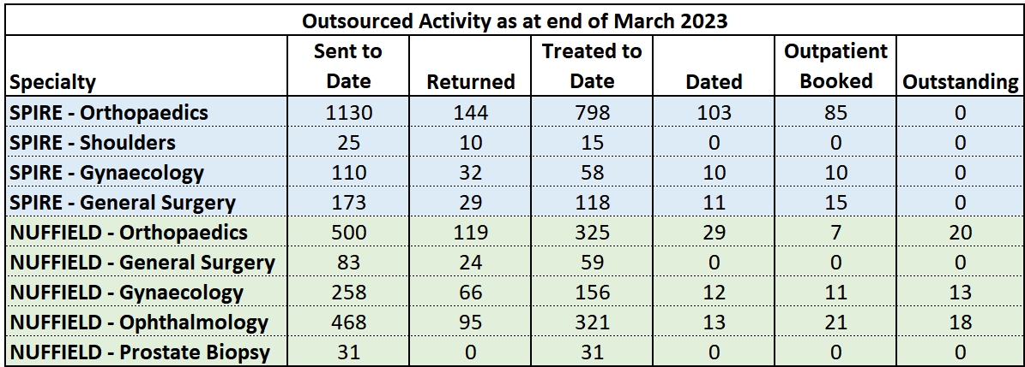  Source: Spire / Nuffield Healthcare
The table above compares the greatest volume specialties of elective activity compared to the average pre & intra Covid levels.
As can be seen, internal activity levels during March surpassed the pre-Covid levels in three of the specialties listed above (green), with Urology and Gynaecology almost at the pre-Covid level (yellow).

Elective Activity continued on the next page…
Elective Activity: What actions are we taking & when is improvement anticipated? |  |  |  |  |  | What are the main areas of risk?
Ophthalmology: CTM continue to work in partnership with C&VUHB Vanguard Programme to reduce waiting times for patients waiting for a cataract operation. Initial agreement was to send Stage 4 patients only, though since 1st April 2023 the agreement is to send 1st New outpatient appointments referred for cataract surgical opinion. Capacity has been divided between C&VUHB, CTMUHB and AB Health Boards. CTM have been allocated 500 slots and are required to send a minimum of 85 referrals per week. Limited pre-assessment nurses to carry out pre-op assessment. A task and finish group has been implemented and underway and agreement has been reached that patients waiting for second eye procedure to have a telephone assessment when their first pre-op assessment appointment is still in date, will undergo a telephone assessment and proceed to second eye surgery when appropriate to free up face to face capacity in the pre-op assessment clinics. To ensure we are meeting the denary training requirement most cataract lists are teaching lists and this is reflected in reduced numbers on the lists. To mitigate this risk an additional non training list on a Friday morning at POW has been set up.  Orthopaedics and Day Surgery: CTM has entered into an insourcing agreement with ID Medical. ID Medical are providing a team of theatre staff to cover 30 theatre sessions per week which will be provided on CTM sites. These sessions are being held Monday to Friday between the hours of 8am-6pm and will primarily cover low risk, high volume day case, such as Urology, General Surgery, OMFS, Orthopaedics and Gynaecology. The scheme is favorably indicating an increase in theatre activity across CTM by utilising existing theatre infrastructure and CTM Surgeons and processes. With a variation of cases and skill mix approximately 2.4 cases per session is being carried out, resulting to circa additional 72 per week. The additional activity at POW is causing a number of bottlenecks in patient flow and recovery space, for this reason the ID Medical team are being relocated to main theatres to enable the substantive day surgery scrub team to carry out the additional activity and core activity to be carried out in main theatres by the ID Medical team. This change will have minimal impact and disruption but will improve surgical flow through the Day Surgery Unit (DSU), currently causing delay/issues with other pathways. ID Medical will continue to be fully utilised in all 10 sessions and kept together as a full team. We will still be working towards the same goal with the additional work, just utilising the ID Medical team differently and enhancing safety. The additional work, managed by POW DSU staff will take priority for cover if we experience any staffing issues. Additionally, with moving lists/practitioners around, we will have the ability to reinstate some minor work in DSU, along with our planned TRAUMA session on a Friday afternoon in DSU – this will reduce some existing pressure on our main TRAUMA list. Weekend WLI lists commenced in February to support Orthopaedic Hand and Pain lists – these are targeting all long waiting patients at the treatment stage of their pathway. Over 156 week LA hands now cleared, weekend lists will now be flipped to support GA’s with the support from the Anesthetist team. The additional support from insourcing is ongoing and day cases at PCH have increased by 17 per week (against planned 12). This is supported through our weekly meeting ensuring productivity and efficiencies are achieved at all times.  Theatre Productivity and Improvement Schemes to Maximise Utilisation: A theatres steering group has been established and will now be reviewed and remolded by the Care Group with the focus on productivity and efficiency and the production of several key metrics. At PCH a theatre workforce model and case for change has been undertaken to provide a gap analysis, the aim is to ensure the establishment is fit for purpose, sustainable and meets the needs for Clinical Futures. The model has now been shared across CTM for a standardised approach and will be collated by the Care Group for analysis.  Urology – Currently operating 6 sessions per week in main theatre and 3 sessions per week in DSU. Anticipating an increase of cases per list from 4 to 5. A multi-disciplinary task and finish group has been set up to consider re-locating the LAPB service to RGH, with the intention of replacing the TRUS biopsy service. A review has been undertaken and an improvement action plan for the service is being developed.  New locum consultant urologist starting on 8 June RGH.  General Surgery – Continuing to utilise all available inpatient and day surgery theatre capacity at POW and Neath Port Talbot hospital. It is anticipated further backfilling capacity will become available from May 2023 to undertake additional day surgery activity supported by the insourcing team, ID Medical. Additional activity will be carried out by a recently appointed 6 month locum. Two current vacancies within the Upper GI Service, one Consultant post currently live on Trac.  T&O – Improve efficiency and case mix in Neath Port Talbot Hospital for elective overnight arthroplasty surgery with the focus on day case activity at POW  Limited ring-fenced inpatient capacity for Arthroplasty surgery  Limited theatre capacity on acute hospital sites.  Outpatients - Increased clinic templates in POW – an additional 2 slots per clinic (12 per week./42 per month)  The demand outweighs the capacity in Urology HB wide  Face to face clinics are done for first appointments as patients need physical examinations. Telephone clinics are undertaken where appropriate for Follow-ups to increase capacity.  RTT  30 cases sent to Vale for LAPPB throughout February and March  WLI’s – clinics POW and RGH. Looking to hold clinics in PCH, YCR and YCC, RGH Theatres,  WLI CLINICS  6 sessions – March  13 sessions – April  2 sessions - May  WLI THEATRES  2 sessions – February  7 sessions - March  Validation – External outsourcing company undertaking validation as of March 2023.  Numbers continue to improve for all stages across the HB  Main theatre post covid there has been 4 cases per list in POW. As of mid April 2023 the lists will accommodate 5 cases excluding PCNL. |  |  |  |  |  | There are sizeable backlogs of urgent patients which will impact on how quickly efforts to reduce the routine backlog are observed in the data.  Funding for the planned care programme is largely already committed towards roll over schemes from 2022/23; increased funding for new schemes is limited.  The organisational change process has the potential to disrupt delivery.  Ophthalmology and Orthopaedics remain areas of risk from a pure volume perspective.  Availability of ‘elective bed capacity’; currently POW only has 9 beds identified for elective care, although plans to reinstate the DSU are being progressed and will conclude shortly.  DSU at PCH now fully operational with the additional support from insourcing theatre team. No ring-fenced inpatient beds at this time due to ongoing front door pressures. This continues to impact on productivity and efficiencies through DSU. All inpatient cases start off within DSU footprint then transferred to available inpatient bed post-operative; this has reduced cancellations.  Day case/Theatres  Working with 2 different PAS systems within CTMUHB  Limited recovery space at POW to support low risk, high volume day case activity  Limited bed capacity at POW to support overnight urgent/routine elective activity  Limited options to relocate diagnostic pathways from DSU due to restricted treatment/recovery space  Previous PCR funding has been frozen due to slow recruitment into vacant positions. High number of vacancies remain across Theatre Practitioner groups limiting ability to increase current scheduled activity.  Currently using high levels of overtime to cover existing planned activity currently reduced.  Unable to recruit ODP’s outside of annual streamlining recruitment every September.  Funding required to recruit into remaining vacancies via streamlining for September 2023 or we will be unable to recruit into ODP posts for the remainder of 2023 and into 2024.  Ophthalmology  Limited Pre-assessment Nurses, a task and finish group has been set up to look at the issues and have health board wide pathways in place.  High volume of complex cases impacting the number of cases per list.  Limited Consultant skillset, particularly for VR and Corneal service.  High volume of theatre training list.  Site pressures in RGH has had impact on theatre sessions due to bed availability.  Urology  Service improvement plan being developed  Primarily functioning on Locum cover at POW with limited Consultant DCC.  Inpatient and day case urology  Pre-COVID  3 x all day main theatres (6 sessions) inpatient lists  3 x DSU lists (3 sessions) daycase  Post COVID  3 x all day main theatres (6 sessions) mix of inpatient and day cases due to only 9 inpatient beds between 5 specialties.  3 x DSU lists (3 sessions) Since March we have 3 additional sessions for day cases with ID Medical.  General Surgery  Limited theatre capacity for upper GI surgery  Consultant Upper GI staff shortages due to vacancies (currently out to advert)  Limited laparoscopic equipment for certain procedure in NPTH resulting in patients being treated out of turn.  Limited consultant capacity for specialist upper limb surgery.  Disproportionate number of higher ASA grade patients on the waiting list to acute capacity  Arthroplasty paused at POW pending NJR report
 | Resetting Cwm Taf Morgannwg – Outpatient Attendances – March 2023
New Outpatient Attendances March 2023 – provisionally 18,328 attendances |  |  |  | Number of patients who have waited over 104 weeks for New Outpatient Appointment at end of March 2023 – 1,523
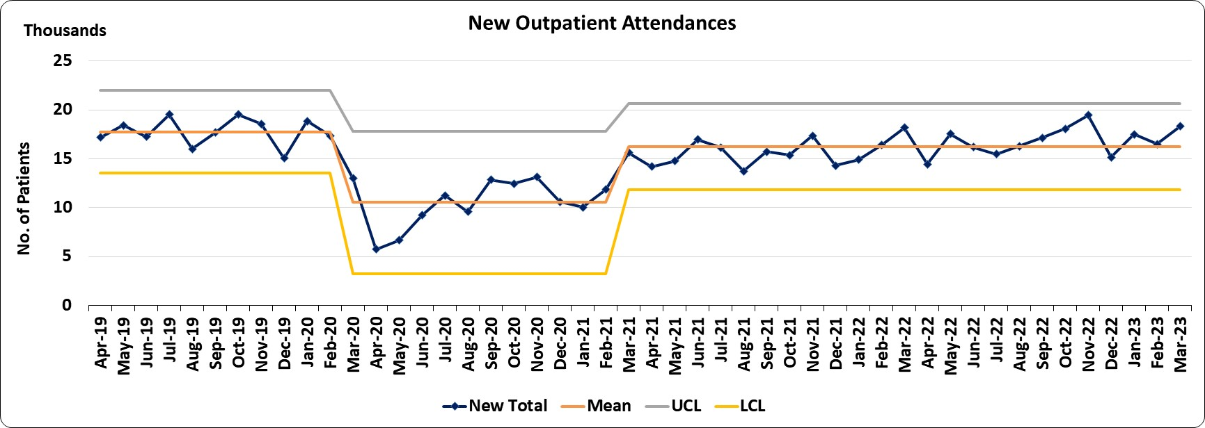 |  |  |  | 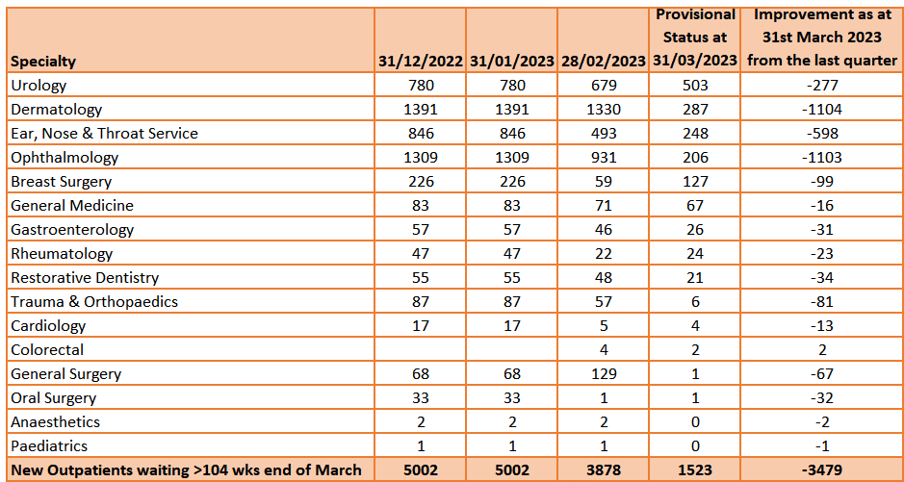  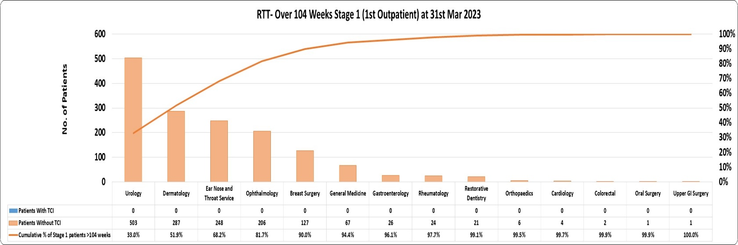

Follow-up Outpatient Attendances March 2023 – provisionally 35,485 attendances
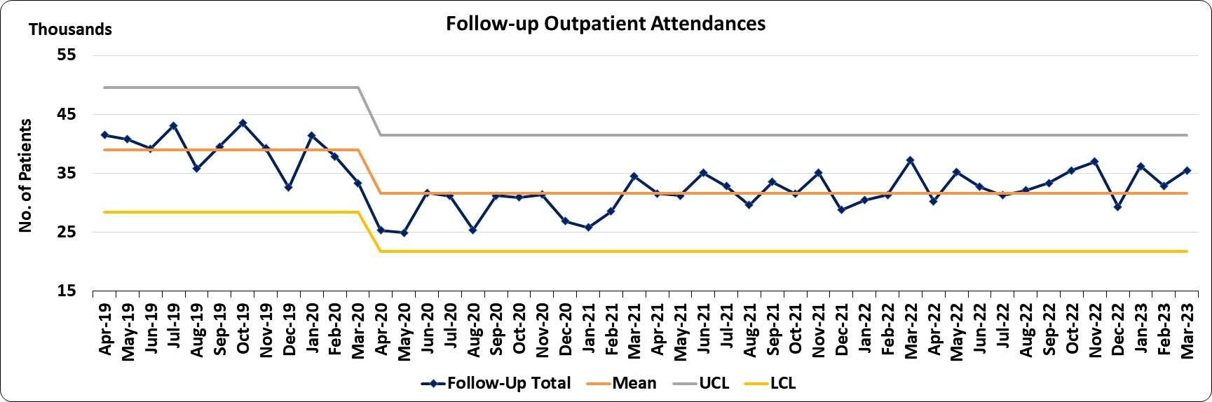
How are we doing? |  | What actions are we taking & when is improvement anticipated?  What are the main areas of risk? |  |  |  |  | What are the main areas of risk?
As at the end of March 2023, there were provisionally 69,497 patients awaiting a new outpatient appointment, of which, 16,768 (24%) patients were categorised as urgent and 10,574 (15.2%) were ophthalmic patients who are prioritised to alternative clinical triage criteria. The total waiting list volume represents an increase of around 1.2% (1,463) on the 68,034 patients waiting at the end of the equivalent period last year.  WG had set a target of having no patients waiting over 104 weeks for a first outpatient appointment at the end of March 2023. As it currently stands, at the end of March there were 1,523 patients who have waited in excess of two years for a new outpatient appointment. We had anticipated that if our plans were effectively implemented we would have reduced the position to c.1,431 and consequently 92 (6.4%) more patients are waiting than predicted. |  | The following actions are being taken to eliminate waits of >104 weeks throughout Quarter 4 2022/23:  Outpatient utilisation and improvement programme: initiated focusing on clinic utilisation booking processes, standardisation & reduction of DNA’s. Partial booking of all new appointments continue at PCH.  Prioritisation exercise: underway to review the realised benefits of recovery schemes to inform the allocation of PCR funds for the next financial year.  Use of WISE for Pain Management patients: CTM’s Wellness Improvement Service (WISE) is now established as the initial intervention for Pain Management, Stage 1 referrals and for any patient coming back to us requiring treatment (Stage 4) we have set up additional backfill pain lists. Of the first cohort of 366, all offered assessment and 39% (142) chose to be off-listed and the remainder (224) underwent assessment and enrolment to Wise.  Super Saturday Clinics: reviewed across all Specialities and already undertaken in Oral Maxillofacial Surgery and Cardiology continue to run with maximum planned activity. Conversion rates continue to be monitored.  Health Board wide Waiting Lists: weekly performance meetings on a specialty, rather than locality level, allowing for whole HB focus on waiting list performance. Addressing inequity across sites e.g. General Surgery patients being transferred from RGH to PCH who have a higher rate of virtual appointments.  Dermatology: Start date of 2nd May 2023 for Locum Consultant who will prioritise inflammatory patients in job plan and are looking for opportunities with the wider MDT including nursing and pharmacy support. This will reduce rather than eliminate >104 weeks. Outsourcing in 2022/23 was successful to deliver the current position.  LGI: CTM has been successful in obtaining funding for cancer pathways relating to Endoscopy. A root cause analysis has been undertaken and the investment will be used in a combination of additional Endoscopy activity and new SOPs for the scheduling of activity. Utilisation in the last 4 weeks has increased by 25% through productivity and efficiency improvements. Utilisation continues to improve through productivity and efficiencies, standardisation of points per procedure and template points across CTM. Robust Partial Booking process implemented and due to go live in April 2023. Text Reminder service set up for both Endoscopy and Radiology to support DNA reduction and increase productivity. Text templates completed and waiting Welsh translation before going live. Weekly deep dive meeting continues with support from DU and NEP looking at weekly utilisation and future trajectories. Mobile Endoscopy Unit extension agreed to maintain additional capacity – templates increased and overbooking agreed to offset DNA rates. This continues to support the USC diagnostic and BSW screening waits.  Ophthalmology - End of year results indicated a positive reduction in new outpatients >104 week waits, primarily for those waiting for an Ophthalmology appointment. October 2022 CTM were reporting 1656 stage 1 patients waiting over 104 weeks, end of year 2023 Ophthalmology reported 206.  Urology - Continuing to offer WLI’s to reduce the patients waiting >104 for a urology appointment, though there appears to be very little uptake from a nursing perspective to support the additional activity during the week or weekend. |  |  |  |  | The main areas of risk in terms of meeting the WG revised priority of no patients waiting over 104 weeks (1st Outpatient Appointment) by the end of March 2023 are in Dermatology, Ophthalmology, ENT, Urology and Cardiology.  Those specialties with a high Urgent Suspected Cancer referral rate have highlighted that the capacity for referrals prioritised as routine will continue to experience long waits.  Weekly Elective Assurance meetings take place with all specialty leads which will now include Diagnostics and Pathology.  A Cancer Performance Assurance forum attended by all stakeholders takes place weekly to review all cancer pathways.  >156 week position for Dermatology waits is 119  >104 week position is 345  (aim for 80-100 to be removed by RME)  Ophthalmology - Non-continuation of high volume outsourcing in the interim of the regional Programme.  - Recurrent demand outweighs capacity.  Urology - Cancer demand is greater than core clinical capacity.
 | Referral to Treatment Times (RTT) – March 2023 (Provisional Position) – Total Open Pathways 114,055
% of patients waiting less than 26 weeks RTT (50.7%) – Target is Improvement Trajectory towards a national target of 95% by 2026 |  |  | Number of patients waiting >104 weeks (6,673) - Target is Improvement Trajectory towards a national target of Zero by June 2023
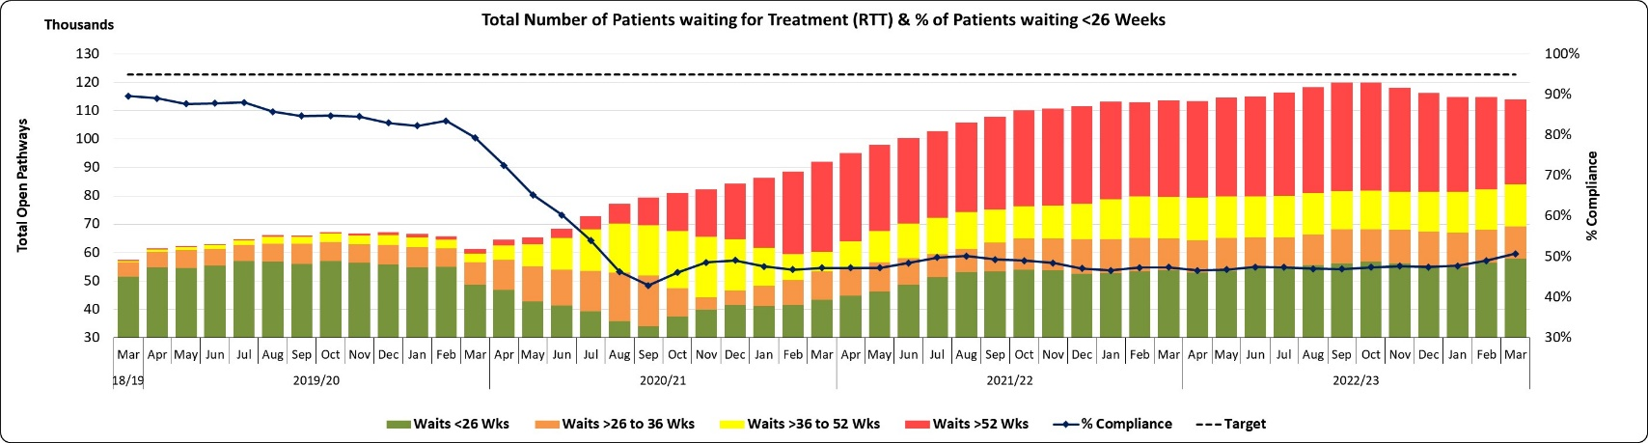 |  |  | 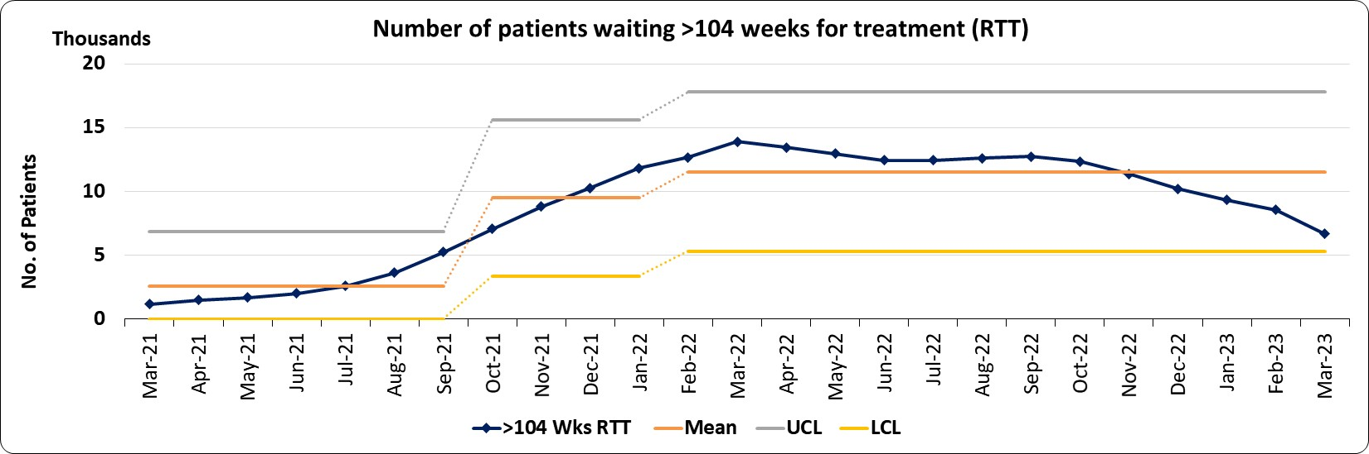
The 26 week position performance for March across Cwm Taf Morgannwg is a provisional 50.7%. Given the long waiting times, this statistic should be considered more as an indicator of our ability to treat in turn and our urgency rates, as opposed to a definitive indicator of progress in improving access. |  |  | The provisional position across Cwm Taf Morgannwg for patients waiting over 104 weeks for referral to treatment at the end of March is 6,673, which as it currently stands is a reduction of 22% (1,883) from the reported February position.
Number of patients waiting >52 weeks RTT (29,900) – Target is Improvement Trajectory towards a national target of Zero by March 2025 |  |  | Number of patients waiting over 52 weeks for a new outpatient appointment (14,603) - Target is Improvement Trajectory towards eliminating over 52 week waits by June 2023
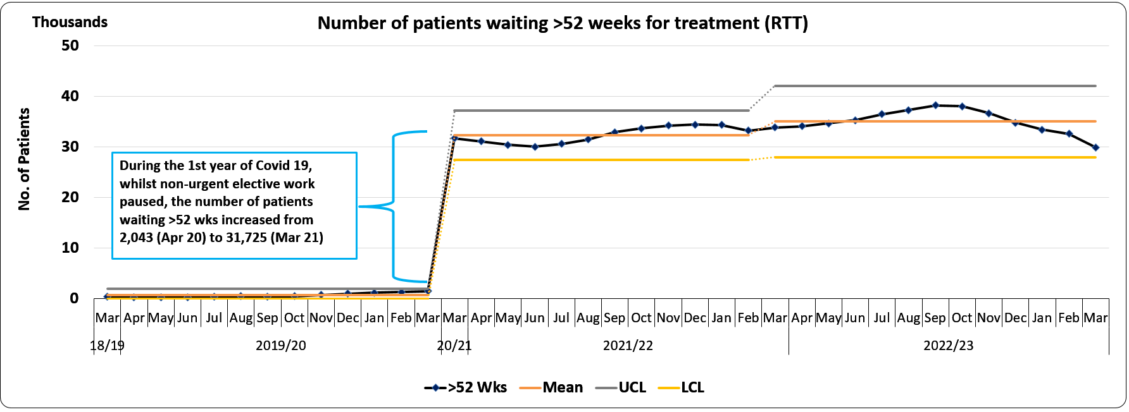 |  |  | 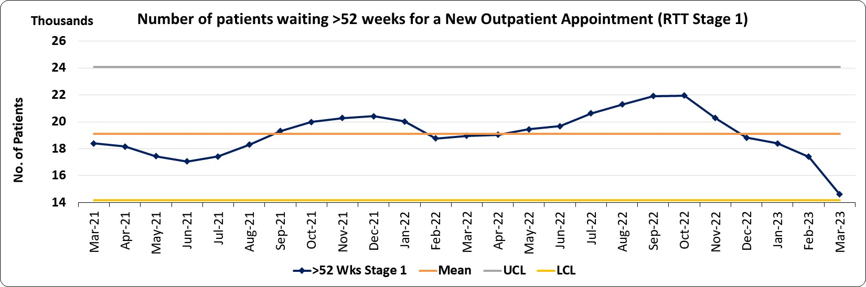
The provisional position across the Health Board for patients waiting over 52 weeks for referral to treatment at the end of March is 29,900, which as it currently stands is a reduction of 8.4% (2,731) from the February reported position. |  |  | The provisional position across the Health Board for patients waiting over 52 weeks at Stage 1 (1st Outpatient Appointment) at the end of March is 14,603, which as it currently stands is a reduction of 16.2% (2,813) from the February reported position.
Number of patients waiting >36 weeks RTT (44,742) Target – Improvement Trajectory towards a national target of Zero by March 2026 |  |  | Number of patients waiting over 36 weeks for a new outpatient appointment (24,193) - Target is Improvement Trajectory towards eliminating over 36 week waits by March 2024
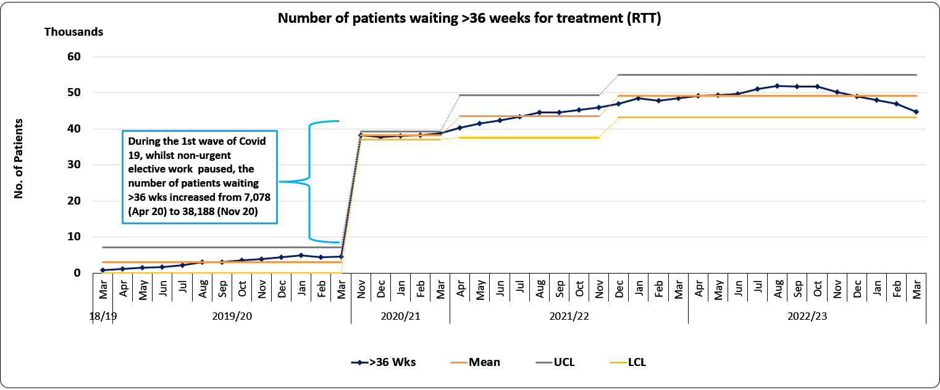 |  |  | 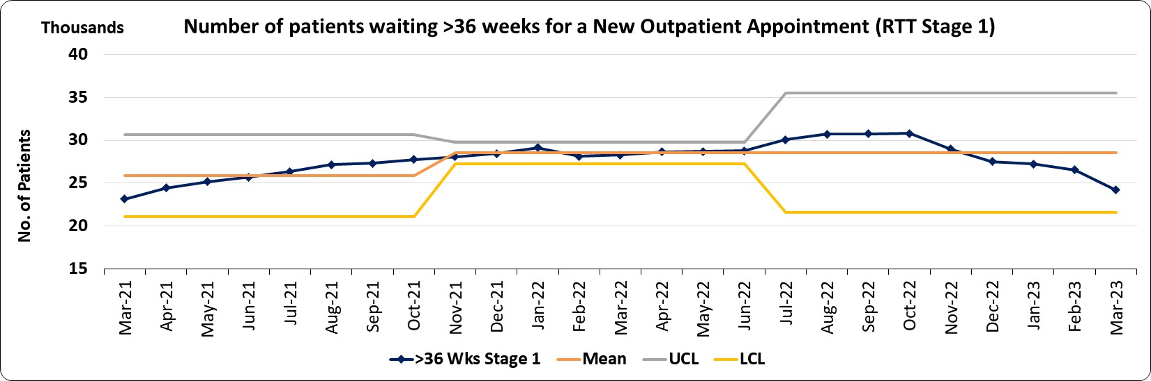
The number of patients waiting over 36 weeks at the end of March, across Cwm Taf Morgannwg, is a provisional position of 44,742 patients, which is a reduction of 4.6% (2,146) from February (N.B. includes the 29,900 patients waiting over 52 weeks). |  |  | The provisional position across the Health Board for patients waiting over 36 weeks at Stage 1 (1st Outpatient Appointment) at the end of March is 24,193, which as it currently stands is a reduction of 8.9% (2,363) from the February reported position. (N.B. includes the 14,603 Stage 1 patients waiting over 52 weeks).

RTT continued on the next page…

 | Cont’d…Referral to Treatment Times (RTT) – March 2023 (Provisional Position) – Total Open Pathways 114,055
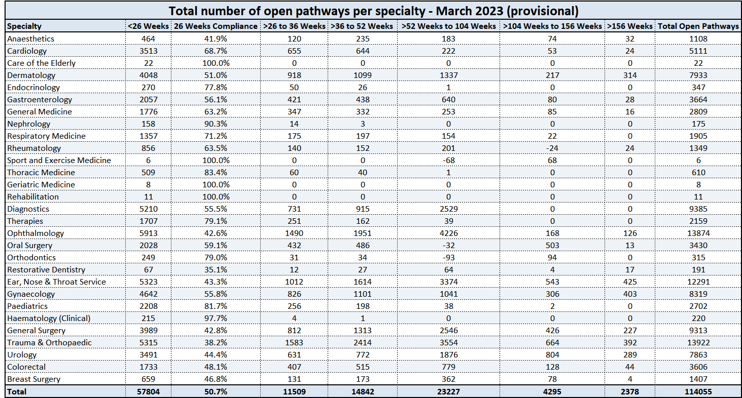 |  |  |  |  |  |  |  |  | How are we doing? |  |  |  |  |  | What actions are we taking & when is improvement anticipated? |  |  |  |  |  | What are the main areas of risk?
 |  |  |  |  |  |  |  |  | PCH continues to make progress with stage 1 over 52 weeks across Surgery, T&O, OMFS and Pain services. The site has provided support across CTM with Surgery, Colorectal and T&O while we work to achieving CTM wide pooled waiting lists. Urgent Gen Surgery waits for first OPA is under 26 weeks. Further support in Q1 to reduce this further and to push patients through the RTT pathway.  Ophthalmology: There has been significant improvements made with the open pathways, albeit still reporting 13874 this was just over 15000 in October 2023, caveating that our recurrent demand for cataract alone is circa 400 per month.  General Surgery: Stage 1 remains at a zero position, though improvement is required for the stage 4 cohort. Whilst core capacity in main theatre remains focused on cancer work, the additional day case capacity currently available by means of ID medial and the appointment of a locum consultant should improve this position.  T&O: Currently have the majority of open pathways above 104 weeks. The majority are currently sitting on the stage 4 pathway, there is currently no suitable capacity at POW to carry out this cohort, though discussions on going with RGH and PCH in terms of merging waiting list and treating longest waiters across CTM.  Dermatology: The position for formal reporting will improve greatly. The outcomes of the patients are still being updated and validated for end of year final position. |  |  |  |  |  | It is anticipated that the length of time that patients are waiting will reduce across all specialties, with patients being seen for first outpatients within two years within all specialties with risks assessed in ENT, Urology, Ophthalmology and Dermatology. In each of these four specialties there are actions being taken to increase capacity. (Weekend clinics and theatre sessions in Ophthalmology and ENT (weekend clinics), the recruitment of a Locum Consultant and additional pharmacy and primary care resource in Dermatology).  Focus on waits currently showing in Rheumatology, Cardiology, Dermatology and Breast Surgery with transfer of patients across locality/consultant waiting lists, additional clinics and re-direction of Pain referrals to Wellness Improvement Service (WISE) are in place. Improvement programmes are in place to realise efficiencies in outpatient departments with a focus on clinic utilisation booking processes, standardisation and reduction of DNA’s. Partial booking is now in place across all specialties which strengthens validation and complements the clinical and administrative validation across all specialties.  Additional IP/DC capacity is in place running to end of March 2023 through the insourcing of theatre staff enabling the centralisation of Orthopaedic inpatient activity and more concentrated day case capacity in PCH. This is supported by the in-sourcing theatres team.  Ophthalmology: The regional Ophthalmology Programme is intended to provide a 12 month solution for additional regional capacity for cataract outpatient and inpatient stages. This Programme has entered implementation stage and as part of the implementation there are 7 work streams, as discussed and agreed by Programme Board on Monday 13th March. CTM has been asked to lead on workforce and booking and scheduling team for the region.  General Surgery: The increasing of day surgery capacity would allow General Surgery to focus on the stage 4 backlog. The appointment of additional upper GI consultants will also help manage current demand.  T&O: The HB plan to centralise arthroplasty to one site should increase both protected inpatient capacity and theatre capacity. The disaggregation with SBU is also anticipated to reduce the Bridgend waiting list by approximately 30%. |  |  |  |  |  | - Insufficient theatre workforce to enable our theatres to run at full capacity. This is looking to be mitigated through insourcing with independent providers, but at increased costs if provided in house.  - Recruitment – remains challenging. Delays in approval to recruit to existing posts within the structure that have become vacant and new posts. The Scrutiny Panel is adding further delays to an already protracted process.  - Staff fatigue / willingness to support additional capacity - additional activity reliant on staff support and less attractive to a number of staff groups following the previously enhanced rates ceasing.  - WPAS issue do not facilitate pooled waiting lists across the UHB increasing the administrative cost and the risk of duplicate entries and ‘lost patients’, which results in losses in productivity, over-reporting and potentially adverse outcome for our patients. A mitigation plan is being developed for pooled lists.  - The availability of sufficient bed capacity.  Ophthalmology  - Non-continuation of high volume outsourcing in the interim of the regional Programme  - Recurrent demand outweighs capacity  - Lack of ring fenced impatient elective capacity  - Lack of theatre capacity.  Urology  - Demand outweighs capacity
% of patients waiting less than 26 weeks to start an ADHD/ASD Neurodevelopment Assessment (29.5%) -Target 80%
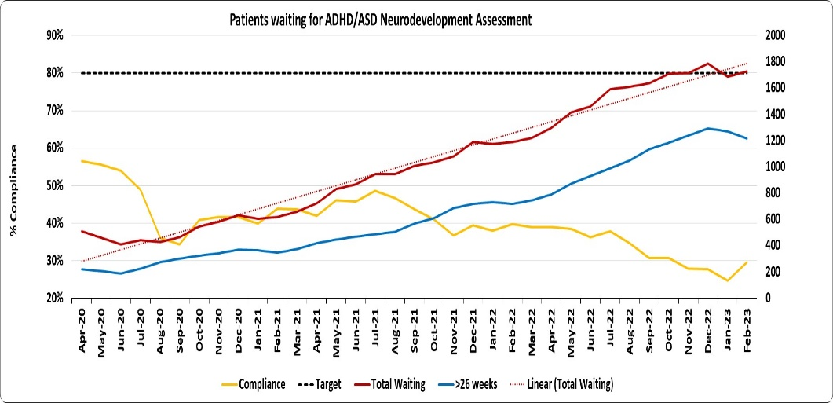 |  |  |  |  | The chart to the left highlights that there has been a significant deterioration in the compliance against the 26 week target for Neurodevelopment services, with compliance at 29.5% for February, well below the target threshold of 80%.  The chart also depicts the total waiting list volume (red), the number of patients waiting in excess of 26 weeks for ND Assessment (blue) and the proportion waiting less than 26 weeks (WG target – yellow). As the waiting list volume has been growing at a fairly constant rate of 36 patients per month throughout the period, this has increased the number and proportion of long waiting patients commensurately.
How do we compare with our peers?
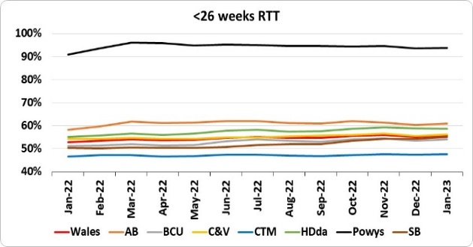 |  | 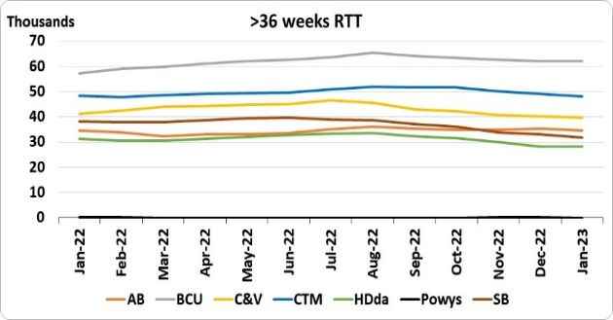 |  |  |  |  |  |  |  | 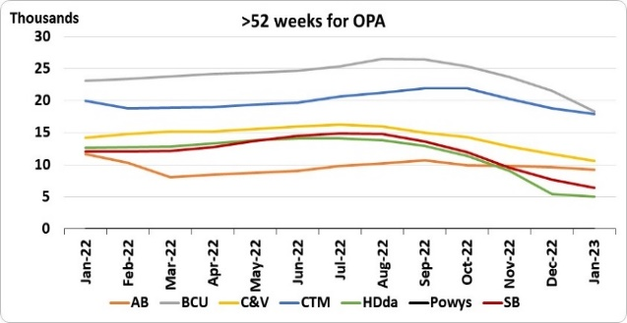 |  |  |  |  |  |  | 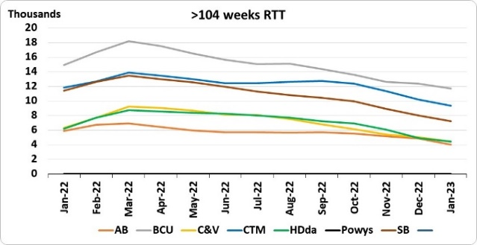 |  |  |  |  | 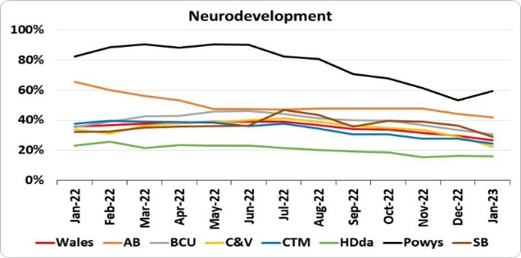
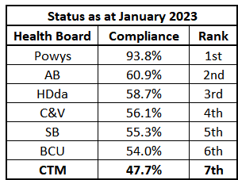 |  | 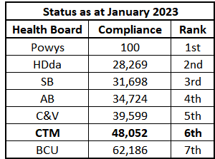 |  |  |  |  |  |  |  | 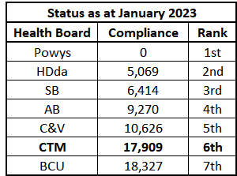 |  |  |  |  |  |  | 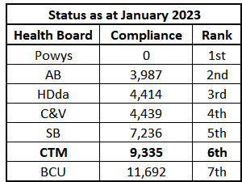 |  |  |  |  | 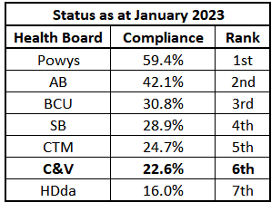
 | Diagnostics & Therapies – March 2023 (Provisional Position)
Number of patients waiting >8 weeks for Diagnostics  Target - 12 month reduction trend towards Zero by spring 2024 |  |  |  |  |  |  |  | Number of patients waiting >14 weeks for Therapies  Target - 12 month reduction trend towards Zero by spring 2024 |  |  |  |  |  |  |  |  |  | Number of patients waiting >8 weeks for Diagnostic Endoscopy  Target - Improvement Trajectory towards target of Zero by March 2026
Total >8 weeks 15,309 |  |  |  |  |  |  |  | Total >14 weeks 1,155 |  |  |  |  |  |  |  |  |  | Total >8 weeks 3,047
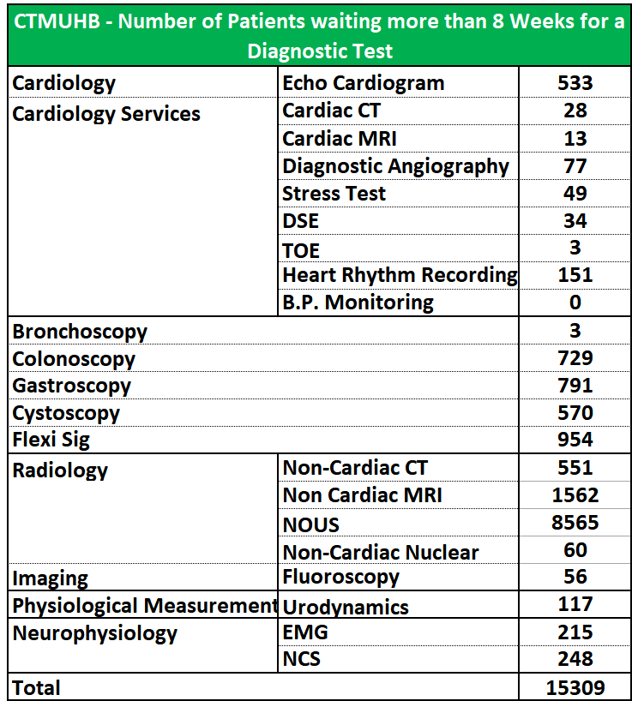 |  |  |  |  |  |  |  | 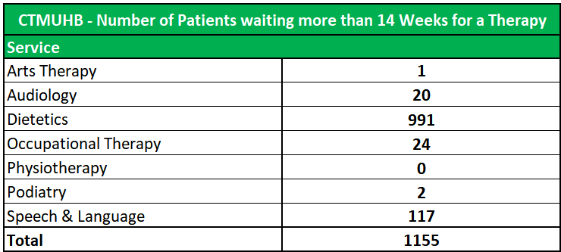 |  |  |  |  |  |  |  |  |  | 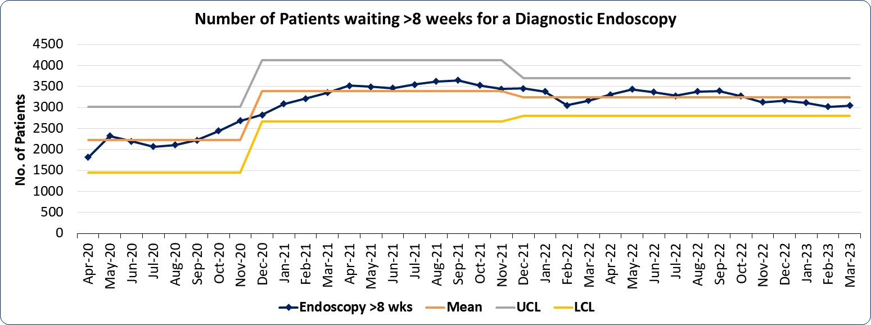
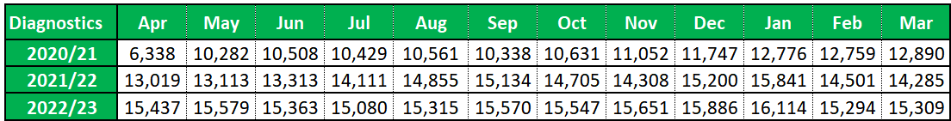 |  |  |  |  |  |  |  | 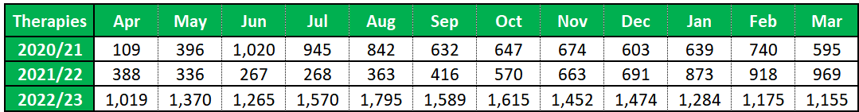
How are we doing? |  |  |  | What actions are we taking & when is improvement anticipated? |  |  |  |  |  |  |  |  |  |  |  |  |  |  |  | What are the main areas of risk?
Diagnostics: Provisionally, at the end of March, 15,309 patients had been waiting in excess of 8 weeks for a diagnostic procedure, which as it currently stands is a small increase of 15 patients on the previous month. Endoscopy also observed a small rise in the number patients waiting in excess of eight weeks (27 patients), with the number of patients currently breaching the target now standing at 3,047. The NOUS service continues to have the highest volume of breaching patients with 8,565 currently waiting over 8 weeks for a scan but is a reduction of over 2% (194) on the reported position for February.  Therapies: There are provisionally 1,155 patients breaching the 14 week target for therapies in March, a reduction 20 patients on the reported position for February.  The Dietetic service accounts for over 86% of the total patients waiting beyond the 14 week target for therapies. |  |  |  | - Structured performance and productivity and to agree remedial actions.  - Weekly tracker implemented to monitor performance.  - Ongoing validation of US, MR, CT lists, inappropriate referrals redirected.  - Realigning patient bookings around clinical priority, improved position has been seen through reduction in USC waits.  - Modality Action Plans and Business Cases being developed to support existing services and to create additional capacity.  - Review of sequences/protocols in MR resulting in time savings which will subsequently increase scanner capacity.  - Pathway work around accelerated imaging for Endoscopy CT/MR and review of current modality pathways.  - Work around staffing rosters to enable operation of the 2nd MR scanner at RGH.  - Additional staff funded for the new Breast Unit.  - Work ongoing in streamlining the Single Cancer Pathway.  - Pathway/process mapping being undertaken to further drive efficiencies.  - Additional patient lists running to reduce waiting times, which has maintained a static position.  - Demand and Capacity monitoring and forecasting of services commenced.  - Funding agreed through Planned Care Recovery Board for in house NOUS solutions, insourcing/outsourcing request to be considered by Board when cases for MRI and CT are also complete.  - Updated D&C modeling for Endoscopy in collaboration with NEP. Improved utilisation through productivity and efficiencies.  - Ongoing work to improve endoscopy pathway including demand management, scheduling processes and access policies.  - Utilisation continues to improve through productivity and efficiencies, standardization of points per procedure and template points across CTM. Robust Partial Booking Process implemented and due to go live in April 2023. Text Reminder service set up for both Endoscopy and Radiology to support DNA reduction and increase productivity. Text templates completed and waiting Welsh translation before going live. Weekly deep dive meeting continues with support from DU and NEP looking at weekly utilization and future trajectories. Mobile Endoscopy Unit extension agreed to maintain additional capacity – templates increased and overbooking agreed to offset DNA rates. This continues to support the USC diagnostic and BSW screening waits.  - POW now using electronic STT. Paper copies to be removed from department.  - Electronic referral system to be implemented in RGH/PCH. |  |  |  |  |  |  |  |  |  |  |  |  |  |  |  | - Current vacancies being held at scrutiny panel.  - Demand and Capacity imbalance.  - Securing funding for additional activity.  - Current sickness and vacancies within the administration teams.  - Lack of Band 2 and Band 3, HCA support staff.  - Consultant vacancies and inability to recruit.  - Radiographer vacancies and inability to recruit.  - Timely appointments for USC/Urgent patients.  - Capital replacement programme work and refurb of 2nd MR scanner at RGH reducing current capacity.  - Bowel Screening – with regards to SCP performance, worth flagging the shortfall in capacity, sessions and screening colonoscopists’ availability to clear the backlog and be able to manage the current and increase in demand anticipated this year following optimization of the BSW programme. Development of a sustainable BSW service over the forthcoming months will be integral to the delivery of the SCP targets for CTM.  - Endoscopy Competing Priorities – faces challenges with competing priorities with the service trying to deliver and maintain the SCP pathway, accommodate longest waiters for delivery of the RTT targets 156 & 104 weeks, hit the 8 week diagnostic target whilst reducing the backlog of overdue surveillance patients.  - Neurophysiology Services – Impact on Orthopaedic Services – Following a recent reduction in the availability of Neurology services in CTM, capacity for Nerve Conduction Studies has been significantly reduced. This will have a direct impact on delivery for the Orthopaedic targets going forward.  - Cardio Pulmonary Service – Backlogs in CPU will continue to directly impact on the delivery of Cardiology targets.

How do we compare with our peers?

How do we compare with our peers?

How do we compare with our peers?
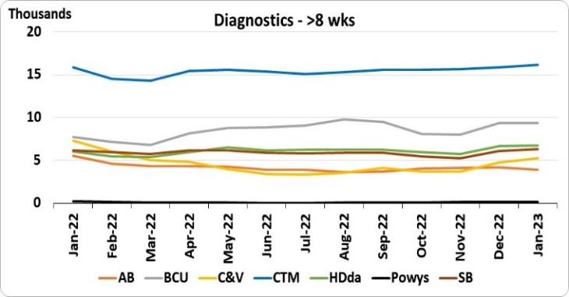 |  |  | 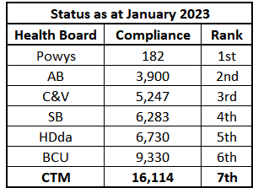 |  |  |  |  | 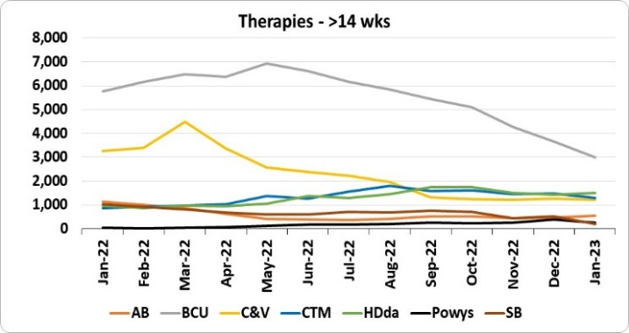 |  |  |  |  |  | 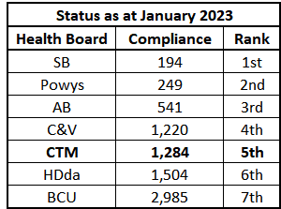 |  |  |  | 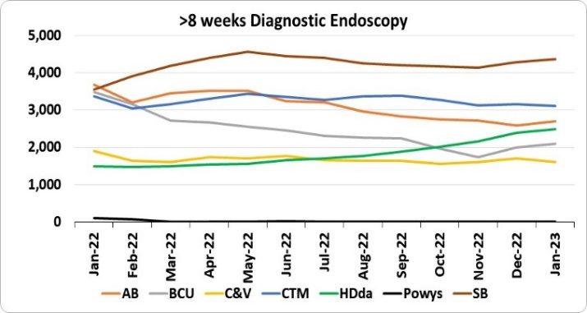 |  |  |  |  |  | 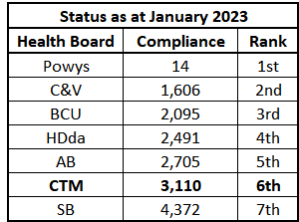
 | Follow-up Outpatients Not Booked (FUNB) – Provisional Position March 2023
Number of patients waiting for a Follow-up with documented target date |  |  |  |  |  |  |  |  |  |  |  | 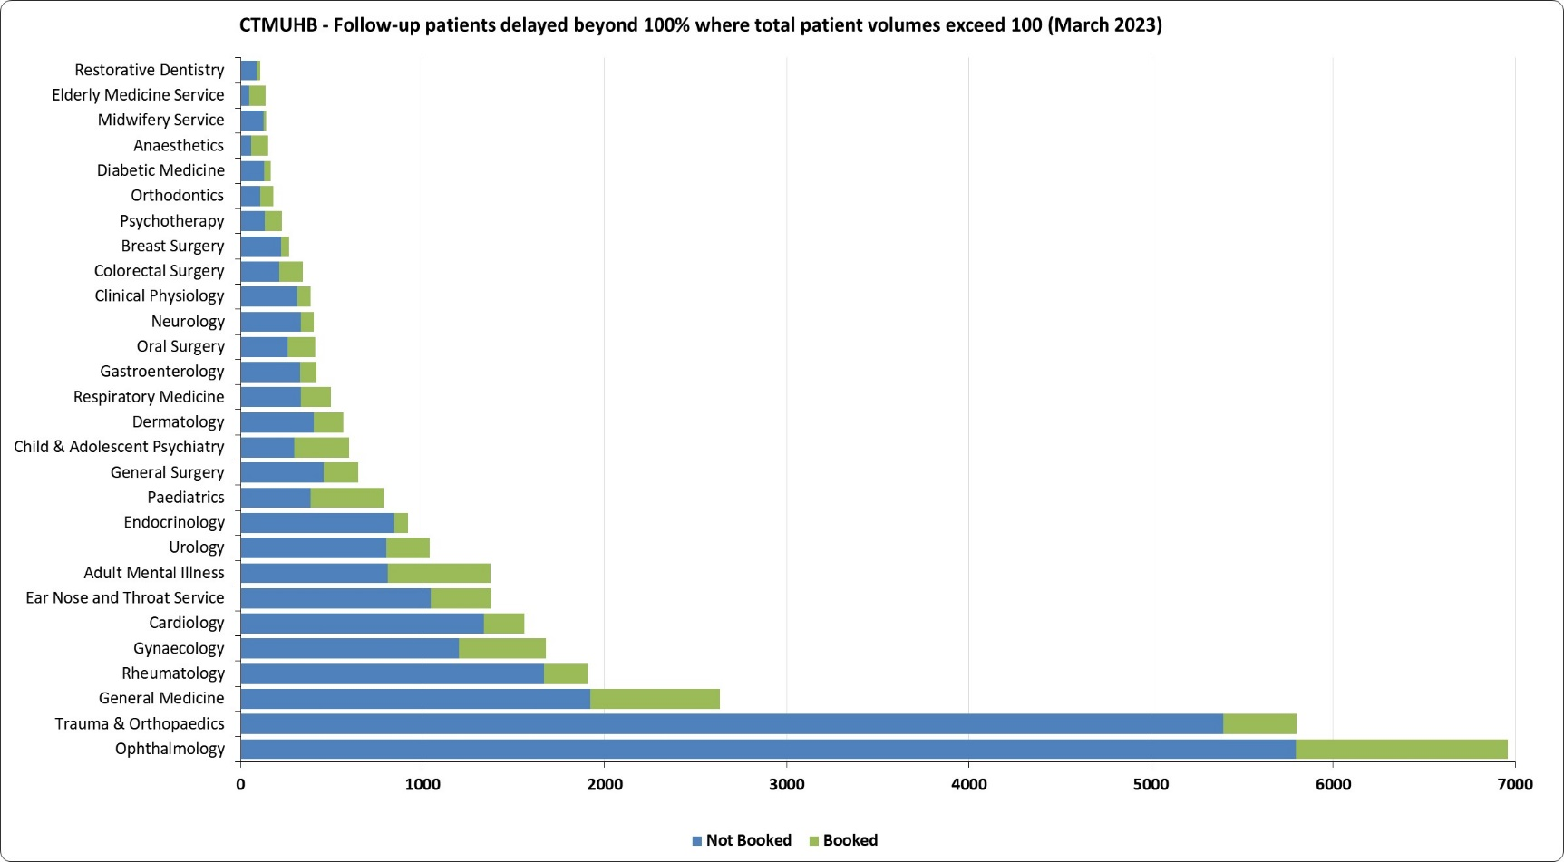

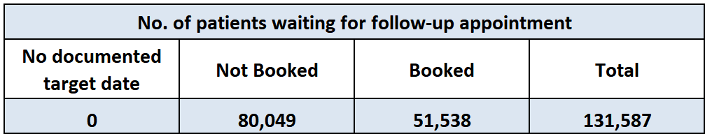

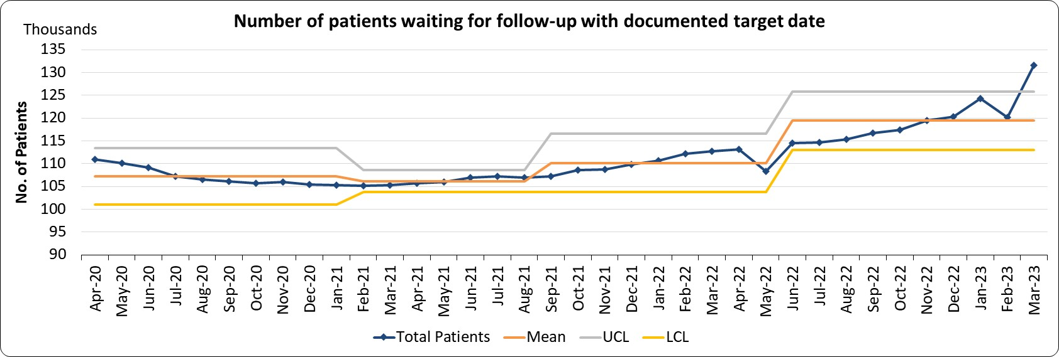

Number of patients waiting for a Follow-up delayed over 100% - Target – A reduction of 30% by March 2023 against a baseline of March 2021 (<=19606 by 2023)

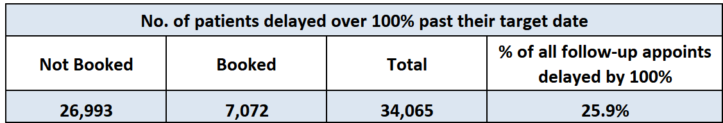
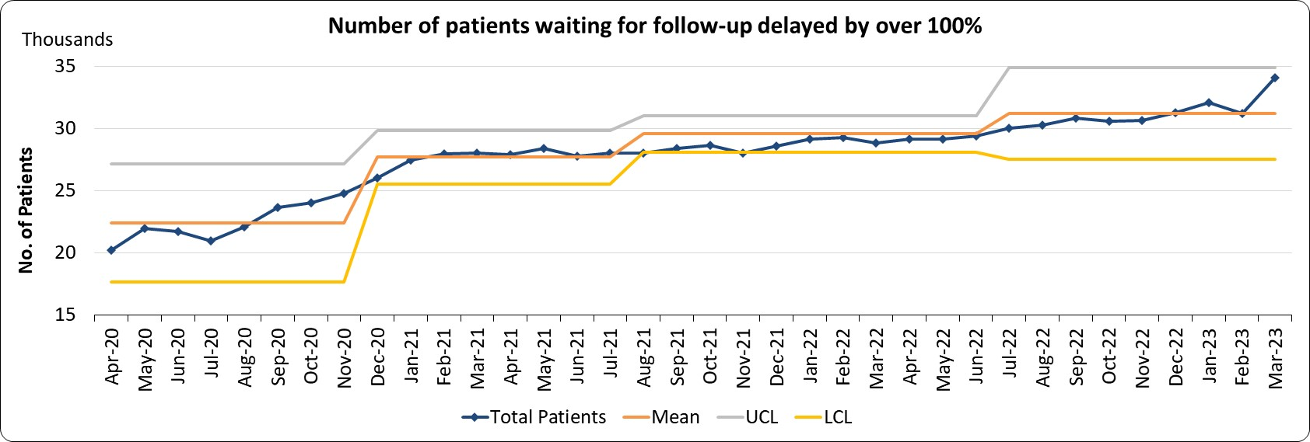 |  |  |  |  |  |  |  |  |  |  |  | How do we compare with our peers?
 |  |  |  |  |  |  |  |  |  |  |  | 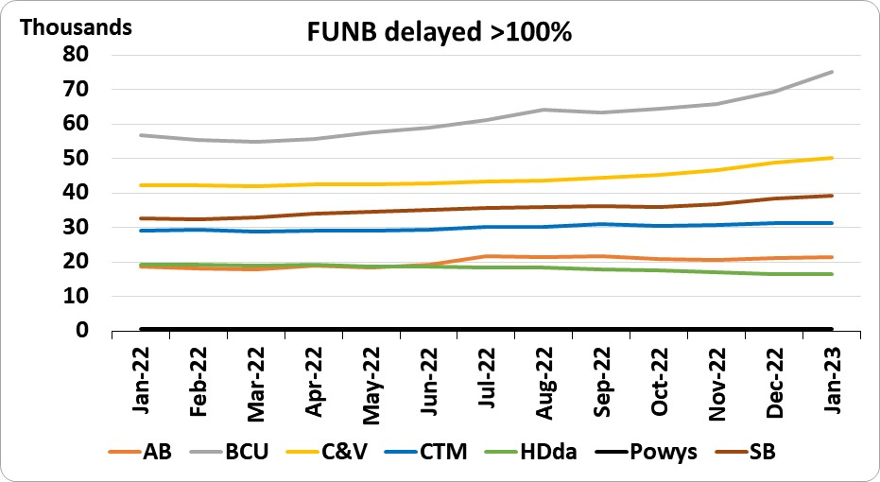 |  |  |  |  |  |  |  |  |  |  | 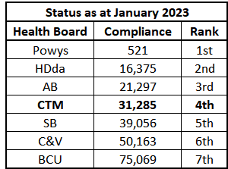
How are we doing? |  |  |  |  |  |  |  | What actions are we taking & when is improvement anticipated? |  |  |  |  |  |  |  |  |  | What are the main areas of risk?
Provisionally, the total number of patients waiting for a follow-up appointment in Cwm Taf Morgannwg UHB, at the end of March 2023, currently stands at 131,587 and of those patients waiting, 34,065 (around 26%) have seen delays of over a 100% past their target date, representing an increase of 18% on the equivalent period last year.  There are currently no patients without a documented target date. |  |  |  |  |  |  |  | Clinical validation of follow-ups not booked (FUNB) by CTM Consultants in Ophthalmology has concluded and outcomes have been updated on WPAS.  Of this cohort, 47% have been discharged. Targeted work on reducing the number of follow-ups not booked across specialties has significantly reduced the number of years that FUNBs are reported as waiting by 5 years.  The in-sourced validation exercise is current under review. Meanwhile the recruitment processes for the Health Board’s central validation team is nearing completion with training and go live for the team is expected April and May 2023. |  |  |  |  |  |  |  |  |  | The March position shows an increase in the numbers of patients awaiting a follow up appointment, this is being notionally attributed to the service’s focus on delivering waiting time targets for new outpatient attendances and increasing the proportion of capacity available for activity and validation towards first appointments rather than review appointments.  Combined outpatient activity levels continue to be below pre-Covid levels (around 8% fewer) with the provisional March 2023 figures below; for new and follow-up patients compared to prior the pandemic:  - Total New Patients seen: 18,328; which as it currently stands is an increase of around 1% on the Pre-Covid average (19/20) of 18,186, and is also a similar increase in attendances during the same period last year.  - Total Follow-up Patients seen: 35,485; around a 12% reduction on the Pre-Covid average (19/20) of 40,500 and is also around 5% lower than the equivalent period last year.
 | Single Cancer Pathway (SCP) – February 2023
% of patients starting first definitive cancer treatment within 62 days from point of suspicion Target - Improvement Trajectory towards a national target of 80% by 2026 – Compliance February 2023 – 41.1% |  |  |  |  |  |  |  |  |  |  |  |  | Patients Treated by Closed Date |  |  |  |  |  |  | Patients Downgraded by Closed Date
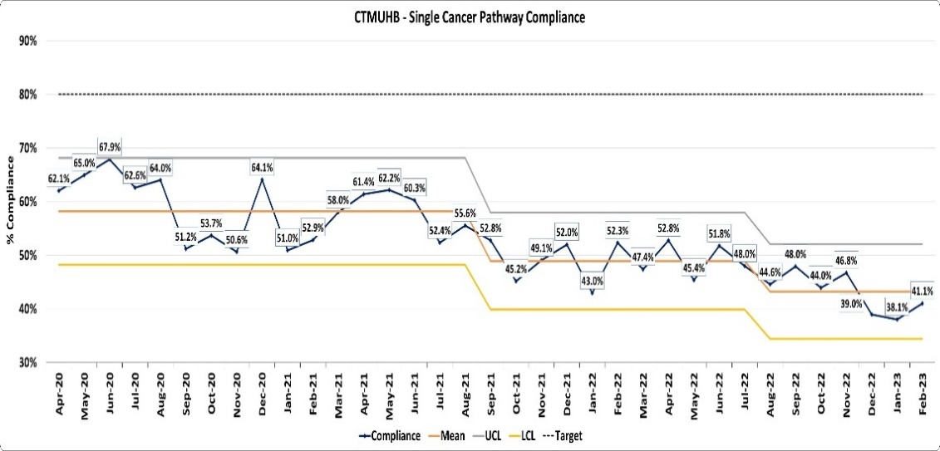 |  |  |  |  |  |  | 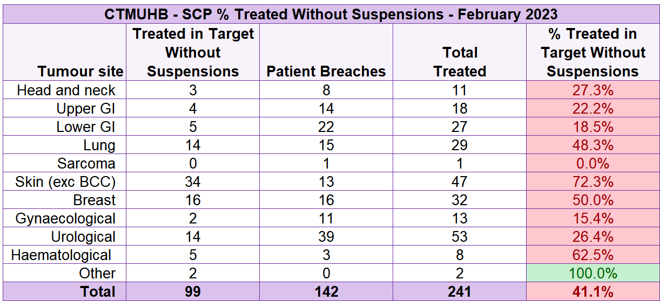 |  |  |  |  |  | 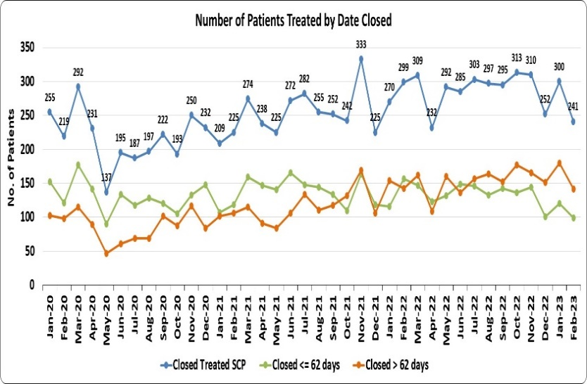 |  |  |  |  |  |  | 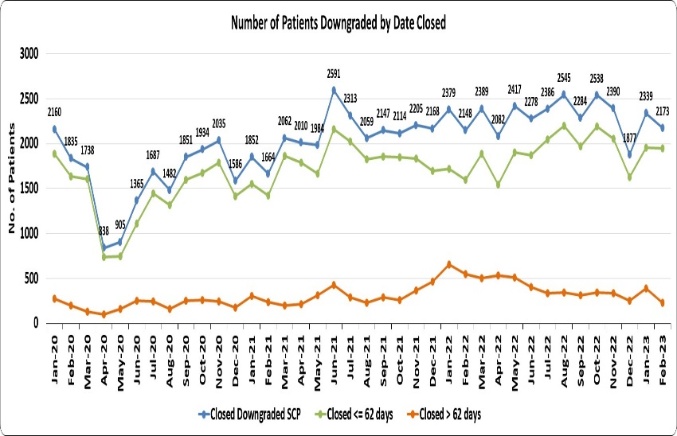
Performance for February remained low at 41.1%, with predicted compliance for March currently at 46.7%.  Delays at first outpatient (42%) and diagnostic stage (40%) continue to be the biggest concern and significant factor for not achieving target. Diagnostic delays in radiology, endoscopy and pathology; albeit improving. Backlog clearance continues. |  |  |  |  |  |  |  |  |  |  |  |  | Overall cancer treatment volumes have increased marginally during the past 12 months to around 286 per month compared to 264 in the equivalent period of the previous year. This represents an average monthly increase of 8%. |  |  |  |  |  |  | The number of patients on the SCP pathway who have been downgraded (told they do not have cancer) after having been seen at 1st Outpatient appointment or following a diagnostic test, has followed a monthly upward trend with the average for the past 12 months being 6% higher than the equivalent time span of the previous year.
Patients currently waiting on a Cancer Pathway and of those patients the number waiting more than 62 days (as at 3rd April 2023) |  |  |  |  |  |  |  |  |  |  |  |  |  |  |  | SCP Compliance detailing Maximum & Median Waiting Times to Treatment
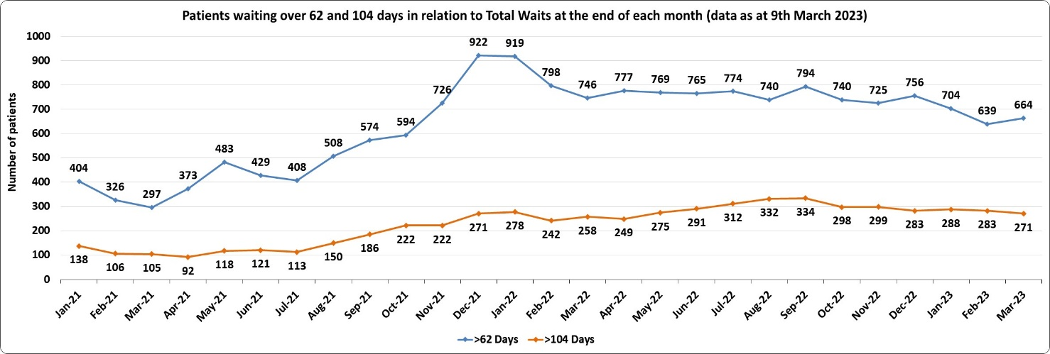 |  |  |  |  |  |  |  |  |  |  | 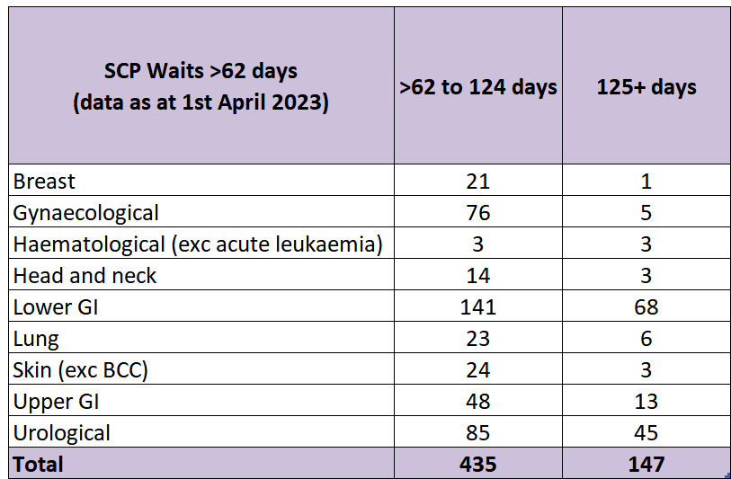 |  |  |  |  | 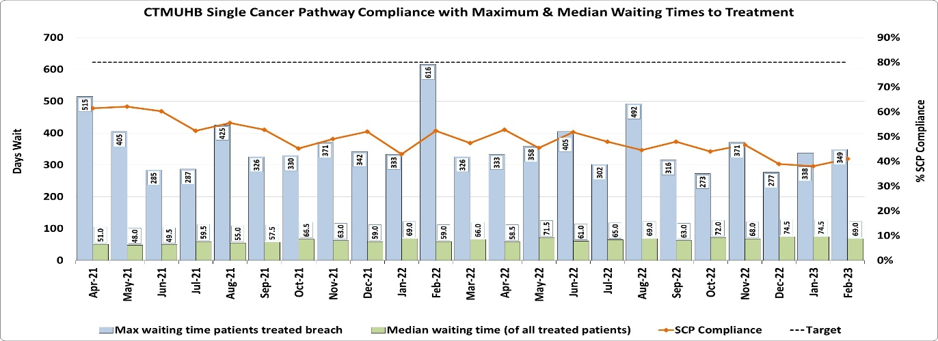
What actions are we taking & when is improvement anticipated? |  |  |  |  |  | What are the main areas of risk? |  |  |  |  |  |  |  |  |  |  |  | How are we doing & how do we compare with our peers?
- With exception of CTC’s (CT Colonography) continued improvement noted in waiting times and turnaround times in radiology diagnostics  - Accelerated imaging for staging CT and MRI post endoscopy for lower and upper GI commenced March 20th  - Additional resources approved to facilitate the roll out of FIT (Faecal Immunochemical Test).  - New Breast surgeon appointed  - Improved processes and theatre utilisation of symptomatic endoscopy lists  - Backlog reduction > 62 days sustained for last 6/12  - Backlog reduction > 104 days  - Merging of Urology MDT’s and streamlining of processes / pathways  - Weekly cancer performance meetings commencing 14th April  - New escalation process developed and planned to go live W/C 17/4/23  - Live Canisc replacement roll out scheduled to go live in breast from 2/5/23  - Initial meeting re merging of lower GI MDT set up.  - Streamlining and standardisation of MDT and clinical lead JD’s |  |  |  |  |  | - Performance challenges evident in all tumour sites whilst backlog clearance remains focus.  - 82% of all patients on the active SCP are at 1st outpatient or diagnostic stage  - Resources required to effectively plan and implement the Wrapper / Canisc replacement programme.  - Delays in pathology, endoscopy and radiology continue albeit they are improving  - Delays in tertiary investigations & treatments at SB, Velindre Cancer Centre and C&V.  - Bowel Screening Wales diagnostic colonoscopy  - Urology tumour site  - Gynaecology tumour site |  |  |  |  |  |  |  |  |  |  |  | 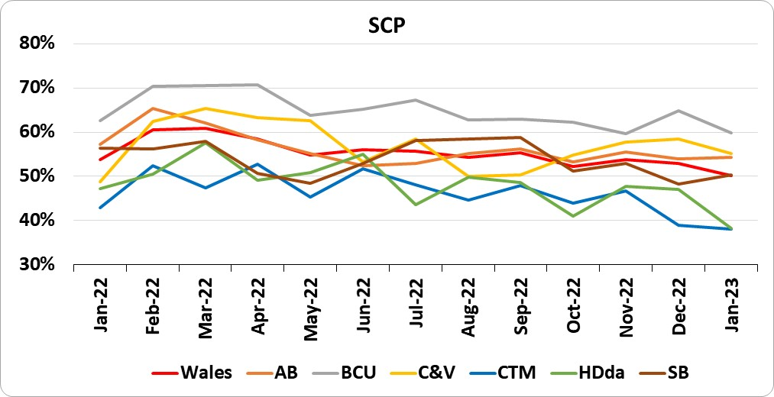  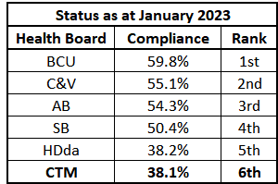
 | Emergency Ambulance Services – Response to Red Calls & Red Release Requests – March 2023
Response to Red Calls - % of emergency responses to Red Calls arriving within 8 minutes (Target 65%) March 2023 – 42.5% |  |  |  |  |  |  |  |  |  |  |  |  |  |  |  |  |  |  | Immediate Vehicle Release Requests
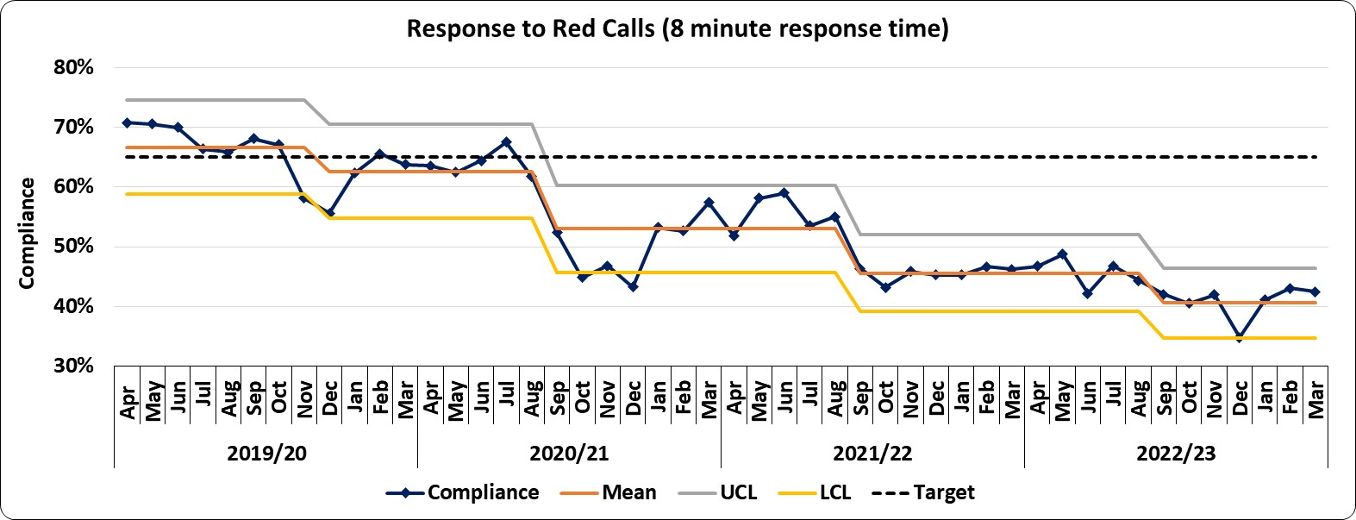 |  |  |  |  |  |  |  |  |  |  |  |  |  |  |  |  |  |  | 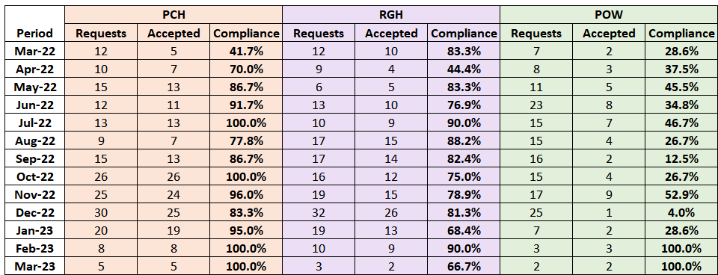*Please note that data for March 2023 is provisional and may be subject to change in future iterations of this report.
How are we doing? |  |  |  |  |  |  | What actions are we taking & when is improvement anticipated? |  |  |  |  |  |  |  |  |  |  |  | What are the main areas of risk?
Response to Red Calls: Response times to life-threatening calls remained low in March at 42.5%, with performance consistently below the compliance threshold of 65%. As can be seen in the chart above, for the past 7 months compliance has fluctuated around the average response times of 40% for Cwm Taf Morgannwg UHB.  The National compliance for March saw 47.5% of emergency responses arriving at the scene within 8 minutes, which as it stands falls just below the 12 month average of 48.8%. Compliance has remained below target since August 2020.  The volume of Red Calls during March totalled 603 for the CTM area which had the same daily rate as in the previous period of around 19 Red Calls per day. The volumes for March are also around 3% higher than the 12 month average of 586. Volumes continue to remain higher than pre-Covid levels and are 9% higher than the equivalent period of 2022.  Immediate Release Requests (shown above right): received when a WAST crew, which is currently with a patient at hospital, needs to be released to respond to an urgent call, totalled 10 during March*. The ED services were able to support affirmatively 9 of those requests. The Ministerial requirement is for all red release requests to be supported. |  |  |  |  |  |  | An Emergency Pressures Escalation workshop was held on the 25 February 2023. The aim of this workshop was to develop a CTM escalation framework that will support how risk is balanced across the organisation alongside associated triggers and actions. A timeline associated to deliver the implementation of the plan is in place; planned implementation Q1 and is on track to be implemented.  The following documents are being updated to support the emergency pressures escalation plan and will be launched at the same time:  - Immediate release SOP  - Pre-emptive transfer SOP  A programme of work is underway to deliver a reduction in ambulance handover waits exceeding four hours. The Programme will look to deliver improvement on a site by site basis, with POW being the first site to “go live”. This is supported by an improvement trajectory and weekly assurance meetings with the COO/Deputy COO.  Plans to establish a regular partnership meeting between WAST and CTM are being progressed to further improve integrated pathway development, communication, seasonal planning. |  |  |  |  |  |  |  |  |  |  |  | System flow and lack of in-patient capacity across sites remains the major risk in responding to red release requests.  Ring fencing offload capacity to ensure immediate release is a challenge due to the acuity of self presenting ambulent patients.  A number of Winter schemes (funded and unfunded) that where due to cease on the 31 March 2023, have been extended, this includes an additional D2RA Ward at the Princess of Wales Hospital Site and the GP assessment area at Prince Charles Hospital.These schemes are currenty supporting our ability to manage risk. This risk sits across a number of Care Groups.  There remains ongoing discussion regarding continuance of a number of schemes.

How do we compare with our peers?

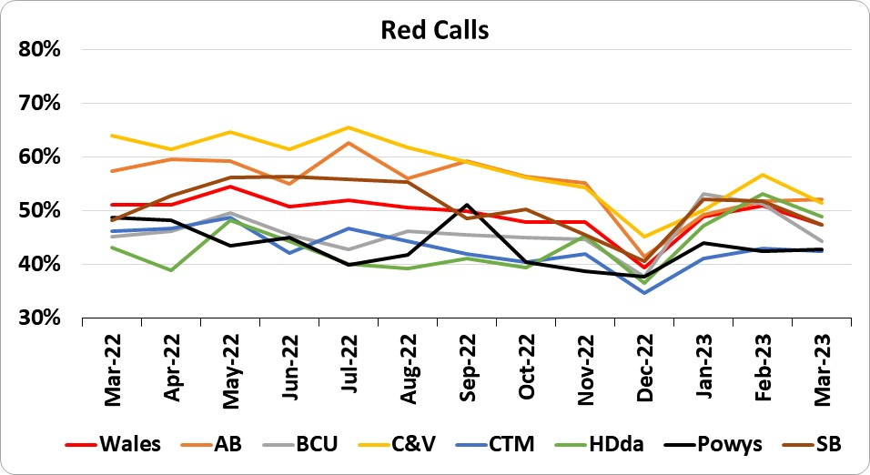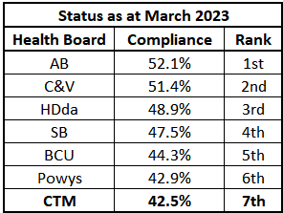
 | Emergency Ambulance Services - Handover Compliance – March 2023
Number of ambulance handovers within 15 minutes – Target Improvement |  |  | Number of ambulance handovers over 1 hour – Target Zero
Total handovers 2,315 of which 472 handovers were within 15 minutes (20.4%) |  |  | 1096 handovers were over 1 hour (52.7% of handovers were within 1 hour)
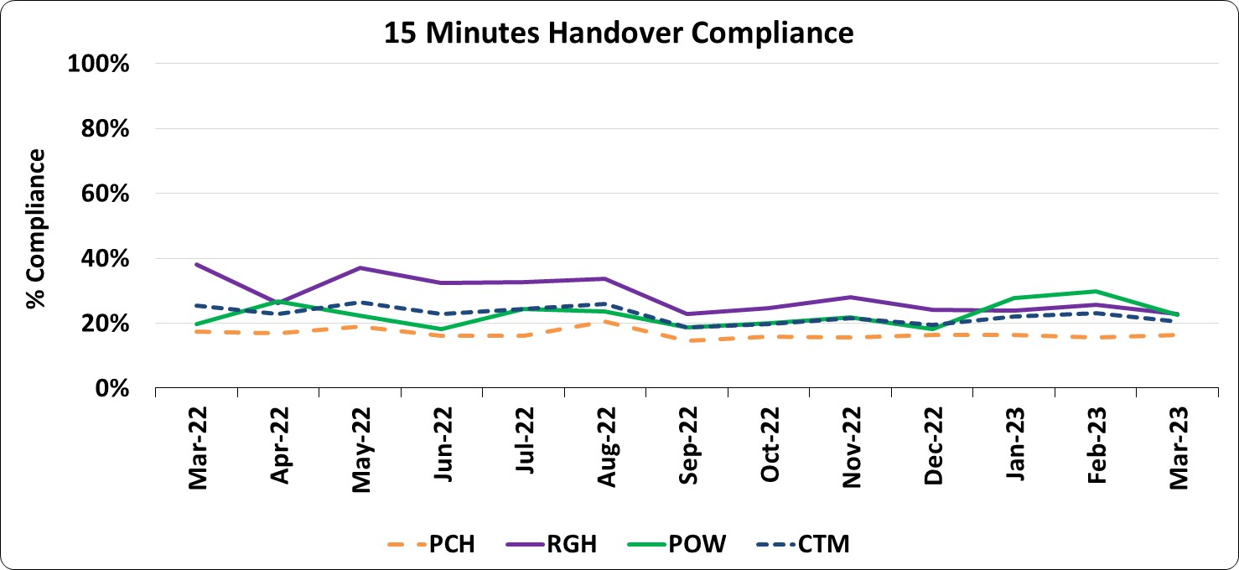 |  |  | 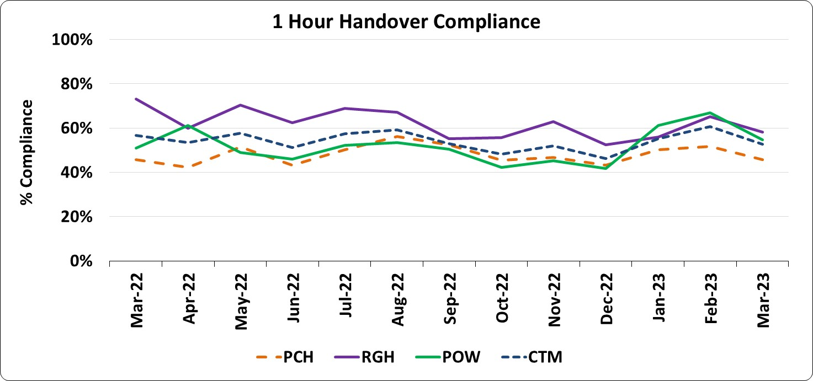
15 Minute Handover Trajectory |  |  | How do we compare with our peers?
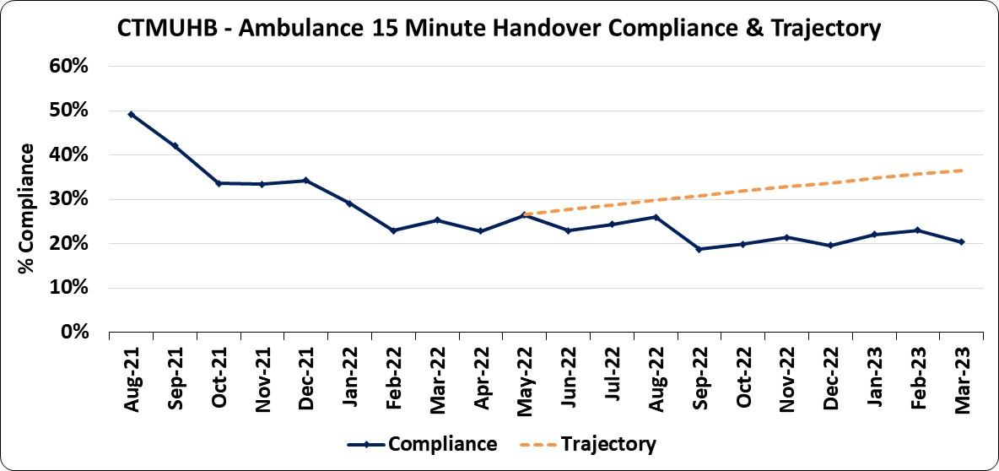 |  |  | 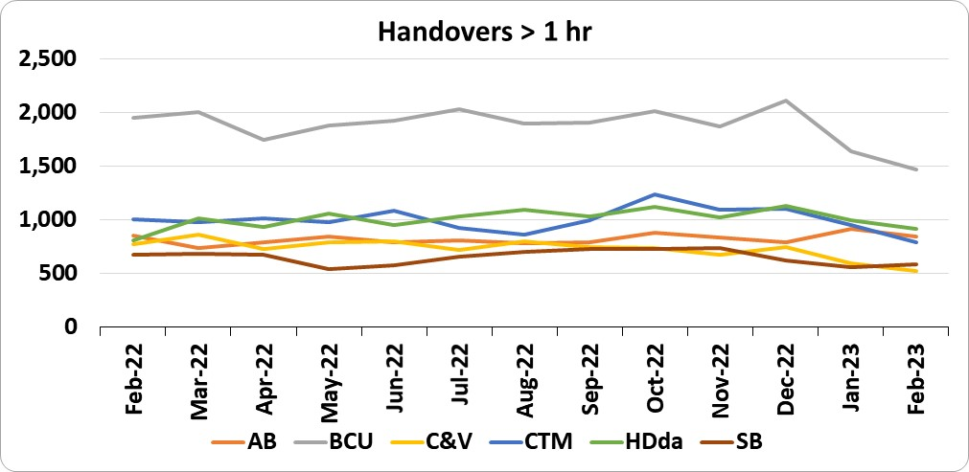 |  | 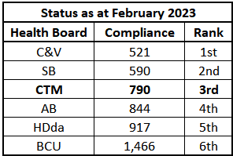
How are we doing? |  | What actions are we taking & when is improvement anticipated?  risk? |  | What are the main areas of risk?
During March 2023 the 15 minute handover compliance remained low at 20.4%, as did the compliance of handovers within one hour (52.7%). Compared to February, the volume of handovers were around 16% higher (on average 3 patients more per day), bringing the total number of ambulance conveyances to our major emergency departments to 2,315, which is also 5.6% higher than the 12 month average of 2,191 per month.  The current volume is around 6% more than the volume seen in the comparable period of 2022. |  | The Navigation Hub was launched in December 2022, demonstrating positive results in terms of reduced conveyances following a WAST contact. WAST contacts had remained low, ongoing work to engage with colleagues from WAST at a local and national level around utilisation of this service prior to conveyance. This work remains ongoing with bi-weekly meetings in partnership with WAST.  E Whiteboard List View was launched in January to support optimal patient flow through the hospital sites, with the aim of improving how we do tomorrow’s work today. A day of care audit was undertaken at the end of March across all sites, which validated data entry into the E whiteboards. This was particulary pertinant to the PCH site as the manual data outputs supported what was evidenced through the E whiteboard.  RGH has sucessfully recruited a Head of Patient flow who commenced in post in March.  A new pan CTM, Safe 2 Start template is nearing completion to be launched across the three acute sites. Work is underway to refine the boarding and pre-emptive transfer policy to provide assurance and to ensure health and safety standards are being met. This is also supported through the emergency pressures escalation plan. The bed management and flow subgroup under the 6 goals programme has now been re-launched to support this. |  | The levels of acuity of patients walking into ED departments remains high. This has been further exacerbated by the ongoing WAST industrial action  System flow remains highly impacted by capacity within social care.

 | Emergency Unit Waits – March 2023 (Provisional Position) - Total Attendances 15,864
% of patients who spend <4 hours in all major and minor emergency care facilities from arrival to admission, transfer or discharge - Target 95% |  |  |  |  |  |  |  |  |  | Number of patients who spend 12 hours or more in emergency care facilities from arrival to admission, transfer or discharge - Target Zero
63.6% were seen within 4 hours (Waiting >4 hrs 5,770) |  |  |  |  |  |  |  |  |  | 13.2% of patients were waiting over 12 hours (2,096)
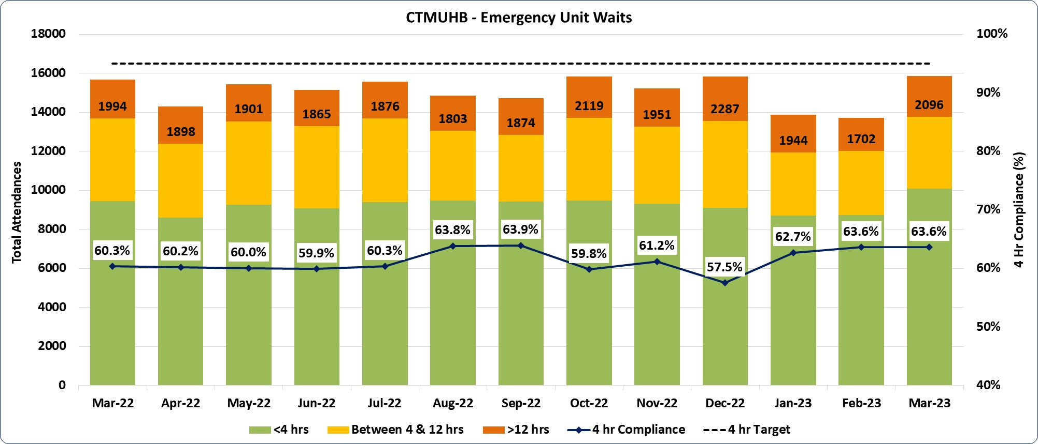 |  |  |  |  |  |  |  |  |  |  |  |  | 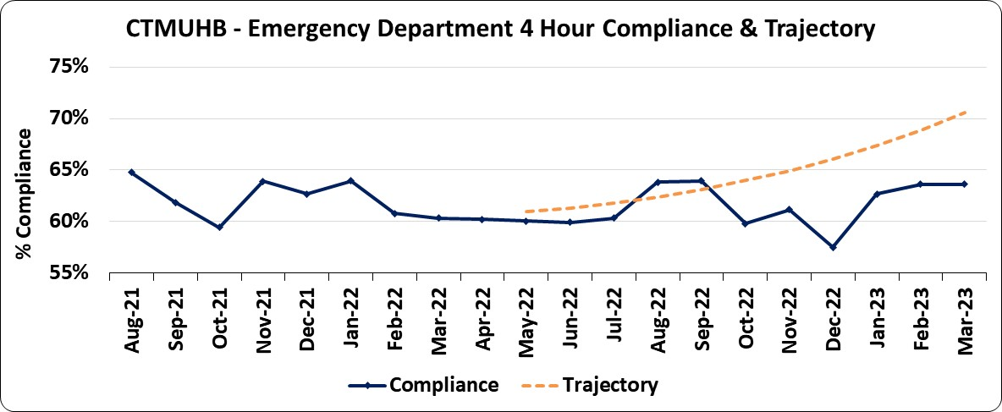
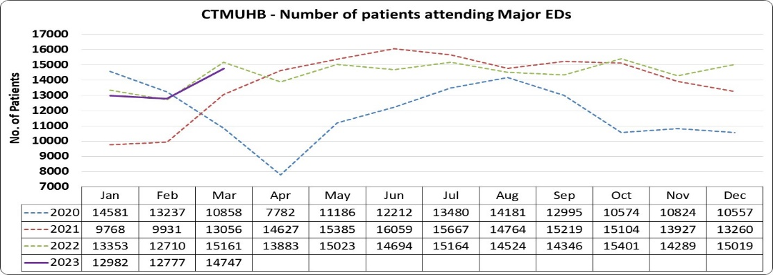 |  |  |  |  |  | 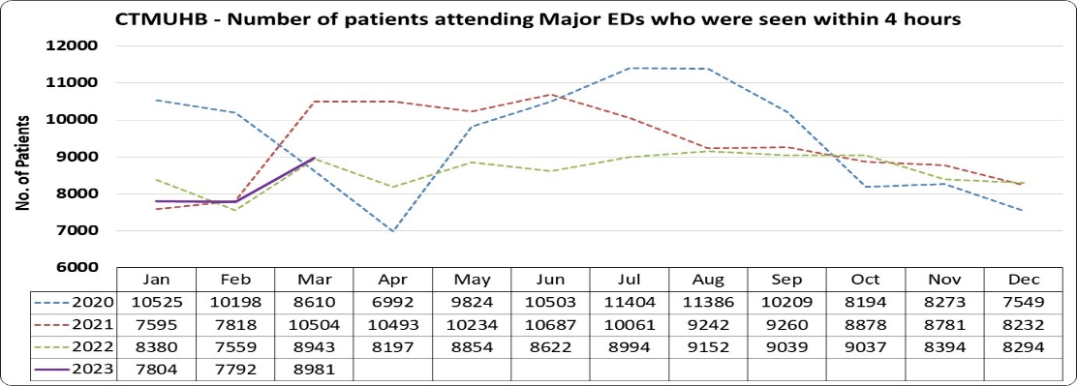 |  |  |  |  |  |  | How do we compare with our peers?
 |  |  |  |  |  |  |  |  |  |  |  |  | 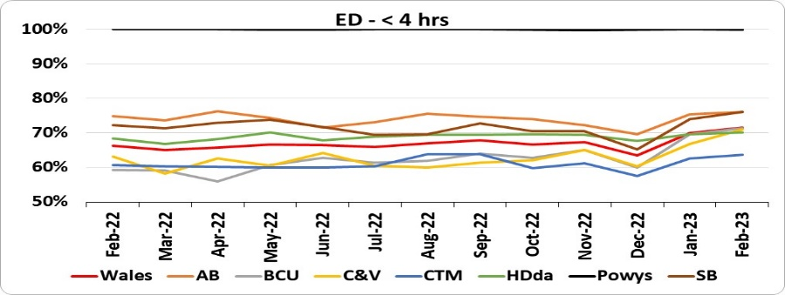 |  |  |  |  | 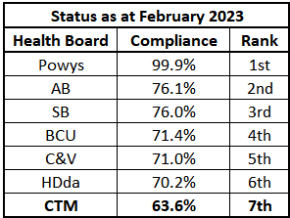
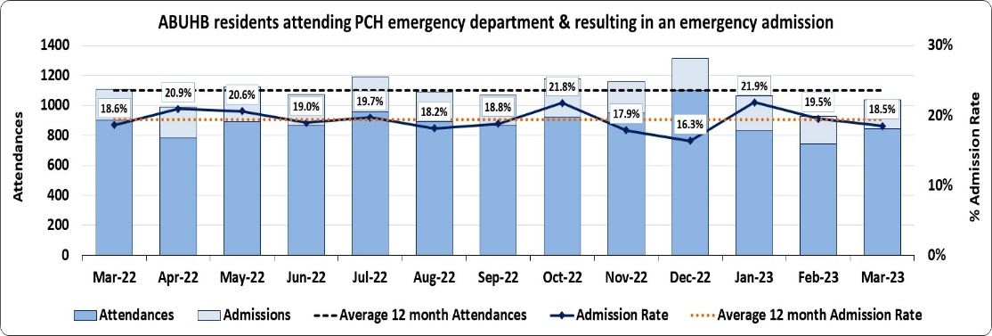 |  |  |  |  |  | 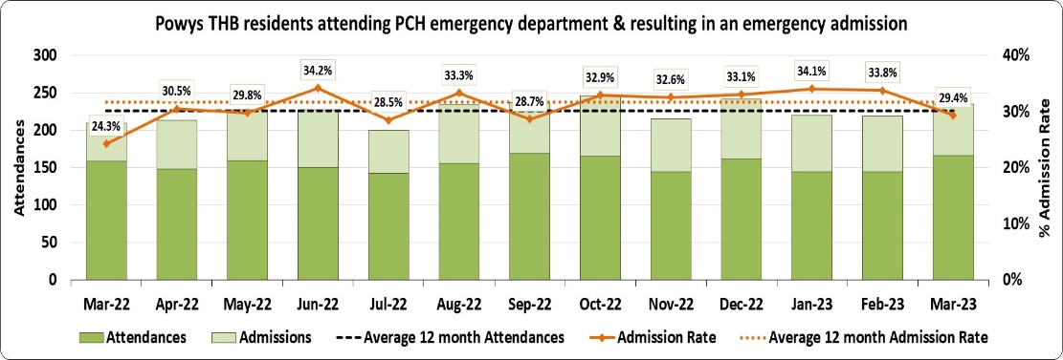 |  |  |  |  |  |  | 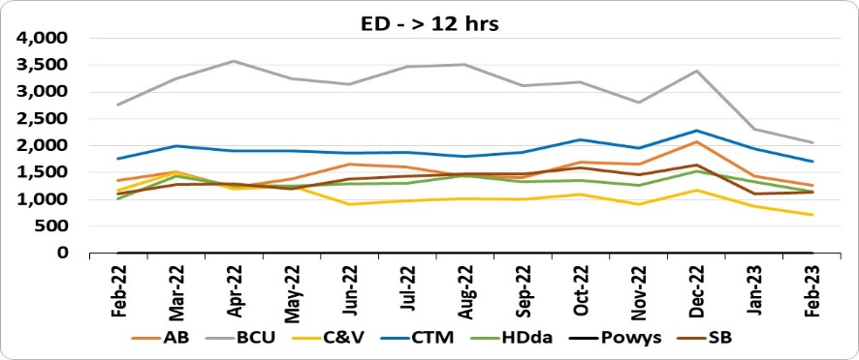 |  |  |  |  | 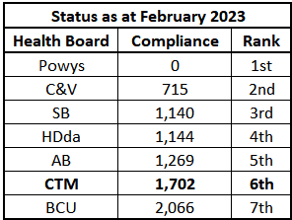
How are we doing? |  |  |  |  |  |  |  | What actions are we taking & when is improvement anticipated? |  |  |  |  | What are the main areas of risk?
Provisionally, during March 2023 the proportion of patients being admitted, discharged or transferred within 4 hours of their arrival was similar to that seen the previous month at 63.6%. A total of 740 patients attended the re-opened unit at YCC, however it remains unclear if this has impacted on levels of demand or compliance at PCH. A 10% increase in attendances by residents from neighbouring ABUHB was observed, with a 7% increase in attendances of Powys residents. Overall attendances at PCH were 15% higher than the previous period with a small fall in the 4 hour compliance to 54.4%, whilst RGH recorded the largest increase in attendances (19%) on those seen during February bringing the total to 5,088 with 64.7% compliance. Although POW attendances increased by 13%, the 4 hour compliance improved to 63.8% and is the highest level seen since June 2021.  All of the CTM’s major EDs observed a rise in the proportion of patients waiting in excess of twelve hours, with the overall total increasing to 2,096 patient breaches; around 19% on the volume seen in February. The number of patients waiting over 12 hours by unit was:  PCH – 894  RGH – 584  POW - 617 |  |  |  |  |  |  |  | Work is ongoing to define and implement medical SDEC’s within PCH and POW, incorporating acute frailty. Both models are working to an implementation date of the end of February and associated benefits should include the “pull” of medical referred patients out of ED. Timelines have shifted due to environmental factors. Work is ongoing to mitigate this.  PCH is seeking to deliver a Frailty/SDEC model on ward 3, however this has been paused due to sustained unscheduled care pressures; aim to deliver in Q1.  Associated work as described above around improving flow, should also begin to improve the 4 hour performance. |  |  |  |  | Significant risk in social care capacity and funding. On the whole, the ready to leave position across CTM remains fairly static.  Capital requirements for the SDEC implementation at PCH and POW and the therapies portion to support front door turnaround is yet to be approved. This remains a high risk and has been highlighted at government level.  Ward 16 @ POW delivers model of care that supports patients that are ready to leave. This is a winter scheme that is delivered by Primary Care and Community and was due to close on the 31 March 2023, this has been extended through April pending a longer term decision.
 | Monitoring Patient Discharge & Flow to 28th March 2023
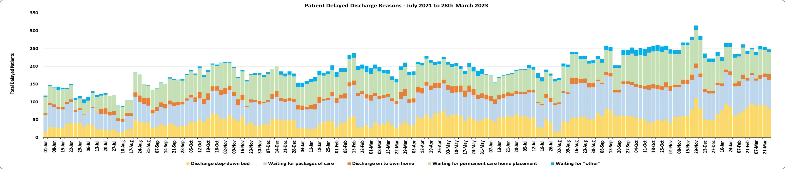
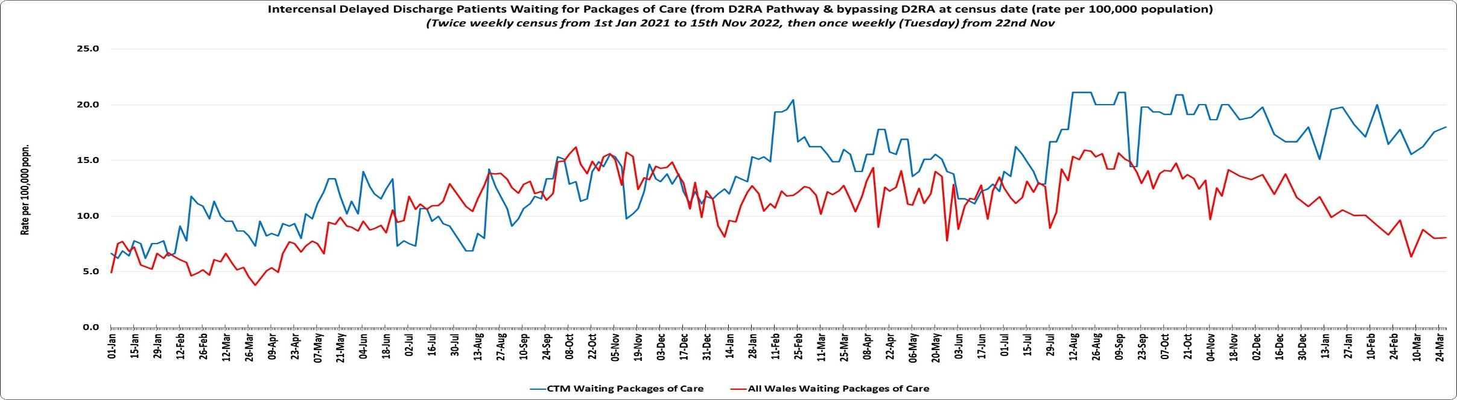 |  |  |  |  |  |  |  |  |  |  |  |  |  |  | 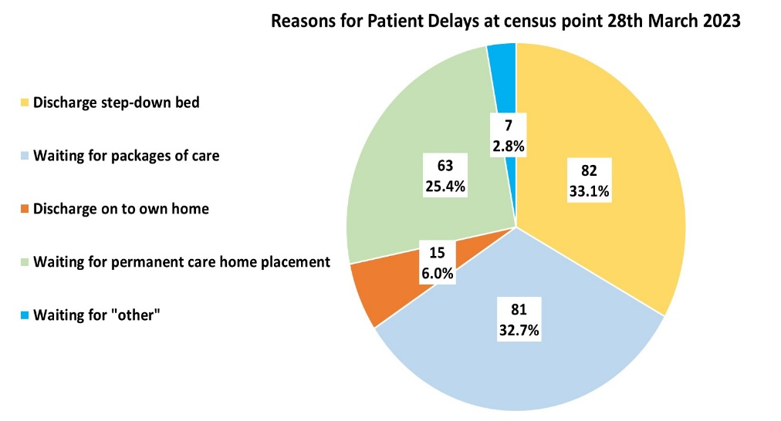
How are we doing? |  |  |  |  | What actions are we taking & when is improvement anticipated? |  |  |  |  |  |  |  | What are the main areas of risk
As is shown in the top chart, the total number of patients currently awaiting their next stage of care, equates to 248 patients, which as it currently stands is a small reduction of 1.6% (4 patients) on the reported position at the end of February. The reasons for patients experiencing a delay in the transfer of their care are detailed in the pie chart bottom right, with almost equal proportions of delayed patients waiting for discharge to step-down bed and waiting for packages of care (33.1% and 32.4% respectively, with just over a quarter waiting for a permanent care home placement.  The bottom left hand chart provides a run chart of the volume of patients whose transfer of care is delayed due to waiting for packages of care, with comparison to the all Wales position. The UHB remains at a similar high level to those seen at the end of January with 81 individuals delayed. This equates to approximately 18 delays per 100,000 population, and as it currently stands is more than twice the national rate which is 8.1 per 100,000 population. |  |  |  |  | The D2RA hub has been implemented as well as the eTOC form, although the performance data shows there has been no significant improvement in the discharge pattern.  This is down to a number of reasons, but the main one is lack of capacity and availability of packages of care in the community.  The D2RA/ETOC has been reviewed and lessons learnt has been captured and an improvement plan has been drafted to improve flow. |  |  |  |  |  |  |  | The Electronic Transfer of Care form remains in development, taking on board associated feedback.  Whilst this standardised document has been launched, we continue to work with local authorities as they adapt to this new way of working
 | Stroke Quality Improvement Measures (QIMs) – February 2023
% compliance with direct admission to an acute stroke unit within 4 hours |  |  |  | % compliance of thrombolysed stroke patients with a door to needle time within 45 minutes |  |  |  |  |  |  | % compliance of patients diagnosed with stroke received a CT scan within 1 hour |  |  |  |  | % compliance assessed by a stroke consultant within 24 hours
PCH |  | POW | CTM | PCH |  |  | POW |  | CTM |  | PCH | POW |  | CTM |  | PCH | POW |  | CTM
24.4% |  | 0% | 16.9% | 16.7% |  |  | 0.0% |  | 14.3% |  | 51.2% | 55.6% |  | 52.5% |  | 70.7% | 55.6% |  | 66.1%
Prince Charles Hospital |  |  |  |  |  |  |  |  |  |  | Princess of Wales Hospital
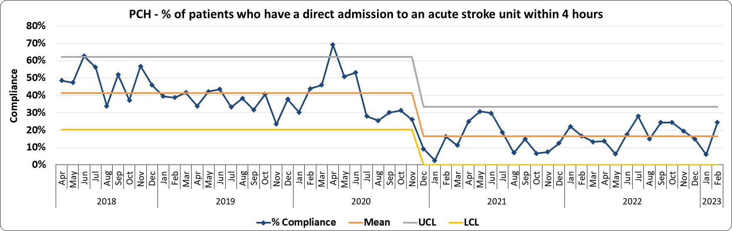 |  |  |  |  |  |  |  |  |  |  | 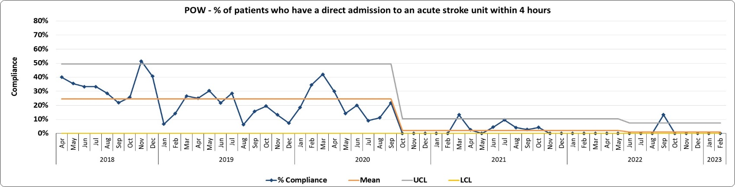
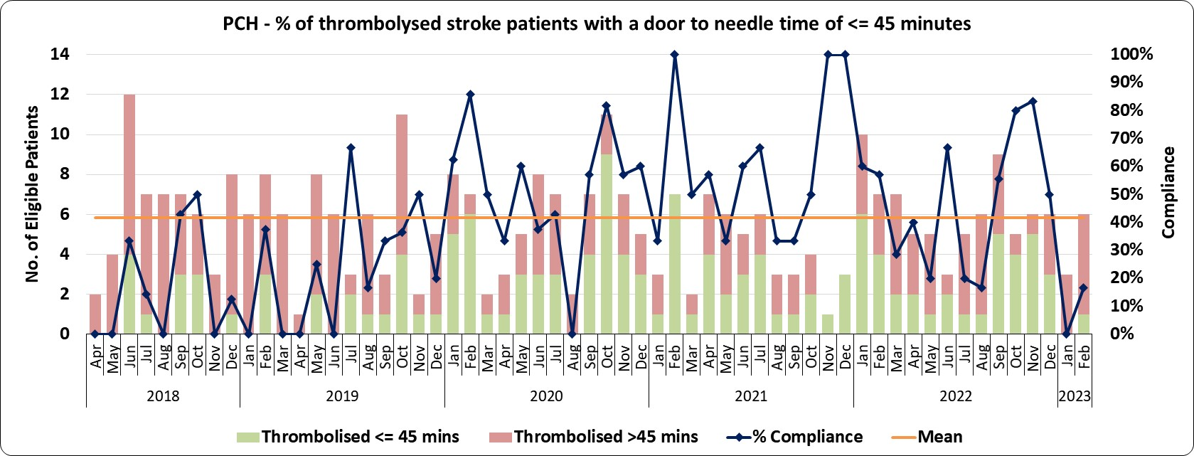 |  |  |  |  |  |  |  |  |  |  | 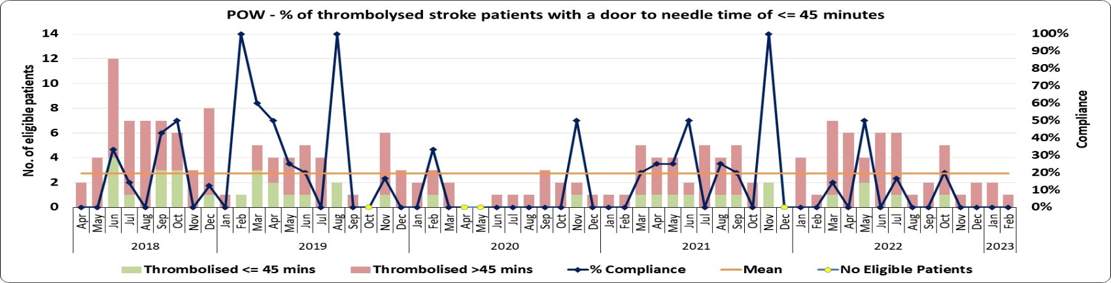
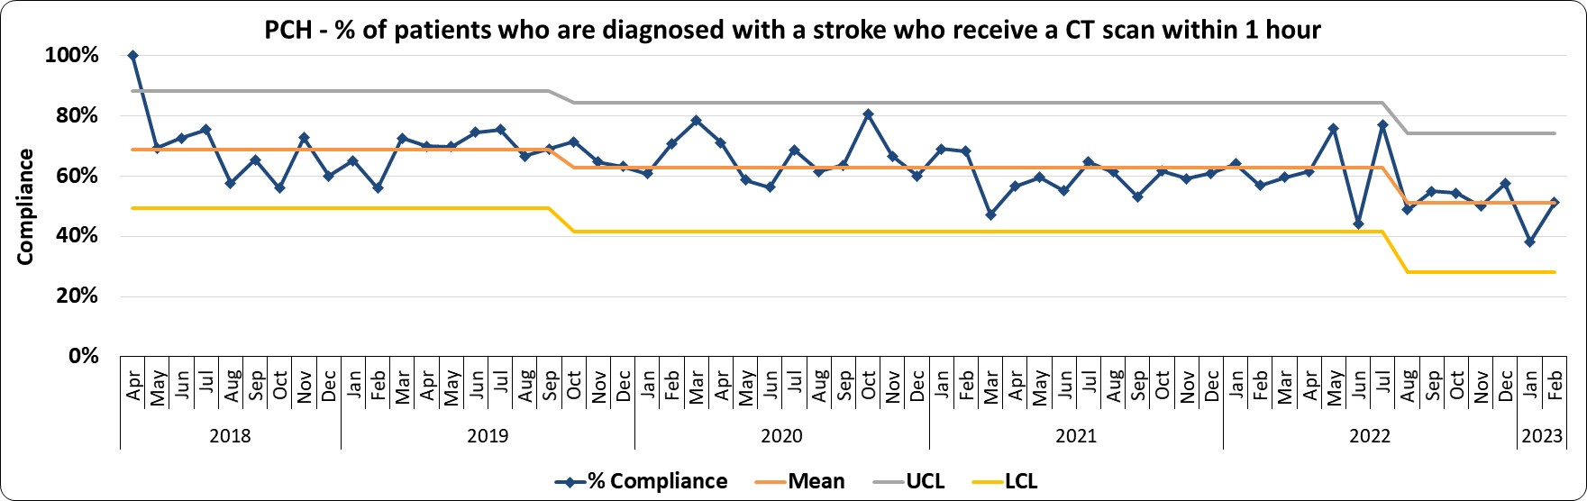 |  |  |  |  |  |  |  |  |  |  | 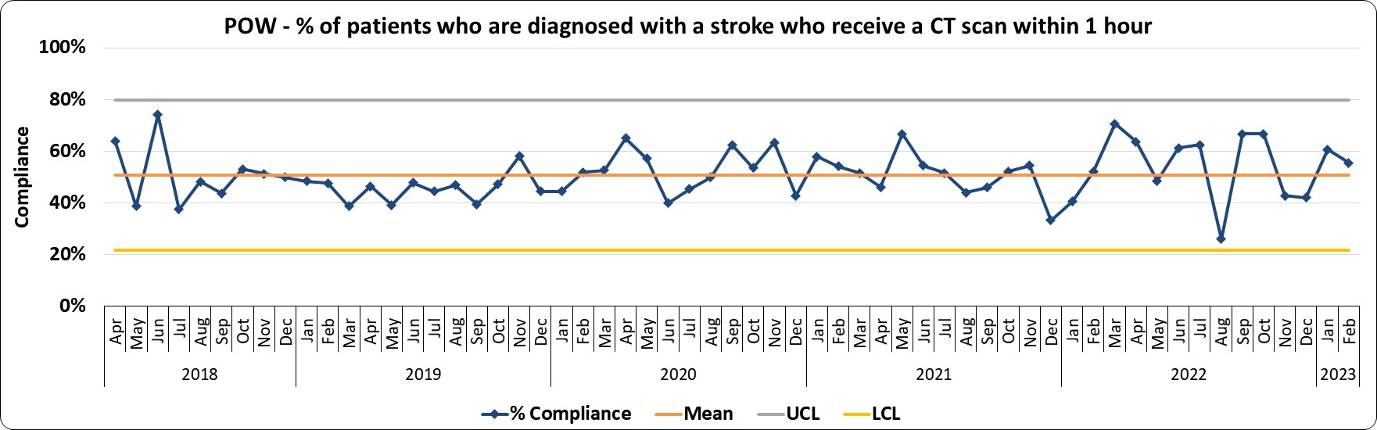
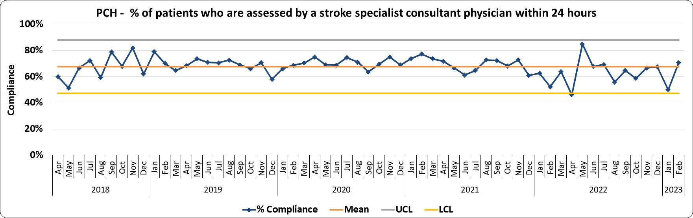 |  |  |  |  |  |  |  |  |  |  | 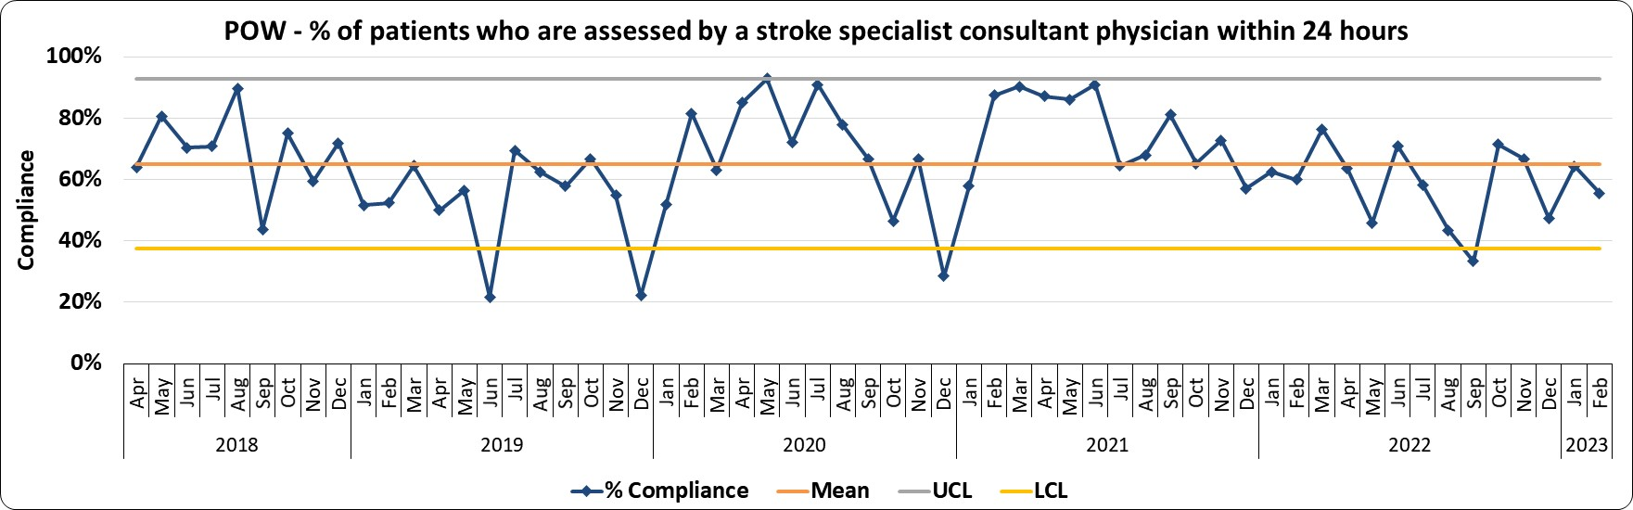

Stroke QIMS continued on the next page…

 |  | Cont’d…Stroke Quality Improvement Measures (QIMs) – February 2023
 | How are we doing? |  |  |  |  | What actions are we taking & when is improvement anticipated?
 | 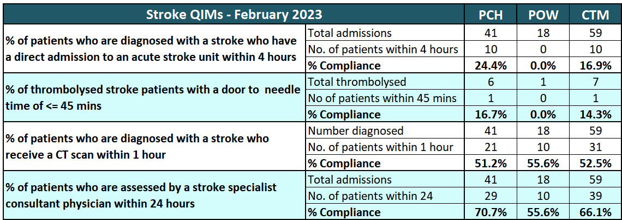 |  |  |  |  | The CTM Stroke Strategy Group has agreed an integrated action plan with a number of short, medium and long term actions, some of which have resource implications. Progress is being made in a number of areas:  - Ongoing active partner in the regional developments with C&VUHB. CTM clinical and operational teams continue to engage well with the regional programme.  - Task and finish group establish to urgently explore solutions/mitigations for effective management of stroke patients self-presenting to the Royal Glamorgan Hospital.  - Stroke Strategy Group, 6 Goals Task and Finish Group and Unscheduled Care Group to meet in April 2023 to discuss and agree overarching strategy for stroke patients in CTMUHB and formalise action plans to implement and operationalise quality and safety improvements including:  - Pathway efficiency  - Clinical outcomes  - Sustainable acute Stroke Services for CTMUHB population  - Work continues to develop services in CTM in preparation for 24/7 access to thrombectomy services in Bristol and changes to RCP guidance regarding stroke management:  - Awaiting final approval for radiographer approved CTA  - Implementing CT perfusion (CTP) scanning to extend the window of thrombolysis and thrombectomy  - Development of new stroke thrombolysis and thrombectomy pathway in anticipation of new RCP guidelines  - Task and Finish group to look at implementation of Brainomix, AI software for interpretation of CTA and CTP to help streamline thrombectomy.  - Awaiting confirmation of start date to commence 24/7 thrombectomy in Bristol.  - Investment in stroke services to improve the patient pathway will enable CTM to improve outcomes for patients and reduce their ongoing need for health (and social) care and support. While it is not possible to allocate the volume of resource required to fully mobilise our plans, some investment will enable us to progress towards our vision of optimal services.
During February, 16.9% (10 out of 59 admissions) of stroke patients were admitted directly to an acute stroke unit within 4 hours. One of the seven eligible patients was thrombolysed within 45 minutes and 52.5% of patients (31 out of 59 diagnosed patients) had a CT scan within an hour. There were also 39 out of the 59 stroke patients (66.1%) seen by a specialist stroke physician within 24 hours of arrival at the hospital.
Prince Charles Hospital achieved a SSNAP ‘B’ rating for Oct-Dec 2022; a significant achievement given current pressures. PCH has not achieved a ‘B’ rating since pre-Covid. Monthly performance for PCH has improved across the 4 QIMs, compared to January 2023. POW has improved in 3 of the 4 QIMs, compared to January.
The following key factors continue to impact on performance against stroke care standards:
- 5-day/week service model for medical and therapy provision.
- Lack of access to an Early Supported Discharge team and adequate bedded rehabilitation unit impact on length of stay and flow of stroke patients through the Princess of Wales hospital
- Unprecedented demand for acute beds and the challenges maintaining a ring-fenced stroke bed impact on the ability to admit to the stroke wards within 4 hours across the whole hospital site.
- Pressures within adult social care result in delayed discharges and increased pressure across all inpatient areas.
- Continued self-presentations to the Royal Glamorgan Hospital (RGH), instead of specialist stroke sites. Demand for acute beds results in delays in subsequent transfer to acute stroke sites and access to specialist stroke services.
 | What are the main areas of risk? |  |  |  |  | How do we compare with our peers?
 | The intended impact of the short, medium and long term actions, along with the regional and national stroke programmes, is to improve the quality, safety and experience of care for patients, their families and our workforce. CTM will develop an improvement plan, with ambitions to achieve a SSNAP rating of ‘A’.  The main risks to achieving this rating are resource challenges and the wider patient flow challenges experienced in ED and throughout the hospital, which make it difficult to ring fence stroke beds, particularly affecting the 4 hour target. Bed pressures also impact the ability to transfer stroke patients from RGH in a timely manner in order to access specialist stroke care. This is part of the wider unscheduled care improvement programme and the wider performance management of the system.  In POW, the ongoing staffing challenges within the therapy services are affecting the ability to update the information on SSNAP in a timely manner which will affect the accuracy of the therapy performance measures.  In order for the national stroke care ambitions to be achieved, local services are required to deliver effective and efficient acute care and rehabilitation post-72hours. Whilst some investment has been identified for 2023/24, it is not possible to allocate the volume of resource required to fully mobilise our plans. |  |  |  |  | 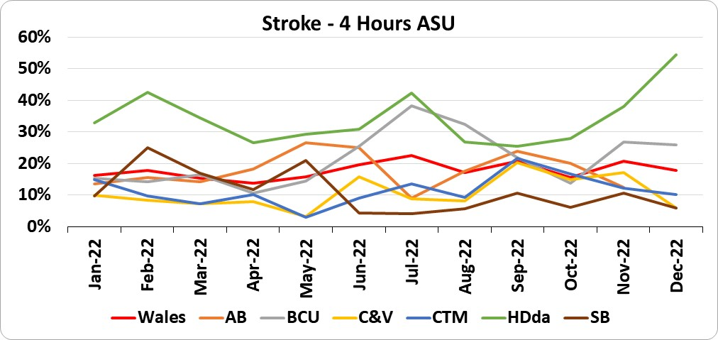 |  |  | 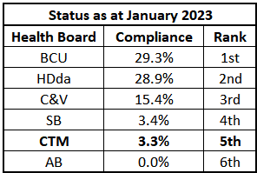
 |  |  |  |  |  | 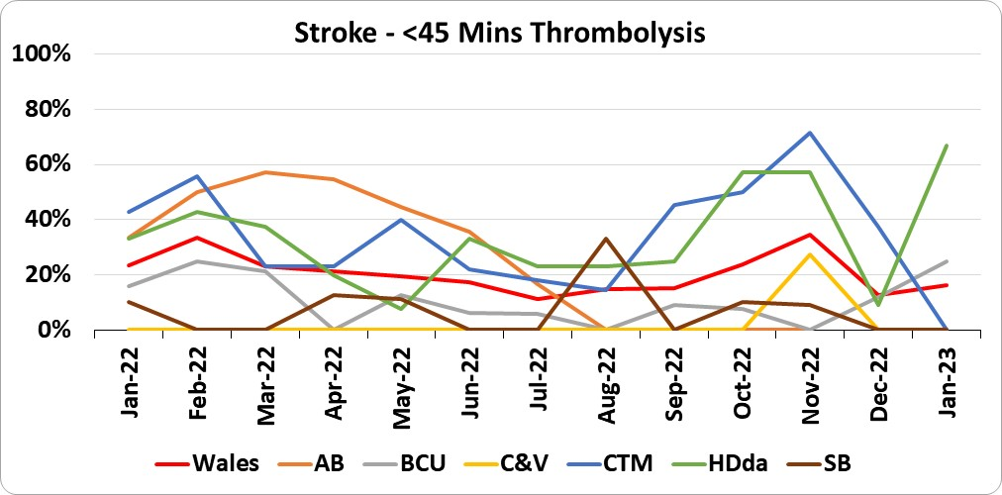 |  |  | 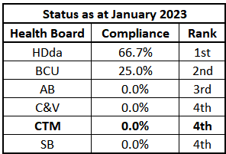
 |  |  |  |  |  | 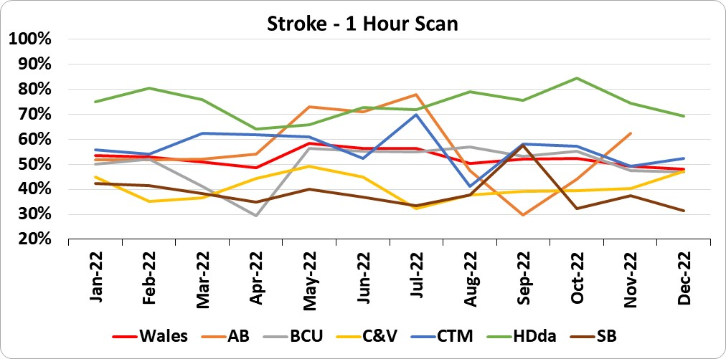 |  |  | 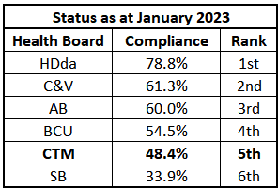
 |  |  |  |  |  | 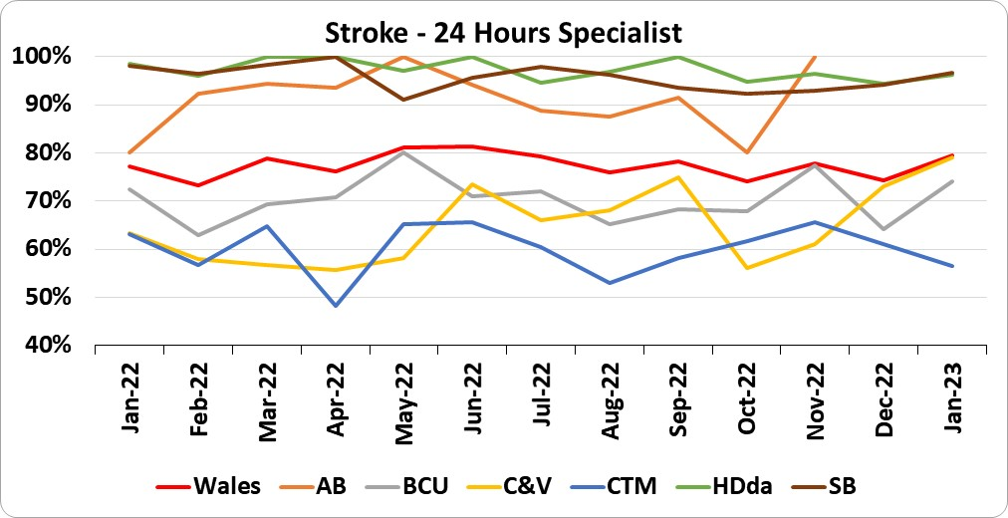 |  |  | 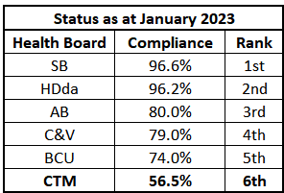
 |  | CTM Mental Health Services (excluding CAMHS) – February 2023

% of assessments undertaken by LPMHSS within 28 days of receipt of referral (87.9%) - Target 80%
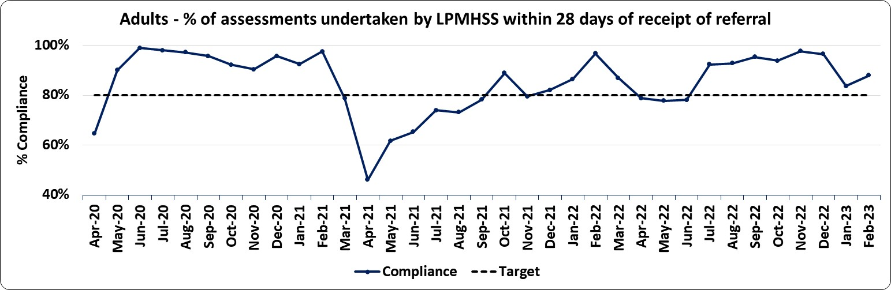 |  |  |  |  |  |  | Part One of the Mental Health Measure relates to primary care assessment and treatment and has a target of 80% of referrals to be assessed within 28 days. The adult mental health services compliance for February remains above the threshold with 87.9% of the total assessments (356) carried out within the required timescale.  Referrals totalled 755, a slight fall on those received during January (805), but a 15% increase on the number of referrals received in the equivalent period last year. Pre-Covid levels were in the region of 1,000 to 1,100 with the average referrals, thus far for 2022/23, averaging 713 per month.

% of therapeutic intervention started within 28 days following an assessment by LPMHSS (91.7%) - Target 80%
Overall the percentage of therapeutic interventions started within 28 days following an assessment by LPMHSS also remained above the WG target with compliance at 91.7%.  This resulted in just 24 of the 289 interventions being outside of the required timescale of four weeks. |  |  |  | 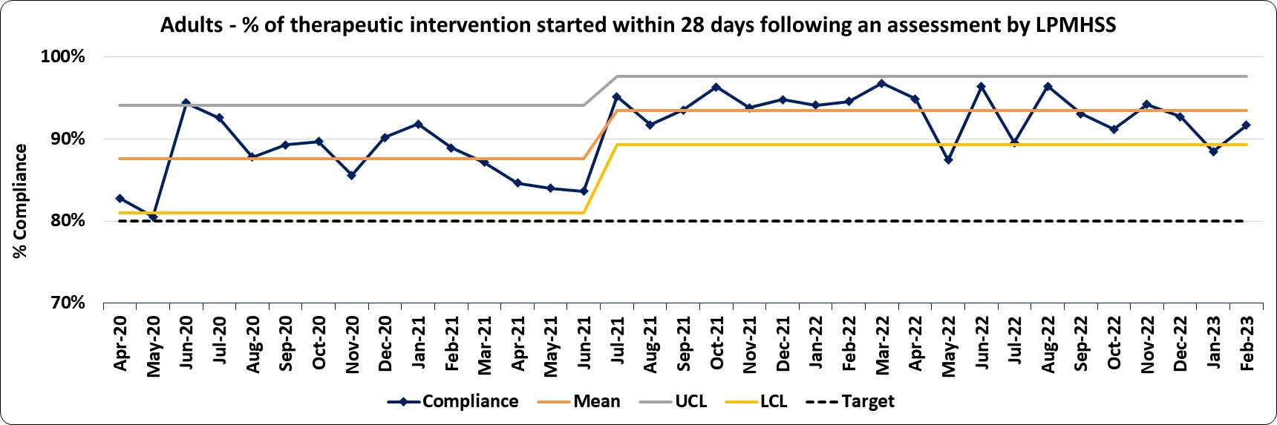

% of HB residents who are in receipt of secondary MH services who have a valid CTP (88.1%) - Target 90%
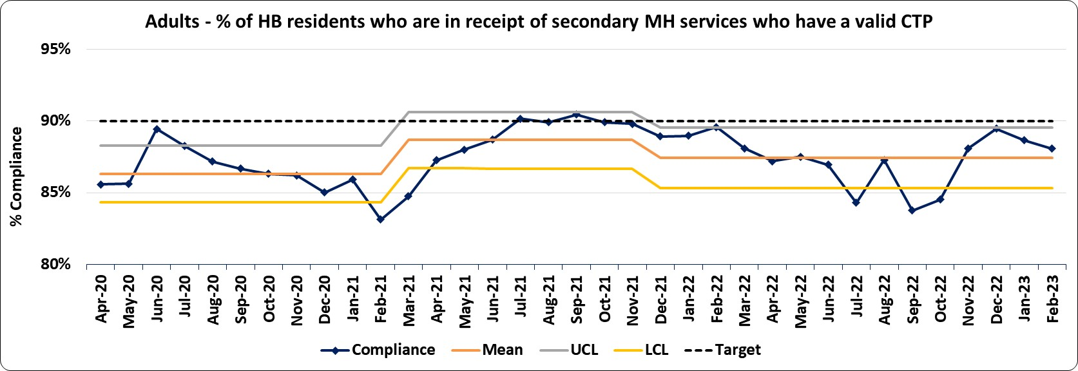 |  |  |  |  |  |  | Part Two of the Mental Health Measure, i.e. % of residents who have a valid Care Treatment Plan completed by the end of each month was reasonably stable at 88.1% during February and continues to remain just below the target threshold of 90%.  As seen in the chart to the left, compliance has remained under the target since April 2020, with the exception July and September 2021.  Part 3: There were no outcome of assessment reports sent during February.
% of patients waiting less than 26 weeks to start a Psychological Therapy (47.5%) - Target 80%
During February, Psychological Therapies compliance remained almost static at 47.5%, although recording its lowest level since April 2020 and continuing to remain below the 80% compliance threshold.  The chart to the right depicts the total waiting list volume (red) with the number of patients waiting more than 26 weeks for a Psychological Therapy (blue) and the proportion waiting less than 26 weeks (the WG target - yellow). The waiting list volume has been growing at a fairly constant rate throughout the period, with demand 13 patients higher than treatment each month. In the period to August 2021 the service improved their waiting list management and treat in turn which resulted in their compliance improving. However, thereafter the waiting list volume has grown to such an extent that the increase in the backlog has been resulting in an almost exact increase in the number of patients waiting over 26 weeks (which has grown at an average of 22 per month since August 2021). |  |  |  | 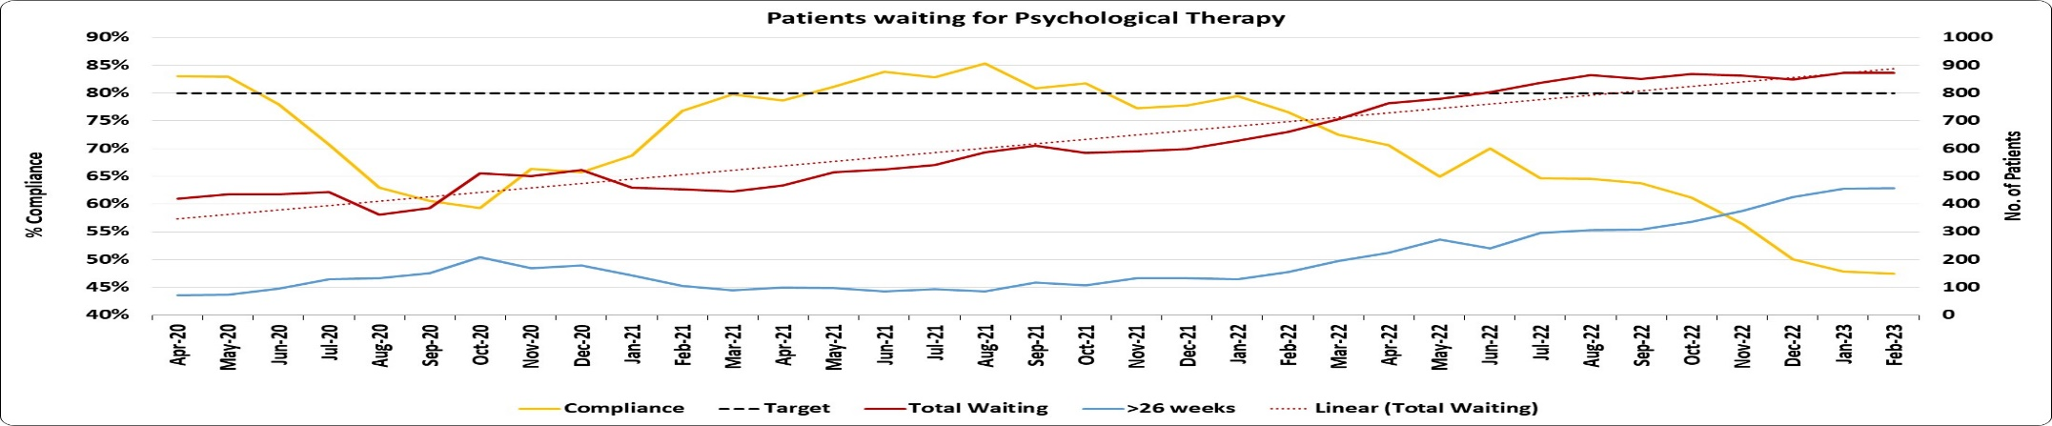
Adult Mental Health Services continued on the next page…
 |  | Cont’d…Mental Health Services (excluding CAMHS)
How are we doing and what actions are we taking? |  |  |  | When is improvement anticipated and what are the main areas of risk?
Part 1a Adult mental health services saw performance improve to 87.9% in February, as did Part 1b wlth performance at 91.7%.  Part 2: Compliance for both Adult, Older Adult and Learning Disability Services combined has decreased marginally to 88.1% and is below the target threshold of 90%  - Adult Services decreased from 86.6% to 85.8%  - Older Adult Services improved from 93.1% to 94.1%  - Learning Disability Services has decreased from 96.8% to 94.6%  Analysis is on-going on Non-Compliant CTPs to identify and prioritise work to reducing risk and providing assurances.  Psychological Therapies: The waiting time standard is; at least 80% of the people who are waiting for an intervention should be waiting for less than 26 weeks. In February, 47.5% are waiting for less than 26 weeks which continues to be well below the compliance target of 80%. |  |  |  | Part 1a: compliance continues to be above the target of 80%. Increased demand during the winter months and the possibility of reduced capacity due  to staff absence poses a risk to fluctuations in performance. Systems are in place to regularly monitor performance.  Part 1b: compliance continues to remain above target.  Part 2: Targeted work on non-compliant CTPs continues. It is anticipated to increase to above target compliance (90%) by the end of March (Quarter 4, 2022/23). Work continues with Local Authority partners to ensure non-compliant social worker led CTPs are prioritised based on reducing risk. The main risk to anticipated improvements remains the reduction in staffing capacity caused by increased sickness and turnover. Managers are being asked to monitor compliance closely in their teams and provide assurance that risks are being managed for patients with non-compliant CTPs.  Senior Nurses have been asked to develop action plans in order to increase compliance and monitored through Mental Health Planned Care Recovery Board. The focus of improvement is around the development of compliance across the multi-disciplinary care co-ordination team. Local teams have been asked to risk assess patients who do not have an up to date CTP in order to provide assurance that care is not adversely affected.  Psychological Therapies: Given the present vacancy levels within the department, 2 sources of external capacity has been secured to address the capacity gap.  1. Outsource intervention for 80 people: Following a successful procurement exercise, a provider has been appointed and the service is being mobilised. The biggest risk to timescales has been the time and resource needed to implement a Data Sharing Agreement, the DPIA and CSIA have now been submitted for final sign off.  2. Recruit two Assistant Psychologists to implement and evaluate a number of tests of change designed to improve waiting list data, ensure “waiting well” and improve utilisation of existing capacity. The Assistant Psychologists started one month early and work to support the waiting well agenda commences April.  Recent recruitment drives for the 4 x 8a practitioner psychologist vacancies (2.8wte) across adult CMHTs has resulted in the appointment of 0.8WTE who will start on 1 May 2023. Applicants for the High Intensity Therapist posts have withdrawn. 0.4 WTE locum psychologist started March 2023.  Responses to an expression of interest to test the market for capacity to support the primary care waiting list have been received and plans to outsource some of this waiting list are under development.  Concurrent work is underway to develop medium term plans to improve quality and performance and sustainable change. Delivery is planned over three stages which seek to (1) develop the capacity and capability for evidence based decision making, (2) make use of data to develop and agree  strategies to maximise existing capacity and to develop the business case to address gaps; options appraisal to support prioritisation of agreed  initiatives and (3) implement agreed strategies.  As part of the first stage, waiting lists are being validated during March and April and each service area is working with business support to review data quality. Processes are being mapped to identify action for immediate improvement along with actions for further system and process change that will better enable management information to inform decision making.

How do we compare with our peers?
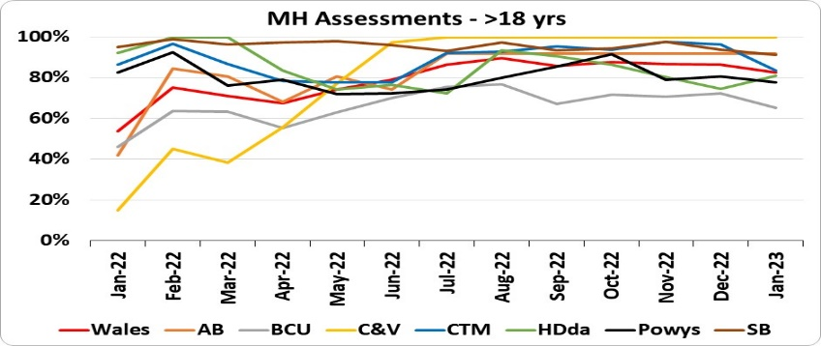 |  |  | 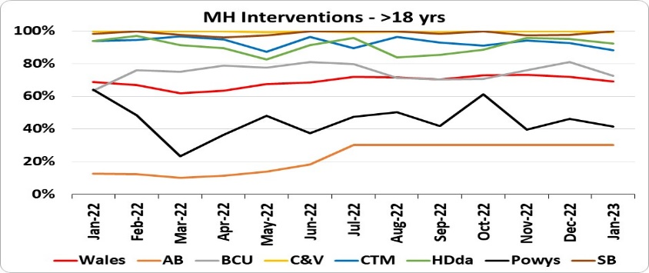 |  | 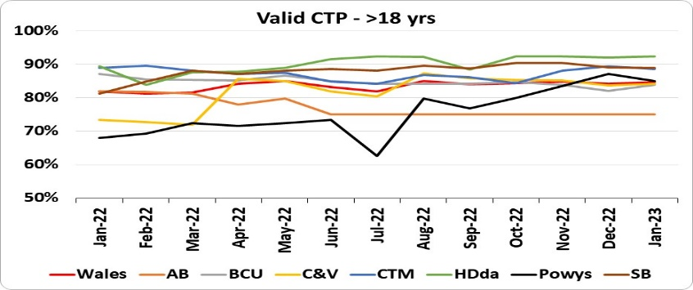 |  |  | 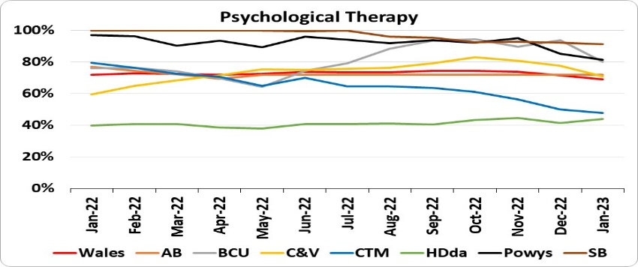
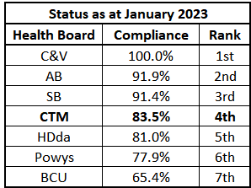 |  |  | 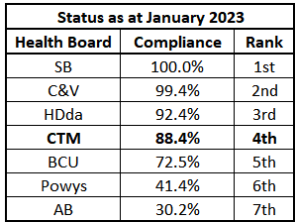 |  | 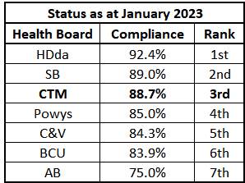 |  |  | 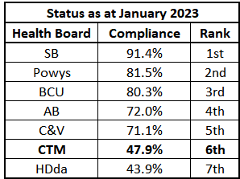
 | CTM Child & Adolescent Mental Health Services (CAMHS) – February 2023

% of assessments undertaken by LPMHSS within 28 days of receipt of referral (30.5%) - Target 80%
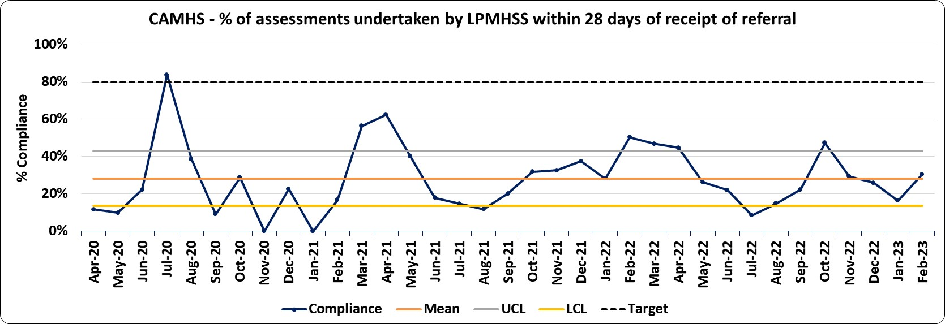 |  |  |  |  |  | Although there was an improvement in performance during February, compliance continues to be at a low level with 30.5% of assessments undertaken within 28 days of referral.  Performance remains well below the WG’s minimum expected standard of 80%, (the last time the target being met was in July 2020).  Compliance continues to remain below the expected standards although with the actions taken in January and February to increase capacity and activity there has been a reduction in the backlog of patients waiting over 28 days and corresponding improvement in Part 1a Performance in February. Whilst demand has increased in February the overall waiting list stabilised. The service expects higher demand in the next few months linked to expected seasonal impact as children and young people approach the exam period.  Sustainable achievement of the 28 day standard requires a significant waiting list reduction as detailed in the chart 2nd left, currently demand continues to exceed activity. The service is working on plans to increase capacity and activity in the longer term to meet the demand.
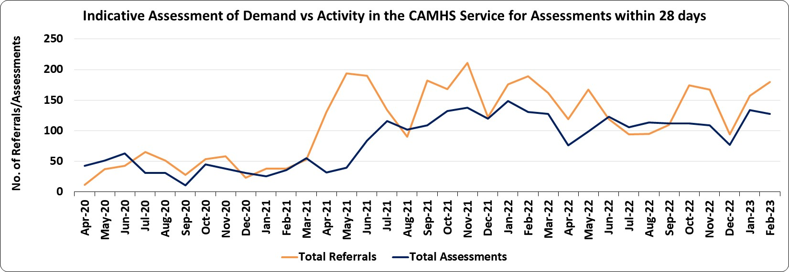

% of therapeutic intervention started within 28 days following an assessment by LPMHSS (36.4%) - Target 80%
Overall the percentage of therapeutic interventions started within 28 days following an assessment by LPMHSS also improved, however remaining low at 36.4% with 28 of the 77 interventions for February commencing within 28 days.  Compliance continues to remain well below the 80% threshold and the last time the target was met was in December of 2020 (90%).  The number of interventions started in February was similar to those during January as the service implemented additional capacity via waiting list initiatives, as well as the introduction of groups run in partnership with a third sector organisation. As a result the waiting list for intervention has reduced and performance has improved. |  |  | 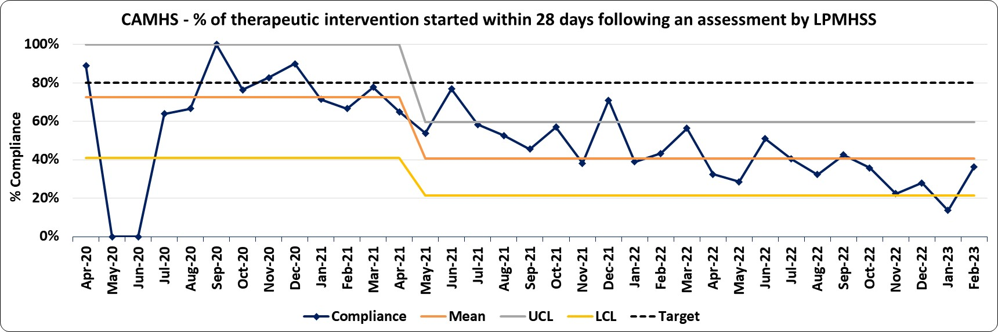

% of HB residents who are in receipt of secondary MH services who have a valid CTP (85.3%) - Target 90%
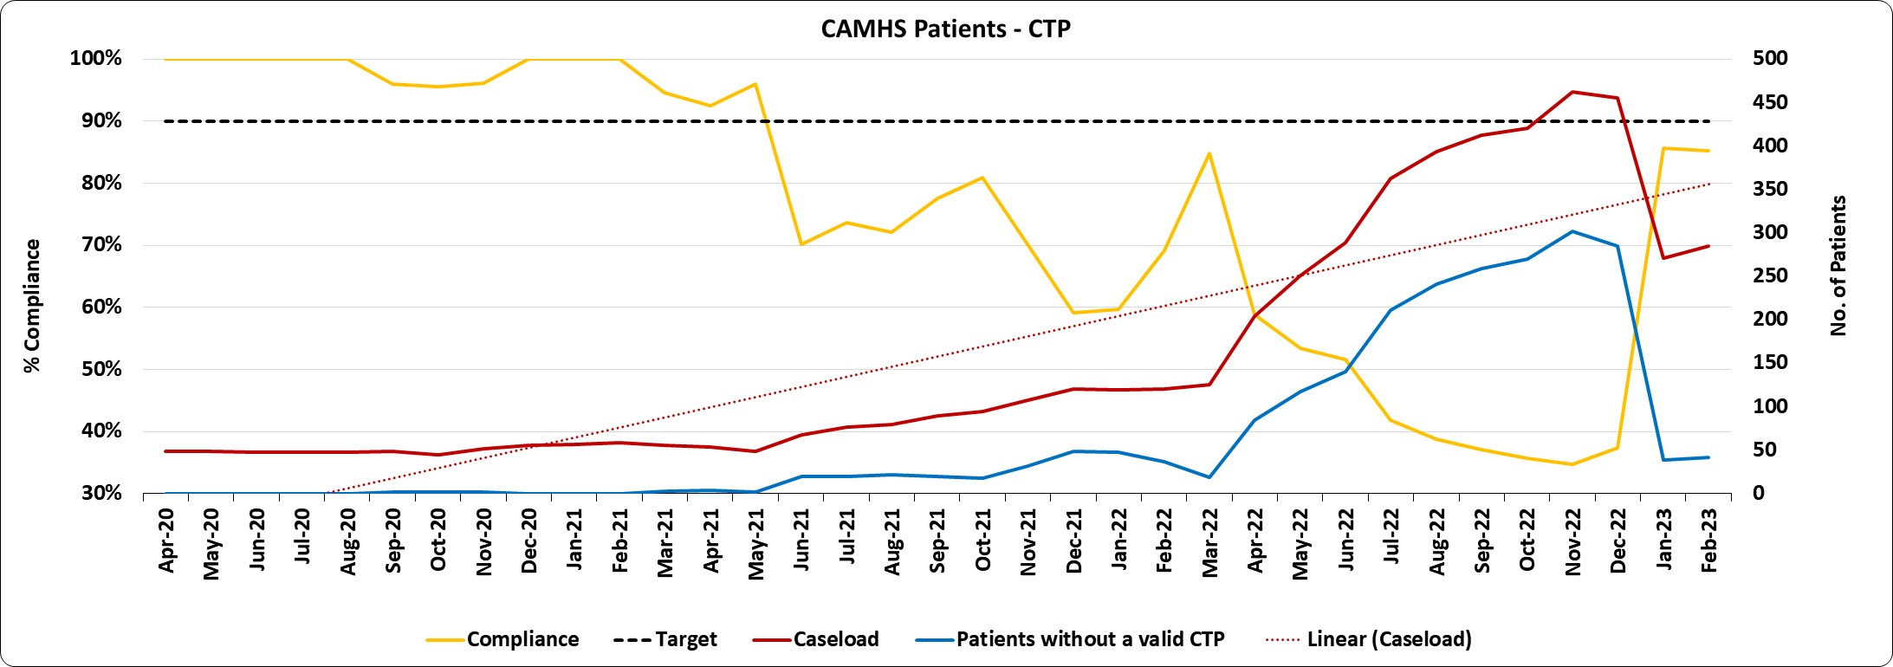 |  |  |  | Part 2 of the Mental Health Measure, i.e. % of residents who have a valid Care Treatment Plan completed by the end of each month remained fairly stable at 85.3% during February, continuing the much improved performance seen from January this year and lying just below the target of 90%.  As seen in the chart to the left; from the start of the period to May 2021 the caseload volume had been fairly constant and compliance remained above the target threshold. Thereafter, caseload volumes increased incrementally until a sharp rise was seen in April 2022, where caseloads to December had grown, on average by 28 patients each month. From January 2023, we observe that caseloads have fallen by over 40% and the number of patients without a valid CTP at the end of the month remains low at 42.  Part 3: There were no requests for a CAMHS assessment under Part 3 of the Mental Health Measure during February.
CAMHS continued on the next page…
 | Cont’d…CAMHS
How are we doing and what actions are we taking? |  |  |  |  | When is improvement anticipated and what are the main areas of risk?
The service has maintained an increase in activity during February and as a result the backlog of patients waiting more than 28 days has improved alongside a reduction in the average waiting time for the service. The slight improvement in performance in February reflects the reduction in the backlog and improved position for both Part 1 a and Part 1b. The focus is to continue to ensure patients are treated in order of longest waits, unless there is clinical urgency. The service is working to sustain the increased activity over the next couple of months via the use of waiting list initiatives in the interim to recruitment.  As noted in previous updates the increase in patients with a valid Care and Treatment Plan (CTP) Part 2 of the service is as a result of quality improvement work to improve the understanding and awareness of the criteria of Part 2 and ensure patients have a valid CTP.  Actions being taken: An improvement action plan and trajectories had been developed to improve compliance for all Mental Health Measures targets, but on reflection of the increasing demand and mismatch in capacity, plans have been revised and reviewed with the senior clinical leads and continues to be regularly reviewed. This work has included revision of the performance trajectories to detail when improvement will be expected with achievement of the MHM targets not expected until the end of 2023/24 given the backlogs in the service.  Actions have already taken place to support improvement, including movement of resources to areas of longest waits, review of caseloads and supporting clinicians with identifying discharge plans and caseload review and wellbeing support for the workforce. Additional WLIs have been in place since September and are providing additional capacity in the interim to recruitment to new posts in the service. The service team leads and administrative support have also received demand and capacity training by the DU.  Recruitment has taken place for new posts funded via the Mental Health Service Improvement Fund and these new posts will enable the service to implement different ways of working in order to manage demand into the service and utilise capacity more effectively  The service implemented new pathways with third sector organisations to provide groups on specific areas of support for CYP, with the first area evaluating positively. These pathways enable the service to increase capacity for interventions and offers peer group support to CYP. The service is also progressing the implementation of a referral pathway to Silvercloud which will provide CYP with the option to receive therapy intervention via a 12 week online course. This is anticipated to be implemented by April, subject to support by Silvercloud.  The In-Reach Service/Whole Schools Approach was implemented at the beginning of September and has been rolled out to 80 schools with implementation into the remaining schools now being targeted in the spring term of 2023. This service will underpin early intervention and prevention in partnership with other organisations, supporting emotional wellbeing resilience in CYP and aim to prevent onward referrals into specialist CAMHS.  In addition to the above, the following actions are being progressed to improve performance:  - Agreement to revise some of the job plans to increase capacity for assessments – a further 3 posts are in the process of being advertised which will provide some additional capacity if the service can recruit  - Implementing text reminders to maximise the available capacity (awaiting ICT support, although no confirmation of timescales)  - Review of the clinical model and review and support for caseload management given the increased acuity in the service – this is taking place in March & April. |  |  |  |  | Outputs of improvements  Part 1a and 1b :  - The additional activity in February has meant the waiting list for Part 1a has stablised despite an increase in demand, reducing the overall waiting time and number of patients waiting more than 28 days. However as the service continues to treat patients in order, unless there is clinical urgency, then it is anticipated that performance will continue to be lower in next few months in order to reduce the backlog of patients waiting more than 28 days. With the actions being taken to increase and maximise capacity available, including recruitment to new posts and working with third sector organisations, it is anticipated there will be more sustainable improvement subject to demand levels from April 2023  - The actions taken to manage demand, namely primary care liaison and roll out of the schools in-reach provision are part of a wider systematic approach to supporting wellbeing and mental health and are anticipated to take longer to have an impact on referral numbers and trend with expectation of having an impact in the medium to longer term towards the summer of 2023.  Part 2: There has been a focus on providing additional capacity and time to support care co-ordinators to complete CTPs with their patients and this has supported the increase in performance reported in January. The remaining patients without a valid CTP will receive/d appointments in the next few months to ensure we meet compliance with Part 2. The service has drafted a SOP and will implement an improved monitoring and reporting system from April.  Main areas of risk:  - Demand and capacity imbalance increasing the backlog of patients waiting to be seen – the service has seen an increase in demand and as a result the waiting list in the winter of 2022 and into 2023, despite making improvements to the waiting list during the summer of 2022. The service is aiming to optimise capacity into the summer of 2023 to target the backlog when demand is expected to be lower.  - Reduced capacity - staff uptake in doing additional clinics has been limited in the last few months and some increase in sickness alongside recruitment lead in times.  - Increased acuity of presentation in CYP has resulted in CYP being unwell and needing more intensive longer-term work or possible admission.

How do we compare with our peers?
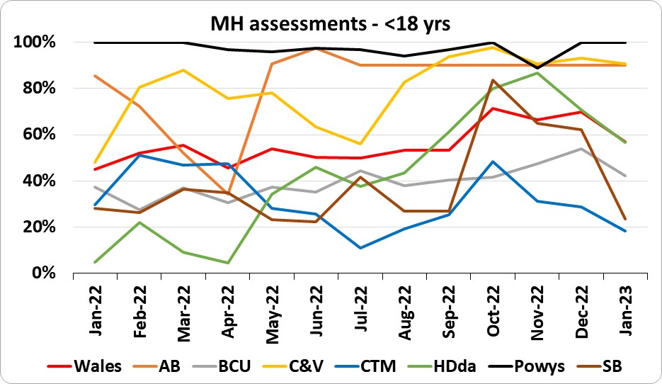 |  | 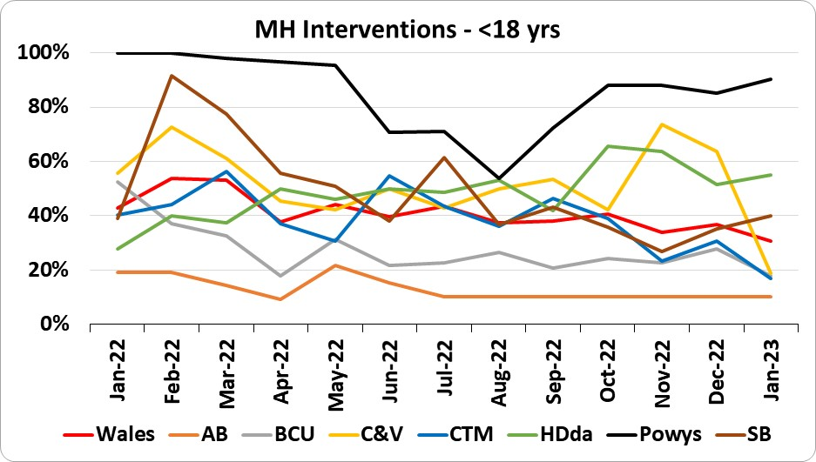 |  |  | 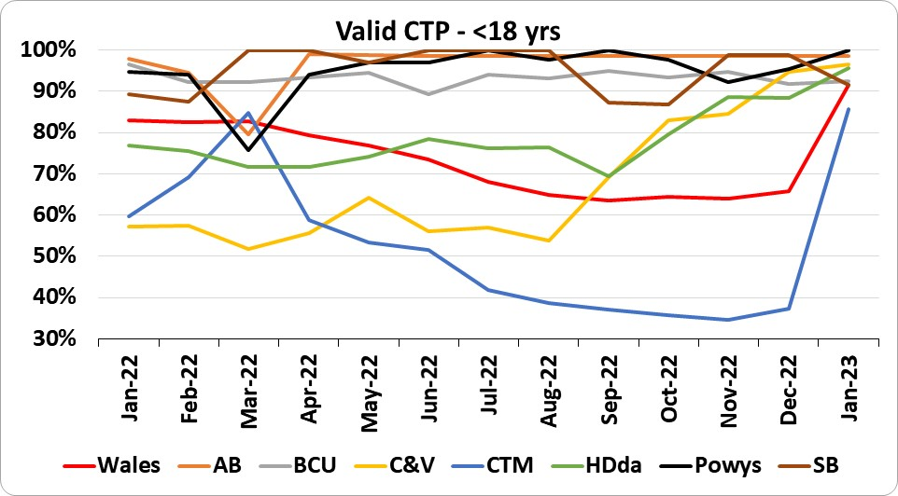
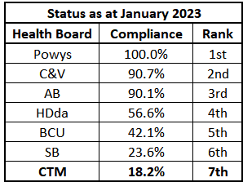 |  | 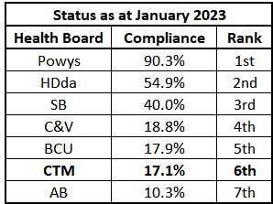 |  |  | 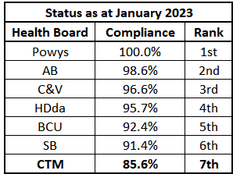
 | WHSSC – Welsh Health Specialised Services Committee

CTM Residents Waiting for Treatment at other Welsh Providers – *Please note that w.e.f. from June 2021, Swansea Bay UHB have applied a LHB residents code to their waiting list submission that has had the impact of revealing an increase in the number of CTM residents waiting for treatment at SB that were previously regarded as being their own residents. This does not affect the management of the patients as they have been reported on SB waiting lists and will continue to do so until the patients are treated.
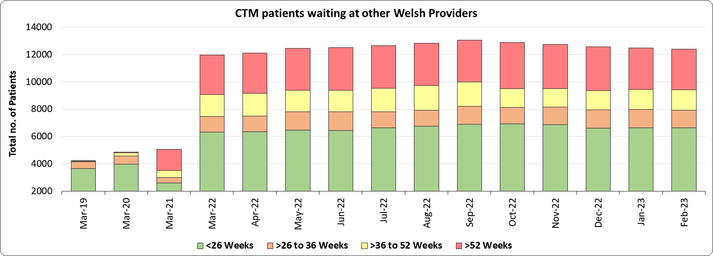 |  |  | 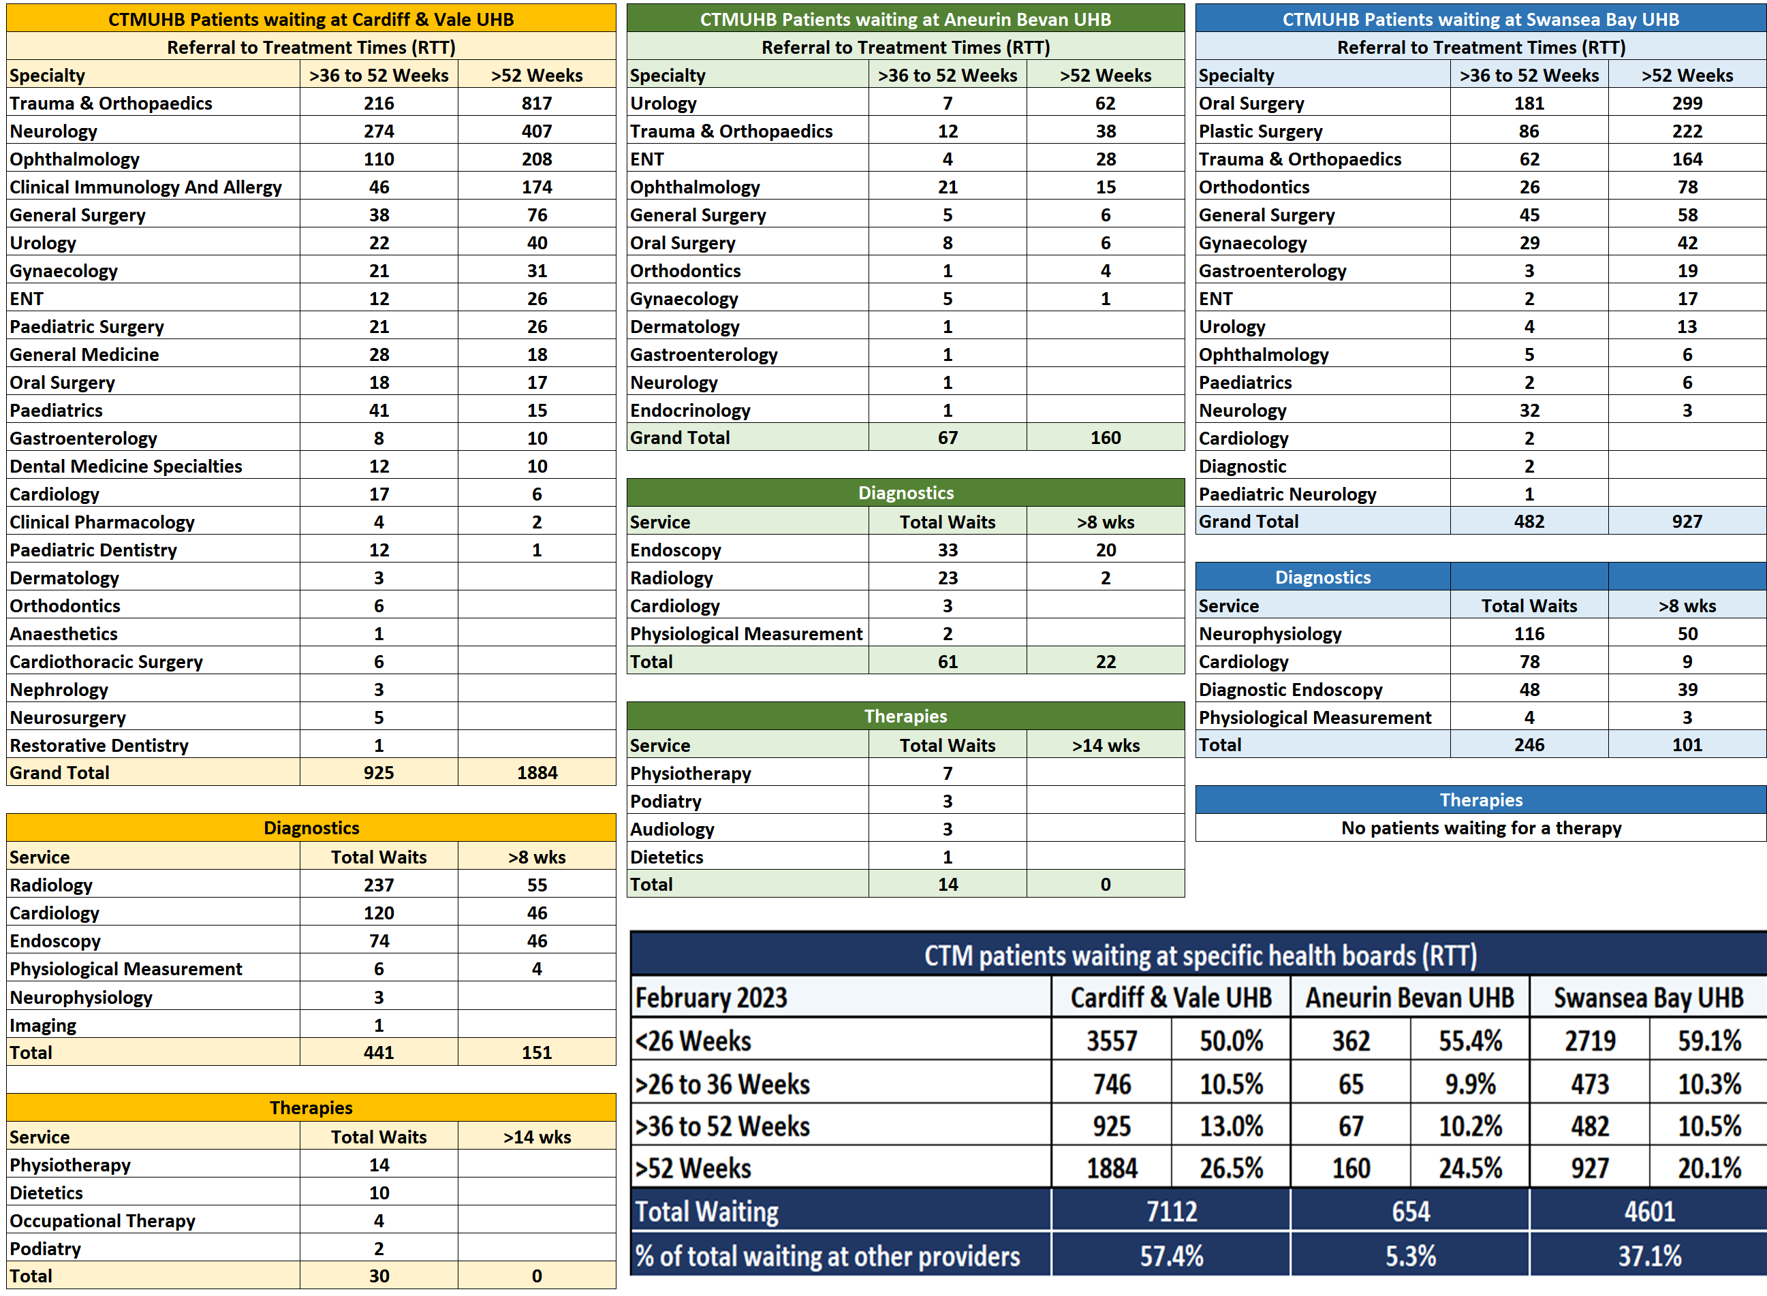
Using data collected and reported by Digital Health and Care Wales (DHCW), the chart above shows waiting times for CTM residents at other Welsh providers, though the actual Commissioner is not WHSSC in all instances.

Over 99% of the waiting lists for CTM residents awaiting services commissioned by WHSSC in other parts of Wales are in three Health Boards. The tables to the right provide the RTT, Diagnostic and Therapy waits for CTM patients waiting for treatment at three specific Welsh providers together with a specialty breakdown of the number of patients waiting.

The number of CTM patients waiting over 36 weeks (RTT) at these three Health Boards in February is 4,445 of which 2,971 are waiting more than 52 weeks. The number of patients waiting over 8 weeks for a diagnostic at these Health Boards is 274 and there are no patients waiting over 14 weeks for a therapy.

CTM Outpatient Attendances at other Welsh Providers

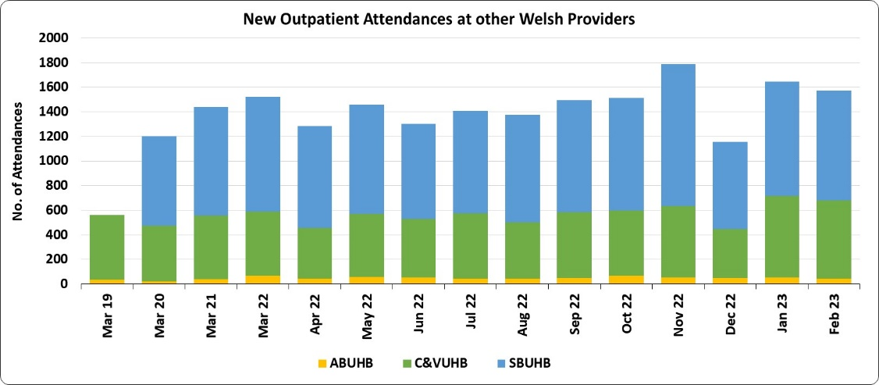 |  | 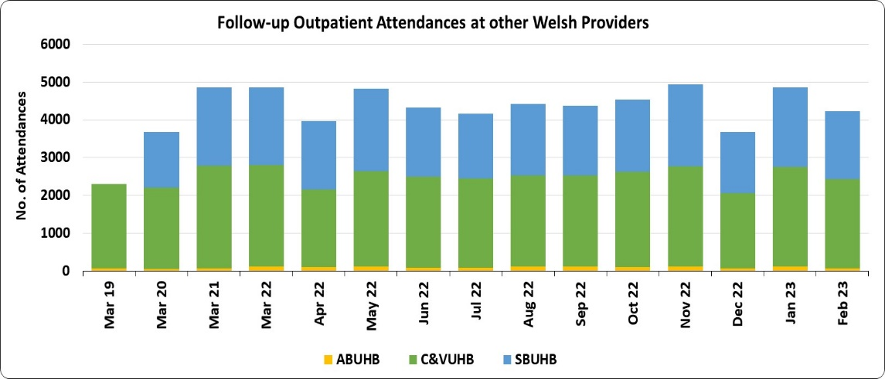 |  | The February 2023 position (March reporting period) continues to show marginal change from the previous reported position.  There are six CTMUHB residents waiting up to 52 weeks for Cardiac Surgery at Cardiff and Vale UHB but no patients waiting in excess of 52 weeks.  The performance of Neurosurgery has remained relatively stable, with no patients waiting more than 52 weeks currently. Nine patients have waited between 36 and 52 weeks (an increase of 4 from the previous month). Neurology waits remain a significant concern with a total of 407 patients waiting more than 52 weeks.

CTM Elective Daycase / Inpatient Admissions at other Welsh Providers

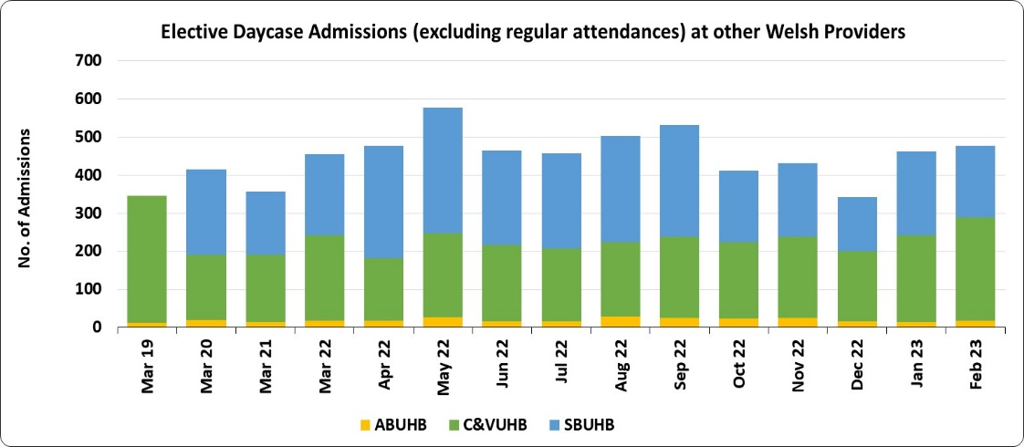 |  | 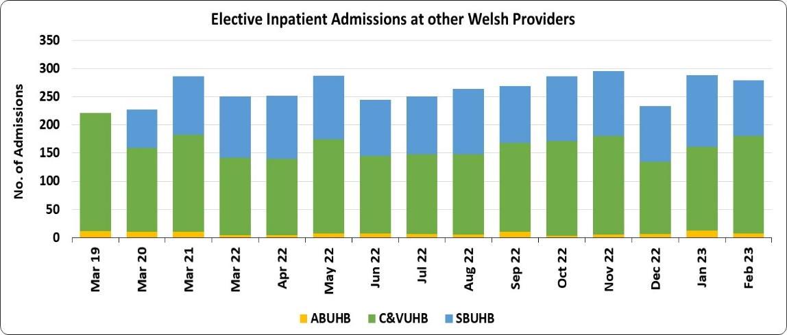 |  | Cardiff and Vale paediatric surgery waits are still over 52 weeks with 26 breaches currently, a reduction of 1 on the previous month.  Plastic Surgery remains an area of concern for Swansea Bay performance with very static status. The number of CTMUHB residents waiting over 52 weeks currently sits at 222 (down one from the previous reporting period).

  - Finance update – Month 12

Updates on the financial position become available on the 9th working day of the month. Consequently there is no further update available to that provided in the last financial report.
- £3M of the accrual which is 6/ of £6.0m.

- KEY RISKS/MATTERS FOR ESCALATION TO BOARD/COMMITTEE

  - The key risks for the Performance quadrant are covered in the summary and main body of the report.

- IMPACT ASSESSMENT

Quality/Safety/Patient Experience implications | Yes (Please see detail below)
Quality/Safety/Patient Experience implications | A number of indicators monitor progress in relation to Quality, Safety and Patient Experience, such as Healthcare Acquired Infection Rates and Access rates.
Related Health and Care standard(s) | Choose an item.
Related Health and Care standard(s) | The 22 Health & Care Standards for NHS Wales are mapped into the 7 Quality Themes. The work reported in this summary and related annexes take into account many of the related quality themes.
Equality Impact Assessment (EIA) completed - Please note EIAs are required for all new, changed or withdrawn policies and services. | No (Include further detail below)  If yes, please provide a hyperlink to the location of the completed EIA or who it would be available from in the box below.  If no, please provide reasons why an EIA was not considered to be required in the box below.
 | Not yet assessed
Legal implications / impact | Yes (Include further detail below)
Legal implications / impact | A number of indicators monitor progress in relation to legislation, such as the Mental Health Measure.
Resource (Capital/Revenue £/Workforce) implications /  Impact | There is no direct impact on resources as a result of the activity outlined in this report.
 | There are no directly related resource implications as a result of this report, although a number of improvement areas have underpinning financial plans.
Link to Strategic Goals | Improving Care

- RECOMMENDATION

  - The Board/Committee is asked to NOTE the Integrated Performance Dashboard.

