three year
integrated medium term plan
2020 – 2023 MARCH 2020

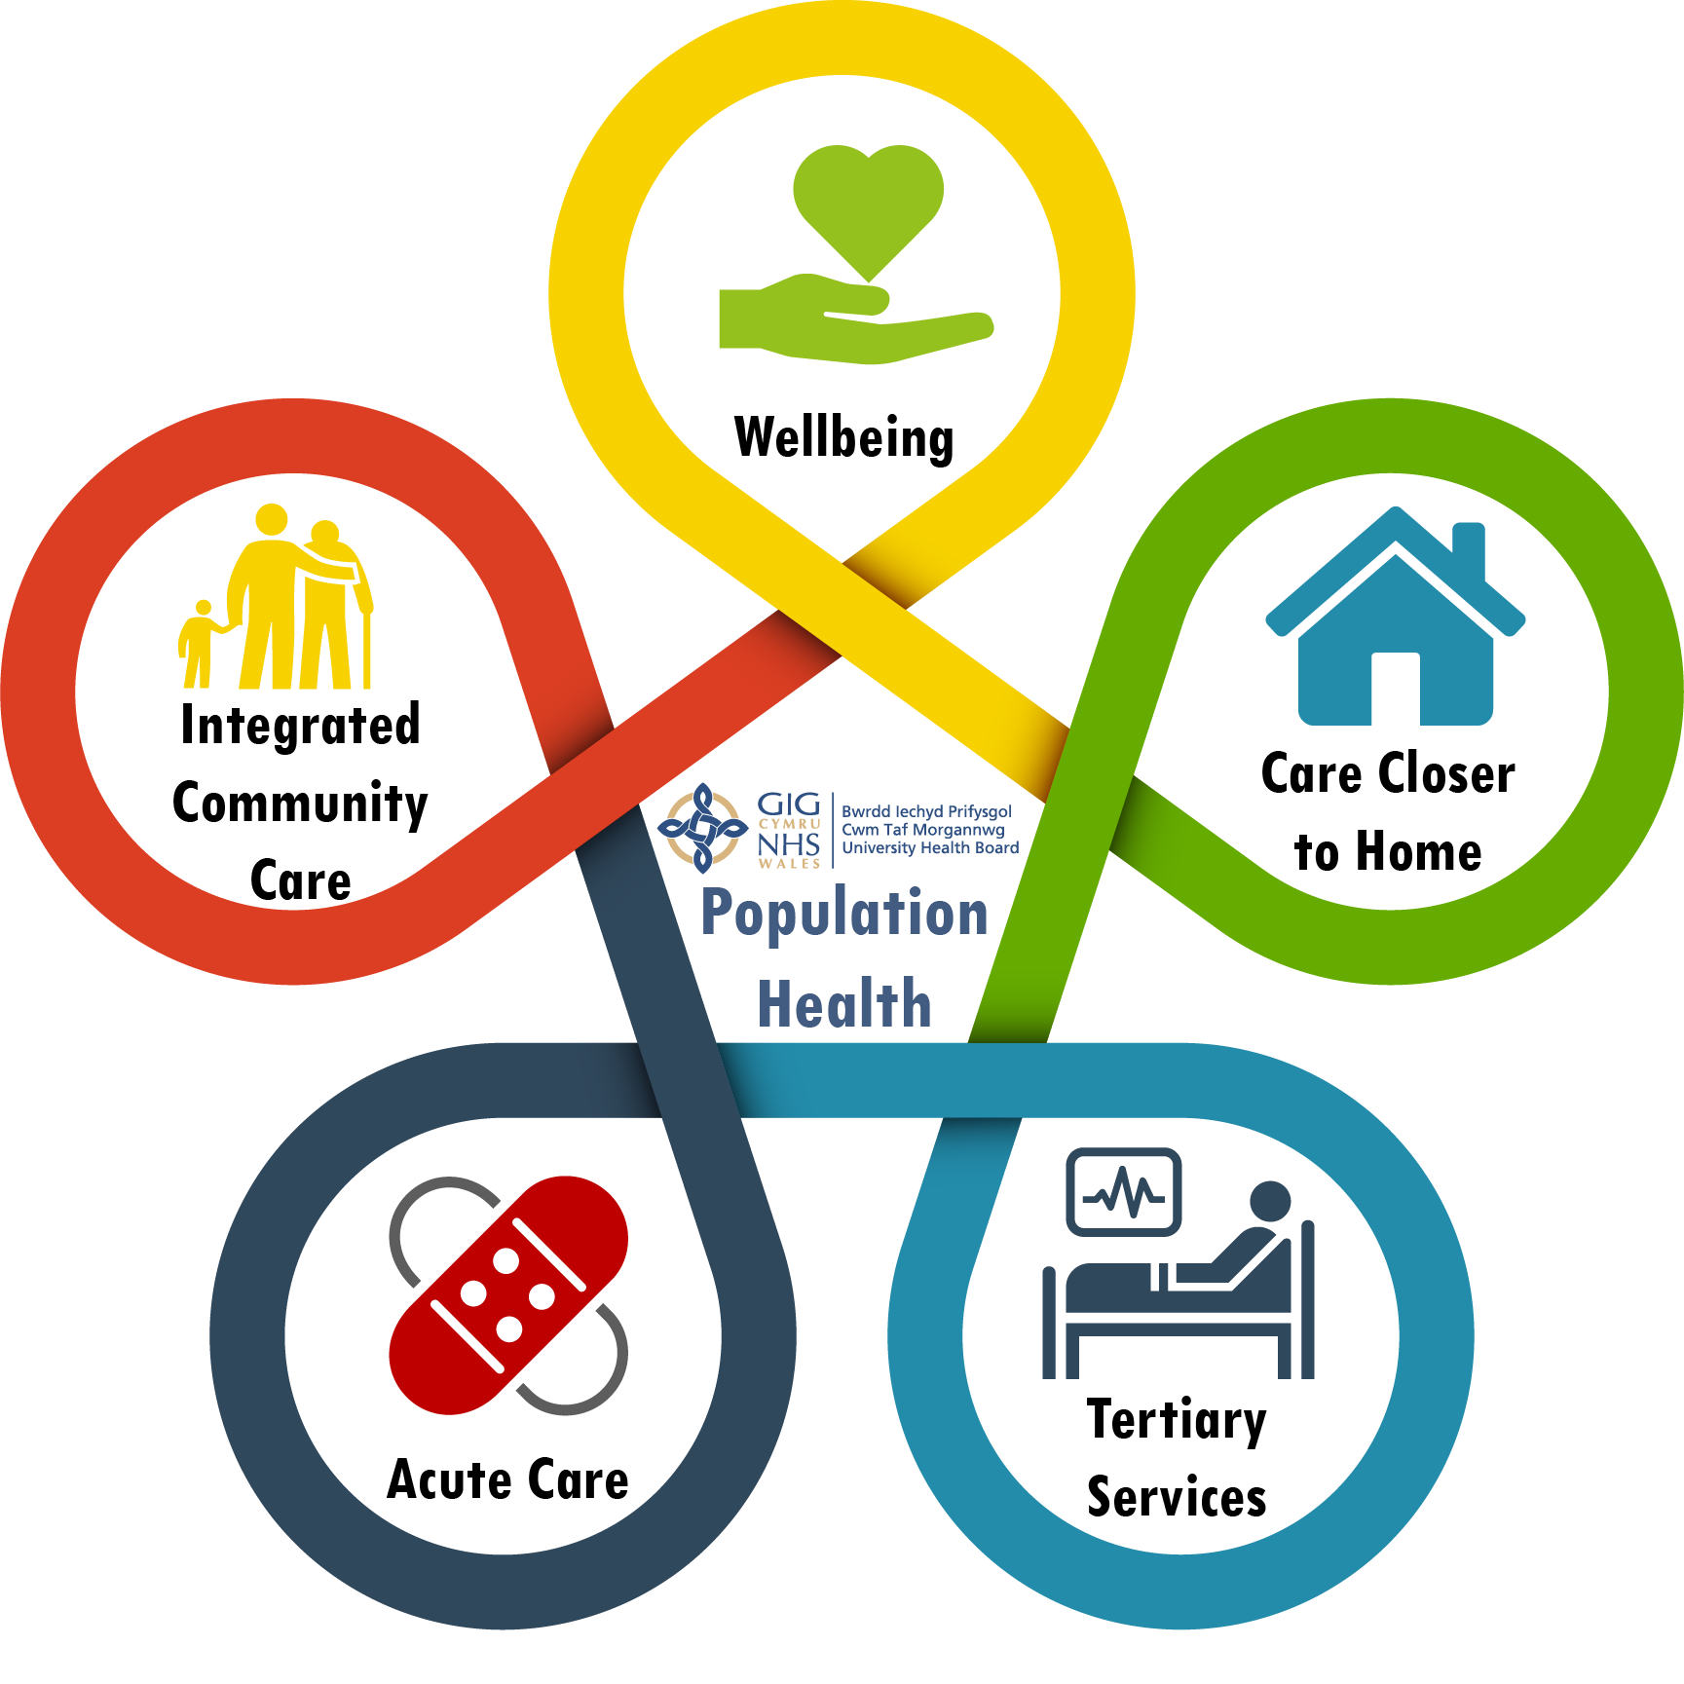

 |  |  | 

Message from the Chair and INTERIM Chief Executive
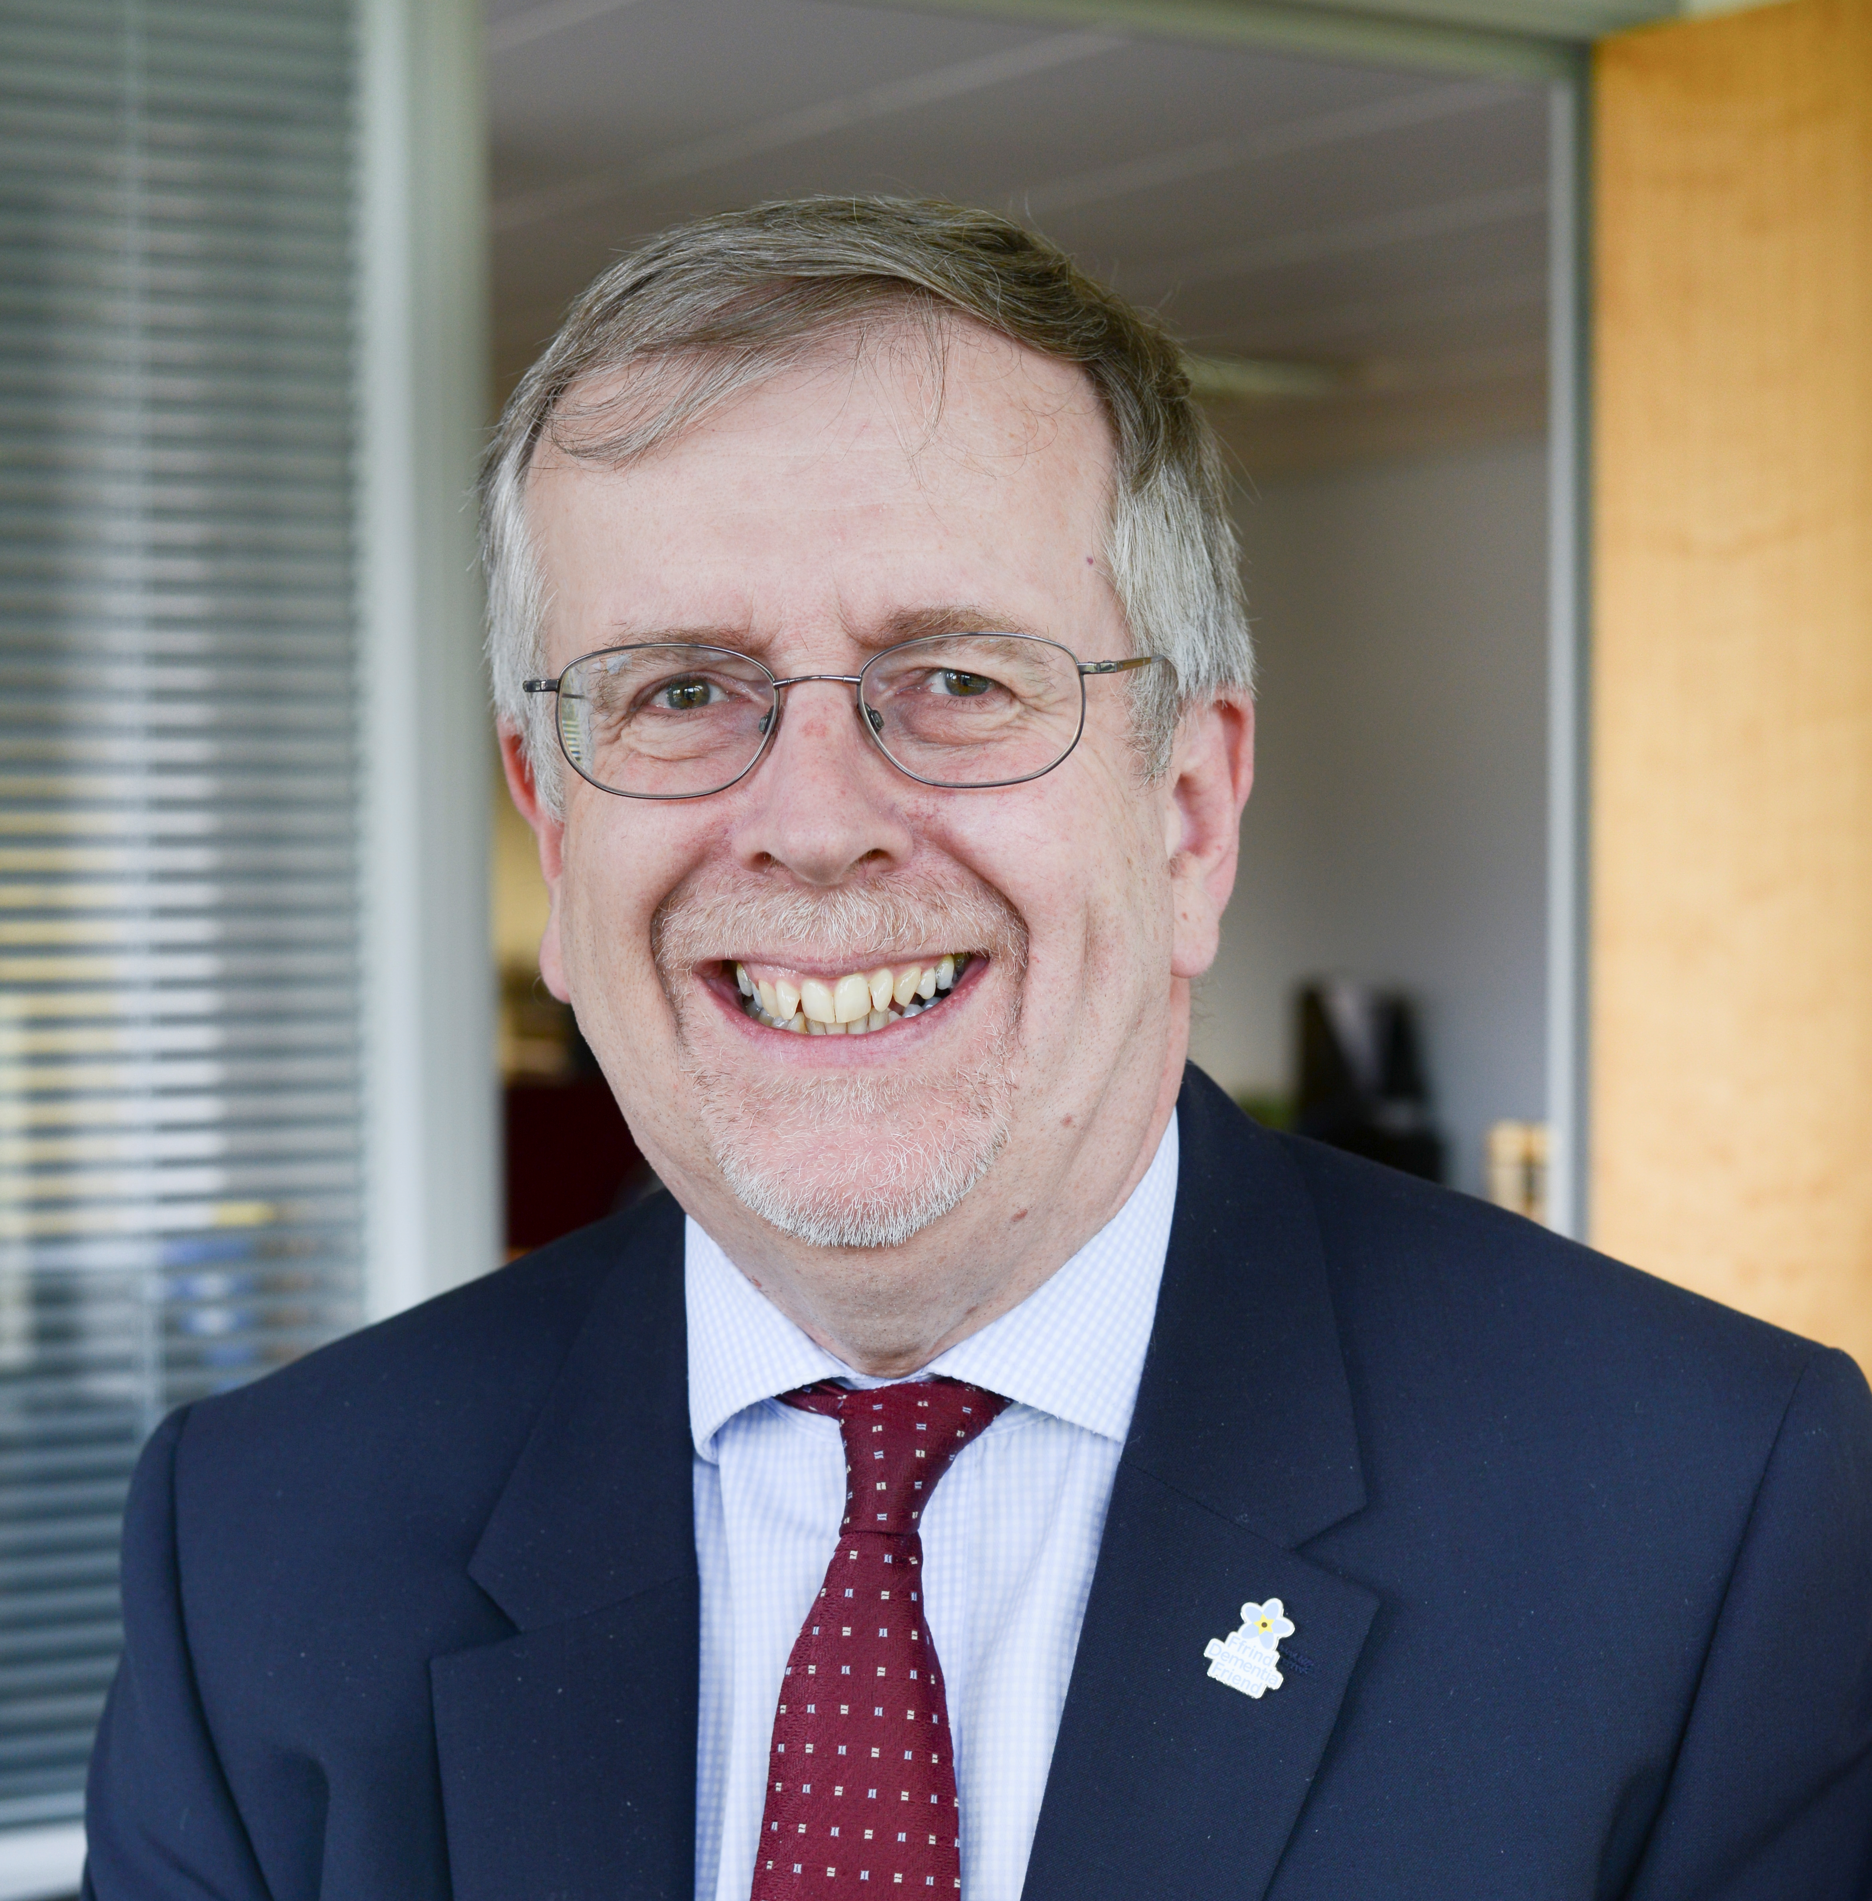 | 
Professor Marcus Longley | Sharon Hopkins
Chair | Interim Chief Executive

On the 1 April 2019, following consultation with the public, partners and staff, Cwm Taf Morgannwg University Health Board (UHB) was formed. This is therefore the first Integrated Medium Term Plan (IMTP) of the new University Health Board, bringing together our plans to deliver safe, quality heath and care for the population of Bridgend, Rhondda Cynon Taf and Merthyr.

The past year has been one of significant reflection and action for the Health Board, not only because of the establishment of our new organisation, but also importantly, as a result of the failings in Maternity Services within the former Cwm Taf University Health Board, in addition to wider concerns raised by the Welsh Government, Wales Audit Office (WAO) and Healthcare Inspectorate Wales (HIW) in respect of quality, culture, leadership and governance. As a result, this IMTP is written in the context of an enhanced escalation status for Cwm Taf Morgannwg UHB, currently in ‘Targeted Intervention’ for quality and governance, and ‘Special Measures’ for its Maternity Services.

The Royal College of Obstetricians and Gynaecologists (RCOG) and the Royal College of Midwives (RCM) published their report into Maternity Services at both Prince Charles and Royal Glamorgan Hospitals on 31 April 2019. Following publication as part of a wider statement, we said,

“On behalf of the Health Board, I [Professor Marcus Longley] apologise unreservedly for the failings in our maternity service. We will now do everything we can to put right the problems identified in the review and we will not stop until our maternity services are of the standard which everyone has a right to expect. We are determined to deliver on the recommendations of today’s report, however we know this will require a significant amount of work”.

The Health Board remains determined to deliver this commitment, and within the wider context of our escalation status, fully recognises the serious nature of the current position and the issues we need to put right for our population. It is vitally important that we do not simply accept the findings of the reports which have been presented, treating the recommendations just as a check list of actions, but that we truly learn from the feedback we have received, and that we deliver the strategic and cultural change required, fundamentally improving the quality of our services and demonstrating this change to all involved. Our approach also seeks to recognise the development of good practice as we seek to ensure a motivated workforce who everyday continue to work with our communities.

Throughout this past year, we have valued the constructive working relationships developed with Welsh Government, WAO, HIW and other regulators, and we will continue to proactively engage and learn from external review bodies and other organisations across the UK. The scale of the challenge that the Health Board faces in achieving sustainable change and improvement remains considerable, and we are committed to addressing this challenge in an open and transparent manner. A key part of this change will be transforming our organisational culture to one which is underpinned by a clear, and shared set of values and behaviours for our new organisation and its people – which will define what is important to us, and our population, and provide clear expectations of how we intend to do go about our business.

Recognising this, we have put in place a comprehensive programme of work to enable the whole organisation to take the opportunity to learn from the reviews and from one another, to share best practice and form new relationships. The programme addresses: Leadership and Culture; Values and Behaviours; Rebuilding Trust and Confidence and Maternity Improvement, with the 10 inter-related workstreams which form part of this improvement journey detailed within section 1.2 of the IMTP.

Learning through engagement has been an important part of setting the tone and ambition for this work. Underpinning any achievement against the programme we have set ourselves is an understanding that when we listen to the views and experiences of our patients and their families, we must ensure that we are seeking to provide the services that people need in the ways that they want. Important examples of this are: the growing use of patient stories across the Health Board, with all Health Board meetings now starting with a patient story; and the whole family engagement work which has been undertaken through maternity services . It is important that we take this opportunity to thank all those patients and their families who are giving their time to join us on our improvement journey.

Our staff are showing the energy and commitment to make constructive and meaningful improvements. As a result an extensive huge cultural conversation is underway within the Health Board. Bringing together the best of the Bridgend Locality and the former Cwm Taf UHB, with real patient experience, has resulted in a draft set of values and behaviours, section 1.3 for Cwm Taf Morgannwg UHB. These will be fundamental in informing decision-making and will underpin the quality of the services we provide to our population.
This engagement has further contributed to the delivery of a key milestone for the new Health Board, the agreement of its mission and vision. Approved in January 2020, these are:

Mission: Building healthier communities together

Vision: Across every community people begin, live and end life well, feeling involved in their health and care choices

The first of many milestones within the IMTP 2020 – 23 is to establish our Operating Model such that it becomes truly clinically-led and community focused. On the 1 April 2020, Cwm Taf Morgannwg UHB will deliver services through three Integrated Locality Groups: Bridgend; Rhondda and Taf Ely; and Merthyr and Cynon. These new structures will bring decision-making closer to those who use our services, empowering staff and providing an easier opportunity for community leadership and involvement in developing and delivering quality services, with a focus on population health. An aligned Quality and Patient Safety Governance Framework will ensure that the Health Board is better positioned to identify, respond and learn from quality concerns in a timely way – putting the patient at the centre of all that we do.

While it is important that we have a clear vision of where we want our improvement journey to take us, it is equally as important that we are able to plan the steps and measure our progress along the way. We have developed a set of milestones and measures, section 1.2., which clearly set out our Health Board’s expectations for Leadership and Culture; Quality and Governance; Rebuilding Trust and Confidence and Maternity Improvement. Delivering across each for these areas will mean that over the life time of this three year plan, we will become a mature organisation, demonstrating good practice which is routinely shared and adopted by others.

Our vision for engagement and involvement is to become an organisation which proactively and routinely provides opportunities for everyone to be involved in our work. As a result, we have taken a number of steps to rebuild the trust and confidence of our population; section 1.X, however, we recognise that this will be further tested as we take the steps needed to secure the sustainability of our organisation’s fragile services. There is an immediate focus on the Emergency Department at Royal Glamorgan Hospital, and the Health Board has already learned a huge amount from listening to what the public and partners have said. We understand that it is essential for the concerns raised and the ideas suggested by individuals, communities and organisations to be heard and for this information to be used to help shape the development and assessment of options for this key service change.

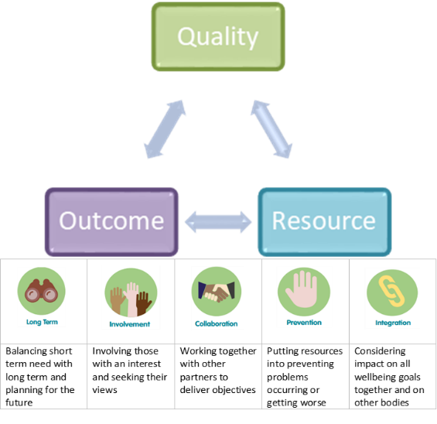
The IMTP has been developed as part of a ‘bottom-up’ planning process, building upon our Directorate, Locality, and Corporate enabling plans. It integrates our service, workforce and financial plans. As plans have been developed, they are triangulated against quality, resource (finance, people, capital, estates, ICT) and outcome. This has been underpinned by consideration of the Well-being of Future Generations Act, Sustainable Development Principle: ‘the five ways of working’.

We recognise the scale of the challenges we face; we are starting out on our improvement journey and there is still much to do. No plan is without risk and while we have delivered the ‘green shoots of change’ we are by no means complacent.

We recognise the need to finish what we have started, and that the capacity of the organisation to develop, learn and grow at the pace required will be tested. Areas of focus for 2020-23 include:

- The continued development of the Health Board, focusing on engaging and empowering our people, embedding our values and behaviours, and a clear structure and operating model.
- Grow clinical and community leadership and deliver robust, simplified and safe decision making; learning through quality improvements and strengthening involvement of patients, staff and partners in service redesign.
- The implementation of the Health Board’s Quality and Patient Safety Governance Framework, including across maternity services.
- The development of the 10 year Health Board Integrated Health and Care Strategy.
- Ensuring the outstanding issues first identified in the South Wales Programme, regarding potentially unsafe and unsustainable services (particularly emergency medicine (A&E), acute medicine and inpatient paediatric services), are fully addressed, following extensive public and clinical discussion.
- Delivery of regional and national service change plans, including Major Trauma services.
- The continued implementation of the Regional Partnership Board transformation ambition and further alignment of Primary Care Clusters and Mental Health Localities.
- Delivery against the NHS Wales Delivery and Outcomes Framework, including ensuring patients are more consistently able to access services in a timely manner.
- Planning for recurrent financial balance.

Key enablers in the delivery of the priorities will be patient engagement and involvement, developing work in relation to the Health Board’s digital plans, and the implementation of the Welsh Language (Wales) Measure 2011. The Well-being Plans and Area Plan for the CTM region form an underlying work programme for the IMTP.

The Health Board objectives, including the improvement journey outlined above, will only be achieved by working closely in with our people, our partners and our local communities; in line with our quality and performance standards; and within a financial envelope which provides value for money and is affordable. This would be challenging enough in a ‘typical NHS year’ however, as we enter a period of huge uncertainty and action related to the global Covid-19 pandemic, our staff, partners and population will be tested in ways not seen for generations. This IMTP sets out our ambition prior to this enormous challenge. In the coming weeks and months the test will be how we flex and adapt this plan while remaining true to our values and vision.

1. STRATEGIC CONTEXT 1
1.1 Health Board Profile 1
1.2 THe Cwm Taf Morgannwg Improvement Journey 1
1.3 Values, Vision And Strategic Objectives 2
1.4 Integrated Health And Care Strategy 4
1.5 Cwm Taf Morgannwg Operating Model 6
1.6 Working In Partnership 9
1.7 Integrated Medium Term Plan 2020 – 2023 Priorities 11
2. PROGRESS IN DELIVERING OUR PLAN 13
3. 2020-23 DRIVERS FOR CHANGE 15
3.1 Key Population Health Challenges 15
3.2 Health Board Challenges and Legislative and Policy Drivers 16
4. QUALITY ASSURANCE AND IMPROVEMENT 19
4.1 Quality Strategy 19
4.2 Quality Assurance and Quality Improvement 19
4.3 Addressing Quality Concerns 20
5. SERVICE CHANGE IN 2020-23 22
5.1 Well-being – Self Care and Supported Self Care 22
5.2 Integrated Community Services 25
5.3 Mental Health, Primary Care and Locality Services 31
5.4 Acute Care – Local and Regional Secondary Care 43
5.5 Tertiary Services 64
5.6 Efficiency Productivity and Value 64
5.7 Performance and Information 66
5.8 Ensuring Integration with Our Partners’ Plans 67
6. WORKFORCE AND ORGANISATIONAL DEVELOPMENT 70
6.1 Organisation Development 71
6.2 Workforce Sustainability 73
6.3 Development and Transformation 77
6.4 Wellbeing, diverse and engaged workforce 83
6.5 Workforce Performance Reporting 87
7. FINANCE - 2020/21 to 2022/23 88
7.1 Statutory Financial Duty 88
7.2 Update on Financial Performance in 2019/20 88
7.3 FINANCIAL STRATEGY 88
7.4 Overview of the Financial Plan for 2020/21 to 2022/23 91
7.5 Income Changes – 2020/21 TO 2022/23 94
7.6 Inflationary, Service Demand and Cost Pressures 97
7.7 Investment in Service Improvement 100
7.8 Non Recurring Costs and Benefits 101
7.9 Medium Term Savings Plan 2020/21 to 2022/23 102
7.10 Key Risks to the 2020/21 Financial Plan 104
7.11 Key Risks to the Financial Plan in Years 2 and 3 105
8. ENABLERS 106
8.1 Innovation, Learning and Purposeful Collaboration 106
8.2 Information and Communications Technology (ICT) 111
8.3 Estates and Capital 116
9. STEWARDSHIP and GOVERNANCE 122
9.1 Board Assurance Framework 122
9.2 Principal Risks to Delivery and Mitigating Actions 124

LOCAL ANNEXES (A1 TO A()

Annex 1 Draft Maturity Matrix
Annex 2 Well Being of Future Generations Sustainable Principle
Annex 3 National Collaborative Commissioning Unit
Annex 4 Joint Health Board and WAST Priority Schemes
Annex 5 Organisational Risk Register

WELSH GOVERNMENT ANNEXES (C1 TO C21)
C1 Outcomes Framework - Delivery of Measures
C2 Service Shift from Secondary to Primary and Community Care
C3 Finance – Statement of Comprehensive Net Income/Expenditure – 3 years
C4 Finance – Statement of Comprehensive Net Income/Expenditure NET profile
C5 Finance – Financial Plan Summary
C6 Finance – RP Assumptions
C7 Finance – Revenue Resource Limit Assumptions
C8 Income and Expenditure Assumptions (Wales NHS)
C9 Finance – Year 1 Savings Plan
C10 Finance – Years 2 and 3 Savings Plan
C11 Finance – Risks and Opportunities
C12 Asset Investment Summary
C13 Asset Investment Approved
C14 Asset Investment Unapproved
C15 Revenue Funded Infrastructure
C16 Workforce - WTE
C17 Workforce - £'000
C18 Workforce - Recruitment Difficulties
C19 Educational Commissioning Information
C19.1 Nursing & Midwifery
C19.2 AHPs
C19.3 HCS
C19.4 Pharmacy
C19.5 Other Professions
C19.6 Medical & Dental
C21 Finance – Supplementary Master Savings Review Template

STRATEGIC CONTEXT

Health Board Profile
Cwm Taf Morgannwg University Health Board (CTMUHB), from 1 April 2019, provides and commissions a full range of hospital and community based services for the residents of Rhondda Cynon Taf, Merthyr Tydfil and Bridgend. This includes the provision of local primary care services; GP Practices, Dental Practices, Optometry Practices and Community Pharmacy and the running of hospitals, health centres and community health teams. The Health Board is also responsible for making arrangements for residents to access more specialised health services where these are not provided within the Health Board boundary.

The resident population of Merthyr Tydfil, Rhondda Cynon Taf and Bridgend was estimated to be 441,293 in 2016 accounting for just over 14% of the Welsh population. Just over 54% of the population live in Rhondda Cynon Taf Local Authority, 13.5% in Merthyr Tydfil and almost 32.5% reside in Bridgend. The Health Board’s catchment population increases to approximately 530,000 when including patient flow from the Upper Rhymney Valley, South Powys, North Cardiff, Neath Port Talbot (NPT) and Vale of Glamorgan.

In the primary care sector, Merthyr Tydfil, Rhondda Cynon Taf and Bridgend have 110 Community Pharmacies, 58 Dental Practices, 54 General Medical Practices and 46 Optometrist Practices. The Health Board manages three District General Hospitals and 46 other sites made up of community hospitals, health centres/clinics and support facilities. Several of our hospitals are now amongst the most modern in Wales.

The Health Board currently employs on average 7,215 whole time equivalent staff, with a headcount of approximately 8,225 and a current pay bill of approximately £542m. As the second largest employer in the area, a significant number of our workforce live and work within the communities that we serve.

Detailed information about the services we provide and our facilities can be found on our website in the section under 'Services'. The Health Board reports regularly on its performance including the Delivery Framework targets set by Welsh Government. The key reporting mechanisms are through the Health Board, Executive Board, the Quality and Safety Committee, Finance, Performance and Workforce Committee and through other Health Board meetings.

THe Cwm Taf Morgannwg Improvement Journey
At the same time as forming CTMUHB, the Royal College of Obstetricians and Gynaecologists (RCOG) and the Royal College of Midwives (RCM) published their report into maternity services at both PCH and RGH. The report highlighted serious concerns about the quality of care, governance arrangements and culture within the service. As well as the need to take immediate action to address the risks highlighted, included in the report’s recommendations was the need to revise and strengthen how the organisation will work with patients, the public and partners to provide reassurance and co-produce services which meet their needs. Following the publication of this RCOG an RCM report, the organisation’s escalation level was increased to Targeted Intervention for Quality and Governance, and Special Measures for Maternity Services.

In November 2019 HIW/WAO published a joint review into the Health Board’s Quality Governance arrangements. The review looked at how Cwm Taf Morgannwg University Health Board’s overall governance arrangements support delivery of high quality, safe and effective services. The publication of the report highlighted a number of significant findings for CTMUHB, including the need to:
- Place a greater focus on the quality of our service
- Develop and deliver stronger systems for quality governance
- Strengthen leadership
- Strengthen how we identify and manage risk
- Develop a culture that supports the delivery of high quality, compassionate and continually improving care.

The Health Board recognises the serious nature of the report findings and the escalation status and issues we are dealing with. The findings within these reports have helped inform our improvement plans in response to being placed in escalation.

During the months following the Health Board entering into increased escalation intervention, we have been working closely with external agencies including Wales Audit Office (WAO), Health Inspectorate Wales (HIW) and the NHS Wales Delivery Unit (DU) amongst others to take the learning and recommendations from reports received to formulate an overarching approach for the organisation to embed sustainable improvement. More detail is available in section 3.2.1. There is also a concerted effort to ensure improvements are made in engagement and involvement with our staff, patients, families and stakeholders to learn from them, identify opportunities and develop a culture that supports and empowers staff and those who use our services to improve their experiences.

A comprehensive programme of work has been established to address Targeted Intervention and Special Measures: Leadership & Culture; Quality and Governance; Rebuilding Trust and Confidence; and Maternity Improvement.

Each of these areas has been assigned a Senior Responsible Owner (SRO) and each has a work programme developed to deliver continuous, sustainable improvement. Progress in relation to these plans is monitored by the relevant Committees, the Full Board and by WG in bi- onthly Targeted Intervention meetings chaired by the Chief Executive for NHS Wales. Reassurance on progress is provided to our population and stakeholders through regular reports to Board. The development of a maturity matrix during 2019/2020 will be key to monitoring progress and evidencing sustainable improvement across the Health Board, a draft of each of the the four maturity matrices can be seen in Annex 1. Definitions for the different Maturity Matrix levels can be seen below, and a self-assessment process is underway to establish the current level the UHB is operating at, so that ongoing monitoring can take place to see progress against the levels.

Criteria | Definition
1 Basic Level  Principle accepted and commitment to action | Health Board is aware of the requirement but is unable to demonstrate meeting it and/or cannot evidence clear plans or approaches to meet the criteria.
2 Early Progress  Early Progress in development | The Health Board recognises what is required for the criteria. The Health Board is able to evidence being able to meet some of the criteria but cannot evidence being able to meet all aspects in full. The Health Board plans to meet all the criteria in full
3 Results  Initial achievements realised | The Health Board meets some of the criteria, in-line with its agreed milestones, it has clear and credible plans to continually and sustainably improve service provision.
4 Maturity  Results consistently achieved | The Health Board meets all the criteria to a high standard, can evidence many examples of good practice against the criteria which are routinely shared and adopted by others.
5 Exemplar  Others learning from our consistent achievements | The Health Board’s excels at all criteria, service provision and patient experience is excellent. The Health Board is leading the strategic agenda through the implementation of innovative practice that is shared with other Health Boards and beyond the organisation to others, enabling realisation of long term sustainability.

A different approach is being actively developed to ensure that the organisation has a culture, mind-set and behaviours that reflect its emerging ambition. Our improvement journey is underway with 10 separate but inter-related workstreams, intended to create a cohesive Health Board, clear on its vision for the future, underpinned by shared values and behaviours, and a strong quality governance framework. The workstreams include:
- Developing and embedding the Health Board’s values and behaviours;
- Developing the CTMUHB vision and mission;
- Taking the vision a step further developing the organisation’s long term Integrated Health and Care Strategy;
- Establishing a clear Operating Model to enable the organisation to achieve its core purpose, based on agreed design principles;
- Establishing a Quality Governance Framework and supporting systems (including workforce skills and support) and embedding these throughout the organisation;
- Reviewing, renewing and embedding the corporate governance framework, processes and systems;
- Designing and implementing an involvement and engagement strategy and framework to ensure ongoing two way engagement and involvement with patients, communities, staff and partners;
- Developing staff capability and capacity for improvement, transformation and making best use of health intelligence becoming a digitally enabled UHB
- Designing and securing leadership and management skills development and continual learning for all staff, and as an organisation; and
- Establishing a clear delivery programme to secure sustainability for the organisations fragile services.

Values, Vision And Strategic Objectives
In April 2019, the boundary between Cwm Taf University Health Board and Abertawe Bro Morgannwg University Health Board (ABMUHB) changed resulting in the establishment of CTMUHB. To help shape the future direction of the new organisation, underpin the developing Integrated Health and Care Strategy, and address the cultural and quality challenges raised, a set of values and behaviours, a mission, vision and strategic objectives have been developed co-productively with patients and staff. .

Values and Behaviours
An extensive cultural conversation is underway within the Health Board and with our local population, beginning the process of developing a culture that supports and empowers staff and those who use our services to improve their experiences. The first phase has been a wide reaching engagement process, with over 4000 interactions, through staff and patient listening workshops and surveys. Following analysis, the insight from this and other reviews has informed the co-creation of a shared set of values and behaviours. The organisations new values and behaviours framework will be launched in April 2020.

Our intention is to:
- Acknowledge and address the cultural and behavioural issues identified
- Bring together the best of the former Cwm Taf and Bridgend organisations
- With staff and patients, co-create a shared set of values and behaviours for Cwm Taf Morgannwg
- Embed our new values and behaviours in to our strategy, systems and process
- Use our new values and behaviours to inform decision making and underpin the quality of services we provide to our population
- Use our new values and behaviours to shape the culture of the organisation
- Create a compelling, shared cultural narrative
- Provide reassurance and rebuild trust both within the Health Board and with our local population and stakeholders

Mission, Vision and Strategic Objectives
The Health Board is not starting from a blank piece of paper in developing a mission, vision and strategic objectives. There is rich information from work underway to deliver the Well-being of Future Generations Act, the Social Service and Well-Being Act and ‘A Healthier Wales: Our Plan for Health and Social Care’. Conversations with staff and partners to inform the Bridgend Boundary Change, the feedback from recent independent reviews including from Royal Colleges, the NHS DU, HIW and WAO reports and the learning gathered from public engagement and patient concerns, can all be used to inform the future ambition of the organisation.

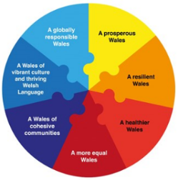
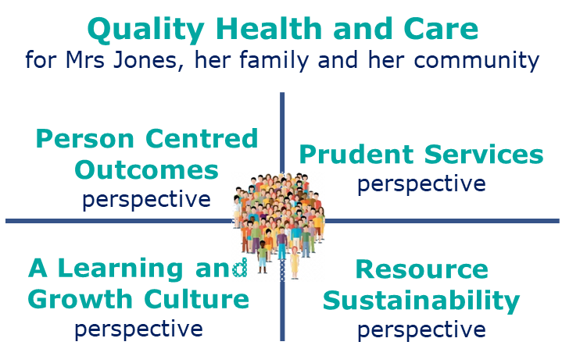
A key milestone for the organisation is the agreement of a mission and vision, whilst ensuring a balanced approach to the development of strategic objectives.

The strategic objectives of the organisation have been developed in such a way that they can also be considered our well-being objectives.

Mission | Building Healthier Communities Together
Vision | In every community people begin, live and end life well, feeling involved in their health and care choices
Strategic Well-being Objectives | - Work with communities and partners to reduce inequality, promote well-being and prevent ill-health.  - Provide high quality, evidence based, and accessible care.  - Ensure sustainability in all that we do, economically, environmentally and socially.  - Co-create with staff and partners a learning and growing culture.

Delivering For The Well-Being of Future Generations
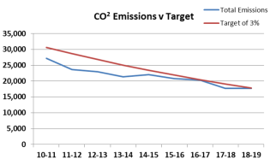
Whilst Annex 2 contains examples of how the Well-Being of Future Generations Sustainable Development Principle is being applied across the UHB, it underpins the planning and delivery of the UHB through the objectives set out above.

In addition, CTMUHB continues its commitment to decarbonisation and biodiversity and will continue to maintain and build on current success with its year on year reduction in energy and carbon emissions. Opportunities will be taken through the Green Growth programme to further reduce energy consumption and review renewable energy opportunities.

The UHBs grounds and gardens contract and service specification requires consideration to promoting biodiversity and ecosystems in the grounds at all our sites. This reduced the frequency and the amount of grass cutting right across the Estate. The aim being to encourage pollinators, insects and native flowering plants and trees. The UHB will continue to build on its recent (July 2019) ISO 14001:15 environmental management external audits success.

“The outstanding quality of the grounds and landscaping demonstrate the positive contribution to local visual landscape and biodiversity that a hospital and clinic campus can contribute, that goes beyond compliance and is in keeping with other health and well-being initiatives related to wellbeing for staff as well as for patients and visitors’.

There are clear ecological practical actions being implemented with regards to leaving some areas in a more natural environmental state with excellent planting to enable there to be flowers open and available for pollinators.”


Sustainable facilities management and the encouragement of ecosystems and biodiversity reduces environmental harm as well as saving money by investing in energy efficiency and water saving methods, such as good insulation, movement sensor control lighting and low flush toilets resulting in lower running costs. The Health Board has implemented the following in support of its environmental management policy and will continue to seek innovative ways to support and make further progress with environmental sustainability:
- Putting in place systematic procedures to monitor and improve performance, for example energy consumption, waste and chemical use;
- Ensuring operational procedures and equipment encourage energy efficiency, for example energy saving light bulbs, insulation and switching off lights when not needed;
- Reducing waste through recycling and re-use (waste to landfill reduced from 389 tonnes in 2016-17 to an estimated 96 tonnes in 2018-19);
- Reducing water consumption, for example low flush toilets and drinking fountains;
- Reduce excessive chemical use and purchase products with low volatility and emissions;
- Providing biodiverse and usable green areas;

Integrated Health And Care Strategy 2020-2030
CTMUHB has been developing and refining an Integrated Health and Care Strategy, rising to and seeking to address its challenges through implementing a whole-system, integrated plan, clearly aligned and integrated with social care, for the benefit of our patients and the communities we serve. We are developing and refining our Integrated Health and Care Strategy using a number of key principles:
- Innovation, quality and access to services will be the overarching principles by which the Health Board will develop clinical pathways and drive forward service change and improvement.
- Clinical leaders will continue to be empowered to work with all staff to develop new models of care, learning from best practice elsewhere but also being supported to design and test out new ideas where safe and possible.
- Closer working relationships with other Health Boards, Local Authorities, the Third Sector, other public sector partners and local communities together with the development of fully integrated services will be paramount to addressing the challenges, looking towards joint targets and accountabilities for the future.
- The Health Board is committed to maximising the use of technology to support and enable service change.

System Wide Approach to Well-Being
Health care services traditionally have been developed to help those who are unwell. As a consequence, most healthcare services are focused in primary care (which accounts for about 90% of health care interactions) and hospital bed-based care (accounting for majority of the remaining care). These services can be reactive and service-centric, largely structured after the specialisms of medicine. We are exploring opportunities to further develop our population healthcare system into one that is more preventative and person-centric, and which considers needs of the broader population, not just those presenting for care. In doing so, we recognise the impact of the Health Board’s interventions and those of others including wider public bodies and the Third Sector.

This involves a different way of looking at groups of people in our population, using analyses of the data we hold to group them by their needs rather than exclusively by their disease condition. It effectively means that individuals with different disease conditions could have similar needs and vice-versa. By developing evidence based anticipatory care plans addressing the holistic needs of these individuals we will aim to reduce their need for healthcare utilisation and promote their independence and wellbeing. This approach requires weaving together and into practice four principles:
Quadruple aim.
Prudent and value-based healthcare.
Equitable healthcare or ‘universal proportionalism’.
Prevention and promotion of health and well-being .

A key thrust of our Strategy and therefore our Plan is therefore about actualising the potential for our healthcare system to drive sustainable improvements to population health, both directly and through leveraging public health, local partnerships and enabling policy and legislation. The Director of Public Health Annual Report 2016/17 contains more detail about our system wide approach to improving well-being.

The strategic service model illustrating our approach is provided below:

Strategic Service Model
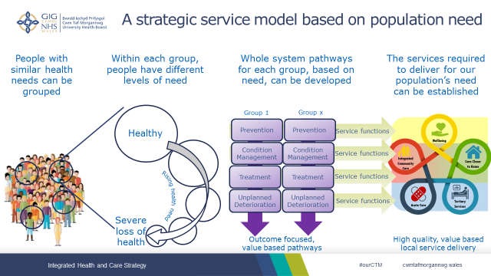

Engagement and Timescales for the Integrated Health and Care Strategy
The steps required to move from mission, vision and objective development, to a published Integrated Health and Care Strategy are set out as follows:

Phase 0 (July 2019 – October 2019)
- Testing the appetite for change and the ambition for a population focus with clinical leaders.
- Agreement on use of a balanced scorecard approach to developing and then turning the strategy into action.
- Agreement that the Strategic Planning Group will provide oversight to the development of the strategy, with a small task and finish group to deliver the work.
- Agreement on a communications and engagement plan.

Phase 1 (November 2019 – January 2020)
- Test and engage on the mission and vision, ensuring they are in keeping with the new organisation’s emerging values.
- Develop strategic principles / objectives.
- Agree the strategic framework for the Integrated Health and Care Strategy.
- Publish an Integrated Health & Care Strategy engagement document, which will be described in the 2020-23, IMTP.

Phase 2 (February 2020 – March 2020)
- Large scale engagement on the mission, vision and values, and on turning the strategic principles into more detailed key objectives.
- Develop high level outcomes and population pathway specifications based on the strategic framework for the Integrated Health and Care Strategy.
- Establish the key enablers to delivering the population pathways, including workforce, digital and infrastructure.
- Publish the Integrated Health and Care Strategy.

Cwm Taf Morgannwg Operating Model
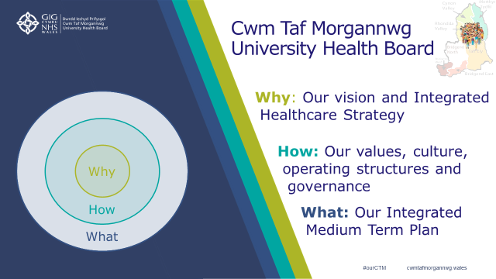
A key enabler for the organisation to achieve our improvement ambitions is our new operating model. An operating model describes how the business of a Health Board is organised and managed. That includes being clear on the ‘why, how and what’ for the Health Board.

The draft vision and emerging Integrated Health and Care Strategy are set out in section 1.3.2 and 1.4. The work and timeline to develop the values and behaviours for the organisation is set out in section 1.3.1 and section 6.1. Below is the further detail on the ‘how’: the operating structure and the corporate governance.

Operating Model
A set of principles have been developed to ensure that any new structure is organised for better outcomes for patients and communities, a more satisfying environment for those of us working in and with the Health Board and to promote an increased perspective of the care system in its widest sense, strengthening work with partners in the third sector and local authorities. These principles which were internally and externally engaged on are:
- Empowering People: Empower staff, entrusting decision making closer to those delivering services. Enhance leadership, positive behaviours & ways of working, embedding an open culture.
- Community Leadership and Involvement: Local health needs and wellbeing met through a community and prevention focus. Foster system leadership, serving the whole person’s needs, through collaboration with partners across all sectors. Strengthen the voice of our communities, patients, staff and partners in service design and delivery.
- Clinically Led, Community Focused Services: Consistency in clinical standards and professional practice with quality and safety at the heart of all we do. Delivery of high value services and outcomes, as close as possible to our communities, supported by sound management, and corporate services.
- Learning and Innovating for Continual Quality Improvement: Support research and innovation in all areas to identify, promote and embed continual service improvement. Enhance team and individual performance through skills development, learning and teaching opportunities, attracting and retaining world class staff.
- Robust, Simplified and Safe Decision Making: Deliver good governance, clear accountabilities and organisational sustainability supported by simple, transparent and robust systems, structures, processes and technology. Have balanced conversations incorporating quality, performance and finance considerations, enabled by proactive data.

Aligning the emerging Integrated Health & Care Strategy and the principles results in the following high level model:
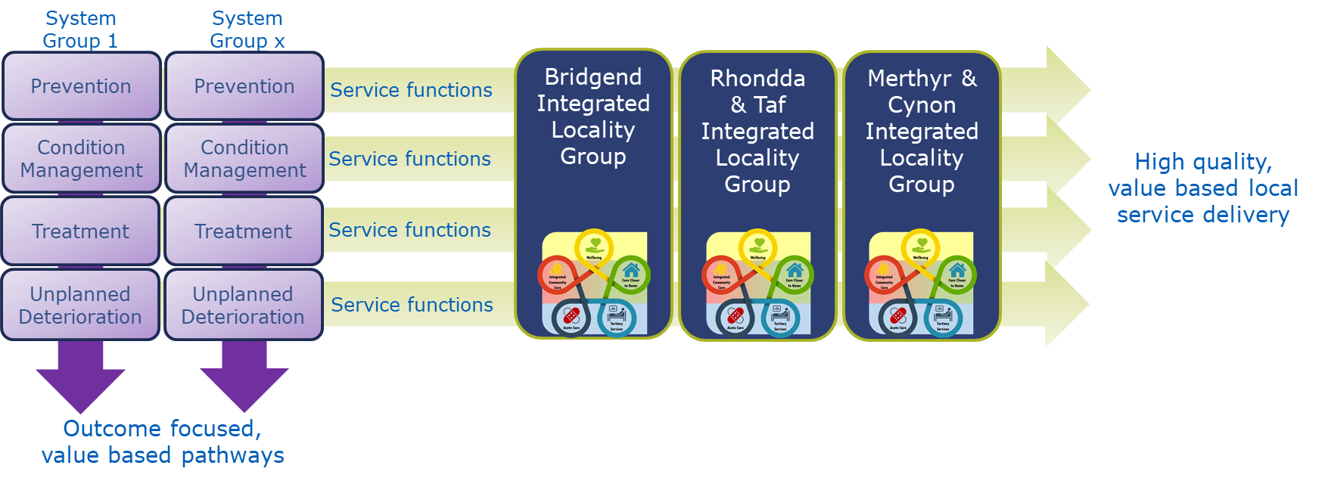

Whilst work is still underway to finalise the operating structures, the building blocks of the structure are:
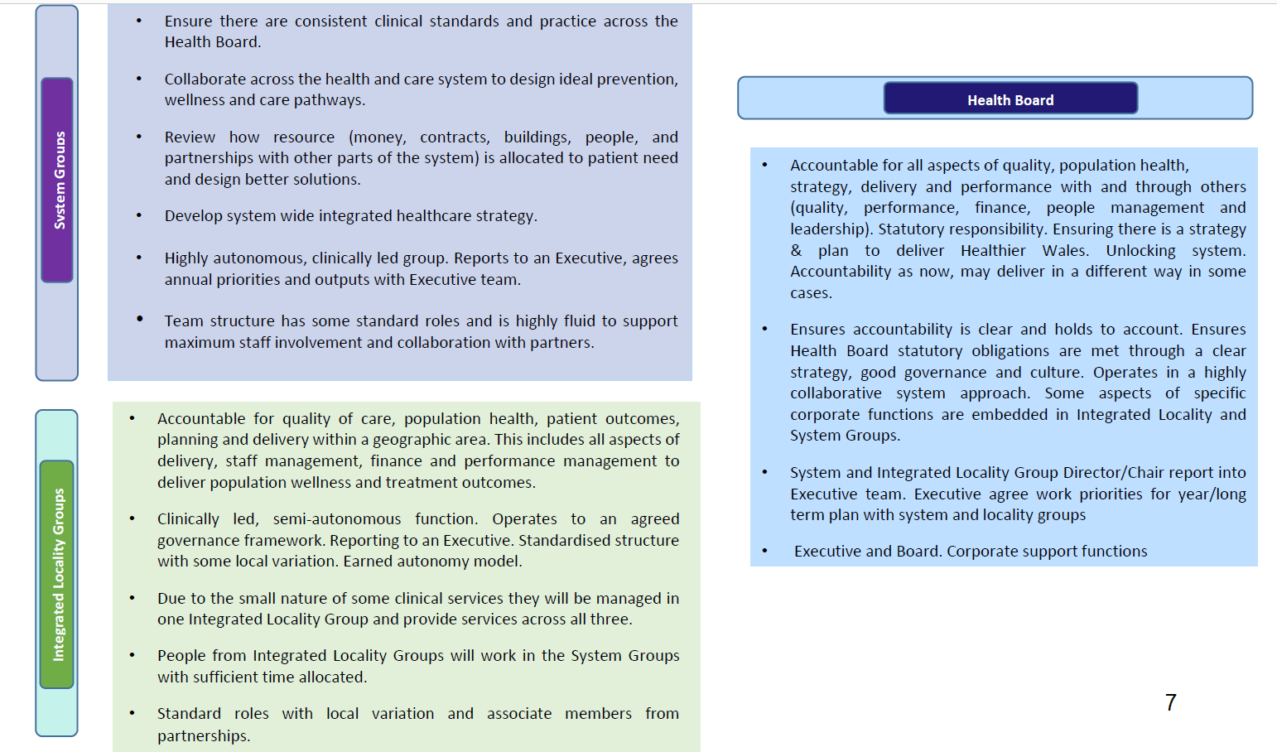

This diagram explains further how these groups’ management arrangements and way of doing business could be organised in a way that brings our focus towards our communities, consider the whole person’s needs and also strengthens relationships with clinical colleagues and partners in local authorities and other sectors so we think about people’s pathways.
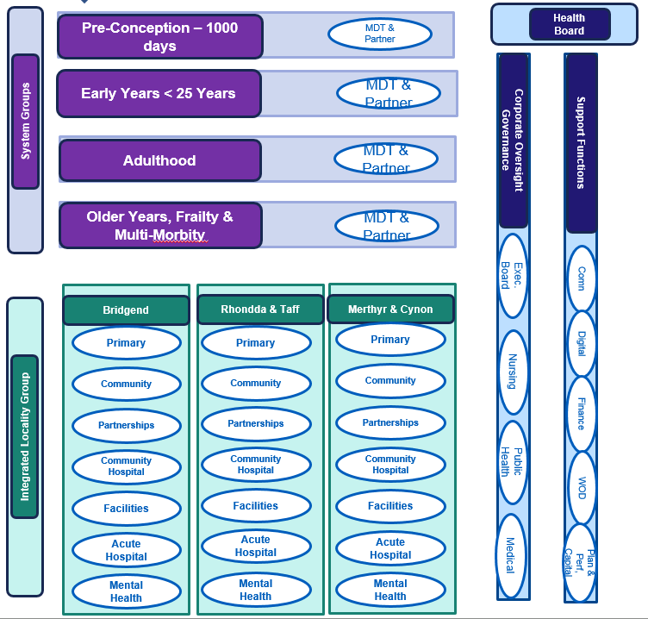

Quality and Corporate Governance
A different approach is being actively developed in the new organisation to ensure a culture, mind-set and behaviours that reflect its emerging ambition as a patient/community centred and quality driven organisation. The UHB is committed to creating a cohesive organisation, clear on its vision for the future, underpinned by shared values and behaviours, and a strong quality governance framework (Chapter 4). Changes are being made to strengthen quality and governance, engagement and involvement, leadership and culture and improvements across our organisation and particularly in our maternity services. As part of this work the UHB is strengthening how it scrutinises and gains assurance on behalf of all stakeholders, linking with the work underway on implementing the new operating model and subsequent management and accountability structures supporting the delivery of operational services.

The Board is responsible for determining policy, setting strategic direction, delivering safe, quality services and ensuring that there are effective internal control mechanisms for the Health Board to support the delivery of high standards of clinical and corporate governance. This is, of course, set against a backdrop of the Health Board ensuring that it remains responsive to the needs of its communities and key stakeholders.

The system of internal control is informed by the work of internal auditors, clinical audit and Directors within the organisation who have responsibility for the development and maintenance of risk assurance and internal control frameworks. Comments on this are made by the WAO, as the external auditors, in their Annual Audit Report and other reports including the Structured Assessment. The work of HIW has an important and significant impact in the Health Board, from both their planned and unplanned inspections and reports. Inspections and reports provided by other regulators also contribute significantly to improving the quality of services provided. As well as responding appropriately to the actions required within individual reports, the Health Board is striving to ensure that general lessons are learned. As a newly formed organisation, CTMUHB has the opportunity to ensure that learning from all areas of the organisation is encouraged in an open and transparent manner, as well as from and with the wider NHS in Wales. We recognise that further work is required to progress this and to be able to demonstrate delivery. The Board is considering how the ‘duty of candour’ is also a more integral part of the everyday work of the Board, with changes being made to the approach of the Board and structure of the Committees to strengthen assurance and promote openness and transparency.

We also have a very active Community Health Council (CHC) who undertake a comprehensive visiting programme and their feedback and engagement with the Health Board is a key assurance tool utilised by the organisation.

The Board takes its accountability for clinical governance, corporate governance, risk management, serious incident reporting and matters of internal control seriously. A review of Ward to Board risk management is underway and will be linked to a re-fresh of the Board Assurance Framework during 2020.

Together, Board Members share corporate responsibility for all decisions and play a key role in monitoring the performance and quality of services provided by the Health Board. The Board provides leadership and direction to the organisation and has a key role in ensuring the organisation has sound clinical and corporate governance arrangements in place. The Board has recently re-committed to a culture of openness, honesty and transparency in decision making and has high standards in the quality of clinical care, financial stewardship, as well as responding to the health needs of the population it serves. Board Members are deeply disappointed with the shortcomings that have resulted in the organisation’s escalation status being increased to Targeted Intervention, but fully accept the issues identified and welcome the learning that can be taken from the interventions.

The Board also recognises its responsibility to provide assurance to our local population and stakeholders, which it aims to do through open and transparent reporting, ongoing engagement and co-production.

INVOLVEMENT nad ENGAGEMENT
During 2019/2020, the UHB has set out a new approach to engagement and involvement for Cwm Taf Morgannwg UHB which aims to implement new ways of working, establishing strong relationships with patients, staff, the public (our communities) and partners, rebuild trust and confidence in our organisation and the services we provide, improve staff morale, and establish a truly collaborative way of working to co-produce effective and high quality services for our communities.

The ‘engagement and involvement’ approach is designed to support the work around our new organisational vision, strategic objectives and values as we strive to deliver excellent care and treatment in an open, honest, transparent and meaningful way.

The vision for engagement and involvement is to become an organisation which proactively and routinely provides opportunities for everyone to be involved in our work. We are working hard, listening to our patients, staff, communities and partners to establish a variety of methods and tools to support meaningful conversations with people so we can listen to their views, suggestions and ideas about the care and treatment we deliver and they can actively contribute and participate in our work.

We are committed to establishing a culture which supports open and transparent conversations with patients, staff, communities and partners and put in place effective methods for two-way conversations to give a greater understanding of people’s priorities and needs and how we can best work with them to make changes and provide the highest quality of services that are co-designed. All of our activities will be underpinned by the below principles:
- Be open and accessible – we will talk and listen to people and take their views and opinions in to account.
- Be transparent – information will be shared in a clear, accessible and relevant way. When we cannot share information, we explain the reasons fully and clearly.
- Be consistent – the messages we communicate are consistent with our aims, values, behaviours and objectives.
- Be compassionate – we will take a more compassionate and considered approach reflected by what we hear from our patients and this will be which will be echoed in our voice and tone.
- Involve - we will create opportunities and encourage people to give us open and honest feedback and contribute their ideas and opinions. This will be done in a variety of ways to ensure these opportunities are as accessible as possible to everyone.

IMPROVEMENT CWM TAF MORGANNWG
At present there are pockets of Improvement activity taking place across the UHB. Many of these are driven either by motivated individuals working in a degree of isolation or by a top down approach. Whilst well intentioned this can result in a lack of coherence at a strategic level, inefficiencies and duplication of effort, little stakeholder engagement, and limited impact or sustainability. There is a clear need to establish a robust improvement function that can support and facilitate service and quality improvement throughout our organisation. It must build capacity for improvement across the organisation, co-ordinate all improvement activity and engage with staff, patients and partners in driving the adoption and spread of the most impactful improvement options.

Whilst the Method for Improvement and Improving Quality Together (IQT) training will remain the main improvement methodology in NHS Wales, given the lead by 1000 Lives (Improvement Cymru), Institute for Healthcare Improvement (IHI) and HEIW, other methods such as Lean Management, Six Sigma, Kaizen for example can be used if applicable. This will depend on the healthcare context and environment and can utilise methodological expertise that also exists within Health Board staff. There needs to be a clear view of the complementary strengths and applications of each, appreciating the profound compatibility of their philosophies and approaches.

Our mission in ‘Improvement CTM’ will be to empower our workforce to take responsibility for implementing continuous improvement that delivers high quality services and value in health and care. All improvement activity will be evidence based, drawing on best practice from within the Health Board and learning from other organisations, as well as listening to what matters to our local population. Staff will be enabled and empowered to use the most appropriate tools and approaches to deliver high quality services. We will take a data-driven approach to identify areas of high potential impact for an improvement focus.

We will draw on learning, expertise, improvement methodologies and support from other organisations or agencies such as other Health Boards’ improvement functions (e.g. Aneurin Bevan UHB’s ABCi), the IHI, 1000 Lives Improvement and HEIW. In developing ‘Improvement CTM’, we will also consider the interface with other Improvement initiatives across our geography – such as the recently-approved Regional Partnership Board (RPB) Research, Innovation and Improvement hub.

Identifying learning and outcomes of improvement activity and sharing findings and knowledge within the Health Board and with our population and partners will allow the scale and spread of initiatives that have high impact. Showcasing the work underway will ensure that the Health Board is recognised as a beacon of Improvement activity.

The high level objectives for ‘Improvement CTM’ are:
- To increase capacity and capability for improvement in CTMUHB.
- To embed a culture where improvement is integral to the operation of service and corporate functions.
Resulting in:
- Improved organisational efficiency, performance and sustainability
- Improved population health outcomes – our ultimate goal

Structure | 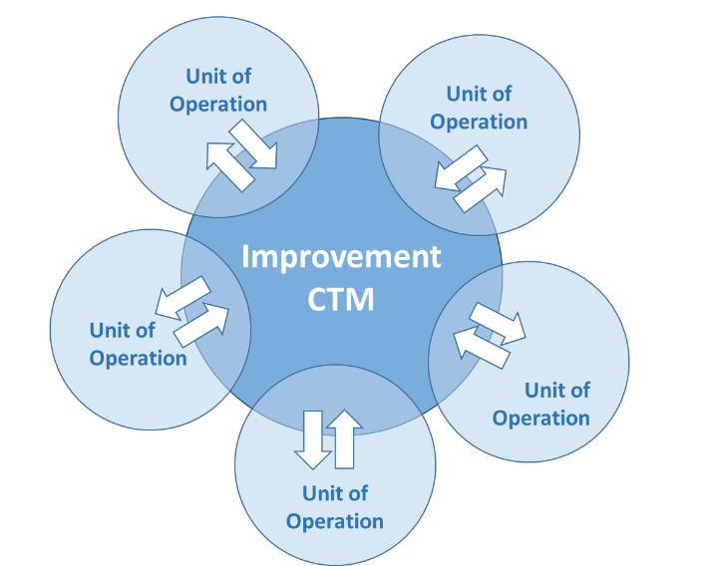 | Function | 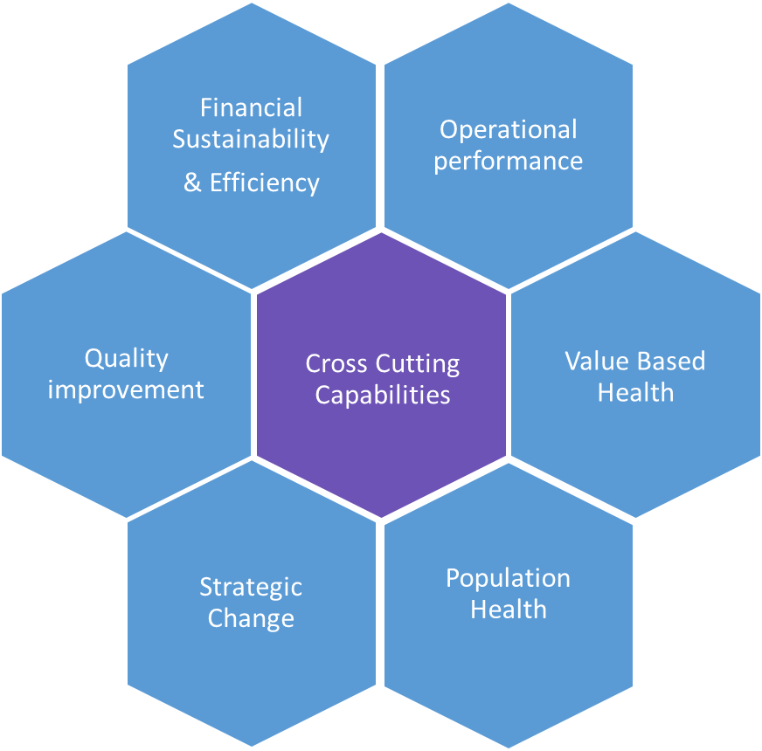

Working In Partnership

Public Services Boards and Cwm Taf Morgannwg Social Services and Well-Being Regional Partnership Board
The Cwm Taf and Bridgend Public Services Boards (PSB) Well-being Plans 2018-23 were published in May 2018. There are many similarities in the Plans and the two PSBs have indicated a willingness to work together to achieve the Objectives of both plans. As we work together it is helpful to note the many commonalities in the well-being objectives as well as distinct differences. We will further explore these over the coming period, seeking to consolidate the commonalities in a coherent work plan and support delivery of all objectives as we deliver the agreed intent of one Public Service Board for the new footprint

The Social Services and Wellbeing Act Wales (2014) set a statutory requirement for the creation of Regional Partnership Boards (RPB) to oversee strategic approaches to delivery of integrated Health and Social Care services. “A Healthier Wales” also confirmed the importance of Regional Partnership working to develop new models of integrated Health and Social Care that are innovative and addresses regional priorities. RPBs are expected to provide a strong oversight and coordinating role as highlighted by the expectations of the national Transformation Programme and the need for RPBs to have lead responsibility on the development, implementation and achievement of individual funding bids. Such national expectations clearly highlight the critical role of RPB’s in delivering the expected transformation of Health and Social Care delivery so that services become better coordinated and seamless.

The boundary change, whilst challenging, has provided us the opportunity to review all governance arrangements, learn from one another and develop simpler more cohesive partnership arrangements to deliver better outcomes for people and communities across CTM.

To reflect the interdependencies between health/wellbeing and housing and education, membership of the RPB has now been extended to include housing, registered social Landlord and education representation.

Whilst there is one RPB covering the CTM Region there remains two PSB’s. The RPB links with the Cwm Taf PSB and Bridgend PSB on its areas of specific responsibility in health, care and wellbeing. The Chair of the RPB is a member of the Cwm Taf PSB for that purpose and to promote effective alignment between the SSWB Act and the Well-being of Future Generations Act. A regional workshop was held in January 2020 to review and align the vision and priorities of the RPB and PSBs within the region.

Regional Collaboration
CTMUHB is committed to working collaboratively and at pace with neighbouring organisations to secure benefits for patients where this is appropriate. The UHB has been an active partner in a number of collaborative mechanisms including the NHS Wales Collaborative, the South East Wales Regional Planning Forum (SEWRPF), WHSCC, NHS Wales Shared Services Partnership (NWSSP), Emergency Ambulance Services Committee (EASC) and the Clinical Networks.

A significant focus for the Health Board continuing in 2020/21 is the work programme of the Regional Planning and Delivery Forum, which includes the Chief Executive, NHS Wales, and Chair and Chief Executive representation from CTM, Cardiff & Vale, Aneurin Bevan, Swansea Bay, Powys, and Welsh Ambulance Service Trust (WAST).

Cwm Taf Morgannwg and Swansea Bay University Health Board Partnership Arrangements
The Bridgend Boundary Change on 1st April 2019 saw the successful transfer of commissioning responsibility for the Bridgend population to CTMUHB.

Over two hundred services were safely transferred to CTMUHB on 1 April 2019. Where services were unable to be transferred either completely or partially, in order to support the transfer of services process and maintain existing patient flows, commissioning arrangements were put in place to support the delivery of services for the population either through the Long Term Agreement (LTA) between the two Health Boards, or through two overarching Service Level Agreements (SLA) for clinical services (which include 155 separate service lines), and 22 separate corporate SLAs. Many of these commissioning arrangements were seen as short term arrangements that required further work to disaggregate the service and decommission the corresponding SLA.

During 2019/20 work has progressed to monitor and refine these SLA and LTA arrangements, with some small contracts ceasing as planned. As we move into 2020/21, the majority of the contractual arrangements will continue as work progresses on developing plans for the longer term arrangements around the Pathology, ICT and the clinical service interface between NPT Hospital (NPTH) and Princess of Wales Hospital (POWH).

Swansea Bay UHB and CTMUHB have developed strong partnership arrangements at both an operational and executive level to complete and close the legacy of the service and commissioning issues arising from the boundary transfer, and to establish fit-for-purpose joint strategic planning arrangements to support the development of services/ service models for the populations of Swansea Bay and CTM.

Integrated Medium Term Plan 2020 – 2023 Priorities
As the Health Board develops and aligns to the ‘A Healthier Wales: Our Plan for Health and Social Care’, some particular areas of importance and focus to articulate in the IMTP 2020-23 include:

- The continued development of the Health Board, focusing on engaging and empowering our people, embedding our values and behaviours, and a clear structure and operating model.
- Grow clinical and community leadership and deliver robust, simplified and safe decision making; learning through quality improvements and strengthening involvement of patients, staff and partners in service redesign.
- The implementation of the Health Board’s Quality and Patient Safety Governance Framework, including across maternity services.
- The development of the 10 year Health Board Integrated Health and Care Strategy.
- Ensuring the outstanding issues first identified in the South Wales Programme, regarding potentially unsafe and unsustainable services (particularly emergency medicine (A&E), acute medicine and inpatient paediatric services), are fully addressed, following extensive public and clinical discussion.
- Delivery of regional and national service change plans, including Major Trauma services.
- The continued implementation of the Regional Partnership Board transformation ambition and further alignment of Primary Care Clusters and Mental Health Localities.
- Delivery against the NHS Wales Delivery and Outcomes Framework, including ensuring patients are more consistently able to access services in a timely manner.
- Planning for recurrent financial balance.

Key enablers in the delivery of the priorities will be patient engagement and involvement, developing work in relation to the Health Board’s digital plans, and the implementation of the Welsh Language (Wales) Measure 2011. The Well-being Plans and Area Plan for the CTM region form an underlying work programme for the IMTP.

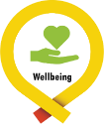
The Health Board objectives will be achieved by working closely in partnership with our staff, partners and local communities; driven by our quality and performance standards; and within a financial envelope which is both value for money and affordable. Examples of the deliverables described within this Plan for 2020/23 are therefore:

Well-being – Self Care and Supported Self-Care

- Progress the priorities set out in the Cwm Taf and Bridgend Well-being Plans, drawing together the developing Cwm Taf Community Zones, reducing isolation and loneliness and increasing volunteering, section 5.1.1.
- Continue actions to address modifiable lifestyle risk factors including Inverse Care Law scheme, implementation of the Tier three obesity service and Adverse Childhood Experiences (ACE’s) section 5.1.2 and 5.1.3.
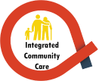
- Roll out a model of population health management based on segmentation and risk stratification, linking and analysing primary and secondary care data in order to segment the cluster population and allow targeted anticipatory care. A key enabler to the Cwm Taf Morgannwg Regional Partnership Board transformation section 5.1.4.

Integrated Community Services

- Deliver a new Area Plan for the new Cwm Taf Morgannwg Regional Partnership Board, including embedding the joint Regional Commissioning arrangements. section 5.2.4
- Delivery of the transformation programmes for Cwm Taf: Stay Well in Your Community and Bridgend: Accelerating the Pace of Change of Integrated Services. These whole system workstreams include a focus on assistive technologies, the next phase of Stay Well@Home and improving access to community health and social care, ‘making every day Tuesday’. section 5.2.4

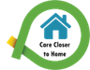
Mental Health, Primary Care, and Locality Services

- Continue to deliver a multi-agency emotional and mental health strategy which encompasses the role of the Specialist Child and Adolescent Mental Health Services (CAMHS) and embed the Choice and Partnership Approach as part of the steps being taken to put Primary CAMHS and Specialist CAMH Services on a sustainable footing, section 5.3.1.
- Ongoing redesign of adult community mental health services to ensure an emphasis on integrated support at ‘universal’ and local primary mental health service level, enabling secondary mental health services to offer more intense input to a smaller number of people with more complex needs, section 5.3.2.
- Development of a cohesive mental health and learning disability framework for training, learning, assurance and quality improvement section 5.3.2.
- Local implementation of the Dementia Action Plan for Wales including development of the memory assessment pathway, enhancement of community based support and joint workforce training and development, section 5.3.2.
- Deliver, at Cluster level, multi-agency, multi-professional teams as a fundamental part of our transformation programmes, enabling multi-disciplinary reviews and interventions across the new Health Board footprint and in line with the Primary Care Model for Wales. Implementation of the 111 service, transforming the GP Out of Hours into an Urgent Primary Care Out of Hours service adopting a digitally enable prudent workforce model, section 5.3.3.
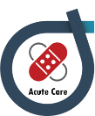
- Continue to deliver against the Primary Care Estates Strategy, including the completing the development of Mountain Ash Primary Care Centre and the next phase of Dewi Sant Health Park, and the Bridgend Health and Wellbeing Centre (Sunnyside) section 8.3.1.

Acute Care – Local and Regional Secondary Care

- Continue to implement the Maternity Improvement Programme under the scrutiny of the Independent Maternity Oversight Panel (IMSOP) to address the serious issues raised section 5.4.3.3
- Further improve our unscheduled care and referral to treatment waiting time performance, section 5.4 and 5.7.
- Take the steps to complete the service change set out in the South Wales Programme (SWP), particularly emergency medicine (A&E), acute medicine and inpatient paediatric services and collectively across the region deliver service sustainability Ophthalmology Services, Regional Diagnostic Services, and Vascular Services, section 5.4.3.4
- Implement the Major Trauma Service change, delivering locally and shaping the regional service, section 5.4.1.3
- Value Base Healthcare Pathway development focused initially on Lung Cancer, Cataracts, Hips and Knees, Heart Failure and Maternity, section 5.4.3.
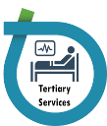
- Continue to deliver against the local requirements of the Welsh Government (WG) National Delivery Plans, including Respiratory, Stroke, Liver, Cardiology, Diabetes, Cancer, Neurological, Critical Care and End of Life Care, section 5.4.3.

Tertiary Services

- Work with the Welsh Health Specialised Services Committee (WHSSC) and others on integrated services identified in their commissioning plans, section 5.5
- Work with the Emergency Ambulance Commissioners on the development of the Emergency Medical Retrieval and Transfer Services, section 5.4.1

PROGRESS IN DELIVERING OUR PLAN
This chapter offers an overview of the progress made in implementing the Health Board’s Plan for 2019-22.
Well-being – Self Care and Supported Self-Care

- Continued recruitment of and support for Carers Champions, working with partner organisations to ensure Caring Awareness is widely embedded and Carer Aware training is provided for staff across the public and third sector.
- Since the Baby Teeth DO Matter initiative launched in April 2017, dentists in Merthyr Tydfil have seen a 39% increase in children’s attendance, equating to approximately 1,500 children.
- In support of the Health, Well Being and Creative Arts Strategy launched in December 2018 an Arts and Health Coordinator has been appointed to develop an arts programme which supports, nurtures and works with our patients, staff, visitors and the wider community in a variety of ways across a range of art forms.
- The Maternity Services Liaison Committee has been relaunched which allows women and their families to feed back their experiences and requests for improvement back into the system. Women in the maternity units are also now being regularly asked about their experiences.

Integrated Community Services

- At the NHS Awards in September 2019 the award for ‘Providing services in partnership across NHS Wales’ was won by Cwm Taf Morgannwg UHB together with Aneurin Bevan, Swansea Bay UHB, Hywel Dda UHB and Cardiff and Vale UHB for work on the ‘South Wales Motor Neurone Disease Care Network’.
- Children from Treorchy Primary School have spent time with people living with dementia and their families at Ysbyty George Thomas as part of the work to raise intergenerational awareness of dementia and involve the community in the care and support provided
- The Health Board and Bridgend County Borough Council (CBC) have signed a partnership agreement to support more older people to remain independent and keep well at home. The agreement is to ensure services are more joined-up with the aim of maximising patients’ recovery with shorter stays in hospital.
- The Waun Wen Leg Club in the Rhondda received an international award at the annual Lindsay Leg Club Foundation Awards for their work to provide community based treatment and care for people of all ages who suffer leg-related problems.
- The new Integrated Substance Misuse Service for Rhondda Cynon Taf and Merthyr Tydfil, commissioned by the Area Planning Board, commenced on 1st April 2019 provided by Barod, working in close collaboration with the Health Board’s Community Drug & Alcohol teams. A review is now underway by the APB of the substance misuse services provided in Bridgend.
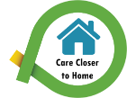
Mental Health, Primary Care, and Locality Services - Care Closer to Home

- The Primary Care and Community Resource Team provides vital clinical support across a range of care settings and are central to the training and education of health and social care professionals working in GP practices, Community Nursing Services, Community Hospitals, Care Homes and Local Authority staff.
- As an extension of the Choose Pharmacy Common Ailments service, a Sore Throat Treat and Test (STTT) service has been rolled out in our community pharmacies, offering a more accessible alternative to, and reducing demand for GP services.
- Following extensive stakeholder engagement a new service model has been agreed for adult community mental health services, shifting the focus, resources and activity to universal and primary care level enabling more prevention, early intervention and intensive person centred interventions.
- In order to create a more home from home environment and link patients to their former activities outside hospital, the older people’s mental health ward at Royal Glamorgan have created a ‘pop-up’ traditional pub, hair and beauty salon and created a beach scene in the garden. This will improve patients’ experience during their stay and help them to relax.
- For those patients in receipt of secondary mental health services with a valid care and treatment plan, performance at the end of September 2019 was 91.6%.
- Access to specialist CAMHS has improved to 89% against the 28 day target of 80%.

Acute Care – Local and Regional Secondary Care

- Continued implementation of the Early Diagnosis programme, improvements made to the urgent suspected cancer pathway, development of the Rapid Diagnostic pathway and single cancer pathway implementation.
- Working to achieve the Single Cancer Pathway target and is making steady progress. A Cancer Programme Board has been established to provide strategic oversight for cancer services and waiting time performance.
- The Health Board continues to have the best performance across Wales for one hour emergency ambulance patient handovers in PCH and RGH and has performed highly with regard to the 15 minute ambulance handovers. The challenges that are currently being experienced in relation to patient handover in Princess of Wales Hospital are being addressed through a programme of collaborative interventions which involve Senior Clinicians, Medical Staff and WAST.
- The Health Board works closely with WAST colleagues to sustain performance on the RED calls 8 minute response times. This year has seen the Health Board’s performance remain above target (65%).
- WAST colleagues have continued to work collaboratively with us to support the Stay Well @Home Service where they refer directly to a multi-agency single point of access to avoid conveyances to hospital.
- The freestanding Midwifery-led unit was established in RGH in March 2019 with the new maternity unit established in PCH providing doctor-led maternity care in labour and local neonatal unit.
- The special care baby unit at the Princess of Wales Hospital has been awarded Stage 3 Baby Friendly accreditation from UNICEF and the World Health Organisation which recognises partnership working with parents and families to develop close relationships with their babies during their stay in the neonatal unit.
- The new state-of the-art Macmillan Unit on the RGH site took its first patients in September 2019 following a multi-million pound build by Macmillan Cancer Support and the Health Board, offering inpatient, outpatient and palliative day care to people in the Rhondda and Taff Ely areas.
- The newly refurbished state-of-the-art Paediatric Assessment Unit at Princess of Wales Hospital was officially opened. Patients and families are able to benefit from improvements of the significant renovation including a full redesign of the wards using a Lego theme and the installation of new equipment.
- Endoscopy staff at Princess of Wales Hospital have had their JAG accreditation from the Royal College of Physicians renewed with no recommendations for improvement, demonstrating their commitment to delivering the best care with a highly trained, supported and motivated team.
Tertiary Services

- Represented the Health Board on the network Board for Major Trauma to take forward implementation of the Major Trauma Network for South and West Wales and South Powys. Support obtained from the CHC regarding implementation of Major Trauma services within CTMUHB.
- The Health Board agreed the proposal put forward by WHSSC for the development of a single site model for the delivery of thoracic (chest and lung) surgery based at Morriston Hospital, Swansea.

Overarching Enablers

- Our award-winning national recruitment campaign #joincwmtaf has increased applications for our nursing, medical and allied health professional adverts. We are making progress despite the demographic profiles of our nursing population and the voluntary movement of ward based nurses into other roles.
- Ongoing implementation of the Graduate Growth programme which is designed to grow the next generation of management leaders within the Health Board.
- Implementation of a staff engagement programme called ‘Let’s Talk Culture’, ideas from which will be used to create the values and behaviours which will help shape the new organisation.
- Following funding from WG, work has commenced on the PCH ground and first floor phase 1b works which will tackle areas associated with the fire enforcement notice and provide a new restaurant, Barista Café, kitchens and new Pharmacy department.
- Examples of quality improvement initiatives undertaken over the last year can be found within the Health Board’s Annual Quality Statement and the Quality and Safety Committee papers.

2020-23 DRIVERS FOR CHANGE
Having considered the progress made against the 2019-2022 Plan, this chapter offers an overview of the new and ongoing challenges which the Health Board must look to address through delivery of this updated Plan.

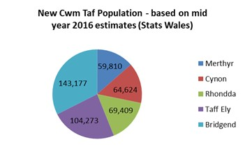
Key Population Health Challenges

Our Population

The CTM population served by the Health Board is 441,293 (Stats Wales 2016).

Years of Life and Years of Health - Source: Public Health Wales Observatory
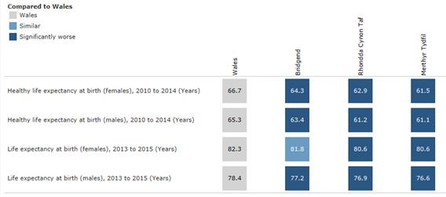
Life expectancy and healthy life expectancy in each of our Local Authority areas is lower than the Wales average, with the Bridgend County Borough population slightly higher than Rhondda Cynon Taf County Borough and Merthyr Tydfil County Borough for both males and females.

A Fair Chance for Health - Source: Public Health Wales Observatory
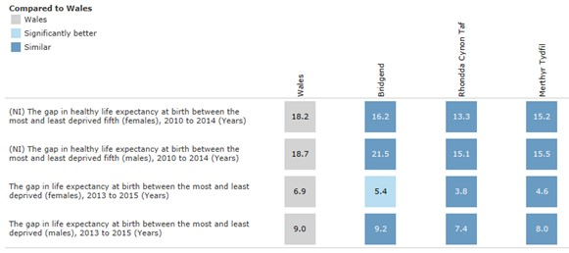
The gap in life expectancy and healthy life expectancy in all our Local Authority areas is lower than Wales and there are great inequalities in outcomes for the poorest compared to the most affluent.

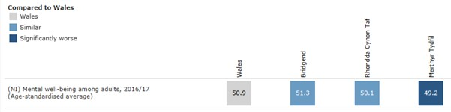
Mental Well-Being - Source: Public Health Wales Observatory
Mental well-being of adults in Bridgend County Borough is higher than Wales, Rhondda Cynon Taf County Borough and Merthyr Tydfil County Borough.

Ways of Living that Improve Health
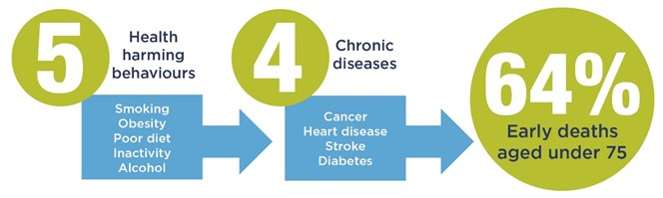
Many of the factors that contribute to the inequalities in health and well-being are preventable. Healthy lifestyles can increase the quality and quantity of life and poor lifestyles can decrease it. In particular, five harmful behaviours contribute to the four major causes of disease that account for 64% of early deaths. Evidence is also increasing that the same healthy behaviours can help reduce the risk dementia.

A View of Key Population Health Challenges
In developing a view of the most significant challenges facing population health and wellbeing we have taken account of factors such as: magnitude of impact, numbers of people affected, short- to medium-term projected trends and availability of opportunities to redress. The following are major health and wellbeing challenges in the Health Board, which the healthcare system could tackle both directly and in partnership:
- Frailty – associated with an ageing population and low healthy life expectancy
- Obesity/overweight
- Inequalities in health outcomes
- Loss of wellbeing (mental health)
Source: The Fifth Wave

Health Board Challenges and Legislative and Policy Drivers
Alongside the challenges faced by all public service organisations in terms of improving health outcomes, system sustainability, service quality, performance, and ensuring financial balance and sustainability, CTMUHB is also tackling the significant issues which have led to the organisation’s escalation status being increased to Targeted Intervention. The Health Board is fully committed to addressing these challenges and does not underestimate the fundamental and comprehensive nature of change required to deliver the improvements needed for patients, the workforce and partner agencies.

Quality Challenges
Through triangulation of a range of data sources, including internal and external reviews, national and local audit, patient and staff experience, the Health Board continues to improve its understanding, and therefore, response to, the challenges to quality that exist, which resulted in WG raising the escalation status for the UHB to ‘enhanced monitoring’ – the second of four levels, in January 2019. Subsequently, a number of external reports have made a number of recommendations to assist the UHB in planning for quality, improving, and being able to provide quality assurance:
- A joint review of maternity services by the Royal College of Obstetrics and Gynaecologists (RCOG) and the Royal College of Midwives (RCM) was published in March 2019. Recommendations from the review continue to be addressed under the scrutiny of the Independent Maternity Oversight Panel (IMSOP).
- A review by the Delivery Unit (DU) Management of Concerns (Learning Lessons and Managing Risk) and the Supporting Governance Arrangements, (March 2019) was published. The Minister for Health and Social Services, announced three external workstreams, including work to be undertaken by the DU to ensure there are effective arrangements for reporting, management and review of patient safety incidents and concerns.
- A further DU review ‘CTMUHB systems and processes for reporting, management and review of patient safety incidents & concerns’ (September, 2019), whilst identifying some areas of good practice, found key areas of deficiency which are subject to an improvement plan.
- In October 2019, the DU provided the ‘Supportive Intervention On Waiting Lists Reporting In CTM UHB’ identified the need for improvements in waiting list reporting, currently being addressed and reported via an action plan
- Welsh Risk Pool undertook a Services Review of Claims, Redress and Inquest Case Management at CTM University Health Board dated November 2019. Work to address the recommendations identified aligns to that of the Delivery Unit recommendations and improvement plan.
- Recommendations identified within the DU Diagnostic Review – Unscheduled Care, POWH published in November 2019, are being addressed as part of a wider review of emergency care provision.
- The Healthcare Inspectorate Wales Annual Report 2018/19 references the Inspectorates findings in relation to the services provided by the Health Board. Where recommendations have been made, service specific improvement plans are established.
- In November 2019, ‘a review of quality governance arrangements at CTMUHB Joint Review’ undertaken by HIW and the WAO, highlighted a number of fundamental weaknesses in the Health Board’s governance arrangements in respect of the quality of care and patient safety, stating that significant and urgent improvements are needed at both the directorate and corporate level to either strengthen or more fundamentally overhaul existing arrangements, organisational structures and roles. Whilst the review has highlighted some significant concerns, it also highlighted there is cause for some optimism that the required improvements can be made through the new leadership and additional capacity in to strengthen quality governance arrangements.

The improvements required are reported and scrutinised as a component of the response to targeted intervention. Based on the successful utilisation of maturity matrix to support the maternity improvement work, maturity matrices are being developed to support each of the workstreams, including quality. Along with the detailed improvement activity being undertaken within and reported by, specific services and corporate function, a robust framework is in place to ensure the improvements required are actualised.

Workforce Challenges
As described in more detail in Chapter 6, the approach to planning continues to incorporate Directorate and Locality plans together with cross-cutting themes. The workforce implications have been developed as an integrated part of these local plans and the key implications have been identified throughout the Plan. The delivery of these individual plans from a workforce perspective is monitored through the Directorates’ local IMTPs. These are reviewed at the Clinical Business Meetings (CBMs) with the Service Managers and Heads of Workforce who have been jointly engaged in their co-production.:

- Recruitment and retention difficulties, particularly with:  - Junior and SAS Doctors  - Consultant medical staff in certain specialties  - Nursing and midwifery staff  - Primary Care, particularly GPs  - Mental Health services  - Organisational development for maternity services | - Workforce redesign needs to deliver the Cancer pathway  - Workforce implications on the new Major Trauma Network  - Implementation of the SWP  - Impact of Sickness Absence;  - UK leaving the European Union (Brexit)  - Legislative Changes to HMRC rules around employment status and pension taxation;  - Essential skills levels for HCSWs

Performance Challenges
There is no doubt that 2019/20 has been the most difficult performance year for the Health Board , given the significant issues that have come to light, with an urgent need to respond positively to recover from the deteriorating performance that has occurred in a number of areas and regain the confidence of our residents. These issues have come at a time of significant organisational change. In Bridgend we have faced significant challenges in unscheduled care leading to targeted intervention, and breaches in elective Orthopaedic capacity within NPTH provided by Swansea Bay UHB.

The consequences for performance in a number of key target areas has been significant. Interventions carried out by the DU, in some cases initiated by the Health Board, have highlighted governance weaknesses, particularly in terms of ensuring compliance with National rules for patient pathway management, as well as full compliance with data submissions for the purposes of National reporting of waiting times. Whilst the Health Board has already responded to the recommendations and progress has been made, a targeted approach to training and compliance will be in place for 2020/21 onwards.

These interventions have also highlighted key diagnostic areas where competing demands are in excess of available capacity, where in the past the focus leaned too much towards reported waiting time areas. This has now resulted in a balanced approach in areas such as Endoscopy, where the focus in areas such as bowel screening and surveillance monitoring is now greater. It has however highlighted even more the gap between demand and capacity (D&C), not uncommon across Wales, with the UHB fully engaged in the National D&C work.

As well as the impact of dealing with the governance issues around waiting lists, which has increased waiting times, available capacity for elective work has also been affected through unscheduled care pressures, with a greater number of elective cancellations at PCH in particular. These capacity challenges have also impacted on expedient treatment of emergency patients, where we have seen an increase in the number of delayed transfers of care throughout the year, which continues to rise.

The impact from reduced patient flow also extends to services such as Stroke care, where compliance against the Quality Improvement Metrics remains low, particularly for timely transfer to the Stroke ward, but also for access to a specialist consultant within 24 hours of onset, again highlighting the challenges faced by the Health Board in terms of substantive medical staff.

Future plans for improving patient flow and the configuration of unscheduled care within the Health Board is a top priority for 2020/21.

Legislative and Policy Drivers
The Health Board continues to reflect on the legislative landscape of the Well-Being of Future Generations (WBFG) (Wales) Act (2015), the Social Services and Well-Being Act (2014) and the Public Health (Wales) Act 2017, informing our medium term planning as well as our longer term vision and 10 year UHB Integrated Healthcare Strategy as we continue our evolution into CTM.

A Healthier Wales: Our Plan for Health and Social Care and Prosperity for All: The National Strategy, WG 2017 continue to be the bedrock of our plans. The growth of our clinical and community leadership will allow us to rise to the challenges of an ageing population and continued emphasis on well-being and sustainability will ensure we are continuing to improve the health and Wellbeing of our citizens.

The transformation of services required to meet the ambition of Healthier Wales will not be possible without the development of digital services informing evidence based planning through data. NWIS transitioning into a new standalone organisation and the four commissioned strategic reviews of digital health and care in Wales reflects the vital contribution of digital technology and data in modern health and care.

The Health and Social Care (Quality and Engagement) (Wales) Bill will provide the legislative framework through which quality will be expressed, and HBs held to account. The Bill, which is currently at Stage 3 and likely to be passed in 2020 proposes to introduce changes that:

- Place quality considerations at the heart of all the NHS in Wales,
- Strengthen the voice of citizens across health and social services, with a new Citizen Voice Body for health and social care (replacing Community Health Councils);
- Place a duty of candour on NHS organisations, requiring them to be open and honest when things go wrong; and
- Strengthen the governance arrangements for NHS Trusts, by introducing a formal Vice Chair role for each Trust.

Wales remains vulnerable in the decision to leave the European Union and the undetermined impact on health and care services. This has influenced our planning for the next three years ensuring we are able to provide safe and effective services to our patients.

QUALITY ASSURANCE AND IMPROVEMENT
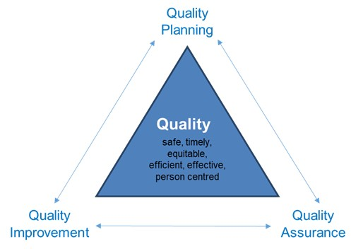
Quality is everybody’s business. This chapter reflects on the Health Board’s plan for quality, the improvements being made and the assurance of quality. Looking to 2020 – 2023, further changes are being implemented to ensure that there is a unified approach across the Health Board following the boundary change of April 2019 and that learning continues following the quality challenges in previous years which resulted in the Health Board escalation to targeted intervention and special measures.

Quality Strategy
As outlined in the previous IMTP, in August 2018 an Interim Quality Strategy was developed for the former Cwm Taf catchment of CTMUHB with 6 key areas of focus: listen, equity, enable, transparent, assure and improve. Whilst the direction of travel was considered as the development of a quality strategy for the new organisation’s footprint during 2019, it is apparent that quality requires fundamental embedding throughout the organisation in terms of planning, improvement and assurance. To enable this, work has commenced on our organisational Values and Behaviours, a critical piece of work in ensuring our workforce is signed up to putting our population and patients at the centre of all we do. Additionally, the UHB’s new operating model, which in turn will inform the development of the UHB’s developing ‘Integrated Health and Care Strategy’, aligns the clinical and managerial leadership at service and locality levels, ensuring quality is embedded in all we do and performance, finance regulatory excellence and most importantly positive patient experience are outcomes of high quality care. The Health and Social Care (Quality and Engagement) (Wales) Bill will provide the legislative framework through which quality will be expressed, and HBs held to account. A Quality Strategy is scheduled for April 2020.

During 2019, the Quality and Patient Safety Governance Framework was developed to enable and establish systems and processes related to quality governance and improve the approach to assurance across the organisation. Progress made and the challenges faced in implementing the quality and patient safety governance framework are highlighted below and a revised version of the Framework, based on learning from implementing the original, is expected at the end of March 2020. This will provide the foundation for the quality improvement approach across the organisation.

Milestones:

Year 1  Q1 Approve revised quality framework  Q1 Ensure all individuals in key operating model roles receive quality governance training  Q1 Commence use of learning and good practice tools to capture both across the organisation  Q1 use newly approved QIA tool for all new plans, service changes, programmes and projects  Q2 Agree quality risks, priorities and ambitions  Q2 Co produce with staff at all levels and stakeholders the quality priorities for remainder of 3 year plan  Q3 Develop the 3 year quality priority plan with delivery milestones  Q4 Commence implementation of the quality priority programme for next 2 years across all 3 localities | Year 2  Q1 Review delivery of year 1 milestones  Q1 – 4 Deliver quality priority milestones for Year 2 | Year 3  Q1 Review delivery of year 2 milestones  Q1 – 4 Delivery quality priority milestones for Year 3  Q2 Plan for 2024 onwards

Progress during 2019-20: | Challenges for 2020- 2023:
- Increased clinical and management engagement  - Review of directorate governance arrangements  - Alignment with values & behaviours work & targeted intervention workstreams  - Quality dashboard development  - All sub groups established, terms of reference review May 2020  - Clinical policies sub group established, good engagement, reporting into Quality Improvement & Clinical Effectiveness subgroup  - Refresh of the framework underway  - Quality governance webpage developed  - Standardised assurance templates finalised and in use | - Generating and sharing learning at pace  - Ensuring full implementation of the recommendations and applying learning following external reviews  - Securing and developing clinical and management leadership & engagement, including front line staff  - Bridging the disconnect between service delivery, middle management and Board  - Addressing variation in directorate governance arrangements and spreading good practice  - Embedding quality governance within new organisational structure at all levels: capacity and capability  - Sustained clinical leadership and ownership of sub groups  - Ensuring refresh of the framework increases its utility  - Sustainable focus and pace at a time of senior leadership flux and competing priorities and demand  - Meeting expectations re performance and finance  - Continuing to embed quality governance alongside the values and behaviours and the new structures

Quality Assurance and Quality Improvement
Quality assurance provides a systematic approach to maintaining consistently high levels of quality through ongoing measurement and reporting on safety, effectiveness and experience, identifying areas for improvement and enabling the sharing of good practice. In 2020, the UHB will continue to progress this work. The Board delegates assurance of quality through the Quality and Safety Committee. The Quality and Safety Committee in turn, now delegates appropriately to the relevant subcommittee. The newly established four sub-committees of Quality and Safety Committee: Quality Assurance, Patient Experience, Quality Improvement and Clinical Effectiveness and Quality Governance and Learning are now functioning and will be further embedded and reviewed as the organisation continues on its improvement journey.

Recognising that the management of risk in the organisation requires further development, the interim Board Secretary is reviewing current arrangements and developing a new plan to ensure that risks are identified, reviewed and mitigated against as a core part of governance at all levels. This will support a clear line of sight from the front line of care to the Board and enhanced interface between Quality & Safety Committee and the Audit committees.

At Executive level, with the recent commencement of the Director of Therapies in post, there are three new Clinical Executives. They, along with the Director of Public Health, will work in partnership and share collective responsibility for quality across the organisation. As three of the four Quality & Safety sub committees are chaired by a Clinical Executive, there are clear plans to further strengthen governance in relation to all areas including national mandatory audits, patient engagement, public involvement and the use of validated data and evidence. This will build on the work commenced in 2018-19.

Medical leadership relating to quality across the organisation will be strengthened through the new operating model. At all levels, development around quality will be implemented through workforce and OD workstreams.

In order to support the quality improvement approach to enhancing the care we provide, to reduce unwarranted variation and to support the pockets of good practice in relation to improvement methodology already in place, a UHB-wide quality improvement function is being established see section 1.6. Looking outwards to learn from others and enhancing our openness and transparency, this will be in partnership with Improvement Cymru.

At Directorate level (pending implementation of the new operating model) the principles and good practice outlined in the framework are starting to be embedded through the quality governance meetings where quality domains and any issues / risks are discussed. Standardised templates for reports and escalation will become the norm. Quality concerns, issues, risks and any reparative actions are now escalated through CBMs. Enhancing and building governance capacity at Directorate level was endorsed by Quality & Safety Committee through to the Board. These service level committees are being reviewed to ensure the quality focus is robust and there is a widespread, unified approach across the UHB. Furthermore, in order to join up planning with quality, performance and finance, all IMTP proposals will be independently reviewed for their quality impact. In future years, this will become more evidence based.

A clear step change, which will continue to be built on over the next three years, is the emphasis that quality is not only a nursing responsibility, rather it is the responsibility of all who work in the Health Board – quality is everybody’s business. This transition has commenced as part of the engagement work in embedding the new framework and is underpinned by a strong WG legislative and policy context.

Addressing Quality Concerns
The joint review by HIW and WAO (November 2019) identified that whilst developments are positive, the scale of the challenge to improve quality and patient safety governance is not to be underestimated and will require focused and sustained commitment by the UHB, the 14 recommendations from the review are aimed at focussing the UHB in addressing the issues raised.

The actions required are mirrored in the interventions being progressed to address the issues raised resulting in targeted interventions, the emerging programme of work has three key strands – quality and governance, leadership and culture and trust and confidence. Building on the experience of developing a maturity matrix for maternity services, a similar matrix for quality governance has been developed which will enable the Health Board to demonstrate progress and be held to account for it by external partners. In conjunction with the continued implementation of the Quality and Patient Safety Governance Framework, the UHB will be better positioned to identify, respond and learn from quality concerns in a timely way. The development of a learning culture is of utmost priority for the Health Board, and will continue to develop over the next three years. In addition to the work being undertaken by the Maternity Improvement Board (MIB), the UHB is undertaking development work around response to concerns. This is being supported by the DU and will be spread across the whole organisation.

The Quality and Governance Maturity Matrix (Appendix A) had an initial self-assessment in preparation for the Cwm Taf Morgannwg UHB Welsh Government escalation meeting at the end of February 2020, the outcome of the self-assessment process for Quality and Governance was an overall score of Level 1 – basic.

The improvement work being undertaken across the organisation is contributing to improvements in quality and progressed will be articulated using the quality maturity matrix. The following priorities identify the high level developments and interventions required. By April 2020, each of the priorities will have been assessed against the quality maturity matrix and a realistic, deliverable trajectory agreed to achieve sustainable improvement:

Overarching quality priorities 2020 - 2023
1. Strengthened focus on quality in strategic planning: to include a whole system, population health perspective shaped by the wider integrated partnership agenda, aligned with each of the 5 ways of working outlined within the WBFG (Wales) Act 2015. This includes the development of an Integrated Health & Care Strategy with quality as the golden thread throughout it, and a revised, joined up approach to developing the IMTP, including a ‘panel’ approach and strengthened guidance related to quality impact assessment
2. Individuals’ voices are better heard: actively enabled through coproduced values and behaviours, investment in real time and friends and family test, a strategic approach to patient stories and targeted focus on the individuals’ experience of the services provided by the Health Board, through the Patient Experience sub-group, reporting directly to Quality & Safety Committee. The Once for Wales Concerns Management System currently being procured for Wales, will support the Health Board in the planning, capture and analysis of Service User feedback. Equally the voice of staff will be better heard. This priority aligns with involvement and collaboration as aspects of the 5 ways of working.
3. Shared learning and continuous quality improvement: Development of Cwm Taf Morgannwg Improvement, aligned with prevention and long term as aspects of 5 ways of working, through improved triangulation of intelligence and data integrity via investment in data systems and staffing, review of national audit where outlier status is applied, development of a database of external reviews, reports, and improvement plans, utilising the learning and governance sub group appropriately.
4. Risk better articulated, shared & mitigated: following an extensive revision of the Health Board’s approach to and management of risk, improving sight of significant service specific concerns and risks, improved exception reporting to Quality & Safety Committee and development of a harm review process. This priority aligns with each of the 5 ways of working.
5. Strengthened two-way Ward to Board sight: ensuring that quality governance and patient safety shapes and features strongly in new organisational structure supported by continued implementation and refresh of the framework.
6. Extensive review and improvement of the management of concerns and serious incidents: through full engagement with supportive intervention of the Delivery Unit and achievement of the improvement plan.

The Health Board recognises that there is more to do and is committed to ensuring that quality underpins all of its work. However, the scale of the challenge is recognised with pace and resilience essential, along with medium term planning and sustainability in mind. The Health Board is working to address many of the issues identified within this report and acknowledges the fundamental challenges that remain.

SERVICE CHANGE IN 2020-23
Reflecting on the progress made in 2019/20 and the challenges the Health Board continues to need to meet over the next three years, this chapter offers a summary, within the context of the Integrated Health and Care Strategy, of the significant service changes planned over the course of 2020-23.

Well-being – Self Care and Supported Self Care

Wellbeing in Partnership
The Cwm Taf Public Services Board (PSB) is chaired by the Health Board’s Chair and the Bridgend PSB is chaired by the Deputy Police and Crime Commissioner. Work will take place in 2020/21 to consolidate the two PSBs.

We will continue to deliver Cwm Taf PSB priorities, working together to find innovative new ways of working for:
- Preventing loneliness and isolation at every stage of life.
- Piloting Community Zones to reduce adverse childhood experiences and find new ways of delivering one public service in our most challenged communities.
- Redesign the services for families and early years, with support from the WG Co-Construction Programme.
- Help people live healthier for longer with one small change.
- Build our economy through tourism and by linking people with the skills needed for careers in public services.
- Exploring patient engagement to ensure a digitally empowered population

In Bridgend the Wellbeing Objectives have many similarities and we will seek to ensure that we work closely together to deliver them:
- Best start in Life.
- Support communities to be safe and cohesive.
- Reduce social and economic inequalities.
- Healthy choices in a healthy environment.

Some of this work also links closely with Area Plans required under the Social Services and Well-being Act. It will be important to dovetail work plans where needed to deliver the most effective and efficient public services.

Building Resilient Communities through a Place-Based Approach
The flagship project for Cwm Taf PSB continues to be the development of place based approaches as a key priority and in response to the “Children First” initiative proposing the development of Community Zones across the Cwm Taf region.

The approach will transform public services to deliver greater emphasis on preventative early intervention services through engaging with our communities differently. By intervening early prior to crisis and by preventing the escalation of the many difficulties some families are facing, including adverse childhood experiences (ACEs), it will be possible to achieve better long-term outcomes for our residents and reduce their dependency on statutory services. As a “pioneer area” for “Children First” we are implementing this place-based initiative in two areas, the Gurnos Estate, Merthyr Tydfil and Upper Rhondda Fach, RCT. A multi-agency Implementation Group including UHB representation continues to progress this work and will also take account of:
- Rhondda Cynon Taf CBC Community Hubs - potentially utilising a similar model to that proposed by the PSB’s “Community Zone” proposal.
- Joint proposals with the LAs continue to develop greater funding flexibility across tackling poverty programmes.
- The Health Board is to date the only pathfinder for Wales taking forward the Co –construction programme of work. For the PSB and Health Board this provides an opportunity to work differently and pilot a new approach with families assessed for additional services according to need through Vulnerability Profiling and sharing of key data between services. Rhondda Cynon Taf CBC is leading this pilot with input by both Merthyr Tydfil and Bridgend CBCs.

Prevention
Prevention of ill health and promotion of good health feature as a theme across all the Health Board’s delivery plans. Action to address modifiable lifestyle risk factors such as smoking, obesity, alcohol consumption above recommended guidelines and lack of physical exercise is fundamental to reducing the prevalence of ill health. Our profile of the uptake of ‘Healthy Behaviours’ shows that we have much work to do to improve life expectancy, healthy life expectancy and to reduce inequalities. This will be supported by WG investment in prevention and early years for CTM.

A summary of the current actions includes:
- “Making Every Contact Count” (MECC) by encouraging our patients, staff, and wider population to adopt one more healthy behaviour, with a view to the majority of the population enjoying four to five healthy behaviours by 2030.
- A focus on Early Years and the prevention of Adverse Childhood Experiences (ACEs).
- The Public Health Directors Leadership Group, including Directors of Public Health from Health Boards and PHW have committed to coordinate action in two key areas:
- Tackle high blood pressure - a co-ordinated approach to prevention will be tested using the identified priority of high blood pressure, the top-ranked clinical risk factor contributing to avoidable disability-adjusted life years (DALYs). We will advocate for and support nationally-templated quality improvement initiatives that optimise the management of blood pressure within primary care clusters, aiming to reduce the preventable burden of cardiovascular disease and related inequalities.
- Reduce smoking prevalence in line with the smoking cessation framework including: assessing the extent to which each of the components has been implemented, identifying actions required and an implementation plan with key milestones, with progress tracked and reported to the DPHs. In addition, the Group is developing a collective vision on smoking prevention and renormalisation to inform the next tobacco control strategy. The Help Me Quit service has been integrated into the Health Board from Public Health Wales and a system wide approach to cessation delivery is being progressed, to include community pharmacy, in-house cessation, antenatal cessation (MAMSS) and the development of a mental health service cessation model.

This will be achieved though the continuation of the following preventative schemes:
- MAMSS, Bump Start and the Joint Care Programmes.
- Inverse Care Law.
- Implementation of WG Healthy Weight Healthy Wales Strategy and forthcoming Action Plan, including Tier 2 and 3 obesity services.
- Best Start research programme.
- Implementation of the Healthy Child Wales Programme.
- Implementation of the WG Healthy and Active Strategy.

Self-Care and Supported Self-Care
Evidence tells us that self-care or self-management programmes for chronic disease improve health outcomes and reduce hospital use, particularly those managing well defined conditions with clear methodology (e.g. those developed in Stanford such as the Chronic Disease Self-Management Programme) and that many individuals feel more satisfied with their care and achieve a better sense of control and self-efficacy through supporting self-care interventions. This reinforces that self-care is needed at all stages of a patient journey, and this includes services designed to promote healthy lifestyle choices, as well as support for helping people manage a health problem.

Our plans for self-care and staying healthy will ensure our population will:
- Have the knowledge, and confidence to look after their own health and to prevent ill health through targeted public health interventions across all age ranges.
- Have an increasing healthy life expectancy so we are not just living longer but have a better quality of life;
- Be aware and linked into wider communities through the work of the Third Sector to improve their health and well-being.
- Targeted advice and support to those who already have poor health or are at high risk of ill health;
- Reduced levels of obesity and smoking.
- Targeted support for people who are out of work. Being out of work is strongly associated with increased overall mortality and poor physical and mental health. In the CTM area, the proportion of the population in employment is lower than for Wales as a whole.
- Our older people will have the knowledge and support needed for “active ageing”, enabling them to live healthy lives for as long as possible.
- Be encouraged to take exercise, eat a healthy balanced diet, stop smoking and reduce drinking below recommended limits, potentially adding fourteen healthy years to life.

Our self-care priorities include:
- Signposting and social prescribing: healthcare professionals need to know how to refer patients to existing programmes. Robust mechanisms for ensuring this information is to hand and up-to-date to be explored.
- Similarly, healthcare waiting areas are appropriate venues for advertising the value of such programmes to patients, and the ways in which this can be used to the full should be developed. Links to telephony services should also be explored. Our Local Public Health Team will work with primary and secondary care to develop centrally coordinated information systems that can be kept up to date.
- Motivational Behaviour Change: evidence indicates that more success is achieved if health care practitioners are skilled in Motivational Behaviour Change and Brief Interventions, and use these techniques in general consultations. These techniques are being offered to healthcare providers in primary and secondary care.
- The National Exercise on Referral programme for people with chronic conditions is similarly available in all areas, and is receiving large numbers of referrals.
- Health and Well-Being Checks for Over 50s – ‘Add to Your Life’: this programme aims to support and empower older people to have greater control over their own health and well-being.
- Mainstreaming the Drink Wise, Age Well service and principles into the Substance Misuse Area Planning Board commissioned service from Barod, promoting healthier choices about alcohol use amongst over 50’s.
- Referral to integrated Smoking Cessation Services to be embedded across pathways.
- Increasing the capacity within our services to deliver condition specific education programmes which promote self-care e.g. X-PERT, Pulmonary Rehabilitation etc.
- Increasing the capacity to deliver the Education Programme for Patients (EPP) to people living with a long-term health condition.
- Further development of peer support activities across the community for those with a chronic condition.

New Approaches to Health and Care – Population Health Management
We have successfully completed a pilot of population segmentation and risk stratification in the Rhondda Cluster. This has led to the creation of a unique integrated dataset combining primary and secondary care data for a population of 80,000 people. This learning has formed the basis of the Risk Stratification and Segmentation work stream within the CTM RPB Transformation Proposal see Section 5.2.2.

Early analysis of the dataset has shown that:
- Multi-morbidity is the norm – it is more common for people to have multiple chronic conditions than to have just one.
- Intervention programmes should not focus on one condition but take into account groups of conditions which can co-occur.
- Patterns of multi-morbidity vary across the pilot population (see map of morbidity below).
- Multi-morbidity is a better predictor of healthcare use than age or frailty.
- There are about 10 specific segments of people in the population defined by the similarity of their needs.
- These segments can become the primary organising logic of integrated prevention, health and care as well as efforts to deliver person-centred anticipatory care

Having now segmented our population by multi-morbidity i.e. long term conditions (LTCs), we will determine which segments are most likely to benefit from anticipatory care and work with healthcare professionals and patients to identify the outcomes which are most important to people in those segments. We will then use the evidence base to identify which interventions will be the most effective in achieving these outcomes for the segments. Examples of interventions which might be more effective in different segments include Enhanced Community Cluster Teams, Community Resource Teams and Stay Well @Home. This approach is now being rolled out across the Health Board.

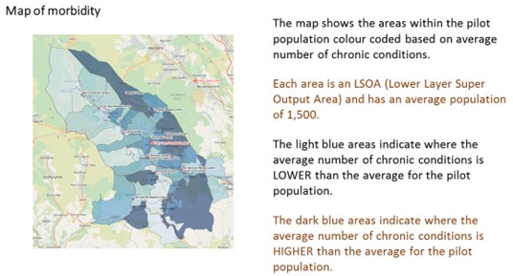

Integrated Community Services

Integrated Health and Social Care
The RPB is the key driver for change in health and social care at regional level, exploring and delivering opportunities for greater integration between health and social care services within Cwm Taf. The Cwm Taf Social Services and Well-Being Annual Report for 2018/19 sets out the key achievements against objectives as well as the forward look as CTM.

As a new CTM Region there is a requirement to refresh priorities for the RPB. Work on a vision, priorities and governance for the new are RPB is being undertaken and will inform the new plan. Whilst it is recognised that the RPB is about to go through a period of transition, clear priorities remain which include:
- Further embedding the new RPB (including housing and primary care clusters representation)
- Developing and delivering a new Area Plan
- Delivery of the transformation programmes for Cwm Taf: Stay Well in Your Community and Bridgend: Accelerating the Pace of Change of Integrated Services
- Continued delivery of the CTM Regional work programme. This includes:
  - Embedding the new Regional Commissioning Unit
  - Delivery of both capital and revenue Integrated Care Fund (ICF) schemes

As part of the UHBs digital strategy, work is ongoing to deploy Vision 360 as a shared care record and to increase accessibility of information across health and care (Section 8.2.1.3).

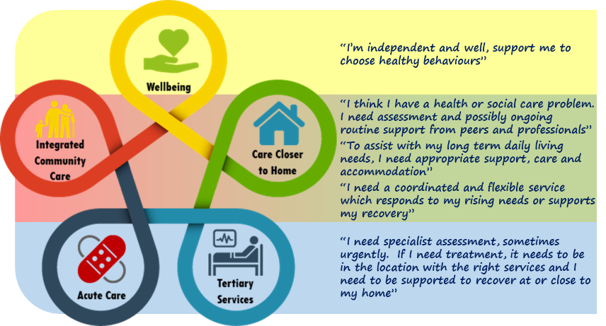
Stay Well In Your Community – Transformation Programme
Developed within the former Cwm Taf Regional Partnership the Cwm Taf Population Health and Social Care model has three layers to it: Wellbeing, Integrated Community Care, Closer to Home; Acute Health and Social Care and Tertiary Health Services; with the voice of the individual at the heart of the development of a seamless service model.

Based on the whole system Cwm Taf Population Health and Social Care Service Model below, the priorities for an initial phase of the Programme is based on the following complementary components:
Multidisciplinary Anticipatory Care and Enhanced Routine Monitoring Services

- Systematise practice, cluster and Health Board level, population health segmentation and risk stratification to enable anticipatory interventions to be targeted at those individuals who are most likely to benefit and to deliver improved health and social care, quality and value (technical and allocative) outcomes. This segmentation/risk score will target the intervention of assistive technology, disease specific community teams and the multi-agency Enhanced Community Cluster Team.

- The further development of a proactive outward facing assistive technology model which combines telecare monitoring and co-ordinates a multi-agency response with proactive outbound calling and links to the Rapid Response Service, enabling people to maintain their independence at home.
- Create, at cluster level, multi-agency, multi-professional Community Health and Well-being Teams to deliver multi-agency, multi professional anticipatory care at a cluster level via targeted MDT assessment and implementation of individual care and support plans.
Rapid Response Services

- To complement the 111 service, deliver a robust and responsive Urgent Primary Care Out of Hours Service through a prudent workforce model and complementary artificial intelligence driven symptom checker application and video assisted triage to reduce in and out of hours demand on GPs.

- Roll out the next phase of the Integrated Stay Well @Home rapid response service across Cwm Taf, to enable referral, via a single point of access, from community based health, wellbeing, pre-hospital and social care professionals.

The transformation programme focuses on scaling up, and crucially linking, pilots which have already delivered proven benefit across Cwm Taf within the Integrated Community Care, Closer to Home layer. These are: Risk Stratification and Segmentation; Cluster Focused Multi-Disciplinary Teams – a ‘Virtual Ward’; Stay Well@Home.

Bridgend: Accelerating the Pace of Change of Integrated Services
Building on a strong track record of partnership working and integration, Bridgend CBC and partners have the ambition to have fully operational accessible services over seven days, over an extended day, as well as providing care and support at night. The desire is to lead in Wales, developing and delivering a coordinated integrated approach to service over seven days; where people experience a continuous, accessible and responsive approach, to collaboratively supporting people, particularly areas excluded from routine access such as, out of hours and secondary care, and WAST services colleagues.

To realise the ambition of delivering coordinated health and social care services seamlessly wrapped around the needs and preferences of individuals; and to deliver where practical and safe to do so, home-based and community models of integrated care and support; Bridgend CBC and partners have three deliverable ambitions that will transform our community services:
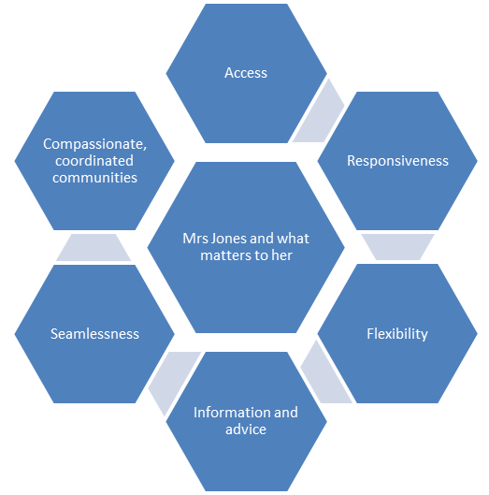
- Transformation Ambition 1: Seven Day Access to Community Health and Social Care Services – “Every Day Is Tuesday”, delivering extended alternative service options to hospital and long term care.
- Transformational Ambition 2: A Primary and Community Care Multidisciplinary Team approach, delivering a one team approach around people, coordinating Primary Care and Community Services Cluster responses.
- Transformational Ambition 3: Developing and Delivering Resilient Coordinated Communities; with key organisations, their partners and the communities that they serve developing benefits, by working collaboratively to apply preventative approaches that enhance the wellbeing of the population of Bridgend County Borough.

MILESTONES
The programme has adopted a whole systems approach to change through expanding successful projects across Cwm Taf Morgannwg to provide greater choice and independence for individuals, whilst reducing pressure on social care, GP surgeries and hospitals. Our collective ambition is to improve people’s quality of life through improving their experience of care; to support the ambition to provide more care closer to home via an integrated person centred co-ordinated model of care; ensuring that outcomes delivered are consistent for all regardless where people reside across the Cwm Taf Morgannwg geographical footprint. The timeframe is as follows:

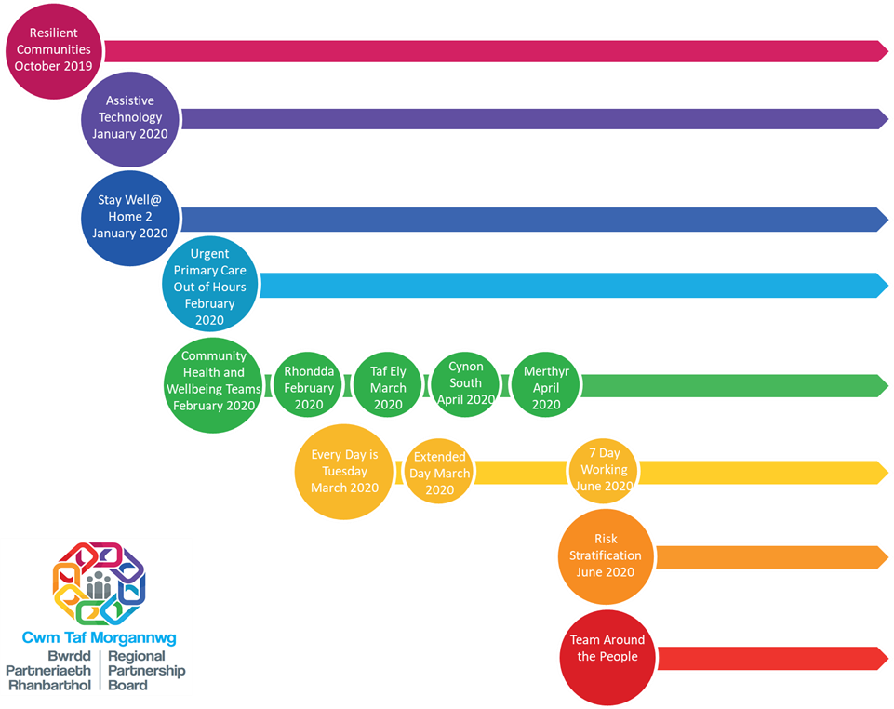

Delivering the Cwm Taf Morgannwg Regional Area Plan
Building on the established Cwm Taf Area plan and identified priorities for Bridgend there is a requirement to develop a CTM Regional Plan reflecting agreed priorities of the new region. During 2019/20 there has been opportunity to learn from the different approaches across the new region which will be built on during 2020/21.

A number of Joint Commissioning Statements and Statements of Intent which were developed under the Cwm Taf area plan will be revisited to determine regional approach and include;
- Joint Commissioning Statement for Older People’s Services 2015-2025. Partners want to deliver a proactive, responsive and seamless service to our older population and those who support and care for them. Older people must be able to access a range of services that promote their health, well-being and independence, reduce reliance on long-term specialist services and emphasise choice and control. Delivery of the Stay Well in Your Community Programme is key this. See Section 5.2.2 for further detail.
- Joint Statement of Intent for Learning Disability Services. The Region’s SOI was endorsed by partners in November 2017 It describes a shared commitment to deliver a new model based on the following:
- Maximise the use of universal services.
- Increase early intervention, prevention, information, advice and assistance.
- Build community support and develop people’s independence.
- Sustain people in their own homes.
- Enable people to live full lives and achieve their potential.
- Keep people safe.
- Make the best use of our resources.
- Joint Statement of Intent for Children, Young People and Families (CYPF). The SOI is focused on the following shared vision , that:
- CYPF will live safe, healthy and fulfilled lives and achieve their full potential.
- Families and communities will be more resilient and independent.
- Our focus on communities will give children, young people and families the best possible environment to thrive.
- The balance of resource will shift from safeguarding, substitute and complex care to early, targeted help.

In order to support delivery of this, a small Regional Commissioning Unit (RCU) was established to complement and support the resource already within partner organisations. This is enabling the Region to develop and implement regional commissioning plans for integrated service provision for a variety of client groups and develop joint community arrangements for the accelerated provision of integrated health and social care.

Pooled Funds
There are a number of pooled budgets in place across the Region, including the Youth Offending Service, Integrated Equipment Service and learning disability packages of care. These funds provide an enabler for increasing value and improving outcomes through integrated and seamless services for a range of patient and client groups.

An overarching pooled fund for residential and nursing care has been established and is operating as set out in a Legal Agreement between partners, hosted by RCT CBC. It essentially encompasses all older persons’ independent residential and nursing placements in establishments located within the regional footprint.

Bridgend’s Care Home Pooled Funds arrangements have remained within the Western Bay area for 2019/20. During this transition year, Bridgend are represented on the existing Cwm Taf Pooled Group and four key actions have been identified with a view to establishing a new CTM Pooled fund arrangement by 31st March 2020. These are:

Action 1 – Market Positions Statements to be refreshed across the new region.
Action 2 - Review pooled fund contracts with a view to aligning contracts across the region.
Action 3 - Reviewing existing pooled fund arrangements to determine any changes required to extend the fund.
Action 4 - Consideration be given to future commissioning arrangements across all regions, in light of the Bridgend boundary changes, and to progress a Commissioning Strategy for the region.

Integrated Care Fund (ICF)
The WG published Guidance on the ICF, previously referred to as the Intermediate Care Fund, in April 2018 and updated Guidance made effective from the 1st of April 2019. The Guidance sets out the objectives and priorities; conditions; governance requirements; and reporting arrangements to WG for ICF in 2019/20. The Guidance has now been updated for 2020/21

A Written Agreement has been developed in line with the ICF Guidance to provide assurance to WG and the Regional Partnership Board that robust processes are in place to manage the effective delivery and management of ICF capital and revenue funds.

The level of ICF funding coming into the region in 2019/21 increased from £5.608m to £12.7m, due to inclusion of the Bridgend ICF allocation and increased funding available, and it remains at this level for 2020/21. The local infrastructure to support and manage the volume of funding has been reviewed to ensure robust governance arrangements are in place to enable the Partnership to deliver the Board’s priorities.

In line with the requirements of the Social Services & Well-Being (Wales) Act 2014, within CTM Partners have worked together in developing ICF proposals to establish a wider range of sustainable, integrated services for older people and preventative services for people with learning disabilities, children with complex needs and carers dementia and the integrated autism service.

For 2019/20 the established successful ICF projects were sustained and continue to deliver a range of outcomes. As required by the ICF guidance, the CTM Region’s revenue priorities are set out in the Investment Plan 2019/2020 which accompanies this Written Agreement. The Investment Plan outlines the objectives and ICF principles that were used to select those priorities and the anticipated outcomes for each.

In addition to ICF revenue, ICF Capital totalling £5,049,000 was allocated to the Region for 2019/20. This funding supports a total of 11 Major capital programmes and 19 smaller discretionary programmes. In line with revised RPB membership to include Registered Social Landlords and Housing, building closer working between the health, housing and social care sectors is a welcome development.

All ICF schemes are subject to quarterly evaluation with detailed RBA cards produced in addition to monitoring required by WG. The WAO review of ICF report is published and provides opportunity to build on existing practices and programmes within the region.

Social Value Network
The Social Value Network and associated Social Value Forum was created as part of the Regional Leadership arrangements to support social value based providers develop a shared understanding of the common agenda and to work together to enhance community capacity.

Three successful Social Value Network events took place with excellent involvement and attendance of large and small third sector organisations across CTM and representation from service users and carers.

The three big themes were; Children and Young People (December 18); Investing in Community Support to tackle Loneliness and Isolation (July 18) and ‘Citizens, Coproduction and Commissioning.’

Carers Strategy Implementation
The Health Board is committed to playing its part in delivering the CTM SOI for Carers following the Cwm Taf Carers Strategy 2016-19. This was developed by working with partners across Bridgend, Rhondda Cynon Taf and Merthyr Tydfil, including Carers and has now been incorporated into the actions for Carers in the CTM RPB’s Area Plan. The CTM Carers Partnership reports directly to the RPB and is working to ensure that carers of all ages in CTM are recognised and valued and being fundamental to supportive and resilient families and communities; will not have to care alone; and will be able to access information, advice and support to help meet their needs, empowering them to lead healthy and fulfilled lives whilst balancing their caring role and life outside caring.

Significant progress has continued to be made in 2019/20 including the development of a Carers Policy for CTM staff; establishing a Carers Network with the Third Sector; the provision of relevant, timely information for carers and staff distributed through GP surgeries and community pharmacies; and the development of a pilot project, working closely with partners in the third sector, to support Carers of all ages within a hospital (acute and community) setting particularly around discharge planning. The Health Board will continue to work with partners to address national priorities to further improve the support available to Carers by focusing on issues that matter to them including supporting carers to have a life beyond caring; identifying, recognising and supporting carers so that they can continue to care; and providing information and advice when they need it.

The WG provided transitional funding of £1million per annum for Wales in 2018/19 and 2019/20 saw a £161K allocation for CTM to protect and build on progress and support the expansion of carers rights on the implementation of the Social Services and Well-Being Act. This funding has enabled the continuation of the Carers Co-ordinator post in the Health Board and a number of joint projects with the LA’s, including respite activities for adult carers and young carers.

Wider Integrated Services

Integrated Substance Misuse Service
Following an external review and recommissioning process, the Cwm Taf Substance Misuse Area Planning Board awarded the contract for provision of tier 1 and 2 Substance Misuse Services for Rhondda Cynon Taff and Merthyr Tydfil to Barod from 1st April 2019. Barod are working in close liaison with the Health Board’s specialist tier 3 Community Drug and Alcohol Teams (CDAT) and CAMHS substance misuse service, within a joint clinical governance framework. Responsibility for the Primary Care Drug and Alcohol services (PCDAS) has transferred to CTMUHB and a review of the caseload, protocols and governance arrangements is currently underway.

All parties report an improvement in partnership working, particularly evident through the Joint Allocation Meetings, and in transition arrangements for young people who are not yet ready for transfer to adult services. An important element of the new integrated services is a greater focus on prevention and awareness raising which has been undertaken through service presentations, workshops and community events, including Pontypridd’s Big Bite in August 2019 where 368 brief interventions were delivered. Work is ongoing to further streamline pathways between tier 2 and 3 services.

From 1st April 2019 the Area Planning Board’s remit has been extended to cover the whole of CTM. Substance Misuse services in the Bridgend area are provided by WCADA and the Health Board’s CDAT which currently also serves the NPT area via an SLA with SBUHB. A Bridgend Development Sub Group of the APB has been established to oversee the smooth transition from Western Bay / Abertawe Bro Morgannwg, to develop an understanding of the services in Bridgend, to consider the findings from the external service review commissioned by Western Bay APB, and to work towards alignment of services across CTM. Due to the complexity of the service and the process of recommissioning, the APB has agreed to defer any changes to the commissioned services in Bridgend until at least 2021/22.

A summary of the priorities for 2020/21 are:
- Continuing to embed and refine the operational and governance arrangements between the Health Board’s CDAT, CAMHS and the rest of the new ISMS service in RCT and Merthyr Tydfil.
- Work towards aligning substance misuse services across the Health Boards footprint, starting with repatriation of the current SLA with Swansea Bay University Health Board (SBUHB) for the CDAT service.
- Reviewing the primary care Enhanced Services for Substance Misuse.
- Scoping the need for the development of an Alcohol Related Brain Disease (ARBD) service.
- Reviewing the current provision of inpatient detoxification services.
- Planning for the transfer of the Taff Ely CDAT from Llwyn-yr-Eos in Church village to the Dewi Sant Health Park development in 2020/21
- Regular and coordinated reviews of drug related fatal and non-fatal drug poisonings in order to develop appropriate and affective interventions to reduce harm.
- Increasing the rate of testing and treatment for Blood Borne Viruses (BBV).
- Improving the management of people with co-occurring substance misuse and mental health needs, including a more integrated multi-agency service response for more vulnerable people such as the homeless.

Sexual Assault Referral Centre (SARC)
Health Boards and all key stakeholders across the South Wales region have been increasingly engaged in modelling work to support a sustainable model for SARC services. Ongoing modelling and planning work has been carried out during 2018-19 with the relevant statutory agencies and clinical representation across all stakeholders. In September 2019, the statutory bodies approved a series of recommendations and financial framework to support a commitment to implementation of three acute SARC hubs for adults and two SARCs hubs for children up to the age of 16 years. Costs associated with establishing hubs and spokes are anticipated to be phased over a three year period as the service model is developed and implemented with anticipated commencement in 2020/21. Health Boards’ financial contribution has been split on a population basis. Further work will take place early 2020/21 to develop the commissioning framework, as well as the service model and costs associated with phase 2 and 3 (spokes and Forensic Medical Services), which will require formal approval through the Boards of the statutory organisations prior to any further funding commitment being made.

Mental Health, Primary Care and Locality Services

Children, Young People and Families Emotional, Mental Health and Well Being
Our vision is to support the underlying principle of early intervention and prevention across all levels of need. We are planning to develop fully integrated health and well-being services where children, young people and their families will receive a range of services by the right person, at the time when we can make a real difference to their needs and at the place that is most beneficial to them.

We will continue to challenge existing practice and further develop ways of working differently with strong service pathways to enhance care and support for children and their families. Within the community we look to recruit further community paediatrics to further strengthen the community model of integration being developed in partnership.

Work has also been undertaken across the Health Board and with partners to fully implement the Continuing Care Framework for Children and Young People. There are now guidelines in place for the management of 16-18 year olds within the health board and a transition protocol from CAMHS into Adult Mental Health has been completed.

The multi-disciplinary Neurodevelopment service continues to offer a dedicated service to children referred for assessment of ASD and ADHD. Non-recurrent funding has been provided in 2019/20 to provide additional capacity in order to meet the growing demand for this service and recurrent funding will be sought for this going forward. There is also to be ongoing review of the Halcyon ‘Specialist Parenting support Project’ funded by the Health Board and Local Authority to demonstrate the significant changes in medical and service behaviours that have been supported by this service since its inception in order to seek to secure permanent funding for the future.

Significant work has also been undertaken regarding the development and implementation of plans to prepare us for the Additional Learning Needs (Wales) Act being introduced in 2020.

Following the Bridgend transition, work has been undertaken within the directorate to strengthen the relationship with Children and Young People (CYP) services based in Bridgend. Over the last year, integration has been achieved in many areas of the service and good working relationships have been developed. This has been strengthened by ensuring service development has been undertaken in Bridgend, such as the reintroduction of tertiary Neurology services for Paediatrics in POWH.

MILESTONES

Year 1  Q1: Bid produced for therapist input in the NNU  Q1: Confirm investment and continue to refer to Halcyon service  Q1 Paediatric Neurology clinics run in POWH  Q1: Work on PAU interdependencies with A&E, Obstetrics and Gynaecology.  Q2: Bid complete for therapist input into NNU and taken for sign off  Q2: Implementation of ALN Act  Q2: Review future requirements of Halcyon service  Q2: Implementation of PAU in RGH and completion of SWP programme  Q3: Recruitment of Therapists for NNU  Q4: Recurrent Funding for ND service sought to meet 26 week target  Q4: Implemented Halcyon service model as appropriate to resource | Year 2  Q1: Funding for recurrent funding for Halcyon project sought  Q1: Evaluation of PAU in RGH.  Q1: Realisation of benefits of recurrent funding of ND service  Q1-4 Continue to run Paediatric Neurology clinics in POWH  Q1-4: Implemented Halcyon service model as appropriate to resource | Year 3  Q1: Realisation of benefits of PAU in RGH  Q1-4: Continue to run Paediatric Neurology clinics in POWH  Q1-4: Implemented Halcyon service model as appropriate to resource

Child and Adolescent Mental Health Service
The Child and Adolescent Mental Health Service (CAMHS) is an integral part of the Health Board’s Children and Young Peoples Service. We currently provide Primary and Specialist CAMHS to our resident population together with the population of Swansea Bay UHB. CTM also manages a range of networked services (Young People Drug and Alcohol and Learning Disability) as well as a range of South Wales and all Wales tertiary services.

As such, the Health Board will continue to manage Ty Llidiard, an inpatient unit based on the Princess of Wales Hospital site, that covers the South Wales area, an all Wales Tertiary Forensic service and the Mid and South Wales Eating Disorders Service. In addition the on call rota that services the previous Network area (including C&V) will be maintained.

Work continues to review our core business and to develop a multi-agency emotional and mental health strategy that will look to foster even greater linkages with other services and partner agencies. To this end we are working with local authorities to develop a model for an emotional well-being service at Tier 0 that will increase liaison with partner agencies and provide a focus on prevention and early intervention. ICF funding has been received for this and will align to early intervention models targeting families with specific risk factors including a range of Adverse Childhood Episodes (ACE) and, or evidence of low resilience.

Following the review by the DU of the Primary Child and Adolescent Mental Health Service (PCAMHS), significant progress has been made on the areas for improvement the action plan identified. It had previously been identified that there was a significant mismatch between the demand on the service and its capacity and action was taken to increase the staffing establishment by 50% as a consequence. The DU review helped to identify where efficiency could be improved within the service to further support increased activity and reduced waiting times. There has also been investment in 3 additional posts that will be focused on liaison work e.g. working with schools to focus on prevention and early intervention. A trajectory has been developed for PCAMHS to meet the referral to assessment waiting time target by the end of 2019/20.

The Specialist CAMHS (SCAMHS) has continued the process of aligning its services more consistently to provide a psychological therapies service to young people/families via the adoption of the Choice and Partnership Approach (CAPA). The CAPA model emphasises quality, the provision of focused therapeutic input and evidence informed interventions. It also provides a clear picture of D&C so that the Directorate can work towards ensuring that the service is delivering to its’ maximum and that D&C are balanced.

Supported by this approach, the service has secured additional funding from WG to recruit the staff required to recurrently meet the 80% target for referral to assessment, with the funding currently being used to deliver additional clinics to sustain compliance in the meantime. This target was and continues to be achieved. Further work has commenced to ensure that this continues to be sustainable with the recruitment of 3.3 WTE staff and waiting list initiative clinics being undertaken.

Alongside the introduction of CAPA, we have introduced the new All Wales referral criteria and a single point of access through which all PCAMHS and SCAMHS referrals are assessed, to ensure that children are actively managed into the right services in a timely manner. The service has also embarked on a programme of up-skilling staff so appropriate interventions can be offered using qualified therapists in post to provide quality consultation.

The Health Board in conjunction with WHSCC is reviewing the commissioning service specification for the Tier 4 service provided at Ty Llidiard and a revised draft has recently been circulated by WHSSC for consultation. Following previous serious incidents and reviews from QUAIT and HIW, a detailed action plan was developed and significant progress has been made in implementing this, as reflected in the 2019 HIW inspection report. Further to a number of environmental upgrades such as security and anti-ligature work has been completed and this will ensure an appropriate environment that can safely manage children with more challenging needs at Ty Llidiard. Linked to this and as described above, WHSCC have recently consulted on a revised service specification for tier 4 inpatient CAMHS services incorporating a specification for the development of an Enhanced Care Area within Ty Llidiard.

As part of the integration of CAMHS with CYP new ways of working and greater collaboration, at all levels of services, all possible opportunities are being explored, including collaborative approaches with our local partners. This includes our commissioning intentions with our LA colleagues such as the MAPSS project funded through WG ICF. The service aims to help Looked after Children at risk of mental illness or emotional and behavioural difficulties by providing specialist placement support.

We are also seeking to employ 1 WTE CAMHS consultant nurse as a way of managing medical workforce pressures via a robust governance framework. This will allow medics to allocate clinical activity and free capacity, whilst also empowering Nursing.

Milestones

Year 1  Q1: Implement ICF funded early intervention model  Q1: Advertise and recruit CAMHS Consultant Nurse  Q1: Recruitment of 3 addition posts for PCAMHS  Q1-4: Further alignment of SCAMHS with CAPA  Q2:Model for MAPPS project confirmed  Q2: Upskilling of qualified therapists working in  PCAMHS/SCAMHS to provide consultations  Q3: Outcome of WHSCC consultation on revised Tier 4 inpatient service – Enhanced Care Area in Ty Llidiard  Q4: Complete delivery unit action plan for PCAMHS  Q4: SCAMHS 80% target continues to be achieved  Q4: Completion of Ty Llidiard action plan | Year 2  Q1: Benefits realisation of 3 additional posts for PCAMHS including reduced waiting times  Q1: Benefits realisation of Consultant Nurse with more capacity for medial colleagues  Q1-Q4:Further alignment of SCAMHS to CAPA model  Q2: Business case for Enhanced Care Area in Ty Llidiard approved.  Q4:Further embedding of therapists within PCAMHS/SCAMHS to provide consultations  Q4:Embedding of MAPPS project  Q4:Sustained 80% target being met in SCAMHS | Year 3  Q1: Continue to deliver MAPPS project  Q1: Embedded CAPA model across Health Board  Q1:Delivery of Enhanced Care Area model in Ty Llidiard  Q4:Sustained 80% target being met in SCAMHS  Q4: Reduction of waiting times in PCAMHS sustained

Adult Mental Health
Quality and Governance have taken centre stage for the Adult Mental Health Directorate this year, with the establishment of a robust framework and mechanism for learning and reporting on quality, safety and risk issues across the portfolio. Extensive work has been undertaken to review and start to align practices, policies and structures across the new CTM footprint. External scrutiny via HIW /CIW has further stimulated a focus on quality improvement, and has prompted a strategic review of our estate and subsequent capital business case development.

Meanwhile our vision for mental health services remains to build upon the successful implementation of our ‘Recovery Model’ and take it to a logical point where all but the most acute episode of illness is treated and cared for within the community whenever possible. The aim is to shift the balance so around 90% of our resources are in the community setting operating on a 24/7 and 365 day basis.

Our main areas of focus in recent years to enable this shift have been our Valley Life programme in older people’s mental health services, and our redesign of adult community mental health services. This work is being refreshed to be an integrated approach with Bridgend CBC.

Transforming Older Adult Services
2019/20 has seen the final phase of our ‘Valley Life’ programme with the transfer of the older adult mental health Ward 35 at PCH into the community. This move is being supported by the development of an integrated day service model and planned redesign of the day unit in 2020 at Keir Hardie Health Park (KHHP) using ICF capital funding.

A number of workstreams are addressing other aspects of older people’s mental health services including Memory Assessment Services, Dementia Care in General Hospitals, What a good OPMH Ward Looks Like, End of Life Dementia Care and Assistive/Digital Technologies. All are contributing to the implementation of the WG Dementia Action Plan overseen by the Dementia Steering Group, alongside other multi-agency workstreams addressing Raising Awareness and Understanding of Dementia in our Communities, and Dementia Workforce Development. With Dementia ICF funding we have been able to enhance our Specialist Dementia Intervention Team (SDIT), providing intensive support to care homes and family carers to help them prevent and manage dementia related ‘behaviours that challenge’; we have established an Occupational Therapy Memory Assessment Team to help people newly diagnosed with dementia develop strategies to help them maintain employment and other usual daily functioning for as long as possible; and in Bridgend we have developed an integrated dementia day service and link service. In both areas, ICF funding has also been used to support third sector organisations to provide community based support and develop Dementia Friendly Communities.

Discussions with Rhondda Cynon Taff CBC around the potential development of an Extra Care Housing facility on the Ysbyty George Thomas Hospital (YGT) site has prompted development of a wider vision for integrated health and social care provision in the Rhondda, including primary care. This will require consideration of options for the re-provision of the Dementia Wellbeing Centre, Day Unit and 14 bedded Supported Recovery Unit currently located in YGT. A proposal paper is being developed to scope potential options, benefits and impacts.

Community Mental Health Services Redesign
Through our ongoing redesign of adult community mental health services, involving extensive engagement with staff, partner agencies, service users and carers, we have developed a service model based on the principles of improved integration, a greater focus on prevention and earlier intervention, and a bio psychosocial approach. The new model reflects an increased emphasis on integrated support at ‘universal’ and local primary mental health service level, enabling secondary mental health services to offer more intense input to a smaller number of people with more complex needs.

We are working in partnership to ensure improved availability of, information about and access to services that promote and enhance emotional and mental wellbeing across our communities. This is being accompanied by a review of the current third sector commissioned services to ensure there is appropriate and equitable access to services at this level across CTM, and that the services provided are of good quality and can evidence good outcomes.

A key enabler to effect the shift to universal services is our investment in cluster based Mental Health Practitioners who offer mental health assessment, medication monitoring, advice and information within primary care, as well as connections to other appropriate services. Offering a rapid response to GP referrals, appointments can also be made directly with the Practitioners without the need to see the GP first. The Practitioners will also be able to refer directly to primary and secondary mental health services should they feel the patient is in need of more intensive and specialist mental health care and support. Funded initially via the Stay Well in Your Community Transformation Programme, ongoing funding will be secured through the Mental Health Transformation Fund and by shifting resources through anticipated released capacity in the LPMHSS/CMHT service.

Another key enabler, to ensure the most effective use of specialist resources and outcomes for patients in our proposed new model, is a redesign of our adult mental health outpatient’s service. This has involved a review of the role of consultant psychiatrists in care co-ordination, with a view to introducing a different skill mix thereby releasing consultant and senior psychiatrist capacity from outpatient clinics to enable them to instead provide expert support to Mental Health teams and other professions such as GPs. Improved partnerships with benefits agencies are also being explored to enable a clearer understanding and process for supporting patients to access benefits for which they are eligible, reducing reliance on outpatient services for such purposes. The proposed new model for outpatients is expected to result in:
- More timely and responsive access and improved patient experience
- Improved patient outcomes
- Reduced numbers of patients being cared for under CTP, enabling more intensive and meaningful support provided to people to help them achieve their CTP goals, and compliance with MHM Part 2 targets)
- More effective use of consultant psychiatrist resource

Engagement on the service model has also highlighted the need for a more timely and integrated response to mental health crises in our communities, and this will be a key priority for the Directorate with our partners, particularly the Police and Third Sector, over the coming period. All partners across the Health Board have signed up to the Wales Crisis Care Concordat National Action Plan 2019-22 which sets out our shared commitment to responding to and supporting people of any age who experience a mental health crisis or a significant deterioration in their mental health that could lead to crisis and potential contact with the police and / or detention under the Mental Health Act.

In response to WG’s report “Everybody’s business – a report on suicide prevention in Wales” December 2018, a South Wales PSC Mental Health Triage Pilot was set up in January 2019. Community Psychiatric Nurses (CPNs) from the 3 health boards have been seconded to assist the police in supporting any person in Mental Health crisis or distress, and help provide alternatives to section 136 detention wherever appropriate. An evaluation report has shown that overall triage is considered to be a valuable service that provides police with additional support in the management of MH related incidents. The expertise of triage staff was praised and considered to be of benefit to both the police and those in need of support. On the whole, police staff considered triage to have a positive impact on their practice, particularly in terms of confidence building when dealing with incidents they consider outside their area of expertise. This opinion was shared across police and health, and interviewees across the services which has resulted in a continuation of the triage beyond the pilot.

To ensure a timely response to people experiencing first episode of psychosis, a multi-agency working group has been established to develop Early Intervention in Psychosis (EIP) services further within CTM. The aim is to develop a framework that takes existing patterns of service delivery and ensuring that clinical leadership and governance arrangements are in place. Whilst also taking into consideration national guidelines, assessment needs of our population and workforce requirements.

Integrated Autism Service
The Integrated Autism Service (IAS) forms part of a Wales wide Autism Strategy initiative to develop support for adults with Autistic Spectrum Disorders and their families. The vision for the IAS is for collaboration between health and social care in partnership with education, Third Sector organisations and other services. The IAS consists of a range of professionals who have the required skills to ensure low level support and brief interventions as well as having access to skilled practitioners who can support and intervene where required in relation to those with or affected by Autism. Offering adults a diagnostic assessment if needed, IAS also offer advice and support on managing anxiety, developing social skills, accessing leisure and recreational activities, developing daily living skills and accessing other services as appropriate to the individual’s needs.

The service has seen a significant increase in referrals over the past 6 months, which along with the level of vacancies within the team has led to difficulty meeting demand. A service review has led to a new team skill mix and structure which, when fully appointed to, will provide more capacity enabling timelier assessments. Meanwhile a waiting list initiative is being undertaken to provide diagnostic assessments.

Local Mental Health Partnership Board
Priority service developments are being enabled with the significant and welcomed WG investment in mental health services via the Mental Health Service Improvement Fund. In 2018/19 this funding enabled us to invest in improving the range of psychological therapies available; develop the commissioning structure for mental health related Continuing Health Care; develop local low secure and forensic services; help advance practice within adult inpatient care; enhancing community based support for people with dementia; and enhancing the local primary care CAMHS. Building on these developments we are using £1.28m of this year’s funding to continue development of psychological therapies and to invest in services to provide EIP, Perinatal Mental Health, Eating Disorders, Crisis Care and advancing practice in adult mental health care. The remaining £1m funding is being used to enhance primary, secondary and crisis CAMH Services.

Together with our partners we are making sound progress in the Local Mental Health Partnership Board addressing the locally agreed priorities through multi-agency workstreams. These cover:
- Prevention of Suicide and Self Harm (SSH): Overseeing implementation of the Cwm Taf #Project 34+ and Bridgend SSH action plans, with a view to developing a CTM SSH action from 2020. WG funding in 2019/20 is being used to raise awareness of suicide and self-harm within communities and with key staff, and to offer support to those affected.
- Children and Young People: Opportunities continue to take place in relation to how children and young people are involved in the development of service delivery. Development continues to take place that reflects priorities that have been agreed by all agencies.
- Dementia: Local implementation of the Dementia Action Plan for Wales overseen by the multi-agency Dementia Steering Group and various workstreams which address Raising Awareness and Understanding of dementia in our Communities, improving memory assessment and diagnosis, enhancing community based support provided both by third sector and specialist health and social care services, and joint workforce development, ensuring all staff who come into contact and/or care for people with dementia have the understanding and skills to meet their needs.
- Co-occurring Mental Health and Substance Misuse: Local implementation of the national framework, with a focus on improving pathways between mental health and substance misuse services, and staff training in conjunction with the University of South Wales; increasing links with housing agencies to improve the service response to more vulnerable people such as the homeless.
- Adult services: Access and Recovery – taking forward the redesign of adult community mental health services, and crisis support.
- Service User and Carer Engagement: All of the above workstreams have involved service user and carer engagement. Following the transition of Bridgend County Borough a Task and Finish group has been set up to develop a Service User and Carer Framework.

The revised All-Wales Together for Mental Health Delivery Plan for 2019-2022 was published in January 2020. The CTM Mental Health Partnership Board has arranged a stakeholder workshop session to review and align priorities to the new Delivery Plan for the coming period, to inform future direction. In the meantime partners within CTM Together for Mental Health Partnership Board continue making progress addressing the local agreed priorities through multi-agency streams.

Our Adult Mental Health priorities for 2020/21 and beyond include:
- Developing a cohesive mental health and learning disability framework and team for training, learning, assurance and quality improvement.
- Development of an integrated crisis presentation and accessible early response model in and for our communities.
- Continued implementation of our community mental health services redesign, including new models of service at universal and primary care level to meet increasing demand for mental health services in a timely, helpful and effective way.
- Introduction of clear pathways / service response for a population with early psychosis presentation or at risk of developing this.
- Progress planning for a CTM mental health bed model that will see fit for purpose estate to meet the needs of the population. This includes options for the re-provision of services currently based at YGT as part of the integrated health and social care model for Rhondda.
- Production of a clear, co-produced plan for the future of rehabilitation and recovery services, with a view to enabling individuals’ greater integration in the local community.
- Seeking to re-provide placements closer to home for people supported in out of area independent hospitals and residential facilities.
- Development of a more MDT approach to forensic services in conjunction with partners in the criminal justice system to meet population needs.
- Further rollout of shared care models of care for people with dementia.
- Development of the memory assessment pathway and service to meet the needs of our ageing population.

Milestones

 | Year 1 | Year 2 | Year 3
 | By Q4 - mental health and learning disability framework developed for training, learning, assurance and quality improvement; team in place and work plan agreed | Year 1 impact and outcomes report & recruit further clinician | Year 2 impact and outcomes report & recruit further clinician
 | Q4 - Delivery of an integrated crisis presentation and accessible early response model in and for our communities. | First annual report with full evaluation and quarterly KPI's; further £300k investment secured from new WG ring-fenced funding if available | 2nd annual report
 | Q1 – Cluster based Mental Health Practitioners fully operational  Q4 – Evaluate the impact of the service and develop sustainability plan | Sustain delivery of the service and ongoing evaluation of impact on primary and secondary mental health service model
 | Q4 - New service model agreed for EIP service and new service to commence | Evaluation of impact of new EIP service and pathways
 | Q4 - proposal for a CTM mental health bed model that will see fit for purpose estate to meet the needs of the population | Business Case submitted to WG for approval | Commencement of capital build
 | Q4 - Final coproduced proposal for the future direction of rehabilitation and recovery services | Implementation of the proposal | Ongoing implementation and evaluation
 | Q4 – develop business case for local re-provision of mental health placements | Implement the business case | Evaluation
 | Q4 – implementation of MDT Forensic service | First annual report and quarterly KPIs | 2nd annual report and quarterly KPIs
 | Q4 - Clear model agreed for dementia shared care, outcomes and finance plan with milestones presented through key directorate IMTP's | Implementation of new model including any capital work required | Evaluation of the model
 | Q4 – integrated memory assessment pathway agreed and enhanced team in place | First annual report and quarterly KPIs | 2nd annual report and quarterly KPIs

Primary and Community Care
Primary care, as the first point of contact for the majority of people accessing health services day or night, plays a key role in realising the ambition of ‘A Healthier Wales’ offering a whole system approach to health and social care though integrated working with community care services. Shifting from an illness to a ‘wellness’ system, the sector aims to support and anticipate health needs, to prevent illness, and to reduce the impact of poor health and inequality. At the heart of the Strategic Programme for Primary Care (November 2018), is working closely with partners, shifting the focus to a social model of care, ensuring timely access to primary care services when required and working seamlessly across the whole health and social care system.

The Primary Care Model for Wales is a key priority within the NHS planning Framework to support the objectives of A Healthier Wales. Work continues within the Health Board to identify services currently provided in secondary care that could be part of a wider range of services provided within the primary and community care setting. Further detail is provided in Annex C2. The service areas have been identified with reference to the Primary Care Model delivery milestones for 2021-2024, the various long term condition delivery Plans and National Planned Care Programme to reduce demand on secondary care services and provide care closer to home.

The Director of Primary Care, Community and Mental Health Services and other members of the Primary Care team are taking an active role in participating in the national workstreams to shape these components of the model. Outputs from these workstreams are subsequently informing the UHBs local implementation plan.

In CTM we share the ambition of WG to deliver a high quality, sustainable and integrated primary and community care service for current and future generations. Additional WG investment already received in primary care developments, cluster projects and pacesetters, which we will have already mainstreamed, has proved a welcome catalyst for this transformation.

In June 2019, it was announced that CTM RPB, would receive £22.7 million from the WG Transformation Fund to transform the way health and social care is delivered. The RPB’s Transformation Programme, incorporating Stay Well in Your Community (RCT and Merthyr Tydfil) and Accelerating the Pace of Change (Bridgend), see section 5.2.2, represent key elements of the transformational model for primary and community care, offering a local response to ‘A Healthier Wales’ through a whole system approach to sustainable and accessible local health and wellbeing. Reflecting the all Wales strategic programme for primary care, the key components of this model are:
- Informed public.
- Empowered citizens.
- Support for well-being, disease prevention and self-care.
- Cluster Working.
- First point of contact (including clinical triage and phone first systems).
- Urgent care (111, Out of Hours and In Hours).
- Focussing on people with complex care needs.
- Infrastructure to support transformation (MDT working).
- Integrated and responsive Community services.
- Shifting resources.

Our Primary Care Clusters remain at the heart of the transformation of primary care services and the Health Board has worked in earnest with clusters and key clinical leaders to embed and develop the new model. In September 2019 each cluster was required to submit to WG an IMTP setting out their priorities and objectives over the next 3 years to address the health needs of the local cluster population, informing and aligning to the Health Board’s IMTP. These are the first Cluster IMTPs which will be refined and developed through the year in light of internal audit findings and external feedback, ensuring a more inclusive development process, smarter objectives, and robust implementation monitoring processes.

The key themes emerging from the first Cluster IMTPs are as follows, demonstrating a clear alignment to the Health Board’s IMTP and strategic priorities overleaf.

.
Cwm Taf Morgannwg Cluster IMTPs 2020 – 2023 – Common Themes

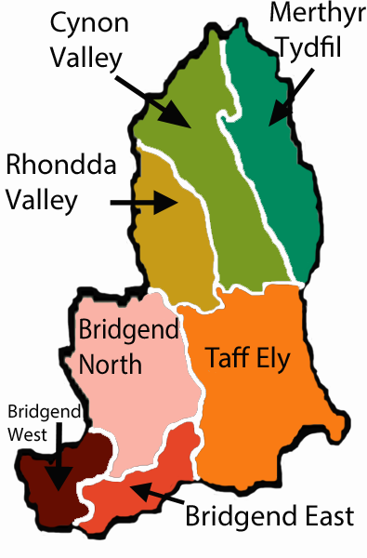
Key Drivers
- Improving population health and reducing health inequalities on a cluster level
- Integrating pathways to provide a holistic, person-centred approach to meet people’s needs
- Enabling timely access to the most appropriate service
- Patient safety, quality and clinical effectiveness
- Ensuring service sustainability in the face of increasing demand and GP recruitment/retention challenges

Primary Care Cluster Priorities
- Health promotion and prevention –healthy lifestyle advice and support; encouraging uptake of screening services particularly bowel and cervical cancer screening; encouraging uptake of flu and childhood vaccinations
- Placed based planning – using information from needs assessment, population segmentation, local intelligence, to enable targeting of service response to local need
- Transformation Programmes : offering an integrated, anticipatory response to help prevent escalation of a health or social care issue and support people to remain in their own home
- Improving access – online information advice and booking systems eg PYB Health; care navigators; promotion of Choose Well and pharmacy Common Ailments service; Out of Hours/111; commissioning of practice based practitioners eg pharmacists, physios, counsellors
- Chronic Condition Management – supporting prevention, early diagnosis, self-management, early intervention and community care, for conditions such as diabetes, MSK, CVD, stroke/AF, COPD, chronic pain, fibromyalgia, frailty
- Determinants of health – linking to information and support to help people address issues relating to their ill health – eg debt, housing, loneliness – via GPSOs, social prescribing, wellbeing co-ordinators etc

Key population health needs and challenges
Lifestyle – high rates of smoking, alcohol use, obesity, inactivity, unhealthy diet, in areas of high deprivation
Cancer screening – low uptake of screening programmes particularly bowel screening, and cervical screening amongst younger women
Immunisation – variable uptake of flu and childhood vaccinations
Clinical Risk factors – high prevalence eg hypertension, AF
Multi-morbidity – high prevalence of COPD, asthma, diabetes, coronary heart disease, stroke/TIA and multi-morbidity
Mental health – above average rates of people reporting and seeking help for emotional and mental health related issues
Anti-microbial Resistance -

Ant

Enablers
- Workforce diversification and training – development of MDT ensuring patients can see the most appropriate professional in a timely manner and GPs can focus on the most vulnerable
- Digital / IT systems and Information
- Governance arrangements

The transition of Bridgend services into the new CTM footprint has been the major contextual issue for primary and community services over the past year, bringing with it both challenges and opportunities. We are aiming to maximise the learning from good practice across the patch, including: capturing the impact on partnership working, decision making and patient outcomes of the integrated community resource team approach in Bridgend; and replicating in Bridgend the successful Health Park model developed in the former Cwm Taf area.

A key achievement in 2019 was the opening of the new ‘Y Bwthyn’ NGS Macmillan Specialist Palliative Care Unit, enabling the transfer of the current service from Pontypridd Cottage Hospital. This purpose designed facility provides a light, spacious and fitting environment for palliative care patients and their families, and has already proved clinically beneficial in terms of facilitating on-site access to acute specialists for treatments and symptom management.

The Director of Primary Care, Community and Mental Health has the Executive lead for improving the health and well-being of homeless and specific vulnerable groups. Health Boards are expected to have in place assessments and plans to identify and target the health and well-being needs of homeless and vulnerable groups of all ages including homeless, asylum seekers, gypsies and travellers, substance misusers, EU migrants who are homeless or living in circumstances of insecurity. The UHB has worked in partnership with LA colleagues, service users and the third sector to improve the health of vulnerable groups and to contribute to the prevention of homelessness:

- Taff Ely Cluster have supported a one stop shop for advice from agencies including Citizens Advice Bureau (CAB), Safe Barod, Job Centre, MIND, Hapi Project for those that are homeless. Further work being explored including the input from specialist nurses and podiatry services to provide access to health services, advice and support. Support to this approach from local businesses who have donated items of clean clothing, toiletries, food and supplies and from local policy community support officers who encourage and signpost the homeless to access this support.
- The IRIS project, which aims to support victims of domestic violence and abuse, is currently accessible to all GP practices in RCT and Merthyr Tydfil County Boroughs. Work is ongoing to extend the project to provide access for all GP practices in Bridgend County Borough.
- The All Wales Alternative Treatment Scheme provides support for violent and challenging patients who frequently have complex and multiple needs including issues with addictions, poor mental health and homelessness. The scheme provides an enhanced service liaising closely with partner agencies to develop comprehensive care plans.
- The Health Board continues to engage and co-ordinate GP care as part of the Refugee Settlement Programme.
- A Homeless Local Enhanced Service has been commissioned with 11 GP practices across the Health Board currently having signed up.
- The Health Board works closely with Women’s Refuge and local GP practices to ensure these vulnerable patients and their children are able to access GP services when needed.

The key priorities for primary and community care services are as follows:

Primary and Community Care Priorities
- Implementation and evaluation of the Transformation Model including the deployment of the wider MDT to support primary care, and securing financial sustainability following the end of WG funding.
- Continued input to support the delivery of improvements across the National Planned Care Programme.
- Maximising use of segmentation, risk stratification and value based health care to inform service redesign.
- Developing and improving Primary/Community Estate to deliver good quality and robust core provision, good quality services, robust as well as supporting the Transformation model.
- Maximisation of digitalisation/IT infrastructure/agile mobile working across Primary Care and Localities
- Improve Information Management through dedicated resource to support data analysis, performance management and reporting and use of information systems.
- Focussed effort on patient engagement and the empowerment of citizens at the planning stage of service change as well as implementation.
- Continue to strengthen and develop systematic workforce planning and training and education frameworks to support wider workforce developments/recruitment/retention including the Training and Development Hub through Pacesetter resource.
- Utilise more fully the Research and Development Resources to evaluate progress and effectiveness .
- Development of Health Parks which bring together primary care, community services and where possible LA services, in all localities. This includes the development of the Health Park model in the new facility in Porthcawl, the Bridgend Health & Wellness Centre (Sunnyside) and at Maesteg Hospital; the public opposition to the ABMU proposal to permanently close Maesteg Day Hospital has been listened to, and it is now the UHBs intention to develop the site to its full potential to ensure we provide care closer to home for the local population.

Primary Care Priorities
- Implement and progress the Primary Care Model for Wales to support the objectives within A Healthier Wales plan for Wales
- Continue to remodel urgent primary care services including
  - Development of MDT
  - Tender for GP services via consortium
  - Roll out of 111
- Continued review of enhanced services across CTM in order to harmonise and ensure most efficient use of resources supporting the shift of service delivery out of hospital and into the community.
- Support the ongoing maturity and development of Clusters and their clinical and managerial leaders.
- Support a quality improvement programme of work to address the high incidents of antibiotic prescribing and community acquired infections, as part of the Health Board’s Anti-Microbial Resistance programme, and other drug groups where prescribing is an outlier.
- Improve oral health and the range and quality of dental services provided in primary care including :
  - Review and remodelling of Community Dental Service following its repatriation from C&VUHB
  - Increasing access to Dental Services
  - Implementation of dental reform contract
  - Continued implementation of Baby Teeth Do Matter
  - Increase access to services for bariatric patients
  - Repatriation of paediatric GA activity to RGH
  - Delivery of domiciliary service in Bridgend County Borough
  - Development of intermediate care services, such as minor oral surgery, in conjunction with secondary care colleagues to reduce referrals in to hospital and provide care closer to home.
- Improve eye health and strengthen access to optometry services across CTM, including:
  - services for low vision - Implement Glaucoma monitoring in primary care and further promote Eye Health Examination Wales (EHEW).
  - Cluster IMTPs for 2021-24 to include actions to increase provision of eye care services in the community and specific actions to include at least one optometrist in the cluster with advance training for medical retina and glaucoma.
- Support the current managed practices and consider their return to independent status and manage other practice through the Health Board if necessary in the future.
- Support the expansion of clinical services where demands are growing, e.g. Aural Care, and roll out to the Bridgend Locality.
- Mainstreaming Pacesetter initiatives through 2020/23.
Within the context of the developing Health Board Integrated Health and Care Strategy, continue to support the identification of services that can be provided in primary and community care settings in order to alleviate the demand on secondary care services and provide care closer to home
Community/Localities Priorities
- Continued review and development of our community hospitals to support patient flow including:
  - optimising contribution to patient flow through ensuring effective, outcome based care and enabling timely discharge/transfer of care
  - develop a shared care approach to meeting the needs of patients with complex needs and behaviours
  - targeted and innovative recruitment strategies
  - review of the stroke rehabilitation pathway
- Scale up and roll out the District Nursing Neighbourhood Nursing approach, supported by the DN Principles and use of Malinko software, this together with issue of laptops/iPad to the DN moves the staff to being a digitally enabled mobile workforce
- Ensure the effective functioning of the new ‘Y Bwthyn’ NGS Macmillan palliative care unit and its integration with other on-site services at RGH.
- Continue to support End of Life Care (EOLC) Board initiatives such as Hospice @Home, mainstreaming Future Care planning and addressing the findings of the NACEL audit.
- Review current Continuing Health Care provision and ensure that robust processes continue to be in place to scrutinise packages.
- Development of the Lymphoedema service within RCT & MT and work towards repatriation of the SLA with SBUHB for the Bridgend service.

Milestones

Year 1 | Year 2 | Year 3
Transformation Programme – Q4 - Evaluation of CT and Bridgend models and lessons learned to inform alignment and sustainability of future services Development of financial sustainability plan | Sustaining service following end of WG funding and in light of evaluation | Sustaining service and ongoing evaluation
IM&T  Q1 – Appointment to dedicated IM&T post  Q4 – Evaluation of post and impact on data evaluation and reporting | Continue to develop new areas to monitor and report | Continue to develop new areas to monitor and report
Oral Health – Q2  - CDS – Implement recommendations from review.  - Access – Look to reduce contracts which are not meeting contract value and redistribute where need is greatest  - Dental contract reform – Continue to roll out  - Baby Teeth Do Matter implement roll out to Bridgend Localities  - Paediatric GA – Assess D&C within RGH 6. Domiciliary Visits – Repatriate and deliver throughout CTM  - Repatriate MOS from Swansea Bay | Sustain service delivery and continual assessment | Sustain service delivery and continual assessment
Urgent Primary Care – Q1  - Nurse Practitioners working in PCCs.  - 111 implementation  - Commence contract with GP consortium | Review, audit and build on progress. Contract monitoring of new contract | Review, audit and build on progress. Contract monitoring of new contract
Eye Health and Optometry  Q1  - Continue to promote EHEW  - If funding agreed commence glaucoma service within primary care  Q4 – Monitor progress and impact on secondary care waiting lists and outpatient care activity | Continue to delivery whilst monitoring progress and impact on secondary care | Continue to delivery whilst monitoring progress and impact on secondary care
Neighbourhood Nursing  Q1 – Secure funding through IMTP and scope plan for phased implementation  Q2 – If funding agreed, commence planned roll out | Review and consider other areas
Community Hospitals  Q1  - Review flow process  - Commence planning for dementia shared care if funding agreed  - Commence review of stroke pathway  Q4  - Evaluate changes to flow process  - Evaluate status of dementia Shared Care work if funding agreed  - Review status of changes to stroke pathway | Evaluate year 1 actions and commence year 2 plan which may be shared care in YCC | Evaluate year 2 actions and commence year 3 plan based on potential role out to YCC
Lymphoedema Services  Q1 – Additional staff appointed in RCT and MT  Q4 – Agree repatriation of Bridgend service and termination of SLA with SBUHB | Evaluate year 1 actions and commence year 2 plan | Service now core business
Aural Health  Q1 – Appoint staff and roll out service to Bridgend locality | Deliver and evaluate the service | Service now core business

Acute Care – Local and Regional Secondary Care
Acute care faces several present and future challenges, not least of which are:
- An ageing population and associated rise in hospital attendances associated with frailty.
- High population morbidity with mental health, substance misuse, poor lifestyle choices and long term conditions all playing significant roles.
- Growing levels of complex needs in the population (high-need, high-cost patients).
- Challenged performance on key scheduled and unscheduled care indicators such as RTT and A&E waiting times.
- Difficulties in recruitment and reduction in the numbers of medical trainees in key areas leading to service sustainability issues.
- Opportunities in many areas for improving value and efficiency.

The UHB is committed to place quality and patient safety at the heart of its planning and delivery of healthcare. Our challenge is to design and deliver high quality, high performing, sustainable hospital services for the future, delivering care locally and within our boundaries wherever possible, but effectively collaborating with neighbouring HBs on regional models of care for emergency or elective services where there is evidence that this brings better outcomes for patients.

We will do this by continuing to empower clinical leaders across the organisation to seek out best practice, develop and test innovative new service models, redesign and modernise the workforce, and drive through productivity, efficiency, quality and performance improvements, maximising the use of all our available resources (estate, workforce, technology (eg deployment of digital medical records (section 8.2.1.1), and financial). We are also ensuring both staff and patients are empowered and involved in the design and delivery of services across the organisation.

Unscheduled Care
Much of the work within urgent and emergency care (unscheduled care) continues to focus and build upon the work undertaken over 2019/2020 on patient flow. This is complex and varied and requires continued focus and change to overcome the numerous blockages and changes in the system; however, it is key to improving outcomes and quality for patients, whilst maintaining elective activity within the UHB.

Work to improve our unscheduled care pathway touches many parts of our health and care system and can only be achieved through partnership working with our LA’s, WAST and the Third Sector in particular. Earlier sections of this Plan (Section 5.2.2), have included details of integrated services with LAs such as the services funded from the transformation fund which will transform the way health and social care is delivered. This fund will enable the expansion of existing successful services like Stay Well@Home (SW@HT) and the Virtual Ward and will provide greater choice for patients, whilst reducing pressure on social care, GP surgeries and hospitals. In terms of patient flow these services have been proven to have an impact on conveyances to hospital, with admission avoidance and supported timely discharges from hospital to home. This includes deployment of Vision 360 as a Shared Care Record and increased accessibility of information across Health and Care.
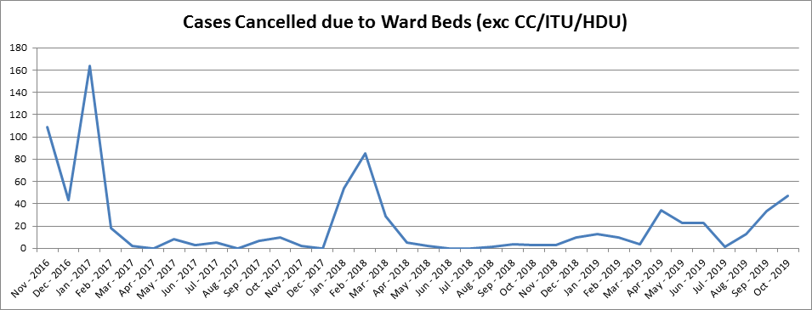
The impact of these initiatives on both unscheduled and scheduled care is being monitored and evaluated by using a number of overarching performance and quality indicators. This ensures there is alignment and collaboration across the whole system. For example, as can be seen from the graph the number of elective/day case cancellations has dropped considerably in comparison to previous years and have remained relatively low in numbers since the commencement of the SW@H service, despite an increase in demand. This is an indication of improvements in overall patient flow since the introduction of the SW@H service.

A summary of key Service areas/changes to be undertaken during 2020/2021, which have a significant impact on unscheduled care and patient flow are as follows:

Implementation of the remaining requirements of the South Wales Programme – In March 2014, the SWP Board confirmed agreement of recommendations in relation to the provision of emergency medicine (A&E), acute medicine and consultant-led maternity and inpatient services. The outcome, based on an extensive consultation exercise, was that in order to address the fragility and quality of these services, there would be a reduction in the number of sites delivering this level of care.

PCH and POWH were identified as two of five sites that would continue to provide these services, along with the University Hospital of Wales (UHW), Royal Gwent Hospital RGwH) and Morriston Hospital (MH). In relation to RGH, it was agreed that whilst inpatient paediatric services would no longer be delivered from the site, a new local paediatric assessment unit (PAU) model would be developed for the Rhondda and Taff Ely populations to ensure the majority of children would continue to have their care delivered locally. A new free-standing midwifery led birthing centre would also be provided from the hospital.

Within the recommendations, it was also agreed that RGH would become a beacon site for developing a new and innovative model of acute medicine that maximises the opportunity of delivering the widest range of medical care in a local hospital setting. The first delivery of service change against the SWP was the establishment of the acute medicine service in RGH from September 2015. This established a new 50 bed unit co-located with the Emergency Department (ED) followed by a £6m investment in the Diagnostics Hub in RGH in November 2016.

The specific challenges associated with the RGH site have resulted in the need to retain paediatric inpatient services on site to allow time to develop and consider options for a new emergency medicine (A&E) model.

Set and supported effectively, within the South Wales regional context, a plan has been developed to implement the remaining elements of the SWP to provide safe, high quality, accessible and sustainable services. Specifically, local service models for emergency medicine, completion of the acute medicine beacon site model, paediatric assessment at RGH and the transfer of consultant led inpatient paediatric services to PCH by September 2020.

Stroke Services - The UHB have continued to make progress with regards to the implementation of the “Together for Health – Stroke Delivery Plan”. Following the Bridgend boundary change, we have been working to refresh our approach to stroke service improvement, focusing on how we can further improve the quality and performance of our stroke services to the communities we serve. It is recognised that there is a direct correlation between stroke services performance/quality and the level of escalation within a DGH in particular, because stroke services currently rely heavily on the support of the ED. In summary the challenges within our current stroke service which are more pertinent to patient flow and unscheduled care are as follows:
- Both stroke units currently run a 5 day service. There are real challenges to being able to consistently deliver high compliance for assessment by a consultant within 24 hours across the organisation, given that there is 2.6 WTE Stroke Consultants at PCH and 2.0 WTE at POWH, with very limited middle grade cover. There are also challenges in delivering a 7 day service for nursing and therapy provision due to current staffing numbers.
- Thrombolysis rates and door to needle times continue to be a challenge and is an area of focus for further improvement.
- Both stroke units have a specific challenge around achieving the 4 hour target for admission to the stroke unit. Significant patient flow issues and pressures across both sites have a direct impact on stroke service provision.
- Within PCH there is a Community Stroke/Neuro Rehabilitation service which is currently funded out of National Stroke/Neurological on a non-recurring basis. There is also an Early Supported Discharge Service which is currently funded out of Intermediate Care Funds (ICF), so currently there is no long term funding identified for these services. Within POWH there is no stroke/neuro rehabilitation service or an Early Supported Discharge Service which has a direct impact on patient flow.

There is a plan to produce a new CTM Stroke Improvement plan May 2020 which will drive service improvement and quality.

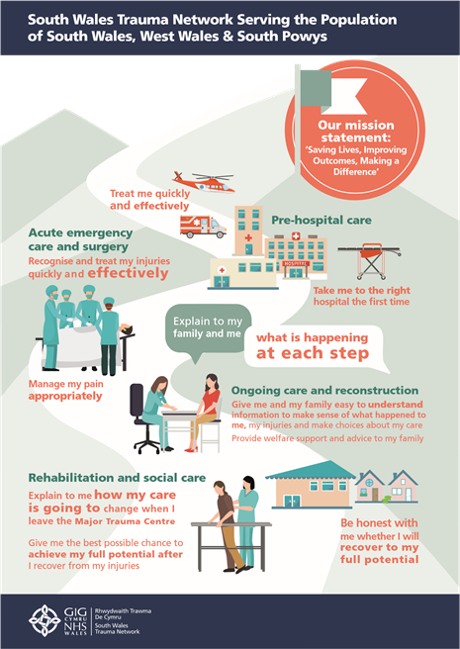
Major Trauma - One of the key priorities within unscheduled care for 2020/2021 and beyond is the implementation of the major trauma model across CTMUHB. Trauma Units will be operational at PCH and POWH from 1st April 2020. This is being taken forward as part of the integrated network for South and West Wales and South Powys. The likely impact which is being planned for will be:
- Patients who would have been seen in RGH will now flow to PCH or POWH,
- There will be an increased flow to UHW for patients who would have been seen originally within CTM
- There will be implications with regards to the repatriation of patients back from UHW in a timely manner and the provision of their rehabilitation needs.

This development will have the following quality outcomes / benefits:

Objective | Benefit
Health gain | Improving survival  Improving functional outcomes  Improving timely clinical and patient experience | Improving data collection  Enhanced response at major incidents or mass casualty events  Enhancing injury prevention
Equity | Enhanced access to specialist care  Enhanced patient flow  System wide improvements in care | Equity of care for trauma in older people  Veterans trauma network
Clinical skills and sustainability | Enhanced multi-professional training and education | Enhance recruitment and retention of workforce  Development of new roles and ways of working
Value for money | Economic benefits  Savings across the system | Value to other patient groups and networks

Alignment to the National Unscheduled Care Development
National Emergency Department Quality and Delivery Framework
The Minister for Health & Social Services has requested an understanding of ‘what good looks’ like for patients accessing an ED and the creation of a National ED Quality & Delivery Framework (EDQDF) for NHS Wales. Further detail can be found in Annex 3. However key activities to date and planned are included in the story board below (see also section 8.2.1.2).

Pre Hospital
Often an individual’s care and support needs are best provided in the community or their own home. A significant focus therefore continues to be those priorities which, through integrated care and partnership working, either address an individual’s rising need before they require hospital admission or directs them to the correct service for their need.

Priorities and initiatives being put in place within Integrated Community Services and Primary Care, including WAST are:
- Delivery of the RPBs Stay Well in Your Community Programme, (see section 5.2.2) including the use of Advanced Paramedic Practitioners within the Enhanced Community Cluster Teams and partners including WAST supporting the SW@H service by referring directly to a multi-agency single point of access to avoid conveyances to hospital.
- The introduction of appropriate sign posting of patients to alternative primary care professionals, dentists, optometrists and pharmacists based on assessment of identified need.
- Encouraging utilisation of the common ailments scheme within community pharmacies where appropriate.
- Following evidence gained from a pilot, the virtual ward will be rolled out as part of the UHBs wider Transformational Plan.
- Encouraging the use of alternative methods for GP consultations such as, telephone triage and advice software such as WebGP.
- Cluster schemes have commenced around chronic conditions management. These include COPD where a team follow up a patient recently discharged from hospital following an acute exacerbation of COPD to ensure they are not relapsing and at risk of a further admission. The evaluation of the scheme has shown a decrease in GP attendance, OOH call and emergency admissions. The primary care team are currently developing plans to roll out this initiative across the UHB.
- Joint pathways have been agreed with WAST for chronic conditions such as diabetes, falls and respiratory. Where patients can be kept at home the paramedics will pass information onto the GP and District Nurse and a visit will be made to the patient within 48 hours.

Ambulance Services
The Welsh Ambulance Service NHS Trust (WAST) has an important and increasing role to play in supporting sustainable improvements across the unscheduled care system in Wales. A range of scalable service transformation initiatives have been proposed and discussed with the Chief Ambulance Services Commissioner (CASC) and Health Boards through the EASC and EASC Management Group. It is proposed that WAST and the Health Board will prioritise the expansion of the following three service initiatives to be included as key developments within the Health Boards respective IMTP for 2020/21:
- Initiative 1: Expansion of the Falls Response Model focussing on the implementation of a level 2 falls response service within each Health Board;
- Initiative 2: Expansion of the Advanced Paramedic Practitioners (APP) model;
- Initiative 3: Expansion of pre-hospital clinical pathways / wider system referral pathways focussing on a national Respiratory pathway (other national pathways to be identified and prioritised in collaboration with UHB colleagues).

Further specific areas of work will include:
- Following establishment of CTMUHB in April 2019, WAST will now need to change their operational management boundaries to align with the new health board arrangements. Commencing April 2020 WAST will be developing the required workstreams to take forward this work.
- Review of the current pathways of care between WAST and CTMUHB in a programme of work that will review, refresh and improve options for patients. In particular focusing on more robust alternate pathways for conveyance.
- Development of a Standard Operating Procedure with CTMUHB Patient Access Team to utilise transport options other than default WAST resources for GP admissions
- Develop secondary triage of calls suitable for referral to established patient pathways in partnership with CTMUHB and Local Authorities.
- In conjunction with CTMUHB explore developing the Single Integrated Clinical Assessment and Triage (SICAT) model across South East Wales.
- Develop a Respiratory Pathway with CTMUHB Primary Care Team or Local Authority @ home service to support patients in their own homes and negating the need to admit to DGH unnecessarily.
- Develop a D&V Pathway with CTMUHB Primary Care Team or Local Authority @home service to support patients in their own homes and negating the need to admit to DGH unnecessarily.

Ward Based Care
Many of the bottle necks and delays within the system occur during the early part of the day and weekend discharge rates are minimal. Plans are already being implemented to:
- Continue the daily multidisciplinary board rounds on District General Hospital (DGH) sites.
- Monitor the implementation of the anticipated day of discharge model on all hospital sites in line with the frailty model.
- Monitor implementation of criteria led discharge across all hospital sites.
- Utilise the discharge lounges facilities on each DGH site.
- Audit and monitor the live bed management/patient transfer system.
- Continue with daily deep dives at each of the community hospitals.

Supporting the Emergency Department
A range of actions are already underway to improve system performance in the acute part of the unscheduled care pathway and these include:
- Establishment of Ambulatory Emergency Surgical Unit (AESU) in POWH to improve performance within the ED in re-routing patients from ED to the AESU, improve patient flow and improve 4 hour target compliance.
- Establishment of a frailty at front door service in POWH with a multi-disciplinary front door assessment service to deliver comprehensive geriatric assessment for older patients attending the POWH Acute Medical Unit and ED to ensure all suitable patients have an early assessment and follow the appropriate pathway to meet their needs.
- Ambulatory care facilities, including Age Connect Morgannwg early discharge support service, are aligned with the EDs on all acute sites.
- Following a meeting with WG joining other EDs in Wales to host the British Red Cross “Well Being and Home Safe Service” which is a volunteer led service. The service will be operational from December 2019 at PCH and RGH, 10 hours a day 7 days a week. The service has been operational at POWH over the last year as part of a pilot project.
- Psychiatric liaison and crisis resolution services.
- Review on a case by case basis those patients who remain in the ED over 12 hours to understand the reasons and highlight issues within the patient pathway.
- Dedicated space on each DGH site to protect minor injuries stream.
- Further develop Consultant in Acute Medicine model to improve cross cover and depth of Consultant cover and in-reach into the ED to cover medical intake.
- Increase senior decision maker medical workforce and develop robust models for practitioner and nursing workforce to ensure sustainable emergency medicine model.
- WG has allocated funding to all Health Boards for a frequent attenders service. Two Case Managers and admin assistants have been funded until the end of the financial year. Clinically led frequent attenders meetings are now held on a regularly basis on each site.
- As mentioned previously the SW@HT service including a skill mix of social workers, occupational therapists, occupational therapy technicians and physiotherapists, working seven days a week from 8am to 8pm, will undertake assessment at EDs and support individuals to be discharged home. SW@HT will access a four hour response from social care and the nursing @home service to ensure appropriate support can be provide in the community to ensure a safe timely discharge.
- Implementation of the new ED Clinical Information and Management System (section 8.2.1.2).

Discharge and Locality Based Care
As mentioned above, as one of the Transformational Fund requirements, one element of current community health service provision which requests a key development in the shift to “out of hospital” care to date, is our @Home Single Point of Access which includes a range of clinical interventions supported by Triage:
- Consultant led assessment (72 hour)
- Initial Registered Nurse Response (4 hour)
- Community IV intervention (same day)
- Community replacement fluids e.g. subcutaneous.

These services help bridge the gap between core primary/community and secondary care services and support our district nursing and GP colleagues in complex assessment and care in the community.

Summary of other key areas of work particularly over the Winter Period
Further information on these initiatives is detailed within our Winter Plan 2019/20.

Work on patient flow across the whole healthcare system continues with implementation of the following interventions:
- Implementation of revised local escalation protocols.
- Improved use of WAST pathways and operational efficiency measures.
- Local Authority preparedness.
- Robust planning for the Christmas and New Year service provision
- Increased focus on the implementation of the Seasonal flu campaign
- Zero tolerance of ambulance delays.
- Daily deep dives by senior nursing team.
- Twice daily site based flow meetings.
- Continued implementation of daily board rounds.
- Planning anticipated dates of discharge.
- Live bed management system.
- Robust implementation of Choice Protocol.
- Continued strengthening of the Primary Care out of Hours service.
- Implementation of a communication plan aimed at promoting local and national winter health messages.

Milestones

Year 1 | Year 2 | Year 3
Regional Transformation  See section 5.2.3 for detailed milestones for years 1 & 1)  Implementation of the SWP  Q1 Continued implementation of the Communication & Engagement Plan.  Q1 Approval of detailed service models.  Q1 Business case development and approval.  Q2 – Q4 (September 2020) Commencement of the implementation of emergency medicine service model (dependent on model & any capital requirements), completion of acute medicine beacon site model, paediatric assessment unit at RGH and transfer of consultant led inpatient paediatric services to PCH by September 2020.  These milestones will need to be further discussed / agreed.  Stroke  Q1 Implementation of the Stroke Service Improvement Plan which will include the scoping work for HASU development.  Winter Planning & Managing periods of increased demand  Q1 Undertake a review/ evaluation of Winter 2019/2020 and consider lessons learnt.  Q2 Commence Winter Planning preparedness for Winter 2020/2021.  Major Trauma  Year 1 - As part of the Network plan for South & West Wales & South Powys, implementation of major trauma model across CTMUHB. Trauma Units to be operational in PCH & POWH by 1st April 2020. To include recruitment of TARN & Rehab Coordinators, Major Trauma Practitioners &  Year 1 – Network Programme Business Case will be developed to describe the schedule of business cases to be producing during Y1 & Y2 in order to support subsequent developments of the programme.  Year 1 – Network to provide Health Board’s with guidance on the phased approach to develop landing pad/rehab facility. Major trauma practitioners /rehabilitation coordinators /therapists to form a team, supported by weekly visit by rehabilitation consultant.  Develop model for landing pad/rehabilitation facility | Continue the evaluation of the Transformation Programmes.  Commence post implementation evaluation.  Q1 Review and implement year 2 of the Stroke Service Improvement plan, the scale of service change dependent on the outcome of the HASU service scoping work.  Q1 Undertake a review/evaluation of Winter 2020/2021 as part of the rolling cycle to plan to meet increased demand. Development of a plan within Q2 in line with WGs requirements. Q3 Winter Plan implementation.  Years 2 & 3 – Major Trauma therapy/rehab/  neuropsychology requirements to be delivered.  Year 2 – Business Case for Orthogeriatric requirements to be developed. | Continuation of Winter Planning cycle as described.  Years 3&4 – Orthogeriatric requirements to be delivered.  Year 3 - Delivery of dedicated landing pad within existing infrastructure OR new infrastructure depending upon local service developments circumstances.  Delivery of nursing staffing requirements.

Planned Care
The UHB clearly recognises the benefit of early assessment and treatment on health outcomes and places a high priority on achieving national access targets which, as part of the planned care system, includes looking across primary care, community and hospital services. Our primary and community care section demonstrates that we are committed to re-balancing planned care pathways and through our cluster plans we are seeking to develop appropriate components in primary and community care to reduce the reliance on secondary care; reflecting the principles of prudent healthcare.

We continue to take positive steps to improve our performance, including implementing a range of ‘enabling’ measures that are linked to improving patient flow and process efficiency; all contribute to the development of a sustainable service model. We remain committed to our journey of continuous improvement necessary to develop a sustainable service model for planned care.

The UHB has placed a strong emphasis on quality in the delivery of care and services for the populations we serve. This is within the context of the Quadruple Aim to ensure that people are supported to manage their own health and wellbeing and to live independently in their own homes for as long as possible, supported by targeted multi-professional integrated health and social care services that will meet their needs delivered by the right professional at the right time as locally as possible; and with strengthened patient and staff involvement and empowerment in the design and delivery of care and support across the organisation. It is imperative that we have an ongoing dialogue with patients and staff to continuously identify what constitutes high quality care and ensure that meaningful patient involvement is embedded in our quality improvement programmes.

We will continue to improve the ability of the organisation to listen to and learn from our patients and their families and ensure that the planning and delivery of services is based on a robust process centred around meaningful engagement, learning from patient experiences both positive and negative, in order that we can improve the experience of patients and their families. We will continue our approach to embed Patient Reported Outcome Measures (PROMS) to support the implementation of both a Prudent and Values Based Healthcare approach across the organisation to ensure we deliver and monitor desired outcomes that matter to individuals.

Children, Young People and Families
We are planning to develop fully integrated health and well-being services where children, young people and their families will receive a range of services by the right person, at the time when we can make a real difference to their needs and at the pace that is most beneficial to them.

Over the last year, CTMUHB has implemented the centralisation of the Neonatal Unit to PCH in line with the SWP. The newly built unit ensures care for new born infants in line with national guidelines and robust pathways have been put in place to ensure safe and effective care for those in need of the unit. Further work will be undertaken to strengthen therapies input within the Neonatal Unit to develop integrated and joint working processes.

Work will also be undertaken to ensure capacity can be met safely in the Neonatal Unit in POWH by the completion of a business case to highlight the need for funding for the stabilisation cot, 1 HDU and 1 Special Care cot and the additional staff resource needed to deliver care effectively.

The provision of safe, sustainable paediatric services remains both a priority and a challenge for the Health Board through the ongoing full implementation of the SWP, whilst service delivery plans for paediatrics such as the Paediatric Assessment Unit in RGH are being finalised. At the same time we must also consider the short and long term impact on other associated services such as Obstetrics and the ED. Regional Paediatric, Obstetric and Neonatal services remain central to our work and require strong links with our neighbouring Health Boards.

We will continue to challenge existing practice and further develop ways of working differently with strong service pathways to enhance care and support for children and their families.

Milestones

Year 1  Q1: Bid produced for therapist input in the Neonatal Unit.  Q1. Business case completed for Neonatal Unit in POWH for extra costs and staff resource.  Q1 Paediatric Neurology clinics run.  Q1: Work on Paediatric Assessment Unit interdependencies with A&E, Obstetrics and Gynaecology.  Q2: Bid complete for therapist input into Neonatal Unit for approval.  Q2: Implementation of Paediatric Assessment Unit in RGH.  Q3: Recruitment of Therapists for Neonatal Unit. | Year 2  Q1: Evaluation of Paediatric Assessment Unit in RGH.  Q1-4 Continue to run Paediatric Neurology clinics in POWH. | Year 3  Q1: Realisation of benefits of Paediatric Assessment Unit in RGH.  Q1-4: Continue to run Paediatric Neurology clinics in POWH.

Women’s Health and Integrated Sexual Health Services
The Health Board provides a range of maternal, women’s health and integrated sexual health services. The last year has been a year of challenge, change and learning with significant work to improve services being undertaken following a number of critical reviews by external bodies including the RCOG and HIW.

There are five priority areas for sexual health in Wales over the next five years (2019 – 2024). These have been clinically identified and seek to reduce social and healthcare costs. Progress has been made against the priorities in the following areas:

Long Acting Reversible Contraception (LARCS) are routinely offered within Sexual Health clinics and there is close working with LA partners such as substance misuse services and Families First to help target the most vulnerable in our society. Future developments will include sexual health staff training midwifery staff to deliver LARCS postnatally and the development of an electronic Emergency Hormonal Contraception module that will audit LARC offerings.

98% of people with needs relating to STIs contacting a service are offered to be seen or assessed with an appointment or as a ‘walk-in’ within 2 working days of first contacting the service and 80% of people are seen or assessed within 2 working days of first contacting the service. The service is going to look at a bid for text messaging results to improve turnaround times.

This year processes have been implemented to support women to be able to self-refer to the Pregnancy Advisory Service, this change aligns the services in the UHB with those in other UHBs across Wales. Other changes to the way in which these services are delivered has improved accessibility and patient experience. Work will continue with the aim to offer an appointment for assessment within 5 working days of contacting the service.

HIV patients are seen and managed in a timely manner within the service and Pre-Exposure Prophylaxis (PrEP) is routinely offered to patients accessing our service. An HIV specialist pharmacist has been funded full time this year, this development has yielded both clinical and financial benefits. In addition, the home delivery service for HIV medicines has helped improve patient experience.

There are also plans in place for 2020 to become paper light within our services to assist in the implementation of an All Wales Electronic Case Management system for sexual health services.

In addition, the development of Sacral Nerve Stimulation service is recognised by the UHB. It is estimated that around 120 patients in Wales could potentially benefit from the sacral nerve stimulation procedure. Work has shown that outsourcing treatment can cost up to 30% more than this procedure being provided in Wales. Support has been given to developing a more detailed proposal.

Maternity and Obstetrics Services
In March 2019 the obstetrics element of the SWP was implemented with consultant led obstetric care being consolidated on the PCH site and a freestanding midwifery unit being established on the RGH site.

The importance of accommodating women’s choice in birthing location has been improved by the consolidation of consultant led care in CTM and provides increased options for where women can birth. Women who require consultant led care can now choose between PCH, POWH and UHW as part of regional arrangements. As a result of these changes women now have four birthing options: Consultant - Led Birth; Alongside Midwifery Unit; Freestanding Midwifery Unit and Home Birth.

Regional work is continuing to take place to fully understand the new flows that are occurring due to the recent consolidation of services in the UHB and to ensure that the resources match the demand. This monitoring has identified that as a result of women’s choice, C&VUHB have seen higher than excepted CTM births at University Hospital Wales. This has led to endorsement that a further 200 consultant led births for CTM women to transfer to UHW. In developing the joint plans across CTM and C&V UHB’s, the Regional Obstetrics Planning Group considered the following:
    - maintaining women’s choice was paramount;
    - ante-natal care should be provide as locally as possible via C&V staffed ‘spoke’ ante-natal clinics that will be provided at RGH;
    - midwifery led services would always be offered to women where clinically appropriate; and
    - operational delivery must be sustainable.
The ‘spoke’ antenatal clinics have been designed for a capacity of approximately 400 women, to enable all those women who choose to birth in C&V to receive their antenatal care closer to home.

Maternity Improvement Programme

Following concerns raised early in 2018 regarding failings in maternity services within the former Cwm Taf Health Board the Royal College of Obstetrics and Gynaecologists (RCOG) were commissioned by CTUHB to undertake an independent review and establishment of the Maternity Improvement Board (MIB) in September 2018. The concerns were further escalated and the wider concerns raised by Welsh Government, Wales Audit Office (WAO) and Healthcare Inspectorate Wales (HIW) regarding quality, culture, leadership and governance, which resulted in escalated monitoring to special measures for maternity services for the UHB.

The Royal College of Obstetricians and Gynaecologists (RCOG) and the Royal College of Midwives (RCM) published their report into maternity services at both Prince Charles and Royal Glamorgan Hospitals on 31 April 2019. There were a number of areas of concern raised within the report that the UHB were tasked to respond to. An independent Oversight Panel was appointed which set out to:

- Provide assurance, constructive challenge and oversight of the improvement against the 70 RCOG/RCM recommendations
- Establish and agree an independent multidisciplinary process to clinically review relevant cases and to ensure that any learning which emerges from these reviews is acted upon by the UHB and others

The following structure was put in place and has been working to review and implement the learning from the report and the review and improvement work that has followed:
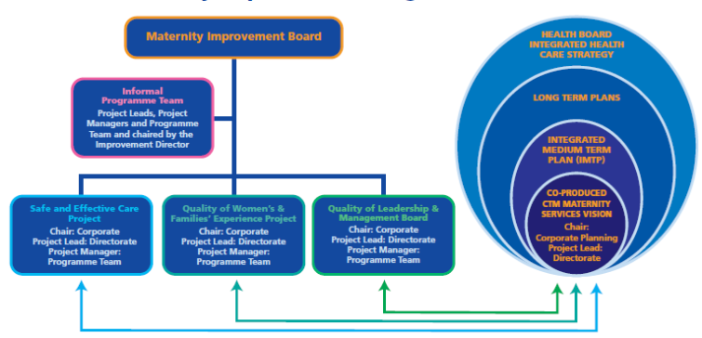

Immediate actions taken forward have focussed on Consultant cover, training and induction, staffing levels specifically of midwifery teams, governance and safety, senior management and leadership as well and work to review and improve the culture and behaviours across the organisation.

There has been significant progress made in the following key areas with a few of the key developments evidenced:

Safe and effective Care – Evidencing early progress:

Work has been undertaken to align Maternity Theatres with the Anaesthetics, Critical Care and Theatres (ACT) directorate for staffing and day to day theatre running. Priorities for this work include the reduction of hospital acquired infections and improvements to the maternity theatres to ensure compliance with the relevant standards. Funding has been received for stage one of these developments and a further business case is being developed to support the transfer of obstetric emergency theatre cases to the ACT directorate.

Potential efficiencies were identified within maternity services linked to the implementation of a dedicated Pharmacy resource. A pilot demonstrated that discharges were quicker and missed doses were reduced with the service in place. A business case to substantively support this development will be progressed this year and once established further opportunities to expand the initiative through the directorate will also be explored.

Other areas of progress include:
- Governance Framework in place for midwifery and Consultant leads for key elements
- Increased audit activity and updating of clinical guidelines
- Full multi-disciplinary engagement
- Engagement and learning including women and family stories

Quality of Management and leadership – evidence of early progress:

- New Maternity Service leadership team largely in place, with a New Clinical Director, Directorate Manager and Director of Midwifery.
- Recruitment of three Consultant Obstetrician and gynaecologists, Consultant Midwife, Deputy Head of Midwifery, Intra-partum Lead Midwife as well as additional registered midwives recruited at PCH
- Training programme developed and improved compliance

Quality of Women’s and Families’ Experience – evidence of early progress:

Ongoing engagement has continued to ensure the quality of women’s experiences, work is being undertaken on the miscarriage pathway to bring in line with NICE guidance to ensure high quality care for women who have suffered a pregnancy loss. This is being undertaken with a multidisciplinary approach with colleagues from midwifery, gynaecology, primary care and pathology engaged.

Other areas of progress include:
- Women’s experience Midwife appointed
- Community engagement events held across Merthyr, Llantrisant and Bridgend
- Lay Chair in place for ‘My Maternity My Way’
- Increase in the governance team to improve and speed up the response to complaints and concerns raised by women and families.

What others are saying about our improvement work:

The Minister/IMSOP’s first quarterly report published on 8th October 2019 noted:

- Better understanding of the problem and underlying causes
- The Health Board has recognised that there are broader, deeper organisational issues to be addressed
- Foundations for improvement largely in place
- Reasonable assurance about the eleven ‘make safe’ recommendations
- The reconfiguration of services has been achieved without obvious negative consequence

The CHC report August 2019 of 3 unannounced visits to PCH in June and July 2019 noted:

- Women reporting generally good experience of care but mixed picture in terms of staff morale

Health Inspectorate Wales (HIW) inspections of RGH September 2019 – teams congratulated for significant improvements to staff morale, culture environment and women’s experience

Health Education and Improvement Wales (HEIW) October 2019 – a really positive training experience for medical trainees. ‘Teaching was described as brilliant’.

Moving forward and key milestones for the coming year:

We are aware that there are still areas for development and ongoing improvement and over the next year the UHB and Directorate of Obstetrics and Gynaecology service will aim to continue to further learn from the engagement work we have committed to, and further implement the recommendations made. Key milestones will be:

- Working on sustainable improvement on themes from women at PCH – eg timely analgesia
- Continue to improve complaint response times and experience
- Improvement plan focussing on moving from ‘early progress’ through to ‘results’ phase in the maturity matrix
- Focus on working in partnership with staff, women and families and other stakeholders to drive sustained improvement
- Improvement through the lens of Values and Behaviours
- Engagement and completion of our maternity vision and strategy

Gynaecology Services
Following the implementation of the SWP, gynaecology services are now provided in a different way across the UHB.

A Gynaecology Day Assessment Unit (GDAU) with Early Pregnancy Unit (EPU) has been established on the RGH site. The GDAU and EPU provide consultant led services throughout the day, responding to the health needs of our women. Also nurse led clinics run from the GDAU allow for waiting times to be further reduced. Additional work is being undertaken to review the clinical model in the GDAU to scope the potential for other services to be provided from there in the future such as nurse led pessary clinics.

The GDAU’s in PCH and POWH are currently under review to ensure consistent services are provided across the UHB with the additional aim of improving flow through the sites.

Theatre availability continues to be a concern in PCH, POWH and RGH and while significant improvements in RTT have been seen there is still more to be done. The business case for outpatient hysteroscopy has been updated recently and shows the benefits of moving this service to outpatients rather than undertaking them in main theatres. In many cases an outpatient setting is preferred by women and this change will release inpatient capacity helping to improve waiting times. Further work will now be undertaken to incorporate the POWH service into future service plans to ensure consistency and equity across the UHB.

Milestones

Year 1  Q1 – Q4 Maternity Improvement Programme.  Q1 Sexual Health Services to become paper light  Q1 Implementation of Miscarriage pathway.  Q1 Emergency maternity theatres business case completed.  Q2 Training of midwifery staff to deliver LARCS postnatally.  Q2 Expansion of services in GDAU RGH to include nurse led clinics.  Q2 Expansion of maternity pharmacy support.  Q2 Bid for text messaging STI results  Q3 Development of an EHC electronic module  Q3 Emergency Maternity theatres aligned to ACT directorate.  Q3 Outpatient Hysteroscopy business case that includes POWH service to be completed.  Q3 & 4 Review of PCH GDAU and new service model agreed. | Year 2  Q1 – Q4 Maternity Improvement Programme.  Q1 All Wales Sexual Health Case Management System in place  Q1 Implementation of STI Text Messaging results  Q1 Review of GAU POWH and new service model scoped.  Q1 Benefits realisation of GDAU in RGH.  Q1 Implementation of Outpatient Hysteroscopy model across the UHB.  Q2 Benefits realisation of LARCS being delivered postnatally.  Q2 review of Maternity Pharmacy Support and further expansion of service.  Q3 Audit of data from EHC module and changes made regarding LARC offering  Q3 Evaluation of GAU in PCH and benefits realised.  Q3 New service model for GDAU POWH implemented. | Year 3  Q1 – Q4 Maternity Improvement Programme.  Q1 Benefits realisation of STI text messaging results  Q3 Benefits realisation of new service model in GDAU POWH.  Q3 Continued audit of EHC module

Local and Regional Elective Care
The UHB has been proactive over a number of years in developing elective services and determining specific areas which would benefit from service redesign. Delivery of this work programme will assist the organisation in meeting the target trajectories for RTT, diagnostic and cancer targets:
- Efficiency, Productivity and Value: The aim is to accelerate the delivery of productivity and efficiency targets for Theatres and Outpatient Improvement. Directorates are supported to develop actions that impact positively on improving access and waiting time targets also ensuring alignment to the D&C plans. This includes a programme to measure the impact of these activities on the planned care system overall and in particular to evidence these changes to improvements in RTT performance and how these can be maintained.
- Improve day case rates and options for delivery: There is a focus on understanding demand, capacity and utilisation across the Health Board sites, capturing opportunities for more effective use of resources to increase day case rates across the UHB and benchmarking current activity against the British Association of Day Surgery (BADS).
- Improving patient flow: Key enablers are increasing day of surgery admission, improved treat in turn rates and pre-operative assessment.
- Pathway Transformation: There will be continued focus on delivering activities that will improve patient pathway management for elective care across the whole pathway from Primary into Secondary Care. This includes the identification of alternative pathways and the development of services across primary and secondary care to offer alternatives to outpatient, inpatient or consultant led hospital delivered care. These elements are key to ensuring the delivery of RTT and need to be maintained into 2020/21 and beyond.

The work is being driven by the Health Board Planned Care Group, chaired by the Chief Operating Officer. Its purpose is to develop a strategic framework to deliver and measure improvements across the planned care system, creating opportunities to organise services to reflect the principles of both Values Based Health Care and Prudent Health Care.

The Health Board has set a challenging trajectory for delivering the 36 week RTT target across all specialties by March 2020, with it being maintained thereafter. This will require additional capacity to be delivered in key specialties such as Orthopaedics, ENT, General Surgery and Ophthalmology to keep the number of patients waiting over 36 weeks to a minimum. This will be further supported by continued progress on planned care initiatives, supported through enhanced PMO resource, as well as consistently delivering expected levels of capacity committed to within our detailed D&C plans.

Following an internal review by the UHB, it became apparent that a number of waiting lists were not being reported to WG. As a result, the UHB requested support from the Delivery Unit (DU) in resolving the issues identified and to provide assurance that actions have been put in place to mitigate future risk of inadvertent non-reporting of waiting lists. Following publication of a report from the DU, the UHB has agreed an action plan to deliver their recommendations:

- Quantify the scope of patients who have not been appropriately reported and assure there are no other areas of potential concern from a reporting perspective.
- Ensure that any clinical risks to the patients affected is identified and appropriately managed.
- Ensure at the earliest opportunity that all waiting lists are appropriately reported going forward.
- Ensure the specialties affected have access to sufficient capacity to ensure that patients can be seen in a timely manner in line with RTT targets.
- Establish what systems, processes and governance arrangements need to be in place to prevent situations like this occurring again.

A summary of the key elements of the work programme is detailed below:
- Breast Services – The project to centralise breast services was completed in 2017/18 and all clinics and surgery is now undertaken at RGH. A preferred option has been identified for the future provision of breast services that would co-locate outpatient and imaging services enabling improved patient flow, enhanced facilities for training, enhanced patient experience and improved environment for patients and staff. The focus for 2020/21, linked to the wider RGH developments, will be continue to plan for the dedicated state of the art Breast Centre on the RGH site, supported with money raised by the Giving to Pink campaign, as part of the wider programme of planned service changes for the RGH site.
- Cancer – During 2017/18 the Health Board established a formal Early Cancer Diagnosis Programme which focuses on improving survival outcomes for our local population. The key elements of the programme which continue in to 2020/21 include:
  - Embedding and evolving the Rapid Diagnostic Clinic as a mainstream service following a successful two year pilot phase.
  - Public awareness – A programme of community engagement to address barriers to early presentation of cancer, recognising the culture within our local communities in relation to cancer presentation.
  - Increasing and strengthening diagnostic capacity to facilitate the delivery of the Single Cancer Pathway. Developing expertise and increasing resource to deliver national optimal pathways.
- Theatres – development of a dedicated day surgery unit on the RGH site; standardise Pre-Operative Assessment Screening Service.
- Outpatient Improvement - reduction in outpatient DNA rates from improved text and remind coverage; improved delayed Follow Up Not Booked Position with particular focus on clinical risk; work collaboratively across Health Boards to explore predictive modelling options to minimise DNAs and cancellations; explore the potential to introduce new technology approaches to deliver outpatient services closer to patient’s homes and communities.
- Develop and implement expansion of current Glaucoma team in POWH to enable provision of services that meet the new eye care measure as part of the national planned care work.
- Development of a nutrition team in POWH to provide support for patients in accordance with NICE recommendations for patients who require nutritional support to be managed by a dedicated multidisciplinary nutrition team.
- Develop a sustainable Heart Failure Team across the UHB.
- Implementation of a sustainable cardiology service in POWH. The service currently delivers all treatment and diagnostic services within RTT targets however performance is maintained with consultants working more than 10 sessions and some additional WLI activity.
- Develop a sustainable ITU Consultant workforce in POWH to improve quality, safety and patient experience.
- Maintain the endoscopy service at PCH and expand the endoscopy services in RGH, as part of the interim plan, leading to the longer term Phase 2 development of the Diagnostic Hub and achieving JAG accreditation.
- Develop organisational frailty and orthogeriatrician model across the UHB.
- Development of dedicated ring fenced acute NIV service on the acute sites to deliver timely, safe and effective care to patients whilst acknowledging the prospective remodelling in line with the South Wales Plan.
- Develop enhanced neurophysiology services for the local population.
- Gastroenterology – roll out of an out of hours 24/7 upper GI Bleed Roster (currently 12 hours a day).
- Progress on Improved Critical Care infrastructure in preparation for organisational changes, changes in demand anticipated and to meet the Critical Care Network quality standards.
- Progress on the plans to deliver a central decontamination unit on POWH site that maintains JAG accreditation.
- Establish tracheotomy specialist nurse.
- Re-design of Chronic Pain service across the UHB to provide additional capacity to meet RTT targets and to be able to provide a high quality service and address inequity of access across the UHB.
- Re-design of elective/emergency Trauma & Orthopaedic Service to provide timely trauma surgery and reduce cancellations of elective surgery due to the impact of trauma, including the provision of E-PROMS as a key enabler to increase the provision of virtual follow up appointments.
- Develop a sustainable Urology workforce model across the UHB to improve quality, safety and patient experience.
- Undertake clinical review of Ophthalmology services across the UHB and implement a service model that will provide patients with equitable access to a safe, effective and sustainable service.
- Undertake clinical review of Oral and Maxillo-facial (OMF) service provision and develop a sustainable service model across the UHB that will provide patients with equitable access to a safe and effective OMF and restorative dentistry service.
- Continue to work with HB colleagues across the region to take forward the implementation of the vascular service centralisation ensuring that the service model provides a safe and timely service for our residents.
- Continue to work with HB colleagues across the region to take forward the development of the National Ophthalmology Electronic Patient Record, e-referral and development of regional high volume cataract facility for South East Wales.
- Cochlear – development of an agreement with WHSSC on plans for provision of cochlear implant service in POWH.

Alignment to National Planned Care Programme
The National Planned Care Programme provides a methodology for improving the delivery of planned care services in Wales. The Programme structure provides a balanced approach to service change, based on prudent healthcare principles, which are designed to augment HB efficiency measures and changes to the capacity of existing health care processes. The key priorities for improvement include:
- Ophthalmology: Implementation of new eye care measure; increased number of patients seen by multi-disciplinary practitioners (optometrists, advanced nurse practitioners) where clinically appropriate; implementation of the cataract pathway.
- Orthopaedics: Virtual follow up activity for hip and knee arthroplasty (PROMS).
- ENT: Implementation of follow up guidelines.
- Urology: Self-management follow up of patients with prostate cancer; to remain in the community and to reduce unnecessary follow up appointments.
- Dermatology: Tele-dermatology to support primary care and provide better access to specialist opinion in rural areas; roll out of low risk surgical procedures to be undertaken in primary care; appointment of clinical fellow posts.

The UHB Planned Care Group oversees the implementation of plans arising from the National Planned Care Programme through their individual delivery groups based on the common principles of:
- Best in class.
- Clinical value prioritisation.
- Integrated Care.

Central to the Planned Care programme is finding ways of empowering patients to take greater control over their health, backed by evidence that this leads to better outcomes and lower costs. The Health Board has continued our focus on ensuring greater involvement of patients in decision-making on their care/treatment options.

As part of the National Planned Care Programme, the Outpatient Transformation Steering Group, chaired by the CTMUHB Chief Operating Officer, continues to provide a mechanism to take forward the outpatient transformation agenda across NHS Wales on a collaborative basis. Areas of focus identified by the Steering Group include virtual clinics, hospital initiated cancellations, referral criteria, and Follow-Up Not Booked. The latter is within the context of the WAO report on the Management of Follow-Up Outpatients across Wales (October 2018) to reduce follow ups particularly in urology, ophthalmology, ENT and orthopaedics. The UHBs Planned Care Group will oversee the implementation of the associated work programme during 2020/21.

Milestones

Year 1  Q1-4 Improved Did Not Attend (DNA) and Follow Ups Not Booked (FUNB) position across the Health Board.  Q1-4 Delivery of Single Cancer Pathway.  Q1 development and agreement with WHSSC on sustainable Cochlear service model provision for CTM residents.  Q2 Embedding the Rapid Diagnostic Clinic as mainstream service.  Q2 Development of business case for regional high volume cataract facility.  Q2 Have implemented the National Ophthalmology Electronic Patient Record and e-referral.  Q3 Gastroenterology – roll out of an out of hours 24/7 upper GI Bleed Roster (currently 12 hours a day).  Q4 have implemented the vascular service centralisation model.  Q4 implemented sustainable Urology workforce Model.  Q4 submission of business case for the development of RGH including state of the art breast centre and dedicated day surgery unit.  Q4 Programme of community engagement to address barriers to early presentation of cancer.  Q4 Expansion of glaucoma team in POWH to meet eye care measure requirements.  Q4 Development of nutrition team in POWH to support patients in accordance with NICE recommendations.  Q4 Developed sustainable Heart Failure Team across the Health Board.  Q4 Implementation of sustainable cardiology service in Princess of Wales Hospital.  Q4 Implementation of sustainable ITU Consultant workforce in POWH. | Year 2  Q2 Redesign of elective / emergency trauma and orthopaedic services  Q4 development of RGH breast centre and dedicated day surgery unit.  Q1-4 Improved DNA and FUNB position across the Health Board.  Q1-4 Delivery of Single Cancer Pathway. | Year 3  Q1-4 Improved DNA and FUNB position across the Health Board.  Q1-4 Delivery of Single Cancer Pathway.  Q1 Implement frailty and orthogeriatrician model across the Health Board.  Q1 Development of dedicated ring fenced acute NIV service on the acute sites to deliver timely, safe and effective care to patients whilst acknowledging the perspective remodelling in line with the SWP.  Q4 have implemented regional high volume cataract facility.
Q4 Deliver a central decontamination unit in POWH site that maintains JAG accreditation.
Q4 have undertaken clinical review of ophthalmology services and implemented a sustainable service model.
Q4 have undertaken clinical review of OMF service provision and implemented a sustainable service model across CTM that will provide patients with equitable access to a safe and effective OMF and restorative dentistry service.
Q4 Improved critical care infrastructure across CTM to meet the critical care network quality standards.
Q4 Establish tracheotomy specialist nurse service.
Q4 Redesign of chronic pain service across the Health Board to provide high quality service, meet RTT targets and address inequity of access across CTM.
Q4 Develop enhanced neurophysiology services for the local population.

Alignment to National Delivery Plans – The WG has published a series of National Health Delivery Plans setting out national agreed actions and defining performance measures and outcomes within a frame of reference for action by HBs in Wales. In response, the HB has developed local delivery plans with the key priorities including:

Delivery Plan | Priorities 2020/21
Stroke | Improve thrombolysis rates and door to needle time.  Address workforce challenges.  Work to achieve 4 hour target for admission to the stroke unit.  Identify long term funding for a Community Stroke/Neuro Rehabilitation service currently funded by National Stroke/Neurological Implementation Groups until March 2021. Service is solely funded from this source with no further confirmation of WG funding after this time.
Cancer | Early Cancer Diagnosis Programme.  Single Cancer Pathway implementation.  Cancer workforce sustainability and succession planning.  Maintain high level of peer review compliance.  Continue to engage with Velindre NHS Trust to explore opportunities to develop more integrated services with the aim of improving quality and patient experience.
Liver Disease | Preventing liver disease.  Timely detection of liver disease.  Implement robust pathways to deliver fast, effective and consistent care.  Improving information for patients.  Improved support for patients to live with advanced liver disease.
Neurological Conditions | Development of Epilepsy Specialist Nursing Service.  Development of long term Neurological Strategy for the UHB.  To improve neurophysiology waiting times.  Identify long term funding for a Community Stroke/Neuro Rehabilitation service as above.
Rare Diseases | Identify and improve the pathway for patients with unknown or delayed diagnosis.  Ensure better use of patient feedback, best practice and evidence to improve pathways for primary, secondary and specialist services.
Diabetes and Endocrinology | Ensure referral pathway for children with suspected diabetes is embedded across the UHB.  Psychology business case for children’s services completed.  Identify individuals at risk of diabetes and instigate supportive strategies to reduce the risk including clear signposting to lifestyle change / support activities / information.  Improve general diabetes in pregnancy education for people with diabetes.
Respiratory disease | Increase the number of smokers who are motivated to quit using NHS support.  Implement evidence based pulmonary rehabilitation service across the whole UHB.  Ensure quality standard for acute non-invasive ventilation service is met.  Enhance existing model for training and education of healthcare professionals working in GP practices, community services and community hospitals.  Increase asthma awareness and improve outcomes for CYP asthma.
Chronic Fatigue Syndrome, Fibromyalgia and M.E. | Identification and collaborative working with Consultants with an interest in ME.  Finalise the implementation of the fibromyalgia and CFS/ME pathways.  Development of psychology support service for patients with CFS/ME/FM.
End of Life Care | Address the key actions highlighted by the National Audit in End of Life Care (NACEL) particularly promoting the use of the Care of Decisions Tool for the Last Days of Life across our hospital wards and community settings.  Continue to promote public awareness of the need for more open discussions about death and dying, such as through Byw Nawr and Marie Curie Talk About campaigns, and to embed Advance or Future Care Planning enabling people to express their preferences for care at the end of life.  Continue to develop Hospice @Home services for adults and children, enabling people to be cared for and to die at home should that be their wish.
Heart Disease | Achieve RTT waiting times for outpatients, diagnostics and treatment pathways.  Remodel chest pain service to include implementation of the Heartflow system, expansion of the Cath lab and cardiac CT, and repatriation of PCI.  Review of local cardiac physiology service.  Review of the heart failure service provision.  Participation in Cardiac Peer Review and NCAP audit.  Participation in the AWACI project, including electronic test requesting and digitisation of notes.
Critical Care | Ensure all acute admissions are assessed for the risk of developing acute kidney injury.  Ensure all acutely unwell patients are screened for sepsis and appropriate care pathway delivered where indicated.  Ensure all patients requiring general surgery have their mortality risk calculated – those with greater than 10% will require assessment for post-operative critical care admission.  Allocate critical care units as appropriate.  Ensure critical care patients are managed by dedicated critical care consultants and middle tier doctors.  Increased provision for enhancing services to care for level 1 patients outside of critical care where appropriate.  Prioritise critical care discharges.  Develop mechanisms to undertake ongoing assessment of Delayed Transfers of Care impact.
Oral Health | Implement the agreed set of actions to focus on targeting children and their parents to start oral health promotion and prevention early in a child’s life.  Maintain the provision of Minor Oral Surgery (MOS) in Primary Care.  Continue to explore the range of services that can be delivered from the Dental Teaching Unit building on the successful introduction of MOS and sedation services.  Explore the upskilling of the General Dental Practitioners workforce and seek to reduce the high number of referrals in to secondary care.  Implementation of recommendations from completed Designed to Smile service review.  Following transfer of Community Dental Service from CaVUHB and SBUHB (Bridgend), continue to review core services to ensure service delivery is integrated, streamlined and improved (where appropriate).  Support implementation of phase 2 of the dental e-referral system (phase 1 implemented July 2019).  111 service redesign of dental call handling and review of current service to streamline urgent dental care across the UHB.  Continue to raise awareness of oral cancer and its risks to improve patient outcomes.
Eye Health | The vision set out in the Eye Health Care Delivery Plan which extended to 2020 is being evaluated by WG and the new direction for service development is awaited. High quality, patient focused and integrated services which improve eye health for the population remain the priority along with ensuring those who develop sight impairment receive appropriate care, support and rehabilitation.  WG’s current priority areas will continue to be incorporated in the Local Eye Care Plan with focus on preventing avoidable sight loss and improving eye health; early identification of poor eye health and sight problems; providing high quality, efficient, accessible services; ensuring integration of services and patient focussed delivery; and providing care and support for people living with sight / dual sensory impairment.
Pain Management | Within CTM our aim has been to develop new, more accurate ways of assessing and treating types of chronic non-malignant pain and provide guidance about when patients should be referred to the chronic pain service. This will allow patients in both primary care and hospital services to be referred to the most appropriate specialists for their needs
Specialist Neuromuscular Services in Wales | Patients with neuromuscular conditions have specialist and complex needs. Whilst not a local priority for CTM in 2020/2021 the Welsh Neuromuscular Network (WNMN) have identified challenges and inherent risks to the current services, which they have shared with key stakeholders. Additional funding is required to develop services on an all Wales basis to address services risks and sustainability issues. A formal business case is to be developed during 2020/2021 for consideration by HBs.

Through the Regional Planning and Delivery Forum, the UHB is committed to working collaboratively and at pace with neighbouring organisations in the region to secure benefits for patients where this is appropriate. The following progress has been made over the course of 2019/20:

Workstream | Progress in 2019/20
Paediatric, obstetrics and neonates | - Implemented flow changes in March 2019 in line with the SWP service model reflecting adjusted activity following CTM internal engagement. Further flow changes agreed for South CTM to UHW in March 2020.  - Continued clinical collaboration to ensure quality service challenges are being collectively managed across the region  - Completed capital scheme in UHW Obstetrics.  - Continued planning in the regional context to support paediatrics models in line with the emerging service models for emergency medicine as outlined in the work programme for 20/21 below.
Vascular services | - Delivered a regional out of hours interventional radiology rota  - Continued detailed planning to centralise South East Wales Vascular network with aim to implement from August 2020 subject to successful public engagement and consultation in Q4 2019/20 and approved regional business case in Q1 2020.
ENT | - Sustainability issues have been addressed within CTM through integrating the medical workforce across the CTM hospitals.  - The regional clinical body continue to work collaboratively to provide joint head and neck cancer MDT with surgery provided at both UHW and RGH
Diagnostics | CT/MRI  - The DU supported a standardised approach for repeating the regional D&C work for MRI and CT for 2019/2020.  - Continued to utilise available capacity in MRI within the UHB. Aneurin Bevan UHB planned to utilise 400 of the 800 spare MRI slots available for utilisation within CTMUHB.  - Continued to offer the opportunity for C&V to house a mobile unit on the RGH site so they can increase capacity as and when required.  Endoscopy  - The Regional Diagnostic Planning group have developed a close working relationship with the National Endoscopy Programme Board. This will avoid duplication and enhance the work of both groups.  - To date the Regional Diagnostic Group has not come up with collaborative solutions for the delivery of endoscopic services in the short term. However, work has progressed during 2019/2020 within CTMUHB to develop a plan for Phase 2 of the Diagnostic Hub for which there has been agreement that the emphasis will be on the development of endoscopic services. As with Phase 1 of the Diagnostic Hub which focused on CT and MRI services, there is an expectation from WG that the Hubs development will offer support at a regional level. It must be noted that this is a 3 – 5 year plan.  Endoscopic Ultrasound (EUS)  - During 2019/2020 a regional option appraisal process was undertaken. To ensure robust engagement with key stakeholders this was undertaken both ‘in-house’ within UHBs and at a regional workshop held on 13th May 2019.  - The Preferred Option: All HBs agreed there would be enough activity in the future for a three site model, when demand reached the expected levels and that plans would be developed for a phased approach, as demand increased incrementally.  - Phase 1: To develop a networked two site model based on the current two providers in SE Wales at Aneurin Bevan and Cardiff and Vale UHBs. This phase would focus on improving the sustainability of these current units by increasing capacity, trained operatives as well as utilising the capacity regionally.  - Phase 2: As demand on the service increases, it was agreed there will be a need for extension of service provision. These services would then be expanded to a three site model i.e. development within the Diagnostic Hub within the UHB. The training programme undertaken in Phase 1 to extend to UHB staff.
Ophthalmology | - Two major regional workstreams have been established, led by the ABUHB Director of Planning, Digital & IT.  - The first work stream is progressing digital enablers and an electronic patient record for ophthalmology, driving regional transformation as the pilot for a national EPR rollout. The group provides an effective conduit between national group work and action plans at a local UHB / Directorate level. Key actions this year have included the finalisation of the final business case, baseline review of IM&T / equipment requirements and the agreement of common infrastructure standards as a pre-requisite for project rollout.  - The second workstream is progressing an option appraisal for a regional cataract treatment facility, following confirmation of a clinical consensus to proceed in principle. A project initiation document has been prepared, and options for a project manager are now being finalised.
Orthopaedics | - The Orthopaedics planning group identified limited benefits to regional collaboration on enhancing capacity given the local opportunities for both service pathway improvements and capacity development planning. Each UHB was focusing on specific local pathway and capacity reconfiguration and redevelopment opportunities to optimise local service sustainability and access. This related specifically to:  - the implementation of the clinical futures strategy in Aneurin Bevan UHB;  - the configuration opportunities presenting in CTM with the inclusion of POWH within the UHB’s service and estates infrastructure; and  - The development of CAVOC at UHL as part of Cardiff’s strategic clinical services plan.  - Clinical and planning time and commitment required to support the above is significant and considered to be of better value to the individual UHBs and the wider regional system.

The 2020/21 work programme seeks to build upon progress made to date and the maturing approach to regional planning, with the following summarising the specialty work programmes.

Workstream | 2020/21 Work Programme
Emergency Medicine (A&E), Acute Medicine and Inpatient Paediatrics | - To continue the established programme of work to implement the remaining requirements of the SWP namely emergency medicine, acute medicine and consultant led inpatient paediatric services  - To deliver the recommended services models in partnership with other health boards, ensuring patient flows across the region can be supported as a result of the changes.
Vascular services | - Post implementation review of the Out of Hours Interventional Radiology Service.  - Undertake Public Engagement and consultation in early 2020  - Implement from August 2020 subject to successful public engagement and consultation.  - Submission of a capital case for a hybrid theatre at UHW to support centralisation.
Diagnostics | In relation to CT and MRI the regional group has:  - Agreed to continue using a standardised approach to D&C planning with the support of the DU, to strengthen the planning of the regional work.  - As part of the collaborative approach, spare capacity within the UHBs Diagnostic hub will continue to be offered up to partners in the region. Commissioning arrangements are to be formalised.  - All HBs have identified that reporting capacity remains an issue and that all were outsourcing to managing this increasing problem. The South Central & East Regional Planning & Delivery Forum have requested an assessment across HBs be undertaken to determine the scale of the problem. Following this exercise a decision will be made as to whether imaging reporting becomes a work stream to be taken forward collaboratively during 2020/21.  Endoscopy  For 2020/21, the regional group will:  - Utilise the standardised approach to D&C planning for endoscopy being developed, with the support of the DU, within the National Endoscopy Programme Board.  - Assess D&C and explore opportunities for joint working and shared working around solutions for meeting any shortfall in capacity.  EUS  - Continue to progress work to implement Phase 1 of the network EUS model as described between Aneurin Bevan and Cardiff and Vale UHBs.  - Continue to establish and implement a training programme across the three UHBs.  - Continue to develop a joint booking system for the EUS service.  - By July 2020 develop a business case for the sustainable regional EUS networked model.
Ophthalmology | - Progress EPR workstream in accordance with agreed milestones and consistent with national programme rollout (to include FBC submission, staff recruitment, equipment procurement and IM&T capability testing.  - Secure project management support for regional cataract treatment facility option appraisal, prepare outline business case informed by UHB ophthalmology projections for demand / capacity / medical staffing. Submit OBC to WG by financial year end.

Tertiary Services
CTMUHB commissions a range of services from neighbouring HBs and from specialist centres across both Wales and England. Whilst most are commissioned through our specialist commissioners including WHSSC and EASC, there are some tertiary and specialised services that remain the commissioning responsibility of the UHB.

Some of these tertiary services are commissioned on a collaborative basis with other commissioners, such as cancer services from Velindre NHS Trust where a Velindre Collective Commissioning Group has been established to ensure a consistent commissioning approach from all commissioners.

For other tertiary services within NHS Wales the UHB has commissioning responsibility for, these are commissioned from both Wales, through contractual arrangements and usually from services in England on an individual patient basis. These services are commissioned on patient need.

Efficiency Productivity and Value
EPV is a coordinated programme of improvement projects which forms one of the key pillars of CTM’s improvement agenda to drive service and quality improvement throughout the organisation. The programme underpins the strategic objectives of the organisation and incorporates both financial and non-financial efficiency, improvement and values based initiatives.

The programme was developed and prioritised by individual directorates and executive cross cutting leads ensuring buy-in for the initiatives, improving the success and sustainability of implementation and outcomes, and targeting work on improvements where there is the largest opportunity.

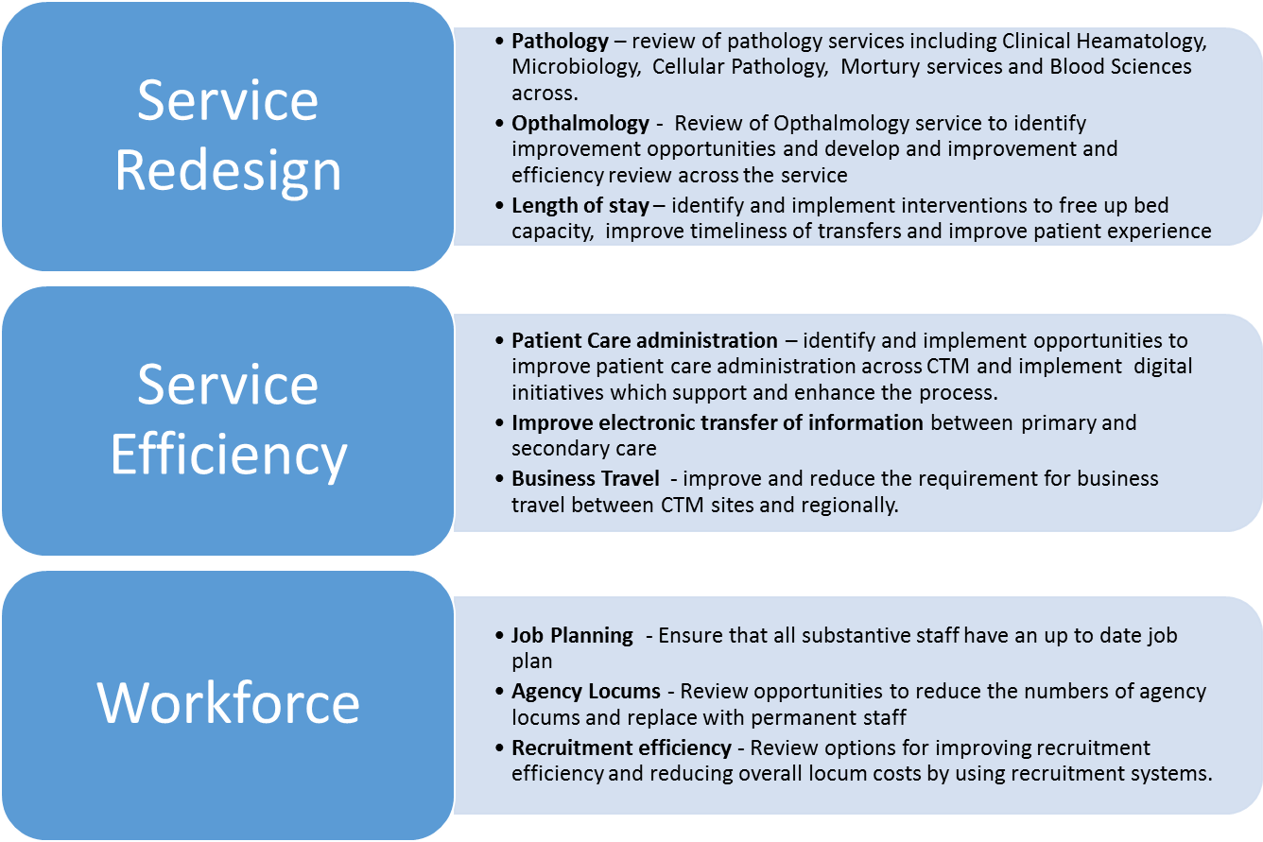
A prioritised programme of improvement projects have been developed from across the whole CTM organisation. These initiatives cover a wide range of areas including pathway/service redesign, productivity, workforce, non-pay management, income generation opportunities and digital and they comprise a mix of both cash releasing and cost avoidance schemes. It is intended that the programme will be developed on a continual pro-active basis in response to changing organisational requirements and through the existing governance structure. Examples of the projects are detailed in this diagram.

Estimates of the resources to develop and deliver the EPV programme are included within the financial plan. Digital solutions are also integral to a number of these projects.

As in the 2019/20 plan, the ownership and accountability for the development and delivery of the projects will be at directorate/locality level, with only a small number of cross cutting schemes managed outside this structure.

The clinically and operationally led programme will be supported by a common programme and project approach, provided by the organisations Programme Management Office (PMO), and will adopt a MDT model including enabling functions drawn from Finance, Planning, Informatics, Communications, ICT, Procurement, Innovation, Workforce and R&D. This represents how the CTM Improvement approach will effectively support and deliver the key organisational priorities. This will ensure the optimisation of scarce resources, provide greater control over delivery and improve outcomes.

The following table summarises the current programme by category and value.

Performance and Information

Performance
Whilst the 36 week target for RTT times was met for CTMUHB at the end of March 2019, with the Bridgend figure of 844 slightly above the position profiled by ABMU, the events of this year has put us in a very different position on a number of key target areas, with RTT performance in particular decreasing significantly. There were 367 patients out of the 844 that were waiting in excess of 52 weeks. The combined 26 week compliance for March 2019 was 89.7%, with the compliance at Cwm Taf being 91.6%. Both the 8 week diagnostic target and 14 week therapy target were met in Bridgend, with Cwm Taf achieving the therapy target, but having 27 patients waiting over 8 weeks for diagnostic intervention.

However, the events that have occurred have highlighted the fragility of both the extant solutions to elective waiting time targets, as well as the staffing capacity in place to mitigate risks in the delivery of unscheduled care. The implications of HMRC initiated changes has significantly reduced the number of consultants prepared to backfill theatre sessions to deliver extra activity changes and undertake waiting list initiative activity. Only recently, the only substantive A&E consultant at RGH handed in their notice, increasing further the urgent need to review the delivery of unscheduled care within the UHB. As has been the case for a number of years, the most significant cost pressure faced by the UHB is the scale of agency/locum expenditure.

Staffing challenges also exist in Radiology, where demand outstrips capacity in areas such as Non-Obstetric Ultrasound on a monthly basis, where additional clinical sessions continue to be the extant solution. Whilst there is a balanced approach in Ultrasound services across Obstetrics, cancer, consultant and GP referrals, the substantive staff can deliver only so much per month and this is before we see the impact from the implementation of the Single Cancer Pathway. It remains the case however that the fragility of the Urology service continues to adversely affect the UHBs overall compliance against the Cancer targets, in addition to the afore-mentioned Radiology challenges.

Data governance issues have now been exposed and as a consequence, the UHB has established a group to ensure a sustainable response to interventions that will focus on the following three areas: Harm Review, Compliance and Training. In addition, a revised Standard Operating Procedure for Waiting List Management has been issued and a transparent daily reporting process that shows all patients waiting for all elective services, regardless of their official WG reporting status has been operational since November. This work continues to be supported by the DU.

There have been numerous delays to realising robust and reliable data flows from SBUHB, in light of the fact that Bridgend hospitals continue to use their Patient Administration System. A daily flow of waiting list has now been delivered, but not in a timely manner that allows a consistent approach to waiting list management across the UHB. In addition, there are a number of other data flows needing to be established. This is hampering the UHBs ability to deliver across the organisation as a whole.

The table in Annex C1 shows the profiled performance that we will be aiming for as a UHB over the next 12 months, as we strive for improvement in our service provision. These are based on what continue to be outturn projections for March 2020. Significant strides have been made on development of performance data in recent years and the Integrated Performance Dashboard continues to be developed to incorporate data covering the whole of CTMUHB.

Our ambition continues to be to have balanced D&C plans where demand is met from internal core capacity, a component of which is provided on a Regional basis. The organisation will however continue to make use of outsourcing opportunities where internal solutions to D&C gaps is not enough to meet the demand, though clearly given the fragility of long standing capacity solutions, a more sustainable approach has to be developed for the future.

Demand and Capacity Profiles
This year we are adopting the same consistent approach to D&C across all hospitals, making use of data from the Swansea Bay Welsh Patient Administration System (WPAS) for POWH. This continues to be a challenge, given that a robust data flow has yet to be established. Our approach has been enhanced this year, though crucially it continues to have a direct link between activity and job planning. The latest iteration of our models include:
- Outpatient and Theatre elements have been integrated into a single model
- Each Speciality has individual plans for hospital sites and services
- Theatre Demand is calculated as a function of conversion from OP instead of the derived demand used in earlier iterations.
- A section has been added to allow for backlog reduction and additional FUNB work in order to allow Directorates to add in the additional demand that these areas may generate through specific initiatives
- Additional summary functionality to facilitate scrutiny and assessment of plans

Ensuring Integration with Our Partners’ Plans
In developing our Plan, we are mindful of ensuring these integrate effectively with the strategic plans of our partners. We have actively shared our emergent planning priorities with our partners, which has been undertaken through discussion and correspondence. The following provides a short summary of some of the key areas of interface with NHS Partners.

Velindre University NHS Trust
The Welsh Blood Service, hosted by Velindre, plays a fundamental role in the delivery of health care. The service works to provide blood services, which allow patients to improve the quality of their life, and saves the lives of many people every year. Through the national Blood Health Plan, WBS are focusing activity on using tools to make appropriate use of type O negative blood and reduce errors in the mis-identification of patients to improve transfusion practice.

The Velindre Cancer Centre is a specialised treatment, teaching, research and development centre for non-surgical oncology and treats a number of our patients with chemotherapy, systemic anticancer treatments, radiotherapy and related treatments, together with caring for some patients with specialist palliative care needs. Along with other commissioners, we have agreed to financially support Velindre to develop and implement plans to bring about change and transformation to the way cancer services are delivered. Velindre University NHS Trust have identified a 3 stage approach to their IMTP development:
- Core Business ( SACT, Radiotherapy, Outpatients & Inpatients) within Existing resources
- Service Development through efficiency gains and
- Development through new commissioner investment

Core business for 2020/21 will be supported with the introduction of a new contracting model to ensure appropriate funding for services provided. The core business will also require enhancement to take account of the level of growth expected in NICE and high cost drugs, especially immunotherapy treatment as well as core services such as radiology.

Service developments through efficiency gains will support the introduction of some new developments, especially new radiotherapy techniques, but many of these new techniques will require new investment.

Velindre University NHS Trust has also identified a range of new developments for investment for 2020/21 but given the level of investment required to meet core business, further work will be required before finalising the IMTP to understand the prioritisation of these developments before any investment decisions can be made.

The Health Board continues to work collaboratively with Velindre NHS Trust on the Transforming Cancer Services (TCS) Programme Business Case, which was approved by the Health Board in March 2018. The UHB commissioning and finance teams are working closely with their Velindre counterparts to ensure that business cases provided value, however cancer services provided through the new centre are likely to be a cost pressure for the UHB. During 2020/21 it is anticipated that the UHB will work collaboratively with Velindre to look at developing a model for delivering Acute Oncology between Velindre and the UHB, supporting the TCS work.

Welsh Health Specialised Services Committee
Hosted by CTMUHB, WHSSC is a joint committee made up of the seven UHBs in Wales and is responsible for planning specialised and tertiary services on our behalf. The UHB is involved in dedicated discussions on the development of the Commissioning Plan for Specialised Services for Wales 2020-23. The key priorities for WHSSC’s six programme areas are set out in the following work programmes: Mental Health; Cancer and Blood; Cardiothoracic; Neurosciences and Complex Conditions; Renal; and Women and Children.

2020/23 will present a major challenge to the UHB with emerging new treatment such as Advanced Therapeutic Medicinal Products (ATMP). ATMP’s such as cell and gene therapies, are set to transform current care pathways with revolutionary treatments that repair, replace, regenerate and re-engineer genes, cells and tissues to improve current, or even restore normal function; potentially offering durable and curative outcomes where unmet medical need exists. The first of these treatments were commissioned in 2019/20 and are expected to rapidly be approved by NICE for use in NHS Wales over the next few years. Whilst potentially life changing for the small groups of patients that will benefit from them, the resource implications are a major challenge. The UHB is committed to fund the introduction of ATMPs as they are statutory due to being NICE approved.

The commissioning of the Major Trauma network by WHSSC is also a key priority for 2020/23 and has been prioritised for investment by the UHB.

Other key strategic Priorities include supporting investment in expanding and developing Cystic Fibrosis services, Mental Health Services and Thrombectomy. In addition, other areas prioritised for investment include:
- Expanding the indications for PET scanning
- Prolonged Disorder of Consciousness (PDOC)
- Fetal Medicine
- Inherited Metabolic Disease (Adult)
- Neuroendocrine Tumours (NETs) Phase 2
- Paediatric Cardiology Standards
- Hereditary Anaemias
- Percutaneous mitral valve leaflet repair
- Temozolomide for adjuvant treatment
- Allogeneic haematopoietic stem cell transplant for primary immunodeficiencies
- Canakinumab for periodic fever syndromes: TRAPS, HIDS/MKD and FMF (ages 2 and older)
- Lung volume reduction by surgery or endobronchial valve for severe emphysema in adults
- (HIPEC) for the treatment of peritoneal carcinomatosis (PC)

The UHB will continue to support the work of WHSSC to increase equitable access to services using the analytical and information reports from the MAIR system, which identifies patterns of differential access to services which, together with the newly introduced Referral management system, should ensure appropriate use of specialised services. In addition, the UHB will support WHSSCs Quality Assurance Framework, to ensure patient centred safe services are delivered.

The UHB will continue to work with WHSSC to deliver the priorities for the WHSSC agenda and to look at further opportunities to improve the management of pathways between secondary care and tertiary services.

Emergency Ambulance Services Committee (EASC) and Welsh Ambulance Services Trust (WAST)
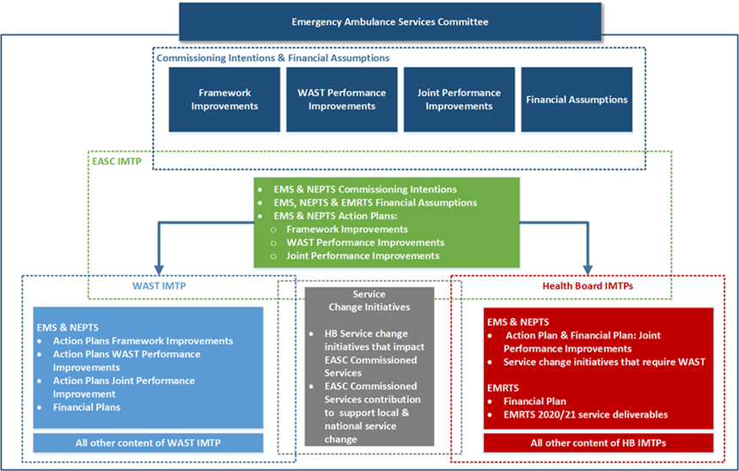
Hosted by CTMUHB, EASC is a joint-committee made up of the seven HBs in Wales and is responsible for commissioning on our behalf the following services:
- Emergency Ambulance Services.
- Non-Emergency Patient Transport Services (NEPTS).
- Emergency Medical Retrieval and Transfer Services (EMRTS).

The National Collaborative Commissioning Unit on behalf of EASC develops Commissioning Intentions for EMS and NEPTS. The 2020-23 Commissioning intentions can be found in Annex 3. In order to align commissioning intentions with the Plan, the following process illustrated on the right is followed.

WAST is commissioned to deliver ambulance services and the relevant joint Health Board and WAST priority schemes for 2020/21 can be found in Annex 4.

NHS Wales Shared Services Partnership
Shared Services provide an invaluable role in supporting our work with 95% of NHS Wales expenditure processed through shared services systems and processes. Shared Services support is helping the organisation to maximise every pound spent though supporting work on value based procurement and ensuring effective contracting models are in place with our contracted services in primary care. As set out in the Plan, recruitment and retention of staff is a key enabler for our plans. Maximising Hire to Retire and the agility of our Electronic Staff Record is crucial to be able to respond as staffing pressures emerge.

Shared Services plays an important role in unsung areas which support service sustainability and transformation. We will continue to work with the service in areas such as:
- Scan and Store Service are creating capacity in GP surgeries to meet population growth.
- Developing contracting models that allow for greater collaboration and sharing of premises across multiple public, private and third sector partners.
- Delivering an effective laundry service, supporting the smooth and efficient running of hospital services.

Health Education and Improvement Wales
The Health Board is working in partnership with Health Education and Improvement Wales (HEIW). Through planning discussions we have already provided the opportunity to share our agendas, priorities, plans and challenges. We are particularly pleased to work closely with the organisation as it develops and integrates workforce planning and leadership and succession planning into its core objectives.

WORKFORCE AND ORGANISATIONAL DEVELOPMENT
Since the boundary change the new organisation’s workforce has seen a significant growth to approximately 12,000 head count and 10,500 WTE at December 2019. The geographic area and population we serve has also increased with 3 District General Hospitals and growth in primary and community care provision and partnerships.

The establishment of a Workforce and Organisation Development plan for the Health Board which supports a focus on patient safety and quality of patient care is critically important. The scale of the challenges and the context for the development of this plan include the Royal Colleges’ Review of Maternity Services, Targeted Intervention, the WAO and Health and Care Inspectorate Wales Report, the Bridgend boundary change, the implementation of a new Operating Model and the development of an Integrated Health & Care Strategy. In addition, the plan reflects the quadruple aim contained within “A Healthier Wales”:
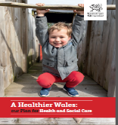
- Improve population health and wellbeing;
- Better quality and more assessable health and social services;
- Higher value health and social care; and
- A motivated and sustainable health & social care workforce.

All of these elements require significant culture change which is reflected in leadership at all levels of the organisation. Ensuring alignment to ‘The NHS Patient Safety Strategy’ of improving patient safety, building on the foundations of a safer culture and safer systems. There is a need to embed the newly developed Operating Model and to ensure that there are simple, transparent and robust systems and structures in place. The model below illustrates the Workforce and Organisational Development plan for the Health Board which will be achieved with a clear progressive organisation development plan supported by aligned and integrated workforce processes and interventions.

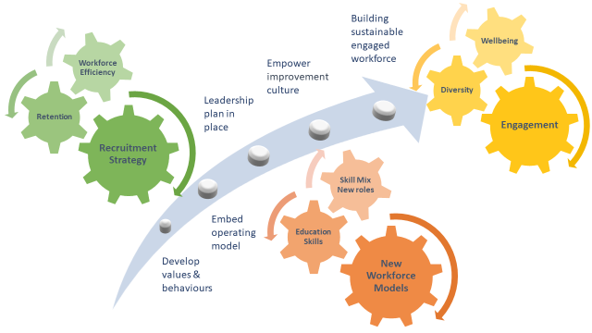
The overall aim will be to support ‘A Healthier Wales: Our Workforce Strategy for Health and Social Care’ in making CTM a great place to work and helping our staff to work better by fully engaging them, investing in skills and capability and enriching their health and wellbeing at work.

Organisation Development
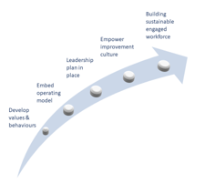
The OD plan will facilitate the rebuilding of trust and confidence in the organisation and will build a foundation of shared values and behaviours across the organisations owned and modelled from the top, an ongoing programme of leadership development supporting the development of a culture of empowerment and improvement and an engaged, sustainable workforce. The OD plan aims to ensure that the “golden threads” of “open, transparent, engaging, involving, clinically-led and managerially supported are reflected in all of the key milestones of the plan. Programmes of work will focus on clear outcomes which lead to an organisation which is able to respond and learn, understand and build on strengths, support improvement and de-escalation. The key organisation development milestones and actions are therefore as follows:

Developing Values and Behaviours
Work commenced in November 2019 involving staff and patients -'Let's Talk Culture' and a series of 'In Your Shoes' and 'In Our Shoes' workshops across the health board. The aim is to:
- Bring together the best of the former Cwm Taf and Bridgend;
- Create a compelling, shared cultural narrative;
- Develop our values and behaviours to inform our decision-making
Together we plan to co-create our culture, involving significant numbers of staff and patients in big, creative, listening workshops alongside a major culture survey that will underpin this work. Then to translate values into behaviours that patients and staff do / don’t want to see, with a climate that makes it easier to appreciate and speak up, as well as to tackle poor behaviours and encourage positive ones.

Embedding the Operating Model
The vision of the new operating model is to empower staff and transparent, distributed decision making closer to service delivery, open culture, enhanced leadership, clinically led services, integration and collaboration, clear accountabilities, enhanced team and individual performance. The baseline for measuring the impact of the operating model will be provided by the culture survey referred to above.

Leadership Plan
A Healthier Wales recognises that “Dynamic leadership will be needed to instigate change, empower others and lead by example, as well as to create the conditions for continuous innovation and improvement to drive up the quality and value of services”. Whilst the RCOG report was specific to Maternity Services it also identified overall failings in culture and leadership and Targeted Interventions have therefore prioritised development work in a number of areas. The Staff Survey also highlighted a need to focus on leadership development. Much of following work has already commenced and will be continued as an urgent priority:

- Maternity Services. A procurement process for Maternity Services relating to effective team relationships and the culture and behaviours that shape those relationships commenced in August 2019, with development of a project specification with clear deliverables, which was circulated to all providers on the National ‘Behavioural Insights (RM6004)’ Framework. This process closed with no suitable providers being appointed. The Health Board subsequently approached Roffey Park and Mindset Practice to determine whether they could meet the requirement of the project specification. Both have submitted proposals working in partnership to deliver a leadership & development programme for Consultants and Senior Midwifery Teams, as well as Band 7 Midwifery staff. Following this a workshop will take place for all staff based around delivering a safety culture and supporting staff to take personal responsibility for professional behaviours. Proposals were submitted on 10th October 2019, and the lengthy procurement process concluded on 18th October 2019. Work will commence at pace during November 2019 with the Consultant Body and Senior Midwifery team, which will continue to be monitored and supported via the Independent Panel, and Maternity Improvement Board.
- Board Development. A programme of Board development has been commissioned from Deloitte as part of the Targeted invention support for the Health Board.
- Executive Development. Following the release of the RCOG report into Maternity services, Lifetree, an external OD consultancy, have been instructed by the Health Board to work with the Executive Team. The Executive Team is responsible for leading the new Health Board through its transformation, so it is vital that they are given the opportunity to reflect on the issues raised within the RCOG report, take ownership of the challenges and develop a positive way forward. A key enabler for this work will be the ability to establish a leadership culture that is both positive and supportive as well as open and challenging across the organisation – with a focus on quality above all. An initial session was delivered with the Executive Team in August 2019, and subsequent sessions commenced in October 2019, December 2019 with sessions concluding in February 2020.
- Senior Leadership and Management Development. This will be addressed in two phases:
  - Delivery of immediate leadership development interventions based on the best of existing programmes to support the new Operating Model and a distributed leadership approach. This will include investing in building core (basic management development skills and capability).
  - Assessment of leadership capacity and capability to develop a new leadership offering based on the reviewed Values and Behaviours work to support clinically led services focused on quality and safety.

Empowerment and Improvement Culture
Empower people, taking decision making closer to those delivering the service and increasing service level autonomy. In both the organisation design and underpinned by values and behaviours modelled from the top. Linked across to leadership development. One of the overall aims of the cultural change that is desired – focus on “improvement as the beating heart of the organisation, enabled by proactive data insights and skills development”.

Building Sustainable and Engaged Workforce
The overall aim is to develop and support excellent consistent clinical standards and professional practice providing the best quality and outcomes. To improve the employee experience across the whole Health Board, taking into account concerns raised in the independent review into maternity service, target intervention and the ‘quadruple aim’ to ‘enrich the wellbeing, capability and engagement of the health and social care workforce’. The health Board has developed a framework for improving employee experience.

The framework looks at the whole employee journey which broadly speaking is broken down to, attract, recruit, on-board, develop, retain and depart. These stages can be used to define the most critical stages that have the most influence on an employee's perception. Following this framework provides a clear and structured approach to improving Employee Experience:
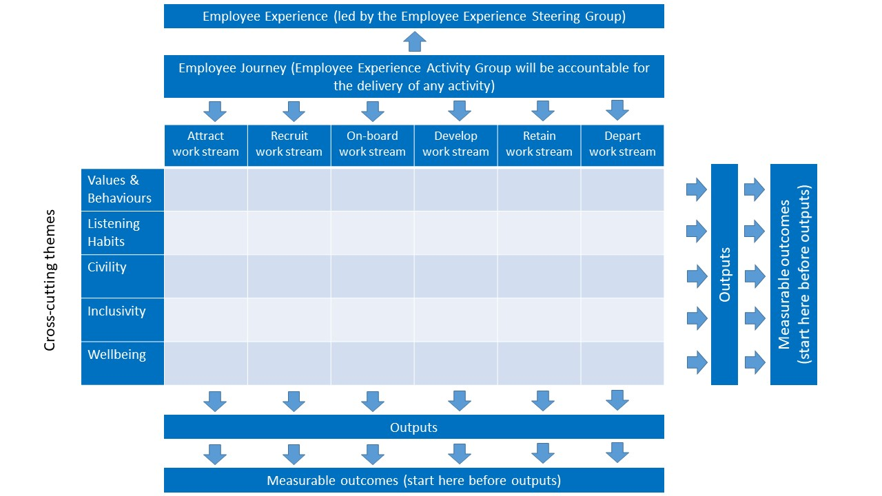
- Employee Experience Steering Group, chaired by an Independent Board Member, the Employee Experience Steering Group’s role is to provide strategic direction and ensure the outcomes of any activity contribute to an improved Employee Experience.
- Employee Experience Activity Group, chaired by the Assistant Director of Employee Experience and Wellbeing, the Activity Group will be accountable for the delivery of any activity which contributes to an improved Employee Experience.
- Employee Experience Workstreams, led by appropriate accountable leads (to be identified), the workstreams will mirror the most critical stages of the employee journey (Attract, Recruit, On-board, Develop, Retain, Depart).

The CTM PSB has a joint workforce development project group, which is now part of the ‘Strong Economy’ work stream. Along with the Health Boards partner organisations, the aim is to collectively ensure we have a skilled and sustainable public services workforce for the future and there is a programme plan underpinned by the principles and goals contained within the Social Services and Well-Being (Wales) and Well-Being of Future Generations Acts. The work stream is due to launch its Employability Pledge in February 2020. Opportunities partners may provide include:
- Apprenticeships
- Work experience placements
- Employability programme
- Volunteering opportunities
- Work with schools, colleges and Universities
Each of these areas of focus will be ongoing over the duration of the IMTP and will continuously develop and support the growth and sustainability of the Health Board.

We will have increased the organisation Engagement index score, improved the experience of staff appraisal, the effectiveness of team working (i.e. innovative teams), and experience of leadership. Measured by staff survey.

Workforce Sustainability
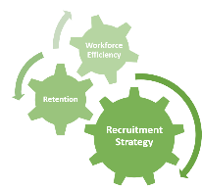
Maximising the efficiency and productivity contribution of the workforce is a key component of our workforce plan. The priorities include ensuring our operational and management systems/processes are robust to facilitate the effective management and deployment of our staff. Where practical we will utilise e-employment systems to minimise waste. There will continue to be workforce productivity cross cutting work programmes to oversee a range of activities that will support efficiency, productivity, service improvement and release savings from the pay bill which supports the overall vision of ‘A Healthier Wales: Our Workforce Strategy for Health and Social Care’.

Current Position
- Since becoming CTMUHB on 1st April 2019, the workforce has seen a considerable increase of approximately 3089 WTE, talking the organisation to approximately 10,500 WTE as at December 2019.
- We have seen a decrease in year of our staff turnover rates, however there is recognition of gaps in the data so need to use caution when interpreting the data.
- We continue to have a concerning age profile with Estates & Ancillary still remaining high but we have seen a reduction of 2.45% with the addition of Bridgend.
- Recruitment challenges within a variety of professions for example, medical hard to fill post are GPs and Consultants in Emergency Medicine, Histopathology, Urology, Breast Surgery, CAMHS and Paediatrics Recruitment of SAS. Significant pressure remains on the nursing workforce and we continue to build links with Universities
- The premium workforce costs resulting from our recruitment and retention challenges are a key driver of the UHB’s financial position
- Health Board escalation was increased to target intervention and maternity was put into special measures.

Workforce Financial Assumptions:
The assessment of the impact of our plan on workforce is summarised below:

Workforce Plan 2020/21 – 2022/23 | Savings | Investments & Cost Pressures | Net
2020/21 | 235 | 253 | 17
2021/22 | 265 | 196 | -69
2022/23 | 208 | 154 | -54
Total | 708 | 602 | -106

Further details of the year one impact by staff group and the expected model of workforce reduction is shown in the following table. The table below reflects this position for both financial and workforce plan movements:

Workforce Plan 2020/21  Staff Group | Savings | Investments & Cost Pressures | Net
Board Members | 0 | 0 | 0
Medical and Dental | -13 | 25 | 12
Nursing & Midwifery Registered | -72 | 93 | 21
Additional Professional, Scientific and Technical | -2 | 6 | 4
Healthcare Scientists | -5 | 5 | 0
Allied Health Professionals | -4 | 13 | 8
Additional Clinical Services | -72 | 45 | -27
Administrative and Clerical (inc Senior managers) | -46 | 42 | -4
Estates and Ancillary | -20 | 23 | 3
Students | 0 | 0 | 0
Total | -235 | 253 | 17

It should be noted that the estimated WTE referred to above, does not in all cases mean a real reduction in employed staff. This WTE reduction will be released through skill mix change, reduce usage of bank staff and efficiencies.

Efficient and Effective Workforce Processes
Maximising the efficiency and productivity contribution of the workforce is a key component of our workforce plan. The priorities include ensuring our operational and management policies, processes and systems are robust to facilitate the effective management and deployment of our staff. Where practical we will review business processes and deploy e-employment systems aiming to minimise waste and drive up productivity. There continues to be two significant cross cutting work programmes to oversee a range of activities that will support the efficiency programme by driving up productivity, leading to service improvement and ultimately the release of savings.

Medical Workforce Efficiency
Our medical efficiency programme continues to focus on a range of activities to improve productivity and control utilisation of the medical workforce. Activities for 19/20 onwards fall into the following areas:
- Planned Medical Productivity savings as a result of Direct Engagement and Negotiated Rates. During this financial year, Executives will assess the risks and benefits of mandating Direct Engagement across the Health Board, in addition to challenge around the sign off and bookings of high cost agency locums. Finance and Workforce will work through anticipated savings by Directorate based on Locum usage to date. This is built into CRES savings targets identified for each Directorate.
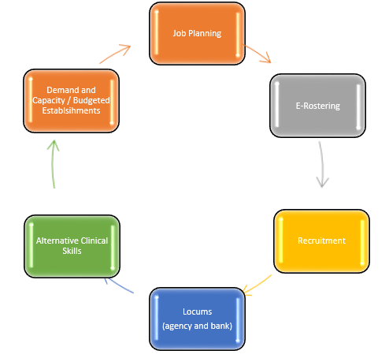
- System development and enhancement of E-Rostering to ensure we are making best use of the e-rostering system for medial rostering and planned activities.
- End to end enabled process for internal ADH’s/WLI’s and Medical Locum Bank which is likely to include the development of an internal locum bank e-system. This will provide greater visibility and reporting on rates across the Health Board, and will streamline the authorisation to payment process which is currently fragmented across the Health Board.
- To provide bottom up analysis of demand/capacity to determine establishments for each speciality. Define and seek agreement on a set of principles and parameters to be employed in medical staff planning and budget management. To include D&C plans setting out the resource (WLI’s), which in turn defines the rostering requirements. Areas to then focus on will include turnover, hard to fill vacancies, sickness, maternity, training gaps etc.
- Continuing to working in collaboration on all Wales activities wherever possible through the lead of WG, specifically around the purchasing of services (rostering software, managed services, locum provision etc.
- Job planning metrics continue to demonstrate productivity aligned to D&C plans and monitor working patterns to drive up productivity and meet the needs of the directorate. A further review of the job planning materials and training will be relaunched.
- Recruitment can be split into two themes 1) timely transactional processing of approved medical vacancies, and 2) analysis of skill requirements and identifying alternative methods of recruitment. A strategic approach around hard to fill vacancies will include an overseas campaign and more flexible working arrangements for doctors who decide to take time out from training programmes.
- Alternative skills – Where repeated attempts have been made to recruit doctors with no success, alternative practitioners are being considered.

Nurse Efficiency and Productivity
The Nursing Workforce Group ensures regular and formal dialogue between functions to ensure the Health Board manages and reacts to the challenges facing the Nursing and Midwifery workforce, including support staff. Likewise it enables the Health Board to monitor compliance with the Nurse Staffing Levels (Wales) Act 2016 and provides opportunities for the group to review and monitor service productivity and operational challenges, particularly the effective retention of the nursing and midwifery workforce.
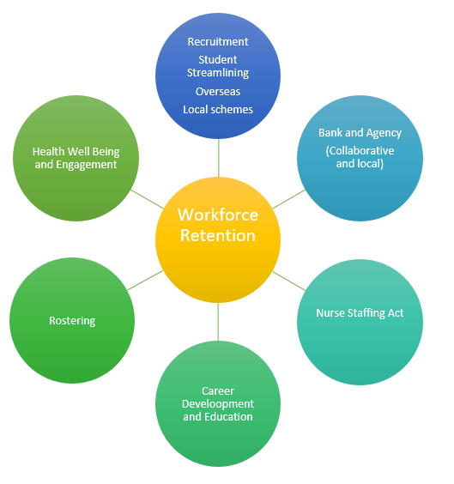
Nursing Workforce Group shares practice, experience, and opportunities across functions, including, but not limited to, good practices, wellbeing, recruitment, development, efficiency and governance.
By April 2020 we anticipate to have 63 nursing graduates commencing their employment with the Health Board.
Our international recruitment continues. Those previously recruited from the Philippines are still with us, and in July 2019 we re-commenced international nurse recruitment, this time focussed on India. We learnt a number of lessons recruiting from the Philippines, and these have been reflected in to the current exercise. We are confident that the nurses currently being recruited are of excellent calibre, and will be a significant asset to the Health Board. Arrivals started in September, with cohorts due every month this year except December.

Digital Workforce Productivity
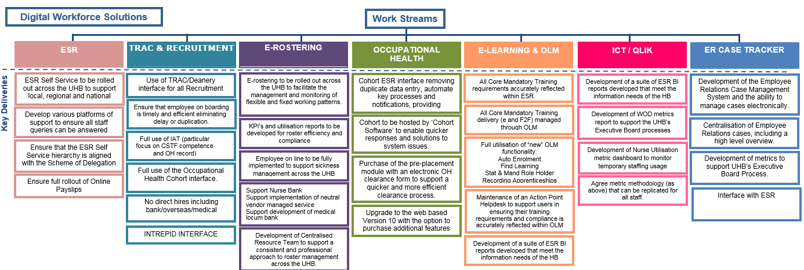
The heart of the NHS Wales ESR Hire to Retire work programme is digital transformation, with enhancements to the ESR solution focusing on accessibility and usability. In other words maximising the everyday technology people use outside of workplace and inside the workplace. Digitising workforce transactions through ESR is key to improving efficiencies and reducing waste across the Health Board and continues to be developed in the following areas. The overarching themes are set out below:

Pathways to Employment
The Health Board continues to work in partnership with its local authorities, Bridgend, Merthyr Tydfil and Rhondda Cynon Taf to deliver its successful Pathways to Employment scheme which supports local unemployed individuals into paid employment:

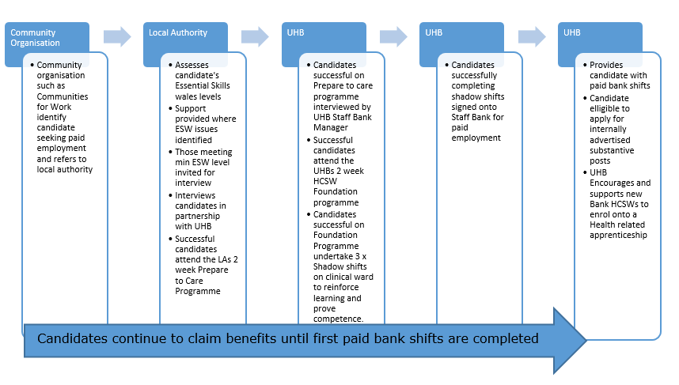
A typical month will average 10 work experience trainees referred to the Health Board for inclusion on its Pathways to Employment programme, where they are provided with the same level of vocational training as that provided to new starters recruited to fill substantive posts as clinical Health Care Support Workers (HCSW). Over the past year 99 members of the local community have progressed through this route and successfully gained paid bank shifts with the Health Board and many have progressed further into full employment.

The Health Board also continues to work with several external organisations, providing ad-hoc bespoke work experience placements designed to meet the needs of the individual including Remploy, supporting adults into paid employment and Llamau, supporting looked after young adults and a variety of local training providers such as People Plus, Tydfil Training, ITEC, Communities 1st & Communities4work.

We will have stable turnover, lower levels of sickness absence, a cost reduction in agency usage, improved KPIs (e-rostering, hire to retire), timely production of rosters, improved productivity and attracting the right skills in a cost effectively and timely manner

Development and Transformation
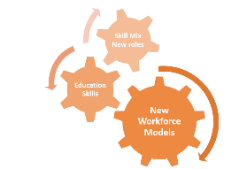
A Healthier Wales: “A key feature of any positive employment offer is the opportunity to learn and to develop and here new, community based models of care provide a real opportunity to re-evaluate education and training and to develop more flexible career pathways. Specific. Education and training needs will differ for each staff group and profession”

Skills development
Learning and development approach which supports the overall organisation development direction of building a distributed leadership model, empowering staff with increased autonomy to improve services. Enhancing team performance through the development of staff skills to improve quality and safety at all levels. Ensuring maximum return on investment for what the Health Board invests in skills development. Prioritisation of those skills that have greatest impact on delivery of clinical service strategy and quality improvement. Ensuring our approach is closely aligned to ‘A Healthier Wales: Our Workforce Strategy for Health and Social Care’.

Clinical Education - Strategic Professional Education
The focus for Clinical Education over 2020-23 is to establish robust education governance systems and standards through which we will manage and control our educational activity. Providing clarity and routes of escalation through to board, demonstrating accountability for continuous improvement of quality and performance and ensuring all our healthcare professional staff are fit for practice and fit for purpose.

CTM has a multi-professional clinical education function bringing together undergraduate and post-graduate education and training for Medical, Nursing & Midwifery, Allied Healthcare Professions, Pharmacy and Health Care Scientists.

An Education Governance Board with a named Executive lead for multi-professional education is being developed. This board will be supported by undergraduate/pre-registration and postgraduate/post-registration & advanced practice education committees, undertaking a quality assurance and risk management approach. Organisational education and training activity for all healthcare professions will be:
- Mapped to gain clarity on current organisational delivery D&C;
- Evaluated for quality and compliance with regulatory requirements;
- Evaluated for return on investment; and
- Aligned with service development priorities and training needs analysis.

We will ensure that education offered to our current staff is optimised to support and underpin retention, explore ways to increase our capacity to support undergraduate clinical placements and increase multi-professional learning and development at all levels.

The Health Board has introduced a 6 week development programme for new Consultant and experienced SAS doctors. This programme has been co-developed and contains, for example, quality governance, concerns/complaints and values based health care. The 1st cohort is nearing completion with the next due to start in November 2019.

Once for Wales 2020 Nursing and Midwifery Education Realising professionalism: Standards for Education and Training
These standards will replace NMC ‘Standards to Support Learning & Assessment in Practice’ 2nd Ed 2008 (SLAiP). Since their introduction the Health Board continues to work in collaboration with all relevant stakeholders including partner Universities and HEIW. The latter leading the All Wales Pre-Registration Nursing and Midwifery Group, which continues to focus on workstreams related to the implementation of the new standards.

Since the inception of the new standards the Nurse Education Team have continued to support and prepare our Nursing & Midwifery workforce who will be supporting students in clinical practice. We currently have approximately 2000 registered staff on our ‘central’ mentor database, with the priority being to update all mentors whilst also utilising their mentorship experience to transition into the new requirements (recognise prior learning). This is achieved through a 3 hour transition update session. We have facilitated up to nine sessions per week, across all areas of the Health Board, including attending community sites, etc to relieve the pressures of staff release. To date we have completed the transition training for 350 current mentors, with many other sessions planned and advertised across the organisation between now and April 2020.

Physician Associate (PA)
The main focus of introducing the role of PA to the Health Board has been within Primary Care and Acute Medicine. Primary Care have employed 3 and are recruiting a further 2, which will be deployed with GP Practices. In December 2019 the first of our interns will have completed their internship year and her GP practice has confirm they wish to retain her. They have agreed to fund 50% next year with a view to fully funding the year after. Acute Medicine currently have 2 employed (1 is an experienced PA) and are recruiting to a further 8 posts.

Paediatrics did recruit 2 interns but unfortunately 1 failed her PGc and the other accepted a position with another Health Board. Paediatrics have taken this time to review the offering and intend to recruit to a bigger cohort of 4 in May/June 2020, which will hopefully attract Welsh graduates. Other specialties that have expressed an interest in looking to introduce the PA role are Mental Health and Surgery.

Options to streamline the recruitment process of PA across Wales is being explored, to reduce internal competition for jobs. Ensuring that as cohorts increase in Welsh Universities we are able to offer positions to retain them (condition of their bursary payment is they must work within Wales for 18 months post obtaining their PA qualification).

HCSW Development and Opportunities for New and Extended Roles
The Health Board continues to work on a local and a national basis, to develop, manage and monitor compliance of the Clinical HCSW career and skills framework, through the use of the ESR. The illustration sets out local pathways.

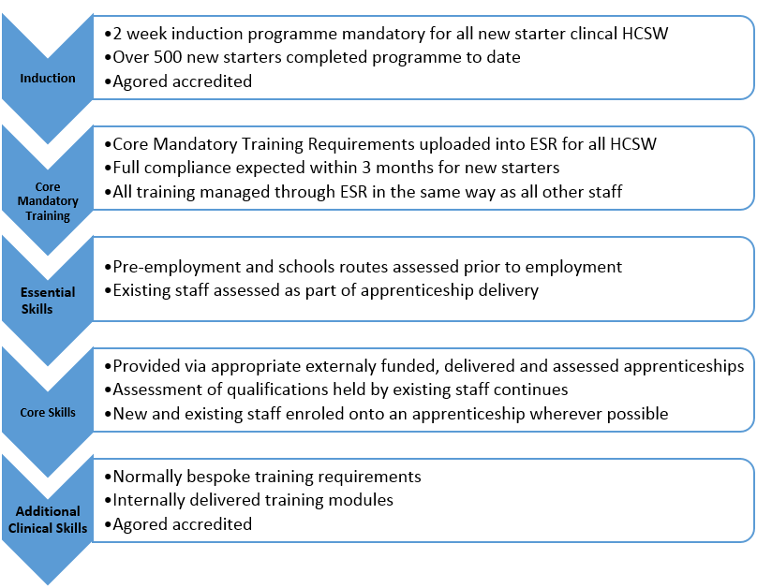
Clinical specialities within the Health Board continue to be supported to create Learning Pathways. Using them to guide HCSWs through appropriate education and training requirements. The focussed effort delivered to support the regional Diagnostic Hub, with appropriately trained HCSW, through the structured delivery of apprenticeships is still proving to be effective, as the HCSW in this area progress through their apprenticeship. This same model of focussed effort is now being employed with Maternity Services to undertake a training needs analysis and deliver appropriate apprenticeships (when available) to Maternity HCSW. In the meantime staff will be supported to undertake programmes of learning which will support clinical development in their role.

The Primary Care Clusters continue the development of their clinical HCSW with Clinical Practice Educators delivering accredited training and education in:
- Physiological measurements and brief intervention to smoking cessation
- Basic wound care, ANTT and suture/clip removal
- Immunisations for influenza, pneumonia, shingles and b12 injections
- Obtain venous blood samples
- How to perform an ECG
- Diabetic Foot assessment

The Health Board continues to support HCSW through flexible routes into Nursing and attainment of the Bachelor of Nursing (Adult) degree. There are presently 20 HCSW following this route; 7 with the Open University; 8 with the USW and 5 with Swansea University.

The Health Board also continues to support HCSW to attain level 4 education via the USW and there are currently 11 HCSWs studying year 1, 22 on year 2 and over 25 expressions of interest for 2020/2021 academic year, from secondary and community care. HCSWs from Primary Care are funded separately and there are additional Primary Care HCSWs undertaking Certificate of Further Education (Level 4). The Health Board continues to use externally funded apprenticeships to upskill clinical HCSWs with over 100 currently enrolled onto an appropriate framework.

Apprenticeships and Vocational Qualifications
The Health Board is committed to the opportunities apprenticeships afford to our service, delivery improvement and upskilling of people from within our local communities, from which the majority of our HCSWs are sourced.

The delivery of the clinical and non-clinical HCSW frameworks are directly dependant on the Health Board’s ability to source externally delivered and funded Apprenticeships and standalone vocational qualifications. To accommodate the increasing demand for apprenticeships, the Health Board has greatly enhanced its working relationships with local apprenticeship providers, with most reviewing their delivery capability to ensure they meet our needs. While apprenticeships are offered to staff in any discipline, the current focus continues to be on the enrolment of Clinical HCSWs onto an appropriate apprenticeship framework and staff in management roles onto an apprenticeship in Leadership and Management.
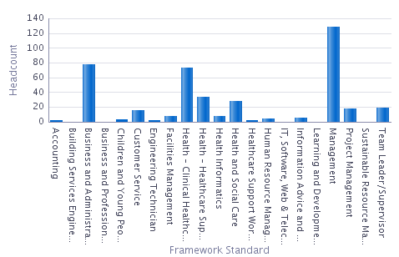
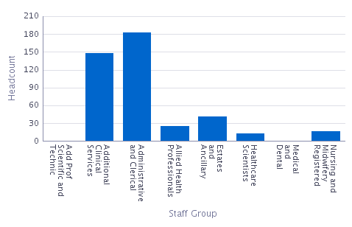
Number of Apprenticeships by Staff Group: Numbers of Apprenticeships by Apprenticeship Framework Type

Workforce Transformation
Ensuring consistency in clinical standards and professional practice, providing the best quality and outcomes across all our services is a priority. Supported by right staff with right skills, effective workforce models of delivery. Community focused with local community needs being met through a community and prevention focus. System Leadership which serves the whole person’s needs, not just part.

Primary and Community Enhanced Resource Service
Following investment from the WG transformation fund, the Health Board has embarked on 'Transforming Health and Social Care Outcomes Together – Development of a 'Primary and Community Enhanced Resource Service'. This programme of work followed a series of engagement workshops with our GP and Practice/community colleagues to explore sustainability and workforce development. As part of this work the clusters reflected on the current model of delivery for Primary Care and the growing issues around sustainability and they recognised the need that something more radical is required to shape primary care clusters moving forward. The key theme to come out of these workshops was that sustainability was dependent on GPs being the co-ordinators of care, whilst supported by a strong multidisciplinary team within and wrapped around clusters, responding to patient’s needs. It needed to be anticipatory in nature and not reactionary.

The workforce aim is to maximise the newly developed multi-disciplinary and multi-agency workforce in a wholly integrated way. The focus is on our primary care and community clinicians alongside our LA and third sector partners. Ensuring as much care is provided as close to home as possible. Ensuring our District General Hospitals (DGH) are only used for Acute and Specialist activity. Aligning to the principles of the Quadruple Aims and Prudent Healthcare and the 5 ways of working in the ‘Wellbeing of Future Generations Act’, in order to have a long lasting positive impact on service delivery, resilience, adaptability and sustainability.

The multidisciplinary/multi-agency model will provides a continuous learning environment for both the individual and the system. Supported by the Pacesetter initiative, the Health Board has developed an Academy Training programme for ‘Advanced Training Practices’ (ATPs) based on a hub and spoke model for pre-registration nurses and ANPs, which will be the focus from 2020 – 23. It is hoped that the ATPs will evolve into multidisciplinary training centres and work will commence following evaluation of the nursing element. It is hoped this will increase the number of structured educational placements, promote Primary Care as first choice employment destination and allow clusters to focus on ‘grow your own’, increase training capacity and capability, accommodate multi-professional training and upskill existing staff. The ultimate aim is the development of ‘Centres of Excellence’ for all health and social care professionals.

GP’s need to place themselves at the centre of a multidisciplinary team as an Expert Medical Generalist and the senior decision maker. Specialist services, including those in primary care, need to work more closely with general practice. This model is predicated on strong and robust General Practice that has a multidisciplinary/agency wrap around team. The implementation of the new operating model for the UHB is designed to support and facilitate the development of patient focussed multi-disciplinary working at Locality and Cluster level.

The Stay Well in your Community Programme aim is working with partners collaboratively to develop a whole system approach for an integrated health and social care model that delivers services closer to home. A project board has been establish with a number of supporting workstreams which are:
- Risk Stratification and Segmentation.
- Assistive Technology.
- Stay Well @Home Phase 2.
- Enhanced Community Cluster Teams - This compromises of Physician Associates, Physiotherapy, Occupational Therapy, Speech and Language Therapy, Generic Therapy roles, Mental Health Practitioners, Pharmacist, Pharmacy Technician, ANP, District Nurse and HCSW/Phlebotomist. Some may already exist within the system but need to work differently and be aligned through a single integrated process/team reflecting the need of the current population.
- Urgent Primary Care Out of Hours.
- Digitally enabling the staff, increasing their mobility to take advantage of the approach to an integrated health and social care model.

These are supported by 4 enabling groups one of which is workforce. All partners are represented on the workforce group, whose main aim is to ensure the recruitment required for the programme is in place, oversee and advise on workforce implications relating to the change in models required.

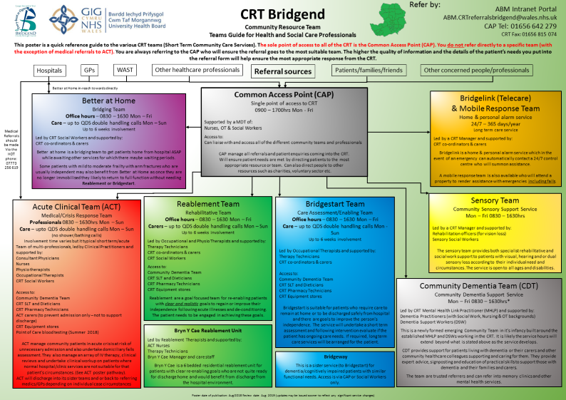
Within the Bridgend area of the Health Board they have an already established community resource team and the transformation fund resources are helping to enhance the current model.

Other initiatives which will continue to take place in Primary Care includes practice manager mentorship, independent prescribing for Nurses/Pharmacists and Advanced Nurse Practitioner MSc placements outside of the training hub cohort. In addition to this we will continue the funding for backfill of GP mentors, as this is an essential part of the Clinical Skills MSc and Independent Prescribing qualifications.

Other Examples of Workforce Transformation
The Health Board has received an indicative allocation of £1.38m from WG in relation to Critical Care, for Outreach and the introduction of a Post Anaesthetic Care Unit (PACU). This will result in additional recruitment, enhancing/changing existing staff that will affords us an opportunity to review the workforce model, to ensure the workforce is sustainable, prudent and quality driven.

The Health Board has a strong Ambulatory Emergency Care service which is consultant lead and delivered/supported by Advance Nurse Practitioners and trainees. Further development of the Ambulatory Emergency Care in POWH should help patient flow and will be part of the redesign of the front door.

The introduction of an A&E Physiotherapist has been evaluated and this service change has resulted in a reduced length of wait to diagnosis and plan treatment by up to 14 weeks and has significantly reducing demand on orthopaedic services. This service change ensures that patients are on the most appropriate pathway.

Hand surgery patients who would previously receive post-operative review with a consultant are now being seen by a Specialist Occupational Therapist, therefore releasing consultant time to do only what they can do, in line with prudent healthcare principles.

Following the Advance Paramedic Practitioner (APP) pilot programme in North Wales and building on the Bevan Exemplar in St John’s GP Practice in Aberdare, the Health Board is in discussions to offer the opportunity to have a rotation (8) of APP to support both 999 and primary care in and out of hours. The business case is currently being worked through.

A new model of care for patients medically fit for discharge has been piloted in our community hospital Ysbyty Cwm Cynon (YCC). Ward 1 is made up of registered staff and HCSW by day looking after patients who need enhanced care. On the other end of the ward, totally independently, HCSWs are responsible for the care of up to 8 patients in individual cubicles who are medically fit for discharge. The HCSW team work during the day while the unit is covered by 2 registered staff by night, these registered nurses undertake an initial assessment and develop a care plan. The HCSW then mirror the care plan and help their readiness for discharge, suggesting changes that may be required to the care plan, to aid in the prevention of readmissions. This is also an example of how effective delegation can impact on patients, staff and the service quality.

A new opportunity is the development of a multi-professional rehabilitation assistants (MPRAs). A proposed model would see generic therapy support workers/MPRAs working alongside nursing teams to embed a rehabilitation culture and ethos into our community hospital wards. Proposed posts include:
  - Generic band 4 therapy support workers providing both occupational therapy and physiotherapy; and
  - Generic band 4 therapy support workers providing both speech & language therapy and nutrition & dietetics.

The generic therapy support workers will have patients delegated to them who have been assessed by the registered Therapist, in order to deliver the therapeutic rehabilitative intervention plan identified. This will free up the registered Therapist to carry out further assessments and more complex interventions.

Underpinning programme of change the ‘Care Aims’ staff development sessions (funded by HEIW) is a model of practice developed which is designed to support practitioners demonstrate evidence-based practice through systematic reflection. The model focuses on impact of care, clarity of boundary of care, understanding clinical risk and clinical need. Malcomess (2015) acknowledges that adopting this model usually represents a change in culture and practice. The majority of therapy practitioners have undergone this development with and also a focus on the Community Paediatrics multi-disciplinary team.

We will deliver on the ambition with partners, of the ‘Stay Well in your Community programme, improved opportunity to innovate and skill mix change in priority areas e.g. investment in HCSW conversion and invest in training and development.

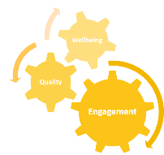
Wellbeing, diverse and engaged workforce
A Healthier Wales: “By making health and social care a good career choice, investing in training and skills, and supporting health and wellbeing at work, we will be able to get and keep the talented people we need to work in Wales.”

Wellbeing of staff at work and a healthier workforce
Reflecting the focus in the NHS Wales Planning Guidance on the priority areas set out in “A Healthier Wales” on ensuring wellbeing of staff. In October 2019 the Health Board introduced an Employee Experience Steering Group and its role is to ensure the development and successful delivery of the Employee Experience work stream. This covers the employee life cycle from recruitment to exit, and incorporates all interactions. The group will support the organisation to promote positive experiences among our staff, with a vision of making the Health Board a great place to work.

The Employee Experience work stream includes resources, support and training currently provided from Organisational Development, Health and Wellbeing, Learning and Development and Chaplaincy. This will be a whole programme approach to supporting employees during their employment. This will also include enhancing our Health & Wellbeing offer to staff – counselling, occupational psychology & more ‘soft’ services such as mindfulness.

A ‘Wellbeing Support Directory’ has been developed and the directory includes a range of Health Board services and NHS approved external/3rd sector services for line managers and employees to access. These include contact numbers for crisis services, web links and information on the chaplaincy service, cancer services, LGBT, support for employees experiencing abuse, addiction, family and relationship difficulties.

Work is underway with the Chief Pharmacist in Medicines Management to provide dietetic sessions for employees with Irritable Bowel Syndrome. The dietary plan is an evidence based ‘FODMAP’ diet which has been shown to improve symptoms in over 75% of sufferers. Currently Gastrointestinal disorders is 3rd highest level of sickness absence in the Health Board. Maternity Staff Support.

Of course, managing attendance at work is a priority for the UHB and this will continue, however a more evidence-based, wellbeing approach to keeping our people in work is likely to impact sickness absence more significantly than managing sickness alone. This dual approach will allow the UHB the best opportunity to impact its sickness absence rates and improve the working environment for all staff.

International Health Partnerships
The Health Board continues to be committed to International Health Partnership (IHP) working and renewed its pledge to the Charter for International Health Partnership in Wales at the ‘Celebration and Recommitment’ event held on the 17th Oct 2019. The Interim Exec Director of W&OD and the lead IHP for the Health Board provided a presentation on the organisations experience of IHP activity and was proud to witness the continuing professional development (CPD) resources i.e. Toolkit and Framework being launched as part of the ‘All Wales’ Toolkit.

Going forward the Health Board are planning to launch its own internal ‘Celebration and Recommitment’ to the Charter in early 2020 in order to continue raising awareness and cultivating further interest in IHP as well as looking to support new IHP projects.

Maternity Staff Support
It was recognised that in the wake of the Independent review, targeted support was needed for staff within maternity services. There were increased levels of sickness absence particularly stress related and the Health Board commissioned specialist external counselling support. We have also recently employed a Consultant Clinical Psychologist/Head of Psychological Health & Wellbeing, who will spend her first couple of months working in Maternity Services supporting staff.

Equality & Diversity
The Health Board is committed to the principles of equality and diversity and the importance of meeting the needs of the protected groups under the Equality Act 2010 and the specific requirements of the Public Sector Equality Duty in order to:
- Advance equality of opportunity between people who share a relevant protected characteristic and those who do not;
- Foster good relations between people who share a protected characteristic and those who do not; and
- Eliminate unlawful discrimination, harassment and victimisation.

Our vision is that ‘we know equality exists, we believe it matters and together we can change things’. In order to achieve this we have developed 3 strategic aims which are:
- To improve access and experience for patients throughout the health board;
- To improve staff engagement and experience; and
- To improve mainstreaming, monitoring and compliance.

Since April 2019 this has included Bridgend services and our new Strategic Equality Plan for 2020-24 reflects a consistent approach throughout our services. In support of this we produce an annual work plan which is scrutinised by the Equality and Welsh Language Forum which in turn reports to Quality and Safety Committee.

Resources have been rolled-out to including POWH e.g. hearing equipment and on-line interpretation. Excellent feedback has been received to date and has also raised awareness at the local Deaf Club in Bridgend. The Health Board also won the Action on Hearing Loss awards for ‘Excellence in Healthcare’ for the second time.

We have a growing and thriving LGBT* staff network for the Health Board and has led to the development of awareness events, a dedicated helpline, coaching and mentoring for LGBT staff and allies. Both former health boards achieved high rankings on the Stonewall Employers’ Index and intend to build on this. This work has won an HPMA award and were finalists in the ‘wellbeing of staff category’ in the recent NHS Wales awards.

The Health Board has achieved Disability Confident Level 3 and we are the first Health Board in Wales to do so. The Equality and Human Rights Commission highlighted in their report “Is Wales Fairer?” the employment rate for non-disabled people (73.4%) was almost twice that for those with a disability which highlights the importance of making a difference with this work. It also makes reference to improving access to Mental Health Services for certain groups (will initially be focussing on Black and Minority Ethnic) and service users who are deaf or have other sensory loss. We are also taking account of changes in society e.g. the increasing number of people presenting as transgender.

A network is being established to promote our policy and internet resources so that both managers and staff are equipped to manage issues that they may experience. An Accessible Buildings Policy has also been agreed which will be used by Capital Planners in the contracting process for new builds and refurbishments. The aim is to empower disabled staff and service users to visit buildings and comment on suitable adaptations which would meet the needs of disabled people.

In terms of gender pay equality, a gender equality review has taken place with development of an action plan to address any emerging issues.

There has been development to improve the quality and completeness of the Equality Impact Assessment process and ensure a strong link to IMTP developments.

The Strategic Equality Plan will link with the emerging Integrated Health and Care Strategy and the objectives will be supported by training and ongoing communications including roadshows, event and articles.

Welsh Language
The Health Board is committed to improving and promoting bilingual service provision and recognises the positive impact this has upon our service users. Annual monitoring and statistical reports are submitted to the Welsh Language Commissioner and WG outlining the steps taken to progress the Welsh Language agenda. Following receipt of the Welsh Language Standards a new Bilingual Skills Strategy has been developed which focuses on how the workforce can strategically deliver services through the medium of Welsh, and identifies potential options for increasing the number of our Welsh speaking staff to meet the needs of the local population. The Health Board also provides opportunities for staff to learn Welsh with courses available in all three general hospitals as well as reception skills courses across the region. Welsh speaking staff are encouraged to develop their Welsh Language skills by attending confidence building courses as well as residential courses provided by Dysgu Cymraeg.

The Welsh Language Standards are very wide ranging and a new working group, chaired by senior management, has been established to develop an action plan in relation to their delivery. The work of this group includes addressing very significant increases in demand for translation, awareness raising, training, policy development and new ways of working throughout the health board. Two new translator posts have been created to support our existing translator to meet the increased demand to translate documents such as patient letters, signs, posters and digital media. We are working closely with Welsh Language leads from other Health Boards to ensure a consistent approach and to jointly develop and share resources. Progress with the Welsh Language Standards is monitored by the Equality and Welsh Language Forum.

The implementation of the Welsh Language Standards has helped the Health Board further embed the objectives of the More Than Just Words strategy and new action plan for 2019-2020. The ‘Active Offer’ forms part of the Corporate Orientation training for new staff including all HCSWs. All wards across the Health Board have been audited to ensure staff comply with Welsh Language Standards and ‘More Than Just Words’ action plan. The audit ensures staff ask and note patient language preference and ensures patients are able to identify Welsh speaking staff. The introduction of an online interpretation services has also enabled staff to provide Welsh interpretation at short notice.

The Welsh language team works closely with primary care managers to ensure they are able to access the training available to Health Board staff. General practice managers are encouraged to monitor compliance with the Welsh Language Standards and have received auditing and promotional documents to support them with this.

Work Experience
Working closely with HEIW, Careers Wales and our local schools and colleges the Health Board has developed a framework of careers support and work experience activities that support the needs of our local students whilst also supporting the Health Boards agenda around recruitment of our future workforce, delivery of the Future Generations Act, Corporate Social Responsibility and maintenance of the Corporate Health Standard Platinum award. This work will be expanded to incorporate activity within the Bridgend footprint.

Recently the Health Board was presented with a Gold Valued Partner Award by Careers Wales, recognising the support it gives to schools and young people to gain a better understanding of the world of work.

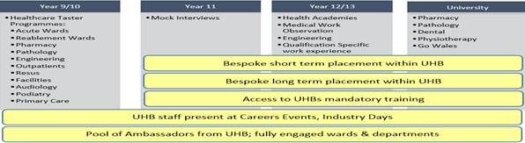
Requests for schools work experience has increased over recent months. Anecdotally it is suggested that this is a result of schools in the RCT area preparing for the introduction of Curriculum 2022 by piloting the Gatsby Good Career Benchmarks approach to good careers guidance. The Gatsby Benchmarks require at least 91% of all pupils from Year 8 to Year 13 to have:
- Quality experiences of the workplace – by the age of 16 and again by the age of 18
- At least 7 Memorable encounters with employers and employees.

As one of the largest employers within the area it can be assumed that the Health Board will have a corporate social responsibility to support our local schools in the delivery of this work experience and this may pose a challenge for the Health Board going forward.

In terms of raising the ambition of our local school children to consider medicine:
- Organise and manage the annual Medical Work Observation Scheme which is heavily involved with Doctors in and out of training. This scheme includes workshops on writing personal statements, reflection and ethics whilst ensuring the experience necessary is evident for an application to study Medicine.
- Host the annual schools awareness event, which has a world café style workshops for the different Healthcare professions. Local school careers leads / Careers Wales Reps are usually in attendance.
- Medical Education attend careers fairs / open days and ensure that either Medical students (usually from WAMS – widening access to medicine scheme) or Training Grade Doctor from the local area / school attends.

Volunteers
Since 1st April 2019, logistically volunteering has expanded significantly, this has resulted in a joint working approach to centralise the volunteer process, systems, training and correspondence and we continue to work jointly and develop a robust volunteer service across the Health Board. We also continue to work with our third sector partners including, Bridgend Association of Voluntary Organisations (BAVO), Voluntary Action Merthyr Tydfil (VAMT) and Interlink along with our local Job Centres and Communities for Work.

Engagement and joint working with our Third Sector Organisation has resulted in the first Pets as Therapy Volunteer and the Lindsay Leg Foundation, is coming up to its first successful year with a strong team of volunteers supporting the weekly sessions. Joint working with our local schools and colleges has been a driver with the volunteer service and has developed and implemented the first “Junior Ward Volunteer” scheme which is aimed to provide opportunities for 14-16 year olds on a ward environment. The Maternity Buddy Volunteer scheme still proves to be extremely popular and further volunteers have secured places to study their Midwifery Degree.

Further work has included the effective partnership with communities for work and the Learning and Development Team, which has resulted in volunteers having the opportunity to apply for the “Pathways to Employment scheme” with opportunity to undertake further training and if successful to join the staff bank. It is imperative that as a Health Board we ensure the volunteers are recognised and valued for their dedication and commitment and will be hosting a celebration event in the coming months.

We will maintain Platinum Corporate Health Standard, increase health and wellbeing of our staff measured through the staff survey, achieve the standards for Equality and Welsh Language, increase our numbers of welsh speaking staff and continue to support and engage our school and volunteers.

Workforce Performance Reporting
In order to measure progress in implementing the Workforce and OD plan the health board will adopt the workforce performance framework adapted from a model developed by joint research undertaken by CIPD/CIMA/CMI http://www.valuing-your-talent-framework.com/framework-detail.html. The framework demonstrates the health Boards intention to ensure a robust holistic workforce and OD performance approach, informed by a range of data including measures of staff experience. The model from the bottom up comprises:
- Inputs – basic information about the workforce resources of the Health Board. This will be developed further via the continuing work to develop E-Systems.
- Activities – converting the basic building blocks into higher value outputs through HR processes: performance reviews, recruitment, learning needs analysis etc. The plan includes a range of actions to maximise these activities and additional measures of progress will be developed over time.
- Outputs – add measurable value to the organisation and are the result of effective human capital management activities, e.g. leadership capability, diversity
- Outcomes – desired organisation culture, improved productivity, focus on improvement and quality
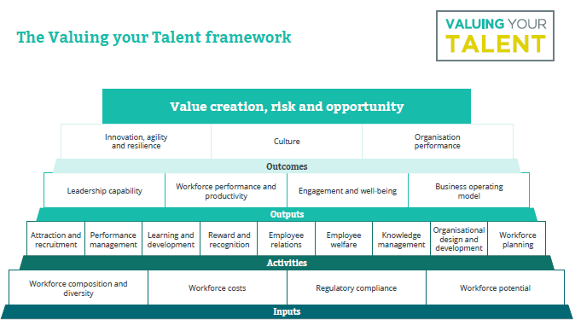
Key performance measures identified in the sections above are therefore:
- Inputs: WTE, WTE costs, Professional Regulation (Source: ESR, Oracle Finance
- Outputs: Time taken for “on-boarding”, levels and experience of Performance Appraisal (Source: Recruitment system, ESR, Consultant Appraisal system)
- Outcomes: Staff Experience of leadership, Engagement Index, Sickness levels (reasons for sickness absence, (Source, Staff Surveys, ESR)
- Outcomes: Linked to overall CTM performance measures but including high level measures of organisation culture.

FINANCE - 2020/21 to 2022/23
The financial plan for 2020/21 to 2022/23 builds on the current Cwm Taf plan and is based on the funding confirmed in the 2020/21 allocation letter.

Statutory Financial Duty
Cwm Taf Morgannwg UHB has a statutory duty to achieve break even over a period of 3 financial years. This applies to revenue and capital expenditure. Performance against the 3-year rolling duty for revenue is summarised below:

 | Actual | Actual | Actual | Actual | Forecast
Revenue: | 2015/16 | 2016/17 | 2017/18 | 2018/19 | 2019/20
 | £k | £k | £k | £k
Surplus /(deficit) | 22 | 18 | 23 | 25 | 0
Rolling 3 years |  | 70 | 63 | 66 | 48

Update on Financial Performance in 2019/20
Cwm Taf Morgannwg UHB has recently submitted its M11 Monitoring Returns to Welsh Government. This showed a forecast breakeven position for 2019/20 and a target recurrent deficit of £11.9m.

We noted in our Monitoring Return submission that the latest bottom up forecasts were £16.7m and that a final review of the forecast recurring position was being undertaken to inform this IMTP submission. The forecast recurrent deficit going into 2020/21 has subsequently been increased to £17.9m to reflect recent patient flow and contracting changes and this is the starting point for our medium term financial plan for the three year period 2021/22 to 2022/23:

 | £m
Planned recurrent deficit | 3.5
Unplanned BG recurrent deficit | 7.4
Forecast recurrent overspends from bottom up directorate forecasts | 6.0
Total | 17.9

FINANCIAL STRATEGY
The core purpose of the financial strategy is to support the delivery of the IMTP, and the fundamental aims and strategic objectives of the Health Board.

Assessment of the current financial position

The former Cwm Taf University Health Board has planned for and achieved breakeven over a significant number of years. However in 2019/20 as the new Health Board Cwm Taf Morgannwg was created, it has faced both significant additional priorities for management and leadership time, as well as significant new financial pressures. These demands on time and financial pressures include:

- Addressing targeted intervention and maternity special measures with the very wide programme of work on quality governance, quality improvement and values and behaviours which we are engaged in, alongside investment in clinical leadership.
- Developing a new operating framework and structure for the new organisation, which has been developed through 2019/20 and will come into effect from April 2020
- Major service reconfiguration planning, in particular in considering the future options for the ED in the Royal Glamorgan Hospital
- The financial pressures resulting from the Bridgend transfer
- Increased premium clinical workforce costs as a result of the ongoing recruitment and retention challenges, which increased during 2019/20
- Lower savings delivery than in the former Cwm Taf, resulting to a large extent from the competing priorities and demands on management time

After a number of years of the former Cwm Taf reducing its recurrent deficit, these pressures have driven the new Health Board temporarily into a larger recurrent deficit during 2019/20. RTT performance has also deteriorated due a combination of issues affecting all health boards and some CTM specific issues.

Under the previous Welsh Government allocations, circa £10m to £13m of the £17.9m underlying deficit of the Health Board is assessed to relate to the Bridgend area. However, this is changed radically under the new allocation formula. The table below shows the impact of the new allocation formula. Under the formula, the target CTM share of overall Health Board allocations is 15.1%. In 2020/21, this will only be used to allocate growth in allocations, and so the CTM share of general funding growth will be 15.1%. However, over the life of the next government term, it is planned to equalise total funding with the formula shares. As the CTM total allocation in 2020/21 is 15.24% of the total, this will mean that over time funding growth will be abated by £5.4m to reduce the CTM allocation share to 15.1%. In line with Welsh Government advice, this abatement is not reflected in the IMTP as its timing and phasing is not yet clear, but a key point for the financial strategy is that the current £5.4m “overfunding” against the formula is entirely in the former Cwm Taf area. Whilst it is for the Health Board to allocate resources internally, if these were allocated in line with the formula over time, then this would represent an £18.8m decrease in the former Cwm Taf area and a £13.4m increase in Bridgend.

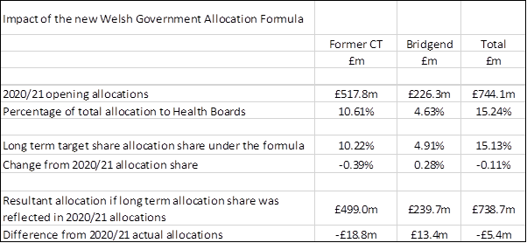
The implications of the new allocation formula in considering where the underlying deficit of the Health Board lies is summarised below. It shows that in the longer term, as the total allocation share reduces to 15.1%, and assuming the Health Board uses the new allocation formula as an strong indicator of health need in allocating resources internally, then:

- The underlying deficit reflecting the move to the target share increases by £5.4m to £23.3m, albeit the £5.4m increase only arises gradually over time. In other words current overall spend is £23.3m (3.1%) over the long term CTM formula allocation.

- The Bridgend deficit of circa £10m to £13m under the old formula moves to a surplus of circa £(3.4)m to £(0.4)m. In other words, the current Bridgend expenditure is slightly under the long term formula allocation share by between 0.2% to 1.4%.

- The former Cwm Taf deficit of £4.9m to £7.9m moves to a deficit of circa £23.7m to £26.6m, in other words the current spend is around 4.7% to 5.3% over the long term allocation share.

The key points from this assessment of the current financial position to inform the financial strategy are as follows:

- A key driver of the Health Board’s financial position is premium workforce costs resulting from recruitment and retention challenges, particularly for medical and nursing staff but also in other areas.

- The level of efficiency savings achieved has fallen in 2019/20 and needs to be significantly increased. This will need to be done in a way which aligns with the overall objectives of the organisation, including in particular improvement to quality and safety and outcomes. This will need a refreshed approach with stronger clinical leadership, and supported by the various enablers for overall improvement which are being put into place.

- The overall strategy needs to be informed by a better understanding of the utilisation of overall resource across the different locality areas and the outcomes being achieved. Change plans need to reflect a gradual alignment of the use of resource by area with the needs based formula allocation. This will need a greater level of allocative and technical efficiency within the former Cwm Taf area in particular. However, given that unavoidable annual demand and cost pressures of 3.5% to 4%, which will exceed the likely increases in general funding of 2% per annum, and there are improvement priorities which will have additional costs, then all areas will need to achieve a core level of improvement in the use of resources of at least 2% per annum.

Objectives of the financial strategy

These objectives are as follows:

- To achieve breakeven in each financial year, and to gradually reduce the level of recurrent deficit to achieve recurrent breakeven within the period of the 3 year plan.

- To achieve year on year reductions in premium workforce costs and premium planned care costs (waiting list initiatives and outsourcing).

- To achieve year on year improvements in efficiency, quality and value (outcomes relative to cost).

- To utilise financial improvement to re-invest in improving service quality and outcomes wherever possible.

- To achieve closer alignment over time between the needs based formula funding allocations from the Welsh Government, and our actual use of resources, and so improve equity of resource use.

Key actions to support and deliver the strategy

The key actions within the finance function are as follows:

- Analysis and review/interpretation of the pattern of spend in each locality area, in comparison with both the formula allocation and the pattern of spend in other localities across Wales. It will look at patterns of expenditure across different sectors (primary, secondary, tertiary etc) and across different health programmes and conditions (respiratory, neonates etc). It will also look at variation between GP practices in terms of whole system use of resources. This will be linked in with the population health analytical work referred to elsewhere within the plan.

- Increased analysis and intelligence and interpretation of opportunities for improvements to efficiency through the efficiency framework. These will be aligned with both opportunities for cash releasing savings and improvements in productivity to close the current capacity shortfalls against recurrent demand.

- Enabling plans to support directorates to reduce workforce premium costs are being developed. These be informed by an analysis (to be undertaken) of the total premium (excess) workforce costs across the Health Board broken down into different staff groups and services this analysis. Priority will be given to medical and nursing staff groups, but the approach will roll out across all staff groups. In some areas, part of the solution to chronic workforce shortages will be include re-design or reconfiguration of current services in partnership with other Health Boards, particularly where we have fragile clinical services.

The key enablers around delivery across the organisation as a whole include:-

- The move to the new locality based delivery groups supported by system groups looking at service improvement across the delivery groups. Investment in the clinical leadership of these groups will support the new population health approach and also improve the capability for cross heath system improvement at a local level.

- Investment in improvement capacity and support. The investment in CTM improvement and in a team to support Population Health and Value Based Healthcare will together with investment in analytics and the existing PMO provide much better support for change.

- The work on developing the performance and accountability framework and the work on values and culture will further support change.

Overview of the Financial Plan for 2020/21 to 2022/23
The key assumptions driving the CTM financial plan for the next three years are summarised below:

- A forecast underlying deficit at the end of 2019/20 of £17.9m.

- Additional recurring allocations from Welsh Government of £27.8m for 2020/21 followed by £25.3m per annum for each of the next two years. The 2020/21 increase includes a 2% general allocation uplift, the cost of further Agenda for Change & medical staff pay uplifts plus specific funding for investment in Clusters and Mental Health services (See Section 1.5).

- Additional non-recurring allocations from Welsh Government of £21.7m in 20/21 and £5.6m in 2020/21. This includes assumed allocations for bridging funding and Targeted Intervention plus the Health Board’s transformation programmes (See Section 1.5).

- Provision for recurring inflation, cost and service pressures of £39.3m in 2020/21, £37.2m in 2021/22 and £36.4m in 2022/23. These figures include provision for an annual pay awards plus incremental drift and non-pay increases from 2019/20 in line with projected inflation (See Section 1.6).

- The plan includes £4.0m for new recurring investment in service improvements in 2020/21 followed by £1.5m and £3.7m per annum in each of the following two years. The 2021/22 plan includes £1.5m investment in Clusters, £1m in Mental Health services, £1m for local investment plus £0.5m for major trauma and £0.5m for other All Wales initiatives (See Section 1.7).

- The plan also includes £12.1m of new investment in the SWYC and APCIS Transformation programmes in 2020/21, of which £9.8m is recurring spend from 2021/22 (See Section 1.5.4).

- The plan includes provision for a number of other non-recurring costs and benefits with a net benefit of £8.8m in 2020/21 followed by net benefits of £3.1m in 2021/22 and £1.4m in 2022/23 (See Section 1.8).

- Recurring savings of £20.6m are planned in 2020/21. This is circa 2.3% of an estimated controllable budget for CTM of circa £900m. The total recurring savings requirement over the three years is £63.2m (7.0%) (See Section 1.9). In addition, a cost release of £6.2m is required in order for the recurrent costs of the planned transformation of out of hospital services to be financially sustainable from 2021/22 after transformation funding stops in March 2021.

- Availability of Welsh Government strategic capital funding to support the capital costs of the key changes included in the plan is assumed. There is no key dependency between capital funding and planned savings in 2020/21, but as service plans for change and improvement are developed and reflected in refined year 2 and year 3 financial plans, there is likely to be some dependency on capital funding availability.

- It is assumed that the depreciation costs of all future capital schemes are fully funded by the Welsh Government, in line with current policy. These additional costs and consequent non-cash backed allocation changes are not included in the financial schedules pending clarity on approvals.

The 3 year financial plan is shown in the table below, with costs and deficits shown as positive numbers and income and surpluses as negative numbers.

The key elements of the Plan are explained in the following sections:

Income Changes – 2020/21 TO 2022/23
A summary of the assumed new allocations from the Welsh Government for 2020/21 to 2022/23 is shown in the table below:

 | 20/21 | 21/22 | 22/23
 | £m | £m | £m
Recurrent:
Core un--earmarked growth monies | (25.3) | (25.3) | (25.3)
Investment in Primary care clusters | (1.5) | 0 | 0
Investment in Mental Health services | (1.0) | 0 | 0
Total Recurrent | (27.8) | (25.3) | (25.3)
Non recurrent:
Bridging funding | (5.0) | (2.2) | 0
Targeted Intervention (TI) funding | (3.5) | (3.5) | 0
Transformation programmes | (12.1) | 0 | 0
Delivering RTT performance | tbc | tbc | tbc
Invest to save funding- Records digitisation | (1.0) | (0.5) | 0
Invest to save funding – Overseas nursing | (0.5) | 0 | 0
Invest to Save repayments- Records digitisation | 0.4 | 0 | 0.5
Invest to Save repayments- Overseas nursing | 0 | 0.6 | 0.6
Estimated repayment of 2017/18 AME funding for retrospective CHC claims which crystallise in 2020/21 | 0.5 | 0.5 | 0.5
Estimated new AME funding for new retrospective CHC claims provided for in 2019/20 | (0.5) | (0.5) | (0.5)
Total non-recurrent | (21.7) | (5.6) | 1.1
Grand Total | (49.5) | (30.9) | (24.2)

The key points to highlight are as follows:

Core Un-Earmarked Growth Monies
The individual items making up the assumed recurrent funding are summarised below:

 | 20/21 | 21/22 | 22/23
 | £m | £m | £m
Core cost growth uplift of £100m across NHS Wales (2% uplift) based on 15.1% share | (15.1) | (15.1) | (15.1)
Cost growth uplift of £13m for Mental Health services based on 15.4% share | (2.0) | (2.0) | (2.0)
A4C pay awards | (6.4) | (6.4) | (6.4)
DDRB pay awards | (1.8) | (1.8) | (1.8)
Total | (25.3) | (25.3) | (25.3)

Bridging funding
Section 1.3 describes the reasons for the Health Board moving temporarily into a more significant recurring deficit in 2019/20 after many years of incremental reductions in its recurring deficit. The level of cost reductions and efficiency savings needed to return to a financially balanced position in 2020/21 would be £25.6m and, while it is dealing with the wide range of issues described in Section 1.3, this is beyond the reach of the Health Board in 2020/21. The Health Board has set itself a savings target of £20.6m for 2020/21 and is making progress in identifying savings to deliver this target (Section 1.9). The IMTP requires bridging funding of £5m in 2020/21 in order to achieve financial balance in 2020/21, plus a further £2.2m in 2021/22.

The various steps the Health Board is taking to support improvement, including the new operating model and structure, the investment in clinical leadership and in Cwm Taf Morgannwg Improvement and Value Based Healthcare and Population Health Management, will enable greater efficiency savings alongside improved outcomes. With both the bridging funding and this improved delivery, the Health Board can then resume the record of financial balance delivered by the former Cwm Taf Health Board over many years, including achievement of recurrent balance.

Targeted Intervention
The Welsh Government has provided £3.0m of financial support in 2019/20 for actions to address the Health Board’s Targeted Intervention Status. The level of financial support for future years has not yet been confirmed by the Welsh Government. The financial plan assumes the following:

- £3.5m of TI funding in 2020/21 and 2021/22 to continue the enabling activities and service improvements which were started in 2019/20.
- This supplements £2m of Health Board funded investment in clinical leadership capacity and quality governance and quality improvement which was committed to in 2019/20 and is included in the 2019/20 recurrent deficit.
- TI funding ends in 2021/22. From 2022/23 the Health Board funds within an overall balanced plan the elements of the 2020/21 and 2021/22 activities which it considers need to continue on a recurrent basis. These are estimated at present to have an annual cost of £1.5m.

This includes investment in CTM improvement and in developing an improved capability to support Value Based Healthcare and Population Health Management, which are critical for the Health Board to plan and deliver the quality based financial improvement which is highlighted through the IMTP and is a major component of the medium term savings plan (see Section 1.9).

A summary of this showing the planned areas of investment from the assumed TI funding is shown in the table below:

Regional Partnership Transformation Programme
A summary of the income and spend profiles for the two Transformation programmes: Stay Well in Your Community (SWYC) in partnership with RCT and MTCBC, and Accelerating the Pace of Change of Integrated Services (APCIS) in partnership with BCBC are provided below:

The combined requirement from the two programmes is a cost release from existing models of care of £6.2m in 2021/22.

The 2019/20 financial plan includes a £1.7m provision for increased demand from unscheduled care admissions and associated growth in bed days. A further provision of £1.5m has been built into the financial plan for 2020/21 and into the 2021/22 plan. Provided the Health Board can manage within its existing bed base, through admissions avoidance enabled through the new out of hospital services and through improved length of stay, the planning assumption is that the recurring reserve by 2021/22 will provide a £4.7m recurring contribution to the £6.2m required for the transformation sustainability plan (See Section1.6.8). The balance of £1.5m will need to be delivered through bed reductions enabled by the impact of the out of hospital investment in reducing emergency admissions, or (as a fall back) by scaling back the level of out of hospital investment.

Delivering RTT Performance

The financial plan includes a provision of £2.3m per annum for demand and activity growth (See Section 1.6.7). It is important to note that this sum largely relates to diagnostics not planned care, and it is for new demand growth only.

Demand and capacity plans have been developed to meet planned care demand in 2020/21, and where possible reduce the RTT backlog as at 31 March 2021.

The approach has included:

Assessment of which of the drivers for the 2019/20 projected outturn RTT performance are non-recurring and which recurring, and thus establish the recurrent capacity shortfall for 20/21 before changes in 20/21. It should be noted that the forecast outturn RTT breaches in 2019/20 was after significant outsourcing funded from non-recurrent Welsh Government performance funding. The recurrent capacity shortfall is therefore significant and this has been driven by a variety of drivers such as pension changes and USC pressures.

Assessment of feasible improvements to productivity, pathways and capacity to reduce the recurrent capacity gap and start to reduce the backlogs at the end of 19/20.

Resultant performance improvement trajectories.

Resultant cost implications.

This means that in the absence of productivity improvement and funded capacity increases, RTT performance would continue to deteriorate. The estimated cost which would deliver on the below is estimated at £7.5m. This is not included within the IMTP pending further discussion with the Welsh Government.

This would:

enable recurrent demand to be met (and so avoiding a further deterioration of the RTT backlog)

clear an element of the backlog in medical specialties.

Primary Care Inflation
As in previous years, we are assuming that the cost of the DDRB pay awards for GDS and GMS contractors in 2020/21 will be matched with an additional allocation from WG.

Potential Additional Allocations
Likely additional Welsh Government allocations for specific purposes, over and above the core 2% uplift, funding for pay awards, primary care inflation and the specific 2020/21 allocation increases for primary care and mental health, have yet to be confirmed and so have been excluded from the plan.

Inflationary, Service Demand and Cost Pressures
The table below shows the projected inflationary, demand and other cost pressures for the next three years, which are anticipated to be fairly stable over this period.

Inflation and other cost pressures | 20/21 | 21/22 | 22/23
 | £m | £m | £m
Inflation
Pay rises and incremental drift | 14.3 | 14.3 | 14.6
Primary care inflation | 0 | 0 | 0
CHC inflation | 1.2 | 1.2 | 1.4
NHSFNC inflation | 0.3 | 0.3 | 0.3
Non-pay inflation | 2.2 | 2.2 | 2.2
LTA inflation – core 2% | 2.6 | 2.6 | 2.6
LTA inflation – net impact of A4C pay awards | 0.7 | 0.7 | 0.7
Subtotal | 21.2 | 21.3 | 21.8
Service and demand pressures
CHC growth | 1.2 | 1.2 | 1.4
Primary care prescribing | 2.3 | 2.3 | 2.3
Community pharmacy | 0 | 0 | 0
NICE  Nurse Staffing Act | 3.5  0 | 3.5  0 | 3.5  0
Internal cost/demand/service pressures | 5.5 | 5.5 | 4.0
Claims WRP | 1.7 | 0.1 | 0.1
WHSCC demand and cost pressures | 3.6 | 3.0 | 3.0
EASC demand and cost pressures | 0.3 | 0.3 | 0.3
Subtotal | 18.1 | 15.9 | 14.6
Total | 39.3 | 37.2 | 36.4

The basis for the above estimates is outlined below:

Pay cost inflation

Pay rises and incremental drift | 20/21 | 21/22 | 22/23
 | £m | £m | £m
Wage awards | 9.5 | 9.5 | 9.5
A4C incremental drift | 0.7 | 0.7 | 0.7
Medical and dental pay | 3.0 | 3.0 | 3.0
Medical and dental incremental drift | 0.3 | 0.3 | 0.3
Consultant commitment awards | 0.3 | 0.3 | 0.3
Estimated inflation on external agency costs @1.5-2% | 0.5 | 0.5 | 0.8
Total | 14.3 | 14.3 | 14.6

Pay cost pressures have been assessed to remain broadly stable over the three years of the plan.

Continuing Health Care (CHC) and NHS Funded Nursing Care (FNC)
Cwm Taf Morgannwg currently spends circa £50m per annum on external CHC placements. The anticipated cost increases for each year of the plan have been based on average price inflation of circa 2.5% per annum (£1.2m) and volume growth of circa 2.5% per annum (£1.2m). The plan also includes £0.3m per annum for NHSFNC price inflation.

Non Pay Inflation
As at November 2019 the consumer price index (CPI) was reporting 1.5% inflation with the retail price index reporting 2.1% inflation (RPI). The plan includes a non-pay inflation estimate of £2.2m (circa 2.0%) per annum for each of the 3 years. No material allowance has been made for the potential price rises resulting from changes in exchange rates or the impact of Brexit which represents a potential risk to the plan.

LTA Inflation
Provision has been made for a 2% per annum tariff increase on all income and expenditure LTAs over the three years of the plan at a net cost of £2.6m per annum. Provision has also been made for the impact of A4C pay awards on LTAs at a net cost of £0.7m per annum.

Primary Care Prescribing
The financial plan assumes growth in primary care prescribing costs of £2.3m for 2020/21 which is based on the estimated growth provided by the Medicines Management directorate. This annual growth is matched with a corresponding savings target of £2.3m for 2020/21 which reflects the planning assumption that growth will be managed through a combination of directorate savings plans and price reductions on Category M drugs.

The financial plan assumes annual growth of £2.3m per annum for year 2 and year 3 of the Plan, matched by a corresponding savings target for the same value.

Community Pharmacy
The financial plan does not make any provision for growth in community pharmacy expenditure costs over the next three years.

NICE and New High Cost Drugs (Including Hep C)
The cost of NICE technical appraisals and nationally adopted high cost drugs has been a significant cost pressure in recent years. The latest planning assumption is an annual increase of £3.5m per annum for each of the 3 years. This includes:
- Internal NICE growth within CTM (£2.0m)
- Anticipated financial impact of growth in NICE and other high cost drugs for CTM residents at Velindre Trust and other Health Boards (£1.5m).

The internal NICE growth estimate within CTM includes provision for the following:
- Growth on existing NICE ( based on average growth over the past 3 years) - £0.5m
- FYE of Daratmumab business case - £0.5m
- Estimated part year effect of new NICE announcements in 20/21- £1m

Local Cost, Demand and Service Pressures
A £5.5m provision has been made in the financial plan for 2020/21 to cover local cost, demand and service pressures. The key areas are summarised below:

 | 2020/21  £m | 2021/22  £m | 2022/23  £m
Demand and activity growth | 2.3 | 2.3 | 2.3
Other non-activity related cost pressures | 1.7 | 1.7 | 1.7
Increased demand for beds | 1.5 | 1.5 | 0
Total | 5.5 | 5.5 | 4.0

The basis for the above cost estimates for 2020/21 is outlined below:

Demand and activity growth
2020/21
£m
Endoscopy demand growth | 0.35
Radiology- Out of hours USC reporting growth | 0.15
Radiology - Increased imaging and reporting demand ( including Single Cancer Pathway) | 0.4
Increased drugs and consumables due to increasing demand | 0.5
Neurophysiology service gap/demand growth | 0.1
Increased non pay costs due to elective capacity gaps | 0.5
Increased eyecare costs | 0.3
Total | 2.3

Other non-activity related cost pressures

2020/21
£m
Increased costs for Bridgend clinical negligence and personal injury claims | 0.5
Increased employer costs due to final pay pension control charges from Pensions Agency | 0.2
Pre commitment to roll out partial booking | 0.1
Pre commitment SARC | 0.1
SIFT income shortfall for Bridgend | 0.1
Microsoft 365 cost increases | 0.5
Other ICT cost increases for ED and Child Health systems | 0.2
Total | 1.7

Increased demand for beds

The 2019/20 financial plan includes a £1.7m provision for increased demand from unscheduled care admissions and growth in bed days. A further provision of £1.5m has been built into the financial plan for 2020/21 and 2021/22. Provided the Health Board can manage within its existing bed base through admissions avoidance and improved length of stay the planning assumption is that:

The recurring reserve in 2020/21 of £3.2m will be released on a non-recurring basis (See Section 1.8).
- The recurring reserve in 2021/22 will provide a £4.7m recurring contribution to the sustainability plan for the Transformation programme (See Section 1.5.4).

Welsh Risk Pool (WRP)
The cost of clinical negligence and other claims previously met by the Welsh Risk Pool have been met by Health Boards since 2015/16. A risk sharing arrangement has been put in place such that all costs are shared between LHBs proportionate to their shares of the devolved budget.

Up until 2018/19 the new risk sharing arrangement has not resulted in any additional cost pressures for Health Boards. However, the latest information from NWSSP is indicating an additional charge in 2019/20 of £0.5m to CTM (circa £4.5m across all health boards).

Based on the latest information provided by NWSSP, the plan includes a provision of £1.7m for 2020/21 plus a further £0.1m per annum for each of the following 2 years.

WHSSC Demand and Cost Pressures
The financial plan includes a sum of £3.6m for WHSSC demand and cost pressures in 2020/21 followed by £3.0m per annum for each of the following two years. The latest estimates from WHSSC are that they require an additional £3.6m in 2020/21 which is in line with the CTM financial planning assumption.

EASC Demand and Cost Pressures
The financial plan includes the following sums for EASC for 2020/21:

 | 20/21 | 21/22 | 22/23
 | £m | £m | £m
EMRTS | 0 | 0.3 | 0
Other | 0.3 | 0 | 0.3
Total | 0.3 | 0.3 | 0.3

The £0.3m for 2020/21 represents a 1.5% increase on the £20m LTA value and is in addition to £0.4m (2%) funding for inflation.

Investment in Service Improvement
The following table sets out the planned investments over the three year period:

Service improvement | 20/21  £m | 21/22  £m | 22/23  £m
Recurring investment:
Locally determined developments | 1.0 | 1.0 | 1.7
Actions to address TI status required recurrently after Welsh Government TI support funding has ended ( See Section 1.5.2) | 0 | 0 | 1.5
Investment in Clusters- nationally funded | 1.5 | 0 | 0
Investment in Mental Health services – nationally funded | 1.0 | 0 | 0
All Wales initiatives/top slices | 0.5 | 0.5 | 0.5
Major Trauma local investment (The £2.2m commissioned development is funded directly by WG)) | 0.5 | 0 | 0
Total Recurring investment | 4.5 | 1.5 | 3.7

Service Improvement – Locally Determined
The financial plan for 2020/21 includes £1.0m for locally determined investment decisions. The planned allocation of this £1.0m is set out below.

Service improvement | 20/21  £k | 21/22  £m
Recurring investment:
DER infusion pump system | 104 | 0
Maternity records data quality/merge | 59 | 0
BI/data quality to support Quality governance | 207 | 0
Vascular reconfiguration | 250 | 500
To be prioritised | 380 | 500
Total Recurring investment | 1,000 | 1,000

There are a number of planned areas of development within the service change section of the IMTP. In most cases these require detailed proposals to be developed for corporate consideration. The potential funding sources for these schemes within the overall financial plan are as follows:

- From re-allocation of existing resources within the relevant service area or locality, including on an invest to save basis.
or
- From the overall internal development resource provision outlined above.
or
- From any relevant Welsh Government specific funding.

Service Improvement – All Wales
The Health Board has supported a number of All Wales initiatives in previous years in areas such as paramedic banding, non-medical education, postgraduate medical education, 111 roll out etc. The following additional top slices have been included in the 2020/21 Allocation Letter:

 | 20/21  £m | 21/22  £m | 22/23  £m
Paramedic banding | 0.2 | 0 | 0
Genomics strategy | 0.3 | 0 | 0
Provisional estimate | 0 | 0.5 | 0.5
Total | 0.5 | 0.5 | 0.5

Non Recurring Costs and Benefits
Non Recurring costs | 20/21  £m | 21/22  £m | 22/23  £m
Retrospective CHC claims ( matched with assume WG income) | 0.5 | 0.5 | 0.5
Laboratory Information Network Cymru Programme ( LINC) costs | 0.4 | 0.8 | 0.7
Bridgend transition – planning and change resources | 0.2 | 0 | 0
ED & paediatrics reconfiguration – project resources | 0.2 | 0 | 0
Equipment replacement | 0.5 | 0.5 | 0.5
Local Invest to save schemes | 0.6 | 0.6 | 0.6
Other non-recurring costs | 0.3 | 0.3 | 0.3
Total | 2.7 | 2.7 | 2.6

Non Recurring benefits | 20/21  £m | 21/22  £m | 22/23  £m
Release of recurrent reserve for increased demand for beds (Section 1.6.8) | (3.2) | 0 | 0
Slippage on recurrent investments in service improvement (Section 1.7) | (1.0) | (1.0) | (1.0)
Contribution towards existing cost pressures from non-recurring In year WG allocations | (2.0) | (2.0) | (2.0)
Accountancy gains | (4.3) | (1.8) | 0
Other non-recurring expenditure reductions | (1.0) | (1.0) | (1.0)
Total | (11.5) | (5.8) | (4.0)

Medium Term Savings Plan 2020/21 to 2022/23
The following table sets out the planned savings over the three year period:

 | 20/21  £m | 21/22  £m | 22/23  £m | Total  £m
General recurring efficiency and redesign savings(2% of pay and non-pay budgets in 20/21, reducing to 1.75% and 1.5% in 21/22 and 22/23) | (15.7) | (14.1) | (12.5) | (42.3)
Specific recurring efficiency and redesign savings:
Primary care prescribing | (2.3) | (2.3) | (2.3) | (6.9)
Medical staffing | (1.0) | (1.0) | (1.0) | (3.0)
Reduced bed requirements resulting from improvement to inpatient delays and discharge | (0.3) | (0.9) | 0 | (1.2)
Records digitisation I2S project | (0.6) | (0.3) | (0.1) | (1.0)
Overseas nurse recruitment | 0 | (2.2) | 0 | (2.2)
Other strategic savings schemes including reconfiguration , redesign and pathways | (0.7) | (2.3) | (3.6) | (6.6)
Total recurring savings | (20.6) | (23.1) | (19.5) | (63.2)
Non recurring contingency | 0 | 0 | 0 | 0
Total | (20.6) | (23.1) | (19.5) | (63.2)
Recurrent cost release resulting from transformation investment | 0 | (6.2) | 0 | (6.2)
Grand Total | (20.6) | (29.3) | (19.5) | (69.4)

The total recurring savings over the three year period is £69.4m which is around 7.7% of the Health Board’s controllable expenditure (excluding capital charges and primary care contracts) of circa £900m.

The plan includes £6.2m of cost reductions resulting from transformation investment. Of this £4.7m is assumed to be cost avoidance (£1.7m in 2019/20, £1.5m in 2020/21 and £1.5m in 2021/22), and £1.5m from absolute cost reduction in 2021/22 (see section 1.5.4).

It is important to note that the £2.3mm per annum for demand and activity growth in Section 1.6.7 above is for new growth only. The planning assumption is that recurring demand and capacity gaps will need to be managed from a combination of additional productivity gains in 2020/21 (which are over and above the £20.6m cash releasing savings requirement noted above) and Welsh Government funding.

Savings Plans for 2020/21
Further information on the latest savings plans for 2020/21 is provided in the Savings Plan Annex and is summarised below:

 | Target | Latest forecast as at 13 March | Latest forecast as at 13 March | Green & Amber schemes | Green & Amber schemes
 | £m | £m | % | £m | %
General recurring efficiency and redesign savings- 2% of pay and non-pay budgets in 20/21. | (15.7) | (9.1) | 57 | (8.6) | 55
Specific recurring efficiency and redesign savings:
Primary care prescribing | (2.3) | (2.9) | 126 | (2.6) | 113
Cross cutting medical staffing savings | (1.0) | (2.5) | 250 | (2.5) | 100
Reduced bed requirements resulting from improvement to inpatient delays and discharge | (0.3) | (0.3) | 100 | 0 | 0
Records digitisation I2S project and Patient Care Administration | (0.6) | (0.4) | 67 | (0.4) | 67
Other strategic savings schemes including reconfiguration , redesign and pathways | (0.7) | 0 | 0 | 0 | 0
Cross cutting nursing productivity savings | 0 | (0.6) | 0 | (0.6) | 0
Cross cutting procurement savings | 0 | (0.5) | 0 | (0.5) | 0
Total savings | (20.6) | (16.3) | 79 | (15.2) | 74

The delivery methodologies and capabilities outlined in 1.9.2 to support medium term savings will only have a partial benefit during 2020/21, and so savings in 2020/21 will have a greater transactional focus, but implementation of improved capability and ways of working will be progressed as quickly as possible in 2020/21 to support delivery in 2020/21 and into 2021/22.

Savings Plans for Years 2 and 3 (and subsequent years)
As described in the financial strategy, achieving financial sustainability and the broader objectives in the strategy around best value and improved quality and outcomes requires a deeper level of service improvement, including development involving new service models and pathways, service reconfiguration as well as productivity improvement. This will require investment in value based health care capability, improvement support for directorates, improved analytics as well an investments in digital functionality to support changes and in new workforce models.

A summary of the medium term savings opportunities is provided below:

Key Risks to the 2020/21 Financial Plan
The key risks to the 2020/21 financial plan are summarised in the following table. The table shows the worst case position (as per the WG financial templates) and also a more realistic probability adjusted risk which applies probability assessments to the worse case position:

Table 1  Risk Assessment of 2020/21 financial plan | Plan Assumption | Worse Case Risk | Probability | Probability Adjusted Risk
 | £m | £m | % | £m
Funding risks:
New Treatment Fund - assumed continuation of non-recurrent funding received in 19/20. | 2.6 | 2.6 | 10 | 0.26
Unavoidable costs associated with the Health Board’s Targeted Intervention status exceeding available funding from WG | 3.5 | 0.5 | 50 | 0.25
Savings delivery risks:
Shortfall against planned savings delivery. | 20.6 | 5.4 | 50 | 2.7
Cost pressure risks:
Unavoidable recurring Service and demand pressures are greater than Plan estimate | 18.1 | 4.0 | 50 | 2.0
Pay rises, incremental drift and inflation costs are greater than Plan estimate | 21.2 | 2.0 | 25 | 0.5
Shortfall against planned non-recurring benefits | 11.5 | 3.0 | 50 | 1.5
Potential LTA differences with Welsh NHS organisations | 0 | 2.0 | 25 | 1.0
Surplus / Deficit before Contingencies |  | 19.5 |  | 8.2
Contingencies |  | 0 |  | 0
Surplus / Deficit after Contingencies |  | 19.5 |  | 8.2

- This risk assessment does not include potential costs of outsourcing to meet existing planned care demand and capacity gaps. It is assumed that this is a performance risk as opposed to a financial risk.
- The plan also assumes that there will be no adverse financial impact from the introduction of the new IFRS16- Accounting for finance leases.

Financial Risk Management Plans for 2020/21
- Further development of savings plans, and the capability and capacity to plan and deliver service improvement and change.
- Further development of demand and capacity planning, reflecting both improved pathways and improved productivity in the delivery of services.
- Further increasing the rigour of requiring clear expected outcomes to be demonstrated before investment in re-designed services is approved.

Key Risks to the Financial Plan in Years 2 and 3
The key risks for years two and three are similar to those in 2019/20:

- Welsh Government allocation assumptions.
- The impact of moving to the new allocation formula over the 5 year term commencing in 20/21 represents a potential risk of £1.1m in 2021/22 and £1.1m in 22/23.
- Delivery of savings, and the cost release from transformation in line with the plan.
- Managing cost and demand pressures in line with the plan.

ENABLERS

Innovation, Learning and Purposeful Collaboration
Innovation is at the heart of our objectives and we are strengthening our role as a catalyst for transformation and accelerated improvement in health care delivery. We have also built our profile and partnerships with those within and outside of CTM in order to enhance the local economy and our reputation for innovation. This integration of continuous learning, quality improvement and strategic innovation is a key thrust of our development as an organisation over the next few years. The Executive Board has approved an innovation strategy ‘Cwm Taf IDEAS’ which describes the key pillars of innovation as we see them operating in a context of academic partnerships of which citizens are part. This ‘house of linked innovation’ shows the domains of innovation which we will focus on and seek to integrate with a bottom-to-top quality improvement programme ‘Improvement CTM’.

Improvement CTM will add value and address the 3 high level objectives set out in section 1.6 in 4 key ways. It will:

- Co-ordinate and Communicate Improvement
- Co-ordinate existing improvement work across the organisation and upscale successful initiatives accessing key stakeholder support such as the Accelerate programme and Agor IP
- Communicate achievements and successes both internally and externally to showcase excellence.
- Identify New Improvement Opportunities
- Working with the organisations’ units of operation (departments, wards services or cluster teams) to identify improvement opportunities
- Establish a suite of Improvement initiatives prioritised based on CTMUHB’s current escalation status, healthcare data and opportunities in a wider environment.
- Introducing improvement capability to existing operational pressures within the organisation
- Develop the Improvement capability in the system and the workforce
- Identifying improvement champions in each CTMUHB business unit.
- Upskilling the workforce and disseminate learning
- Working with external and academic partners to develop training materials and courses
- Build and recognise communities of Improvement practice
- Recognise well developed improvement capabilities and bring these together to establish a community of practice.

House of Linked Innovation
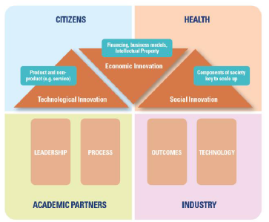

Current Innovation activities include:
- Ward based e-Whiteboards: Developed internally by CTMUHBs ICT Department the e-whiteboards replicate the traditional pen and board approach used in secondary care wards to represent inpatients. A successful application to the Accelerate programme to help develop and refine the concept has been made and is currently underway. The potential commercialisation of this approach is being explored. (see section 8.2)
- Recycling of Waste material: Growing interest and awareness of the volume of hospital waste has driven a number of innovative projects to explore ways of reducing the impact of waste. Linking into the Sustainable Operating Theatres initiative in partnership with CaVUHB, Life Sciences Hub and the Accelerate programme. Working with a joint KeSS studentship between USW and an industrial partner, Thermal Compaction Group Ltd to explore the recycling potential of some of the most common non-hazardous types of plastic.
- WAST Ideas portal: WAST have created the Welsh Innovation Improvement Network (WINN) and we have been exploring with them the potential to adapt many of their ideas. Primarily this includes the WIIN online ideas portal which takes staff through a set process to structure their idea and to allow it to be triaged appropriately into either a research, innovation or improvement pathways. We are looking at ways to incorporate this into the current CTMUHB structure.

NHS Wales Innovation Leads Group
The NHS Wales Innovation group are the leads for innovation within our respective organisations. We meet regularly with a remit to discuss areas of mutual interest, share knowledge and support the adoption and scale of innovation nationally. The Group has agreed to focus on the following three areas initially:
- Intellectual Property policy and approaches
- Social enterprises/revenue creation vehicles
- Development of a shared NHS Wales Innovation competency framework and skillset

Commercialisation of Innovation
We will continue to develop the capacity to pursue the commercialisation of innovations developed within CTMUHB. There are a number of options that can be adapted to allow this to occur which includes the industrial commercialisation CTMUHB IP, alongside the creation of social enterprises, community interest companies and co-operative models.

Innovations that may have potential for commercialisation realisation include (but are not limited to) training courses for healthcare staff, patients and the general public; consultancy services; devices; software tools; and services. Our intention in pursuing the commercialisation of at least some innovations is not, primarily, to generate income (though this may be a welcome by-product), but, rather, because we perceive that this route encourages in at least some cases a certain rigour, and provides opportunities to achieve spread and scale, which will ultimately result in greater patient benefit and greater impact in support of the strategic priorities of the Health Board, NHS Wales and WG.

The Health Board has an excellent working relationship with AgorIP (hosted by Swansea University), an organisation funded by WG. AgorIP provide an all Wales support and advisory service for recognising and developing partnership (industry, academia, investors) and commercialisation opportunities in academia and health. Through the joint appointment of an IP development manager the Health Board will look to access AgorIP support to commercialise IP where relevant and the potential to create spinouts as required.

Key outcomes include
- As part of our ongoing relationship with AgorIP through the joint appointment of an IP Development Manager we are actively looking at the ways in which we can work with industrial partners to commercialise IP.
- Exploring the potential of creating a social enterprise based in the innovative Colorectal Education work of Professor Haray.

Academic Partnership Board
The Health Board and its academic partners are driven by a shared commitment to ensure excellent health, medical care, research, innovation and health care education in the region. The parties recognise that there are synergies between them that provide positive opportunities for collaboration which potentially exceed the traditional university hospital model with a key objective of promoting quality and service improvement.

As such there is a long history of collaborative working between the Health board and its academic partners and the Academic Partnership Board (APB) provides a formal mechanism whereby the strategic and operational benefits of partnership can be established and integrated across the Health Board and the Universities. Its primary aim is to promote collaborative efforts to improve the health, wellbeing, education and wealth of patients and the population.

The APB is chaired by Professor Kelechi Nnoaham, Executive Lead for Research, Innovation and Improvement and brings together senior leaders from the University of South Wales, Cardiff Metropolitan and Cardiff. Recently academic membership has been expanded to include the Open University in Wales and it is expected further academic partners will be invited to join.

The APB provides to explore opportunities for the further development of collaborative activities between the members of the partnership - especially in relation to clinical services, research, teaching, innovation and improvement, providing advice thereon to appropriate decision-making bodies.

To support the APB, the Academic Partnership Steering Group (APSG) chaired by Professor John Geen, R&D lead for the Health Board, acts as its operational delivery function. The APSG ensures that all appropriate action is taken to deliver the operational obligations set out by the APB and it has delegated authority for effective decision-making in respect of the implementation of the work plan agreed by the APB.

With the recent creation of a dedicated Health Board Innovation team which act as the secretariat for both the APB and APSG the respective Terms of Reference and work programme have been refreshed and updated. The APSG now regularly reports on each of the four key work programme themes which include:
- Workforce Development (to include Training, Education and Workforce re-design)
- Innovation and Commercialisation
- Research And Development (includes Service developments, Service evaluations)
- Population and Public Benefit (includes Corporate and Social Responsibilities)

Key Elements from the current Work Programme include:
- Informing the format of, and responding to the upcoming WG triennial review of Health Board Status. This includes gathering key examples of partnership working across education & Teaching, Research & Development and Innovation & Improvement.
- The process of capturing all honorary appointments, joint contracts and clinical academics between the Health Board and its academic partners. Such colleagues are exemplars of academic partnership working and endeavours and a key priority of the APB is to both accurately capture this activity and increase the numbers of staff with these roles.

Research Innovation and Improvement Hub
CTM Social Services and Wellbeing Partnership Board (PB) has set out in its Regional Plan - a whole system population health and social care model which responds to the voice of the individual through three interwoven layers: Wellbeing; Integrated Community Care, Closer to Home; and Acute Health and Social Care and Tertiary Health Services.

The partner organisations (Bridgend, Rhondda Cynon Taf and Merthyr Tydfil CBCs, the Third Sector, Care Forum Wales, Social Care Wales alongside CTMUHB) are responsible for making sure that safe and effective services are delivered that make a positive difference to people’s lives, now and in the future. Through the WG Transformation fund, these partners have successfully applied for £22.7 million to help deliver the vision set-out in A Healthier Wales, the long term plan for health and social care delivery in Wales, and the Partnership’s expectation is for the RI&IC hub to help in this endeavour.

The ambition for the Research, Innovation and Improvement Hub is for it to act as a focal point, bringing together examples and the supporting evidence base of work and initiatives currently underway across our Health and Care Partnership. With the prudent focus of knowledge management mobilisation and best practice scale-up at its core, it will seek to drive the adoption and spread of promising RI&I activity at pace and scale.

The initial priority of the Hub and its team will be to focus on identifying existing examples of RI&I activity across the footprint to evaluate its potential impact and the ability for it to be transferred across all partners. It will look to track such examples from initial innovations and pilots to more mature interventions that will create a pipeline of activity with a focussed and engaged Hub team. They will engage with all partners in a structured way driven to identify the activities that have the greatest potential impact on improving quality outcomes of health and social care value. This will provide a robust evidence based methodology that can accurately identify and prioritise the activities and initiatives and ultimately we would like to be able to undertake this approach for all RI&IC hubs across Wales.

Anchored within the Partnership Board and engaging equally with its partner organisations the hub will be positioned in the centre to act as a focal point for RI &I knowledge generation and capture.

It will help to:
- IDENTIFY examples of innovation and good practice from across the region to help deliver whole system population health and social care new models as set out by the PB in its regional area plan.
- PRIORITISE and coordinate RI&I activity based on existing population health & care management (PH&CM) expertise, providing PH&CM expertise to other RI&I hubs and championing a population segmentation and risk stratification approach for Wales.
- ENGAGE with and support key stakeholders at all organisational levels to accelerate the implementation and adoption of innovative approaches to health and care service delivery.
Key Element from the RI&I work plan include:
- Develop a robust process to gather examples of RI&I activity to include proformas to capture case studies and identification of key stakeholders such as R&D leads, QI managers etc. to link with colleagues undertaking activity.
- Connect and link to evaluating experts to develop capacity so that activities with the greatest potential impact and/or scalability can be championed and promoted.
- Work with RPB partners to publicise and promote examples of current good practice collected form the good practice census, both internally and externally
- Develop compendiums (electronic and hard versions) to detail activity that can be easily shared.
- Develop the use of online ideas sharing portals across RPB organisations that (1) give staff the opportunity to generate ideas, (2) help identify improvement and innovation support for those ideas, and (3) act as a robust means of recording activity for governance and reporting purposes.

Working with the Bevan Commission
The Bevan Commission continues to support a number of Bevan exemplars, Health Board staff who have applied to the programme to design and develop innovative ideas. In addition the Health Board is actively supporting staff to become innovation adopters as part of the Bevan adopt and spread programme. The following 5 projects have been successfully accepted for Cohort 5 of the Bevan Exemplar Programme:

1 | Development of a communication tool that enables people to self-manage lifelong conditions
2 | An Innovative Approach to ILD Management – Right People @ Right Time
3 | Connected Learning – using apps and virtual reality to facilitate pre-registration pharmacist (PRP) training in the primary care sector
4 | Using Population Segmentation and Risk Stratification to Deliver Asthma Care Where it’s Needed Most
5 | Exploring the adaptability of the Hafal Recovery Programme in supporting mental health inpatients transition to community discharge.

Research and Development
CTM is an ambitious Health Board which has a distinct population on which to undertake high quality, ethical and collaborative research, with the aim of helping to develop and change patient care, population health, outcomes and experience for the better. Details of the extensive research and development portfolio can be found in Book A2 and the key targets for the Academic Partnership Board include:
- Establishment of a Clinical Research Facility at RGH (March 2020) to develop the infra-structure to increase commercial research for the Health Board and our patients and develop further collaborative research opportunities with our Academic partners.
- Following the formation of CTMUHB, the Health Board’s Research and Development (R&D) team to progress the full integration of all research in Primary, Secondary, Community care and Population Health across the Health Board.
- Ensure equitable access of our researchers, research partners and population to high quality research to support change and improvement in the wealth, health and well-being of all.
- Support the delivery of the key aims of “A Healthier Wales” and the Quadruple Aims, by promoting research as a function of all the workforce, and by supporting the development of Principal and Chief Investigators in all specialties and professions.
- To deliver on the 2019-2022 Health Board R&D strategy to maintain University Health Board status through increased investment in research capacity, by increasing research activity and increased participant recruitment by opening and supporting more high quality non-commercial portfolio studies and commercial studies.
- To work with Health and Care Research Wales with the implementation of the OneWales approach to research governance and study set-up.
- Following the recent increase in the research capacity, continue to progress the Primary Care, Community, Mental Health and Population Health research agendas and deliver on the documented frameworks and strategies in these areas.
- Continue to seek and support new opportunities for research to include Community Diagnostics, Cell and Gene Therapy, Precision Medicine, Genomics, Social care, Therapeutics and Technologies.
- Research and Development team will continue to build on recent successes and encourage, support and assist Health Board researchers and academic partners in the submission of high quality, collaborative funding applications to major funding schemes.

 | Priority | Target Date
1. | Development of a Clinical Research Facility at the RGH site. | March 2020
2. | Continue to monitor and review any proposed change in NHS R&D funding model and its associated impact and risk to the Health Board R&D function and activity. | April 2020 - March 2021
3. | Recruit x1 additional research officer and x1 Research Nurse | March 2020
4. | Development of an R&D internet webpage. | March 2020
5. | Complete the development of “in-house” SOPs | April 2020
6. | Development of a communications plan. | April 2020
7. | Developing a central research repository, to detail ongoing research, research findings, publications, service developments, best practice and quality initiatives. | June 2020
8. | Continue to support Primary Care research activity to include dentistry and optometry, and secure continued funding from the Health Board in support of the Primary Care R&D strategy to 2023. | Ongoing
9. | Support research into new technologies, therapeutics, and procedures (eg. Point of Care testing, Cell and Gene therapy, antibody conjugates etc) | Ongoing
10. | Undertake at least 15 commercial studies and recruit at least 50 patients during 2020/21. | March 2021
11. | Undertake at least 85 Clinical Research Portfolio studies and recruit at least 3300 patients during 2020/21 | March 2021

Information and Communications Technology (ICT)
Investment in ICT is a critical enabler to allow the Health Board to support the challenge of working across traditional boundaries and to support integration between the various Health Services and other Public Sector bodies.

These priorities are:
- Facilitate delivery of the expected organisational benefits from the integration of Bridgend & Cwm Taf to be realised by overcoming the numerous technical challenges in regards to digital and information systems, architecture and services.
- Maximise the benefits to be gained from existing systems by: widening use of the systems, increasing the uptake of the functionality within them and putting the appropriate governance and control structures in place for the data to be accessible across all NHS Wales systems
- Enhancement of in-house developed systems to provide greater functionality, supporting both the RPB and Health Board’s improvement and transformational programmes
- Deployment of Digital Medical Records, improving the accessibility of information and our custodianship of our citizen’s personal data
- Deployment of the Welsh ED System as an enabler to improving the unscheduled care system

Our clinical and ICT strategy enables working across the artificial boundaries of hospital and community. From the patient perspective, the services should be integrated and seamless, with health, social care, and other professionals being able to work supported by common, reliable, up-to-date information. The Health Board’s strategy aligns with national policies and direction such as the Service Redesign, South Wales Plan.

For this vision to succeed, as the patient moves physically between care settings and providers, all the appropriate clinical and social care documents must be available at the point of treatment in a timely manner. Clinical teams must have the tools and ability to work in a more agile manner, access to the records of patients must move from inconvenient paper based and hospital based systems, to electronic records, accessible using the latest technology, and delivered in a manner that does not compromise patient confidentiality and safety.

To support this mobile working vision ICT must provide infrastructure and hardware to deliver the clinical record and applications at the point of care. The era of static working is rapidly becoming replaced with the concept of agile staff based and working where most appropriate to meet clinical needs.

ICT needs to enable a Digital workforce but alongside this there is a requirement to both train and support to enable the business change processes to be achieved.

The clinical application design itself needs to be re thought with the requirement to provide information at the point of care using both tablet and app based designs as opposed to traditional desk top deployments.
The strategic direction as defined in the Informed Health and Care Digital Strategy states:

Digital technologies and online services have become part of the daily lives of many people in Wales. We can bank, shop, work, read, and enjoy music and films, book holidays and stay in touch with friends and colleagues across the globe online, using PCs, tablets and mobile devices such as smartphones. The Informed Health and Care Digital Strategy outlines how we will use technology and greater access to information to help improve the health and well-being of the people of Wales. It describes a Wales where citizens have more control of their health and social care, can access their information and interact with services online as easily as they do with other public sectors or other aspects of their lives, promoting equity between those that provide and those that use our services in line with prudent healthcare and sustainable social services.

The Plan sets out the strategic context, in which ICT is operating, the Health Board requirements for the Directorate in line with the Corporate Business Plans and the collaborative working with NWIS and other Health boards.

Digital Health Strategy
Our Digital Health Vision is:

The Health Board will aim to become a digital exemplar within NHS Wales, as an innovator and early adopter of digital technologies and approaches, to enhance care quality, better engage with patients and deliver sustainable services

This vision is supported by a plan to actively participate in and deploy national solutions. The following priorities are identified for 2020/21:

Information for You:
- Exploring patient engagement to ensure a digitally empowered population
- Bi directional communication with the patient so they can contribute to and share information about their health and care manage appointments and communication
- Value based healthcare encouraging the use of PROMs and PREMs
- Tailor hospital communication to people based on their needs and requirements by recording and making available relevant information
- Improve access and reduce cost of translation services by making the most of digital applications
- Extend the availability of freely available Wi-Fi across NHS sites as part of a wider co-ordinated approach
- Provide guidance and support to our patients to promote their use and benefit from digital services

Supporting the Professional:
- Establish an Integrated digital health & care record
  - Continuing the Deployment of Digital Medical Records, best of breed systems and intelligent applications all built to standards.
  - Continue to work with other HBs to establish a strategic and tactical approach for digitising the patient record where it is considered valuable to do so.
- Maximise the benefits to be gained from existing systems by widening use of the systems, increasing the uptake of the functionality within them and putting the appropriate governance and control structures in place for the data to be accessible across all NHS Wales systems
- Deployment of the Welsh ED System (WEDS) as an enabler to improving the unscheduled care system
- Facilitate delivery of the expected organisational benefits from the integration of Bridgend & Cwm Taf to be realised by overcoming the numerous technical challenges in regards to digital and information systems, architecture and services.
- Enable health and social care to undertake joint decision making and provide joined-up care, benefiting everyone who receives health services, care and support

Improvement & Innovation:
Data to Knowledge
- Provide safe and effective joint working between different organisations and with citizens directly, establishing frameworks and the architecture which enable timely data sharing. As part of the federated NDR/CDR programme, during 2020/21, the UHB will seek to enable the sharing and wider clinical use of the data stored in GP, Community, Mental Health, EU, Outpatient, Theatre & Maternity information systems
- Enable our patients and residents to benefit from the availability of their: cancer, test results, community & GP data recorded from across Wales (& potentially England)
- Improving national decision making & from national analysis by sharing the extended information in our warehouse with the NDR
- Assist clinicians at every level to make better decisions & deliver better outcomes
- Improve the understanding and management of how services work together & demand for those services

Bridgend Boundary Change
The boundary change has had profound implications for ICT. Over the years, ABMUHB built an enterprise ICT solution of which Bridgend is an integral part. In order for the UHB to realise the strategic benefits of the organisational reconfiguration, whilst continuing to maintain patient safety, we are working to bring together the data and elements of the infrastructure and applications for RCT, Bridgend and Merthyr (i.e. live data sharing) and to address unwarranted variation and costs .

In doing so it is apparent that delivery of the wider IMTP requires the up-levelling of the functionality and performance of the digital and informatics enterprise across the whole UHB and the adoption of common standards supporting the work of the regional partnership board and the South and South East Clinical Networks.

Having undertaken a costed appraisal of the options in 2019/20, the UHB will accelerate delivery of the digital programme in 2020/21 subject to support for digital transformation being forthcoming from WG.

Maximising Existing Assets
The UHB will be seeking to make the best use of existing solutions already available to the NHS and care sector in Wales. Our tactical approach includes adopting more solutions already in use across NHS Wales (agnostic of supplier), widening use of systems already in use in areas of the UHB, increasing the uptake of the functionality within these systems and putting the appropriate governance and control structures in place for the data to be accessible across all NHS Wales systems (e.g. opening up the data and taking advantage of the open architecture in place. The following table indicates our objectives.

Table 1: Maximising Available Assets
Solutions | Description | Benefits of Maximising the Asset
My Health Online | Allows patients to access their health records | Increased capability from Q1, opportunities to interact electronically with patients with wider scope
PROMS and PREMS | Patient feedback on clinical services | Health Board has much lower take up of the service than neighbouring Health Boards. Opportunity to improve care.
GP Test Requesting | Electronic requesting of tests from GPs | Remove paper requesting, improve time to returns results. Awaiting pathology to rollout
WCRS | Storage of clinical documents in the national repository | More documents from an increasing number of clinical systems are available for sharing. Increases patient safety by making the document available nationally.
Welsh Admin Portal (WAP) | Electronic referrals | 30% of received referrals are still paper. Improve efficiency, quality and timeliness.
Welsh Patient Referral Service (WPRS) | Electronic referrals and triage | Only service using WPRS is Cardiology. Need to extend to remaining specialities but it requires work on WPRS/WPAS to accommodate sub specialities. This will need to be in conjunction with the Boundary changes to ensure consistency across the 3 units
Welsh Clinical Portal (WCP) | Access to nationally held patient information | Opportunity to improve usage and knowledge of capability. Improves patient safety and clinical efficiency. Maximising the sunk assets
Hospital to Hospital Referrals | Electronic referrals between Health Boards | Remove paper referrals. The Health Board is pilot site for Wales. Cardiology is the specialist currently being tested
My Health Text | National solution for texting patients | Leverage national solution and discontinue local solution.
Electronic Requests and Results | Electronic requests and results for secondary care | Currently lead health board in Wales for TRRR with 87% of in patient requesting performed electronically
Electronic Outcome Forms | Electronic capture of OP clinic information | The Health Board wishes to be the pilot site for this capability, which can be rolled out across the health board.
O365 | Microsoft 365 | Office 365 is a line of subscription services offered by Microsoft as part of the Microsoft Office product line
CITO - eforms | A scanning solution with the functionality of e form development | Following the scanning of the legacy record to a record digital format. eForms will be developed to capture the data in a structured format
RedCap | Survey tool for data capture in a structured format | REDCap is a browser-based, metadata-driven EDC software and workflow methodology for designing clinical and translational research databases.

Deployment of Digital Medical Records
At present, the UHB primarily relies on paper patient records which will be replaced with electronic versions of similar records. Digitisation of the medical record is one step to developing the Electronic patient record, the benefits of which include:
- Digital records that accessible on any site at any time, to multiple users simultaneously.
- Instant availability of the patient’s full clinical history can result in swifter clinical decision making, improved clinical efficiency and effectiveness, improved patient safety and the ability to confirm diagnoses and implement appropriate treatment more quickly.
- Fewer lost records and lost individual documents as the proportion of digitised records grows.
- Improved ability to search the patient record for specific episodes, reference to clinical conditions and terminology, filtering and sorting by speciality, clinician, timeframe, etc.

This initial also delivers substantial financial savings:
- Medical Records staff reductions from reduced record handling due to digitisation produce a potential recurrent cash saving of £308k p.a. from 2024/25. This target has been agreed.
- Reduction in Medical Records costs for record storage, transport and stationery by £35K pa from 2024/25.

Deployment of the Welsh Emergency Department System
The A&E department is part of a whole system approach to emergency care. It requires specific design features, focused on flow, but needs to operate as part of an integrated health system.

In 2014 NWIS was asked to manage procurement on behalf of NHS Wales Health Boards and UHBs to establish an appropriate contractual arrangement to enable the phased implementation of an ED Clinical Information and Management System (EDCIMS) across NHS Wales. This would be a common solution to enable UHBs to procure and implement a new suite of applications, hardware and services to support ongoing delivery of Emergency Services. The new ED system is expected to deliver the following high level benefits.

Table 2: Welsh ED System High level Benefits
Feature
Real-Time Live patient tracking, triage monitoring and triage management supporting clinical decision making. Live patient status and treatment pathway tracking enables improved communication with patients and relatives.
Integrated with other hospital systems (e.g. Welsh Clinical Portal, Welsh Patient Administration System), for better communication across care settings.
Improved clinical information flows, reduced duplicated collection of information thus releasing clinical time for patient care
Ability to view the patient record across all EDs in Wales using the same system. This will particularly support the identification and management of vulnerable patients and enable clinicians to speedily note relevant clinical history. Security and access model will be required to for the new system moving forward.
Transfer appropriate information, particularly discharge letters, electronically to GP systems, i.e. via the WCCG using current interfacing links.
Clinical audit reporting and outcome measurement
Eradicate the requirement for hybrid paper/electronic data capture e.g. avoids the need to scan paper records into electronic systems, allowing the reallocation of resources.
Save time looking for information by having everything in one system. The key for this functionality is integration with other systems.
Quicker access to information for operational teams and the Information team
Patient location tracking supports the improvement in patient flow across the hospital, again integration is key as this will build on functionality already in place.
Effective audit for triage and patient pathway management. Robust evidence to facilitate service improvements.
Reduced clinical time required on administrative tasks enabling improved clinical presence at departmental and patient level.

Deployment of Vision 360 as a Shared Care Record & Increased Accessibility of Information across Health and Care
The UHB, as part of RPB, is engaged in the transformation of the integrated system for integrated care. A Shared Care Record is the underpinning digital initiative which supports the transformation programme. It will seek to make the disparate systems used by care workers more seamless and improve the flow of information.

There are many people, services and organisations that have an interest in the sharing of patient data. In order to ensure we get the right information to the right people at the right time and in the right place, there are several key elements that need to be in place and work together to form the whole solution. The solution is not just the software, it is all these elements brought together to enable consistent, seamless access to patient data for all parties.
- Users – users need to be confident, supported and able to use the solution effectively.
- Processes – processes need to be effective to ensure ease of use of the solution, remove unnecessary data entry and duplication.
- Information Governance – needs to be appropriate and proportionate to ensure patients’ data is protected whilst allowing access to those who need it to provide care (either directly or indirectly) to patients.
- Software – needs to be integrated wherever possible to allow data to be entered once and used many times, easy to use and support the delivery of care, not hinder it. To be of the most benefit software should be able to be used in offline mode.
- Infrastructure and connectivity – the foundation to enable the solution to work, it needs to be fit for purpose to support the requirements of the service and its patients.
- Devices – the correct devices to allow access to the software whether connected or offline.

The priorities outlined above are expected to deliver financial and clinical benefits to the UHB as explained in each section.

Modern architecture / strong governance
Supporting new ways of working within clusters and across professional groups and organisations, to deliver increasingly seamless pathways and the greater empowerment of citizens and patients requires the UHB and our partners to:
- support the use of mobile connected devices,
- with widespread access to fast internet and intranet resources
- using single sign on across safe and secure networks
- delivered in a way which is enabling and seeks to maximise the benefits and use of these assets
- works agnostically of the employee’s organisation
- And which protects and secures our own and our stakeholders sensitive and financial resources.

In 2020/21, the UHB will continue to work with stakeholders in leading a digital infrastructure strategy and implementing the agreed implementation programme.

Estates and Capital

Estates
The Estate is one of the UHBs largest assets and consists of a range of facilities and services that support the provision of healthcare services to our residents. The Estates Strategy is being revised to take account of the merger with Bridgend and will continue to describe the UHBs existing estate and broadly outlines known and potential changes proposed to it over the next five years.

As a result of the merger, the UHB now manages three DGHs, six occupied community hospitals, 1 Mental Health site and 35 health centres/clinics/support facilities. Within Primary Care, GPs own and manage a large number of premises, many of which the UHB shares or utilises to some extent. In 2017/18 former Cwm Taf UHB purchased the Sanken building in Pencoed which underwent significant capital development to create the National Imaging Academy which we host on behalf of NHS Wales.

The current Estates Strategy describes the current condition of the estate, supported by a wealth of data that is submitted as part of the annual Estates and Facilities Performance Management System (EFPMS) returns. A summary of the key issues is outlined below:
- Major improvements have been made in the condition of the estate over the last few years, with 63% now built post-1995 and only 3% built pre-1945.
- Overall compliance against fire safety standards has improved considerably (85% of the estate compliant in 2017/18, compared with 75% in 2009/10), work is still required to ensure that compliance against fire standards is improved at PCH.
- The overall levels of risk adjusted backlog maintenance have reduced over the last few years with the sale of a number of old community hospitals. The total risk adjusted backlog costs in 2017/18 were £5.531m compared to £5.775m reported in 2016/17. It must be noted that these figures exclude the costs associated with the ground and first floor scheme at PCH.
- The data suggests that a significant maintenance backlog has built up at RGH, which is now 19 years old, with increasing pressures on the building and the accommodation in terms of overall space, functional suitability, and lifespan of major areas of plant/equipment. Steps taken to address this position will be further addressed in the capital section of this report.
- Dewi Sant Hospital also requires significant additional investment to bring this up to standard and ensure that it is fit for purpose for the planned Health Park. Elements of the infrastructure will be addressed in the phase 2 business case which has been approved by WG as part of the Primary Care pipeline to establish a Health Park on the site.
- A significant increase in expenditure is required to reduce the overall backlog maintenance costs
- There are a number of primary care practices in poor condition which will need to be addressed as part of the Primary Care Estates Strategy. In the past, the development of new Primary Care premises has been achieved largely through the use of third party developers with funding support for any increased revenue costs met by WG. 2017/18 saw the introduction of the WG Primary Care pipeline and support for a return to a third party developer model. WG will therefore be providing revenue support to the new build Mountain Ash Primary Care Centre under a third party developer solution. In addition, WG has also ring-fenced a capital fund which has supported Aberdare Health Centre in 2017/18 and the refurbishment of Tonypandy Health Centre which completed in 2019/20 and phase 2 of the Dewi Sant Health Park. The merger with Bridgend has seen the creation of a Health Centre on the Sunnyside Wellness Village transfer to the UHB. This project is developed in conjunction with Linc Housing which will see the creation of a new capital build and the disinvestment of 4 UHB owned community sites. Steps will be taken to develop a programme to address remaining practices in need of investment and improvement.
- Completion of the Specialist Palliative Care unit on the RGH site which has enabled services to transfer from Y Bwthyn, Pontypridd Cottage Hospital. The project has been a success in working in partnership with Macmillan to deliver a state of the art facility for patients.
- A review of the four facet survey for the Bridgend boundary properties which will identify the current status and condition of the estate, once this is finalized, this alongside all the information on former Cwm Taf will support the development of a new estates strategy covering the new health region and inform further capital investment decisions.

In terms of energy management, the Health Board recognises that the consumption of energy and water is necessary for the provision of healthcare services, but that it also has a responsibility to be energy and resource efficient by minimising unnecessary energy usage.

The Health Board has already invested in various low or zero carbon technologies which will help drive it to a zero carbon emitting organisation. The level of consumption in 2016/17 was (410 kWh/m²) and was rated as a green performance nationally. Improvements made since 2017/18 have further reduced the consumption to 406 kWh/m² which has maintained compliance with the green national performance indicator, whilst CO₂ (kg/m²) emissions reduced from 106 to 95kg/m². This is despite the completion of the Diagnostic Hub at RGH in June-2017 which increased the site electricity consumption by 11%.

In 2017/18, the Health Board recorded a total energy cost of £4,713,770, compared to £3,746,573 reported the previous year. This increase is mainly attributed to an increase in utility rates.

The Health Board’s ‘Strategic Assessment of Energy Efficiency Opportunities’ report has been undertaken with consultancy support from the WG Energy Service (WGES) and comprises the recommendations of six detailed energy audits completed in August 2018. The work identified the potential for a 13% carbon saving that can be achieved across the six audited sites. Work to deliver this will continue through this Plan’s term.

This IMTP sets out a number of service changes, many of which will have a significant impact on the estate. The Estates Strategy will outline this in more detail, but some of the more major impacts include:
- A major redesign of services provided from RGH, which will require capital refurbishment as an enabler. In 2019/20 a first phase of this scheme completed when consultant obstetric and neonatal services transferred to PCH and an interim freestanding midwifery Unit was developed. Further development phases include a Paediatric Assessment Unit when inpatient paediatric services transfer to PCH alongside the centralisation of breast services, changes in day surgery and endoscopy configuration (and expansion of capacity) and include changes arising from the SWP including the Acute Medicine model.
- Development of the second phase of work to establish a ‘health park’ type facility on the Dewi Sant site, with a mix of primary and community health care, social care and Third Sector partners using the site for ambulatory care is ongoing. Phase 1 completed in 2017/18 and the business case for phase 2 was approved by WG in November 2019.
- Service remodelling which will see Tonteg Hospital and Pontypridd & District Cottage Hospitals becoming surplus to requirements, and further reviews on-going to determine whether any further community premises may be vacated in the future.
- The completion of the building of the specialist palliative care facility and link corridor on the RGH site in partnership with Macmillan which opened in 2019/20.
- In addition further investment in plant and infrastructure will be required to ensure that the estate can continue to support the delivery of services in a sustainable manner.
- In relation to services provided in the Bridgend area, these will become part of the overarching capital programme and are being prioritised accordingly, but some key services and infrastructure changes are:
- Urgent works to respond to the Fire Enforcement Notice covering theatres at POWH. Some work will be achieved quickly and other aspects, including above ceiling damper work, will be a longer and more detailed project. Work is ongoing with the fire service to develop a safe and effective response to ensure discharge of the notice.
- Development of a centralised decontamination unit in POWH to maintain JAG accreditation. The All Wales audit in 2016 identified a need for a centralised scope decontamination facility on the site however more recent concerns have also identified an urgent need to upgrade and increase capacity in the HSDU on site. As a result a centralised decontamination scheme to include all decontamination facilities is under development which will secure consistent compliance to quality standards and compliance to health and safety and building requirements.
- A need to develop an area to support the admission of surgery and gynaecology patients on the day of their elective surgery which will have the benefit of improvement of patient experience alongside more effective theatre and bed utilisation within the hospital.
- Capital investment to support the changes related to the assessment of emergency surgical attendances at the front door to create an Ambulatory Emergency Surgical Unit by relocating the current fracture clinic to an area not used by pathology.
- Planning permission has been secured for an onsite decant area which could support a programme of ward and department upgrades and improvements.
- The development and implementation of expansion of the Glaucoma team at POWH which would require a capital investment in equipment, ICT infrastructure and some internal reconfiguration required to deliver this increased capacity.
- There is increasing pressure to redesign the ITU department This would require a business justification case to support works that could cost in the region of £4-5M
- Requirement for a programme of theatre plant refurbishment for POWH which will include the need for decant and phased laminar flow theatre activity. This could require an investment of circa £2.5M to deliver.
- Alongside this there are a number of smaller departments and areas requiring refurbishments programmes and space adjustments which the capital team will need to work with the relevant directorate to develop a deliverable phased programme of works to address.

Over the next three years, the strategic objectives for our estate are to ensure that:
- The estate is developed to meet emerging service models.
- All statutory and safety obligations are achieved.
- Backlog maintenance levels are reduced year on year to a nominal amount.
- Performance against the 6 national targets is improved, with the 90% target achieved by 2020/21.
- The cost per square metre is reviewed each year, reducing it if possible, taking account of the safety of the service.
- Continue the work with Public Sector partners on asset collaboration.

Capital
The UHB recognises the importance of ensuring that strategic links are made between significant service change plans and capital investment. The capital programme is therefore developed in alignment with service planning and the emerging clinical services strategy for the whole of CTM.

Availability of WG strategic capital funding to support the capital costs of the key changes included in the Plan is key and our biggest risk. Our three year capital plan includes a number of schemes which are critical to deliver key service changes, many of which are key enablers for savings included in the Plan. Without continuing to secure this capital funding stream, the relevant revenue savings within our Plan could not be fully achieved.

Major capital investment is required to implement a number of elements of the Plan. The Bridgend merger has introduced a range of additional priorities for capital investment alongside those already existing within the old Cwm Taf boundary, these include statutory compliance, including a live fire enforcement notice in POWH, the enablement of service model changes, facilitating performance and efficiency improvements and maintaining the Health Board’s assets (estate and equipment) to a high standard. These priorities have been drawn together over the last 12 months and specific major schemes include:
- PCH ground and first floor refurbishment project (phases 1A and 1B approved with business cases for phase 2 currently undergoing scrutiny in WG).
- Strategic programme to develop the primary care estate. Three capital schemes within the CTM area, Tonypandy, Dewi Sant Health Park phase 2 and Sunnyside have been identified in phase 1 capital for ring-fenced WG funding with Mountain Ash receiving revenue support to proceed under a third party development arrangement. Tonypandy Health Centre business case was approved in 2018/19 and works completed in the summer 2019/20. Approval of the Business case for Dewi Sant Health Park phase 2 was received in November 2019 with work starting on site in early 2020. The Sunnyside scheme transferred over from Bridgend with an OBC submitted to WG. Work is ongoing to complete the FBC with the receipt of planning permission and contractor tender submissions. It is planned for work to commence in early 2020/21. This will enable the disposal of 3 community premises with the merger to a single site.
- Major radiology modernisation programme across all DGHs including POWH, with WG funding received for the replacement CT scanner in POWH in 2019/20, key priorities for the next cycle will be MRI in RGH and POWH and a possible acceleration of the second CT scanner in PCH from the original Ground and First Floor Programme as well as investment in aging general X Ray rooms.
- Major engineering infrastructure schemes in RGH. A strategic programme has been endorsed by WG and includes replacement of electrical and mechanical systems, generators, switchgear and air handling plant (phase 1 standby generators completed in 2017/18 with WG funding). The business case for the electrical phase required a re-tender submission which delayed its submission to WG to the end of 2019/20. Funding approval is expected to enable works to commence in 2020/21. Once electrical works commence, then work on developing a business case for the cooling and ventilation elements will start. In POWH work to develop a case to support an urgent requirement for theatre plant refurbishment programme will need to commence.
- Significant investment will be required for the POWH site to address a number of statutory and infrastructure risks. The 4 facet survey has required further reworking and will support a prioritised programme of development. However one of the highest priority investments has had to be the addressing of the fire enforcement notice in theatres on the POWH site. The level and nature of work and investment in the theatre areas may cause significant site disruption and it would be prudent to consider upgrade to the theatres on the site whilst this disruptive work takes place.
- In addition to the above it has become apparent that major investment will be required in the fire alarm system on both the POWH site and other sites that have transferred from Bridgend including Glanrhyd, Maesteg and other community premises. Work is ongoing to determine the total costs and discussions are taking place with WG around funding.
- CTM will be required to complete anti-ligature works in properties transferring from Bridgend. The former ABMUHB commenced works in limited area in the estate prior to the merger however that work will now need to be completed. An exercise of due diligence has been undertaken by multi-disciplinary teams to revisit the clinical audits carried out to inform required works; it is expected that revised costs will be submitted to WG for funding to enable works to commence in early 2020/21.
- A recent HIW inspection of mental health services at RGH has reported concerns within the infrastructure of the current inpatient unit affecting patient dignity and respect. As a result the UHB have had a recommendation that the unit requires investment to address the issues raised. Work is ongoing to develop the scope of the project and a scoping meeting has been arranged with WG to enable this to move forward.

Schemes to enable service model changes include:
- Redesign of RGH to facilitate the outcome of the SWP. The transfer of the neonatal and consultant led obstetric services to PCH has enabled the development of an interim FMU at RGH. This was the planned first phase of the site wide programme, however the delay to the transfer of inpatient paediatric services to PCH has also delayed development of further stages of the programme. In view of the emerging clinical services strategy and review of services on the RGH site it has become clear that some priorities have changed and the previously planned strategy may need to be re-phased. The expansion of endoscopy capacity remains critical both in terms of performance and for JAG accreditation and the centralisation of outpatient breast services remain a high priority. As a result a review of the programme phases and options will be carried out in order to prioritise some projects for earlier investment.
- Reconfiguration of the Dewi Sant site to complete the development into a Health Park facility, this work will complete during this IMTP cycle.
- Creation of an integrated primary and community care development in Mountain Ash.
- Redesign of the dementia day service at KHHP using ICF Capital funding, to support a new integrated and person centred health and social care model, accompanied by a major culture change project based on the Dementia Care Matters principles.
- Development of centralised decontamination services at POWH to address JAG concerns over the current arrangements on the site and to ensure compliance with legislation, and decontamination policies as well as securing capacity and replacing gaining equipment and infrastructure in the current HSDU.
- Creation of an emergency surgical assessment unit at POWH to support front door services and improve emergency performance.
- Creation of day of surgery assessment areas to improve theatre and bed utilisation at POWH.
- Development of a decant ward at POWH to support the delivery of a programme of ward upgrades and improvements alongside programme of further service works with additional capacity to facilitate projects.
- Capital investment to support the Glaucoma team expansion and improved performance at POWH.
- Review of corporate accommodation requirements for the new organisation.
- Schemes to facilitate improvements in performance and efficiency include:
- Major ICT investment to enable the move towards electronic health records, for example including electronic prescribing, document management technology, digital dictation and digitisation.
- Expansion of the neonatal unit at POWH in support of the South Wales Alliance programme for delivery of these services.
- Energy management improvements to secure revenue reductions.
- Radiology Information system replacement.
- Radiology IT performance and resilience.
- WCCIS implementation.
- Theatre plant upgrade programme at POWH.
- Redesign and upgrade of the ITU department at POWH.

A number of these schemes have already received WG funding approval and relate specifically to the organisation’s quality and financial plans with capital funding required to facilitate the changes in service models that will lead to achievement of cost reduction plans. Work is on-going to ensure that the appropriate business cases are developed to secure the critical funding still required and that they are submitted in a timely fashion. Elements of this investment plan are already acknowledged by WG and either already secured or included in the future All Wales Capital Programme.

With the pressures on WG capital funding over the next 3 years, the UHB will continue to take advantage of any other funding opportunities or routes which become available, such as the Health Technology Fund, ‘Invest to Save’ and Integration Funds.

The capital priorities for investment will be included within the detailed templates submitted and will include the projects outlined above.

In addition to the funding requirements outlined above for both approved and priority ranked unapproved schemes, throughout the next planning cycle the UHB will also continue to develop work on:
- Continued development of the primary care estates and improvements to infrastructure to include:
- Further development and agreement of a second phase Primary and Community Care Estates Development Plan, with associated integrated health and social care developments where appropriate, supporting the delivery of the Primary and Community Care Plan and implementation of the Social Service and Well-Being Act.
- Jointly develop KHHP as a Health and Wellbeing hub for older people with cognitive impairment as part of the Valley Life project.
- Development of a new Primary and social care facility at Mountain Ash under a 3PD development.
- Development of a plan for accessing Primary Care Improvement Grants to support practices requiring infrastructure improvements.
- Further expansion of the Health Park model once Dewi Sant Phase 2 is complete with consideration being given to how YCC and Ysbyty Cwm Rhondda (YCR) may also be able to contribute to this service model in their respective communities.
- Remodelling of wards at YCC and YCR to support the development of shared care ward environments for patients with Dementia
- Completion of all phases of the physical refurbishment works of ground and first floors at PCH to meet the requirements of a live Fire Enforcement notice.
- Significant changes to the RGH site as outlined above and further consideration also of Development of phase 2 plans for the Diagnostic Hub.
- Equipment replacement programmes, statutory compliance and backlog works across the whole Health
- Implementation of a Digital health records system, implementation of the Welsh Community Care Information System, completion of the WEDS emergency system implementation and other ICT investment to support digital health.
- Continuation of a disposal programme, with disposal of Pontypridd and District Cottage Hospital, Tonteg Hospital and Ystrad Clinic
- Review of community premises to determine whether there are further opportunities for site rationalisation.
- Further development of the Williamstown Warehouse to support the continued centralisation of medical records storage/ management and realise the opportunity for digitisation.
- Continuation of benchmarking of costs against English and Welsh providers.
- Negotiations with WG to secure the significant levels of capital to enable change.
- Development of an accommodation control plan for RGH and integrate into a HB wide accommodation control plan.

STEWARDSHIP and GOVERNANCE

Board Assurance Framework
The Board received its Structured Assessment 2019 from the WAO at the Audit Committee meeting in January 2020. The overall conclusions were as follows:

The Health Board finds itself in a very challenging position. It must urgently address significant weaknesses in governance and risk management arrangements. It must tackle on-going workforce challenges and its organisational culture. Delivering the Bridgend boundary change has been a significant achievement, but the transfer has added to the complexity of the new Health Board’s organisational change priorities. New leadership in key executive roles, coupled with an acknowledgement and understanding of current challenges, and a good track record of financial management and strategic planning give some optimism that the required improvements can be achieved.

Overall, this year’s Structured Assessment work has led to five recommendations in relation to: committee structures and processes, performance management arrangements, change management and IMTP reporting. Action in response to these recommendations are being developed and will go to the February 2020 Audit Committee.

The performance management arrangements will change with the implementation of the new operating model, based on the performance management framework which emphasises a culture of continuous improvement and learning in all that we do.

The Health Board’s Board Assurance Framework (BAF) is aligned to its three year Plan and there is a need to continually review these arrangements to ensure that lessons learnt from across the organisation, such as serious incident reporting and from external reviews, are taken on board swiftly and comprehensively.
The BAF maps the business of the Board and its Committees against its Strategic Well-being Objectives. The populated BAF has been refreshed to align with the refreshed IMTP, ensuring it reflects all sources of assurance in light of the suite of independent reviews conducted during 2019/20.

The BAF is designed to support the Board to deliver its Strategy as outlined within this Plan. The framework also serves to inform the Board on the principal clinical and corporate risks to the delivery of the Health Board’s objectives. The BAF aligns principal risks, key controls, its risk appetite and assurances on controls alongside each objective. Gaps are identified where key controls and assurances are insufficient to mitigate the risk of non-delivery of objectives. This enables the Board to develop and monitor action plans intended to close the gaps. At a high level, the schematic to the right represents the Board Assurance System:

The Board will:
- Determine its strategic direction and related objectives.
- Identify the principal clinical and corporate risks that threaten the achievement of its objectives.
- Agree its “risk appetite” recognising the interdependencies of objectives and the impact of mitigating clinical and corporate risks.
- Agree the key strategic and operational plans that will deliver those objectives and which encompass the controls and actions in place to manage the identified risks.
- Monitor delivery through robust performance, scrutiny and assurance arrangements.
- Ensure that plans are in place to take corrective action where there is minimal assurance that agreed objectives will be fully delivered.
- Sustain and uphold dynamic clinical and corporate risk management arrangements across the Health Board.

In November 2019 the Board revised how it receives assurance on risk and agreed to transfer delegated scrutiny and assurance on risk management arrangements from the Quality and Safety Committee to the Audit Committee.

In line with current arrangements, each principal clinical and corporate risk is assigned to the Board or as appropriate to a Board Committee, which has responsibility on behalf of the Board to seek assurance and provide scrutiny so that those risks are being managed in accordance with the agreed risk appetite, approved plans and the organisations values. Each risk has a lead director allocated in order that the mitigation actions are owned and acted upon and regularly reviewed and updated.

To ensure appropriate scrutiny and assurance arrangements are in place, the Board is supported by a number of committees, namely Audit; Quality & Safety; Remuneration and Terms of Service; Mental Health Act Monitoring; Finance, Performance and Workforce; Charitable Funds and the Primary and Community Care Committee. In November 2019, the Board approved the establishment of the Information Governance and ICT Committee, and broadened the remit of the Primary and Community Services Committee to include Population and Partnerships. The Board also agreed to increase the regularity of the Charitable Funds Committee from annually to quarterly. These committees of the Board undertake scrutiny and assurance in relation to the delivery of the Board’s strategic priorities, compliance with legislation, providing safe and effective services, learning lessons, sharing good practice and delivering other key targets identified within this IMTP.

The Health, Safety and Fire Committee (including staff side representatives) was re-launched in December 2019 and ensures that health and safety issues are properly considered and managed in line with the Board’s Strategy and related policies. Regular audits are being planned on prioritised areas and this information will then be used to ensure necessary improvements are introduced and implemented. A training programme is in place and related resource issues are being addressed to ensure improved compliance and uptake of training.

The introduction of the Quality Governance Framework in February 2019, as well as the arrangements to underpin the work of the Quality and Safety Committee has seen an early improvement in assurance on quality and safety matters, including scrutiny on the progress of delivering against the Maternity Improvement Project.

Independent Members (IMs) and Directors recognise the important role they play in connecting the Board with all levels of the organisation. Board Engagement is a key focus, with Board Development session venues rotated across all areas of the UHB, all being followed with Board ‘walkabouts’ giving Board members opportunity to gain better understanding of the services, environment and patient and staff experience. Board engagement is supported through the ‘Let’s Talk’ engagement events launched in August 2019 with continuous, regular events for staff and patients through informal drop-in sessions and more structured events such as the ‘Let’s Talk Culture’ sessions encouraging staff and patients to develop Values and Behaviours for the new CTMUHB.

During 2019, WG commissioned the development and delivery of a bespoke Board Development Programme for CTMUHB Board. Deloitte were successful in the competitive tender and commenced initial scoping work during October 2019. The scoping work will inform the development and content of the subsequent programme to be delivered throughout 2020 to which all Board Members will be required to attend. In addition, the WG have reviewed and re-launched a 2 day induction programme for all new IMs in NHS Wales. The programme has been opened to all IMs appointed since April 2018. Four eligible IMs have been put forward to attend the induction programme scheduled for December 2019. It is intended that any material released by WG to the Chairs and Board Secretaries of NHS Wales will be used to strengthen wider Board Development.

The UHB will ultimately approve and oversee implementation and delivery of the 3 year Plan. Central to implementation and delivery of the Plan is robust local scrutiny and assurance arrangements endorsed by the Board that provide assurance in relation to contractor services, directly provided services and commissioned services.

Principal Risks to Delivery and Mitigating Actions

Integrated Risk Management
The Health Board has an approved strategy for risk management and a related action plan that clearly outlines the organisation’s risk appetite and process for ensuring the Board’s plans are built on a foundation of risk assessment that informs mitigating actions. Chapter 7, Section 7.10 also outlines a number of specific risks to a number of current financial assumptions in the Plan which are key.

Learning has been identified as a result of the products of intervention where risk management can be strengthened across the organisation. A comprehensive review is being undertaken to identify opportunities to strengthen risk identification, assessment, mitigation and escalation from ward to Board. This work will assess the Board’s risk appetite in relation to the achievement of strategic objectives set by the Board, and support officers in managing risks locally, enabling effective decision making.

Staff awareness of the need to manage risks is encouraged through regular communication and the Health Board’s Risk Management System ‘DATIX’. Included in this system are the incident reporting system and the risk register. The risk register continues to be rolled out to better capture assessed risks and the actions being taken to mitigate and/or escalate them.

Prior to September 2019, the Board received the Corporate Risk Register bi-annually. At the Board meeting in September 2019, the Board agreed to receive the Risk Register at every meeting. Work continues to ensure the processes that underpin the timely escalation of risks is effective and will be linked to the re-fresh of the BAF.

Each Committee with an allocated risk, reviews them on a quarterly basis. The Executive team ensure key risks aligned to delivery are considered and scrutinised by the relevant Committee of the Board which is then approved by the Board when it receives the report for scrutiny. The Corporate Risk Register is received and updated at each monthly Management Board to ensure risks identified are accurately reflected.

In reviewing the robustness of a developing organisational risk register, Board Members consider whether the top recorded risks are those that they can relate to and indeed evidence that they are informing the work of the Board and its Committees in delivering its related Strategy. As at January 2020, the top risks outlined within the Health Board’s risk register are set out in Annex 5.

