

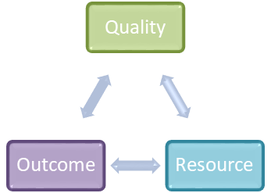

PERFORMANCE
MANAGEMENT FRAMEWORK
FOR IMPROVEMENT

FINAL DRAFT
2 March 2020
Contents

1. Purpose 3
2. Context 3
3. Why Performance Management Matters 5
4. Principles of the Performance Management Framework 6
5. Enabling Positive Ownership and Accountability 8
6. Roles, Responsibilities, Behaviours and Accountabilities 9
7. Developing a Coherent Set of Performance Measures 13
8. Performance Improvement 15
9. Performance Monitoring and Assurance 17
10. Key Outcomes and Review 18

Appendices
1 - Board Assurance System
2 - Overview of the Health Board’s Operating Model
3a - Integrated Locality Groups - overarching role and responsibilities
3b - Integrated Locality Groups - summary of specific accountabilities
3c - Integrated Locality Group - senior team and relationships/accountabilities
3d - Integrated Locality Group Example
4a - Systems Groups - overarching role and responsibilities
4b - Systems Groups Example
4c - Systems Groups - mapping service/disease/age group areas
5 - Summary of Executive Portfolios
6 - Six Data Quality Characteristics – Audit Commission
7 - Sources of assurance
8 – Board Assurance Framework

Purpose

The purpose of this document is to set out the performance management framework for the organisation which underpins all of our desire for continuous improvement in the services we provide. The framework must facilitate collective working together to achieve the best outcomes, quality services and resource effectiveness for our community and patients, and make our working lives easier in the process.

Context

The key purpose of this framework is to support a culture of continuous improvement and high performance across the organisation, by:-

- Outlining aspirational, stretching but also achievable objectives relating to improving our population’s health and improving the safety and quality of services provided to our communities and patients.
- Enabling positive staff ownership and accountability.
- Developing a coherent set of performance measures and targets/standards.
- Implementing rigorous performance assurance and review mechanisms across the organisation.
- Utilising performance improvement plans, tools and techniques to support individual and team achievement.
- Supporting the Board Assurance Framework and effective risk management.

The Performance Management Framework is set within an overarching strategic context which can be summarised in the diagram below:-

PERFORMANCE MANAGEMENT, MONITORING AND REVIEW
INTEGRATED HEALTH & CARE STRATEGY AND IMTP

Our mission, vision and strategic well-being objectives are set out in the organisation’s Integrated Medium Term Plan (IMTP) as follows:

Mission | Caring for you: Healthier together
Vision | In every community people begin, live and end life well, feeling involved in their health and care choices
Strategic Well-being Objectives | - Work with partners and communities to reduce inequality, promote well-being and prevent ill-health.  - Provide high quality, evidence based, and accessible care.  - Ensure sustainability in all that we do, economically, environmentally and socially.  - Co-create with partners and staff a learning and growing culture.

Particular areas of importance and focus for us in the latest IMTP 2020-2023 include the following:

- The continued development of the Health Board, focusing on engaging and empowering our people, embedding our values and behaviours, and a clear structure and operating model.
- Grow clinical and community leadership and deliver robust, simplified and safe decision making; learning through quality improvements and strengthening involvement of patients, staff and partners in service redesign.
- The implementation of the Health Boards Quality and Patient Safety Governance Framework, including across maternity services.
- The development of the 10 year Health Board’s Integrated Healthcare Strategy.
- The steps to complete the service change set out in the South Wales Programme, particularly emergency medicine (A&E), acute medicine and inpatient paediatric services.
- Delivery of regional and national service change plans, including Major Trauma services.
- The continued implementation of the Regional Partnership Board transformation ambition and further alignment of Primary Care Clusters and Mental Health Localities.
- Delivery against the NHS Wales Delivery and Outcomes Framework.
- Planning for recurrent financial balance.

An essential pre-requisite for delivering our vision and strategic objectives is a clear operating model underpinned with an effective performance management framework, with clear lines of responsibility and accountability at both team and individual level.

The strategic objectives are owned by us all as a collective Health Board. Responsibility for the operational delivery of these objectives are assigned to an Executive Director to provide Health Board-wide leadership and identified through the Personal Development Review (PDR) process with the Chief Executive. Links and co-dependencies to other work areas and levels across the whole Health Board are worked through to team and individual objective setting and appraisal.

This framework aims to support us all as staff to ensure that at all levels of the organisation, we understand what is expected of us individually and collectively with our respective teams, and how our role contributes to the delivering overarching vision, mission, strategic objectives and performance of the Health Board. At a high level, the diagram at Appendix 1 represents the Board Assurance System, within which performance management is an intrinsic part.

Why Performance Management Matters

Performance management is taking positive action in response to actual performance to ensure that outcomes for our patients, staff, partners and the public are better than they would be otherwise. Clear performance management arrangements are integral to our overall planning and delivery of services.

Motivating our Individuals and Teams

As individual members staff members and teams, we need to know what is expected of us and what part we play in the overall success of our Health Board. Effective performance management is about being positive and helping individuals to really excel at what they do best. The need for regular, annual appraisals and personal development reviews need to be embedded across our organisation. This assists us all to focus on our learning and development needs, so that we can reach our full potential and deliver the very best services to our service users. Our line managers are fundamental to fostering an environment that is positive, constructive and professional, and that our staff are engaged in two way communications about their performance.

Improving Services and Outcomes for our Patients and Population

We need to ensure that we are delivering primary, community, and secondary care services, plus commissioning tertiary care services, which meet our patients’ needs. Our ambition to improve health and well-being of our local communities and population lies at the heart of this framework. Performance management provides us with a way of making decisions about where to focus our resources depending on needs at any one time. Over time, performance management allows relative measurement to be made so that we can see if we are delivering our activity and outcomes, and if extra efforts need to be made in particular areas to achieve our service improvements.

Working with Partners

As a Health Board, many of us work closely with our Local Authority, Primary Care, Academic and Third Sector partners, as well as with many other statutory and voluntary agencies. Ways of measuring success across our organisational boundaries and for integrated services is ever more important. Work is underway as part of our Public Service Boards’ and Regional Partnership Board’s work programmes to ensure that there are increasingly clear partnership objectives set out and common methods of measuring outcomes across our integrated work under development.

Reputation and Profile

Our performance is measured against that of other Health Boards in Wales and is benchmarked with other health services across the UK and beyond. Whilst this can sometimes pose challenges in terms of comparing data, this helps to inform us and others of how we are delivering services and also to demonstrate our success relative to others. This is important because where others may be doing better than we are in particular areas, we can learn from them to improve our performance and continue our cycle of improvement. Demonstrating positive performance is also important for maintaining high levels of public, patient/carer and stakeholder (including ourselves as staff) confidence in us as an organisation and maintaining a strong reputation for the high quality delivery of services.

Using Public Monies Effectively and Efficiently

We want to ensure our services are sustainable and need to ensure that ‘every pound counts’ towards delivering services. We aim to be as efficient and productive as possible so that we have as much resource as possible available for the delivery of our front line services. Making clear links between resources and outcomes for patients and our communities helps us to put our performance into context so that we can demonstrate that we are delivering best value.

Principles of the Performance Management Framework

The following seven principles underpin our Performance Management Framework:-

- Performance in the round

Performance in the Health Board is centred on three main areas:

- The quality of services, including the safety of services, activity delivered and experience of service users, and how they improve health outcomes.
- The outcome of services provided, clinical and non-clinical and how they relate to population health improvement.
- The resources utilised to provide services, including workforce, financial and infrastructure resources.

Performance across all these three important dimensions needs to be constantly monitored and managed. This should be celebrated where we have success and escalated where we have concerns. It is important to ensure that a healthy tension is maintained between the three dimensions, avoiding an over-focus on any one dimension. The following provides a useful ‘aide-memoire’ diagram that will be seen as it becomes more commonly used across a range of meetings and performance discussions in the organisation.

ii Creating a performance improvement culture

The framework is intended to support the development of a culture of balanced, continuous performance improvement, delivered for the benefits of patients and our staff. This performance improvement culture needs to be supported by clear objectives at all levels which drive and promote a culture of high performance and accountability, supported by the Performance Development Review (PDR) process and appraisal process. At Locality, Systems Group and Corporate level, the framework should be used as a driver for supporting cultural change and staff engagement, together with the importance of sharing learning and celebrating success and good practice across our organisation.

iii Transparency

The measures and evidence used to assess performance should be as clear as possible, with a focus on desired outcomes. Individuals, Localities, Systems Groups and Corporate teams need to clearly understand what is required of them if they are to be held to account through a performance management process. They will need to know what they are expected to achieve, how their performance is being assessed and what to expect if performance falls below expected levels including what additional support can be made available to help support them.

iv Delivery focus

The three-way performance management approach described above needs to be integrated, action orientated and focused on delivering improved performance in line with local Integrated Medium Term plans (IMTPs), our over-arching IMTP and the new Integrated Health and Care Strategy for the organisation.

v Proportionality and balance

The performance management arrangements within the framework will seek to ensure that performance management support, interventions and actions are proportionate to the scale of the performance risk, and that an appropriate balance between challenge and support is maintained.

vi Accountability

Performance management arrangements should ensure that all parties are clear where lines of accountability lie and the framework helps to set this out in conjunction with the organisation’s operating model. Where this is not clear, this should be brought to the attention of senior management or an Executive representative so that accountability arrangements can be made clearer.

vii Empowerment and delegation

Higher performance will look to earn greater levels of delegated authority, with conversely greater levels of performance management intervention and support in underperforming areas.

Enabling Positive Ownership and Accountability

A key element of the framework is the need to ensure that as individuals and teams we are aware of our personal accountability for the delivery of improvements in service and performance. The Health Board’s strategic objectives will be cascaded into objectives for all teams and individuals throughout the organisation, with measurable targets set and agreed. This process will be underpinned by the PDR cycle which should be regularly monitored by line managers and is part of our organisational workforce dashboard.

At every level of our organisation, staff should be involved in the process of agreeing their plans, objectives, performance measures, targets and outcome measures to ensure ownership and understanding of the process. Performance improvements and objectives must be assessed to be achievable, although stretching.

Building on one of the main principles of staff empowerment, we will continue to build a positive culture of recognising and celebrating success. Furthermore, we will continue to actively encourage the establishment of conferences and learning events where positive ownership of performance improvement and objectives can be demonstrated. Understanding the positive impact that recognition of achievement of objectives can bring, including proactive nomination of excellent work to local and national awards schemes.

Roles, Responsibilities, Behaviours and Accountabilities

As staff will be aware, a huge cultural conversation is underway within the Health Board, beginning the process of developing a culture that supports and empowers staff and those who use our services to improve their experiences. The will result in our new values and behaviours framework being launched in April 2020. Whilst it is everyone’s role to manage performance, the Health Board must drive a culture of performance by providing a clear vision, et of values and behaviours, together with associated priorities, goals and objectives.

The new organisational operating model we are implementing highlights leadership and management functions, accountabilities and responsibilities. This is critical to the effective application of the performance management framework. Effective performance management requires defined roles and responsibilities, and clear ownership of outcome measures. Our operating model describes how the we will organise and manage our business, with Appendix 2 providing an overview taken from the operating model. A summary of individual and group roles in terms of performance management responsibilities is briefly described below.

Individual Staff Members (Clinical and Non-Clinical)

Importantly, as part of our shared set of values and behaviours, every employee contributes towards performance improvement and management by being encouraged and supported to identify improvement opportunities and to take the required action. It is important that staff own the data and information that relate to their own areas and understand how that translates to the performance of their services, taking positive personal action and responsibility to improve their own practice and performance.

As indicated above the PDR and appraisal process, set as a positive two-way process with their line manager, will be fundamental to agreeing objectives, reviewing progress and supporting an individual’s personal development to help them thrive and develop in their job as they seek to improve services.

Individual Line Managers (Clinical and Non-Clinical)

Line managers are fundamental to fostering a performance management environment that is positive, constructive and professional and for ensuring that staff are engaged in two way communications about their performance.

Line managers need to have sufficiently regular supervision of, and face to face discussion with, the staff who report directly to them to ensure that they understand expectations and how they are performing. This will enable any requirement for support or development to be positively addressed. It is important to note that managing performance is not an ‘add on’ to the other responsibilities of a line manager, but it is an essential part of the role and vital to do well.

Integrated Locality Group Directors

Integrated Locality Group Directors have accountability for their respective localities and report to the Director of Clinical Services Operations. The overarching role and responsibilities can be found at Appendix 3a, together with a summary of specific accountabilities at Appendix 3b. Appendix 3c highlights the Integrated Locality Group senior team and relationships/accountabilities and Appendix 3d sets out an example structure. The Integrated Locality Group Director is supported by:

- One (or more) Group Doctor (if the Integrated Locality Group Director isn’t a Doctor)
- Locality Director of Nursing
- Locality Group Allied Health Professional
- Locality Director of Operations
- Locality Head of Public Health
All of the above are directly accountable to the Locality Group Director, with professional accountability through to the appropriate Executive lead.

Further support is also provided to the Integrated Locality Group by a set of business partners, including a quality governance, finance, and workforce and planning lead. Their lines of accountability will be directly through to the Group Manager. The two exceptions to this arrangement is the Group Pharmacist and Quality Governance leads, who will be directly accountable to the Chief Pharmacist and Executive Nurse Director respectively for the Health Board, but who will be responsible for delivery of their work programme within the Group, to the Locality Group Director.

Each Integrated Locality Director will chair their own performance management meeting of their respective locality. These will need to be consistent across the three Groups. Integrated Locality Group Directors, recently appointed, are being asked to work these arrangements through in greater detail, but arrangements will need to include the following as a minimum:

- Performance will be reviewed monthly through a formal and collaborative process.
- Performance meetings will be chaired by the Integrated Locality Group Director with their senior team in attendance, with both support and challenge as its ethos.
- The performance management process will take a holistic view of the sub-group area’s performance in improving population health and providing services holding the three performance domains (quality, outcome and resource) at the centre.
- Aspects considered will include culture, leadership, workforce engagement, research, innovation, staff and partner involvement, patient and community experience, quality, outcomes, activity and financial performance.
- Systems Groups will actively inform Integrated Locality Group performance management meetings to escalate any ‘red’ areas where recommendations have not been adopted for two way conversation about reasons and actions to address.

The three Integrated Locality Groups performance will be reviewed monthly through a formal and collaborative process, chaired by their lead Executive, the Director of Clinical Services Operations and with other Executive Directors in attendance as required, again - with both support and challenge as its ethos. The process will be a two way dialogue with set performance metrics and time dedicated to items identified by the Integrated Locality Group.

Systems Group Directors

Systems Groups Directors have accountability for their respective systems groups through to the Executive Director of Strategic Planning. Appendix 4a sets out the Systems Groups’ over-arching role and responsibilities, together with Appendix 4b which highlights an example Systems Group. An outline of current systems groups’ mapping is at Appendix 4b.

The Systems Group Directors will be supported by a team consisting of a range of clinical and non-clinical colleagues from both the Integrated Locality Groups and the Corporate Teams. Whilst the team will not be directly accountable to the Systems Group Director, they will be expected to agree a proportion of their time that they can commit to delivering the agreed work programme of that Systems Group. They will be accountable for the delivery of that work programme to the Systems Group Director however.

Each Systems Group Director will chair their own performance management meetings of their respective Systems Group. These will need to be consistent across the Groups. When appointed, Systems Group Directors will be asked to work these arrangements through in greater detail, but arrangements will need to include the following as a minimum:

- Performance will be reviewed monthly through a formal and collaborative process.
- Performance meetings will be chaired by the System Group Director with their senior team in attendance, with both support and challenge as its ethos.
- The performance management process will take a holistic view of the sub-group area’s performance in improving population health and providing services holding the three performance domains (quality, outcome and resource) at the centre.
- Aspects considered will include culture, leadership, workforce planning, research, innovation, staff and partner involvement, patient and community experience, quality, outcomes, activity and financial considerations.
- Integrated Locality Groups will actively inform Systems Groups performance management meetings to escalate any ‘red’ areas where recommendations have not been adopted for two way conversation about reasons and actions to address.

The three Systems Groups’ performance will be reviewed regularly through a formal and collaborative process, chaired by their Executive, the Director of Strategic Planning, with other Executive Directors in attendance as required.
Executive Directors

Executive Directors have a wide range of services to deliver, with Appendix 5 providing an outline of responsibilities in the new operating model, against which they will be performance managed. Executive Directors are supported by a range of senior managers (clinical and non-clinical), some of whose roles are set out above.

Each individual Executive Director will be expected to have in place their own regular performance review and management meetings within their own portfolios, with other Executive Director in attendance as required, which reflects the ethos and approach of this performance management framework.
Executive Directors will be expected to work these arrangements through in greater detail and will need to include:

- Monthly performance review through a formal and collaborative process.
- Performance meetings will be chaired by the responsible Executive Director with their senior team in attendance, with both support and challenge as its ethos.
- The performance management process will take a holistic view of the sub-group area’s performance in improving as appropriate population health and providing services holding the three performance domains (quality, outcome and resource) at the centre.
- Aspects considered will include culture, leadership, workforce planning, research, innovation, staff and partner involvement, patient and community experience, quality, outcomes, activity and financial performance.

Executive Director Performance is reviewed by the Chief Executive through the PDR process and also by the Remuneration and Terms of Service Board Sub-Committee.

Chief Executive

The Chief Executive is the Accountable Officer for the Health Board. They have overall statutory responsibility and accountability for patient safety, governance and performance management.

Performance management of the Chief Executive is undertaken by the Health Board via the Remuneration and Terms of Service Board Sub-Committee and specifically by the Chair via regular PDR.

Health Board’s Management Board

The Management Board will consist of Executives, Corporate Directors, Integrated Locality Directors, System Group Directors and key clinical roles for specific functions. Part of its function is to ensure that there is Health Board wide leadership and agreement of key elements of strategy, management of risk, planning, performance and urgent pieces of business, with a strong clinical voice in the leadership and management of Health Board business. It will adopt the design principles of the Operating Model in its mode of operating, which includes setting the appropriate leadership tone and listening and learning culture within the organisation.

Systems and Integrated Locality Groups will agree their plans through the Health Board’s Management Board and seek to deliver their mandate through good collaborative relationships. The performance management process will provide a mechanism to escalate specific issues, where they cannot be resolved via other routes and also allow performance of the individual systems groups themselves to be reviewed.

As the Systems Groups are highly transformational, it is expected they will mature, evolve and develop over time with the end formation being different to the starting point. Three and six monthly reviews points will happen through the Management Board to assess if the current form of the Systems Groups is delivering the intended benefits.

Chief Executive-led Planning and Performance Meetings

The purpose of these meetings will be a strategic review of planning and performance for the Integrated Locality Groups, Systems Groups and corporate functions. They will include a review of service delivery together with a forward look to the coming 6-12 months, linked with IMTP development. The meetings will be will be run in a ‘Board to Board’ style and chaired by the Chief Executive or their nominated deputy. This will involve the senior management teams (clinical, non-clinical, and executives) and will meet quarterly.

Consistent data sources will be used for the meeting, adopting a ‘data pack’ approach (electronic increasingly), so that the focus of the meeting can be by on an exception-basis and agreeing appropriate actions. The meetings will be formally minuted and action logs will be maintained in order to keep a record of progress, identify and mitigate risks, explore future priorities and to capture and disseminate good practice.

Developing a Coherent Set of Performance Measures

In managing performance across any part of our organisation, the use of performance measures is important and all staff, teams, groups and localities are strongly encouraged to keep developing their access to data and use of business intelligence to support their understanding and continuous improvement of their services. Expert support can be offered from the corporate teams such as quality and patient safety, performance and information, workforce and finance. These teams can assist staff in the provision and interpretation of information underpinning services and it is all staff’s responsibility to seek out these services and to highlight what training, support or access they feel may be required.

Required key performance measures (KPMs) to support various monitoring requirements can be accessed from across the organisation depending on the purpose. This includes work on performance trajectories, allowing actual to be compared with planned performance and utilising other tools and techniques such as run charts, so performance and trends can clearly be determined over time. This includes information in areas such as:

- Quality and Safety indicators, including incidents.
- Patient Experience feedback.
- Complaints and Concerns.
- Clinical Audit and Outcomes.
- Activity
- Population and Public Health indicators
- Evidence of research and innovation
- Partnership measures.
- Measures set within the Welsh Government National Outcomes Framework.
- Locally set service standards and targets.
- Workforce information including cultural, staff involvement and education indicators.
- Finance information
- Comparative data including benchmarking information.

In addition, performance trajectories and risk assessments are often developed for specific strategic objectives in order to demonstrate the likely timescale for achievement and to compare actual performance against. Many of these are currently set out in the Health Board’s Quality, Performance, Workforce and Finance Dashboards and are set by the Health Board as part of the integrated planning and delivery process.

Further work is being undertaken to establish new sets of indicators and dashboards, together with improvement trajectories, aligned to the new Operating Model. These dashboards will support both the local clinical, management and executive processes of performance management as described above and also support the performance monitoring and assurance processes of the organisation and its sub-committees, as part of the Board Assurance Framework.

Underpinning this work is the importance of good data quality and integrity, which is everyone’s business. Robust and timely data is essential to inform decision making and identify where performance needs to be improved. Data requirements should be designed along the principle of ‘getting it right first time’ in order to avoid wasting time and money spent on cleansing data, interfacing between different information systems, matching and consolidating data from multiple databases, and maintaining outdated systems.

The Audit Commission has provided six key characteristics of good data quality which have been adopted by the Health Board. These are commended to all staff to adopt as part of their roles in capturing and supplying data, as part of delivering good patient care. The characteristics can be seen at Appendix 6. We are also currently refreshing our approach to data quality and have recently seen further investment into clinical coding and clinical audit to support this work.

Performance Improvement

In line with our all of our vision, values and behaviours, it is important that everyone is supported to operate at their appropriate level of autonomy and able to identify what support they require for performance improvement and what challenges or blockages are facing them that they need help with to remove. It is recognised that where performance may not be where we want it, collectively we may need to provide support, whilst at other times, it may be more an isolated issue that an area needs to improve through innovation, for example with the use of ICT which may be reprioritised to help.

We will continue to promote and develop both a culture and a capability of continuous performance improvement through an integrated approach to improvement activities using techniques and support such as:-

- Values and Behaviours Programme
- Let’s Talk Culture events
- PDR and appraisal processes
- Clinical and other audits
- Effective recruitment processes
- Education, Training and Development
- Coaching for improved performance
- Leadership and Management Framework
- Succession planning and associated processes
- LEAN Methodologies
- PDSA Cycle (1000 Lives Plus)
- Improvement and Value Based Healthcare Team and support
- Project and Programme Management support, via the PMO
- Workforce Policies
- Public engagement events

The organisation is also continuing to develop its systems and processes for anticipating and responding to good and poor performance. In several areas, we use a red/amber/green system to facilitate this process. Often this is utlisied as follows:

- Green: outcome/objective/target achieved.
- Amber: missing outcome/objective/target but on agreed performance improvement trajectory – usually within a specific % set out of the target, depending on the area.
- Red: persistently not meeting outcome/objective/target and highly unlikely to meet outcome/objective/target within specified period.

Depending on the nature of the indicator and area of performance, the procedure for managing such performance could be seen as follows:

- Green rated performance – routine monitoring.
- Amber rated performance – routine monitoring possibly for a period and/or for some indicators - enhanced monitoring via an exception report at managerial level, possibly including the Locality/Systems Group Director and/or if necessary Executive level performance meeting depending on the performance area, together with associated remedial actions and a trajectory for improvement.
- Red rated performance – escalated performance, linked in to the Locality/Systems Group Director and Executive led performance meetings, requiring a detailed action plan and regular reviews with agreed timescales. There may on occasion be need to trigger an escalated performance meeting(s) with the Chief Executive also depending on the circumstances.

Performance on any indicator that is “red” should require:-

- A sense from the area as to what enablers in terms of support may be required to help further support performance improvement.
- An action plan with a trajectory for improvement and designated review points.
- A risk assessment of the impact of under-performance on, amongst other impacts, the quality and safety of care provided by the Health Board.
- Discussion, action planning and assurance of progress at the Group and Executive led performance meetings to seek recovery, in order to provide additional levels of support and assurance.
- “Red” performance areas should be clearly noted in performance dashboards and, where particularly significant, highlighted in covering reports. This can support discussion at Management Board, where exception reports/action plans may need to be signed off.
- “Red” performance issues must be considered when developing, updating and cross-referring to local and organisational risk registers.

It is important that all avenues to explore the reasons for poor performance are fully understood and discussed at all levels, so that improvement support can be provided, if required, to help achieve more positive performance. If more fundamental issues exist there are HR policies and procedures that can be adopted, but these should only be seen as a last resort.

Performance Monitoring and Assurance

The process for monitoring performance, managing risk, receiving assurance and escalating concerns are outlined below. These processes commence at individual and team level, with assurance and escalation of risk managed as appropriate through to Board level. The diagram below demonstrates the route accountability and assurance takes within the organisation.

Holding to Account
Flow of Information

Everyone, throughout the Health Board, needs to assure themselves that controls are effective to manage the principal risks. The Board Assurance Framework (BAF) provides assurance to the Health Board on the delivery of its objectives, outlined within its 3 Year Integrated Medium Term Plan (IMTP) for 2020/2023 and through robust risk management processes. The role of performance monitoring and assurance on delivery of its key objectives is a key aspect of this work.

Assurance, provided from across the Health Board, with everyone playing an important role, provides Board members with the evidence that the Health Board is operating effectively and achieving its desired outcomes. The organisation at every level needs to be confident that the systems and processes are operating in a way that are effective and driving the delivery of objectives by focusing on minimising risk.

The organisation also uses a number of methods to obtain assurance through internal and external sources. A good system brings together and triangulates internal and external assurance sources and should also be a combination of quantitative and qualitative information. Such sources include:

- Clinical Audits – a quality improvement process that seeks to improve patient care and outcomes through a systematic review of care.
- Self-Assessment – staff and services across the Health Board self-regulate in a variety of ways and aim to improve through various self-assessments and peer reviews.
- Internal Audits - useful in providing an independent and objective assurance of the Health Board’s governance arrangements. Internal Audit provide an opinion on whether the organisation’s policies, processes and procedures are in place across the organisation to ensure the Health Board’s risk management, governance and internal control processes are operating effectively.
- External Audits - external auditors undertake an annual assessment of the organisation’s use of resources and annually provide their opinion on whether the Health Board has proper arrangements for securing financial resilience and good performance in its operations.

A potential, but not exhaustive list of sources of assurance is attached at Appendix 7 for information and the current Board Assurance Framework is summarised and attached at Appendix 8.

Key Outcomes and Review

The following sets out the key anticipated outcomes from the delivery of the Performance Management Framework and provides a useful baseline for staff and the Health Board against which to measure progress and the effectiveness of the framework:

- All staff employed by the Health Board will have a clear understanding of the Performance Management Framework and will believe that achieving good performance is an important part of assuring safe and good quality services for patients, understanding their own personal responsibility for their own performance.
- We will have a demonstrable appreciation as to how their work contributes towards the delivery of all priorities in support of patient care.
- Development activity and resources will be properly aligned to driving up performance improvement and continuous improvement.
- Integrated Performance Management Frameworks will be in place across the organisation, including at corporate, integrated locality and systems levels.
- There will be integrated and timely reporting with high quality commentary for performance reviews.
- Good data quality arrangements will be in in place at all levels with staff appreciating their roles and responsibilities in the production of good information.
- Consistency in our approach to managing performance issues.
- Staff at all levels will play a key role in monitoring and managing performance.
- Positive external and internal and clinical audit reports.
- The Health Board can receive assurance that the Framework is operating effectively.

This framework will come into effect on 1 April 2020 and will be reviewed annually by the Management Board.

Appendix 1 – Board Assurance System

VISION AND OBJECTIVES
Strategic vision, objectives agreed through 3 year IMTP
CONTROL ARRANGEMENTS
- Operational plans
- Performance Framework
- Scheme of delegation
- Standing Orders & SFIs
- Policies and procedures
- Action plans
- Management meetings
- Systems & Processes

ASSURANCES
- Performance measures
- External (WAO), internal and clinical audit
- Regulatory and inspection agencies (DU, HIW etc)
- Delivery and action plans
- Board Reports
- Committee Highlight reports
- Stakeholder Feedback
- Patient Experience – Inc. Patient Stories
- Site visits
- Welsh Government performance meetings
- Escalation status
- Deep Dives
RISKS
- Principal risks identified from IMTP & Risk Registers
- Board determines its risk appetite
- Ongoing review and monitoring through risk register

BOARD DETERMINES ITS RISK APPETITE

ASSURANCE
SYSTEM

REPORTING
- Reports to Board & Committees inc incidents, concerns etc)
- Reports to Welsh Government (inc TI & SM)
- Annual Report, Governance, Quality and Financial Statements

Appendix 2 – An Overview of the Component Parts taken from the Health Board’s Operating Model

Health Board
- Accountable for all aspects of quality, population health,
strategy, delivery and performance with and through others (quality, performance, finance, people management and leadership). Statutory responsibility. Ensuring there is a strategy & plan to deliver Healthier Wales. Unlocking system. Accountability as currently and will deliver in a different way in some cases.

- Ensures accountability is clear and holds to account. Ensures Health Board statutory obligations are met through a clear strategy, good governance and shaping the organisation’s culture. Operates in a highly collaborative system approach. Some aspects of specific corporate functions are embedded in Integrated Locality and System Groups.

- System and Integrated Locality Group Directors report into Executive team and members of the Management Board. Executive agree work priorities for year/long term plan with system and locality groups

- Executive and Board. Corporate support functions

Appendix 3 – Summary of Executive Portfolios
 | Medical Director | Director of Nursing | Director of Therapies and Healthcare Sciences | Director Clinical Services Operations | Director of Finance | Director Workforce and Organisation Development | Director of Public Health | Director Strategic Planning | Director Corporate Governance/Board Secretary
Portfolio  Executive with Lead Responsibility for area  *Shared | Professional Standards and Regulation – Medicine  Support to Clinical Governance *  Standards Support to Systems Groups  Clinical Audit and Effectiveness | Professional Standards and Regulation – Nursing and Midwifery  Patient Experience (incl. complaints and concerns)  Clinical Governance Quality and Safety (Lead executive)  Safeguarding  Deprivation of Liberty Standards (DOLS)  Infection, Prevention and Control | Professional  Standards and Regulation - Allied Health Professional, Health Care Scientists  Support to Clinical Governance*  Health and Safety  and Fire | Operational Service (OS) Delivery  OS Performance  OS Planning, Improvement and Redesign  Facilities  Independent Contractor Management (including. GMS) | Finance – Strategy , Planning, Performance  Procurement  Capital  Estates | Human Resources  Organisational Development  Learning and Development (non-clinical)  Equality & Welsh Language  Clinical Education and Resus**  Occupational Health and Wellbeing  Workforce Productivity & Efficiency (inc. Medical | Public Health  Improvement and Transformation (incl. Value Based Health Care)  Research, Innovation and Development  Support to Clinical Governance * | Strategic Planning (incl. systems groups)  Civil Contingencies  Strategic Planning  Performance Monitoring  Digital and Health Intelligence  Commissioning (incl. WHSCC and EASC)  Partnerships | Corporate Governance  Involvement, Engagement and Communication  Information Governance  Freedom to Speak Up  Risk Management
**Clinical education arrangements are in the process of being reviewed and finalised.

Appendix 4a – Integrated Locality Groups Overarching Role and Responsibilities

- Accountable for quality of care, population health, patient outcomes, planning and delivery within a geographic area. This includes all aspects of delivery, staff management, finance and performance management to deliver population wellness and treatment outcomes.

- Clinically led, semi-autonomous function. Operates to an agreed governance framework. Reporting to an Executive. Standardised structure with some local variation. Earned autonomy model.

- Due to the small nature of some clinical services they will be managed in one Integrated Locality Group and provide services across all three.

- People from Integrated Locality Groups will work in the System Groups with sufficient time allocated.

- Standard roles with local variation and associate members from partnerships.
Integrated Locality Groups
Appendix 4b: High Level Summary of Specific Accountabilities for Senior Locality Team
 | Quality | Leadership, Management and Professional Standards | Strategy Development | Service Performance Delivery and General Delivery
Locality Director | Ultimately accountable for the quality of service provided by the group Ensure care is of the highest quality through the Groups active involvement in the Systems Groups standard setting and monitoring mechanisms. | Provide leadership, direction and support to all staff within the Group fostering an open and inclusive style of management, encouraging team working and good working relationships. This also includes the positive management of services with independent contractors.  Proactive adoption and monitoring of all clinical and clinical professional standards and audit recommendations. | Continually improve and transform the services provided to the community through proactive involvement of staff, patients and external partners in developing a Locality strategy in line and as part of with the Health Board’s integrated strategy. | Provide high quality population health, wellness and integrated care delivery services for the community, within budget and in alignment with national and local targets.  Keep services safe through strong and robust Locality group governance (quality, staff engagement, activity, clinical standards and financial) which links closely to Health Board wide governance.
Group Doctor | Responsibility and accountability for all clinical governance issues and shared responsibility with the Head of Nursing and Head of Allied Health Professionals for the overall discharge of clinical governance in the Locality.  Ensure a robust and clearly understood approach is taken to clinical governance, including Clinical Risk for the Locality. | Promote workforce redesign maximising multi-disciplinary skill mixing for the ongoing sustainability of services.  Ensure that there is high medical staff engagement and that all medical staff are supported through development and meaningful appraisal;  Support medical colleagues in the proactive adoption and monitoring of professional standards and audit recommendation | Transform and keep services sustainable by participate in annual and medium term strategic and operating planning and the performance management of those plans; | Continually drive up quality by developing and managing systems for robust locality clinical group governance (quality, staff engagement, activity, financial and complaints) which links closely to Health Board wide governance ensuring there is strong and supporting oversight of all aspects of Group business.
Group Nurse | Responsibility and accountability for all quality governance issues and shared responsibility with the Group Doctor and Head of Allied Health Professionals for the overall discharge of clinical governance in the Locality.  Ensure a robust and clearly understood approach is taken to clinical governance, including Clinical Risk for the Locality | Ensuring that there is high nursing staff engagement and that all nursing staff are supported through development and meaningful appraisal;  Support nursing colleagues in the proactive adoption and monitoring of professional standards and audit recommendations;  Promote workforce redesign maximising multi-disciplinary skill mixing for the ongoing sustainability of services. | Transform and keep services sustainable by participation in annual and medium term strategic and operating planning and the performance management of those plans. | Continually drive up quality by developing and managing systems for robust Locality clinical group governance relating to nursing (quality, staff engagement, activity, financial and complaints) which links closely to Health Board wide governance ensuring there is strong and supporting oversight of all aspects of Group business.
Group Manager | Develop strong and effective management processes and systems relating to quality in line with the Quality Governance framework. | Improve the working environment by developing high staff engagement and ensuring that all staff are supported with development and meaningful appraisal.  Improve the experience and quality of the organisation for staff and the community by developing ways of working to maintain continuous learning and development through a positive and open culture.  Improve health for the community by establishing a way of working that brings strong and meaningful collaboration with other public and third sector organisations. | Ensure we offer the community a sustainable service by leading on annual and medium term strategic and operating planning and the performance management of those plans.  Continually improve the services provided to the community through systems of proactive review and the involvement of patients, external partners and staff. Ensure all staff are actively support to be involved in Systems Group work. | Improve the sustainability and care provided to the community by establishing and managing the processes including finance and activity performance and meeting agreed delivery targets.  Maintain and drive up service quality through support to senior team clinicians to develop and then manage systems for robust Locality group governance (quality, staff engagement, activity, financial and complaints) which links closely to Health Board wide governance ensuring there is strong and supporting oversight of all aspects of Group business.  Improve the well-being of the local community and the sustainability of service by ensuring the Group’s work is equally focussed on illness prevention as well as treatment.
Quality Governance Lead | Support the Quality Governance agenda, and ensure that the Quality framework requirements are delivered within the Locality.  Ensure that quality is considered in every aspect of business.  Runs the ‘businesses of the systems and processes of quality which have been designed by the manager and are the leadership accountability of the clinical leaders within the group.

Appendix 4c - Integrated Locality Group senior team and relationships/accountabilities.

CEO

Executive
Executive Director of Nursing
Executive Director of Therapies & Health Care Scientists
Executive Director of Public Health
Executive Medical Director

Chief Pharmacist*

Group Director
(Clinical)

Group Manager
Group Doctor
Group Nurse
Group Allied Health Professional
Head of Public Health
Group Pharmacist*

Appendix 4d – An Example of an Integrated Locality Group (ILG) – Sample Template
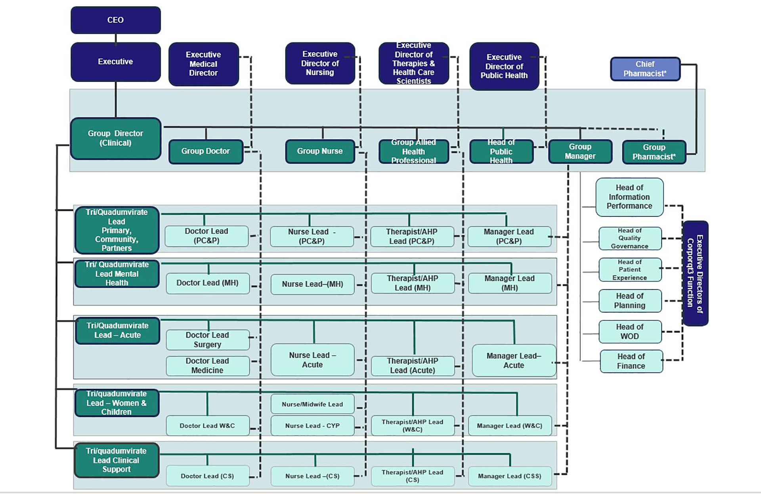

Appendix 5a – Systems Groups Overarching Role and Responsibilities

- Ensure there are consistent clinical standards and practice across the Health Board.

- Collaborate across the health and care system to design and implement best practice prevention, wellness and care pathways.

- Review how resource (money, contracts, buildings, equipment, commissioning, people, and partnerships with other parts of the system) is allocated to patient need and design better solutions.
- Develop system wide integrated healthcare strategy.

- Highly autonomous, clinically led group. Reports to an Executive, agrees annual priorities and outputs with Executive team.

- Team structure has some standard roles and is highly fluid to support maximum staff involvement and collaboration with partners.

- Manage the work of national delivery plans.
System Groups
Appendix 5b – An Example Systems Group
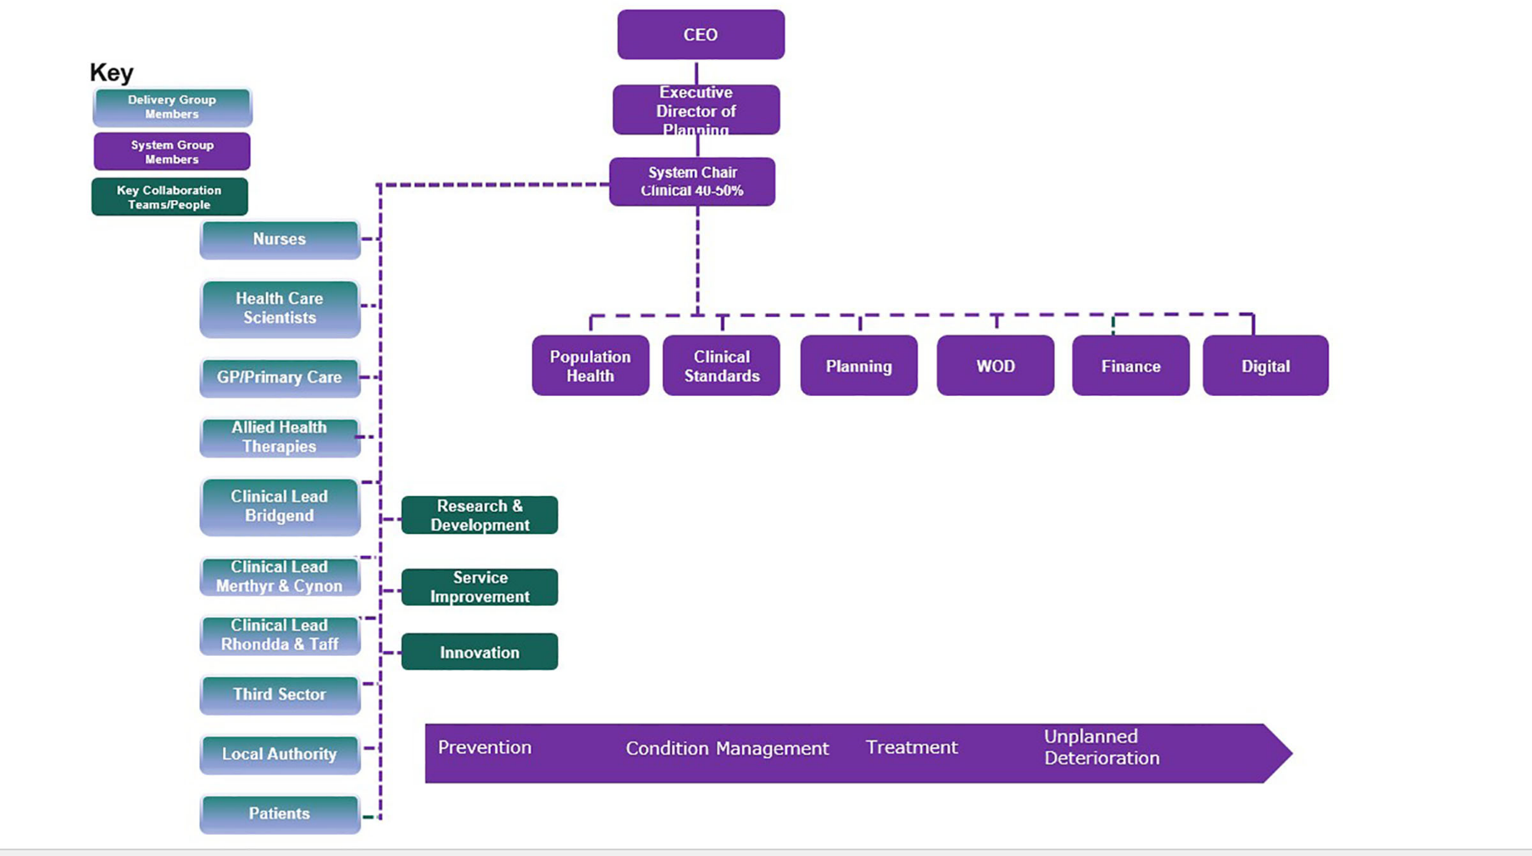

Appendix 5c – System Group Mapping
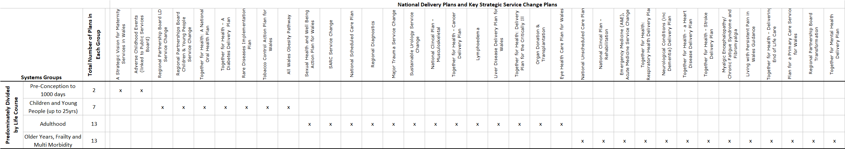
Appendix 6 – Data Quality Characteristics (taken from the Audit Commission)

Accuracy: Data should be sufficiently accurate for their intended purposes. It should be captured once only, although the data may have multiple uses. Reported information that is based on accurate data provides a fair picture of performance and should enable informed decision making.

Validity: Data should be recorded and input within the necessary format required. This ensures consistency of reporting. Where ‘proxy’ data are used to compensate for an absence of actual data, bodies must consider how well these data are able to satisfy the intended purpose.

Reliability: Managers and stakeholders should be entirely confident that data is reflecting real changes rather than variations in data collection approaches and methods.

Timeliness: Data should be captured as quickly as possible after the event or activity and must be available for the intended use within a reasonable time period.

Relevance: Data captured should be relevant to the purposes for which they are used. This entails periodic review of requirements to reflect changing needs.

Completeness: Information is extracted regularly and efficiently and communicated quickly.

Appendix 7 - Potential (but not exhaustive) sources of assurance.

Internal Sources | External Sources
- Patient Experience Reports/Surveys  - Site Visits  - Local Clinical Audits  - Integrated Performance Reports  - Concerns/Compliments Reports  - Incident reporting (inc. serious incidents)  - Targeted Intervention/Special Measures Maturity Matrices  - Deep Dives  - Workforce information  - Staff Surveys  - Benchmarking  - Internal Audit  - Board & Committee reports  - Committee Highlight Reports & Minutes  - Quarterly progress reports with implementation of IMTP  - Local counter fraud work  - Board Member Patient Safety Walkabouts  - Results of internal investigations  - Whistle blowing  - Infection control reports  - Compliance against legislation (e.g. Mental Health Act, Health & Safety, Fire Safety, Data Protection, Welsh Language, Equality Duty, Employment law) | - National Clinical Audits  - Wales Audit Office reports  - Welsh Risk Pool Assessment reports  - Healthcare Inspectorate Wales reports  - Community Health Council visits  - Feedback from healthcare and third sector partners  - Royal College visit reports  - Deanery visit reports  - Regulatory, licensing and inspection bodies (HSE/HIW/MHRA/HTA etc)  - External benchmarking and statistics  - Public Service Ombudsman referrals  - Commissioner Referrals Upheld/Fines (ICO/YPC/OPC/WLC)  - HM Coroner Regulation 28 reports  - Accreditation schemes  - National Clinical Audits  - Peer reviews  - Population Health information  - Feedback from service users  - Local/Regional networks (eg cancer networks)  - AM/MP/Local Authority Feedback  - Investors in People  - Welsh Government feedback (JET/TI/Special Measures)  - IMSOP Reports (Special Measures)  - Welsh Government Joint Escalation & Intervention Status

Appendix 8