AGENDA ITEM
5.1

CTM Board

SOUTH WALES PROGRAMME – PROGRESSING OUTSTANDING RECOMMENDATIONS - UPDATE REPORT

Date of meeting | 26/03/2020

FOI Status | Open/Public

If closed please indicate reason | Not Applicable - Public Report

Prepared by | Mark Dickinson, Programme Director
Presented by | Dr Nick Lyons, Executive Medical Director (SRO)
Approving Executive Sponsor | Executive Medical Director

Report purpose | FOR DISCUSSION / REVIEW

Engagement (internal/external) undertaken to date (including receipt/consideration at Committee/group)
Committee/Group/Individuals | Date | Outcome
This specific paper has not been considered by any other committee or group. | N/A | N/A

ACRONYMS
CHC | Community Health Council
CRG | Clinical Reference Group
ED | Emergency Department
EM | Emergency Medicine
EQIA | Equality Impact Assessment
GP | General Practitioner/General Practice
MIU | Minor Injuries Unit
PCH | Prince Charles Hospital
POWH | Princess of Wales Hospital
QIA | Quality Impact Assessment
RGH | Royal Glamorgan Hospital
SWP | South Wales Programme
UHB | University Health Board
WAST | Welsh Ambulance Service NHS Trust

SITUATION AND BACKGROUND

1.1 Situation

In November 2019, the UHB established a formal project to take forward the consideration of the implementation of outstanding recommendations of the South Wales Programme (SWP). As a first stage, the project has been considering, assessing and engaging on alternative options, focusing on emergency medicine at the Royal Glamorgan Hospital (RGH), in order to ensure safe, sustainable and effective care.

At its public meeting on 30 January 2020, the Board agreed that two options (Option A and Option B – see Appendix 1) should be prioritised for further development and assessment within the project structure. The Board also tasked the project with continuing to test the viability of retaining a 24/7 consultant led emergency department (ED) at RGH, including through enhanced efforts to recruit medical staff.

At an extraordinary public meeting on 27 February, the Board received an update report on progress with the project, including in relation to:
- communication and engagement
- work by the project’s Clinical Reference Groups (CRGs) to develop and refine Options A and B
- work to recruit medical staff and make more flexible use of existing staff

As part of decision making to allow the UHB to focus attention and resources on the response to COVID-19, a decision was made by the project’s Senior Responsible Officer (SRO) on 16 March 2020 to temporarily pause many project activities. The approach being taken can be summarised as “pause and consolidate”.

This paper informs and briefs the Board on:
- the overall process to be undertaken to deliver an option for approval by the Board (section 2.1)
- further work undertaken by the project since the February report (section 2.2), including in relation to:
  - the further development of options for future service delivery by CRGs
  - further public and staff engagement activities undertaken
  - expert advice received on additional engagement to be undertaken once work on the project resumes fully
  - efforts to recruit additional substantive emergency medicine doctors
- the rationale for temporarily pausing many project activities (section 2.3)
- details of what project activities have been paused and what activities will continue to consolidate the progress already made.

It is important to note that pressures on the UHB’s Emergency Departments remain acute. Staffing pressures are being exacerbated by the loss of agency staff who are being called back to support the COVID-19 response of their primary employers. The impact of COVID-19, both on demand for UHB and in terms of staff absence or redeployment, will also have a major impact.

It is likely that operational pressures may necessitate rapid decision making to temporarily change the configuration of the UHB’s emergency medicine service provision during the COVID-19 pandemic.

1.2 Background

The background to the current project is set out in the paper South Wales Programme – Progressing Outstanding Recommendations, received by the Board on 30 January 2020.

- SPECIFIC MATTERS FOR CONSIDERATION BY THIS MEETING (ASSESSMENT)

2.1 Overall process

The diagram below illustrates the overall high level process being followed by the project:

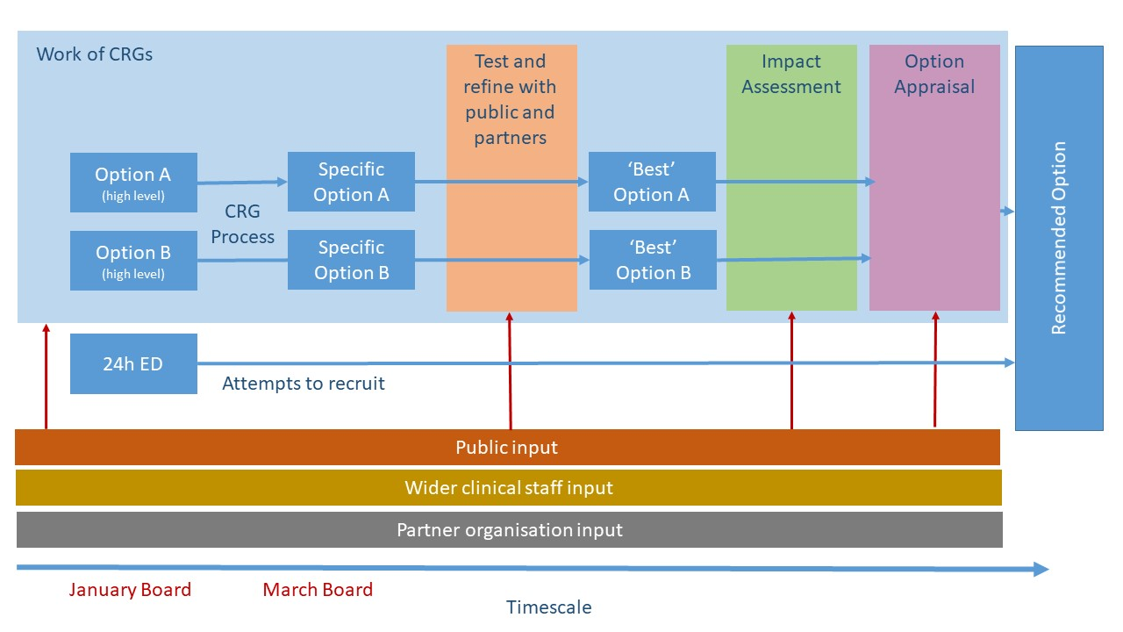
The diagram illustrates a process that takes, as a starting point, the high level options approved by the Board in January for further development and assessment (Appendix 1) and results in a recommended option for consideration by the Board at a future date. The aspiration had been to work to present a recommended option at the April Board meeting, but the temporary pause of many project activities will now prevent this.

As of this report, the project, through its CRGs, is close to being able to describe detailed and specific versions of Option A and Option B (see section 2.2). Some work is continuing to progress this in a way that minimises the need for clinical input (see section 2.3).

The intention is to progress through the following stages:
- testing and refining the specific Options A and B with input and scrutiny from the public, the wider clinical community and partner organisations
- informed by the above process, documenting and modelling ‘best’ versions of Options A and B for assessment and appraisal
- subjecting the resulting options to formal impact assessment, including quality impact assessment (QIA) and equality impact assessment (EQIA)
- informed by the impact assessments, formally appraising the options against a set of clearly defined and weighted criteria, resulting in the identification of a recommended single recommended option for Board consideration

Input from the public, clinical staff and partner organisations will be necessary at the ‘test and refine’, impact assessment and option appraisal stages, in line with best practice and legal requirements.

Although work to actually undertake the above steps has been paused, some activity to prepare for them is continuing (see section 2.3).

2.2 Work undertaken since the February Board report

Further development of options by CRGs

Until the recent suspension of most project activities, the three CRGs had continued to meet and have further developed service models under both Option A and Option B:
- Emergency Medicine
- Acute Medicine
- Paediatrics

The three CRGs have also been working together, and are in the final stages of completing feasible service models for Options A and B, which start to optimise the benefits for the UHB’s community as a whole in respect of the six critical success factors reported in the February board paper. In doing so, the two models under development includes details of arrangements for services directly in scope, together with requirement or assumptions in relation to the other critically inter-dependent and enabling services, including:
- Minor injuries services across the UHB
- Acute hospital illness services across the UHB
- Paediatric inpatient and acute assessment services
- Critical care stabilisation, inpatient and transfer services
- Arrangements for trauma and orthopaedic assessment, treatment and admissions
- Arrangements for medical and surgical admissions assessment, treatment and admissions across the UHB
- Diagnostic requirements at RGH
- Provision of airway support services
- Arrangements for related primary and community services
- Infrastructure and transport requirements
- Workforce models underpinning the delivery of these models across the UHB

Until the pausing of most project activities, the CRGs were due to engage on these models with their peers, our wider stakeholders and the public commencing in late March, with a view to further enhancing the options and ensuring that all reasonable configurations for the wider service model had been considered.

In parallel the CRGs have further developed their approach to appraising the two options, informed by:
- Clinical and professional standards
- The current and previous engagement work with the public, our stakeholders and staff within the NHS (from the UHB and our partner organisations)
- Evidence from the literature

A draft ‘scorecard’ of the proposed standards and indicators which is presently being populated to support the CRGs reach a recommendation, and articulate the risks and benefits of the two options is provided for information in Appendix 2.

Finally, the CRGs have identified a number of opportunities relating to the clinical strategy and wider system design of the UHB and our partners, which will require further consideration but which have a material impact on the service models being proposed for Options A and B.

Public and staff engagement undertaken

Both public and staff engagement events and activities have continued until the pausing of most project activities at the start of the week commencing 16 March. The following are the key events and activities since the February Board report:
- Meeting with members of the Save RGH A&E Campaign Group, attended by the UHB Chair, Medical Director and Programme Director (26/02/19)
- Meeting with local Union representatives attended by the UHB Chair, Chief Executive and Director of Nursing (26/02/19)
- Formal public engagement event held at Pontypridd RFC attended by the Chair, Chief Executive, other Board members and project staff (04/03/20)
- Formal public engagement event held at Ferndale RFC attended by the Chair, Chief Executive, other Board members and project staff (09/03/20)
- Interactive Facebook question and answer session hosted by the Chief Executive (12/03/20)
- Staff drop in sessions attended by combinations of the Chair, Chief Executive, other Board members and project staff held on multiple UHB sites on multiple dates

In addition, the UHB Chair, Chief Executive and Medical Director attended the National Assembly for Wales Health, Social Care and Sport Committee to give evidence in public on 27 February.

Appendix 3 shows a visual representation of the discussion at the public engagement event held on 4 March.

Advice received on additional engagement to be undertaken

The project’s Communications and Engagement Strategy was presented to the Community Health Council (CHC) executive committee on 10 March and helpful feedback has been received.

In addition, the project has commissioned, and has begun to receive specifically tailored expert advice from the Consultation Institute. Specific advice received to date has included:
- the need to map our activities to date against a mapping of best practice to be provided by the Consultation Institute, to identify any significant gaps
- the need to engage specifically with groups representing those with protected characteristics under the Equality Act
- advice on how best to use the concept of public hearings to assist in our process of testing and refining options (see section 2.1)
- advice on how to use online tools to facilitate engagement, particularly during a period when public gatherings are impractical
- advice on the conduct of quality impact assessments

In addition, the project has been drawing on internal UHB expertise in the conduct of quality and equality impact assessments.

Efforts to recruit additional substantive emergency medicine doctors

The adverts reported to the Board in February have closed and have been re-opened to give further opportunities for potential candidates to apply. Most applicants are drawn from long term locum doctors already supporting the UHB. This does not provide any additional capacity but enables internal support arrangements from the Princess of Wales Hospital to RGH to be firmed up.

The UHB has also advertised for locum consultant posts for one year, but has not yet been able to confirm any appointments.

Adverts for Specialty Doctor posts are also live, offering flexible hours, annualised rotas, special interest areas and supporting programmes to support doctors to achieve competences to be on specialist register in the future.

2.3 Temporary pausing of some project activities

Rationale for temporarily pausing some project activities

It is clear that the impact of COVID-19 will prevent the ‘business as usual’ continuation of work on the project in the short to medium term. There is need to focus the UHB’s efforts and resources to the operational response to the pandemic. The UHB also needs to have due regard to the restrictions on the public’s activities, which will prevent the conduct of many forms of engagement.

In particular, the UHB must:
- ensure that clinical staff are not unnecessarily diverted from direct clinical service delivery
- prioritise COVID-19 related public communications over all other communications and engagement
- avoid confusing the public by issuing future proposals during a period in which there will need to be clear and timely communications about any necessary operational service changes due to the impact of COVID-19
- eliminate non-essential face to face meetings and gatherings

Summary of paused and continuing project activities

The approach being taken to the project is best summarised as “pause and consolidate”. We are temporarily pausing most project activities, including:
- meetings of Clinical Reference Groups, which require a significant commitment of clinical time
- public and staff communications and engagement specifically related to the project
- meetings of the project boards.

However, some non-clinical members of the project team will continue work, in the background, to consolidate the progress that has already been made. The focus will be on:
- further developing and assessing the service models under Options A and B, obtaining direct input from individual clinicians, as other pressures allow
- developing and refining the plans for public engagement and involvement, in the light of advice and support received from the Consultation Institute and internal expertise
- developing tools for web-based public engagement
- developing and refining the project approach to impact assessment and option appraisal, including the mechanisms for ensuring appropriate input from the public, clinicians and partner organisations.

This background work, which will be subject to ongoing review to ensure it does not impact on the COVID-19 response, will enable us to resume the full operation of the project and make more rapid progress when the current pressures have passed.

3. KEY RISKS/MATTERS FOR ESCALATION TO BOARD

The following remain key risks and issues relating to the project:
- There is an ongoing need, exacerbated by the impact of COVID-19 to take operational action to ensure safe service continuity of service provision prior to the implementation of future project recommendations.
- The action described in the paper will delay the conclusion of the project, increasing the risk that current service models become unsupportable before alternative arrangements can be agreed, consulted upon, planned and implemented
- Any service changes will be controversial and contested by relevant stakeholders.
- The regional nature of the project, with the need for involvement of other health boards in the development, assessment and implementation of solutions and the overall governance, may compromise rapid decision making.
- Resource constraints, including in relation to capital investment may compromise the ability to implement optimal service models.

4. IMPACT ASSESSMENT

Quality/Safety/Patient Experience implications | Yes (Please see detail below)
Quality/Safety/Patient Experience implications | To be considered within the scope of the project.
Related Health and Care standard(s) | Safe Care
Related Health and Care standard(s) | All standards applicable
Equality impact assessment completed | No (Include further detail below)
Equality impact assessment completed | To be addressed as part of the project.
Legal implications / impact | Yes (Include further detail below)
Legal implications / impact | To be considered within the scope of the project.
Resource (Capital/Revenue £/Workforce) implications /  Impact | Yes (Include further detail below)
 | To be considered within the scope of the project.
Link to Main Strategic Objective | To Improve Quality, Safety & Patient Experience
Link to Main WBFG Act Objective | Provide high quality care as locally as possible wherever it is safe and sustainable

RECOMMENDATION

The Board is invited to NOTE the content of this report and approve the temporary pausing of defined elements of the project, whilst progressing limited elements, subject to ongoing review by the SRO.

APPENDIX 1 – Options agreed by the Board for development

Option | Specific features | Common features
Option A | Implementation of the remaining SWP recommendations with additional service changes  Transition the RGH Emergency Department (ED) from a consultant-led service to a 24 hour nurse practitioner led Minor Injuries Unit (MIU). | Increase access to ‘care closer to home’ across the UHB for those not requiring ED services, through enhanced access to primary care and community services (in and out of hours), in line with the agreed transformation programmes of the Regional Partnership Board.  Implementation of already planned move of inpatient paediatrics from RGH to PCH in September 2020  Development and implementation of an appropriate paediatric service model at RGH (tailored to interface appropriately with the selected ED service model)  GP admissions and paramedic differentiated admissions (of appropriate acuity) direct to RGH wards 24 hours  Ongoing development of RGH acute medicine, ambulatory care and diagnostic services, in line with the SWP
Option B | Overnight reduction in the hours of consultant led ED at RGH  Consultant-led EDs to continue at RGH, Princess of Wales Hospital (POWH) and Prince Charles Hospital (PCH), but with an overnight reduction in the hours of the RGH ED (exact operational hours to be determined based on modelling of demand).  Determine how best to deliver a nurse practitioner-led MIU on the RGH site during the hours when a consultant-led ED is not provided.

APPENDIX 2 – Factors being considered by CRGs

Critical Success Factor | Standard/Indicator
Quality | How many additional clinicians are required to ensure all ED patients are seen within 2 hours (assuming no exit block) - across CTM
Quality | Based on current staffing levels what proportion of time will the EDs in CTM have consultant cover
Quality | How many additional competent clinical decision makers are required so that all patients requiring assessment are seen within 4 hours (paediatrics, medicine, surgery)- across CTM
Quality | Will the model enable adult and paediatric intensive care medicine standards on workforce to be achieved - across CTM
Quality | Are the activity volumes sufficient to achieve optimal outcomes on all sites? (i.e. not too high or too low)
Safety | How many additional consultants are required to provide a continuous admitting consultant presence, on the acute assessment units thereby enabling early consultant review and assessment (within 12 hours) across CTM. (paediatrics, medicine, surgery)
Safety | Relative to now, from the evidence is it expected that there will be a higher, similar or lower case fatality rates
Safety | Are the requisite inter-dependent services as per clinical safety guidelines available to provide safe services for the model described (e.g. rapid access to critical care, adults & paediatric resuscitation team and a surgical opinion) across CTM
Safety | Proportion of clinical decision makers care that would be provided by locum / agency clinical staff (ED, Medicine, Surgery, Paeds at each of the 3 hospitals)
Access | How many patients will have to travel for a longer time for their care and what is the average additional time
Access | For CTM as a whole what will be the 95%ile travel time and travel distance for emergency care
Access | How many high risk emergency admissions face an increase in travel time of more than 10 and 20 minutes (proxy for 10 Km) assuming mountain roads are open
Access | How many high risk emergency admissions face an increase in travel time of more than 10 and 20 minutes (proxy for 10 Km) assuming mountain roads are closed
Access | What proportion of residents of CTM will live within 45 minutes of a hospital providing emergency services (Golden Hour - assuming 15 minutes for WAST)
Sustainability | What is the anticipated use of locum and agency staff required to safely staff to the critical care departments at consultant, middle, nursing and AHPs.
Sustainability | How many additional critical care beds are required - including the ability to repatriate from other hospitals within 48 hours
Sustainability | How many extra assessment trolleys are required in the ED and how many nurses - Rating reflects likelihood of deliverability within 18 months.
Sustainability | What is the likely impact on recruitment and retention of staff to clinical positions where there have been difficulties in recruiting across CTM
Sustainability | Are the requisite interdependent services required to provide safe services sustainable in the medium term
Sustainability | What is the anticipated net impact on expenditure on hospital services?
Strategic Fit | Strategically, what are the pros and cons of the options described from a clinical perspective
Strategic Fit | Is the model achievable?

APPENDIX 3 – Visual representation of discussion at a public engagement event

