AGENDA ITEM
2.16

CTM BOARD

INTEGRATED PERFORMANCE DASHBOARD

Date of meeting | (26/03/2020)

FOI Status | Open/Public

If closed please indicate reason | Choose an item.

Prepared by | Alan Roderick, Assistant Director of Performance & Information
Presented by | Executive Director of Planning & Performance
Approving Executive Sponsors | Executive Director of Planning & Performance

Report purpose | FOR DISCUSSION / REVIEW

Engagement (internal/external) undertaken to date (including receipt/consideration at Committee/group)
Committee/Group/Individuals | Date | Outcome
Operational meetings & discussions |  | NOTED

ACRONYMS
RTT  FUNB  DTOC  PMO  PCH  RGH  CT  POW  YCC  YCR  CTM  RCT  SB  NPT  IMTP  HMRC  ED  IPC  SIs  NUSC  USC  SCP  NOUS  SSNAP  QIM  SALT  CAMHS  p-CAMHS  s-CAMHS  SIOF  SOP  DU  WPAS | Referral to Treatment  Follow Ups Not Booked  Delayed Transfers of Care  Programme Management Office  Prince Charles Hospital  Royal Glamorgan Hospital  Cwm Taf  Princess of Wales  Ysbyty Cwm Cynon  Ysbyty Cwm Rhondda  Cwm Taf Morgannwg  Rhondda Cynon Taff  Swansea Bay  Neath Port Talbot  Integrated Medium Term Plan  HM Revenue & Customs  Emergency Department  Infection Prevention and Control  Serious Incidents  Non Urgent Suspected Cancer  Urgent Suspected Cancer  Single Cancer Pathway  Non Obstetric Ultra-Sound  Sentinel Stroke National Audit Programme  Quality Improvement Measures  Speech and Language Therapy  Child and Adolescent Mental Health Services  Primary Child and Adolescent Mental Health Services  Specialist Child and Adolescent Mental Health Services  Single Integrated Outcomes Framework  Standard Operating Procedure  Delivery Unit  Welsh Patient Administration System

- SITUATION/BACKGROUND

  - The purpose of this report is to provide the Board with a summary of performance against a number of key quality and performance indicators, including areas where the organisation has made significant improvements or has particular challenges, together with areas where the Health Board is under formal escalation measures from the Welsh Government and/or where local progress is being monitored.

  - The Integrated Performance Dashboard is attached as Appendix 1.

  - Following the boundary change on 1 April 2019, the Health Board continues to work closely with Swansea Bay University Health Board and the Delivery Unit in terms of ensuring the robustness of available data, application of the correct rules and appropriate aggregation and presentation of the new, integrated data for the organisation.

  - The Board is requested to REVIEW and DISCUSS the contents of the report and the supporting actions to improve the achievement of national and local targets.

SUMMARY

  - The following provides a high level summary, bringing to the fore any changes to note since the previous report and/or where performance is deviating either from expected levels based on recent experience or from agreed trajectories. Unless noted otherwise, all points below refer to February 2020.

  - The latest RTT projection for year end is 3038 patients waiting over 36 weeks at year end. This represents a reduction of 113 from the previous projection, in the main down to Orthopaedics across the organisation as a whole.

  - The latest Diagnostic projection for year-end is 1085 patients waiting over 8 weeks at year end, with progress having been made in Endoscopy to a level of 1046, with the potential for a further reduction. The remainder is made up of 15 for Angiography, 13 for Urodynamics and 11 for Cystoscopy, with Nuclear Medicine now predicted to deliver the target. The latest Therapy projection for year-end is 0 patients waiting over 14 weeks at year-end.

  - There were 72 elective ward cancellations, with all bar 4 at PCH. This is however an overall reduction of 62 cancellations compared to January. There were 5 theatre cancellations due to an anaesthetist being unavailable. The total number of cancellations due to lack of elective beds this year is 644.

  - Compliance against the unscheduled care 4 hour target improved to a provisional 77.8%, with improved patient flow across all sites. This has had a positive impact on the compliance against the 12 hour target, with the number of patients in this category reducing by over a third to a provisional 830. Improved flow in POW in particular contributed most to the improvement. Ambulance response times also improved in February to 62.4% from 55.7% in January, albeit continuing to be below the 65% target.

  - The DTOC position has deteriorated by almost 50%, from 64 in January to 94 in February, with most of the impact (over 86%) resulting from delays for patients from RCT. This is the highest level observed for over a year.

  - The 31 day NUSC target was not met in January, with 12 patient breaches. The 62 day USC target was similarly not met with 30 breaches, the same volume of breaches as experienced in December. Whilst there is not a specific target set for the single cancer pathway, performance inclusive of suspensions deteriorated by 3% to 65%, with a 7% reduction to 55% for performance exclusive of suspensions.

  - Stroke data for February is not available for this report, but the reported January position against the four key areas shows a slight improvement in both units, though 4 hour compliance in PCH fell by more than 7% to 30.4%.

  - Compliance against Part 1(a) of the Mental Health Measure fell to 62.3% in January from 68.3% in December. Compliance against Part 1(b) also dropped to 88.2% from 94.8%, though the target is being maintained for the Adult service. The Part 2 target of 90% of Care Treatment Plans completed at the end of each month remained static at 87% in January.

  - The provisional p-CAMHS compliance reduced this month to 71.3% from 77.7% in January, with 45 patients waiting more than four weeks out of a total of 157.

  - The Neurodevelopmental target of 80% of patients seen in 26 weeks is not being achieved, with compliance marginally improving to a provisional 60.1%. Waiting times for Specialist CAMHS reduced to a provisional 73% from 80.2%.

- SPECIFIC MATTERS FOR CONSIDERATION BY THIS MEETING (ASSESSMENT)

• Referral to Treatment Times (RTT) – Executive Leads, Chief Operating Officer and Director of Primary, Community and Mental Health
Number of Patients Waiting over 52 weeks– Target Zero
  - As illustrated in the chart, the provisional position for patients waiting over 52 weeks for treatment at the end of February 2020 is 1340 patients, which is 117 more than in January.

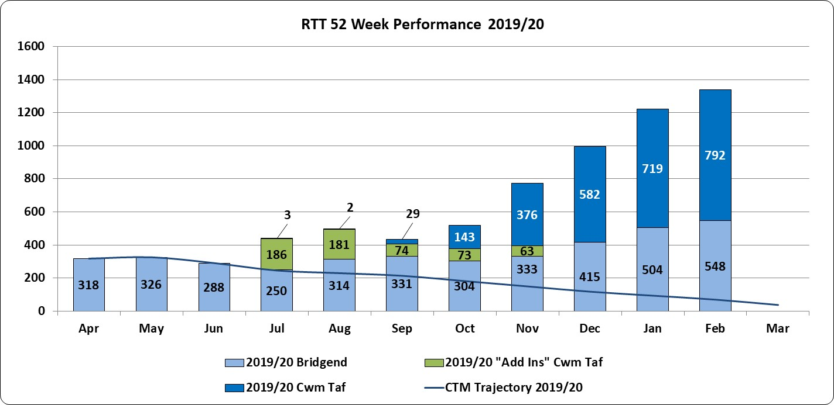

  - The breakdown of the 1340 patients is as follows:

- 548 relate to Bridgend waiting lists (504 in January)
- 792 relates to Cwm Taf waiting lists (719 in January)

Given the plans in place to ensure no patients waiting over 36 weeks in Anaesthetics, Ophthalmology and Oral Surgery in particular, an improved position is expected, but in overall terms, it is Dermatology at CT and Orthopaedics at POW that will make up the majority of the year-end total.

Number of Patients Waiting over 36 weeks – Target Zero
  - As illustrated in the chart, the provisional position for patients waiting over 36 weeks is 4567 patients across Cwm Taf Morgannwg, which is a reduction of 281 from January (N.B. this figure includes the 1340 patients waiting over 52 weeks):

- 3167 patients relate to the former Cwm Taf waiting lists (3422 in January).
- 1400 relate to Bridgend waiting lists (1426 in January).

  - This is due mainly to improvements in Anaesthetics, Ophthalmology and Oral Surgery (CT) and Urology (Bridgend). Elective Orthopaedic capacity at Neath Port Talbot (NPT) continues to be unavailable, which is likely to remain the case until the end of April.

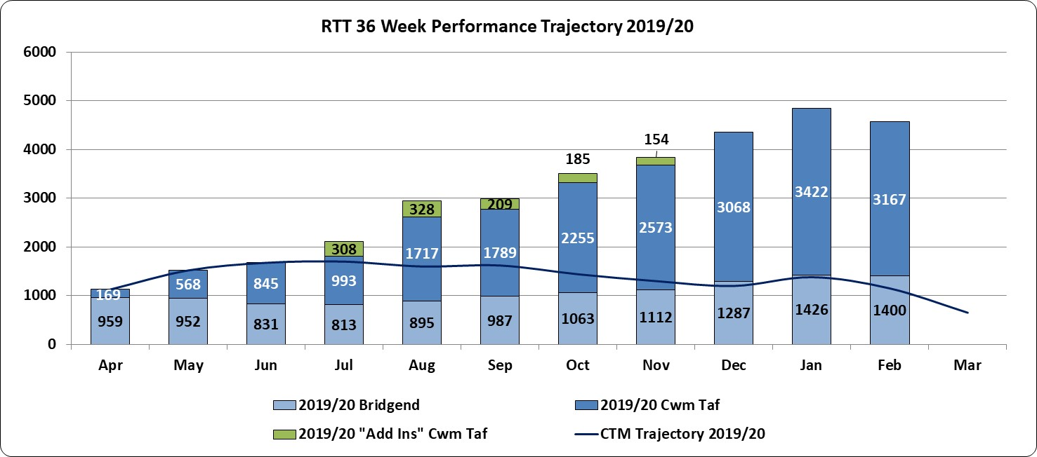

  - The latest projection for year-end has reduced to 3038, though this will be a challenge for a number of specialties, particularly Dermatology, but also for Anaesthetics and Oral Surgery, both of which continue to forecast a zero positon.

  - The previous chart clearly shows how the actual positon has deviated significantly from the original trajectory included in the IMTP for 2019-22, with the year-end forecast shown in the table set to be well above the original IMTP projection of 650.

  - Recent reports have referred to a number of factors that have affected in-year performance such as cancellations, impact of HMRC changes and no access to NPT elective Orthopaedic capacity since the end of October 2019. The following table provides a more detailed breakdown of the factors and recognises the scale of mitigation that needs to be delivered to arrive at the 3038 projection.

  - Whilst there are a number of factors, our ‘achilles heel’ continues to be not delivering sufficient activity, in the main due to either a shortfall against the clinical workforce establishment and/or reduced opportunities for back-filling vacant sessions, a 2019/20 phenomenon that has affected our long-standing, though unsustainable approach to delivering our IMTP RTT commitments in the past.

  - It is not yet clear what impact HMRC issues will have on the delivery of activity from 1 April 2020, a clear risk to our RTT ambitions.

  - The unreported waiting list factor is where a reduction in the total waiting list has occurred in any of the previously unreported waiting lists.

  - The reduced clock resets is a factor that was calculated up to the end of December. Historically, there has always been a more significant impact from clock resets, particularly where additional capacity (often but not exclusively in the private sector) becomes available in the final quarter. A number of actions have therefore been taken to ensure that any clock resets actioned in the final quarter are fully compliant with the Unified Rules.

  - The Management Board has recently approved a revised Waiting List Management Standard Operating Procedure for use throughout the Health Board (HB), which addresses all the issues arising from the DU review of the HB’s waiting list management process.

  - This SOP forms part of an evolving Data Quality Assurance Framework, which will include regular audits of the quality of the HB’s data. Whilst a Business Case is in preparation seeking additional resource to enable this to happen, for now, audits are being carried out by the HB’s WPAS team of all clock resets recorded with a reason of “Refusal of Reasonable Offer”.

  - Directorates are fully engaged with this audit process and where required, amendments are being carried out to ensure the validity of adjustments made to patient pathways.

Number of Patients Waiting under 26 weeks – Target 95%
  - In terms of the 26 week position, the provisional position (excluding the direct access Diagnostic & Therapy figures) for February is 81.4% for CTM (82.5% for Bridgend, 80.9% for CT.

  - The table that follows provides a breakdown by specialty of the 26 week position.

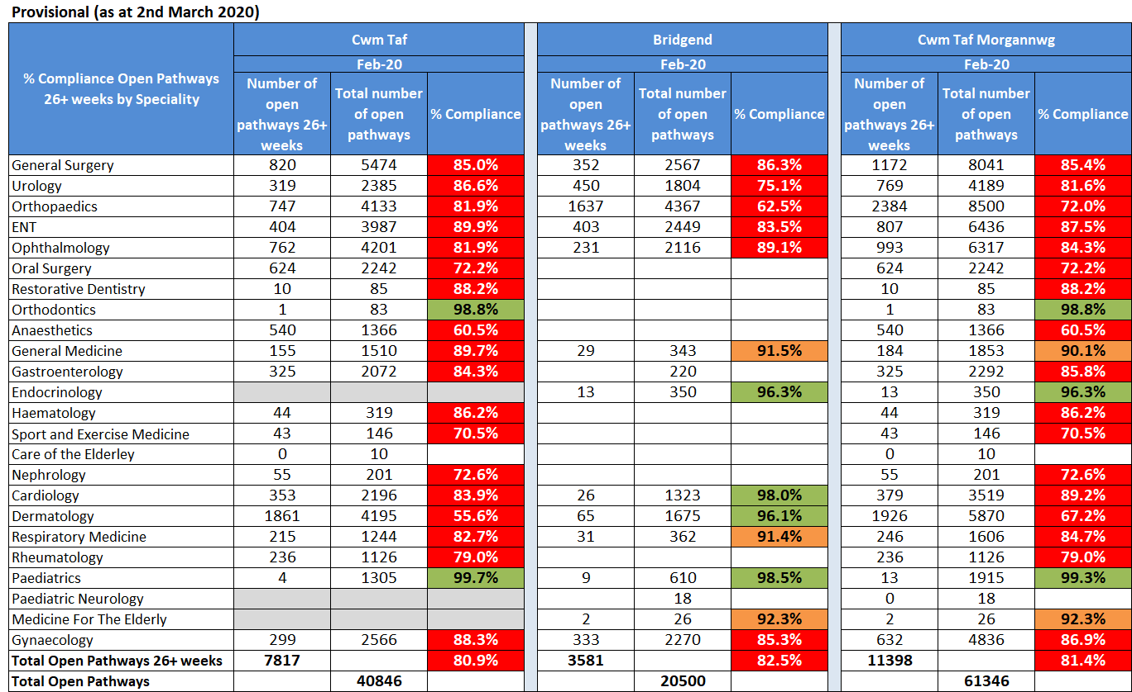

  - Activity levels continue to be closely monitored at the weekly RTT meetings, with continued representation from colleagues across the Health Board. Immediate challenges are in relation to all planned capacity being fully utilised and continue to be around bed and site pressures particularly at PCH, the ongoing HMRC restrictions, and theatre cancellations as a result of anaesthetic cover not being available.

- Diagnostic Waits – Executive Lead, Chief Operating Officer – Target: zero waits >8 weeks

  - The provisional position for February 2020 is 1126 patients waiting over 8 weeks for diagnostic services. This is an improvement from the January position of 1503 patients, of which 1111 patients relate to the former Cwm Taf waiting lists (1473 in January).

  - The table provides a breakdown of the areas that are breaching the 8 week target, inclusive of areas previously unreported.
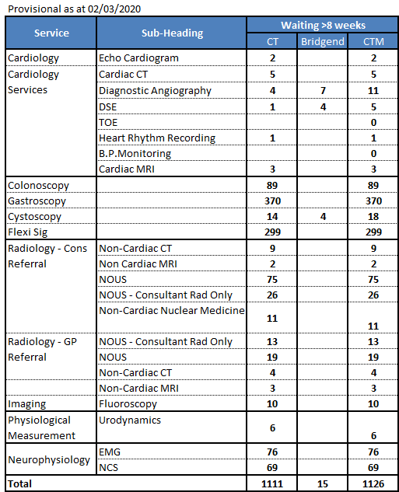

  - The Endoscopy position has improved, with the current forecast for year-end being just over 1000, down from the previously reported projection of 1350.

  - There is recognition however that the Endoscopy demand is in excess of the available capacity and that in addition, there has been equal focus on the endoscopy activity needed for surveillance monitoring and cancer work, such as bowel screening.

  - There has been a further improvement in NOUS this month as a result of additional sessions being held to reduce the gap between capacity and demand. At this stage, the expectation is that there will be no patients waiting in excess of 8 weeks at year-end.

  - The target is now expected to be met for Nuclear Medicine, though Angiography, Urodynamics and Cystoscopy are projecting that there will be a small number of patients waiting over 8 weeks at year-end, all at former CT.

  - The following graph shows the current Cwm Taf Morgannwg diagnostic position, set against the 2019/20 IMTP trajectory, though the current forecast for year-end is 1085 as shown in the table.

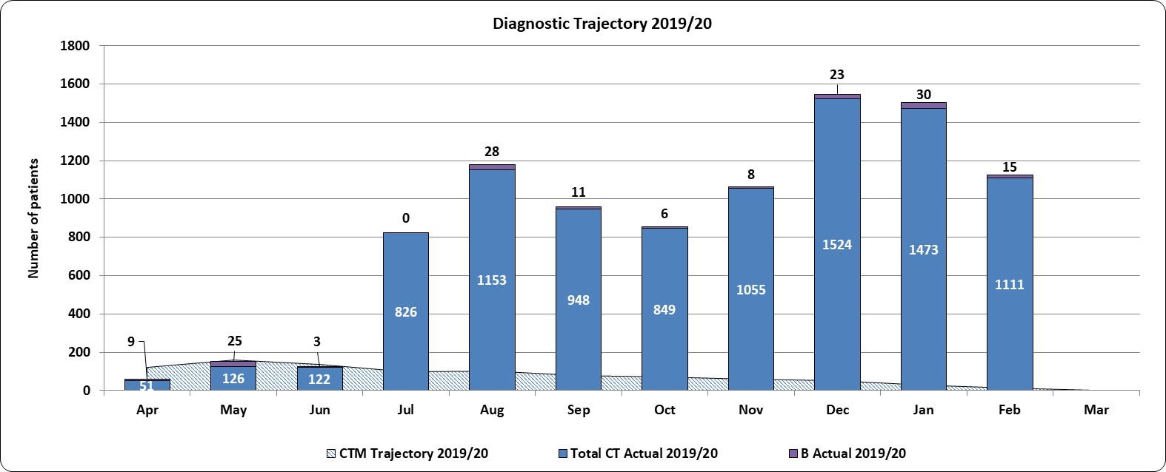

- Therapy Waits – Executive Lead, Chief Operating Officer – Target: Zero waits >14 weeks

  - There were no patients provisionally breaching the 14 week target for therapies in February.

- Surveillance Monitoring (Endoscopy) – Executive Lead, Chief Operating Officer

  - The endoscopy unit at Princess of Wales is a JAG accredited unit and one of the criteria to maintain JAG accreditation is that all surveillance work needs to be 100% in target i.e. 100% of all patients that are under surveillance need to be seen within 8 weeks of the date due. This target is consistently being achieved with all patients usually seen within the month that they are due.

  - Endoscopy patients referred into the Cwm Taf service are managed through four referral pathways, each with their own waiting time target:

- Urgent Suspected Cancer: target 2 weeks (14 days).
- Urgent: target 2 weeks.
- Routine: target 8 weeks (56 days).
- Surveillance: target of 18 weeks (126 days).

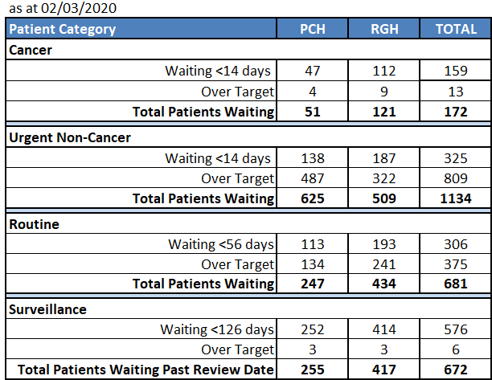

  - The information in the table shown by hospital site, demonstrates that these targets are not being met across all categories of patients in PCH and RGH sites, though there have been improvements.

  - Referral demand into the service continues to increase, with the Directorate’s D&C plan clearly showing that in order to deal with current demand into PCH and RGH, additional capacity is required.

  - The Directorate is currently utilising insourcing at RGH, to accommodate the surveillance backlog patients. The provisional number of surveillance patients waiting past their review date, without an appointment, is 672 (census 2 March 2020). The Directorate is in the process of developing a business case to increase capacity through development of an additional endoscopy theatre on the RGH site.

- Follow-Up Outpatients Not Booked – Executive Lead, Chief Operating Officer

  - Providing regular, consistent FUNB reporting across CTM has been hampered by data flow issues from Swansea Bay UHB, though the position is improving. Progress is being made in achieving consistency of approach across the HB as a whole.

  - A programme of routine pathway validation is being overseen by the fortnightly FUNB Task and Finish Group, with a consistent approach being adopted across all services in CTM.

  - Acknowledging the work required on all hospital sites, the following table shows the reported CTM position for patients waiting 100% beyond their target date.

- Elective Bed Cancellations – Executive Lead, Chief Operating Officer

  - Across the Health Board there were 72 elective ward bed cancellations for February and cancellation levels this year continue to be much higher than last year, adversely affecting the overall RTT position. Additional pressure on beds at PCH in particular is also continuing to affect the unscheduled care stream.

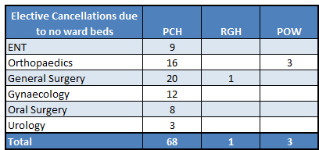

  - The reported number of elective ward cancellations for April 2019 to February 2020 is detailed in the chart below showing a comparison to 2018/19.

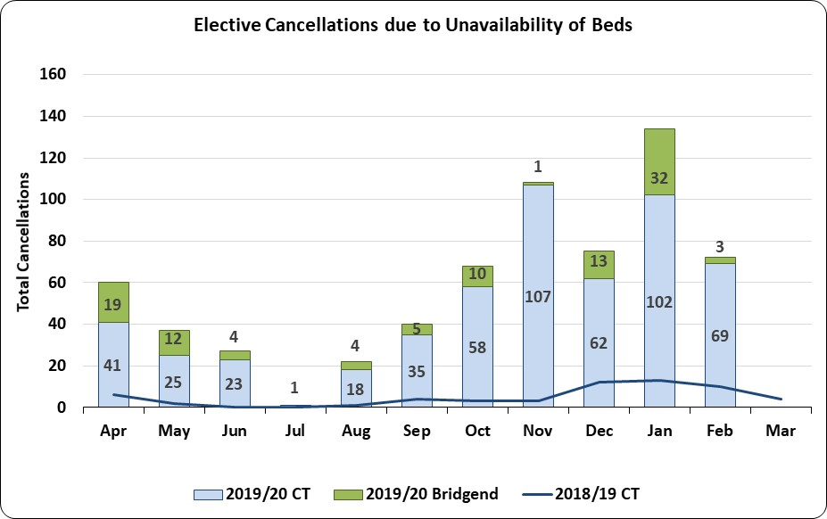

  - For April 2019 to February 2020, the total number of cancellations due to lack of elective beds was 644.

- Theatre Cancellations: Anaesthetics – Executive Lead, Chief Operating Officer

  - During February there were five theatre cancellations with the primary cancellation reason of “anaesthetist unavailable”. The following table details the affected areas:
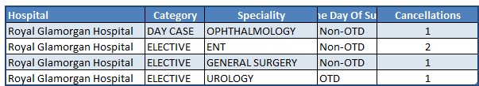

- Unscheduled Care – Executive Lead, Chief Operating Officer and Director of Primary, Community & Mental Health

  - 4 Hour 95% Target: The combined performance for Cwm Taf Morgannwg for the four hour target continued to improve during February to a provisional 77.8%, with the majority of the improvement occurring in POW and RGH, with individual departmental performance as follows:
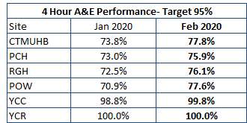

  - 12 Hour Zero Breaches Target: The combined performance for February was a provisional 830 patient breaches (1269 January), halting the rising trend seen since August 2019. Of the 830 breaches, 422 were at PCH, 278 were at RGH and 130 were at POW.

Emergency Ambulance Services
  - The provisional February 2020 performance for emergency ambulance services against the 15 minute handover (Local Measure - Improvement Target) target for CTM improved significantly to 71.8% from 59% in January, with POW seeing the most improvement.

  - The performance for emergency ambulance services over one hour (Target Zero) also greatly improved in February to a provisional 98.3% from 87.8% in the previous month. Compliance at RGH remains stable and reached 100% with POW seeing a vast improvement during February to 95.11% from 62.7% in January. The performance at PCH also improved from 95.1% in January to a provisional 99.1% in February.

  - The response to red calls in January for Cwm Taf Morgannwg was 62.4%, an improvement on the previous two months, 58.2% and 55.7% respectively, but remains below the target of 65%. The Welsh average performance also improved reaching 66%.

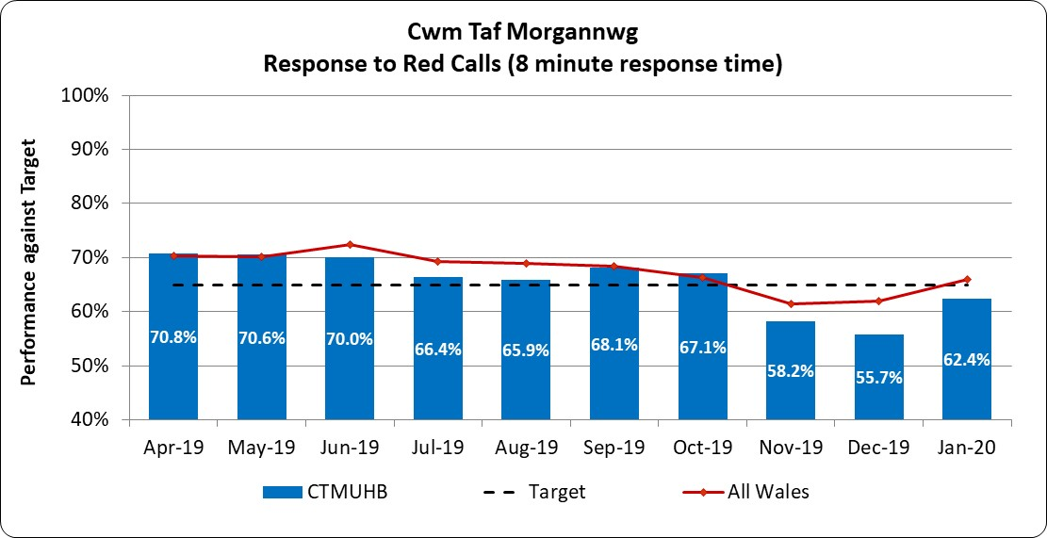

- Delayed Transfer of Care (DTOC) – Executive Lead, Chief Operating Officer and Director of Primary, Community and Mental Health – Target 12 month Reduction Trend

  - The delayed transfers of care (DToC) position for February is shown in the table that follows, as an aggregate for Cwm Taf Morgannwg UHB.

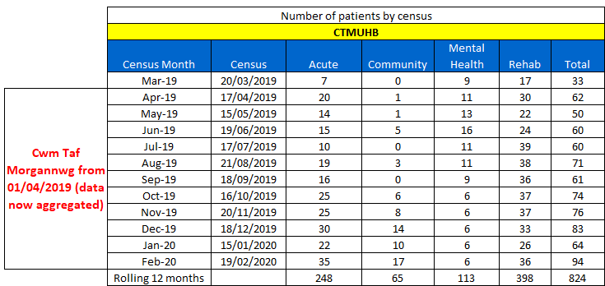
  - The following graph is a comparison of the number of DToC patients March 2018 to February 2019 against March 2019 to date.

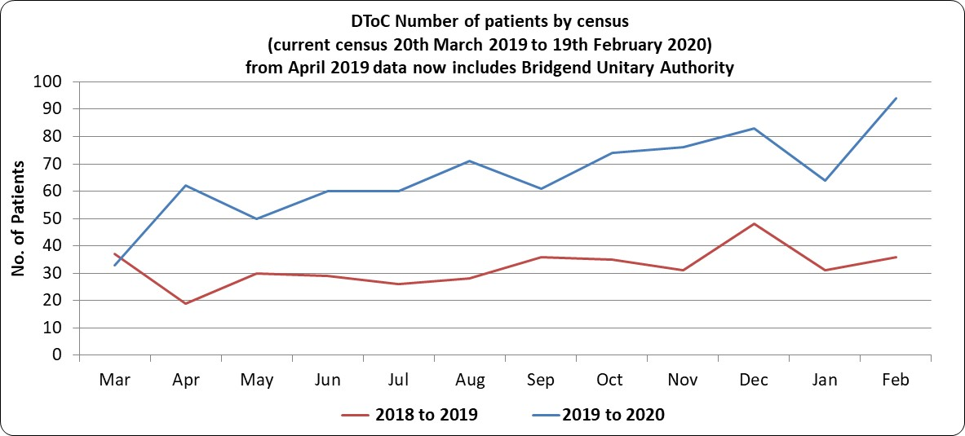

  - This month has seen an increase in the number of DTOC patients to 94 from 63 in January and the level remains more than double what they were for the same period last year. The main reasons remain as previously reported:
- Choice related issues regarding care homes;
- Home care capacity;
- Delays due to housing particularly requests for specialty and adapted housing;
- Delays due to mental capacity.

  - The following table shows the number of DToC patients by locality, with the figure for RCT patients delayed almost double what it was in January. This has been escalated to the Local Authority, who are investigating the reasons behind the increase.
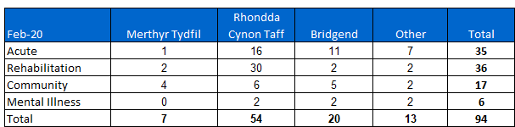

  - The number of actual bed days lost within the month was 1822 compared to the previous month (1452), equating to 52 beds across the HB.

- Cancer 31 Non Urgent Suspected Cancer (NUSC) and 62 Urgent Suspected Cancer (USC) Day Target (escalation level 2) – Executive Lead, Medical Director

31 day target (NUSC) at January 2020: Target is 98%
  - The combined performance for Cwm Taf Morgannwg was 90.4% (amended from the 90.5% shown in the Dashboard, total number of breaches unchanged) with 12 patient breaches; 1 Lung patient breach, 6 Breast patients breached and 5 patients breached in Urology.

  - There was a cluster of 6 Breast Test Wales referrals into the RGH/PCH service which could not be treated in time due to lack of consultant capacity. All the patients were treated between 32 and 39 days.

62 day target (USC) at January 2020: Target is 90%
  - The combined performance for Cwm Taf Morgannwg was 67.4% (amended from the 66.7% shown in the Dashboard, total number of breaches unchanged) with 30 patient breaches.

  - Urology accounted for 22 of the USC patient breaches, mainly through a combination of radiological delays and tertiary centre delays. Gynaecology had 3 patient breaches, 3 patients breached in Lower Gastrointestinal with both Skin and Sarcoma experiencing 1 patient breach apiece.

  - The number of patients already past 62 days awaiting treatment in Urology will result in a similar picture for breaches over the next few months. Short term actions to improve the position have been agreed to reduce the wait for initial diagnostics.

  - In particular a second MRI scanner will be open at weekends in support of the Prostate pathway, whilst the return from maternity leave of a third consultant who can undertake targeted TRUS biopsies will also increase available capacity.

  - For the Haematuria pathway, patients are now being referred directly to CT, with additional sessions underway to clear the backlog.

  - The forecast for the next three months is 98% for NUSC and between 75% and 80% for USC.

  - The following chart shows the Urology position in more detail, with a further deterioration in compliance.

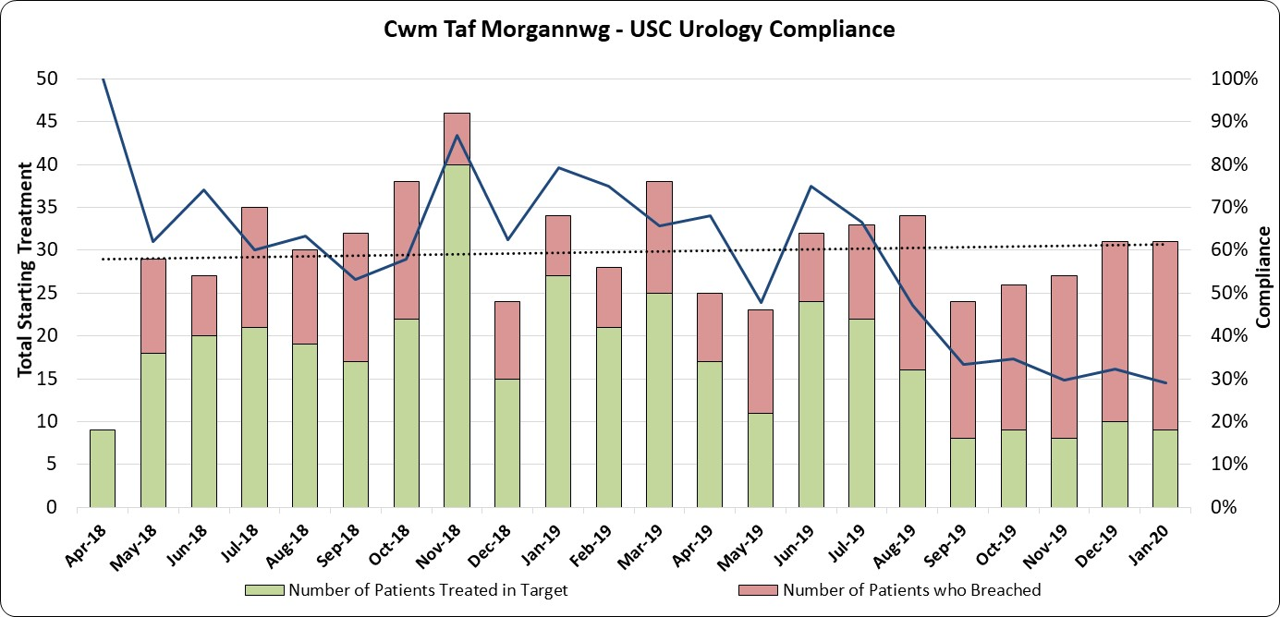

  - The following chart for Gynaecology, shows what can happen in a number of tumor sites, where the small number of patients can lead to more variability in compliance, where in this particular case, the overall trend for treatments undertaken is reducing:

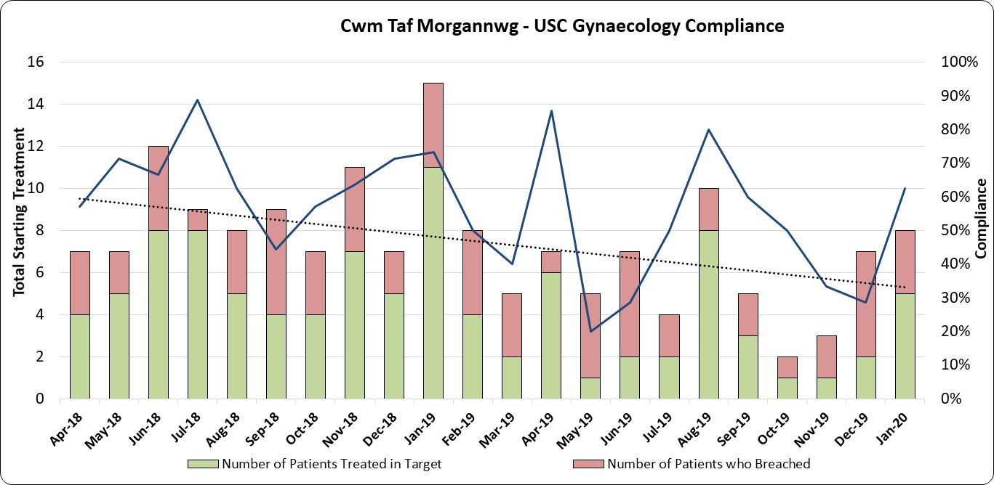

Single Cancer Pathway
  - The Health Board has been formally reporting SCP to Welsh Government, running in parallel with existing cancer pathways for a number of months. Formal reporting to the Welsh Government started in August 2019.

  - The single Suspected Cancer Pathway measures from the point of suspicion until the start of first definitive treatment for all newly diagnosed patients, with the aim of treating all patients within 62 days of the point of suspicion. No performance measure has been set for the SCP as yet but there is an expectation of continuous improvement.

  - The SCP performance for January was:
    - With suspensions 65.0% (68% December 2019)
    - Without suspensions 54.8% (62% December 2019)

The “With suspensions” compliance of 65.0% is an amendment from the 64.7% reported in the Dashboard, with the total number of breaches unchanged, as for USC and NUSC compliance.

  - The summary of specialty SCP performance treated with suspensions is as follows:

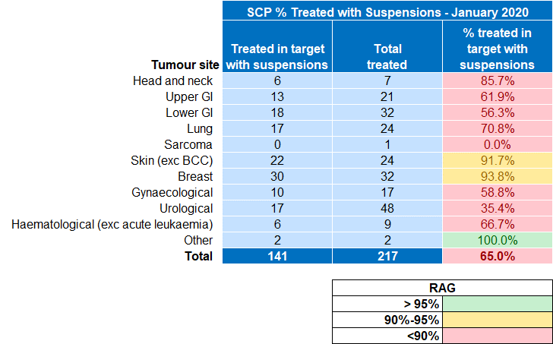

- Quality Improvement Measures - Executive Lead, Director of Therapies & Health Sciences

  - At the time of preparation of this report, the February 2020 data for stroke was not available for reporting. During January, a total of 83 patients were recorded within the Sentinel Stroke National Audit Programme (SSNAP) database:

- 27 patients presented at POW.
- 56 patients presented at PCH.

  - The summary of recent performance for the 4 key indicators is as follows:
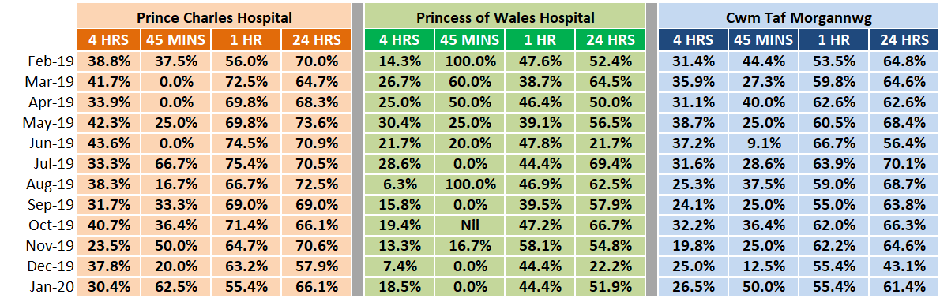
  - There were ten patients thrombolysed, two at POW and eight at PCH. Five of those ten patients were thrombolysed within 45 minutes, all at PCH.

  - Both stroke units continue to find the four hour target challenging. Whilst patient flow has improved for unscheduled care at POW in particular, both units continue to suffer from pressure on unscheduled care services being prioritised over ring fenced assessment beds. Transferring medical outliers to other wards is hampered by the high occupancy rates in both hospitals.

  - Given that both units currently run a 5 day service, review by a stroke consultant within 24 hours is very unlikely to ever reach above 70% at best, with any sickness and/or absence further exacerbating the position.

  - The Directorate IMTP will again state the case for a 7 day service, including additional SALT staff to address well documented shortages. A further priority is to increase the registered nurse establishment on the Acute Stroke Unit from 1.67 to 3.0 per 10 beds, as per National guidelines. Significant improvement in the achievement against these key quality improvement measures will however also require improved patient flow in the unscheduled care stream.

- Mental Health Measure - Executive Lead, Director of Primary, Community & Mental Health

  - Part One of the Mental Health Measure relates to primary care assessment and treatment and has a target of 80% of referrals to be assessed within 28 days. January compliance fell to 62.3% from 68.3% in December with CAMHS falling further to 1.4% from 17.1% in December.

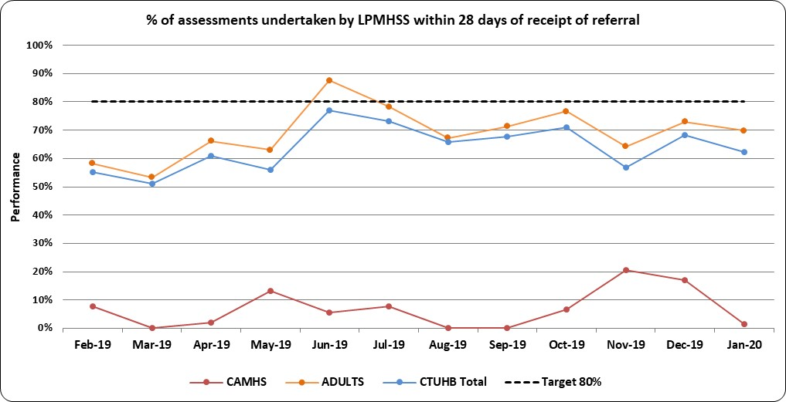
(* Post April 2019 data is CTM aggregate data)

  - Overall the percentage of therapeutic interventions started within 28 days following an assessment by LPMHSS remained above the 80% target during January but fell to 88.2% from 94.8% in December. CAMHS continues to be the only service not meeting the target.

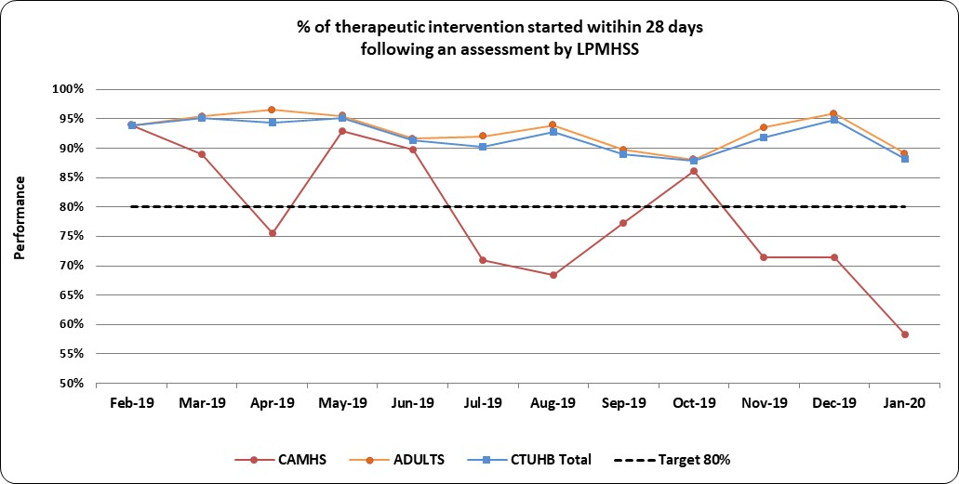
(* Post April 2019 data is CTM aggregate data)

  - Part Two of the Mental Health Measure: i.e. % of Cwm Taf Morgannwg residents who have a valid Care Treatment Plan completed by the end of each month remained fairly static at 87.0% in January from 87.1% in December.

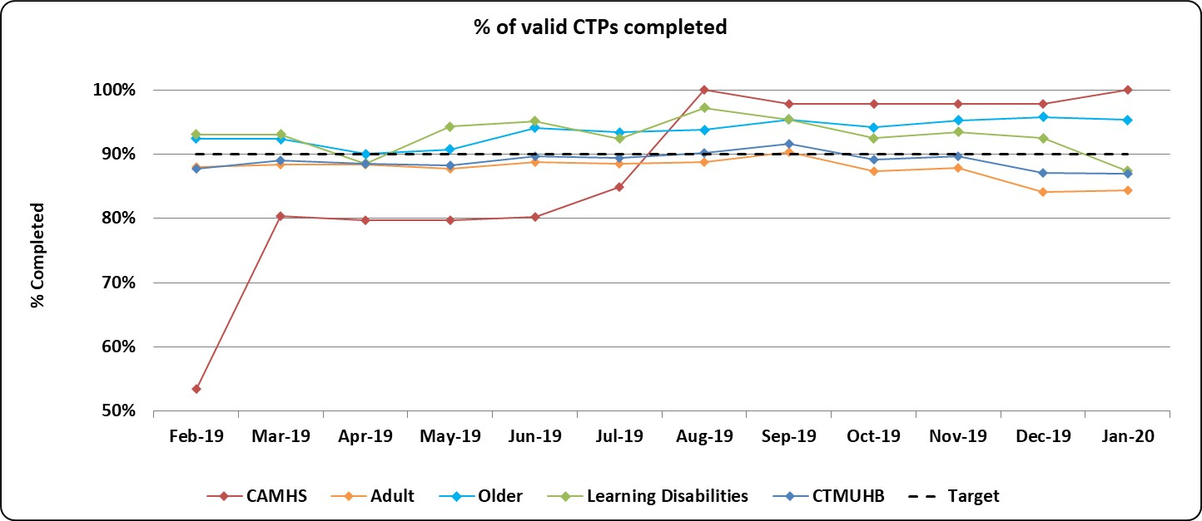

  - Only one assessment was carried out and sent within 10 working days during January (100%) for Part Three of the Mental Health Measure i.e. “All Health Board residents who have been assessed under Part 3 of the Mental Health Measure to be sent a copy of their outcome assessment report up to and including 10 working days after the assessment has taken place”.

Primary Care CAMHS (p-CAMHS)
  - The Cwm Taf Morgannwg p-CAMHS waiting list position as at 2 March 2020 is a provisional 157 patients waiting (an increase of 36), with 45 of those patients waiting more than 4 weeks which is a deterioration from 27 waiting more than 4 weeks at 6 February 2020. The average wait increased from 2 weeks to 3.

  - The additional capacity opportunities identified as part of the Delivery Unit review are continuing to have a positive impact. Recruitment of further staff, improvements in productivity of clinics and changes to clinical staff templates will ensure further reductions in the total waiting list. Compliance with the Part 1(a) mental health measure is however unlikely to be achieved until the total waiting list is reduced to below 100.

Neurodevelopment
  - Compliance against the 26 week target for the former Cwm Taf area for Neurodevelopment services improved slightly in February to a provisional 60.1% from 59.2% in January. Waiting list initiatives are continuing.
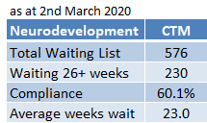

Specialist CAMHS (s-CAMHS)
  - The Cwm Taf Morgannwg position for specialist CAMHS waiting times fell in February to a provisional 73% from 80.2% in January.

  - Patients from RCT are being offered an option to be seen at Bridgend to maximise the use of capacity, with waiting list initiatives continuing.
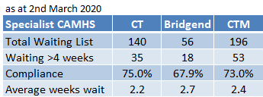

- KEY RISKS/MATTERS FOR ESCALATION TO THE PLANNING, PERFORMANCE & FINANCE COMMITTEE

  - The key risks are covered in the summary and main body of the report.

- IMPACT ASSESSMENT

Quality/Safety/Patient Experience implications | Yes (Please see detail below)
Quality/Safety/Patient Experience implications | A number of indicators monitor progress in relation to Quality, Safety and Patient Experience, such as Healthcare Acquired Infection Rates and Access rates.
Related Health and Care standard(s) | Choose an item.
Related Health and Care standard(s) | If more than one Healthcare Standard applies please list below:  The 22 Health & Care Standards for NHS Wales are mapped into the 7 Quality Themes. The work reported in this summary and related annexes take into account many of the related quality themes.
Equality impact assessment completed | Not required
Legal implications / impact | Yes (Include further detail below)
Legal implications / impact | A number of indicators monitor progress in relation to legislation, such as the Mental Health Measure.
Resource (Capital/Revenue £/Workforce) implications /  Impact | There is no direct impact on resources as a result of the activity outlined in this report.
There are no directly related resource implications as a result of this report, although a number of improvement areas have underpinning financial plans.
A number of indicators monitor progress in relation to Workforce, such as Sickness and Personal Development Review rates.
Link to Main Strategic Objective | To ensure good value based health care and treatment for our patients in line with the resources made available to the Health Board
Link to Main WBFG Act Objective | Service delivery will be innovative, reflect the principles of prudent health care and promote better value for users

- RECOMMENDATION

  - The Board is asked to:

- RECEIVE and DISCUSS the Integrated Performance Dashboard together with this report.

