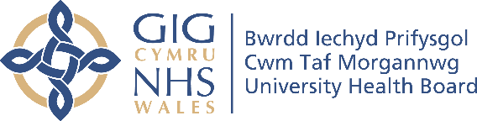
Cwm Taf Morgannwg University Health Board
Improving Maternity Together
Maternity Vision 2020 -2030

What you should expect from your Maternity Care

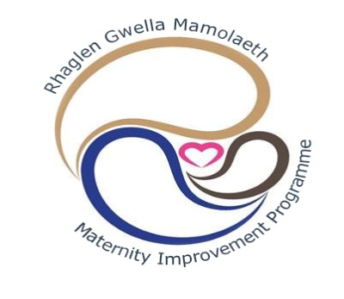

Our Vision
The Maternity Vision for Wales
Pregnancy and childbirth are a safe and positive experience, and parents are supported to give their child the best start in life. This will follow 5 key principles:

Family Centred Continuity of Carer Safe and effective care
Skilled multi-professional teams Sustainable quality services

Our Maternity Values in Cwm Taf Morgannwg
To provide safe and high quality maternity care which will meet the needs of all our communities. Working in partnership with everyone who uses our service, we will develop safe and effective maternity care and support. Every woman and their family will receive excellent care that is right for them.
Our Maternity Mission
- To support parents to be as healthy as they can be
- Give all babies the best possible start in life
- Work with families to want to make healthy lifestyle choices

Delivering for our Communities
We want to be supported to stay as healthy as possible during pregnancy, birth and afterwards
The team will provide information and advice to support us to make healthy choices
If we need Help and advice at any point we will know who to contact
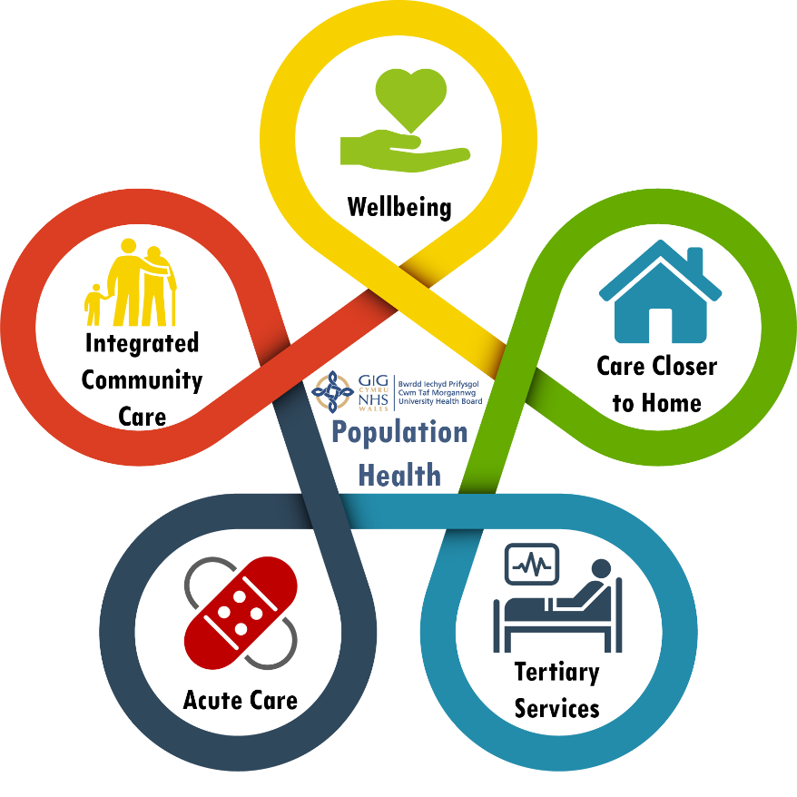

We expect routine antenatal care including scans to be offered close to our home, appointments will be co-ordinated by my named midwife who I see regularly
For the many women who are straight forward when their labour starts they may choose to birth at home, or in one of our midwifery led units
Following birth when we are well my named midwife will discharge me to my health visitor’s care. We will be debriefed to understand the reasons for our maternity care

For women who need extra help and support during and after pregnancy our specialists will maximise well-being and safety
Most women will plan to birth in our labour wards, where all the team and facilities are quickly available. Families will be supported to come in and go home efficiently, when they feel ready to do so

Our maternity goals and how we will deliver them

Teamwork with everyone

- Women and their families will be fully involved in their care to make informed choices
- We will support our team to be skilled and trained
- Our team welcomes change and bring an optimistic ‘can do’ attitude
- Women and families will receive consistent advice and we will be clear and honest in our communication
- Working closely with other organisations to promote healthy lifestyle choices

Delivering safe care for the long term

- We will have the right number of doctors and midwives to provide the best care in the right place
- Ensure our maternity care and support is delivered collaboratively in partnership with all
- Continuity of care, wherever possible, as recommended nationally
- Families will be supported to breastfeed for as long as they wish to do so

High quality care given and received with respect

- Women, their families and staff will be listened to, valued and treated with dignity and compassion
- Communication and information will be appropriate, relevant, consistent and easy to understand
- We will provide the highest standard of care: physical, psychological and spiritual to optimise well being
- Individualised care will include using the language of your choice
- We will enable you to receive specialist care if you need it

Listen, learn and take action

- We will hear and understand families and take meaningful action
- We are curious and look to learn and share our learning
- At the end of the maternity journey, all families will fully understand their experience and care received
- Partners will feel included every step of the way

Realising our vision – what success will look like

Teamwork with everyone / Delivering safe care for the long term
- All essential training and development opportunities will be provided, all relevant clinicians will participate actively and enthusiastically
- Development of new roles, flexible workforce patterns and career succession opportunities will be implemented
- All staff will be expected to reflect of the organisations shared values and behaviours
- Staffing levels across our service will be monitored in line with national guidance and recommendations
- Women and their families will receive routine antenatal care by no more than two community midwives.
- Discharge from maternity services will be completed by the woman’s named midwife
- Women and families will be supported fully with their feeding choices for their baby
- We will promote and encourage healthy lifestyle choices throughout the maternity pathway with all partner agencies, these measures will be monitored closely and will show improvements over time:
  - Weight management in pregnancy
  - Families staying smoke free
  - Healthy eating
  - Families choosing to breastfeed

High quality care given and received with respect / Listen, learn and take action

- Women and families with concerns will be supported promptly (within two working days) to resolve any issues
- There will be multiple sensitive ways of measuring women and families experience of our service. These measures will show an increase in service user satisfaction over time
- Women and families will be able to see how their feedback has made improvements to our service
- All advice and information will be provided in the language or format of your choice / need
- Women and families will be offered debriefing prior to discharge from maternity services and contact details should they wish to access further information post discharge
- All women receiving consultant led care will have an evidenced based reason for this
- Perinatal mental health support is core maternity care and will be reflected in our maternity notes
- Access to specialist perinatal mental health services is seamless when required and will be monitored to ensure waiting times are reduced

