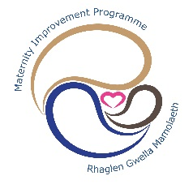
MATERNITY IMPROVEMENT PROGRAMME
HIGHLIGHT REPORT – Programme Plan
Quality of Leadership & Management
Completed by: |  | Kath Doughton  Tarek Allouni | Reporting period: | January | To: | February 2020
Date Completed: | 28/01/2020 |  |  | Next Review Meeting: |  |  | 12 March 2020
Current status: | Headlines:
 | - Details of recommendations agreed and signed off at IMSOP assurance visit held on 18/02/2020  - Future suggested actions  .
  R
  A
  G
Key Achievements This Quarter |  |  | Project Plan: Proposed Achievements Next Quarter
IMSOP validated and approved the following recommendations as complete – 18/02/2020.  Rec 7.13 – Clinical Lead Governance  Rec 7.24 – Identify a clinical lead for senior medical staff  Rec 7.43 – In-depth assessment of the service as it moves into the future  Recommendations verified on 16/12/19 which are now considered closed:  7.6, 7.25, 7.28, 7.33, 7.34, 7.36, 7.40, 7.41, 7.46, |  |  | The following RCOG recommendations have been discussed collectively at the Quality of Leadership & Management January 2020 meeting. It was confirmed that the following recommendations have a trajectory of completion by March 2020.  The following additional evidence will be supplied to IMSOP to validate and approve:  - RCOG 7.5 Panel require evidence that CTG March cycle training was completed.  - Rec 7.29 Panel require further evidence relating to monitoring of bank hours  - Rec 7.70 - Ensure future service change is inclusive – covered under QWE  - Rec 7.68 - for all staff and service users  Closely monitor bank hours undertaken by midwife
Slippage and remedial action |  |  | Issue or concerns
Sudden change of project improvement manager due to illness has resulted in issues with reporting this month. Metrics not available for new project manager to report prior to MIB. Project group meeting with new project manager for the first time on 12 March 2020 and the reporting of measures is an agenda item for discussion. |  |  | Focus for next quarter:  Attached is an updated action plan with provides a focus for the improvement work over the coming months  Revisit recommendations which relate to training with a view to amalgamating
Self-Assessment Against Maturity Matrix
The Health Board is able to evidence early progress against the maturity matrix:

- The health board monitors staffing levels and takes action to address shortfalls.
- The health board has a plan to improve recruitment and retention.
- Training compliance and PADR/appraisal rates are monitored. There are plans in place to improve compliance. There is evidence of an increase in the number of personal development reviews undertaken across the service. With initial feedback positive in regards to the new discussion format.
- There is evidence that the plan to improve the quality of management and leadership is accepted and endorsed by maternity services staff and staff side representatives

Obs & Gynae Directorate Bespoke Mandatory Training Compliance as at 13th March 2020.

There is CTG training planned for 23rd March and this will result in 100% compliance. Forty clinicians are also booked on PROMPT training in March.

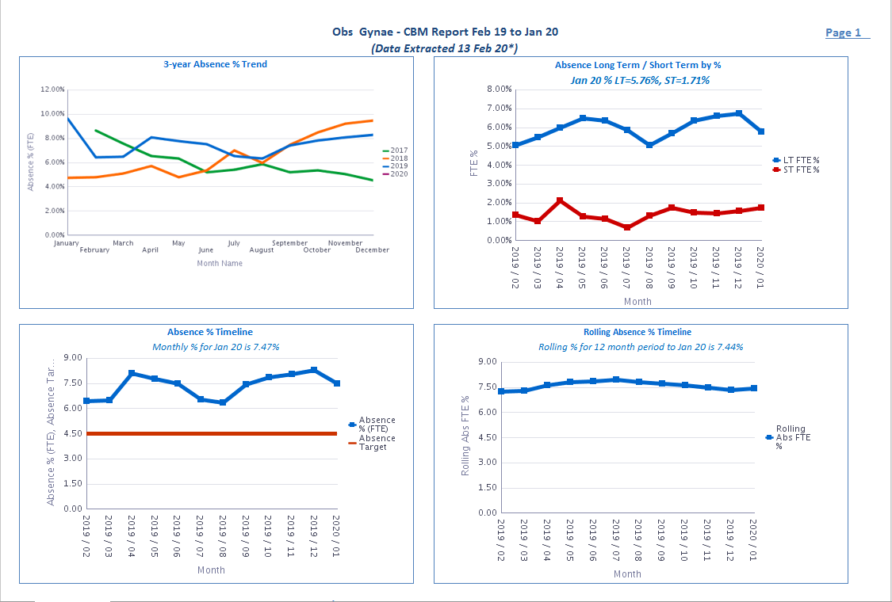

Job Planning: Obstetrics & Gynaecology and Sexual Health Directorate

Quality & Leadership Management Attendance:

PDR Compliance:

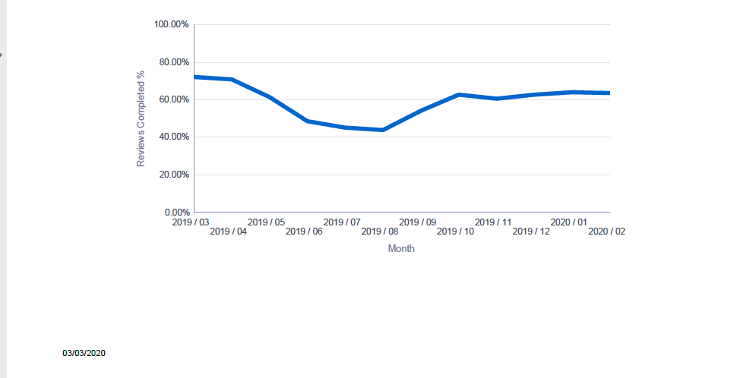

Quality of Leadership & Management
RCOG Reference | Health Board Proposed Status | IMSOP validated and approved | Status Trajectory/ Follow-Up | Recommendation | Examples of assurance evidence from Directorate (Dec 2019)
Rec: 7.5 | In progress | Awaiting clarification from IMSOP | June 2020 | Agree a CTG training programme that includes a competency assessment, which is delivered to all staff involved in the care of pregnant women, both in the antenatal period and intrapartum | • A CTG training programme is now in place for all clinical staff. With a trajectory of full compliance by the end of 2019/20 financial year.  • A competency assessment in line with National standards still needs to be reviewed.  • Compliance Standard Medical staff: 100%  Compliance Standard Midwifery staff: 94%  Monitored weekly through dashboard.  • Variation in compliance is occurring do to both medical and Midwifery turnover, including the high levels of newly recruited staff.  • Training sessions and full days have been dedicated to Midwives which include CTG Interpretation workshop.  Evidence: as above with trajectory and rates.  CTG - Plan  Dashboard (weekly dashboard)  Education forum exception report  Action for sign off as advised at Feb 2020 Assurance Vist.  CTG Training list submitted 09/03/2020  KG Re CTG Programme presentation
Rec: 7.8 | Complete | IMSOP to consider sign off | March 2020 | Ensure external expert facilitation to allow a full review of working practice to ensure:  • Patient safety is considered at all stages of service delivery.  • A full review of roles and responsibilities within the obstetric team.  • An appropriately trained and supported system for clinical leadership.  • A long-term plan and strategy for the service.  • There is a programme of cultural development to allow true multi-disciplinary working. | • Patient safety key focus for governance days. Good evidence of MDT involvement. Becoming embedded and evidence of learning. Needs to be further sustained.  • New CD in post. DM and CD working through job planning.  • A number of new appointees in post and a developing structure emerging.  • Guideline development a key task for Safe and Effective Care. Guidelines allocated to individual forums for updating and leadership. Work to develop new CTM protocols progressing.  • Vision for CTM Maternity Services to be co-produced with women, families, staff and other stakeholders. Engagement events being progressed to seek views.  • Two fold approach: 1) CTM Health Board Values and Behaviour work 2) Maternity-specific work to be commenced with external provider to develop service emotional intelligence. Waiting for final tender approval. To commence when approved and staff able to be released.  Evidence previously presented:  OD Plan  Job plans  Governance Day  Clinical Forum evidence  Leadership structure
Rec: 7.15 | Partial Complete | IMSOP to clarify Mandatory Training  Datix element be managed under S&EC | June 2020 | Educate all staff on the accountability and importance of risk management, Datix reporting and review and escalating concerns in a timely manner. Include this at:  • Junior doctor induction  • Locum staff induction  • Midwifery staff induction  • Annual mandatory training ( check what is classed as mandatory training ) | • Induction programmes for junior doctors, locum staff and midwifery staff all now include session on risk management  • Need to further understand maternity service mandatory training requirements and develop system for monitoring against that compliance.  • Evidenced through the below documents: Induction programmes and attendance lists. HEIW feedback.  HEIW feedback  Governance day  Induction programmes  Trigger list within datix  Clinical incident reviews  Action for sign off  IMSOP to clarify what is classed as mandatory training?
Rec: 7.17 | In progress |  | Sept 2020 | Ensure training is provided for all SAS staff to ensure that they are:  •Up to date with clinical competencies.  •Skilled in covering high-risk antenatal clinics and outpatient sessions. | • Training and Development Forum is taking forward this work. Need to further understand what the clinical competency requirements are, frequency of update and frequency of assessment. Need to further understand trajectories to that compliance.  SAS forum first meeting  Action for sign off  Training programme example that is provided for SAS Staff (November)  Trajectories needed as evidence
Rec: 7.18 | Complete | Clarification sought from IMSOP | March 2020 | Agree cohesive methods of consultant working after the merger with input from anaesthetic and paediatric colleagues. | Action:  Clarification if this relates to the merger with PCH and RGH
Rec: 7.22 | In progress |  | Sept 2020 | Actively discuss the outcomes of Sis which individual consultants were involved in their appraisal. | • Previous discussion with Deputy Medical Director about evidencing this. Email sent to all Consultants. GMC requirement to reflect on incidents.  • Appraisal confidential in nature so difficult to gain assurance.  Current discussions taking place as the individuals appraisals are confidential. Working through an alternative plan.  Action for sign off  Confirm progress with CD
Rec: 7.29 | In progress | Panel requested further information (18/02/2020) | May 2020 | Closely monitor bank hours undertaken by midwives employed by Cwm Taf, to ensure:  • The total number of hours is not excessive  •The Health Board complies with the European Working Time Directive  •These do not compromise safety | • Workforce scorecard to be developed and agreed  Weekly updates in assurance group  Senior midwives meeting minutes  Action for sign off:  Query around compliance with the European Working Time Directive
Rec: 7.30 | In progress |  | May 2020 | Ensure the Medical Director has effective oversight and management of the consultant body by:  •Making sure they are available and responsive to the needs of the service  •Urgently reviewing and agreeing job plans to ensure the service needs are met  • Clarifying what is to be covered as part of SPA activity (audit, governance, teaching, guidelines, data assurance, train more consultant obstetricians as appraisers)  •Ensuring the most unwell women are seen initially by a consultant and all women are seen by a consultant within 12 hour NCEPOD recommendation (national standard) | Action: RCOG to be discussed at OLM Meeting  Ensuring the most unwell women are seen initially by a consultant and all women are seen by a consultant within 12 hour NCEPOD recommendation (national standard)
Rec: 7.32 | In progress |  | May 2020 | Ensure obstetric consultant cover is achieved in all clinical areas when required by:  • Reviewing the clinical timetables to ensure that 12 hour cover per day on labour ward is achieved.  Undertake a series of visits to units where extended consultant labour ward presence has been implemented.  Considering working in teams to ensure a senior member of the team is available in clinics and provide cross cover for each other.  Considering the creative use of consultant time in regular hours and out of hours to limit the use of locums | • Recruitment to workforce plan  • Consultant cover in place. Gaps being managed through locums and additional shifts for existing team.  • Handover attendance documents  • Spot checks by Senior Management Team  Handover attendance documents  Job plans and workforce developed.  Evidence required:  - Rota  - Job plan
Rec: 7.35 | In progress |  | Sept 2020 | Undertake a training needs assessment for all staff to identify skills gaps and target additional training | • Training and Development Forum is taking forward this work. Need to fully understand training needs and training plans for all clinicians.  • 2 year cycle of training needs identified and developed. Confirmed in the Training and Development Forum that mandatory training will take 18 months to bring everyone into compliance.  • Further development of Peri-natal mental health training made compulsory.  CTG, prompt , gap and grow  Dashboard  Action for sign off:  Add in Training needs analysis - speak to KG  Audit Plan 2019/2020  Governance Day Audit Minutes  Audit & ResearchForum Agenda  10.05.2019 Minutes  14.06.2019 Minutes  Governance Structure  Policy
Rec: 7.37 | Complete | IMSOP to agree sign off | May 2020 | Develop an effective department wide multi-disciplinary teaching programme.  • This must be adequately resourced and time allocated for attendance by all staff groups including specialist clinical midwives and SAS doctors.  • Attendance must be monitored and reviewed at appraisal. | Evidence previous submitted:  Training and Development Forum is taking forward this work.  Band 5/6 competencies been developed. Staff grade training standards also being developed.  2 year cycle of training needs identified and developed.  PROMPT skills and drills  Teaching every Wednesday afternoon  Induction pack outlining all the teaching sessions and topics taught.  Midwifery training days
Rec: 7.39 | In progress |  | May 2020 | Review the working practice for how consultant cover for gynaecology services will be delivered after the merger.  •A risk assessment must be performed to determine the case mix of planned surgery on the Royal Glamorgan site when there is no resident gynaecology cover. | • Risk assessment undertaken prior to move to PCH.  • Current model assessed as safe but further work to be completed to ensure sustainability.  Risk assessment  Gynae and Obstetric separate consultant oncall rotas. (Bree/Deb - send e-mail to request )
Rec: 7.42 | In progress |  | On track for December 2020 completion | In conjunction with Organisational Development undertake work with all grades of staff around communication, mutual respect and professional behaviours.  •Staff must be held to account for poor behaviours and understand how this impacts on women’s safety and outcomes | • OD programme launched November 2019.  • Experience of women and families fed back to staff through real-time surveys, governance days, and patient stories.  • DON has written to all midwives about acceptable and unacceptable behaviours  • Evidence of improvement through real time surveys
Rec: 7.44 | In progress |  | On track for August 2020 completion | Support training in clinical leadership  •The Health Board must allow adequate time and support for clinical leadership to function. | Evidence previoulsy submitted:  • Leadership programme commencing.  • Key individuals are being released and supported to undertake leadership development.  • Further work to do to identify talent early and support programmes of development  Job plans  OD Programme  Launch call slides  Improving Maternity Together  AI Outputs  Mindset
Rec: 7.45 | In progress |  | May 2020 | Provide mentorship and support to the Clinical Director  • Define the responsibilities of this role  • Ensure there are measurable performance indicators  • Ensure informed HR advice to consistently manage colleagues’ absence and deployment of staff to cover the needs of the service  • Consider buddying with a Clinical Director from a neighbouring Health Board. | • Support CD in situ  • Training supported  Anju Kumar - support CD currently, been in post since Feb.
Rec: 7.56 | In progress |  | December 2020 | Provide training for staff in communication skills, in particular on:  • Empathy, compassion and kindness | Evidence previously submitted:  OD programme launched November 2019  • CTM Values and Behaviours work  • Directorate and programme leaders modelling appropriate behaviours
Rec: 7.57 | In progress | IMSOP to consider sign off | March 2020 | Continue with efforts to recruit and retain permanent staff. | Four Consultants recruited since the RCOG  Action:  Tarek to speak with HR Lead turnover of staff and new recruits over the past 12 months
Rec: 7.69 | In progress |  | On track for March 2021 completion | Identify and nurture the local leadership talent | • Leadership programme commencing  • Key individuals are being released and supported to undertake leadership development.  • Further work to do to identify talent early and support programmes of development  Evidence previously presented:  OD Plan  Job plans  Governance Day  Clinical Forum evidence  Leadership structure

