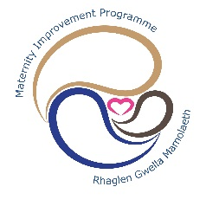 MATERNITY IMPROVEMENT PROGRAMME
HIGHLIGHT REPORT – Safe & Effective Care Project
Completed by |  | Valerie Wilson/Kath Doughton/Kathy Greaves | Reporting period: |  | January 2020 | To: | March 2020
Date Completed: | 04/03/2020 |  |  |  | Next Review Meeting:
Current status | Headlines:
 | - Details of recommendations agreed and signed off at IMSOP assurance visit held on 18/02/2020  - Future suggested actions
  R
  A
  G
Key Achievements This Quarter |  |  |  | Project Plan: Proposed Achievements Next Quarter
IMSOP validated and approved the following recommendations as complete – 18/02/2020.  - DU Report – Simply the current process for review of an incident – agreed partial completion further evidence required – 6 months  - DU Report (1, 2019): Use learning to inform improvement via the newly developing governance arrangements – agreed sign off as complete  - DU Report (2, 2019): Complete the reviews of 43 incidents - agreed sign off as complete as these cases now fall under the clinical review process and are no longer being investigated by the HB  - DU Report (3, 2019): Ensure governance process are consistent - agreed sign off IMSOP Business Manager to confirm with DU  - DU Report (4, 2019): Ensure sustainable change in the midwifery reporting process for incidents - agreed partial completion this will be covered under RCOG Rec 7.51  - Rec 7.14: Consultant meetings are regular in frequency - agreed sign off as complete  - Rec 7.16: additional information submitted with a view to sign off.  - Rec 7.21: agreed sign off complete  - Rec 7.66 – IMSOP Business Manager to confirm |  |  |  | - DU Report – further evidence required on training undertaken with regards to incidents,  - Rec 7.1– progress the review of systems in place for data collection and validation  - Rec 7.2 – Review of all Maternity Unit guidelines to ensure a multidisciplinary approach  - Rec 7.7 - Ensure an environment of privacy and dignity is provided for women & families undergoing miscarriage and abortion  - Rec 7.19, 7.21, 7.23, 7.51 – PTR process in relation to concerns, claims, patient safety incidents,  - Rec 7.55 – Review effectiveness of bereavement services
  Recommendations verified on 16/12/19 which are now considered closed: | Project Plan: Proposed Achievements Next Quarter
  Project Plan: Proposed Achievements Next Quarter
Rec: 7.1, 7.4, 7.9, 7.10, 7.11, 7.12, 7.14, 7.23, 7.26, 7.36, 7.38, 7.59, 7.60, 7.61, 7.65

Self-Assessment Against Maturity Matrix
The Health Board is able to evidence early progress against the maturity matrix:

- The health board has a developing quality governance structure and has full engagement from all of the MDT.
- The health board has a developing quality dashboard and monitors key indicators.
- Clinical incidents are reported and investigated appropriately and learning is focussed on individual incidents. Changes in practice are recommended but there is limited evidence that these changes are implemented and/or impact on future safety.
- Responsibility for patient safety and governance is limited to a few key individuals in the maternity service.
Slippage and remedial action | Issue or concerns
RCOG Rec 7.7: Ensure an environment of privacy and dignity of care for women undergoing abortion or miscarriage | Significant work has been undertaken in the form of:  - Development of a business case  - Identifying a dedicated space on the PCH  site  - escalation to the Head of Midwifery/Service Group General Manager  - Flagged on the risk register  This is currently no available space on the PCH  Site.

Monthly Maternity Monitoring Indicators

February 2010
PCH = Prince Charles Hospital Obstetric Unit, Tair Afon Birth Centre, Home (Cynon and Merthyr localities) and Other (births in transit from Cynon and Merthyr localities)
POW = Princess of Wales Hospital Obstetric Unit, Bluebell Suite, Room 3, Ward 12, Home (Bridgend locality) and Born in Transit.
RGH = Tirion Birth Centre at the Royal Glamorgan Hospital, Home (Rhondda and Taff localities) and Other (births in transit from Rhondda and Taff localities)
Births = babies born
Women = women delivering

Total Births
During February 2020, there were 3 sets of twins born to 365 women.

% of New initial Assessments carried out by 10 completed weeks, by month booked

Run chart going back to 2018 - Former CT only
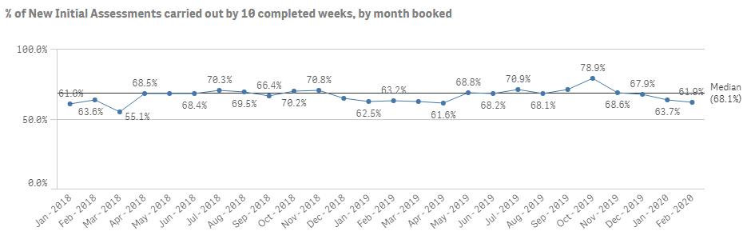

Midwifery and Consultant Led Care at Initial Assessment
Jan 2018-Mar 2019 - Former CT, Apr 2019 onwards CTM
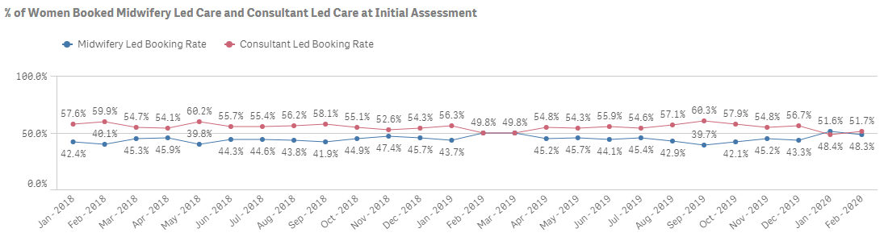

Inductions of Labour
Numerator: Total number of women induced
Denominator: Total number of women delivering
Goal: 20.0%

Normal Births
Numerator: Total number of SVD births
Denominator: Total number of births
Goal: 60.0%

Low Risk Women Commencing NLP
Numerator: Total number of women commencing NLP
Denominator: Total number of women delivering
Goal: 35.0%

Low Risk Women Commencing and Completing NLP
Numerator: Total number of women completed NLP
Denominator: Total number of women commenced NLP
Goal: 30.0%

VBAC Attempted:
Total number of women with a previous CS delivering by all modes, except Category 4 CS. No goal set

VBAC Success
Numerator: Total number of women with a previous CS delivering vaginally
Denominator: Total number of women with a previous CS delivering by all modes except Category 4 CS
Goal: 75.0%

Instrumental Deliveries
Numerator: Total number of forceps or ventouse births
Denominator: Total number of births
Goal: 10.0% - 14.0%

Elective CS – Category 4
Numerator: Total number of women delivering by Category 4
Denominator: Total number of women delivering
Goal: 10.0%
Please note: Previously reported Electives as Category 3 and 4, now reporting as Category 4 only

Emergency CS – Categories 1, 2 & 3

Numerator: Total number of women delivering by Category 1, 2 or 3
Denominator: Total number of women delivering
Goal: 15.0%
Please note: Previously reported Emergencies as Category 1 and 2, now reporting as Categories 1, 2 and 3

Total CS
Numerator: Total number of women delivering by any category of CS
Denominator: Total number of women delivering
Goal: 25.0%

3rd/4th Degree Tear

Numerator: Total number of women delivering having a vaginal delivery with 3rd or 4th degree tear
Denominator: Total number of women having a vaginal delivery

Massive PPH >2L
Numerator: Total number of women having an intrapartum blood loss >2000ml
Denominator: Total number of women delivering

Failed Instrumental

Numerator: Total number of births attempted instrumental delivery and failed
Denominator: Total number of births attempted instrumental delivery
Goal: 12.0%

Term Admissions to Neonatal Unit

Total number of term (>=37 weeks gestation) babies admitted to Neonatal Unit.

Stillbirths

Total number of stillbirths

Early Neonatal Deaths (<=7 days)

Total number of neonatal deaths within 7 days of birth.

Safe & Effective Care - Master Action Plan & Evidence
RCOG Reference | Health Board Proposed Status | IMSOP validated and approved | Status Trajectory/ follow-Up | Recommendation | Current Status ( Jan 20), Examples of assurance evidence
RCOG Rec 7.1 | In progress |  | 30/05/2020 | Urgently review the systems in place for:  •Data collection  •Clinical validation  •Checking the accuracy of data used to monitor clinical practice and outcomes  •What information is supplied to national audits | Evidenced through:  • MITS has been upgraded to incorporate partial Trigger List.  •Audit plan for 2019/20 and achievement/progress of the plan  • Performance Scorecard devised and in use.  • Reporting to National Audits:  • MBRRACE  • Each Baby Counts  Further evidence required:Next quarter  work identified in feedback from Nick Lyons/Mark Townsend requested 19/02/20 - Mark T leading on investment in Qlik Sense and coding of data  • Evidence of additional coding capacity posts  • Evidence of improvements in quality of coding and data entry - through reduction of clinician contact in double checking process
RCOG Rec: 7.2 | In progress | Further Evidence for Consideration  09/03/2020 |  | Ensure all guidelines are up to date, reviewed and ratified by nominated obstetric lead and senior midwife  Any Maternity guidelines developed which contain the administration of medication will require approval by a Pharmacy Lead. | Further Evidence for Consideration 04/03/2020:  Lead midwife identified to look at implementing a consistent and co-ordinated approach to development, approval and monitoring of guidlines  All maternity policies which contain administration of medication are approved via the Medicines Ethics committee which meets on a 12 weekly basis  Lead Obstetric Consultant is also in the process of establishing a guidelines group
RCOG Rec: 7.16 |  | Further Evidence for Consideration  09/03/2020 |  | Consultant availability: ensure that consultants obstetricians are immediately available when on call (maximum 30 minutes from call out to being present) | Via incident reviews the risk team are monitoring the number of occasions the consultant is called – ‘out of hours’ and arrives within the 30 minute recommended response time. This will be reported to the risk midwife for recording purposes.  11/02/20: Meeting KD & ZA  Audit commenced mid-December with a focus on response times for consultants during emergency call outs.  Findings will be shared  18/02/2020: IMSOP Checking Visit  Complete ongoing monitoring by HB  Duties of on call consultant  Jump call escalation policy implemented  Further Evidence for Consideration 04/03/2020:  This is an RCOG recommendation – the UHB report weekly on RG government and rotas are available  https://www.rcog.org.uk/globalassets/documents/guidelines/wprsaferchildbirthreport2007.pdf,  Consultant on-call policy
RCOG Rec: 7.7 | Not progressing | For Consideration  09/03/2020 | 01/03/2020 | Ensure an environment of privacy and dignity of care for women undergoing abortion or miscarriage in line with agreed national standards of care. | Update 04/03/2020:  Significant work has been undertaken in the form of:  • Development of a business case  • escalation to the Head of Midwifery/Service Group General Manager  • Flagged on the risk register  *No dedicated space on the PCH site**
RCOG Rec: 7.19, 7.21, 7.23 | In progress |  | 01/06/2020 | Ensure that a system for the identification, grading and investigation of SI’s is embedded in practice through:  •Appropriate training to key staff members  •Making investigations multidisciplinary and including external assessors. | Evidenced Through:  • The SI trigger list is available for senior midwifery staff and the clinical director and labour ward leads.  • The senior team all have access to Datix and will review all reported incidents within 24 hours (working days) to determine any requiring further investigation and possible SI reporting.  • MDT clinical incident meetings have been established to review incidents and identify any requiring SI reporting  • Incidents which staff consider ‘serious’ are reported to the senior midwifery staff – in and out of hours via the senior midwife on call rota  • There are a group of staff requiring RCA training which has been escalated to the corporate patient safety team who are currently sourcing the training.  • 03/12/19 Update: Draft SI trigger list from WG.  Update 04/03/20: Further Evidence for next quarter  Flow charts which clearly outcline process for SI's  Reporting on themes  Establishment of a learning to Improve Group  Quarterly Impact Assessments
RCOG Rec: 7.20 | In progress |  |  | Actively seek to remove the ‘blame culture’ to allow all staff to develop a willingness to report and learn from Sis. | Evidenced Through:  • Governance infrastructure developed to support no blame culture. Learning from SI's, complaints and patient stories now being used more openly at governance days. Staff feedback at PCH is that safety briefings can still feel critical and bruising.  • Need to build in work programme that includes how to give and receive feedback  03/12/2019 Update: External agencies providing training to all staff. Plan currently being completed.  OD Programme  New management team  HEIW feedback  Datix training
RCOG Rec:  7.27 | In progress | Further Evidence for Consideration  09/03/2020 |  | Consider extra resource to the Maternity Governance and Risk team to ensure:  • Workload is manageable  • That Datix are reviewed, graded and actioned in an appropriate and timely manner | Additional Evidence: 04/03/2020  Lead midwife for Governance has been appointed  Putting Things Right Team has been established which includes a Complaints Handler, Administrative Support, Claims Manager  All new complaints are managed under PTR and performance is monitored on a weekly basis via weekly reports to Executive Group, Corporate Team and Maternity Team
RCOG Rec: 7.51 | In progress |  | Ongoing | Ensure responses to complaints and concerns is core to the work being undertaken to improve governance and patient safety: | Update 04/03/2020  Evidence notes from Governance Day  Establishment of PTR Team  Weekly scrutiny of performance and response to target time
RCOG Rec: 7.55 | In progress | Further Evidence for Consideration  09/03/2020 |  | Review the level and effectiveness of the bereavement service  • Ensure that appropriate support and counselling is available for all families as required  •Consider implementing the National Bereavement Care Pathway that has been developed by SANDS in collaboration with stakeholders including women and their families, RCOG and RCM. | Additional Evidence: 04/03/2020  Bereavement Champions across sites  Packs available for staff which relate to "getting it right first time"  Staff are offered a de-briefing with Bereavement Midwife (reflect & Learning)
Updated risk register is reviewed at Board level | In progress |  |  |  | Update: 11/02/20 Meeting KD & ZA  Risk register is monitored and discussed via MIB and shared at Board meetings  18/02/2020: IMSOP Checking Visit  Complete HB ongoing monitoring  Risk register is live on datix system is always evolving  Ward to board reporting where key risks are highlighted - needs further development  New risk register in HB  Reviewed Q&S Committee  Additional Evidence: 04/03/2020  Evidence of direct regular review of risk process at Board level

