 | AGENDA ITEM 4.5  30 May 2019

University Health Board Report
WORKFORCE & ORGANISATIONAL DEVELOPMENT METRICS

Executive Lead: Interim Director of Workforce & Organisational Development
Author: Donna Hill, Interim Assistant Director of Workforce & Organisational Development
Contact Details for further information: Donna Hill on 07540 945900 or Donna.Hill2@wales.nhs.uk

Purpose of the Health Board Report

To update the Health Board on the key workforce metrics for March/April, with historic trends shown as appropriate.

Governance
Link to Health Board Strategic Objective(s) | The Board’s overarching role is to ensure its Strategy outlined within ‘Cwm Taf Cares’ 3 Year Integrated Medium Term Plan 2019-2022 and the related organisational objectives aligned with the Institute of Healthcare Improvement's (IHI) ‘Triple Aim’ are being progressed, these in summary are:  - To improve quality, safety and patient experience  - To protect and improve population health  - To ensure that the services provided are accessible and sustainable into the future  - To provide strong governance and assurance  - To ensure good value based care and treatment for our patients in line with the resources made available to the Health Board.  This report aims to support improving quality, safety and patient experience and reducing the per capita cost of care in line with the resources made available to the Health Board.
Supporting evidence | The Workforce and Organisational Development (W&OD) team have supplied the suite of graphs; NHS Shared Services Partnership (NWSSP) provide recruitment data, finance provides the finance data.
Engagement – Who has been involved in this work?
Director of W&OD, Deputy Director of Finance

Health Board Resolution To:
APPROVE |  | ENDORSE |  |  | DISCUSS | √ | NOTE | √
Recommendation |  | The Health Board is asked to:  - DISCUSS the report and associated metrics and report and NOTE the detail.
Summarise the impact of the Health Board Report
Equality and diversity |  |  | There are no equality and diversity implications of the report.
Legal implications |  |  | There are no legal implications of this report.
Population Health |  |  | There are no population health implications of this report.
Quality, Safety & Patient Experience |  |  | The quality, safety, patient experience implications result from the availability of the right staff being available with the right skills, at the right place and time to deliver effective safe patient care.
Resources |  |  | Whilst the efficiency of workforce management and deployment systems directly impacts upon the costs of service delivery, there are no direct resource implications arising from this report.
Risks and Assurance |  |  | The purpose of this report is to ensure that adequate workforce metrics are in place to ensure that workforce risks are minimised and significant trends are identified and understood.
Health and Care Standards |  |  | The 22 Health & Care Standards for NHS Wales are mapped into the 7 Quality Themes:  Staying Healthy  Safe Care  Effective Care  Dignified Care  Timely Care  Individual Care  Staff & Resources  http://www.wales.nhs.uk/sitesplus/documents/1064/24729_Health%20Standards%20Framework_2015_E1.pdf  The work reported in this takes into account many of the related quality themes but especially staff and resources.
Workforce |  |  | The report provides an overview of the workforce
Freedom of Information Status |  |  | Open

WORKFORCE AND ORGANISATIONAL DEVELOPMENT METRICS

1. SITUATION / PURPOSE OF REPORT
The report provides details on the key workforce metrics contained within the dashboard, and provides a narrative update on any key issues or trends. Where appropriate, benchmarking data comparing Cwm Taf Morgannwg to other Health Boards has been included.

Summary of Key Messages

Key Points | The report details the key workforce-related metrics, including narrative and actions underway as appropriate. Occupational Health information is now being included in this report (see section 3.6). Where Bridgend services data impacts on the performance reported below, this is noted in the relevant section accordingly.
Highlights | Sickness levels – Sickness in month has decreased from 6.31% to 5.69%. The continued rollout of the new Managing Attendance Policy and associated training is being positively received, and a refreshed Attendance Management Plan is in the process of being produced.  International recruitment – the tender to recommence international nurse recruitment has been released, with returns to be shortlisted/reviewed in late May.  Time to Hire – the time to hire for non Medical/Dental staff is currently 69 days against a target of 71 days.  Job Planning – the number of expired job plans dropping from 200 to 164, and 7 Directorates have increased the number of signed off plans.
Lowlights | Occupational Health – Current waiting time for a Psychologist is 16 weeks.  Retention – turnover for the year-to-date has increased slightly to 10.20% (from 9.81%). The staff groups reporting the highest turnover are Nursing and Midwifery, and Additional Professional Scientific and Technical and Medical and Dental.  Nursing Vacancy Levels – nursing vacancies on our acute and community wards and A&E units remain a concern, with an increase in the deficit on acute wards.  Temporary Staffing Utilisation – demand for and use of temporary nursing resource remains high (trends are available in section 3.5), linked to the vacancy position, with an additional increase in April as a result of the inclusion of the Bridgend area services.

2. BACKGROUND / INTRODUCTION

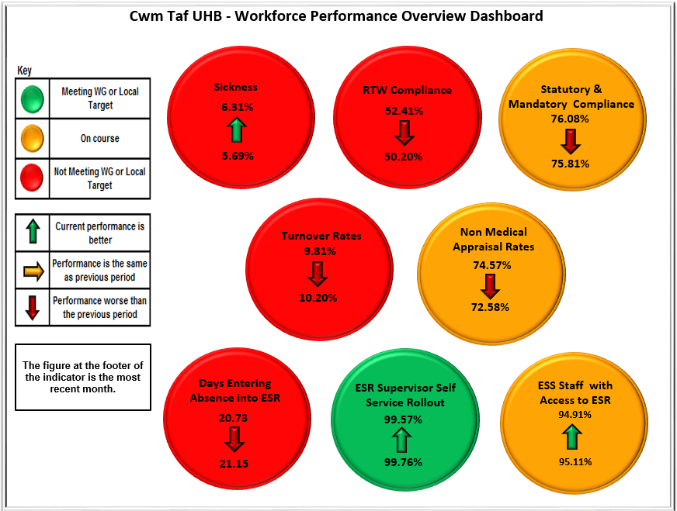
Key Points:
- The chart to the left provides a snapshot of performance against the 8 core metrics measured over a one month period - April 2019 (with sickness figures as at March 2019)
- The arrows signify improvement or deterioration since the last report and the colours represent whether we have met the Cwm Taf Morgannwg or Welsh Government targets
- You can see that of the 8 areas of activity:
- 3 have improved – ESR supervisor self-service rollout, sickness rates and staff with access to the Electronic Staff Record (ESR).
- 5 have deteriorated – Statutory and mandatory compliance, time to enter sickness onto the ESR, non-medical appraisal rates, turnover, and return to work compliance.

3 ASSESSMENT / GOVERNANCE AND RISK ISSUES

The report provides an update against 6 core activity areas with addition metrics in the appendices.
3.1 Resourcing and recruitment activity
3.2 Sickness absence
3.3 ESR and E-Systems roll out
3.4 Personal Development Review (PDR) and core mandatory training compliance
3.5 Workforce utilisation
3.6 Occupational Health and Wellbeing
3.7 Engagement

3.1 Resourcing and Recruitment Activity

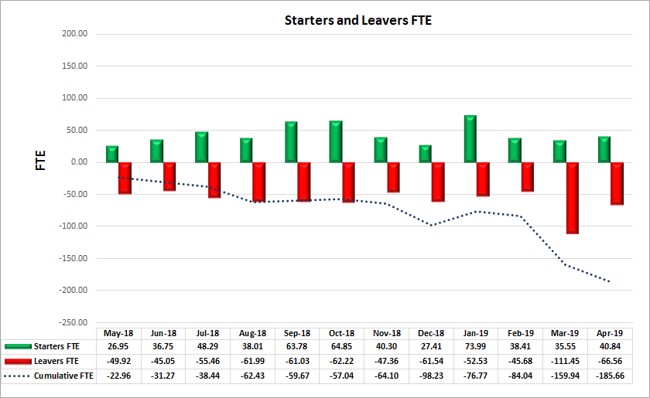
Key Points:
- Headcount at the end of April was 11,736 (10267.40 Whole Time Equivalent (WTE)) – this reflects boundary change
- Cumulative change in WTE was -185.66
- Rolling turnover increased at 10.20% - Additional Professional Scientific and Technical is our highest group at 13.70%
- See Appendix 1 for headcount by Directorate

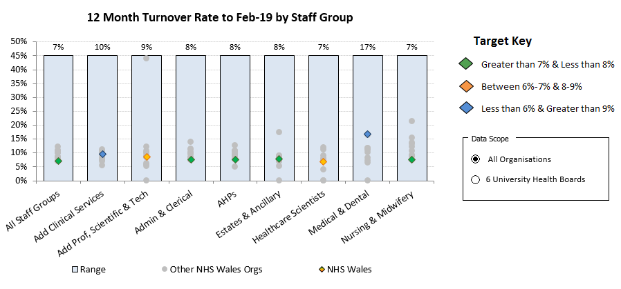
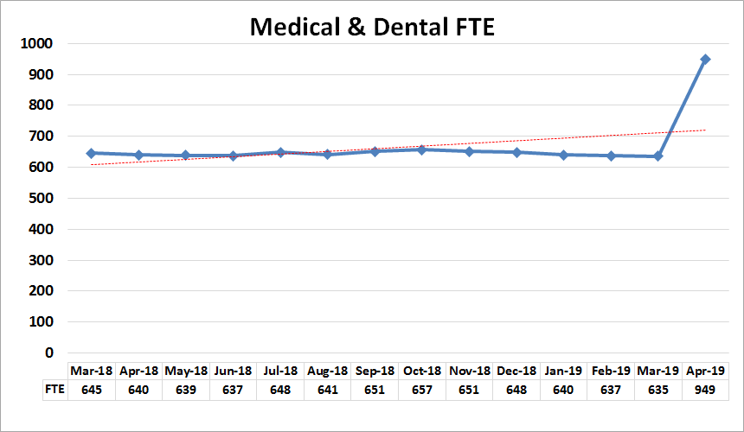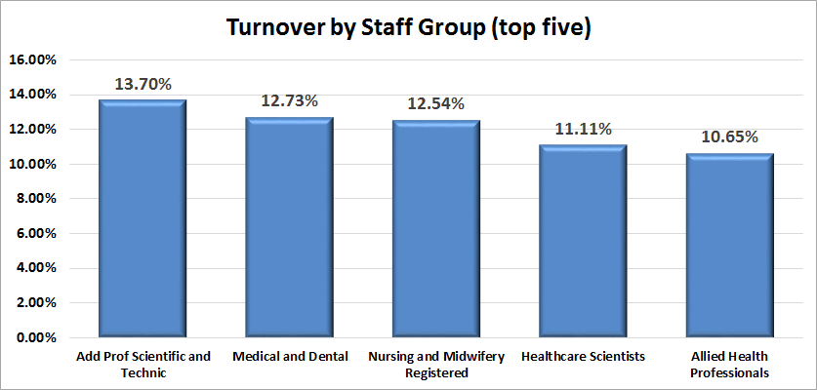
Key Points:
- See Appendix 1 for reasons for leaving for groups over 10%
- Nursing and midwifery remains significant with over 35% of our nurse leavers leaving due to retirement
- Additional Professional/Scientific/Technical, Medical and Dental, and Allied Health Professionals turnover has increased – promotion and retirement factor highly in the recorded reasons for leaving
- Second highest reason for turnover in several staff groups is noted as ‘not known/other’ on ESR however the termination form has been amended and no longer offers this option
- Medical and Dental
- Turnover does not including trainee rotations
- Slight decrease in Full Time Equivalents (FTE) staffing levels over the last month
- Since January 2018, offers of employment made to:
- 34 Consultants (inc. NHS Locums)
- 50 Middle grades
Nursing and Midwifery
Key Points:
- Nursing and Midwifery Registered staff vacancies – excluding Princess of Wales/Bridgend locality:
- 165 WTE in acute and community areas, including:
- 84 WTE at RGH - 15 international nurses preparing for registration
- 67 WTE at PCH
- 89.38 WTE other active Nursing and Midwifery vacancies
- Health Care Support Worker (HCSW) vacancies:
- Deficit at RGH – 33 WTE
- Deficit at PCH – 23 WTE
- HCSW recruitment continues to fill all current vacancies
- Adverts are running which cover the main acute areas, plus we have specialty-specific adverts running
- Details about maternity vacancies and recruitment are included in the Maternity update.
Key Points:
- The tender to re-commence international nurse recruitment has now been released – the initial shortlisting is due to happen in late May
- 9 international nurses currently working for us, all in receipt of Nursing and Midwifery Registration
- Further 10 individuals working towards being able to relocate, currently no indication as to when they are likely to pass the relevant exams
- Professional Practice/Adaptation
- 18 recruited
- 15 started in Royal Glamorgan Hospital (RGH) – all supported by the Practice Development Nurses and peer group
- 3 onboarding for Prince Charles Hospital (PCH)
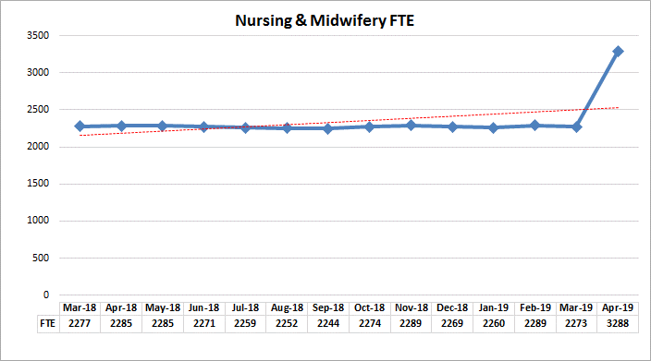

Efficiency of Recruitment Process
Cwm Taf Morgannwg is constantly monitoring its general recruitment performance, with key performance indicators (KPIs) produced on an all Wales basis every month. There are some key stages that can be readily controlled by the appointing managers, namely authorisation, shortlisting and notifying the outcomes of interviews.

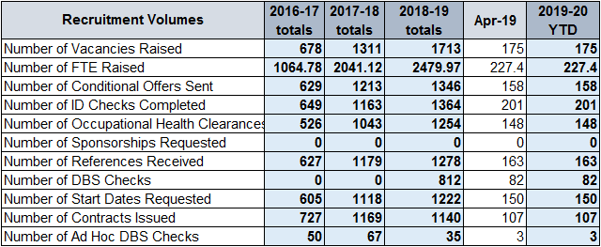
Key Points:
- See Appendix 1 for time to hire comparisons across Wales
- Trajectory is generally improving, and performance has improved through this year compared to last
- Vacancy authorisation and time to shortlist are key areas for improvement
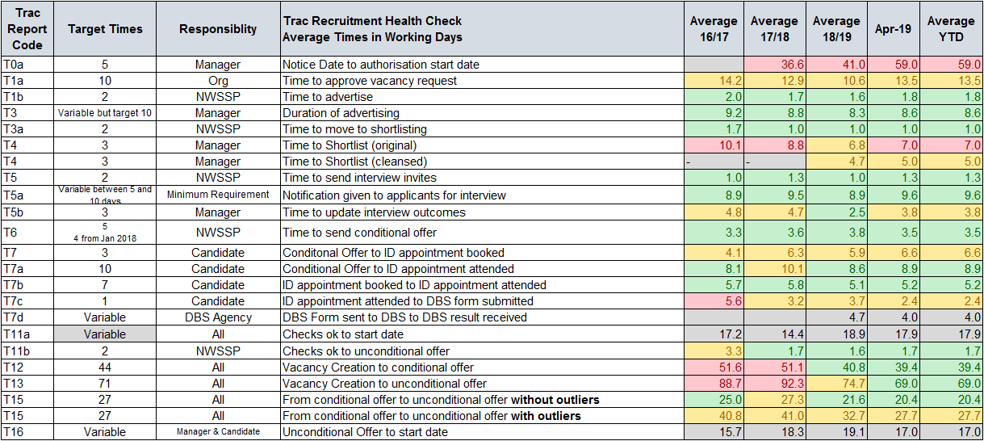

* 2016/17 figures only cover October 2016 to March 2017
  - Sickness Absence
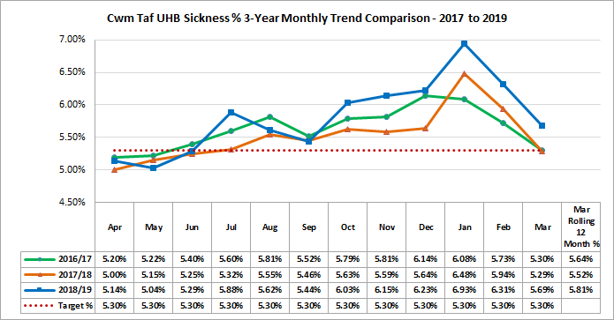
Key Points:
- Sickness has decreased to 5.69% in March 2019, with the rolling average over the past three years remaining at around 5.6/5.8%
- Training for the new Attendance Management Policy commenced in November and is being delivered in partnership. Schedule of dates agreed to 1 April 2019 with 6 sessions per month. Feedback on the training to date is positive, and Cwm Taf Morgannwg are leading the way with training in this area
- Anxiety, stress and depression remains the highest category of sickness absence (see the staff survey action plan)

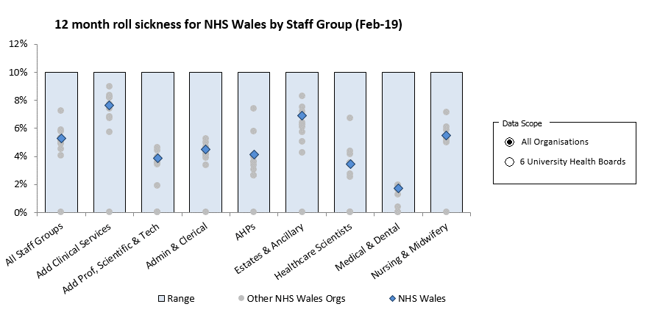

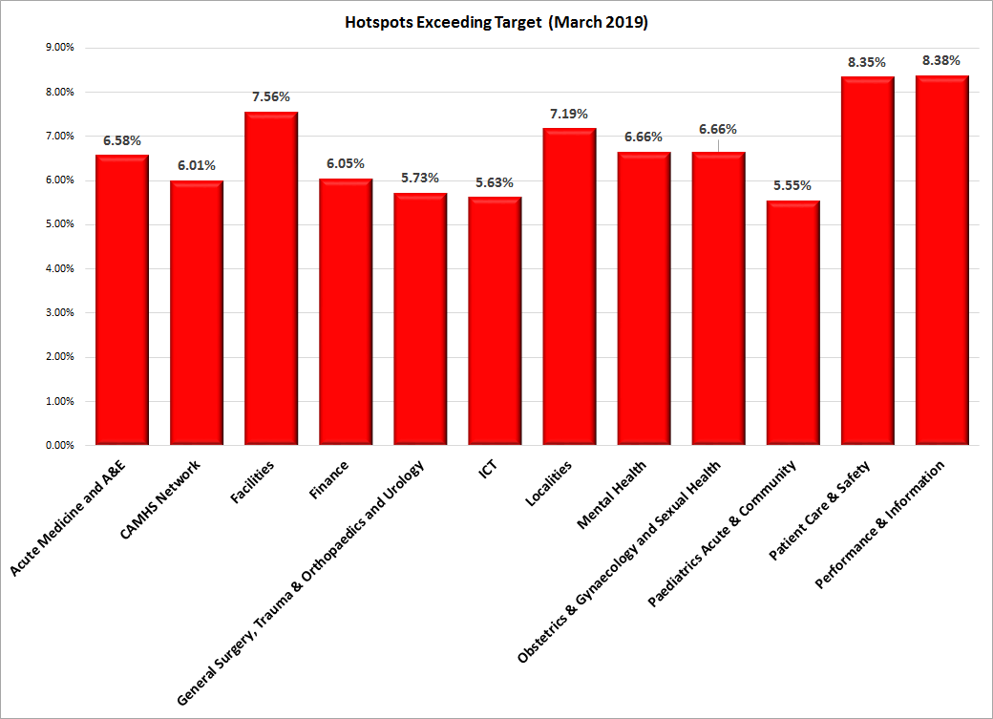
Key Points:
- 12 Directorates (last month there were 12) are above the 5% Cwm Taf Morgannwg target.
- 19 Directorates are below target
- Managing Attendance at Work policy training is continuing, with 20% of managers having undertaken the training to date
- Toolkit has been launched, intitial feedback from managers has been positive
- Health and Wellbeing prospectus has been implemented, which is a person centred, holistic approach to health and wellbeing
- Sickness absence data is scrutinised at monthly Clinical Business Meetings (CBMs) and at monthly nurse staffing meetings
- Frequency of short term occurrences has reduced since January 2019 (666 in March 2019 compared to 917 in January 2019)
- Trend on long term occurrences has increased since the start of the 12 month window (526 in March 2019 compared to 450 in April 2018)
- The emphasis of the new Attendance Management Policy is on prevention of illness and improving health and wellbeing, along with rapid access and early referral of staff to key services
- For additional details, please see Appendix 2
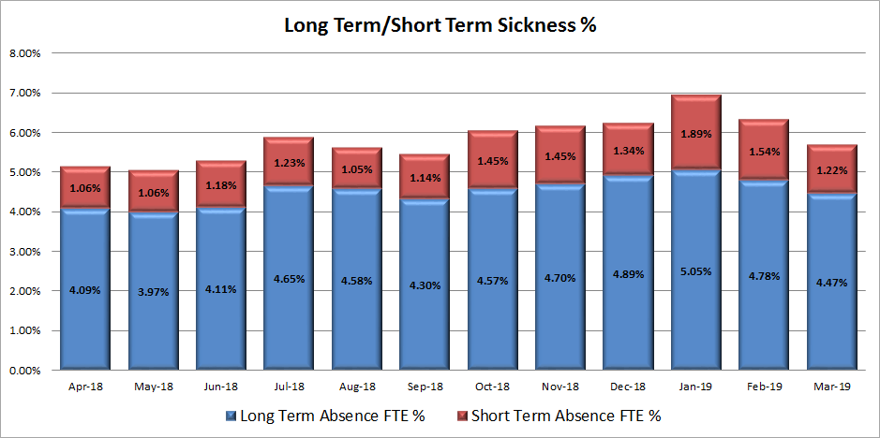

  - ESR and E Systems Roll Out
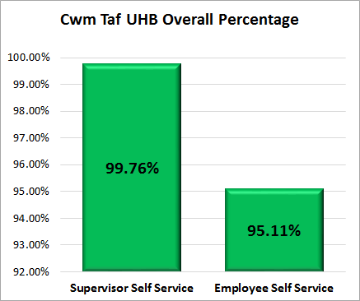
Key Points:
- 99.76% of employees are now managed by a manager with self service access, and 95.11% of employees have an active ESR Self Service account which shows a continuing increase
- 91.30% of employees are accessing their payslip electronically, with a plan in place to capture the remaining staff and target new employees (down from 91.79% in February).
- Please see Appendix 3 for the self service access levels over time
- The chart below provides the position for organisations across Wales, highlighting the majority of organisations exceeding 85% roll out of self service (at February 2019)
Key Points:
- An ESR rollout plan for Bridgend areas will be developed to include Supervisor Hierarchy Structures changes, Employee Self Service (ESR) and Manager\Supervisor Self Service, which will also require a robust staff training programme.
- The UHB is currently recruiting a Senior Workforce Information Officer to oversee this work and other e-enablement projects. The plan will be developed subject to any hierarchical changes that may arise as a result of organisational restructure.
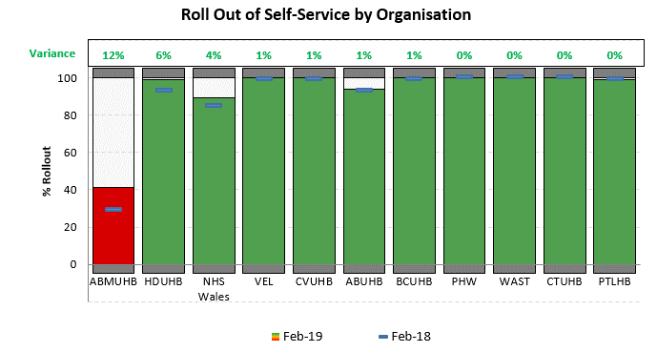
  - Personal Development Review (PDR) Compliance
Key Points:
- As at 1 April 2019 compliance is 73.31% which represents a decrease of 0.66% compared to the 1 March position of 73.97%.
- Cwm Taf Morgannwg are performing well on these metrics when benchmarked across Wales
- Of the Directorates, 3 are performing within the desired target range of 85-100%, 8 are in the 75% - 85% compliance range, and 19 are performing below 75%.
- Of the Directorates, 14 have either seen improvement or remained static in their compliance this month.
- Monthly reports are sent to CBMs and Directors on highlighting the outstanding PDRs. This is being supported by a continued focus from the Directors to ensure the improvement continues.
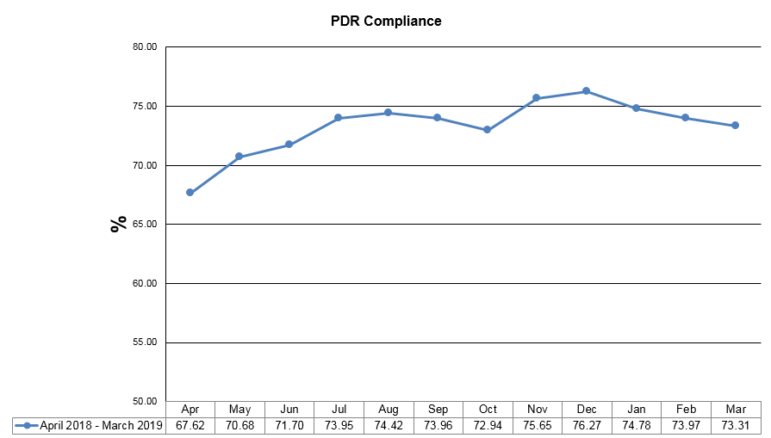
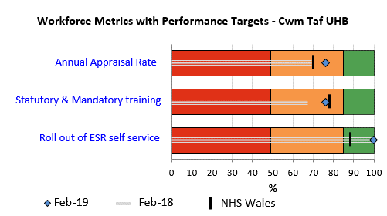

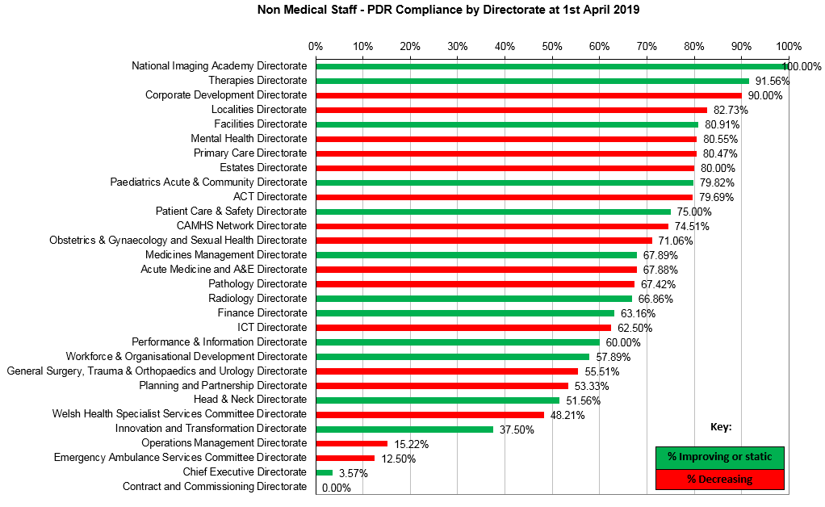
Key Points:
- Managers are continually encouraged to access Business Intelligence (BI) PDR Dashboards through their ESR Self Serve accounts allowing them to view a full set of up to date compliance for their areas
- Appraisal rates by staff group are in Appendix 3
- Learning and Development (L&D) provide a comprehensive suite of reports monthly to Directorate Managers providing the latest PDR compliance data, contextualising performance; what to do to improve compliance; and where to seek further help and guidance
- A shortened, non-accredited PDR Awareness training course for Managers is available.
- Statutory training compliance is slowly but steadily improving, both at level 1 and higher levels (figures at 1 March 2019).
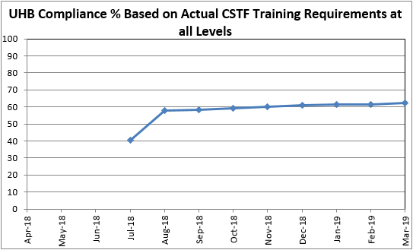
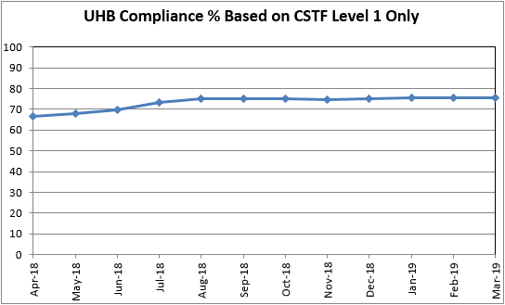

  - Workforce Utilisation
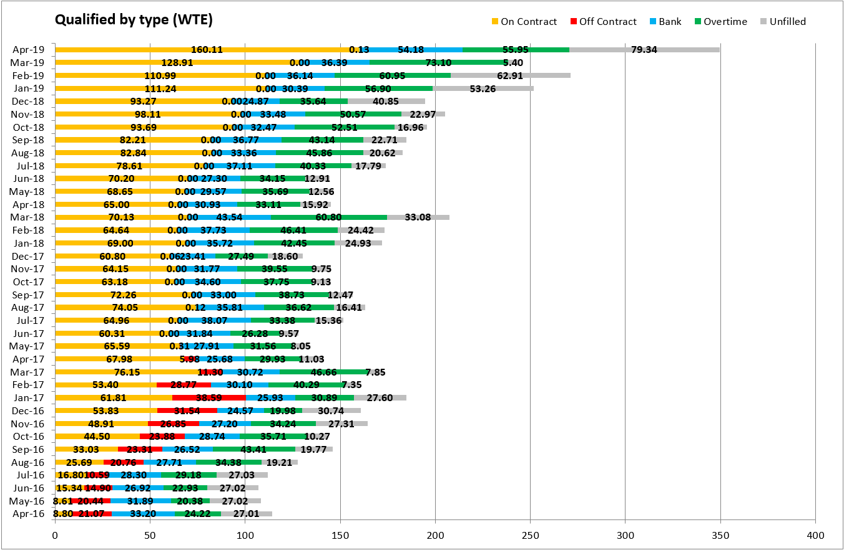
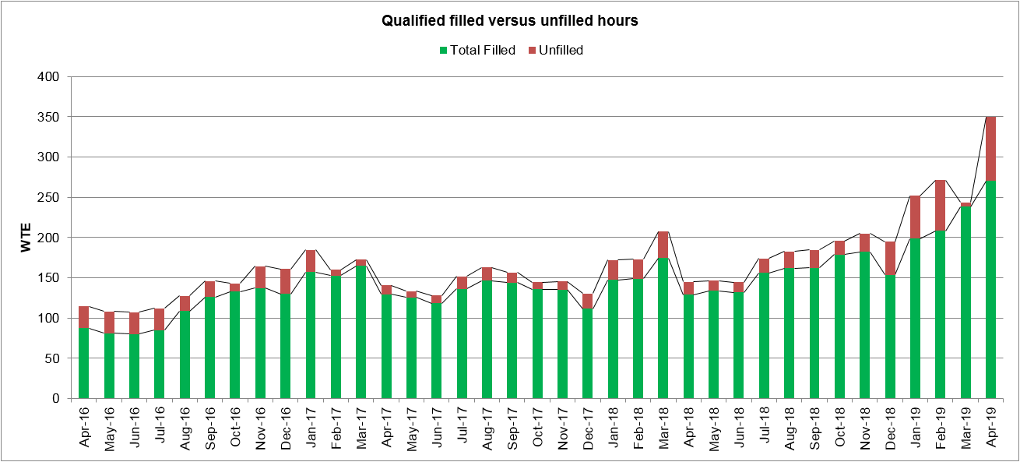
Registered Nurse Temporary Staffing Demand and Supply
Key Points:
- Winter pressures impact is ongoing
- External (agency) supply continues to exceed internal (bank and overtime) supply
- March had the lowest unfilled rate to date – this was largely due to rosters being open and released earlier due to the transition down time
- Top 3 areas for demand:
- Emergency Department POW (12.32 WTE)
- PCH Intensive Treatment Unit (ITU) (11.88 WTE)
- RGH A&E (11.25 WTE)
- Data now includes the Bridgend County Borough Council (CBC) area services
- Information about the reasons for these 3 areas is in Appendix 4
- In addition to ongoing recruitment activity, work will be undertaken to review rostering arrangements to ensure roster patterns are optimum
Healthcare Support Worker (HCSW) Temporary Staffing Demand and Supply

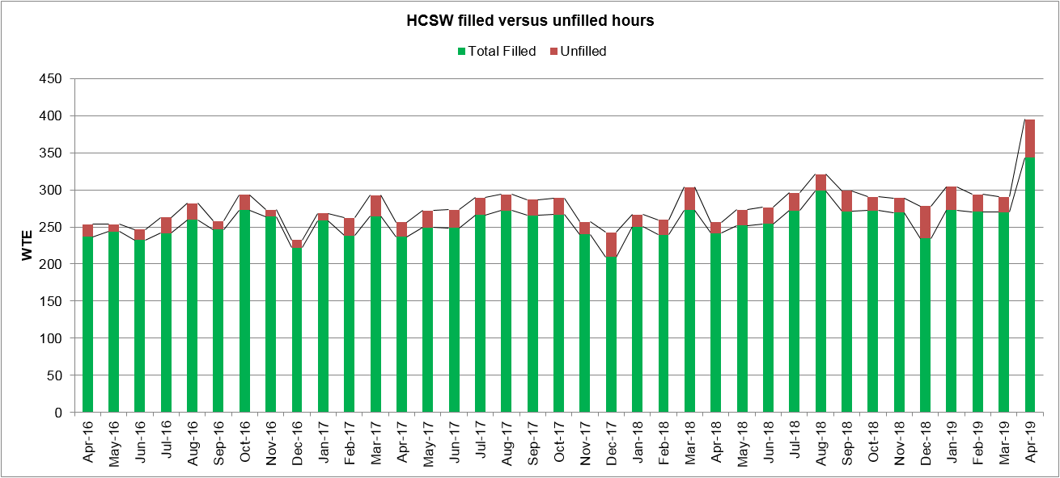
Key Points:
- Demand remains high, April now includes the Bridgend CBC area services
- Top 3 areas for demand:
- Ysbyty Cwm Rhondda (YCR) Ward A1 (21.59 WTE)
- PCH Clinical Dependency Unit (CDU) (13.50 WTE)
- CAMHS Enfys Ward (12.07 WTE)
- Information about the reasons for these 3 areas is in Appendix 4
- YCR Ward A1 has been in the top 3 for the last 6 months due to a requirement for increased supervision
- The demand for HCSW is primarily due to sickness, supervision, acuity levels, and vacancies on the wards.
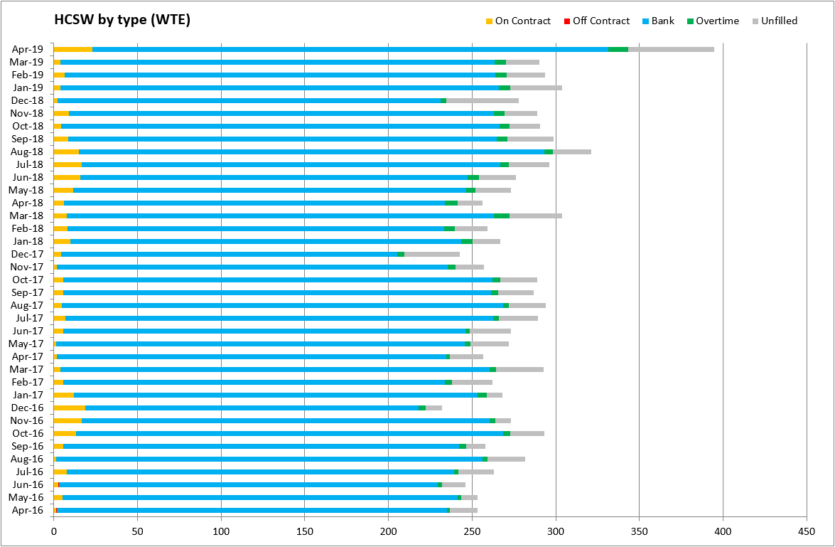
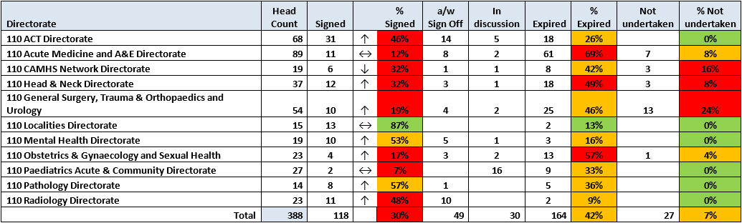
Job Planning
Key Points:
- Several job plan review meetings have taking place in April resulting in the number of expired job plans dropping from 200 to 164. The Job Planning Administration will continue to liaise with Directorates and Human Resource Business Partners (HRBPs) monthly to track continued progress.
- 7 Directorates have increased their percentage of job plans being signed off. This is the result of the Job Planning team and Directorate Managers (DMs) working closely together. A validation exercise of starters and leavers is also routinely undertaken to ensure the data is accurate.
- CAMHS - The percentage of signed off job plans has dropped, as several doctors whose job plans were complete and signed off were removed from the system following TUPE process to Cardiff and Vale UHB in April.
- Paediatrics-Job Plan statistics remain the same due to the ongoing issues with the job plans for new consultants.
- Anaesthetics - The Directorate continue to make progress, with nearly 50% of their job plans signed off. They have 18 SAS job plans which have expired and aim to have these undertaken and in the sign off process by the end of May.
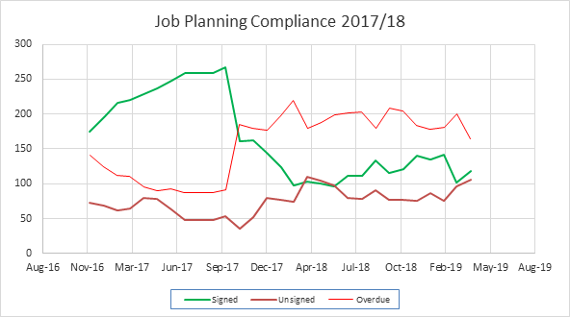

Key Points:
- Acute Medicine & A&E - The Directorate continues to make progress with their job plans, and have provided a concise schedule of when they aim to undertake job plans. The DM has been in regular contact with the department and a validation exercise of starters and leavers has been undertaken to update the system. The Directorate Administrator for Emergency Medicine has also received training on the system to support the inputting of information during the job plan reviews.
- Obstetrics & Gynaecology (O&G) and Sexual Health - Slight increase in the Directorate percentage. Job Planning administration are still awaiting a date to meet with the DM to devise a schedule for all outstanding job plans.
- General Surgery, Urology & Trauma & Orthopaedics (T&O) - Continued issues with rotas and Getting it Right First Time (GIRFT) programme have stopped several job plans from being undertaken, therefore affecting the Directorates figures. However the department are making a concerted effect to undertake job plans where there are no issues.
- Radiology - The Directorate continue to make progress with nearly 50% of their job plans now signed off and a further 10 awaiting sign off and only 2 job plans that have expired.
- Head & Neck - Progress continues to be made and the DM is aware of the expired job plans and these are to be addressed as soon as possible.
- Mental Health - The Directorate has worked very closely with the Job Planning team which has resulted in over 50% of job plans being signed off, a further 5 awaiting sign off and no expired job plans.

  - Occupational Health and Wellbeing

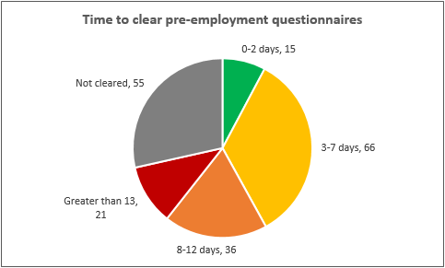
To increase visibility of the activity levels and performance of the Occupational Health and Wellbeing function, key performance indicators are now being reported (trend analysis will be added once there is sufficient data) – below is the March position:
Current Waiting list
Speciality | Next available appointment (weeks)
Occupational Health Physician | 10 weeks
Occupational Health Advisers | 10 weeks
Occupational Health Nurse Screening Assessor | 2 weeks
Physiotherapy  - Case manager appts  - Other | 12 weeks  Self referrals – 2-3 weeks
Counselling | 16 weeks
Clinical Psychologist | 8 weeks (telephone screening)

Key Points:
- The Department has seen 196 pre-employment health questionnaires, the chart to the left shows the time to clear (and the number not yet cleared)
- Of the 55 forms not cleared as at the end of March, 35 have not been processed 16 are awaiting nurse clearance, 1 is awaiting doctor clearance and 1 is waiting for a response
- Waiting lists as at start of March are detailed above by specialty
- For February to March, Did Not Attend (DNA) rates for the following decreased:
- Occupational Health Advisors from 29% in February to 26% in March
- Clinical Psychologist from 23% in February to 24% in March
- Physiotherapy Case Manager appointments from 22% in February to 18% in March
- The DNA rate for the Clinical Psychologist went from 23% in February to 24% in March
- Recruitment plans are underway to fill vacancies and the service is looking to improve access routes to the physiotherapists, including telephone triage for line manager referrals

  - Staff Survey

Organisational progress is monitored via the Staff Survey Steering Group which meets monthly and is chaired by the Deputy Director of Workforce and Organisational Development. The organisational action plan is being progressed in line with their target delivery dates.

To date 131 staff have attended dignity at work awareness training this year, 67 have attended the Stress Management in the Workplace course, and we have 8 people currently attending the Team Care Engagement Programme. Also, there have been 23 participants on the Mindfulness Based Living Course. The next course is full with 12 participants and we have 8 on the waiting list. We continue to monitor uptake of training, working alongside HR business partner teams to identify staff or areas of need.

HR Business Partner teams are working closely with Directorate managers to progress localised staff survey action plans monitored at Clinical/corporate Business Meetings, informed by staff survey data, engagement champions and staff input. Progress against these plans are captured monthly through the steering group, and any necessary support or progress these may need is discussed and agreed.

Monthly staff survey newsletter commenced in March 2019, and we continue to work with communications to share good news stories and updates against the action plan.

Engagement Champions continue to meet monthly, interest has grown for these roles and we currently have over 40 staff involved across all directorates of Cwm Taf Morgannwg. Engagement champions help support the work of the staff survey activating two way communication between staff and the Staff Survey steering group.

Tackling Harassment, Bullying and Abuse

The 2018 NHS Staff Survey, results showed that 24% of Cwm Taf staff felt they have experienced harassment, bullying or abuse (HBA) at work from patients / service users, their relatives or other members of the public. As a result tackling HBA in Cwm Taf Morgannwg was identified as one of the primary areas of focus for action, and an important issue that needed to be taken seriously.

It was crucial that senior stakeholders were involved in this work and the first step was for senior members of the Board, to sign the Call for Action which demonstates Cwm Taf Morgannwg are serious about tackling HBA head on. Dilys Jouvenat (Independent Member) has agreed to act as Board Champion, and will provide a close link to the Board.

Secondly, a clear and robust action plan has been designed to support tackling bullying, harassment and abuse in partnership with staff side colleagues.

A steering group chaired by Dilys Jouvenat is being established to ensure correct governance of this work and to ensure meaningful and decisive action is taken and monitored. This will work in conjunction with the wider staff survey steering group and associated work streams.

The Call for Action is our commitment to work in partnership to create a positive workplace culture and tackle bullying. We will report progress through the Cwm Taf Morgannwg, Working in Partnership Forum and update the Social Partnership Forum (UK), with our learning, action plan highlights and progress. Essentially the Call for Action approach will encompass four key focuses that Cwm Taf Morgannwg pledges to uphold.

- We will foster a culture of inclusive and compassionate leadership, with a zero tolerance approach to bullying & harassment.
- We will tackle bullying in partnership with staff side.
- We will support staff to respectfully challenge problem behaviours.
- We will publish action plans and progress so staff, patients and the public can hold Cwm Taf Morgannwg to account.
The Call for Action was signed by the following, at the most recent Board Meeting on 25 April 2019:
- Chief Executive – Allison Williams
- Chair – Marcus Longley
- Director of Workforce & OD – Joanna Davies
- Independent Board Member and Chair of the HBA Steering Group – Dilys Jouvenat
- Chair of Staff Side (Unison) at Cwm Taf Morgannwg – Ian Cathrew

4. RECOMMENDATION

The Health Board is asked to:

- DISCUSS the report and associated metrics and report and NOTE the detail.

Freedom of Information Status | Open

Appendix 1 – Resourcing and Recruitment

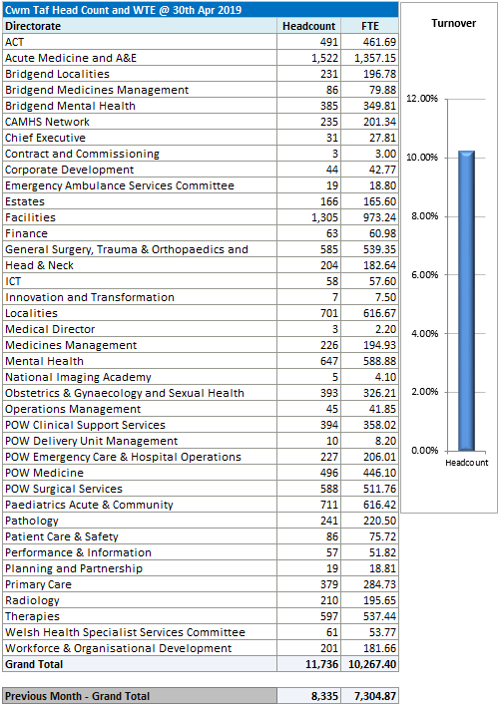

Turnover and Reasons for Leaving (Leaving date between May-18 and Apr-19)

Efficiency of the Recruitment Process – General Recruitment Comparison across Wales
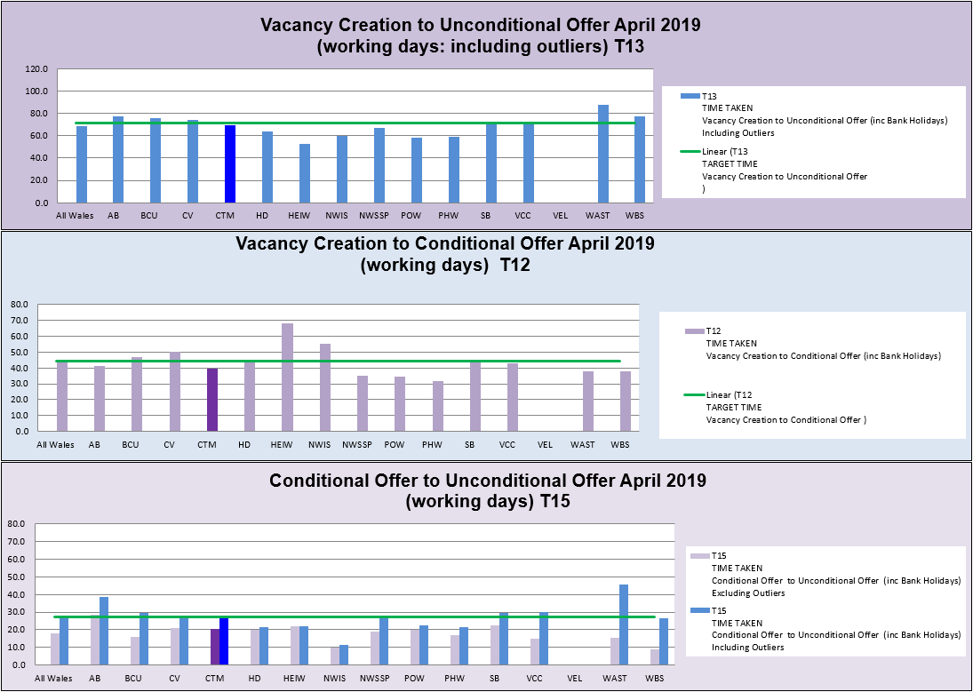

Appendix 2 – Sickness Absence

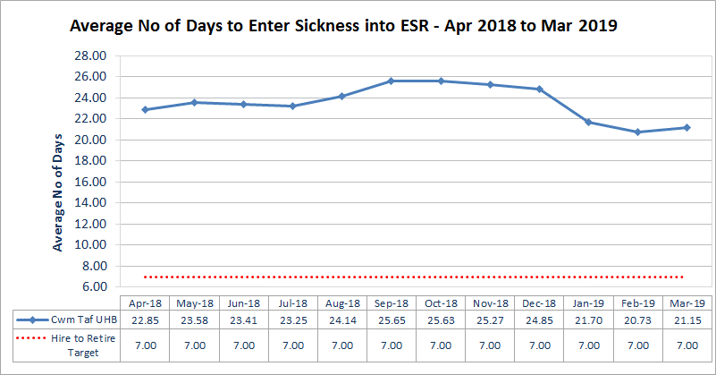

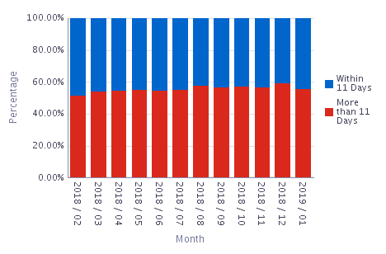
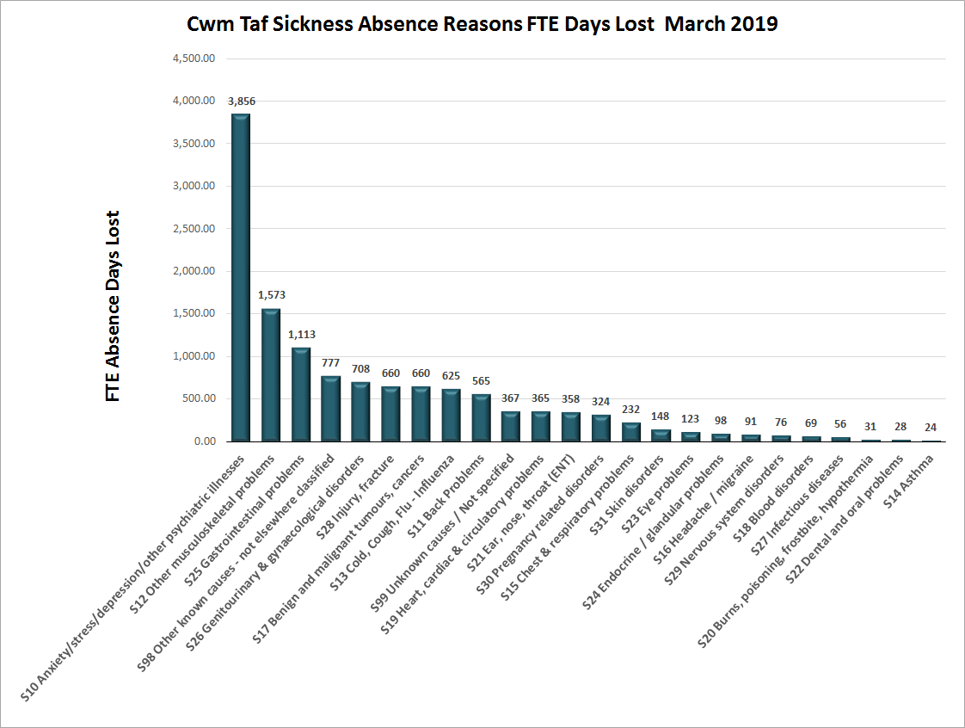

Appendix 3 – ESR and e-Systems

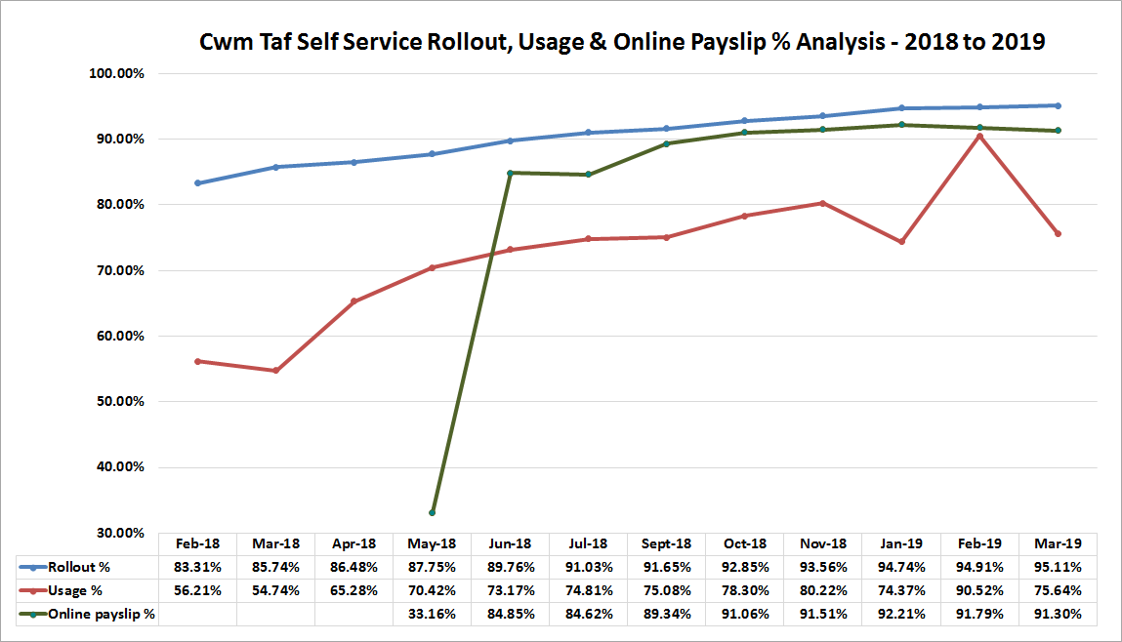

Appraisal Rates by Staff Group

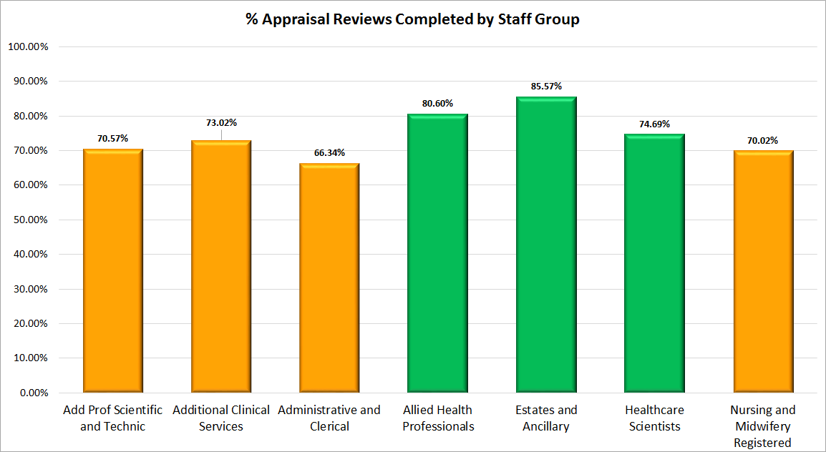

Appendix 4 – Reasons for Temporary Staffing Demand

Registered Nurses (top 3 areas)

Emergency Dept POW | PCH ITU | RGH A&E
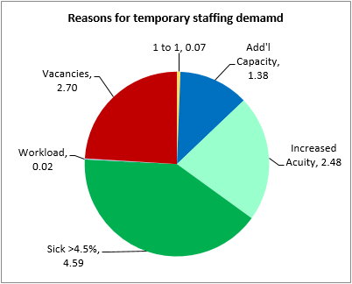
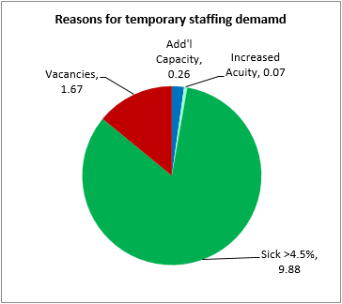
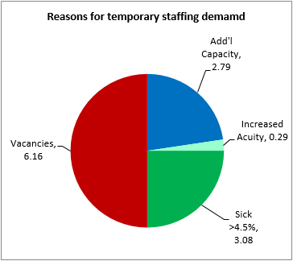

Healthcare Support Workers (top 3 areas)

YCR Ward A1 | PCH CDU | CAMHS Enfys Ward
