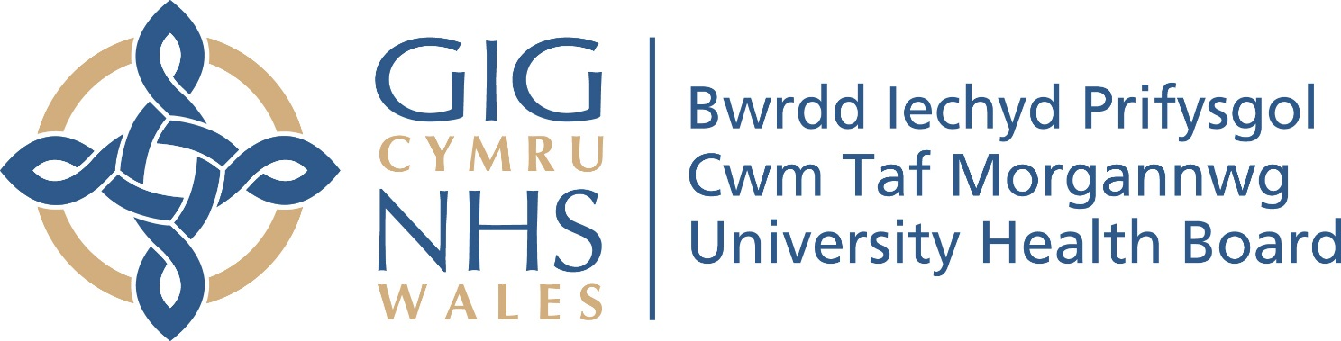

COMMUNICATION
&
ENGAGEMENT
PLAN
2019-2020

CWM TAF MORGANNWG UHB INTEGRATED MEDIUM TERM PLAN
2020-2023

NOVEMBER 2019

COMMUNICATION & ENGAGEMENT PLAN 2019-2020

Purpose

The purpose of this plan is to ensure that stakeholders are engaged in the update of the UHB’s Integrated Medium Term Plan (IMTP) for 2020-2023. Robust engagement will ensure that the purpose of the Plan is understood and that its priorities have been influenced by all those who have an interest in them. The resulting plan should therefore be more reflective of the views of our staff, our service users, their carers, public and our partner agencies.

Stakeholders

An analysis of internal and external stakeholders, ie those deemed to have a particular interest in the plan, has been undertaken in order to determine how best their views can be captured (see table below). Key stakeholders serving and residing in Bridgend, Merthyr Tydfil and Rhondda Cynon Taf areas will be engaged on the development of the IMTP.

Method

General updates on progress and key messages will be communicated on a regular basis via the Chief Executive’s Blog and other communication mechanisms.

Background documentation will be made available for staff to view on the intranet (SharePoint).

In addition, staff have the ability to raise questions or make comments via their usual departmental / directorate meetings or through the ‘Grapevine’ on SharePoint.

More focused discussion will take place in the following groups:

Group | Stakeholders | Lead | Dates | Status
Integrated Planning Group | Internal - Reference Group | Assistant Director of Planning & Partnerships | 22-Oct-19  19-Nov-19  17-Dec-19  21-Jan-19  18-Feb-19  17-Mar-19 | Completed
Cwm Taf University Health Board | Internal –  Board Members | Director of Planning & Performance, Director of Finance & Director of Workforce & Organisational Development | 31-Jul-19  26-Sep-19  28-Nov-19  30-Jan-20  (consider and approve Final draft IMTP) | Completed  Completed
Executive / Management Board | Internal – Executive Directors & Associate Members | Director of Finance, Director of Planning & Performance & Director of W&OD | 18-Sep-19 (to confirm IMTP process for 2020-23)  23-Oct-19  (progress report)  18-Dec-19 (Final draft IMTP presented)  15-Jan-20 (Final draft IMTP)
Quality, Safety & Risk Committee | Internal | Assistant Director of Planning & Partnerships | 5-Nov-19  10-Dec-19  14-Jan-20 | Completed
Finance, Performance & Workforce Committee | Internal scrutiny – Independent Board Members | Director of Finance / Director of Planning & Performance / Director of Workforce & Organisational Development | 24-Oct-19  21-Nov-19  21-Jan-20 (scrutiny of the Final draft IMTP) | Completed  Completed
Launch of the UHB’s Local Planning Framework 2019/20 | Internal – Exec Directors, Assistant Directors, Directorate Teams & Business Partners | Director of Planning & Performance | 21-Oct-19  11-Nov-19
Medical Leadership Forum | Internal – Senior Medical Staff | Medical Director  Director of Therapies | 27-Nov-19
Local Medical Committee (LMC) | External – Primary Care | Director of PCMH, Director of W&OD | 15-Jan-20
Cwm Taf Morgannwg Community Health Council Service Planning Committee | External – Independent CHC Members | Director of Planning & Performance/ Assistant Director – Planning & Partnerships | 27-Jan-19
Stakeholder Reference Group | Internal – Lay Reference Group | Director of Planning & Performance/ Assistant Director – Planning & Partnerships | 10-Oct-19 | Completed
Working in Partnership Forum | Internal – Staff Side | Director of Planning & Performance, Director of Finance & Director of Workforce & Organisational Development
Cwm Taf Morgannwg Regional Partnership Board | External – Partner Agencies | Director of Planning & Performance/ Assistant Director - Partnerships | 16-Jan-20
Cwm Taf Morgannwg Public Service Board | External – Partner Agencies | Director of Public Health | 25-Feb-20
Public Fora | External – citizen engagement | Director of Planning & Performance, Director of Finance & Director of Workforce & Organisational Development | 6-Feb-20  10-Feb-20  11-Feb-20  18-Feb-20  19-Feb-20  (provisional dates to be confirmed)

These sessions will generally take the form of a standard presentation (covering purpose, process, priorities and challenges), followed by questions and discussion.

Feedback

Any views / comments received via the forums mentioned above, through email to lead Executive Directors or via the Grapevine will be collated, analysed and used to influence and inform the final iteration of the Plan.

