AGENDA ITEM
(4.7)

CTM Board

Workforce and organisational development metrics

Date of meeting | 21 November 2019

FOI Status | Open/Public

If closed please indicate reason | Not Applicable - Public Report

Prepared by | Hywel Daniel, Deputy Director of Workforce and Organisational Development (OD)
Presented by | Anne Phillimore, Director of Workforce and OD
Approving Executive Sponsor | Executive Director of Workforce & Organisational Development

Report purpose | FOR NOTING

Engagement (internal/external) undertaken to date (including receipt/consideration at Committee/group)
Committee/Group/Individuals | Date | Outcome
Management Board | 20/11/2019 | NOTED
Finance, Performance & Workforce Committee | 21/11/2019 | NOTED

ACRONYMS
WTE | Whole Time Equivalent
WG | Welsh Government

- SITUATION/BACKGROUND
To update the Committee on the key workforce metrics for September/October 2019, with historic trends shown as appropriate.

- SPECIFIC MATTERS FOR CONSIDERATION BY THIS MEETING

The following narrative describes the high and low lights of the current workforce metrics, as contained within the appendix.

  - What’s gone well

Topic: Medical and dental staffing levels have increased by 21 WTE in the period May-October 2019.
Reason: The Medical Workforce team have seen an increase in recruitment activity across the Health Board, in particular the number of Junior and Senior Clinical Fellows being advertised, which has led to a corresponding increase in the number of offers being made.

Topic: Medical appraisal
Reason: Following the Boundary change in April 2019, the total Doctors required to undertake appraisals increased by 50% of our previous figure. Despite this increase, through forward planning with the Revalidation team at Swansea Bay UHB, Cwm Taf Morgannwg UHB put measures in place to ensure continued engagement and standards in revalidation and appraisal, which is reflected in our monthly, quarterly and comparison figures. In September 2019, the Health Board underwent a Quality Assurance Review by the Revalidation Support Unit on behalf of WG. Although the final report has not been distributed, the initial feedback on the day was positive and reassuring; with areas of note being our robust structures, comprehensive quality assurance processes and a consistent message throughout the Health Board.

  - Areas for Improvement

Issue: Sickness absence continues to be high
Plan: The Health Board continues to deliver the Managing Attendance training, with attendance by line managers and supervisors now around 50%. In addition, to support staff and managers, a Wellbeing Support Directory has been developed, including a range of Health Board services, and NHS approved/third sector services. Work is underway to break down the category of stress to highlight work related stress, and allow positive action to be taken to reduce the impact on individuals.
A Consultant Clinical Psychologist has also been appointed, when in post one of their priorities will be the organisation’s approach to wellbeing. Self-referral times for physiotherapy have improved (musculo-skeletal illnesses are the second highest reason for sickness), and the Health Board is currently working to provide dietetic sessions based on the FODMAP diet (gastrointestinal disorders is the third highest reason for sickness).

Issue: Nursing turnover remains high, with the year to the end of September showing 11.68% turnover
Plan: Nursing Workforce Group have established workstreams to underpin retention. These groups include those focused on career development, recruitment, temporary staffing use, and health and wellbeing. This will also include further work around exit interviews which is particularly low with only 26 received. Additional communications and prompts are also being progressed to ensure timely reminders for managers to ask staff to complete these.

Issue: Job Planning – whilst the number of signed job plans has increased, the overall percentage is well below the expected level
Plan: Following the internal audit review on job planning, refreshed training and guidance is being developed and rolled out across the Health Board. In particular, the medical and dental staff in Princess of Wales will shortly receive training on how to use the E-Job Planning system.

Issue: Nursing: Demand for temporary staff continues to remain high with the majority of registered shifts being filled through agencies, including the off-contract, high cost agency, Thornbury.
Plan: Overseas recruitment is well underway with a current pipeline of 63, with plans to increase this with a recruitment visit to India. Collaborative Bank is still being scoped with Shared Services, once live this will provide the opportunity to pay registered nurses by weekly pay, which may increase the uptake for bank, including Swansea Bay nurses.

- IMPACT ASSESSMENT

Quality/Safety/Patient Experience implications | Yes (Please see detail below)
Quality/Safety/Patient Experience implications | The quality, safety, patient experience implications result from the availability of the right staff being available with the right skills, at the right place and time to deliver effective safe patient care.
Related Health and Care standard(s) | Staff and Resources
Related Health and Care standard(s) | Staying Healthy  Safe Care  Effective Care  Dignified Care  Timely Care  Individual Care
Equality impact assessment completed | Not required
Legal implications / impact | There are no specific legal implications related to the activity outlined in this report.
Resource (Capital/Revenue £/Workforce) implications /  Impact | There is no direct impact on resources as a result of the activity outlined in this report.
Link to Main Strategic Objective | To Improve Quality, Safety & Patient Experience
Link to Main WBFG Act Objective | Provide high quality care as locally as possible wherever it is safe and sustainable

- RECOMMENDATION

- DISCUSS the report and associated metrics and NOTE the detail.
- IDENTIFY any areas for further consideration or more detailed examination. Sickness absence has been considered via a deep dive recently, Workforce & OD suggest statutory and mandatory training. Mandatory training compliance has dipped in recent months to 60.94% at the start of November.

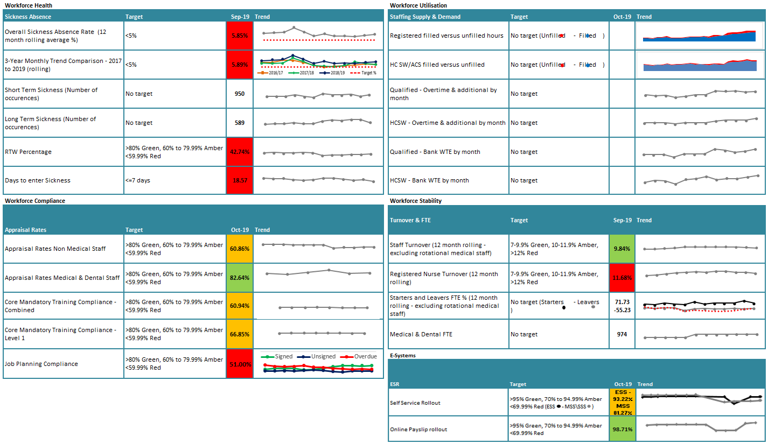
Appendix
