AGENDA ITEM
4.6

CTM Board

INTEGRATED PERFORMANCE DASHBOARD

Date of meeting | (28/11/2019)

FOI Status | Open/Public

If closed please indicate reason | Choose an item.

Prepared by | Alan Roderick, Assistant Director of Performance & Information
Presented by | Ruth Treharne, Executive Director of Planning & Performance
Approving Executive Sponsor | Executive Director of Planning & Performance

Report purpose | FOR DISCUSSION / REVIEW

Engagement (internal/external) undertaken to date (including receipt/consideration at Committee/group)
Committee/Group/Individuals | Date | Outcome
Finance, Performance & Workforce Committee | 21/11/2019 | NOTED

ACRONYMS
RTT  FUNB  DTOC  PMO  PCH  RGH  CT  POW  YCC  YCR  CTM  IMTP  HMRC  NUSC  USC  SCP  SSNAP  QIM  CAMHS  p-CAMHS  s-CAMHS | Referral to Treatment  Follow Ups Not Booked  Delayed Transfers of Care  Programme Management Office  Prince Charles Hospital  Royal Glamorgan Hospital  Cwm Taf  Princess of Wales  Ysbyty Cwm Cynon  Ysbyty Cwm Rhondda  Cwm Taf Morgannwg  Integrated Medium Term Plan  HM Revenue & Customs  Non Urgent Suspected Cancer  Urgent Suspected Cancer  Single Cancer Pathway  Sentinel Stroke National Audit Programme  Quality Improvement Measures  Child and Adolescent Mental Health Services  Primary Child and Adolescent Mental Health Services  Specialist Child and Adolescent Mental Health Services

- SITUATION/BACKGROUND

  - The purpose of this report is to provide the Board with a summary of performance against a number of key quality and performance indicators, including areas where the organisation has made significant improvements or has particular challenges, together with areas where the Health Board is under formal escalation measures from the Welsh Government and/or where local progress is being monitored.

  - Following the boundary change on 1 April 2019 the Health Board continues to work closely with Swansea Bay University Health Board and the Delivery Unit in terms of ensuring the robustness of available data, appropriate data splits, application of the correct rules and appropriate presentation of the new, integrated data for the organisation. The Delivery Unit is supporting the work and Welsh Government are being kept informed of the work as it develops.

  - The Integrated Performance Dashboard is attached as Appendix 1.

  - The Board is requested to DISCUSS and REVIEW the contents of the report and the supporting actions to improve the achievement of national and local targets. This month, there is a further update on the work being undertaken on the potentially unreported waiting lists, as referenced previously.

  - The report provides the Board with an update on progress across a number of key quality and performance targets and specifically including those set out in the National Performance Outcomes Framework. The report also sets out any issues affecting performance and associated actions underway to secure improvement.

SUMMARY
  - The following provides a high level summary, bringing to the fore any changes to note since the previous report and/or where performance is deviating either from expected levels based on recent experience or from agreed trajectories. Unless noted otherwise, all points below refer to October 2019.

  - Unreported waiting lists - 32 unreported waiting lists are now being reported as part of RTT. With 1822 patients in total originally added to the RTT position, 420 over 36 weeks and 239 of these over 52 weeks. Further specialties have been added during October which has increased the total to 1926 although these additional services have not impacted on the 36 and 52 week position, which have respectively reduced to 185 over 36 weeks from 210 and 73 over 52 weeks, reduction of one. The UHB's quality team continues to be kept appraised of progress, with any potential risks identified within these patient cohorts being reported via the Datix incident reporting system, with appropriate, immediate actions being taken to mitigate any potential harm.

  - The RTT position is off trajectory, in part because of the unreported waiting list issue, but also because the core waiting lists are still above planned levels. The main focus of the directorates is to reduce the overall numbers of patients currently waiting over 52 weeks with plans for treating the longest waiting patients in each of their specialties.

  - The endoscopy surveillance position continues to improve as a result of additional capacity being created through an insourced service.

  - FUNB for the former Cwm Taf footprint continues to improve, although numbers still remain high. Work is required to allow the Bridgend footprint to be reported in a similar way.

  - Cancellations - there were 52 elective ward cancellations (an increase of 14) and 2 theatre cancellations due to an anaesthetist being unavailable, a reduction of 6.

  - Unscheduled care targets for the 4 hour target and 12 hour breaches remain challenging, as well as the 15 minute handover target from ambulance to A&E. Ambulance response times were met for red calls, with the deteriorating trend seen since April 2019 being reversed, albeit compliance remains lower than it was in April 2019.

  - DTOC position has deteriorated during October to 74 from 61, with the largest increases seen in Acute and Community services.

  - Neither of the cancer targets were met September, with 5 breaches of the 31 day NUSC target and 24 breaches of the 62 day USC target. Whilst there is not a specific target set for the single cancer pathway, whilst not having a target set, performance "with suspensions" reduced by 3% to 74%, whilst performance "without suspensions" reduced by 6% to 62%.

  - Stroke data for October is not available for this report, so the September position is reported which shows the quality improvement measures. Two key indicators show reduced compliance in September, direct admissions to a Stroke Unit within 4 hours and patients assesses within 24 hours by a specialist consultant physician.

  - Compliance against Part 1(a) of the Mental Health Measure increase to 67.7% in September, though remains below the target of 80%. Compliance against Part 1(b) deteriorated marginally to 88.9%, but remains above the target of 80%. The target is being met for adults. The Part 2 target of 90% of Care Treatment Plans completed at the end of each month was achieved in September at 91.6%. There were 2 assessments carried out during September for the part 3 measure, with the target being met for both.

  - The Neurodevelopmental target of 80% of patients seen in 26 weeks is not being achieved and remains below 70%. However waiting times for Specialist CAMHS continues to improve, rising to 88.1% in October.

- SPECIFIC MATTERS FOR CONSIDERATION BY THIS MEETING (ASSESSMENT)

• Referral to Treatment Times (RTT) – Executive Leads: Chief Operating Officer and Director of Primary, Community and Mental Health.
  - The RTT element of the unreported waiting list review has now been completed. A small number of extra services have been added to RTT reporting since last month’s report which completes this RTT element of the review.

  - The following table is the full list of waiting lists that will now be included within the RTT reporting processes. The figures shown are as at 31st October 2019, prior to any further month end validation before October data is submitted to the Welsh Government for reporting purposes.

RTT additional reported waiting lists
(Total number of patients waiting >36 weeks is 185 as at 4th November 2019
Previously 210 as at 8th October 2019)
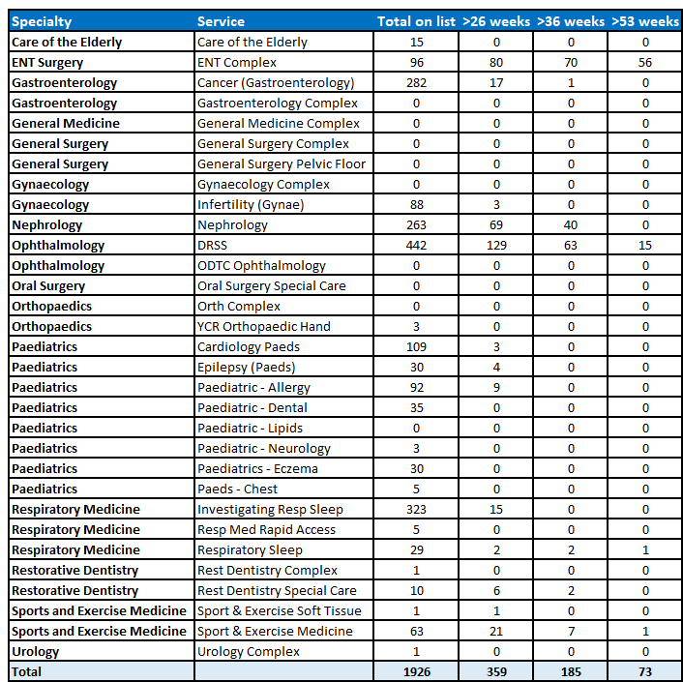

  - The Health Board’s quality team has been kept appraised of progress throughout this process, with any potential risks identified within this cohort continuing to be reported via the Datix incident reporting system, with appropriate, immediate actions being taken to mitigate any potential harm.

  - Validation of the longest waiting patients is now complete, with any further validation required being picked up as part of normal waiting list validation. Plans to treat those remaining as waiting are now underway.

  - The PMO continues to work in conjunction with Directorates around validation of lists and the development of plans to manage patients in line with RTT reporting. An audit trail of all actions is being maintained for each of the areas with all of the above pathways now being reported at the weekly RTT meetings.

Number of Patients Waiting over 52 weeks
  - The provisional position for patients waiting over 52 weeks for treatment at the end of October 2019 is 525 patients, which is a deterioration on the September position of 434. The breakdown of the 525 patients is as follows:

- 307 relate to Bridgend waiting lists (331 in September 2019)
- 145 relates to Cwm Taf waiting lists (29 in September 2019)
- 73 relate to the ‘unreported’ waiting lists that are now being reported (74 in September 2019).

  - Whilst the unreported and Bridgend 52 week positions have improved, the former Cwm Taf position has deteriorated, due mainly to increases in Anaesthetics and Dermatology. The over 52 week position continues to be off trajectory to achieve the end of year projected position. The following graph shows the current 52 week position set against the agreed trajectory for 2019/2020:

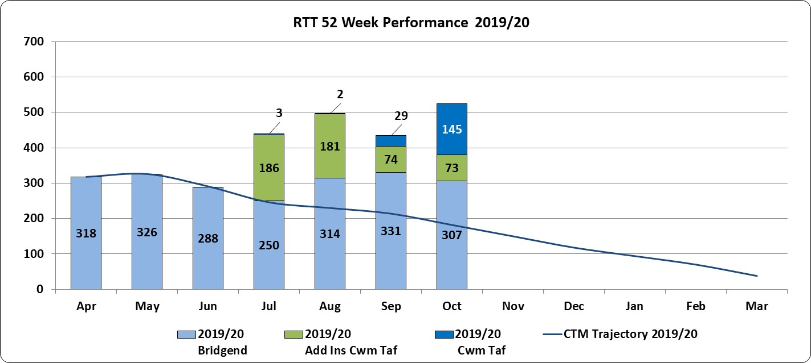

Number of Patients Waiting over 36 weeks – Target Zero
  - The provisional position for patients waiting over 36 weeks is 3567 patients across Cwm Taf Morgannwg (2985 at September 2019). Of the 3567 patients:

- 2296 patients relate to the former Cwm Taf waiting lists (1789 at September 2019).
- 1086 relate to Bridgend waiting lists (987 at September 2019).
- 185 relate ‘unreported’ waiting lists that are now being reported (209 at September 2019).
(N.B. this figure of 3567 includes the 525 patients waiting over 52 weeks).

  - This overall figure shows a deteriorating position from the previous month, with many services seeing an increase whilst recovery plans await implementation, combined with increased inpatient cancellations due to bed shortages.

  - The following graph shows the 36 week position and includes the trajectory position that was submitted to Welsh Government in July. There is significant challenge ahead to meet the anticipated year end position i.e. no patients waiting within the former Cwm Taf footprint at the end of March 2020 and a position significantly lower than 844 patients waiting at year end last year for POW.

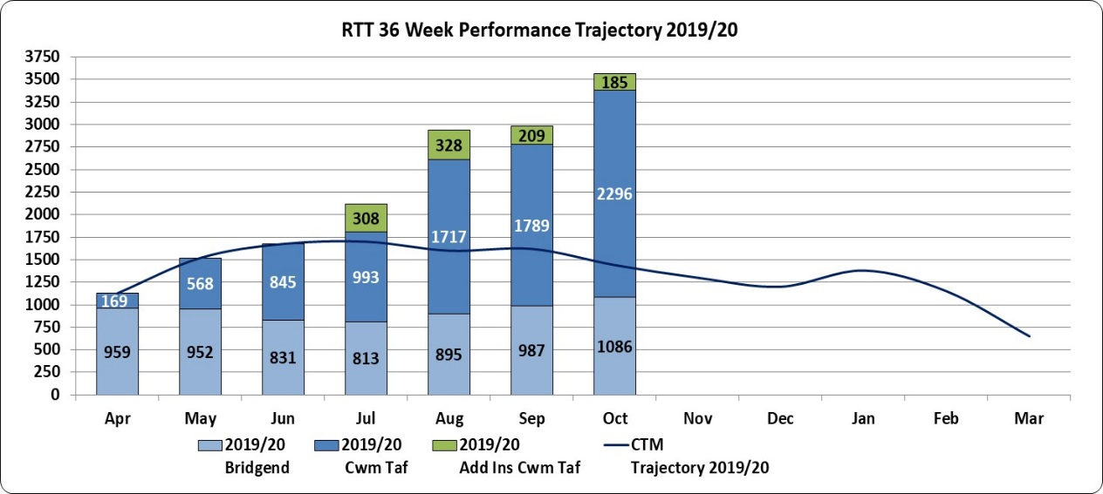

  - The following table provides a breakdown of patients waiting in excess of 36 weeks by specialty:

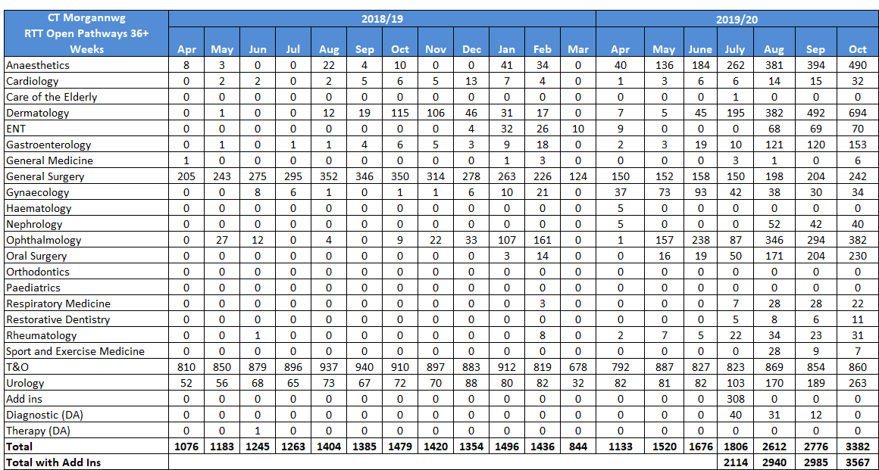

  - Recovery plans include validation of the Dermatology long waiting patients which started late October and outsourcing for Anaesthetics and Ophthalmology. Job plan changes are to be implemented from November to treat the ENT complex patients which were added in from the review of unreported waiting lists.

Number of Patients Waiting under 26 weeks – Target 95%
  - In terms of the 26 week position, the provisional position (excluding the direct access Diagnostic & Therapy figures) for October 2019 is:

- 84.5% of the Bridgend waiting lists waiting under 26 weeks.
- 82.4% of the former Cwm Taf waiting lists waiting under 26 weeks.
83.1% compliance figure for Cwm Taf Morgannwg, which is a marginal deterioration.

  - The following table provides a breakdown, by specialty, of the 26 week position:

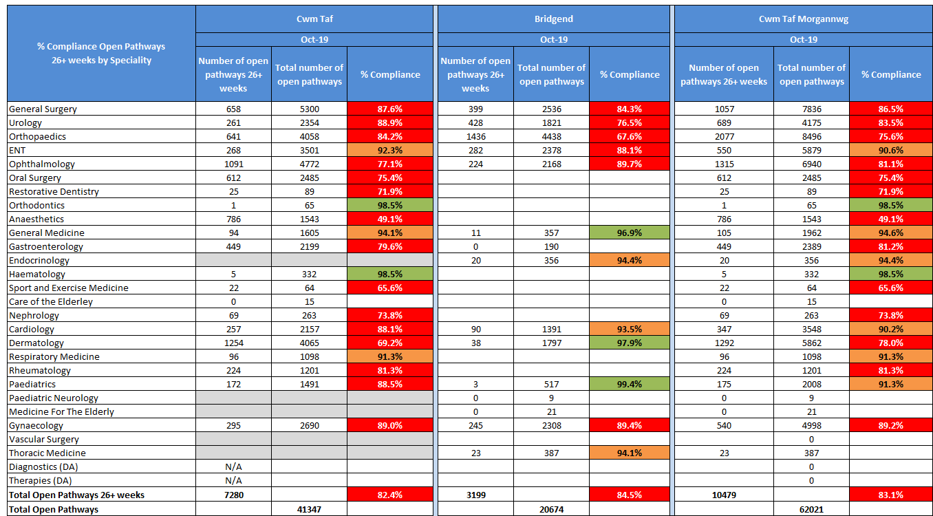

  - The following graph sets out the current and anticipated IMTP performance:

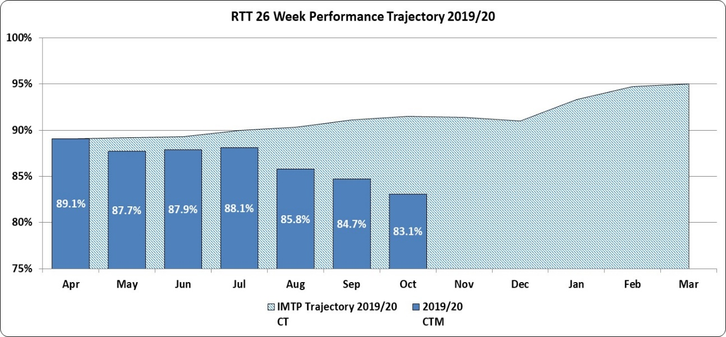

  - Activity levels continue to be closely monitored at the weekly RTT meetings, with continued representation from colleagues across the Health Board. Immediate challenges continue to be around bed and site pressures particularly at PCH, the ongoing HMRC restrictions, and theatre cancellations as a result of no anaesthetic cover available.

Open Pathways
  - The provisional number of open pathways for October 2019 compared to October 2018 is as follows:

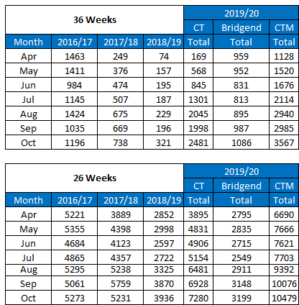

- RTT Commissioned Services - Executive Lead, Director of Planning and Performance.

  - Commissioning data post the 1 April 2019 boundary change remains at present aggregated by the former Health Board areas i.e. the former Cwm Taf and ABMU Health Boards. The new Health Board, Cwm Taf Morgannwg, is currently awaiting a change to Health Board boundary codes (that is the Bridgend patient postcodes need to be allocated to Cwm Taf Morgannwg and not ABMU). This work is awaiting a change in reporting format from NWIS who are in turn reliant upon the National Office of Statistics updating the national post code data set. A provisional framework for completion of this work is October 2019.

- Diagnostic Waits – Executive Lead, Chief Operating Officer – Target: zero waits >8 weeks

  - The provisional position for October 2019 is 873 patients waiting over 8 weeks for diagnostic services. This is a continued improvement on the September position of 959 patients. The breakdown of the 873 patients is as follows:
- 8 patients relate to Bridgend waiting lists (11 in September 2019)
- 865 patients related to the former Cwm Taf patients (including additional patients added from the unreported waiting lists) (948 in September 2019).

  - As with the RTT areas above, work has been undertaken in relation to validation of these lists to fully understand the issues in relation to these services. The following table provides a breakdown of the areas that are breaching the 8 week target and include the additional patients now added in as a result of the work on unreported waiting lists.
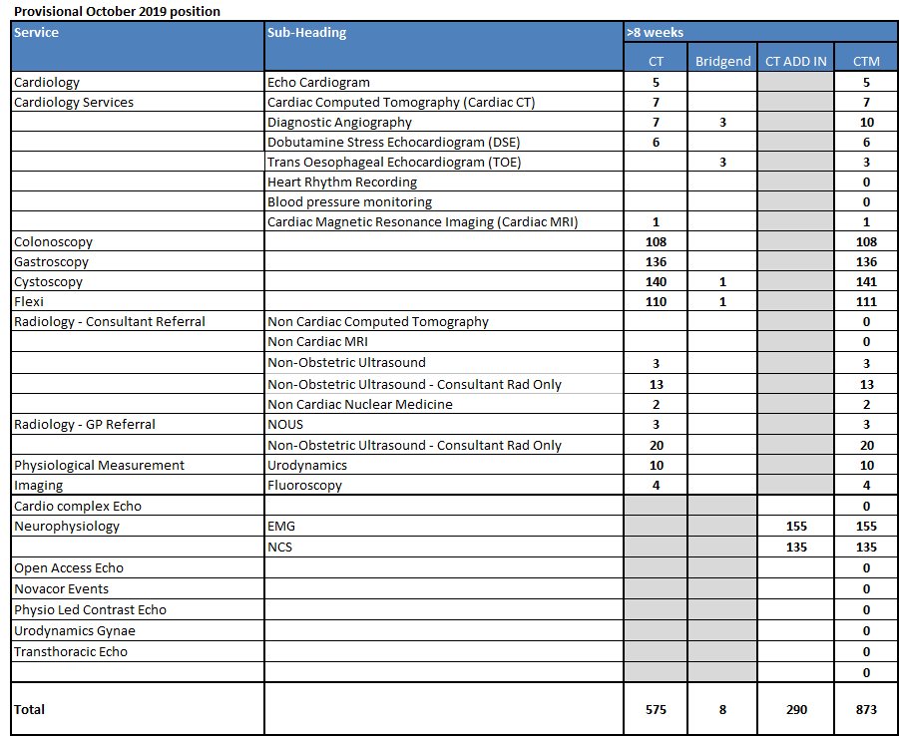

  - Additional activity already undertaken has resulted in a significant improvement for Echo Cardiogram and reduction for Neurophysiology. This will continue over the next few months to address the remaining backlog for Neurophysiology.

  - The following graph shows the current Cwm Taf Morgannwg diagnostic position, set against the 2019/20 IMTP trajectory:
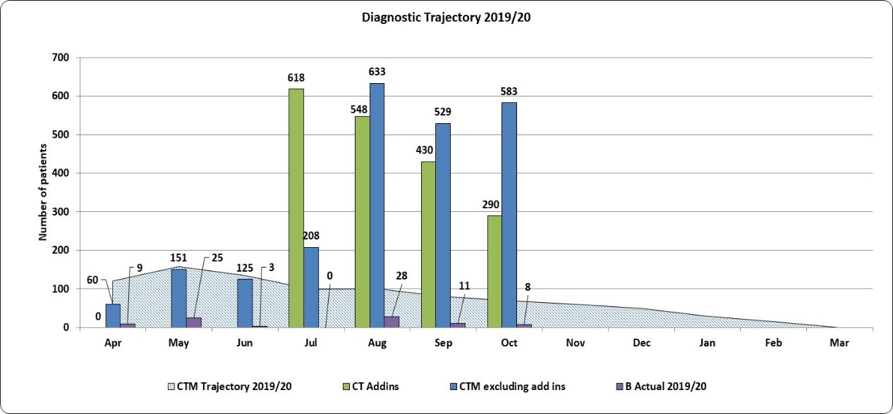
- Therapy Waits – Executive Lead, Chief Operating Officer – Target: Zero waits >14 weeks

  - There are only therapy breaches reported for the Bridgend footprint, which are in Paediatric Physiotherapy, with 58 breaches in October 2019 (37 September 2019). There were no therapy breaches for the old Cwm Taf footprint.
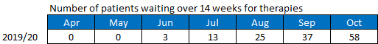
- Surveillance Monitoring (Endoscopy) – Executive Lead, Chief Operating Officer

  - The following tables provide a breakdown of those bowel screening surveillance patients awaiting an endoscopy within the former Cwm Taf footprint. The endoscopy unit at Princess of Wales is a JAG accredited unit and one of the criteria to maintain JAG accreditation is that all surveillance work needs to be 100% in target i.e. 100% of all patients that are under surveillance need to be seen within 8 weeks of the date due. This target is consistently being achieved with all patients usually seen within the month that they are due.

  - It should be noted that patients referred into the Cwm Taf service for endoscopy are managed through four referral pathways, each with their own waiting time target.
- Urgent Suspected Cancer: target 2 weeks.
- Urgent: target 2 weeks.
- Routine: target 8 weeks.
- Surveillance: target of 18 weeks.

  - The information in the table that follows by hospital site, shows that these targets are not being met across all category of patients in PCH and RGH sites. Missing these targets, can adversely impact the patients overall pathway.

  - Other than “routine” waits, the three remaining cohorts of patients are not managed via what is described as an RTT diagnostic pathway. Delays to patients within the USC cohort are discussed at the cancer management meeting.
  - Referral demand into the service continues to increase. The Directorate’s D&C plan clearly shows that in order to deal with current demand into PCH and RGH, additional capacity is required.

  - The Directorate is currently utilising insourcing at RGH, to accommodate the surveillance backlog patients with funding approved to continue the service until the middle of November 2019. The current backlog (census 3rd November 2019) of surveillance patients is of the order of 373, which is an improvement on previous months. The Directorate are in the process of developing a business case to increase capacity through the development of an extra endoscopy theatre at the RGH site.
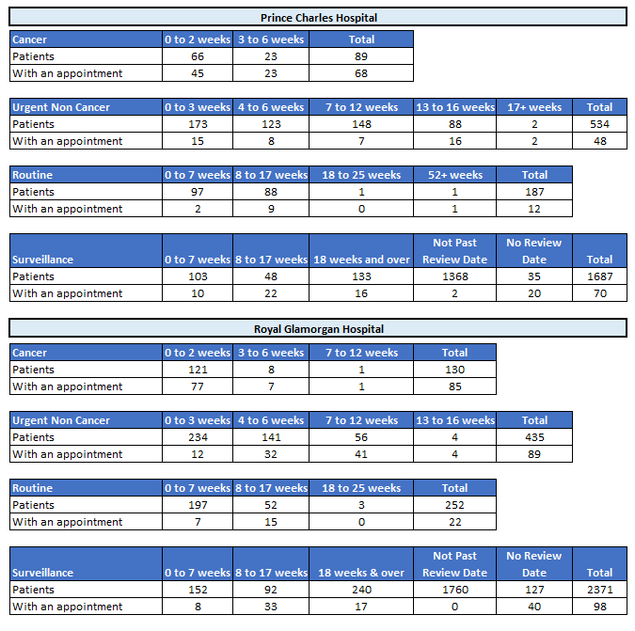
- Follow-Up Outpatients Not Booked – Executive Lead, Chief Operating Officer

  - The follow-up outpatients not booked (FUNB) data provided below is for September 2019 and currently for the former Cwm Taf area only. Further information for the Bridgend area, to provide a new consolidated Health Board position, will be provided in future and is part of the current work programme under development. This is being hampered by data flow issues from Swansea Bay UHB.

  - FUNB reporting is, in the main, paper-based at Princess of Wales Hospital and there is therefore significant work to be undertaken to ensure that this manual reporting correlates with FUNB data pulled from the Swansea Bay UHB WPAS (patient management system). There are also differences in reporting mechanisms between the former Cwm Taf area and Bridgend, which will need to be reviewed. Therefore, it is likely that accurate FUNB data for Bridgend will not be available in the short term.

  - For the former Cwm Taf area, the number of patients waiting for an outpatient follow-up (not booked) who are currently delayed past their agreed target date has shown an improvement over the last four months as follows (with October 2019 a provisional position):
- July 2019 15,342
- August 2019 14,754
- Sept 2019 14,085
- Oct 2019 13,348

  - Fortnightly FUNB meetings continue and work is now also including Bridgend activity, to ensure that there are appropriate plans in place for the Princess of Wales Hospital site.

  - At this stage, the review of potential unreported FUNB waiting lists (over 70% complete) has found no patients needing to be added back into the FUNB cohort.

- Elective Bed Cancellations – Executive Lead, Chief Operating Officer

  - There were 52 elective ward bed cancellations reported for October across the Health Board, an increase of 14 from September, reflecting the additional pressure on beds at PCH in particular, which is also continuing to affect the unscheduled care stream.
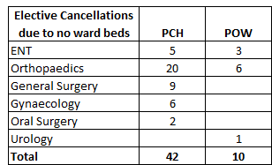
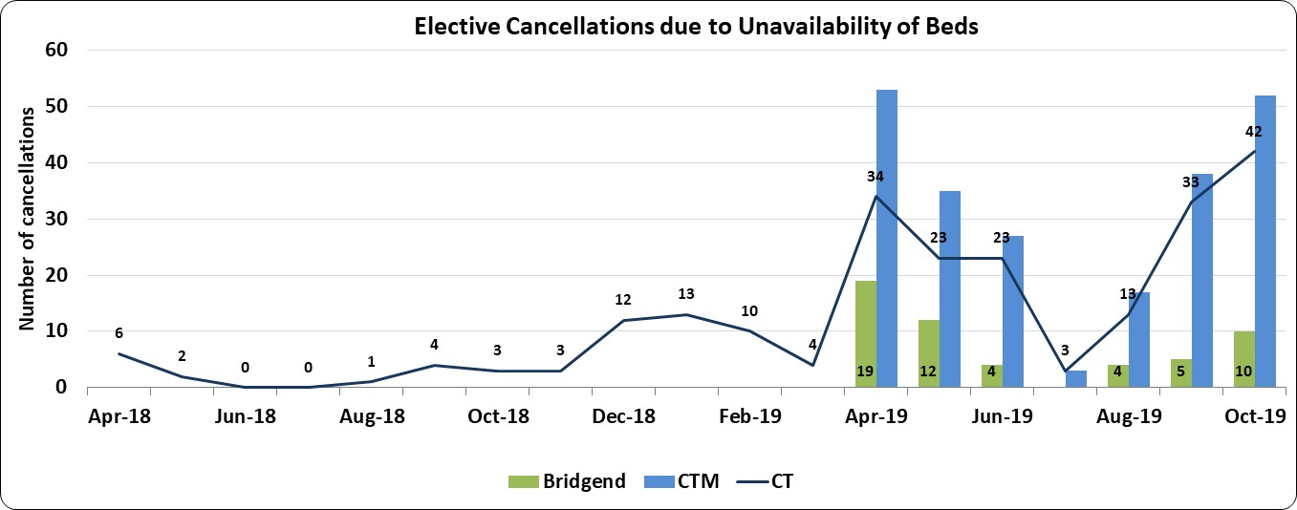

- Theatre Cancellations: Anaesthetics – Executive Lead, Chief Operating Officer

  - During October there were 2 theatre cancellations with the primary cancellation reason of “anaesthetist unavailable”, a reduction from the 8 reported in September. The number of cancellations for this reason will continue be monitored over the next few months. Cancellations occurred in the following service areas:
- Unscheduled Care – Executive Lead, Chief Operating Officer and Director of Primary, Community & Mental Health

  - 4 Hour 95% Target: The combined performance for Cwm Taf Morgannwg for the four hour target shows a slight dip in performance for October 2019 with a 72.3% achievement level. Individual departmental performance was as follows:
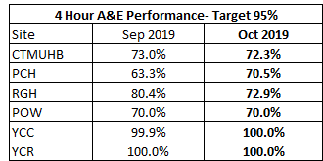

  - 12 Hour Zero Breaches Target: The combined performance for October is 1018 patient breaches, a further deterioration from 998 in September.

  - Of the 1018 breaches:
- 433 were at Prince Charles Hospital
- 171 were at Royal Glamorgan Hospital
- 414 were at Princess of Wales Hospital.

  - The Delivery Unit’s report pertaining to the review of the Prince Charles Hospital Emergency Departments is awaited.

Emergency Ambulance Services
  - The September 2019 performance for emergency ambulance services against the 15 minute handover (Local Measure - Improvement Target) for Cwm Taf Morgannwg fell this month to 65.49% from 69.33% in August.

  - The performance for emergency ambulance services over one hour (Target Zero) slightly improved to 90.01% from 89.25% in the previous month. An improvement was seen in September at Princess of Wales with a compliance for the site at 67.42% from to 60.80% in August. Performance for RGH was 99.48% and PCH 98.18%.
  - In September 2019, the response to red calls was 68.1% for Cwm Taf Morgannwg against a target of 65% and a Welsh average performance of 68.4%. This halts the deteriorating compliance since April 2019.

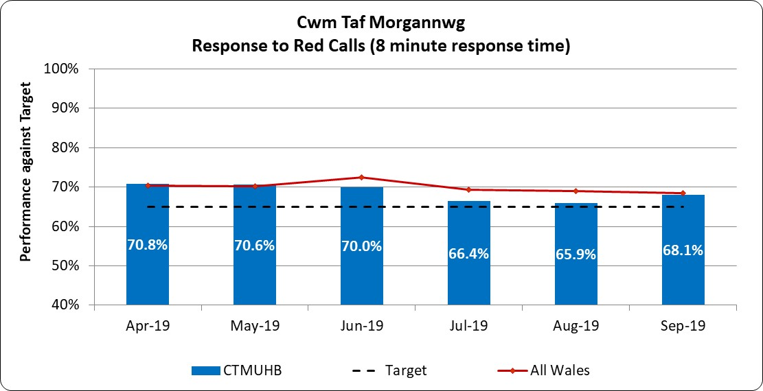
- Delayed Transfer of Care (DTOC) – Executive Lead, Chief Operating Officer and Director of Primary, Community and Mental Health – Target 12 month Reduction Trend

  - The delayed transfers of care (DToC) position for October is presented below as an aggregate for Cwm Taf Morgannwg UHB.
  - The following graph is a comparison of the number of DToC patients November 2017 to October 2018 against November 2018 to date.
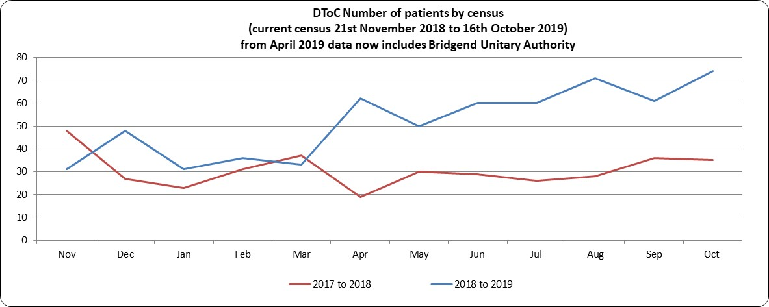

  - The following table shows the number DToC patients by locality:
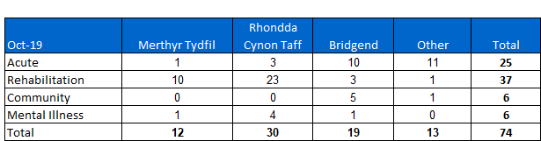
  - This month has seen an increase in both the number of DTOC patients and bed days lost from last month and continues to remain significantly higher than at the start of the year. DToC pressure areas are:
- Choice related issues regarding care homes;
- Home care capacity;
- Delays due to housing particularly requests for speciality and adapted housing;
- Delays due to mental capacity.

  - A specific pressure point for the HB would seem to be related to the number of rehabilitation patients at RCT. This is very often as a result of difficulties mentioned above i.e. accessing and putting in place, nurse care placements and home packages.

  - The following table shows the number of actual bed days lost within the month for the patients whose transfer of care was delayed:

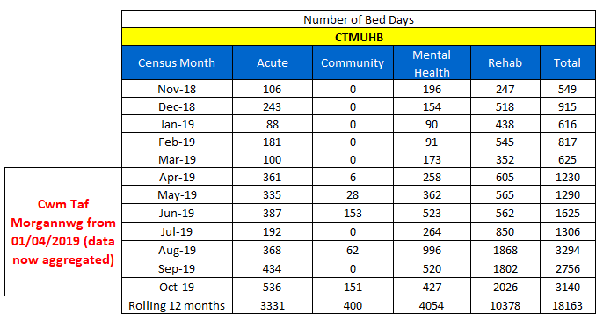
- Cancer 31 Non Urgent Suspected Cancer (NUSC) and 62 Urgent Suspected Cancer (USC) Day Target (escalation level 2) – Executive Lead, Medical Director

31 day target (NUSC) at September 2019: Target is 98%
  - The combined performance for Cwm Taf Morgannwg was 95.2% with 5 breaches.

62 day target (USC) at September 2019: Target is 90%
  - The combined performance for Cwm Taf Morgannwg was 73.0%. There were 24 breaches.

  - Urology accounted for 16 of the USC breaches, mainly through a combination of radiological delays and tertiary centre delays. Lung, Head & Neck and Skin each had 1 breach, Gynaecology 2 and Lower Gastrointestinal 3 breaches, mainly as a result of diagnostic capacity issues.

  - The following sets out the forecast position for the next three months:
Single Cancer Pathway
  - The Minister for Health and Social Care announced in November 2018 his intention to introduce a SCP across Wales, with Health Boards required to publically report performance against the SCP alongside the current cancer waiting times for all patients diagnosed with cancer and treated from June 2019. SCPs will be monitored initially for:

- Breast
- Colorectal
- Head and Neck/Mucosal
- Head and Neck/Neck Lump
- Lung
- Upper GI/Gastric and
- Upper GI/Oesophageal.

  - The Health Board has been formally reporting SCP to Welsh Government, running in parallel with existing cancer pathways for a number of months. Formal reporting to the Welsh Government started in August 2019.

  - The SCP performance for September 2019 was:
- With suspensions 74% (77% last month)
- Without suspensions 62% (68% last month)

  - The single Suspected Cancer Pathway measures from the point of suspicion until the start of first definitive treatment for all newly diagnosed patients, with the aim of treating all patients within 62 days of the point of suspicion. No performance measure has been set for the SCP as yet but there is an expectation of continuous improvement.

  - There remain some challenges in achieving the SCP targets. However, the Directorate has an action plan in place which is regularly reviewed and actioned.

- Quality Improvement Measures - Executive Lead, Director of Planning and Performance

  - At the time of preparation of this report, the October data for stroke was not available for reporting. During September, a total of 80 patients were recorded within the Sentinel Stroke National Audit Programme (SSNAP) database:
- 38 patients presented to the Princess of Wales Hospital, Bridgend.
- 42 patients presented to Prince Charles Hospital, Merthyr Tydfil.

  - There were 4 patients thrombolysed:
- 1 at the Princess of Wales Hospital, though not thrombolysed within 45 minutes.
- 3 patients thrombolysed at Prince Charles Hospital, of which one was thrombolysed within 45 minutes.

Prince Charles Hospital
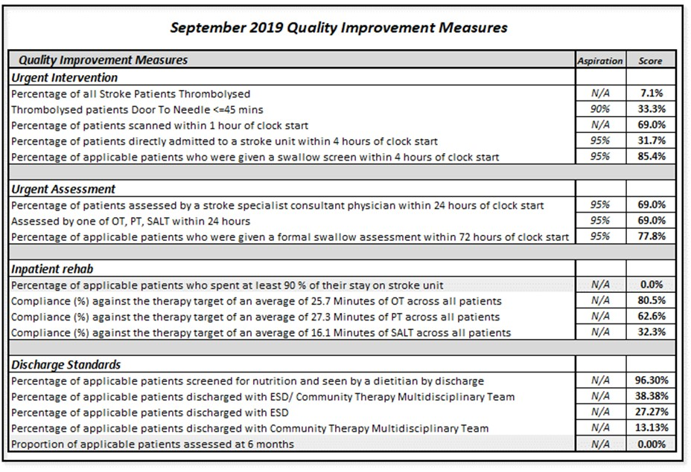
  - The Health Board continues to work with the Delivery Unit with regards to the follow up action plan from the thrombolysis review at the end of last year and on improving overall Health Board compliance.

Princess of Wales
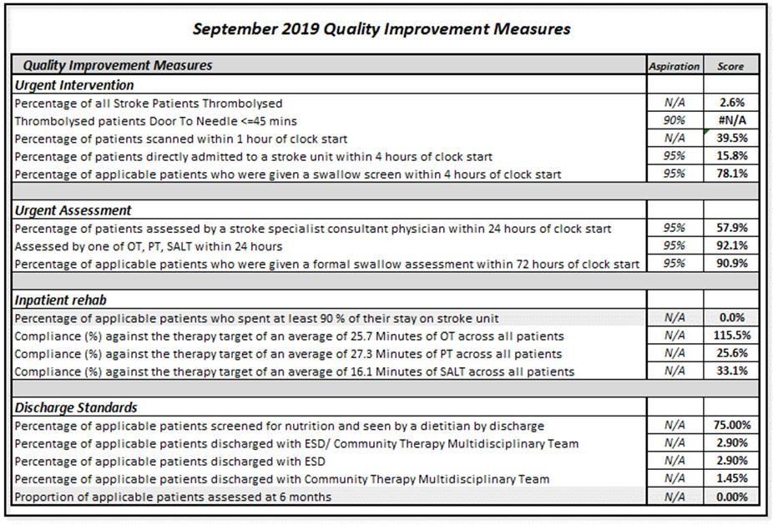
- Mental Health Measure - Executive Lead, Director of Primary, Community & Mental Health

  - The Mental Health data below relates to September 2019 and is aggregate data for Cwm Taf Morgannwg.
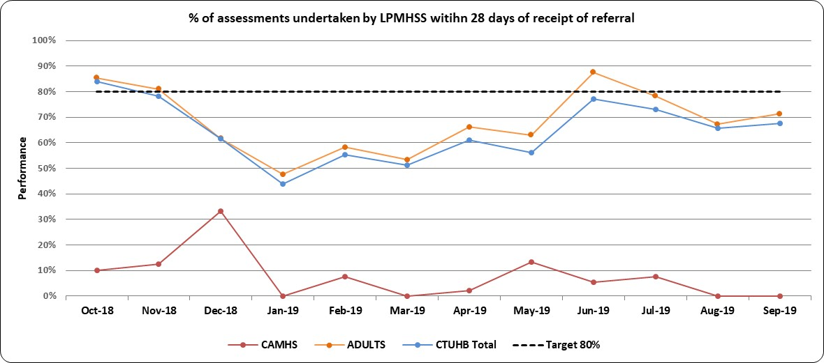
(* Post April 2019 data is CTM aggregate data)

  - Part One of the Mental Health Measure relates to primary care assessment and treatment and has a target of 80% of referrals to be assessed within 28 days. September compliance was 67.7%.
  - The percentage of therapeutic interventions started within 28 days following an assessment by LPMHSS reduced this month from 92.8% in August to 88.95, but remains well above the 80% target. The breakdown of this performance, together with the annual trend is provided in the following graph:

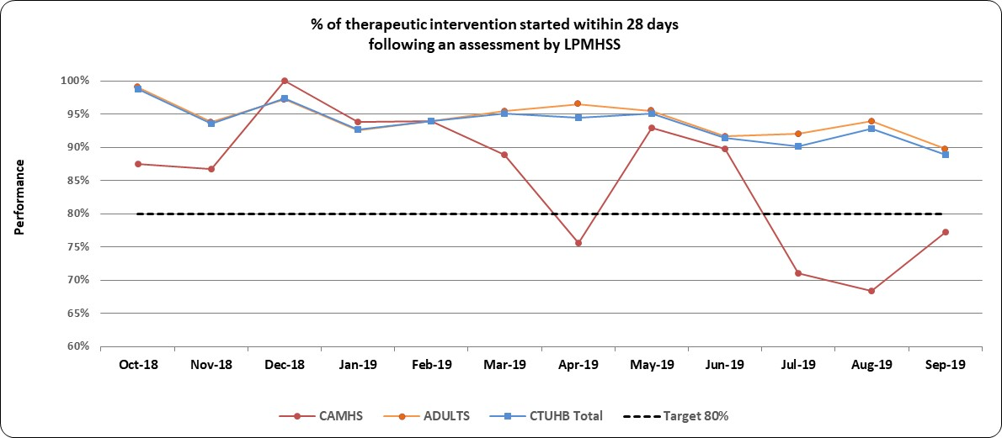
(* Post April 2019 data is CTM aggregate data)

  - Part Two of the Mental Health Measure: i.e. % of Cwm Taf Morgannwg residents who have a valid Care Treatment Plan completed by the end of each month continued to improve in September to 91.6%.
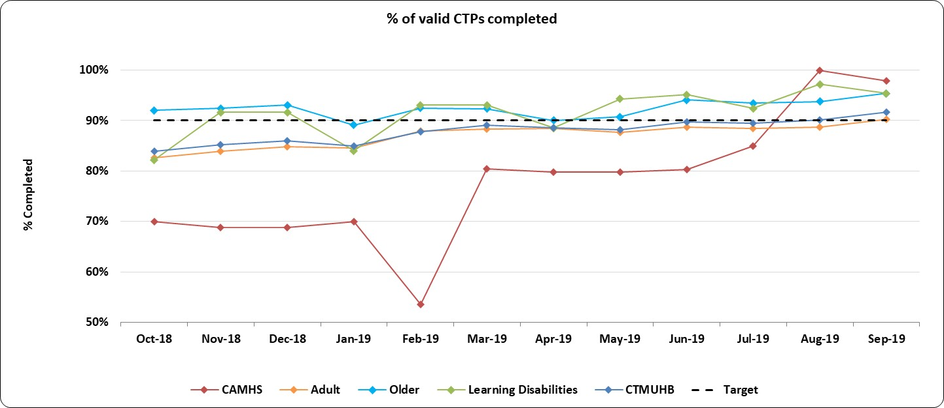
  - Two assessments were carried out during September for Part Three of the Mental Health Measure i.e. “All Health Board residents who have been assessed under Part 3 of the Mental Health Measure to be sent a copy of their outcome assessment report up to and including 10 working days after the assessment has taken place”, both of which were sent within 10 days (100%).

Primary Care CAMHS (p-CAMHS)
  - The Cwm Taf Morgannwg p-CAMHS waiting list position as at 5th November 2019 is a provisional 176 patients waiting, with 92 of those patients waiting more than 4 weeks. The average weeks wait has reduced further to 5 weeks from 7.

  - The additional capacity opportunities identified as part of the Delivery Unit review are continuing to have a positive impact. Recruitment of further staff, improvements in productivity of clinics and changes to clinical staff templates will ensure further reductions in the total waiting list. Compliance with the Part 1a mental health measure is however unlikely to be achieved until the total waiting list reduced to below 100.

Neurodevelopment
  - Compliance against the 26 week target for the former Cwm Taf area for Neurodevelopment services improved to a provisional 65.8% in October from 63.5% in September. The UHB have submitted a bid to Welsh Government to significantly increase the workforce both clinical and administrative to support the service in achieving compliance with the 80% target. In the meanwhile waiting list initiatives are continuing to help maintain and improve on the current position.
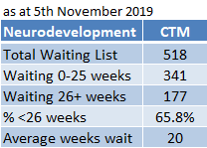

Specialist CAMHS (s-CAMHS)
  - The Cwm Taf Morgannwg position for specialist CAMHS waiting times continued to improve to a provisional 88.1% in October from 84.6% in September.

  - The Directorate and Information Department have undertaken further demand and capacity analysis and this has highlighted the current imbalance between the number of appointments available for “Choice” (new) and “Core” (follow up) patients. The Directorate are working with the clinical staff to rebalance their job plans and clinic templates to allow more Choice patients to be seen which will help improve compliance.

  - Patients from RCT are being offered an option to be seen at Bridgend to maximise the use of capacity, with waiting list initiatives continuing.
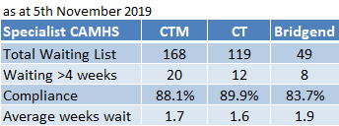

- KEY RISKS/MATTERS FOR ESCALATION TO BOARD/COMMITTEE

  - The key risks are covered in the summary and main body of the report.

- IMPACT ASSESSMENT

Quality/Safety/Patient Experience implications | Yes (Please see detail below)
Quality/Safety/Patient Experience implications | A number of indicators monitor progress in relation to Quality, Safety and Patient Experience, such as Healthcare Acquired Infection Rates and Access rates.
Related Health and Care standard(s) | Choose an item.
Related Health and Care standard(s) | If more than one Healthcare Standard applies please list below:  The 22 Health & Care Standards for NHS Wales are mapped into the 7 Quality Themes. The work reported in this summary and related annexes take into account many of the related quality themes.
Equality impact assessment completed | Not required
Legal implications / impact | Yes (Include further detail below)
Legal implications / impact | A number of indicators monitor progress in relation to legislation, such as the Mental Health Measure.
Resource (Capital/Revenue £/Workforce) implications /  Impact | There is no direct impact on resources as a result of the activity outlined in this report.
There are no directly related resource implications as a result of this report, although a number of improvement areas have underpinning financial plans.
A number of indicators monitor progress in relation to Workforce, such as Sickness and Personal Development Review rates.
Link to Main Strategic Objective | To ensure good value based health care and treatment for our patients in line with the resources made available to the Health Board
Link to Main WBFG Act Objective | Service delivery will be innovative, reflect the principles of prudent health care and promote better value for users

- RECOMMENDATION

5.1 The Board is asked to:
- DISCUSS and REVIEW the Integrated Performance Dashboard together with this report

