AGENDA ITEM
4.13

CTM Board

REGIONAL TRANSFORMATION PROGRAMME PROGRESS REPORT

Date of meeting | 28/11/2019

FOI Status | Open/Public

If closed please indicate reason | Not Applicable - Public Report

Prepared by | Anthony Hughes, Head of Regional Partnership Board Programme Management Office  Clare Williams, Assistant Director of Planning and Partnerships
Presented by | Ruth Treharne, Executive Director of Planning and Performance
Approving Executive Sponsor | Executive Director of Planning & Performance

Report purpose | FOR DISCUSSION / REVIEW

Engagement (internal/external) undertaken to date (including receipt/consideration at Committee/group)
Committee/Group/Individuals | Date | Outcome
Transformation Leadership Group  Regional Partnership Board | November 2019 | SUPPORTED

ACRONYMS
SWYC | Stay Well in Your Community
APCIS | Accelerating the Pace of Change of Integrated Services
PMO | Programme Management Office
TLG | Transformation Leadership Group
RPB | Regional Partnership Board
RCTCBC | Rhondda Cynon Taf County Borough Council

- SITUATION/BACKGROUND
  - Welsh Government announced on 10 June 2019 Transformation Fund investment of £22.7m allocated to the Cwm Taf Morgannwg Regional Partnership. This funding was awarded following a receipt of a proposal which consisted of two programmes: the ‘Stay Well in Your Community’ (SWYC) Programme, within the former Cwm Taf region; and ‘Accelerating the Pace of Change of Integrated Services’ (APCIS) Programme, within the Bridgend locality. Both programmes were developed via engagement with third sector representatives, and operational and clinical staff across the three Local Authorities and Health Board. The overarching aim of both programmes is to provide seamless services closer to home and improving outcomes, wherever people live in Cwm Taf Morgannwg.
  - The financial sustainability plan underpinning the Region’s two transformation programmes includes an approach to risk management which requires investment to be prioritised to ensure the correct balance of recurrent investment to potential recurrent cost release from the wider system.
  - Following the completion of prioritisation, each transformation programme is targeting investment as per table 1.
TABLE 1 | 2019/20 |  | 2020/21 |  | Total
TABLE 1 | £k |  | £k |  | £k
TABLE 1 | Original | Revised | Original | Revised | Original | Revised
APCIS | 3,366 | 2,799 | 3,307 | 2,439 | 6,672 | 5,238
SWYC | 7,228 | 5,613 | 8,833 | 6,363 | 16,061 | 11,976
Total |  |  |  |  | 22,733 | 17,214
The breakdown of the expected recurrent investment by workstream is as set out in table 2 and 3.

TABLE 2  APCIS | Revised 2021/22 Recurrent FYE Funding Requirement (inc. inflation)  £k
Ambition 1:  Every Day is Tuesday | 1,573
Ambition 2:  One Team Around the Person | 1,046
Ambition 3:  Resilient Co-ordinated Communities | 0
TOTAL | 2,620

TABLE 3  SWYC | Revised 2021/22 Recurrent FYE Funding Requirement (inc. inflation)  £k
Workstream 1:  Segmentation | 139
Workstream 2:  Assistive Technology | 1,385
Workstream 3:  ECCT | 4,197
Workstream 4:  SW@W2 | 1,524
Workstream 5:  Urgent Primary Care Services | 0
TOTAL | 7,245
  - In support of wider engagement on transformation, the Regional Partnership Board has recently hosted two Welsh Government ‘Healthier Wales’ workshop events. These were held in Bridgend and Merthyr Tydfil and were attended by Andrew Goodall, Director General for Health and Social Care, Welsh Government and Ifan Evans, Director of Transformation, Welsh Government. The well attended sessions focused on bringing ‘A Healthier Wales: A long-term plan for health and social care’, to life through local transformation.
- SPECIFIC MATTERS FOR CONSIDERATION BY THIS MEETING (ASSESSMENT)
  - The establishment of the Regional Partnership Board Programme Management Office (PMO) is well underway. The PMO will support the delivery of both the SWYC and ACIS programmes. The Head of PMO will lead the transformation work for the region on a day to day basis and will be the main point of contact for Welsh Government. Joint recruitment has been undertaken in order to efficiently fill posts. The focus has been on ensuring we have programme managers to support the immediate delivery work.
2.2 Set out below in Figure 1, the governance arrangements for the programmes have been approved by the Regional Partnership Board.
  - It is proposed that Health Board management of the programmes will be via Strategic Planning Group and Management Board, with scrutiny and assurance provided by the Health Board’s Primary Care, Population and Partnership Sub-Committee.
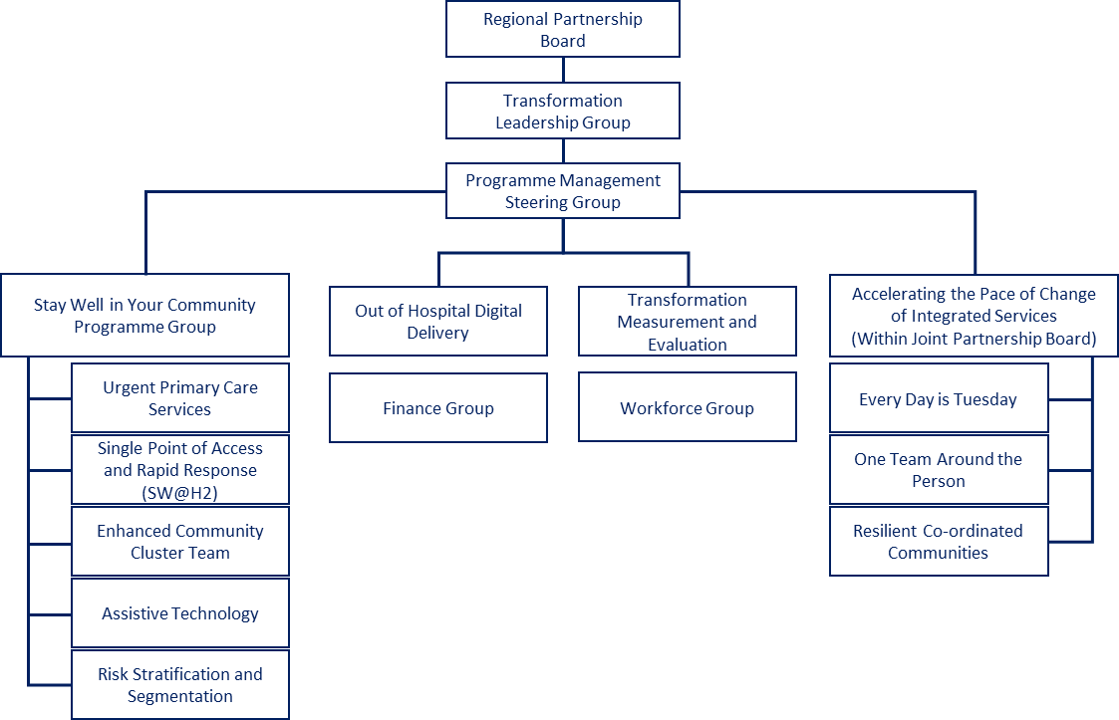
Figure 1
  - Highlight reports are used monthly to demonstrate progress against each work-stream and these are collated into a programme-wide report, which is scrutinised by the Transformation Steering Group, as shown in Figure 1 above. Once approved, the report is then presented at the Transformation Leadership Group (TLG) and Regional Partnership Board (RPB) for approval. Risks and mitigating actions are included within reports, to ensure the programme is on track and risks escalated, if required. Feedback loops are built into the reporting framework, to ensure effective communication at an operational level.
  - In order to achieve the correct financial accountability through the programme, a formal financial governance report has recently been approved by TLG, which clarifies budget allocation and methodology for dealing with programme slippage.
  - Enabling Groups for Finance and Workforce have been set up to provide technical support which increases the pace of change within recruitment and budget profiling. Two further enabling groups will be set up shortly. These are Measurement and Evaluation and Digital to support the programme.
  - In line with the funding active management conditions, the Regional Partnership Board is required to undertake a local evaluation of the Transformation programme, aligned to the national evaluation led by Welsh Government. The evaluation tender has been completed with support provided by Rhondda Cynon Taff County Borough Council (RCTCBC) procurement team. The tender applications were evaluated on 14 November 2019, with Officers from across the partnership forming the evaluation panel. A series of reports will be produced by the successful organisation, with the first being a mid-point review by 31 December 2019.
  - Building on the high-level framework included in the Stay Well in Your Community Welsh Government submission and learning from the integrated performance management metrics in Bridgend, the Programme Management Office will establish an evaluation framework and benefits tracker, working closely with the appointed Evaluation Consultants. This will include monitoring cash releasing savings from the wider system which will mean we can sustain the programmes. Further programme management undertaking will include:
      - Complete Programme evaluation procurement exercise in partnership with RCTCBC;
      - Strengthen the programme governance including the development of an overarching programme dashboard and highlight report, utilising Results Based Accountability (RBA) to capture impact against outcomes;
      - Develop robust quality assurance processes across within the programme;
      - Develop a communication and engagement plan; and
      - Create a team ethos across different work-streams.
  - Progress within the Stay Well in Your Community Programme includes:
Risk Stratification & Segmentation
- Programme Manager (Population Health) is now in post;
- Principle Public Health Intelligence Analyst starts 4 November 2019 and will prioritise evaluation of the predictive ability of population segmentation, for completion by March 2020; and
- Phase 2 of the Rhondda pilot is progressing and preliminary scoping of the predictive ability of the segmentation has been undertaken by Forest View by viewing patient records for those identified as high or moderate risk in segments 4 and 9.

Assistive Technology
- Go live date – End January 2020;
- Staff consultation process completed and feedback provided to staff;
- High level project outcomes defined;
- Detailed work on reporting will be developed following Tunstall Platform implementation;
- Advertising of posts to commence shortly;
- Vehicles for Mobile Responder Services ordered; and
- Slippage bid approved for keysafes linked to Lifeline Users.
Enhanced Community Cluster Team
- Planned implementation w/c 3 February for first MDT in Rhondda;
- South Cynon, Merthyr and Taff Ely over a period of 2-3 months (order of this implementation to be confirmed at a later date when the workshops have taken place in November/December);
- 29 of 82 posts required within this project are recruited at present;
- Test MDTs will be arranged between October and December 2019 to ensure agreement amongst clinical teams that the proposed model and the segmentation data are appropriate; and
- Implementation of the new model will be via a phased approach. Roll out of phased approach to be confirmed in December 2019, following GP engagement.
Stay Well@Home Phase 2
- Go live date – End January 2020;
- Two appointments recruited internally within Single Point of Access (SPA) Team, Senior SPA role advertised externally;
- One Occupational Therapist (OT) role recruited with more interviews arranged;
- Task and Finish groups are focussing on processes including HR, data, performance and evaluation; and
- Links made with OOH Digital Delivery Programme Manager to discuss data needs, workshop delivered in October 2019.
  - Progress within the Accelerating the Pace of Integrated Services Programme includes:
- Expansion to Mobile Response Team – go live date Jan/Feb 2020;
- Better@Home Bridgend Service (additional home care support staff (140 hours) – go live date Jan 2020; and
- Common Access Point – the optimal model is to develop a fully operational Common Access Point to community services that will operate from 8am to 8pm over seven days, however we will take a phased approach to implementation to ensure the service offers value for money and is proportionate to the demand. Phase 1 (extended hours – 8am to 8pm over 5 days) is estimated to go live on 1 March 2020, Phase 2 (extended hours 8am to 8pm over 7 days) will be implemented thereafter and will be dependent on the evaluation of Phase 1 and ongoing demand analysis. The earliest Phase 2 will be implemented (if required) will be June 2020.
Ambition 1 – Every Day is a Tuesday
- Programme Support Officer for Ambition 1, 2 and 3 in the process of appointing;
- Interviews for Mobile Response workers carried out with three appointable candidates;
- Intermediate Care Support Workers, Social Worker, Assistant and OCT posts to be recruited. Pharmacy Technician and Language Therapy posts to be recruited; and
- Further work is underway to determine baseline data and refining performance indicators.
Ambition 2 – One Team around the Person
- Occupational Therapist JD will be finalised and sent for job matching this week;
- Discussions with Physiotherapy departments have been positive and options are being explored;
- Health Care Assistants have been recruited;
- RGN band 5 (×5) these are about to go out for advert;
- Further work required with Head of Primary Care around Home Care Support Service;
- Single Point of Access for District Nursing progressing well and moving to 7 day working will occur quickly, once staff recruited;
- Considerable baseline data on which we will be able to build a matrix for measuring performance; and
- Significant progress has been made within the multidisciplinary team in terms of recruitment and scoping on modelling including reviewing the virtual ward in the Cynon Valley.
Ambition 3 – Resilient and Co-ordinated Communities
- Programme Manager for Ambition 2 and 3 starts 4 November 2019;
- Co-ordinator role in place. All community navigators will be in place for October;
- Grant based investment scheme will be promoted based on three identified themed outcomes during October/November;
- Interviews for the Development Officer role have taken place and the brokerage role has also been appointed;
- The location of Connectors and Hub models has been established and discussions progressing well on the model for information, advice and assistance in relation to the third sector and brokerage related support;
- A focus on growing the range of opportunities that people can be connected to and social prescribing programmes is emerging; and
- A scorecard that joins up a range of investment sources is being developed.
- KEY RISKS/MATTERS FOR ESCALATION TO BOARD/COMMITTEE
  - A risk log covering the Regional Transformation Programmes is included as Appendix 1.
- IMPACT ASSESSMENT
Quality/Safety/Patient Experience implications | There are no specific quality and safety implications related to the activity outined in this report.
Related Health and Care standard(s) | Choose an item.
Related Health and Care standard(s) | Individual Care  Staying Healthy  Staff and Resources  Governance, Leadership and Accountability
Equality impact assessment completed | No (Include further detail below)
Equality impact assessment completed | An Equality Impact Assessment is under development.
Legal implications / impact | There are no specific legal implications related to the activity outlined in this report.
Resource (Capital/Revenue £/Workforce) implications /  Impact | Yes (Include further detail below)
- Transformation funding is profiled from April 2019 - March 2021 to include a realistic view of recruitment profiles, an assessment of non-recurring costs and inflation;
- The financial sustainability plan is predicated on utilising addition Welsh Government ring-fenced income and reinvesting costs released from the wider health and care system.
Link to Main Strategic Objective | To ensure that services provided are accessible and sustainable into the future
Link to Main WBFG Act Objective | Work collaboratively with our public service partners and a broader range of partners to join up health and other services where this potentially represents better value for our residents and care users
- RECOMMENDATION
The Board is asked to:
  - NOTE that further regular updates on Regional Transformation will be received by the Primary Care, Population Health and Partnership Committee of the Board; and
  - DISCUSS and REVIEW the progress made across the Regional Partnership Board Transformation Programme.

