

A Major Trauma Network for South Wales, West Wales and South Powys Programme Business Case
Date: 18/11/19 | Version: 1.0 (Final)
Purpose:
In March 2018, each of the six health boards serving the populations of South Wales, West Wales and South Powys formally agreed to recommendations for the development of a Major Trauma Network for the region, in line with the recommendations of an Independent Panel and following a period of formal consultation.
Since that time, a significant programme of work has been undertaken to develop the configuration of the network and the clinical and operational model. This has been enabled and supported through strong and effective clinical leadership and engagement, and taking account of patient experiences.
This work has culminated in the production of a Programme Business Case which describes the totality of the requirements for NHS Wales to establish the South Wales Trauma Network (‘the network’), serving the population of South Wales, West Wales and South Powys. The case outlines the requirements for the network to become operational and, also, the trajectory of development over a five-year period.
Boards are asked to:
- Receive and discuss the Programme Business Case for the network.
- Note that there has been significant scrutiny of the case, including three formal Gateway Reviews and professional peer review by UK clinical experts.
- Approve the overall network model described in the case (clinical, operational and governance), including the:
  - role of the Operational Delivery Network (ODN)
  - role of the health board, as a provider of respective component of service model.
- Note the importance of the repatriation policy and the importance of the ODN having the authority to implement this, completion of which will form a critical activity in planning network implementation.
- Note that there will be other business cases over the next two to three years to further develop the major trauma centre and trauma units.
- Approve the content of the Programme Business Case, subject to confirmation of the NHS resource allocation for 2020/21, the IMTP prioritisation process, and point 7 below.
- Note that final commissioning decisions on prehospital services, the major trauma centre, relevant specialist services and the ODN, will be taken at meetings of the Welsh Health Specialist Services Committee (WHSSC) and the Emergency Ambulance Services Committee (EASC).

Introduction
The Programme Business Case (PBC) describes the requirements for NHS Wales to establish the South Wales Trauma Network, serving the population of South Wales, West Wales and South Powys. The PBC outlines the requirements for the network to become operational and, also, the trajectory of development over a five-year period of implementation.
This PBC represents the culmination of significant work to develop the configuration of the network and the clinical and operational model. This has been enabled and supported through strong and effective clinical leadership and engagement, and taking account of patient experiences.

Background
In March 2018, each of the six health boards in the region formally agreed to recommendations for the development of a Major Trauma Network for South Wales, West Wales and South Powys, in line with the recommendations of an Independent Panel and following a period of formal consultation:
1. A major trauma network for South and West Wales and South Powys with a clinical governance infrastructure should be quickly developed.
2. The adults’ and children’s major trauma centres should be on the same site.
3. The major trauma centre (MTC) should be at University Hospital of Wales, Cardiff.
4. Morriston Hospital, Swansea, should become a large trauma unit (TU) and should have a lead role for the major trauma network.
5. A clear and realistic timetable for putting the trauma network in place should be set.
Since that time, a significant programme of work has been undertaken, overseen by a Trauma Network Board, which has led to the production of the PBC and initial preparations for implementation of the network.

Network Structure
The structure of the South Wales Trauma Network will be comprised of the following elements:
- An Operational Delivery Network (ODN), to be hosted by Swansea Bay University Health Board, which will provide the management function for the network. It will be a collaboration between all providers of trauma care services in the region, and its governance arrangements will provide appropriate authority to ensure operational delivery.
- A pre-hospital triage tool will ensure major trauma patients are conveyed directly by the Welsh Ambulance Service (WAST) or the Emergency Medical Retrieval and Transfer Service Cymru (EMRTS), or other emergency providers, to the MTC or TUs.
- An adults’ and children’s MTC at University Hospital of Wales (UHW), Cardiff. It will have access to all specialist services relevant to major trauma and take responsibility for the acute care of all major trauma patients in the region via an automatic acceptance policy and manage the transition of patients to rehabilitative care.
- An adult and paediatric TU, with specialist services, at Morriston Hospital, Swansea. It will provide specialist support to the MTC and provide specialist surgery for patients who do not have multiple injuries, for burns, plastic, spinal and cardiothoracic surgery.
- Six adult and paediatric TUs at the following locations:
  - UHW, Cardiff
  - Royal Gwent Hospital, Newport and Nevill Hall Hospital, Abergavenny (until the Grange University Hospital is fully operational, planned for April 2021, at which point it will become the single designated TU for Aneurin Bevan University Health Board)
  - Prince Charles Hospital, Merthyr Tydfil and Princess of Wales Hospital, Bridgend
  - Glangwili General Hospital, Carmarthen.
The TUs will provide care for injured patients and have systems in place to rapidly move the most severely injured patients to hospitals that can manage their injuries, in most cases the MTC. They will also receive patients back who require ongoing care in hospital.
- Rural trauma facilities at Bronglais General Hospital, Aberystwyth, and Withybush General Hospital, Haverfordwest, which will maintain the ability to assess and treat major trauma patients, given their unique geographical locations.
- A Local Emergency Hospital at Royal Glamorgan Hospital, Llantrisant. This hospital will not routinely receive acute trauma patients but, should this occur, it will ensure appropriate initial management and transfer to the MTC or nearest TU.

Clinical and Operational Model

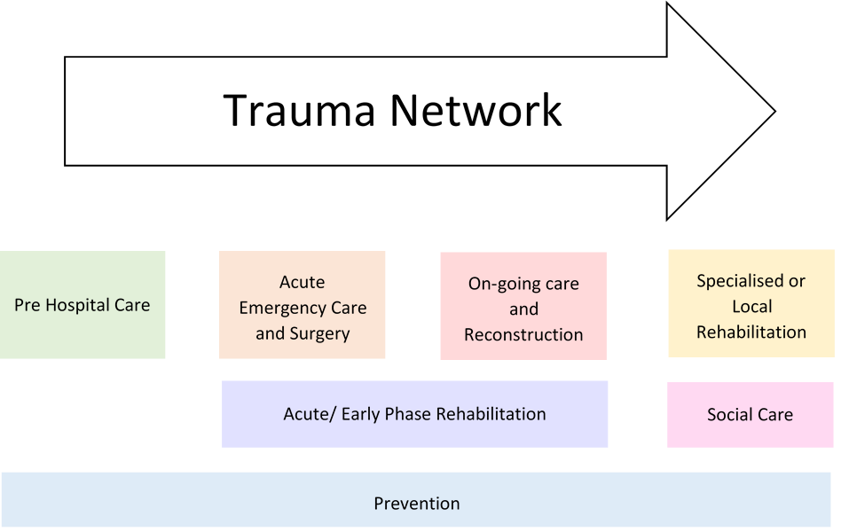
Detailed work has been undertaken to develop the clinical and operational model for the network and to estimate changes in patient flows. There will be an increase of approximately 300 patients being treated per annum at the University Hospital of Wales due to its planned status as the MTC for the network (full details of estimated changes in patient flow across the network are provided in Chapter 4 of the PBC).
The planning work has led to the adoption of the NHS England quality indicators and service specification. Assessments have been undertaken to review current services against these indicators and the estimated changes in patient flows, which has informed the resource requirements for each component part of the network:
- Pre-hospital services (chapter 6) – Five indicators and investment required for new and additional journeys, additional training, establishment of a major trauma desk within the clinical contact centre, and for a transfer and discharge service. These requirements were endorsed by EASC in September 2019.
- Major Trauma Centre (chapter 7) – 52 indicators for adult services and 46 for children’s services. 38 are currently not met, which form the basis for the required investment, five of which are not essential for ‘Day 1’ and implementation of which will be phased. Investment is sought for:
  - Emergency Department – quality of immediate response and stabilisation from 24/7 consultant trauma team lead, dedicated nursing and seven day paediatric trauma team lead until 10pm.
  - Theatres – additional theatre availability to improve timeliness of access to theatres.
  - Critical Care – additional capacity for predicted increase in demand.
  - Poly Trauma Unit – dedicated ward for acute admission and early targeted rehabilitation in readiness for discharge to local care.
  - Trauma and orthopaedics – additional surgical capacity to meet increased activity flow.
  - Hyper acute rehabilitation service – to provide early rehabilitation plans for trauma patients with intensive rehabilitation needs.
  - Specialist services – new local plastic surgery availability on site to deliver improved outcomes (through collaboration with Swansea Bay University Health Board).
  - MTC directorate – senior leadership to drive improvements in rehabilitation, clinical practice, and audit and outcomes.
- Trauma Units (Chapter 8) – 26 indicators, many are already being met or could be met through the provision of network policies and internal re-organisation of resources. The initial focus for additional resources is on key enabling posts to improve clinical governance, data collection and patient flow. Further resources will be required to meet standards in Years 2 and 3. The TU at Morriston Hospital will have a role in providing specialist services support to the network. The PBC includes costs for locating up to four plastic surgeons at the MTC.
- Operational Delivery Network (chapter 5) – investment required to manage the network and coordinate operational delivery.
Essential to the effective operation of the network will be patient repatriation, that is arrangements for patients to return to a suitable local hospital as soon as the acute phase of their trauma care is completed. This will enable patients to continue their treatment closer to home, reduce impact on family and carers, and help provide capacity for the MTC to automatically accept new patients. An automatic acceptance policy is proposed for repatriation of major trauma patients from the MTC, but within the context of supporting interventions. The policy is under development, draft principles for which are:
1. Acceptance of the principle that origin health boards are responsible for their patients, irrespective of where they are being treated.
2. Automatic acceptance will be treated in the same way in both directions (i.e. to the MTC and back to the TU).
3. Any delay in repatriation will lead to a delay in automatically accepting new patients to the MTC.
4. Key features of an All Wales Repatriation Policy will be included.
5. The ODN is given operational authority within the escalation procedures for delayed transfers of care.
There will be an opportunity to pilot the policy before the network goes live.
Rehabilitation services are vital to the care of patients following major trauma. Major trauma practitioners and rehabilitation coordinators will be new roles in the health boards and will be vital in ensuring seamless care and key points of contact for patients returning from specialist care to a TU or the community. A consultant in rehabilitation medicine will operate in each health board on a weekly basis, playing a key role in coordinating the team, managing complex patients and facilitating discharge. In Years 2 and 3, and subject to approval of additional business cases, there will be further enhancement of local and community based rehabilitation including core therapy roles as well as some specialist roles, providing both in-reach and out-reach services. For complex patients who return from specialist care (e.g. traumatic brain injury, spinal injuries), a training and education programme for medical and nursing staff will ensure the skill set of the rehabilitation multidisciplinary team at TUs will be identical to the skill set of that based at the MTC.
Prevention is an essential component of an inclusive major trauma system and the network will be able to make a significant contribution to injury prevention programmes through data sharing, research and educational initiatives. The ODN will be responsible for ensuring attention to prevention activities and the benefits realisation plan described in the PBC commits the network to the development of an injury prevention strategy, in partnership with Public Health Wales.

Network Workforce
The PBC identifies significant additional workforce requirements, the majority of which will work within the MTC. This requires collaboration within system-wide arrangements. The network has developed workforce principles to mitigate the risk of destabilising services as a consequence of establishing the MTC. These principles include shared job plans, portfolio roles and rotational posts across the network.

Staff Group | WTE
Medical Staff | 43.3
Healthcare Support Workers | 37.65
Registered Nurses | 85
Allied Health Professionals, Scientists and Technicians etc. | 27.5
Administrative and Clerical staff | 15
Total | 208.45

Revenue and Capital Costs
The totality of the revenue and capital costs included in the PBC is set out in the tables below. This has been informed by significant scrutiny of the network requirements through the programme arrangements and, also, independently through clinical peer review and Gateway Reviews. Learning lessons from the establishment of major trauma networks in other parts of the UK has been of particular importance. This has informed the scale of the MTC requirements and also the enabling requirements for the pre-hospital services, trauma units and the rehabilitation pathway. This will ensure the maximum benefit for the most seriously injured patients, the majority of whom will go to the MTC. There are some elements of the MTC case that are phased and, also, the resource requirements for the TUs reflect a more phased approach.
Summary of revenue costs
 | 2019/20 | 2020/21 | 2021/22 | 2022/23 | 2023/24
 | £000s | £000s | £000s | £000s | £000s
MTC | £922 | £10,579 | £11,222 | £11,222 | £11,222
Specialist Services | £150 | £910 | £910 | £910 | £910
Trauma Units | £287 | £1,278 | £1,278 | £1,278 | £1,278
Operational Delivery Network | £119 | £496 | £508 | £513 | £515
Pre-Hospital Care | £58 | £1,201 | £635 | £640 | £640
Total | £1,536 | £14,465 | £14,553 | £14,562 | £14,564
Summary of health board and trust funding shares
(Reflects local Trauma Unit / Rehabilitation costs plus share of Major Trauma Centre, Specialist Services and WAST Pre-hospital care)
 | 2019/20 | 2020/21 | 2021/22 | 2022/23 | 2023/24
 | £000s | £000s | £000s | £000s | £000s
Aneurin Bevan | £353 | £3,549 | £3,571 | £3,573 | £3,574
Cwm Taf Morgannwg | £308 | £2,743 | £2,758 | £2,759 | £2,760
Cardiff and Vale | £247 | £2,808 | £2,826 | £2,828 | £2,829
Hywel Dda | £262 | £2,462 | £2,477 | £2,479 | £2,479
Powys | £27 | £225 | £226 | £226 | £226
Swansea Bay | £281 | £2,678 | £2,695 | £2,696 | £2,697
WAST  (2019/20 funded by WG, Year 1 onwards by health boards) | £58 | £0 | £0 | £0 | £0
Total | £1,536 | £14,465 | £14,553 | £14,562 | £14,564

Value, Cost Effectiveness and Benchmark Cost Comparison
The value of investment in major trauma is centred on the benefits from reducing mortality and in reducing the levels of disability in people who have experienced major trauma. Major trauma is one of the major causes of premature death. The NCEPOD report (2007) highlighted that 75 % of major trauma involved young men. Reducing mortality and improving function in this patient group, therefore, has the ability to produce material health gain for any investment. The National Audit Office report (2010) highlighted the potential to reduce mortality by 15 to 40%. This has subsequently been evidenced by the real world experience data from the introduction of the major trauma networks in England, which demonstrated a 19% improvement in case-mix adjusted mortality (Moran 2018).
There is international evidence that investment in major trauma is cost effective. The NHS Confederation (2010) reported the work of Nicholl (Sheffield University Health Economics) which indicated that, based on a 10% improvement in mortality, a health economy could invest £5m per annum per million population and achieve a quality gain cost effective at within the £20,000 per QALY standard. A comprehensive study from the United States (Mackenzie 2010) compared the outcomes in Level 1 trauma centres with non-trauma centres and quantified the cost effectiveness at $36,961 per QALY. When adjustments are made to translate into much lower UK health system costs, investment in major trauma compares well against common investment priorities such as hip and knee surgery.
The lack of a comprehensive baseline cost for the MTC makes comparison with other UK benchmarks problematic. However, the incremental unit cost for the MTC across ISS 9 to 15 and >15 (ISS being a score to measure injure severity) has been assessed to start at £15,190 in Year 1 falling to £13,573 by Year 3. The full cost of MTC activity delivered by an NHS England MTC for the North Wales population, based on real world data, has been calculated as £18,650 per case with a range of £23,576 for ISS>15 and £12,083 for ISS 9<15. It is anticipated that, if all baseline costs were included, the full cost of the new MTC would probably exceed the benchmark, but any financial gap will narrow when, as predicted, activity grows and wider system efficiencies from existing TUs begin to be realised.

Programme Assurance
Development of the clinical and operational model and the production of the PBC have been coordinated and overseen by the Trauma Network Board, with commissioner scrutiny provided by WHSSC and EASC. There was intensive scrutiny throughout the summer and autumn of 2019, including benchmarking of the MTC financial case against a lead English MTC, Gateway Reviews in July, September and October, and professional peer review by UK clinical experts in August. These have collectively informed the final PBC and the resource requirements to enable the establishment of the South Wales Trauma Network.

Next steps
Subject to approval of the content of the PBC and confirmation of funding, the South Wales Trauma Network is planned to go live in spring 2020. Some implementation has already commenced with recruitment to key enabling posts. The Gateway Review undertaken in October 2019 reported growing confidence that a go-live at or around April 2020 would be achievable, with a number of elements of the model being introduced in the first few months after this.
The Trauma Network Programme Board will be refocused on implementation, with a leaner membership once the PBC is approved. There will be some parallel running of the programme team and the new ODN, and full handover to the ODN prior to go-live. Arrangements are planned to hold critical readiness reviews for the MTC and TUs, which will focus on recruitment and, within the MTC, on capital works. Also, the automatic acceptance policy for repatriation will need to be in place. This will inform decisions on the date from which the network will become operational, which will be signed off by WHSSC, as the lead commissioner.

Recommendations
Boards are asked to:
- Receive and discuss the Programme Business Case for the network.
- Note that there has been significant scrutiny of the case, including three formal Gateway Reviews and professional peer review by UK clinical experts.
- Approve the overall network model described in the case (clinical, operational and governance), including the:
  - role of the Operational Delivery Network (ODN)
  - role of the health board, as a provider of respective component of service model.
- Note the importance of the repatriation policy and the importance of the ODN having the authority to implement this, completion of which will form a critical activity in planning network implementation.
- Note that there will be other business cases over the next two to three years to further develop the major trauma centre and trauma units.
- Approve the content of the Programme Business Case, subject to confirmation of the NHS resource allocation for 2020/21, the IMTP prioritisation process, and point 7 below.
- Note that final commissioning decisions on prehospital services, the major trauma centre, relevant specialist services and the ODN, will be taken at meetings of the Welsh Health Specialist Services Committee (WHSSC) and the Emergency Ambulance Services Committee (EASC).

